a)

Let’s assume D=0.4





To find Lm first find the average current flow in Lm





Now let’s assume, current ripple in the magnetization current is equal to 40%.





fs is taken as 100kHz,



Lm is taken as 14.4 , which is explained in part b.

Then, the MATLAB Simulink simulations were done according to values which were found above. 

Figure 1.1: Circuit Schematic of the Flyback Converter

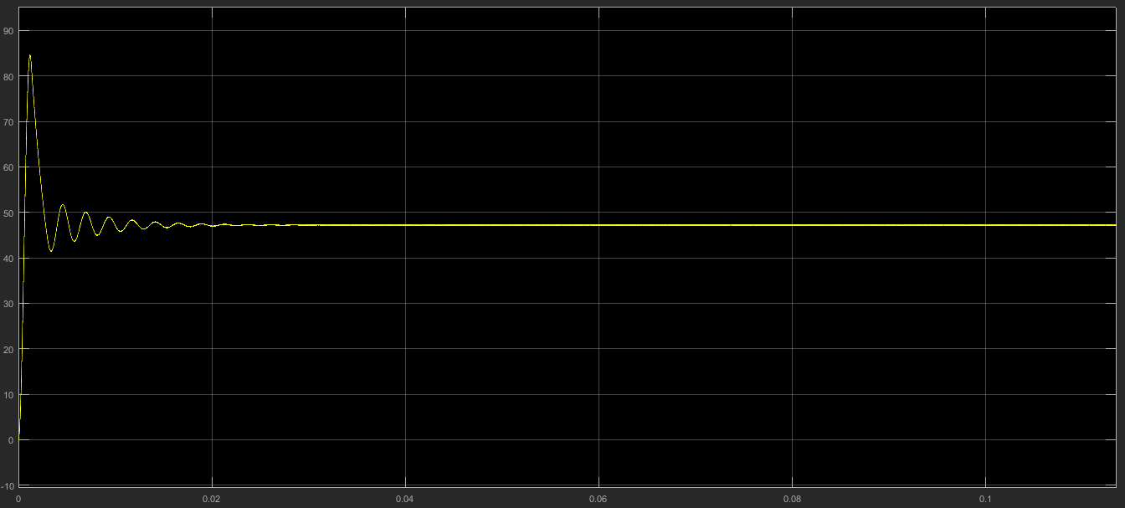

Figure 1.2: Output Characteristic of the Flyback Converter

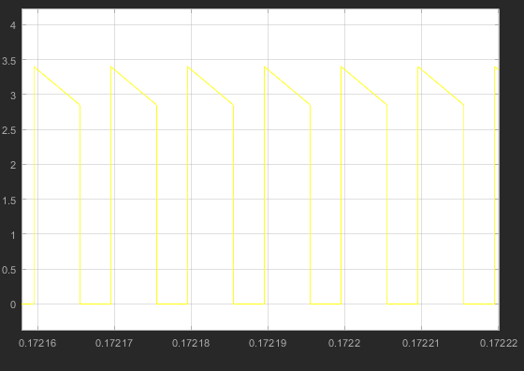

Figure 1.3: Current Flow Characteristic on the Diode

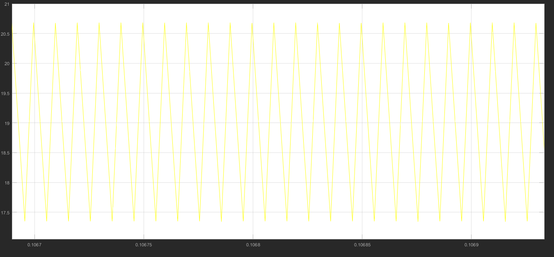

Figure 1.4: Magnetization Current Waveform of the Flyback Converter

b)

Transformer Design

We use 495-5251-ND as a core. Its material is N41.

Bsat is nearly 0.4T, which does not need excess amount of winding to avoid from saturation. To avoid from saturation, core has enough cross sectional area. Inductance factor of the core is 1.6 µH, which is also proper to reach at least 7.5 µH magnetizing inductance. Operating frequency of the converter is 100 kHz, which is in the optimum frequency range of the core. Core loss at 100 kHz is reasonable.

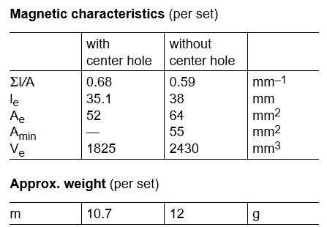

Figure 1.5: Core Properties

$N1>\frac{Vimax*Dmax*\frac{1}{fs}}{Bsat*Ae}$ (9)

From the equation (9), N1>2

Inductance factor of the core is 1.6 µH. In order to have less ripple than 40% on magnetizing inductance current (from part a), N1 should be 2.17, at least. For N1=3, Lm is equal to

$$3^2*1.6 µH=14.4 µH$$

By using the formula (10), N2 is 18.

(10)

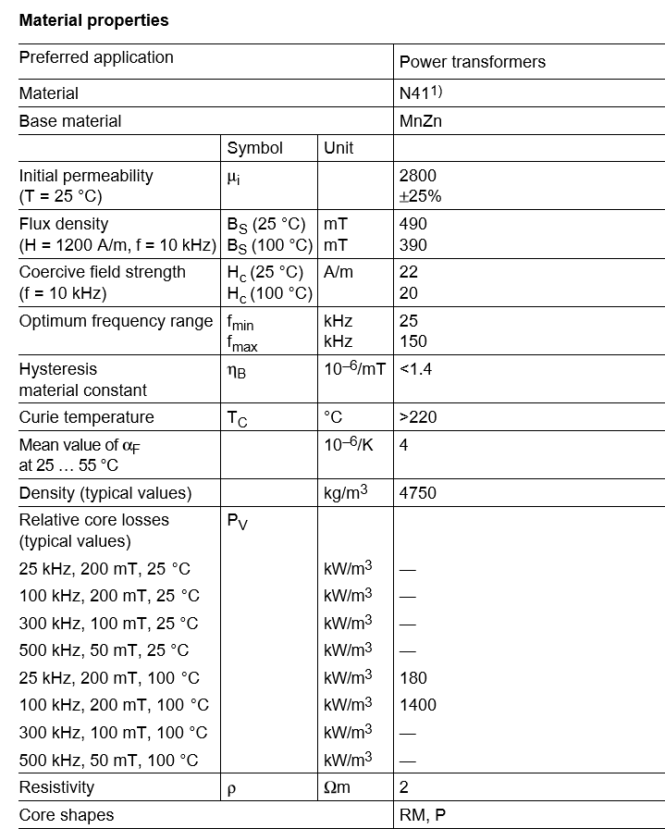

Figure 1.6: Core Material Properties

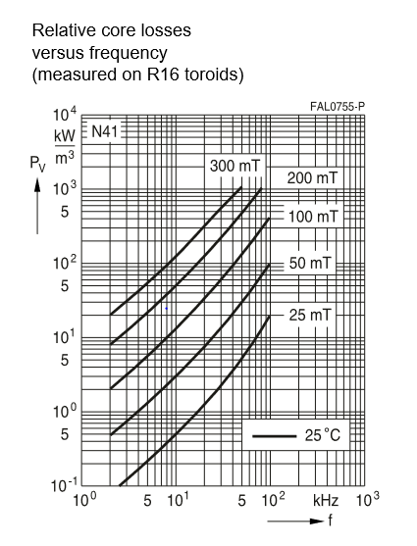

Figure 1.7: Core loss of the material

c)

Ripple on the magnetizing branch current is 3.5 A. Therefore, at the boundary of CCM and DCM, average inductor current is 1.75 A. Input power is

$12V*1.75A*0.4=8.4W$ (11)

Output power is 8.4W if the losses are neglected. Minimum output current is

$\frac{8.4W}{48V}=0.175A$ (12)

d)

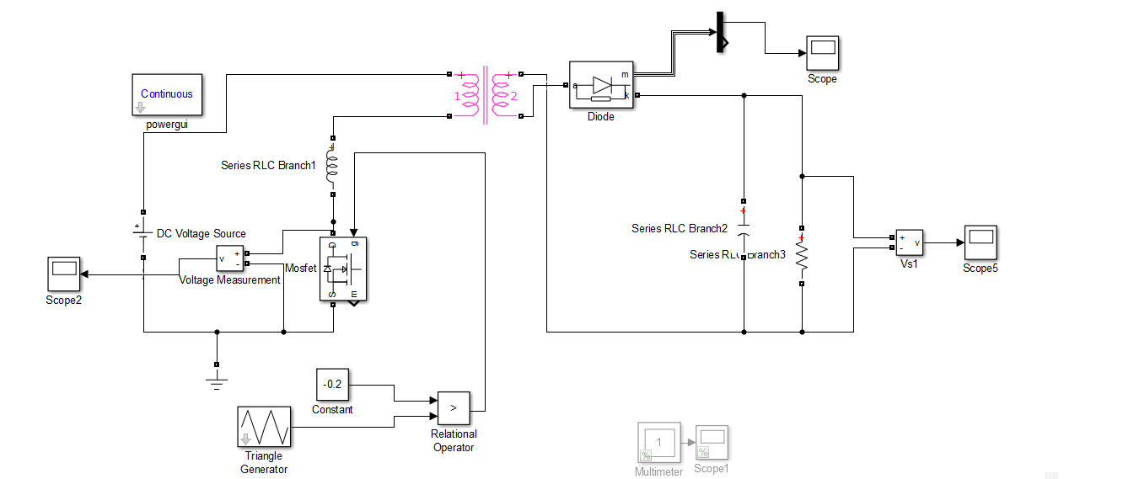

Figure 1.8: Flyback Converter with Leakage Inductance

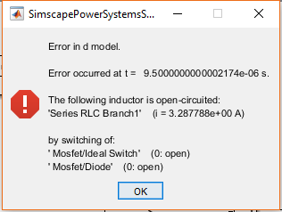

Figure 1.9: Error Caused by Discontinuous Leakage Inductor Current

Leakage inductor current has to be continuous. However, switching causes discontinuity in the current, which results in error inFigure 9. In real, abrupt change in the leakage inductance current cause high voltage difference across the terminals of the switch. Therefore, it is necessary to implement a snubber across the terminals of the primary winding to protect the switch. The snubber will provide a path to current to flow continuously. The snubber seen in Figure 10 helps the switch voltage to stay limited.

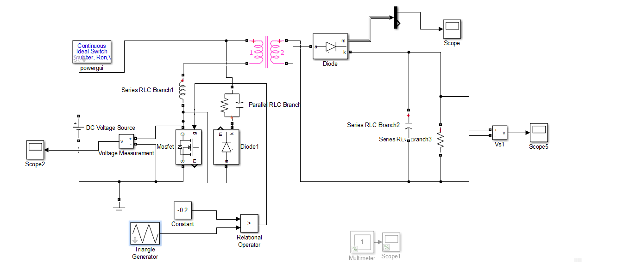

Figure 1.10: Flyback Converter with Leakage Inductance and Snubber

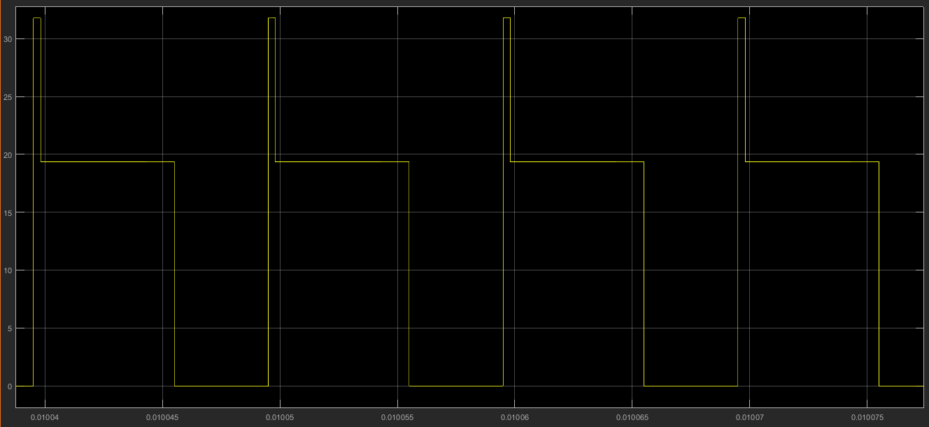

Figure 1.11: Switch Voltage

e)

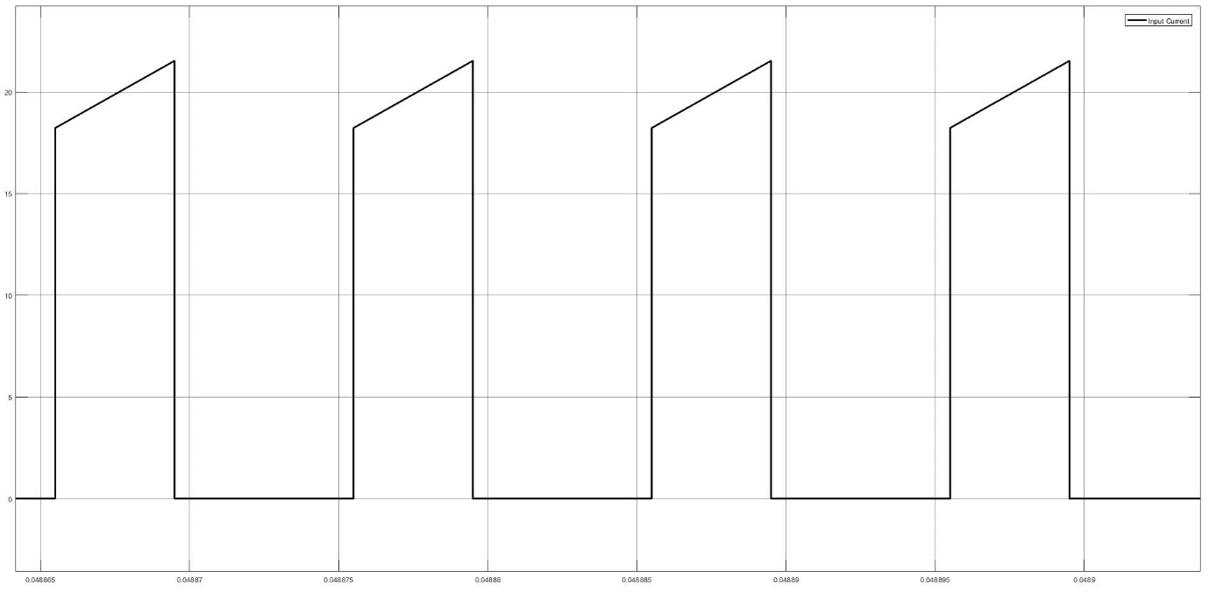

Figure 1.12: Input Current Waveform under Full-Load Operation

Power input during full load operation is,

$$\begin{aligned}P_{in}=V_{s}*I_{input}\#\left(13\right)\end{aligned}$$

$$\begin{aligned}P_{in}=12*17.795*0.4 \#\left(14\right)\end{aligned}$$

$$\begin{aligned}P_{in}=85.416W \#\left(15\right)\end{aligned}$$

$$\begin{aligned}efficiency=\frac{P_{out}}{P_{in} }=0.93 \#\left(16\right)\end{aligned}$$

$$\begin{aligned}I_{out}=1.842A \#\left(17\right)\end{aligned}$$

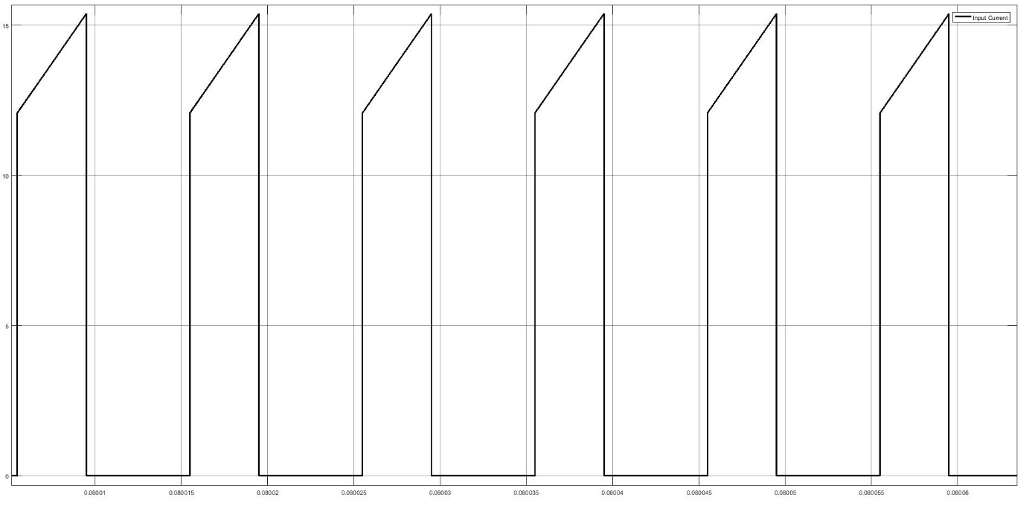

Figure 1.13: Input Current Waveform under 75% Load Operation

Power input during full load operation is,

$$\begin{aligned}P_{in}=V_{s}*I_{input}\#\left(18\right)\end{aligned}$$

$$\begin{aligned}P_{in}=12*13.73*0.4 \#\left(19\right)\end{aligned}$$

$$\begin{aligned}P_{in}=65.9W \#\left(20\right)\end{aligned}$$

$$\begin{aligned}efficiency=\frac{P_{out}}{P_{in} }=0.91 \#\left(21\right)\end{aligned}$$

$$\begin{aligned}I_{out}=1.229A \#\left(22\right)\end{aligned}$$

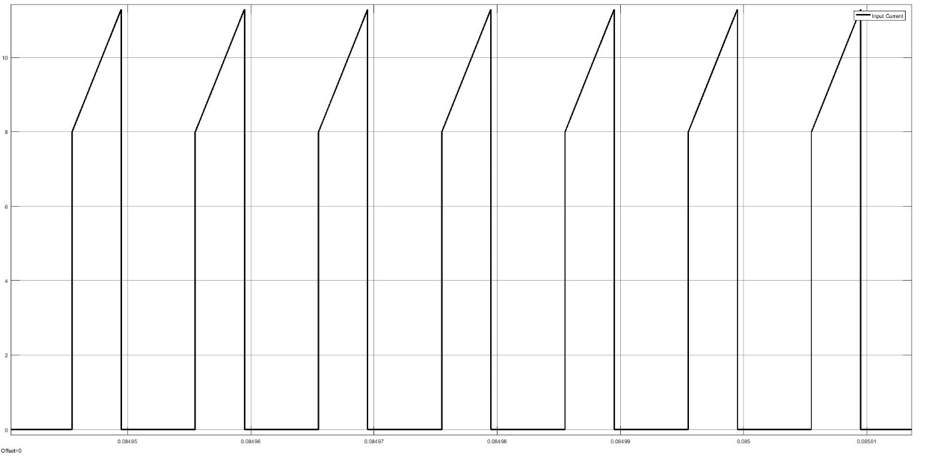

Figure 1.14: Input Current Waveform under 50% Load Operation

Power input during full load operation is,

$$\begin{aligned}P_{in}=V_{s}*I_{input}\#\left(23\right)\end{aligned}$$

$$\begin{aligned}P_{in}=12*9.67*0.4 \#\left(24\right)\end{aligned}$$

$$\begin{aligned}P_{in}=46.416W\#\left(25\right)\end{aligned}$$

$$\begin{aligned}efficiency=\frac{P_{out}}{P_{in} }=0.88 \#\left(26\right)\end{aligned}$$

$$\begin{aligned}I_{out}=0.8192A \#\left(27\right)\end{aligned}$$

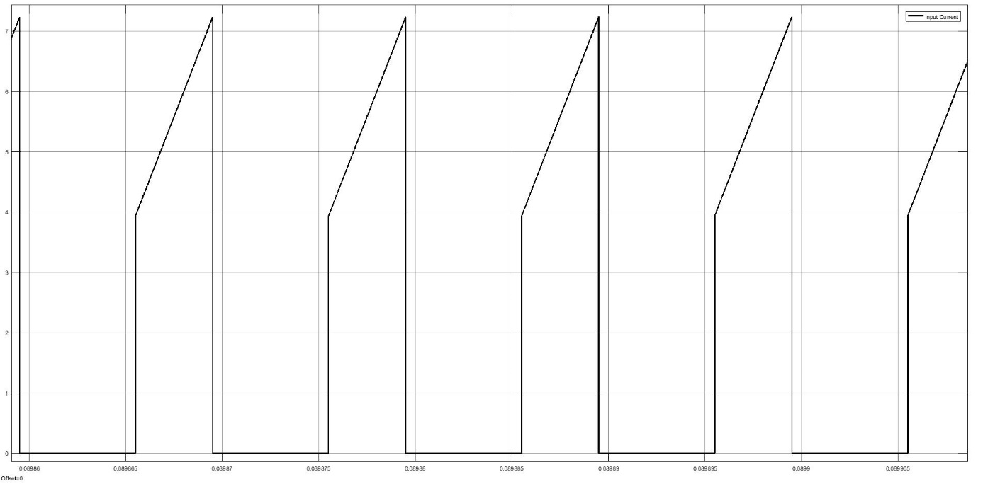

Figure 1.15: Input Current Waveform under 25% Load Operation

Power input during full load operation is,

$$\begin{aligned}P_{in}=V_{s}*I_{input}\#\left(28\right)\end{aligned}$$

$$\begin{aligned}P_{in}=12*5.42*0.4 \#\left(29\right)\end{aligned}$$

$$\begin{aligned}P_{in}=26.016W\#\left(30\right)\end{aligned}$$

$$\begin{aligned}efficiency=\frac{P_{out}}{P_{in} }=0.76 \#\left(31\right)\end{aligned}$$

$$\begin{aligned}I_{out}=0.4079A \#\left(32\right)\end{aligned}$$

As expected, efficiency is decreased with decreasing load. Due to transformer used in flyback converter, transformer has low efficiency due to hysteresis losses (magnetization and demagnetization of transformer core) and eddy current at low load. Since at low load, these losses dominate the output power. Then the efficiency of the flyback converter is low under smaller loads. When load further increased efficiency will start to increase until its maximum level. Since also all of the components has finite resistance which caused power losses such as internal resistance of the switch, internal resistance of the capacitance etc.

f)

Component selection is made by taking cost, performance and compatibility of the products into consideration. Transformer core is selected in part b.

United Chemi-Con EKXG201ELL101ML20S Capacitor is selected for snubber design. Its rated voltage is enough to suppress the voltage caused by leakage inductance current change.

SMC Diode Solutions SB5200TA diode is selected. Its reverse voltage should be at least

$V_{diode,reverse}=Vin*\frac{N_{2}}{N_{1}}+Vout=120 V$ (33)

Selected diode’s maximum reverse voltage is 200 V. Diode current is 3.5 A at most drawn by load side, so maximum current of selected diode is 5A. Forward voltage drop is 1.1 V, which is reasonable to use with 48 V output.

IRF540NPBF-ND Mosfet is selected as switch. It has the capability of passing 33 A drain to source current and blocking 100 V drain to source voltage. Drain to source voltage drop of the Mosfet is about 1 V. In designed converter, switch is subject to 21 A drain to source current, 30 V reverse voltage blocking, which is met by selected Mosfet. Reverse recovery time of the Mosfet is 170 ns, which is suitable for 100 kHz switching.