e.

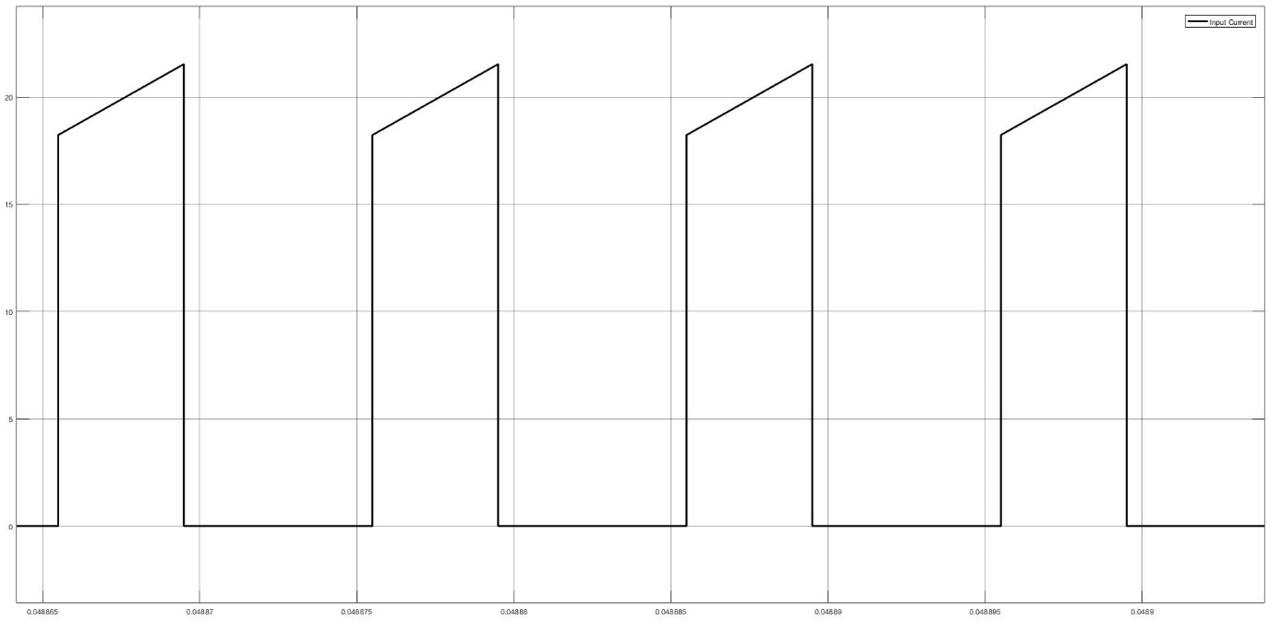

Figure 1: Input Current Waveform under Full-Load Operation

Power input during full load operation is,

$$\begin{aligned}P_{in}=V_{s}*I_{input}\#\left(1\right)\end{aligned}$$

$$\begin{aligned}P_{in}=12*17.795*0.4 \#\left(2\right)\end{aligned}$$

$$\begin{aligned}P_{in}=85.416W \#\left(3\right)\end{aligned}$$

$$\begin{aligned}efficiency=\frac{P_{out}}{P_{in} }=0.93 \#\left(4\right)\end{aligned}$$

$$\begin{aligned}I_{out}=1.842A \#\left(5\right)\end{aligned}$$

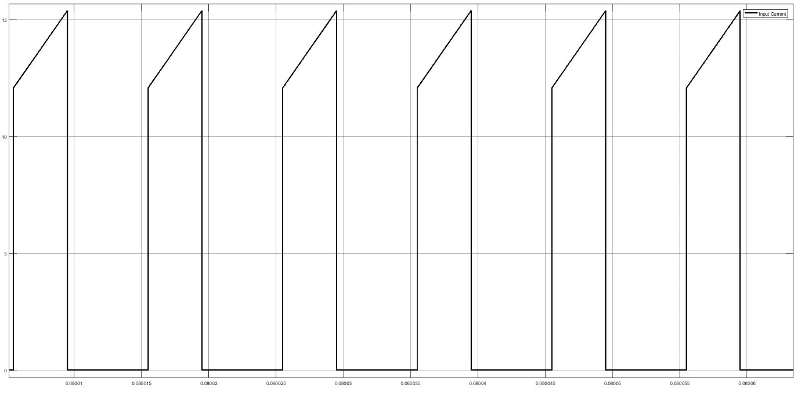

Figure 2: Input Current Waveform under 75% Load Operation

Power input during full load operation is,

$$\begin{aligned}P_{in}=V_{s}*I_{input}\#\left(6\right)\end{aligned}$$

$$\begin{aligned}P_{in}=12*13.73*0.4 \#\left(7\right)\end{aligned}$$

$$\begin{aligned}P_{in}=65.9W \#\left(8\right)\end{aligned}$$

$$\begin{aligned}efficiency=\frac{P_{out}}{P_{in} }=0.91 \#\left(9\right)\end{aligned}$$

$$\begin{aligned}I_{out}=1.229A \#\left(10\right)\end{aligned}$$

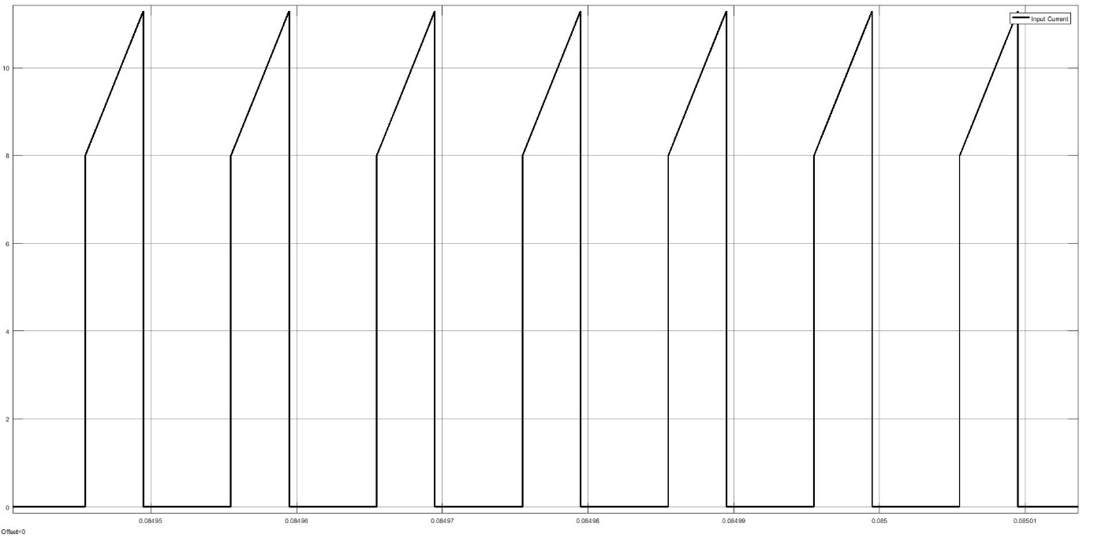

Figure 3: Input Current Waveform under 50% Load Operation

Power input during full load operation is,

$$\begin{aligned}P_{in}=V_{s}*I_{input}\#\left(11\right)\end{aligned}$$

$$\begin{aligned}P_{in}=12*9.67*0.4 \#\left(12\right)\end{aligned}$$

$$\begin{aligned}P_{in}=46.416W\#\left(13\right)\end{aligned}$$

$$\begin{aligned}efficiency=\frac{P_{out}}{P_{in} }=0.88 \#\left(14\right)\end{aligned}$$

$$\begin{aligned}I_{out}=0.8192A \#\left(15\right)\end{aligned}$$

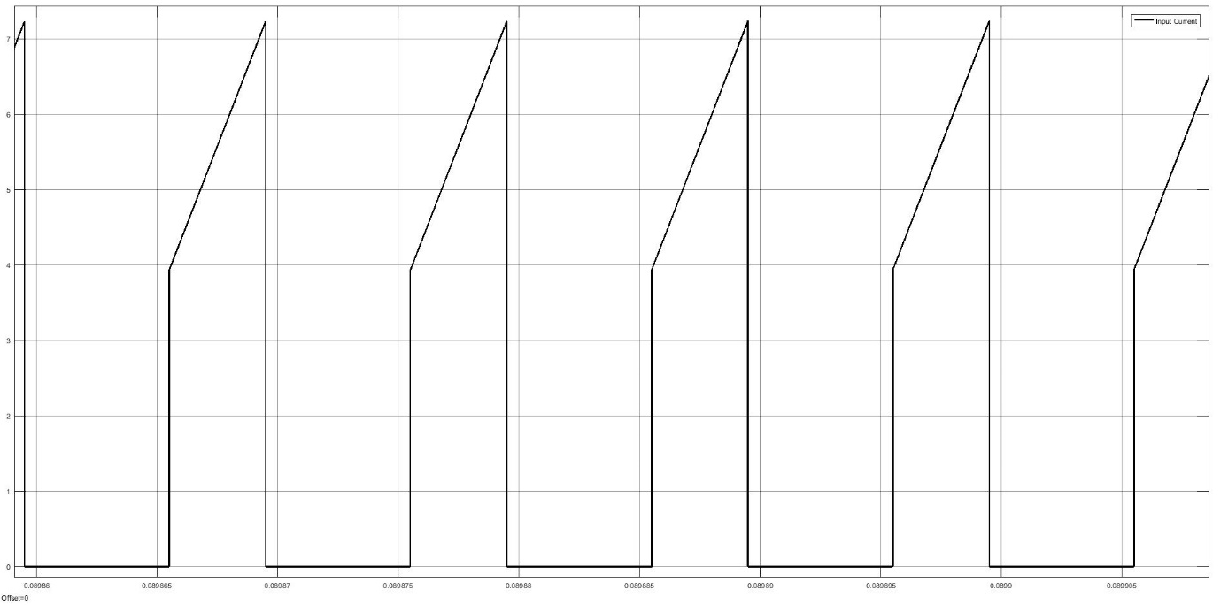

Figure 4: Input Current Waveform under 25% Load Operation

Power input during full load operation is,

$$\begin{aligned}P_{in}=V_{s}*I_{input}\#\left(16\right)\end{aligned}$$

$$\begin{aligned}P_{in}=12*5.42*0.4 \#\left(17\right)\end{aligned}$$

$$\begin{aligned}P_{in}=26.016W\#\left(18\right)\end{aligned}$$

$$\begin{aligned}efficiency=\frac{P_{out}}{P_{in} }=0.76 \#\left(19\right)\end{aligned}$$

$$\begin{aligned}I_{out}=0.4079A \#\left(20\right)\end{aligned}$$

As expected, efficiency is decreased with decreasing load. Due to transformer used in flyback converter, transformer has low efficiency due to hysteresis losses (magnetization and demagnetization of transformer core) and eddy current at low load. Since at low load, these losses dominate the output power. Then the efficiency of the flyback converter is low under smaller loads. When load further increased efficiency will start to increase until its maximum level. Since also all of the components has finite resistance which caused power losses such as internal resistance of the switch, internal resistance of the capacitance etc.