Let’s assume D=0.4

To find Lm first find the average current flow in Lm

Now let’s assume, current ripple in the magnetization current is equal to 40%.

fs is taken as 100kHz,

Lm is taken as 14.4 , which is explained in part b.

Then, the MATLAB Simulink simulations were done according to values which were found above. 

Figure :Circuit Schematic of the Flyback Converter

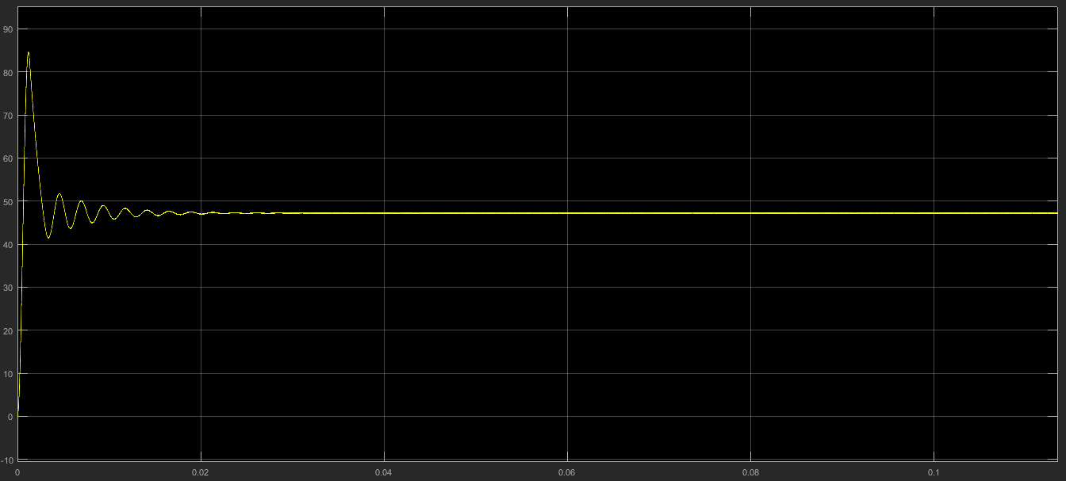

Figure 2: Output Characteristic of the Flyback Converter

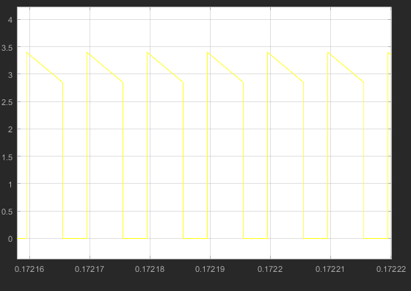

Figure 3: Current Flow Characteristic on the Diode

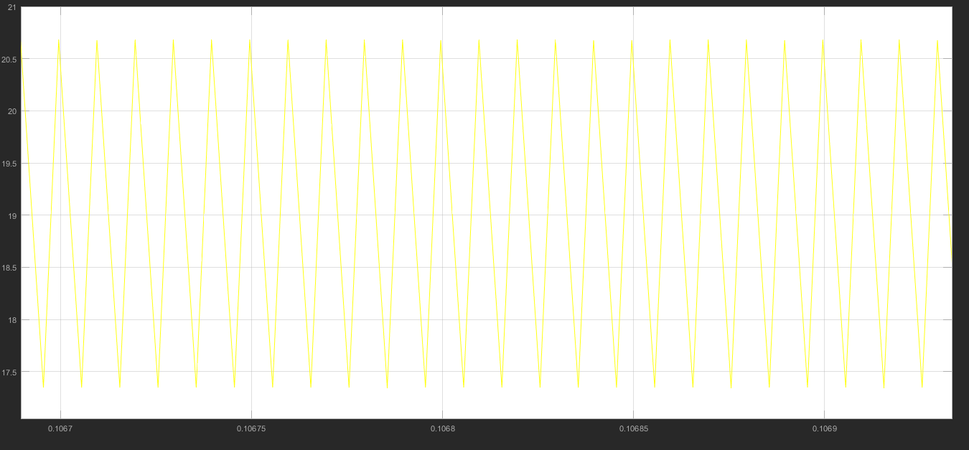

Figure 4: Magnetization Current Waveform of the Flyback Converter