Q2)

a)

TRANSFER FUNCTION OF FLYBACK CONVERTER

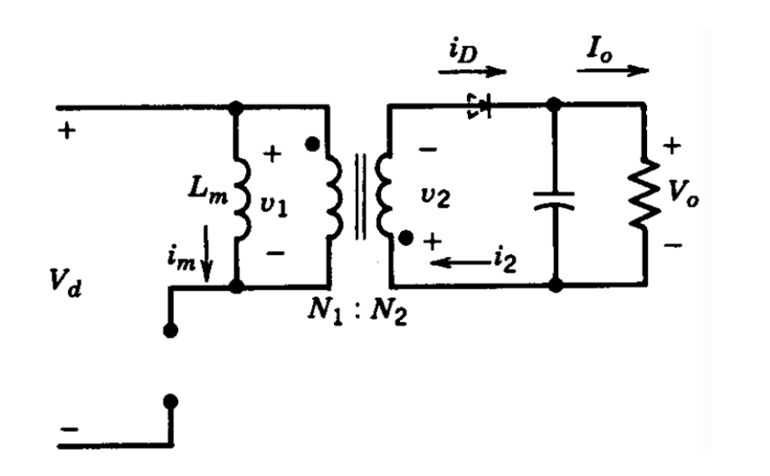

Figure 2.1: Flyback Converter Schematic

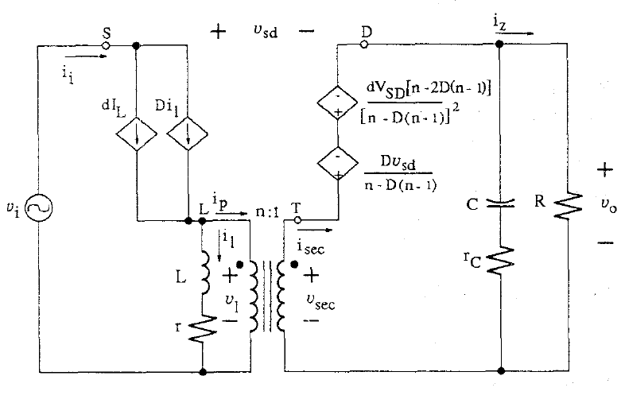

Figure 2.2: Small Signal Model of Flyback Converter

We choose n=1 and circuit schematic will be like that;

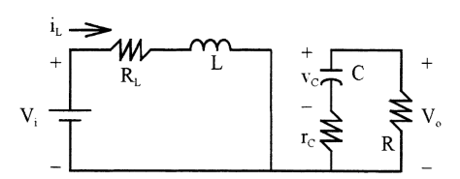

Figure 2.3: Switch ON State When n=1

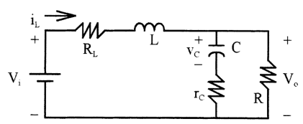

Figure 2.4: Switch OFF State When n=1

By looking ON state:

$-Vi+R_{L}*i_{L}+L\hat{iL}=0$ (1)

$C\hat{Vc}*\left(R+rc\right)+Vc=0$ (2)

By using Eq. (1) and (2)

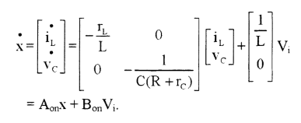

By looking OFF state:

$i_{L}*R_{L}+L*\hat{iL}+R\left(i_{L}-C*\hat{Vc}\right)=0$ (3)

$-Vc+R\left(i_{L}-C*\hat{Vc}\right)-C*\hat{Vc}*rc=0$ (4)

By using Eq. (3) and (4)

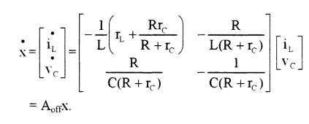

(5)

V0 = [] (6)

A=AON\*D+AOFF\*(1-D) (7)

B=BON\*D+BOFF\*(1-D) (8)

C=CON\*D+COFF\*(1-D) = [ $\begin{matrix}R*rc/(R+rc) & \frac{R}{R+rc}\end{matrix}]$ (10)

$T\left(s\right)=\frac{V_{0}}{V_{i}}=-CA^{-1}B$ (11)

By using Eq. (7), (8), (9), (10) and (11),

T(s) is that form.

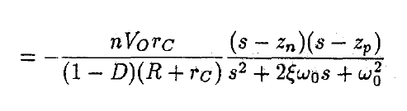 (12)

(n=turn ratio)

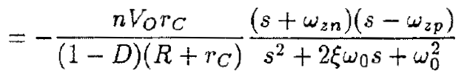

(13)

Where the frequency of negative pole:

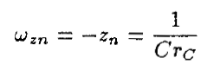 (14)

And the frequency of negative pole:

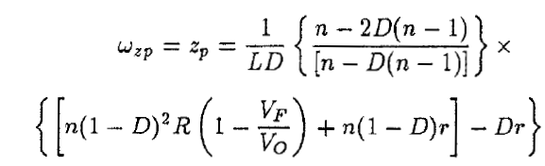 (15)

Angular corner Frequency:

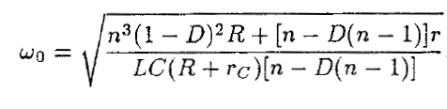 (16)

Damping Ratio:

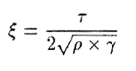 (17)

Where,

 (18)

 (19)

 (20)

In our design,

R=25.6 Ω,

L=14.4 uH,

C=10 uF,

Rc=0.1 Ω

Therefore,

Wzn=105 rad/s,

Wzp=1580138.9 rad/s,

W0=15866 rad/s,

ξ= 0.3119,

Threrefore,

$$T\left(s\right)=0.311*\frac{\left[\left(s+100000\right)*\left(s-1580138.9 \right)\right]}{s^{2}+9896.25s+251729355.8}$$

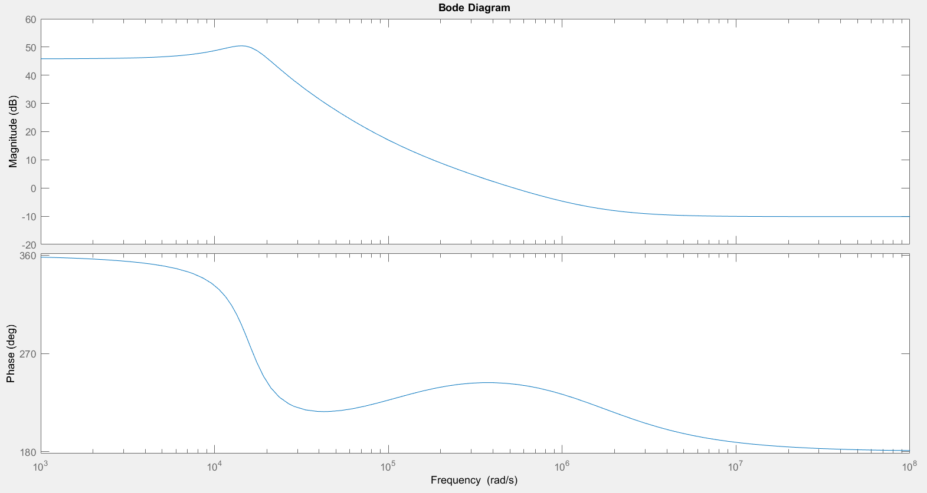

Figure 2.5: Bode Plot for 1:1 Turn Ratio

As shown in Figure 2.5, phase margin is nearly 620 and phase does not drop under -1800. Therefore it is stable system. Also, magnitude and phase waveform characteristics are coherent with flyback converter. At the corner frequency w0, maximum magnitude value is observed as expected. Also, phase margin is coherent with flyback converter. Beyond the frequency wzn of right half plane zero, the grain curve flattens out but the phase angle begins to decrease again. Also, compansator may be necessary in order to increase stability.

We will use 3:18 turn ratio so transfer function is modified for this turn ratio. Now, n=1/6 and

Wzn=105 rad/s,

Wzp=428317.9 rad/s,

W0=2237.84 rad/s,

ξ= 0.677,

$$T\left(s\right)=0.05188*\frac{\left[\left(s+100000\right)*\left(s-428317.9 \right)\right]}{s^{2}+3030*s+5007927.9}$$

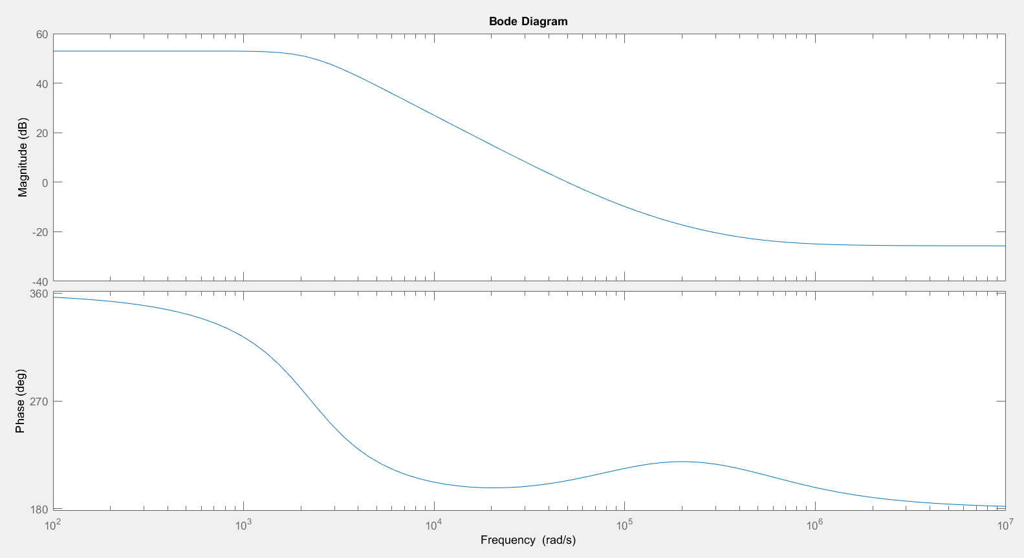

Figure 2.6: Bode Plot for 3:18 Turn Ratio

Again, these magnitude and phase waveform characteristics are coherent with flyback converter topology as explained in flayback converter for 1:1 ratio part. However, phase margin is nearly 250. It is low a bit for stability.

b)

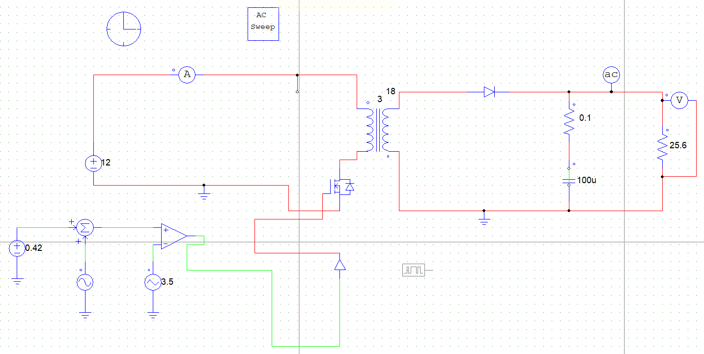

Figure 2.7: Flyback Circuit Schematic

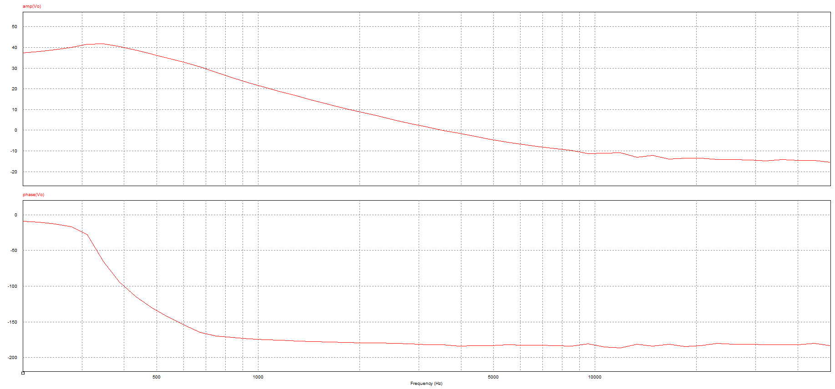

Figure 2.8: Bode Plot for 3:18 Turn Ratio on PSIM

In this part;

R=25.6 Ω,

L=14.4 uH,

C=10 uF,

Rc=0.1 Ω

We simulate flyback converter by using Simulink, Lt Spice and PSIM. 48 V output voltage is observed from 12 V input voltage 48 V; however, there are some problems for bode plot graphs. As shown in Figure 2.8, peak magnitude is observed at angular corner frequency and magnitude and phase waveforms are similar with analytical calculations. However, there is not an increase at wzn frequency.

(Also, frequencies are in terms of rad/sec in MATLAB part in part 2a, whereas frequencies are in terms of Hz in part 2b.)

c)

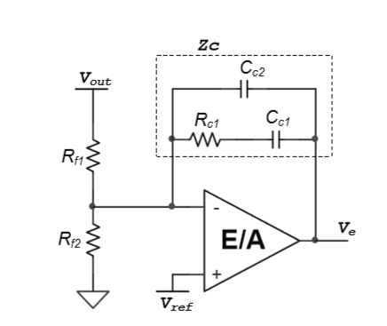

Figure 2.9: Type 2 Controller Model

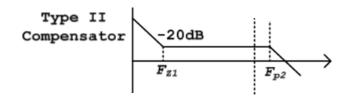

Figure 2.10: Type 2 Compensator Transfer Function Model

In this part, we design type 2 controller. We pay attention that controller pole frequency should be smaller than the switching frequency so low gain is observed at the switching frequency and it makes better the stability.

$$F_{z1}=\frac{1}{2π* R_{C1}{*C}_{C1}}$$

$$F_{p2}=\frac{1}{2π* R_{C1}{*C}_{C2}}$$

Where,

RC1= 16Ω,

CC1= 10 uF,

CC2= 1 uF,

FZ1 = 1 kHz,

FP2 = 10 kHz

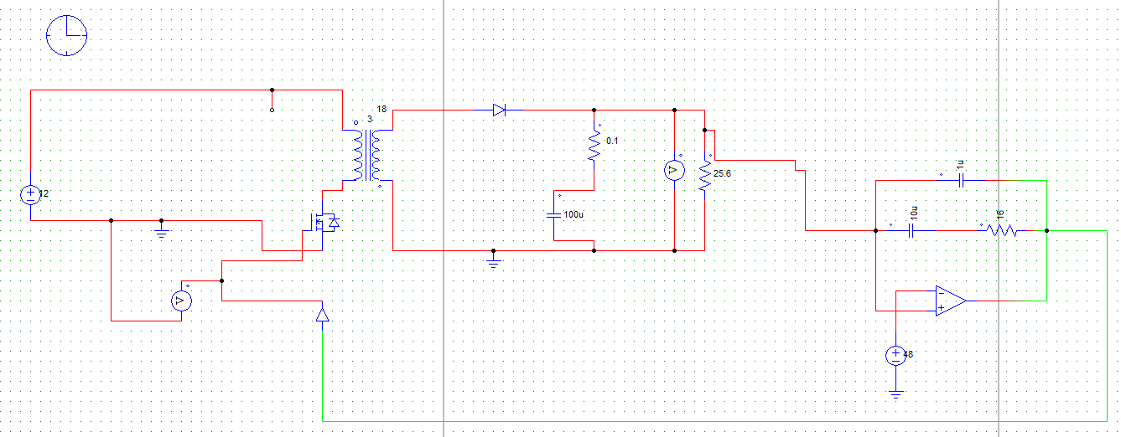

Figure 2.11: Flyback Converter with Type 2 Controller

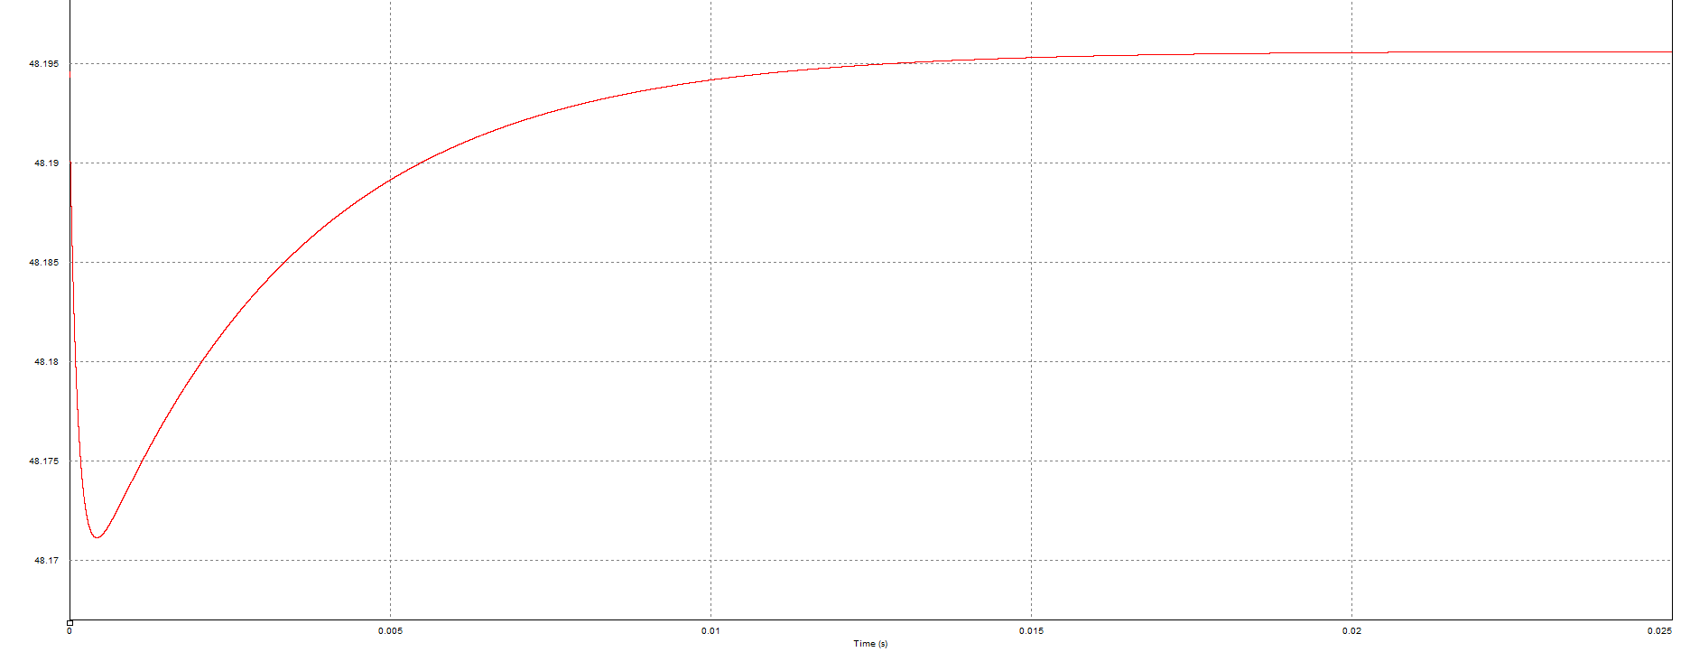

Figure 2.12: Output Voltage for 12 V DC Input

Nearly 48 V output is observed from 12 V input. If input voltage is increased or decreased, 48 V can still be produced.

d)

i)

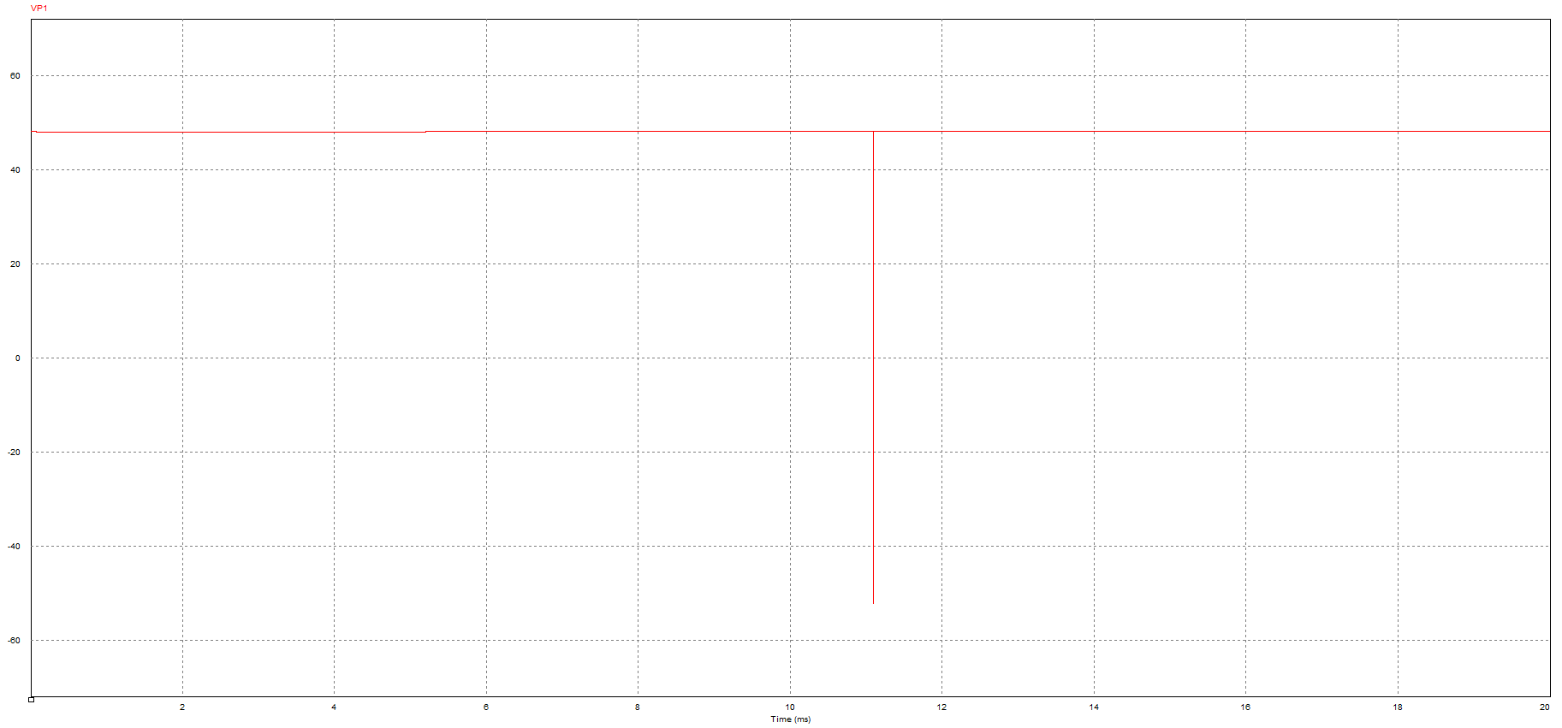

Figure 2.13 : Output Voltage when Load from Increase Half to Full

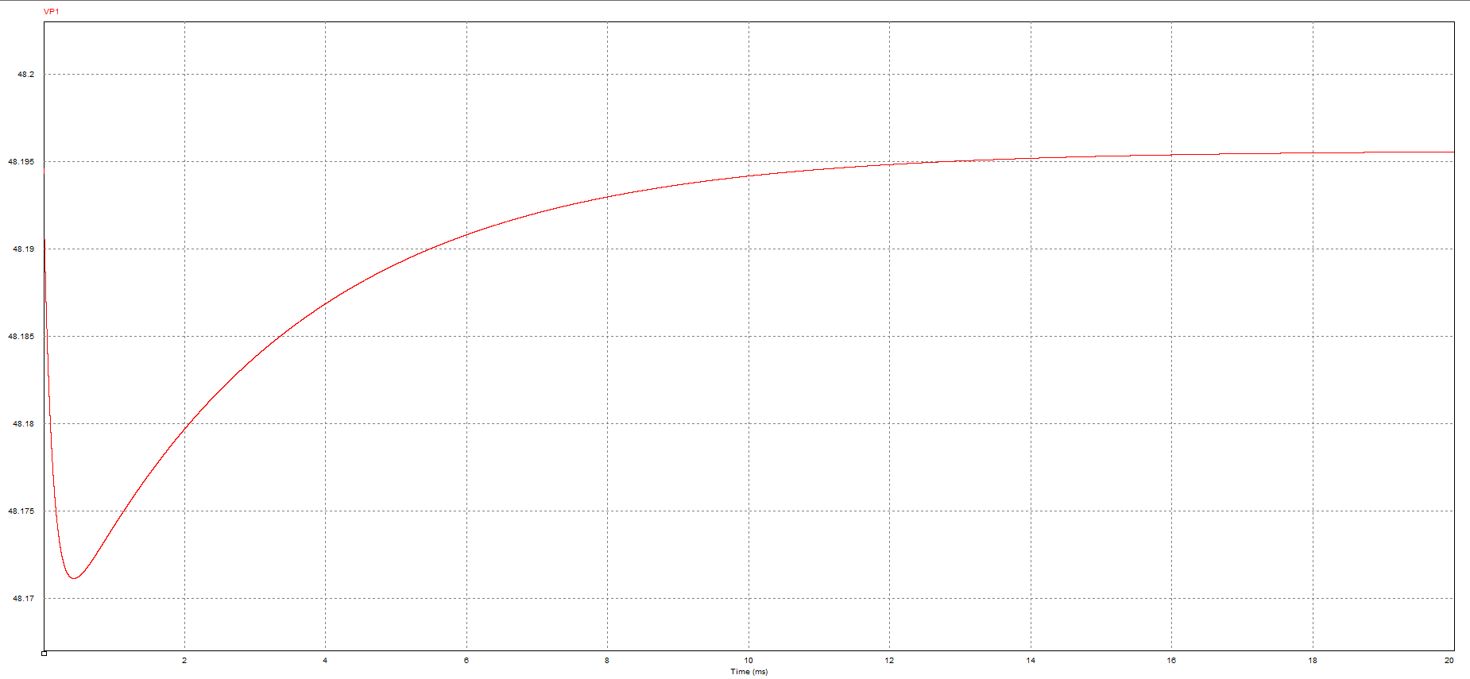

Figure 2.14 : Output Voltage when Input Voltage decrease 10%

In this part, the same output characteristics are observed when input or load is changed. It is strange and most probably false. We expected some oscillations and ripples at the instants that load or input is changed; however, we could not observe this transition and we could not solve this problem.

e)

In this design, we observed that gain at the switching frequency should be low and gain at the low frequency should be high because we want to control DC component and we want to decrease the effect of AC components. We selected pole and zero’s frequencies according to this condition and we selected R and C values of the Type 2 controller in order to achieve these frequencies. If gain was high at high frequency (switching frequency), stability would degenerate.

We should observe a transient period and accuracy should change a bit with respect to load and input voltage but we did nor observed this as explained in part d. It may cause that we may miss some ideality etc.

CONCLUSION

In this project, Flyback design is done. Initially, a core is selected and we design a transformer with real materials. Duty cycle ratio is determined; also, minimum magnetizing inductance is determined in order to stay CCM. Moreover, importance of snubber on the switches is observed and we recognize that snubber is crucial. Also, we choose materials.

On the other hand, controller is another crucial point for a converter. We learned how to find transfer function of a converter and we designed controller. We observed the relation between the controller’s pole and zero frequencies and the switching frequency. These design will help us for our hardware project.