

**EE 463**

***HARDWARE PROJECT***

**AC to DC MOTOR DRIVE**

**Mehmet Eralp KÖSE 2031094**

**Mahmut Enes KARA 2030898**

**Course Instructor: Ozan KEYSAN**

**Course Assistant: İlker ŞAHİN**

# Introduction

In this report, detailed information about Hardware Project of METU EE 463 Course which is mainly driving a DC motor which can be seen on Figure 1, from AC power supply is presented. Main phenomena behind the project is that implementing a controllable rectifier which takes input as 3 phase AC or 1 phase AC and converting it to controllable DC. Then this controllable DC is required to drive DC motor as a load by adjusting its speed.

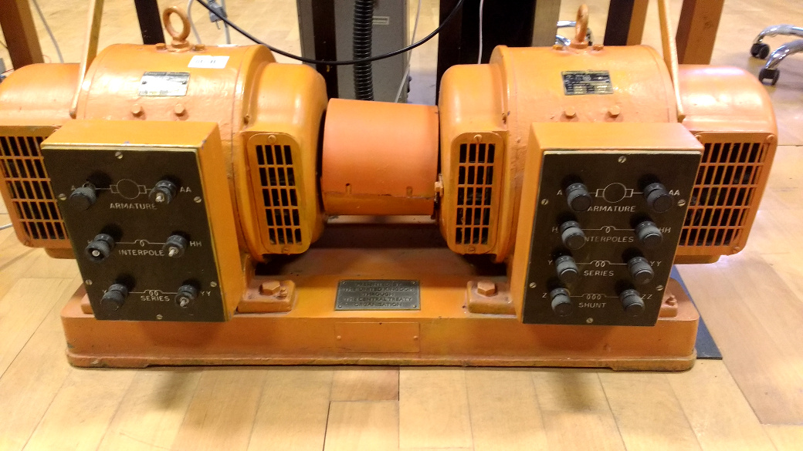Figure 1: DC Motor setup coupled with generator

Project is implemented step by step in order to achieve a successful operation of the driver. Firstly, comparison between rectifiers which are 3 phase thyristor, 1 phase thyristor and 3 phase diode + Buck converter rectifiers are discussed in terms of difficulties, cost and time consumption. So, best option is selected according to our considerations. Then project is simulated in digital environment and performances of the theoretical results are observed. Required equipment and their essential power, voltage, current etc. ratings are calculated and listed. Values of passive circuit components such as capacitors and inductors are obtained from computer simulations. Finally, setup circuitry is constructed with decided components and some test results are obtained while feeding a R load only. Then setup is connected to DC motor and performance of the setup is tested.