REQUIREMENTS ANALYSIS DOCUMENT
for
PERSONAL LIBRARY MANAGEMENT SYSTEM (PLMS)

Issue 1.0
30 October 2026

Prepared by
Team “The Doors”
Mehmet Kaya Aynur
Muhammed Emin Merdun
CSE 443 Object-Oriented Analysis and Design – Project Deliverable #1

TABLE OF CONTENTS
1 Introduction 3
1.1 Purpose of the system 3
1.2 Scope of the system 3
1.3 Objectives and success criteria of the project 4
1.4 Definitions, acronyms, and abbreviations 4
1.5 References 5
1.6 Overview 5
2 Current system 6
3 Proposed system 7
3.1 Overview 7
3.2 Functional requirements 7
3.3 Nonfunctional requirements 11
3.3.1 Usability 11
3.3.2 Reliability 12
3.3.3 Performance 12
3.3.4 Supportability 12
3.3.5 Implementation 13
3.3.6 Interface 13
3.3.7 Packaging 13
3.3.8 Legal 13
3.4 System models 14
3.4.1 Scenarios 14
3.4.2 Use case model 16
3.4.3 Object model 27
3.4.4 Dynamic model 30
3.4.5 User interfaces and Mock-ups 35
4 Glossary of Terms 38
5 Priority 40
6 Traceability 40

Introduction
This Requirements Analysis Document (RAD) specifies the Personal Library Management System (PLMS). It is Deliverable #1 of the CSE 443 Object-Oriented Analysis and Design term project and was prepared by team The Doors. The document defines what the system shall do and models the system conceptually with UML at the analysis level; design and implementation decisions are deliberately left to later deliverables.

Purpose of the system
Many people own a considerable collection of physical books and DVDs but have no dedicated tool to manage it. They do not always know which items they own, where an item is, in which condition it is, to whom it was lent, or how far they have read or watched it. Information that would make the collection more useful, such as summaries, author or director biographies and reviews, must be searched manually on many different web sites. The result is lost items, duplicated purchases and a collection that is owned but not actively used.
The purpose of the PLMS is to give an individual owner one integrated application that
- keeps an organized inventory of the physical books and DVDs the owner possesses (create, read, update, delete);
- maps every local item to records of external internet resources (e.g., Google Books, Open Library, OMDb/TMDb) and enriches it with summaries, biographies and reviews;
- lets the owner build customized reading and viewing lists, including lists generated from recommendations;
- tracks reading and viewing progress at item level and keeps a history of reading and viewing sessions;
- supports reminders, goals and motivational notifications, and keeps the data private, backed up and portable.

Development context. The requirements were elicited from the problem statement “Personal Library Management System” provided by the customer and refined in online elicitation meetings with the customer, in which a desktop application with a local SQLite database was agreed as the target of this project. The feasibility of the enrichment functions relies on publicly documented REST services: Google Books and Open Library offer look-up of books by ISBN, and OMDb and TMDb offer film metadata. Because IMDb does not offer a free public API for this purpose, OMDb or TMDb are used for DVD metadata (see Section 3.3.6).

Scope of the system
The PLMS is a single-user-per-account desktop application. Several user accounts may exist on the same installation (e.g., members of a household), but each account manages its own library. The scope of this release is summarized below.
Table 1: Scope of the PLMS release
In scope | Out of scope (this release)
- Inventory of physical books and DVDs (manual entry and ISBN/barcode look-up)  - Categorization, tagging, searching, filtering, sorting and rating  - Tracking of loans to friends and of lost items  - Mapping to external resources and enrichment with summaries, biographies, covers and reviews  - Detection and resolution of conflicts between local and external metadata  - Default and custom reading/viewing lists, priorities and recommendation-based lists  - Progress tracking, session logs, remaining-time estimation, reminders, goals and notifications  - Local user accounts, password management and data separation  - Import/export (CSV, JSON), backup and restore; optional cloud synchronization | - Native mobile clients (iOS/Android); the requirements are platform-independent so that a later mobile client can reuse them  - E-books, audio books, music and video games  - Reading or playing the media content itself  - Buying or selling items, price comparison or marketplace functions  - Social features (sharing lists, following other users, public reviews)  - Managing loans of a public or institutional library

Objectives and success criteria of the project
The objectives (O) are derived from the problem statement; each one has measurable success criteria (SC) that will be checked in the acceptance tests at the end of the project.
Table 2: Objectives and success criteria
ID | Objective | Success criteria
O-1 | Provide a complete and organized inventory of the owner's books and DVDs. | SC-1: All “Must” requirements of the Inventory Management module pass their acceptance tests.  SC-2: In a test with 50 books that have an ISBN, at least 90% are found and pre-filled by ISBN look-up.
O-2 | Enrich local items with reliable information from internet resources without losing user data. | SC-3: Enrichment succeeds for at least 80% of 30 sample items.  SC-4: No user-entered value is overwritten without confirmation in any test case (FR-33).
O-3 | Support customized reading/viewing lists. | SC-5: A user can create a custom list, add five items, prioritize and sort them in less than 2 minutes.
O-4 | Track reading and viewing progress accurately. | SC-6: Percentage and remaining-time values computed by the system match manually computed values in all test cases.
O-5 | Keep personal data safe, private and portable. | SC-7: No data loss in 20 forced-termination tests; export/import round-trip reproduces all items, lists and progress.
O-6 | Deliver a usable desktop application on time. | SC-8: At least four of five test users complete the core tasks (add, search, list, progress) without help; all deliverables are submitted to the GitHub repository by their due dates.

Definitions, acronyms, and abbreviations
Domain terms (Media Item, Media List, Session Log, …) are defined in the Glossary (Section 4). Acronyms and abbreviations are listed here.
Table 3: Acronyms and abbreviations
Term | Meaning
API | Application Programming Interface
CRUD | Create, Read, Update, Delete
CSV / JSON | Comma-Separated Values / JavaScript Object Notation (file formats for import and export)
DVD | Digital Versatile Disc
EAN / UPC | European Article Number / Universal Product Code (product barcodes printed on DVDs and books)
EARS | Easy Approach to Requirements Syntax [3]
FR / NFR | Functional Requirement / Non-Functional Requirement
GDPR | EU General Data Protection Regulation
ISBN | International Standard Book Number (ISBN-10 or ISBN-13)
KVKK | Turkish Personal Data Protection Law No. 6698 (Kişisel Verilerin Korunması Kanunu)
MoSCoW | Prioritization scheme: Must have, Should have, Could have, Won't have (this time)
OMDb / TMDb | Open Movie Database / The Movie Database (film metadata services)
PLMS | Personal Library Management System
PS | Problem Statement item (used in traceability)
RAD | Requirements Analysis Document
REST | Representational State Transfer (web service style)
SQLite | Embedded, file-based relational database engine
TLS / HTTPS | Transport Layer Security / HTTP over TLS
UC | Use Case
UI | User Interface
UML | Unified Modeling Language
WCAG | Web Content Accessibility Guidelines

References
[1] Customer problem statement: “Personal Library Management System – Problem Statement”, CSE 443, 2026.
[2] CSE 443 Project Deliverable #1 – Requirements Analysis Document (assignment description and RAD template), 2026.
[3] A. Mavin, P. Wilkinson, A. Harwood, M. Novak, “Easy Approach to Requirements Syntax (EARS)”, Proc. 17th IEEE Int. Requirements Engineering Conference, 2009.
[4] B. Bruegge, A. H. Dutoit, Object-Oriented Software Engineering Using UML, Patterns, and Java, 3rd ed., Pearson, 2010.
[5] ISO/IEC/IEEE 29148:2018, Systems and software engineering – Life cycle processes – Requirements engineering.
[6] Object Management Group, Unified Modeling Language (UML) Specification, Version 2.5.1, 2017.
[7] Google Books API documentation; Open Library Books API documentation; OMDb API documentation; TMDB API documentation (online).
[8] W3C, Web Content Accessibility Guidelines (WCAG) 2.1, 2018.

Overview
Section 2 describes how personal collections are managed today and the problems of these practices. Section 3 specifies the proposed system: a functional overview, the functional requirements written in EARS sentence structure, the non-functional requirements, and the analysis models – scenarios, use case model, object (domain) model, dynamic models and UI mock-ups. Section 4 is the glossary, Section 5 gives the priority of every requirement and the resulting release plan, and Section 6 traces the problem statement to requirements and use cases and the use cases to requirements and analysis objects.

Current system
There is no existing PLMS that will be replaced. Today, owners of personal collections manage the tasks that the PLMS will support with a mix of manual practices and unconnected general-purpose tools:
- Memory and browsing the shelves. Most owners know their collection only from memory. To check whether a book is owned, they look at the shelves; items stored in boxes, at another home or lent to someone are easily forgotten.
- Notebooks and spreadsheets. More organized owners keep a handwritten list or a spreadsheet (e.g., Excel or Google Sheets) with columns such as title, author, location and “lent to”. All data is typed manually, the structure differs from person to person, and the list is rarely kept up to date.
- Separate online services. Reading progress is sometimes tracked on social reading sites and watched films on watchlist sites. These services are organized around the online catalogue, not around the physical copy the owner has, so they do not record location, condition, purchase details or loans, and books and DVDs are kept in different places.
- Manual web search. Summaries, biographies and reviews are looked up on search engines, publisher and review sites whenever they are needed; nothing is linked to the owned item.
- Messages and memory for loans. Lending an item is agreed by phone or messaging; there is no reminder when the item is due back.

The problems of the current practice, and the parts of the proposed system that address them, are summarized in Table 4.
Table 4: Problems of the current practice
# | Problem | Consequence | Addressed by
P-1 | No complete, structured inventory; manual data entry | Owner does not know what is owned; high effort to keep a list | FR-1–FR-14, UC-4, UC-5
P-2 | Duplicate purchases | Money wasted on items already owned | FR-8, FR-22
P-3 | Lent or misplaced items are forgotten | Lost items, conflicts with borrowers | FR-12, FR-15–FR-19
P-4 | Information about items is scattered over many web sites | Time spent searching; no link to the owned copy | FR-26–FR-35
P-5 | External data and own notes can contradict each other | Unclear which data is correct | FR-32, FR-33, UC-14
P-6 | Reading/watching plans are kept in different places | No overview of what to read or watch next | FR-36–FR-45
P-7 | Progress and reading/viewing history are not recorded | Owner forgets where they stopped; no statistics | FR-46–FR-55
P-8 | No reminders or motivation | Started items are abandoned | FR-56–FR-60
P-9 | Data is locked in a personal spreadsheet or a third-party service | Difficult migration and backup; privacy concerns | FR-66, FR-70–FR-72, NFR-30

Proposed system

Overview
The PLMS is a desktop application that stores the library of each user account in an embedded local database and connects to external metadata services when a network connection is available. Functionally, it consists of the following subsystems; they also structure the functional requirements in Section 3.2 and the use case diagrams in Section 3.4.2.
Table 5: Functional subsystems of the PLMS
Subsystem | Responsibility | Requirements
Account Management | Registration, login, password change and reset, separation of data per account. | FR-61–FR-66
Inventory Management | CRUD of Media Items (Books, DVDs), ISBN/barcode look-up, duplicate warning, condition and status, loans, tags, search, filter, sort, rating. | FR-1–FR-25
Internet Resource Mapping | Linking items to External Resource Records, enrichment with summaries, biographies, covers and reviews, periodic refresh, metadata conflict resolution. | FR-26–FR-35
Reading/Viewing Lists | Default and custom Media Lists, list entries with priority and order, recommendations, automatic list maintenance. | FR-36–FR-45
Progress Tracking & Notifications | Book and DVD progress, sessions and session logs, remaining-time estimate, reminders, goals and motivational notifications. | FR-46–FR-60
Synchronization & Data Transfer | Optional cloud synchronization between devices, offline operation, import/export, backup and restore. | FR-67–FR-72

The system interacts with the following actors:
Table 6: Actors
Actor | Description
User | The owner of a personal collection who has a User Account. Initiates almost all use cases.
Barcode Scanner | A USB barcode scanner (keyboard-emulation mode) or the computer's camera, used to read ISBN, EAN or UPC codes.
External Metadata Service | An external REST service of an External Provider (Google Books, Open Library, OMDb or TMDb) that returns metadata, summaries, biographies, covers and reviews.
Timer | The system clock; it triggers reminders, loan-due checks and the periodic refresh of external data.
Sync Service | An optional cloud service that stores the synchronized copy of the User's data for multi-device use.

Functional requirements
Functional requirements are numbered FR-1 … FR-72 and grouped by module. Every requirement is a single, testable sentence written in the EARS structure [3]. The pattern used by each requirement is given in the “EARS” column; the priority (MoSCoW) is explained in Section 5. Terms written with capital initials (e.g., Media Item, Media List) are defined in the Glossary and are used with the same names in the use cases and the object model.
Table 7: EARS patterns used
Code | Pattern | Template
U | Ubiquitous | The system shall <response>.
E | Event-driven | When <trigger>, the system shall <response>.
S | State-driven | While <state>, the system shall <response>.
W | Unwanted behaviour | If <unwanted condition>, then the system shall <response>.
O | Optional feature | Where <feature is included>, the system shall <response>.
C | Complex | Combination of the keywords above (e.g., Where …, when …, the system shall …).

Table 8: Functional requirements – Inventory Management
ID | Requirement | EARS | Priority
FR-1 | The system shall allow the User to add a new Media Item by entering its details manually. | U | Must
FR-2 | When the User enters or scans the ISBN of a Book, the system shall retrieve the Book's metadata from the External Metadata Service and pre-fill the Item Form. | E | Must
FR-3 | When the User enters or scans the EAN/UPC barcode of a DVD, the system shall retrieve the DVD's metadata from the External Metadata Service and pre-fill the Item Form. | E | Should
FR-4 | If no External Resource Record matches a scanned or entered code, then the system shall inform the User and keep the Item Form open for manual entry. | W | Must
FR-5 | The system shall classify every Media Item as either a Book or a DVD. | U | Must
FR-6 | The system shall record the following attributes for each Media Item: title, creators (authors or directors), publication/release date, format, condition, physical location, status and purchase details (date, price, store). | U | Must
FR-7 | If the User attempts to save a Media Item without a title or a media type, then the system shall reject the save and highlight the missing fields. | W | Must
FR-8 | If a new Media Item has the same ISBN/barcode, or the same title and creator, as an existing Media Item in the Library, then the system shall warn the User about a possible duplicate before saving. | W | Should
FR-9 | When the User selects a Media Item, the system shall display its Item Detail View with all recorded attributes, linked Enriched Content, list memberships and Progress. | E | Must
FR-10 | The system shall allow the User to update any attribute of an existing Media Item. | U | Must
FR-11 | The system shall allow the User to change the condition of a Media Item to one of New, Good, Fair, Poor or Damaged. | U | Must
FR-12 | When the User marks a Media Item as lost, the system shall set its status to Lost and exclude it from the Available filter. | E | Should
FR-13 | When the User requests the deletion of a Media Item, the system shall ask for confirmation before removing it from the Library. | E | Must
FR-14 | When a Media Item is deleted, the system shall also remove its List Entries, Progress, Session Logs, Reminders and External Resource Links. | E | Must

Table 9: Functional requirements – Loan Tracking
ID | Requirement | EARS | Priority
FR-15 | The system shall allow the User to record a Loan of a Media Item with the borrower's name, loan date and due date. | U | Should
FR-16 | When a Loan is recorded, the system shall set the status of the Media Item to On Loan. | E | Should
FR-17 | When the User records the return of a loaned Media Item, the system shall close the Loan with the return date and set the status of the Media Item to Available. | E | Should
FR-18 | When the due date of an open Loan passes, the system shall notify the User that the Media Item is overdue. | E | Could
FR-19 | The system shall keep the loan history of each Media Item. | U | Could

Table 10: Functional requirements – Categorization, Tagging, Search and Filtering
ID | Requirement | EARS | Priority
FR-20 | The system shall allow the User to assign one or more Tags (e.g., genre, favorite, mood) to a Media Item. | U | Must
FR-21 | The system shall allow the User to create, rename and delete custom Tags. | U | Should
FR-22 | When the User enters a keyword in the Search Panel, the system shall list the Media Items whose title, creator, ISBN/barcode or tags contain that keyword. | E | Must
FR-23 | The system shall allow the User to filter the Library by media type, tag, status, condition, location and progress status, and to combine these filters. | U | Must
FR-24 | The system shall allow the User to sort the Library by title, creator, date added, release date or personal rating. | U | Should
FR-25 | The system shall allow the User to give a personal rating from 1 to 5 stars to a Media Item. | U | Should

Table 11: Functional requirements – Internet Resource Mapping
ID | Requirement | EARS | Priority
FR-26 | The system shall allow a Media Item to be linked to one or more External Resource Records of the supported External Providers (Google Books and Open Library for books; OMDb or TMDb for DVDs). | U | Must
FR-27 | When the User requests the enrichment of a Media Item, the system shall query the enabled External Providers and present the candidate External Resource Records ranked by match confidence. | E | Must
FR-28 | When the User confirms a candidate External Resource Record, the system shall create an External Resource Link and fetch the summary or synopsis, creator biographies, cover image, and critic and user reviews. | E | Must
FR-29 | While no network connection is available, the system shall queue enrichment and refresh requests and execute them after the connection is restored. | S | Should
FR-30 | If an External Provider returns an error or does not respond within 10 seconds, then the system shall inform the User and leave the local data of the Media Item unchanged. | W | Must
FR-31 | When the User requests a refresh of a linked Media Item, or 30 days have passed since its last refresh, the system shall check the linked External Resource Records for updated data. | E | Should
FR-32 | If refreshed external data differs from a value that the User entered manually, then the system shall record a Metadata Conflict and let the User either keep the local value or accept the external value. | W | Should
FR-33 | The system shall not overwrite a value that the User entered manually without the User's confirmation. | U | Must
FR-34 | The system shall allow the User to remove an External Resource Link from a Media Item. | U | Could
FR-35 | The system shall show the provider name and retrieval date next to all Enriched Content. | U | Must

Table 12: Functional requirements – Reading/Viewing Lists
ID | Requirement | EARS | Priority
FR-36 | The system shall provide the default Media Lists “To Read”, “Currently Reading”, “Watch Later”, “Currently Watching” and “Favorites” for every User Account. | U | Must
FR-37 | The system shall allow the User to create a custom Media List with a name and an optional description. | U | Must
FR-38 | The system shall allow the User to rename and delete custom Media Lists. | U | Must
FR-39 | When the User deletes a Media List, the system shall remove only its List Entries and keep the Media Items in the Library. | E | Must
FR-40 | The system shall allow the User to add a Media Item to, and remove it from, any Media List at any time. | U | Must
FR-41 | The system shall allow a Media Item to belong to more than one Media List at the same time. | U | Must
FR-42 | The system shall allow the User to sort a Media List by date added, priority, personal rating or title, and to reorder its List Entries manually. | U | Should
FR-43 | The system shall allow the User to assign a priority of High, Medium or Low to each List Entry. | U | Should
FR-44 | When the User requests recommendations for a selected goal or mood Tag, the system shall generate Recommendations from the unfinished Media Items of the Library using their tags, creators, ratings and progress status, and allow the User to save them as a new Media List. | E | Could
FR-45 | Where automatic list maintenance is enabled, when the progress status of a Media Item changes to In Progress, the system shall move it from “To Read” or “Watch Later” to “Currently Reading” or “Currently Watching”. | C | Could

Table 13: Functional requirements – Reading/Viewing Progress Tracking
ID | Requirement | EARS | Priority
FR-46 | The system shall allow the User to record the reading progress of a Book as the number of pages read and chapters completed. | U | Must
FR-47 | The system shall allow the User to record the viewing progress of a DVD as the minutes watched and scenes viewed. | U | Must
FR-48 | The system shall calculate and display the percentage completed for every Media Item that has Progress. | U | Must
FR-49 | The system shall estimate the remaining reading time of a Book from the User's average reading speed in previous Session Logs. | U | Should
FR-50 | When the User starts a session for a Media Item, the system shall run a session timer until the User stops it. | E | Should
FR-51 | When the User ends a reading or viewing session, the system shall store a Session Log with the date, start time, end time, duration, start position and end position. | E | Must
FR-52 | The system shall display the Session Logs of a Media Item in chronological order. | U | Must
FR-53 | When the progress of a Media Item reaches 100%, the system shall set its progress status to Completed and record the completion date. | E | Must
FR-54 | The system shall display a visual progress indicator for each Media Item with Progress in the Library View, List View and Item Detail View. | U | Should
FR-55 | If the User enters a progress value larger than the total pages, chapters, runtime or scenes of the Media Item, then the system shall reject the value and show an error message. | W | Must

Table 14: Functional requirements – Reminders, Goals and Notifications
ID | Requirement | EARS | Priority
FR-56 | The system shall allow the User to create, edit and delete Reminders for a Media Item with a date, time and optional recurrence. | U | Should
FR-57 | When the time of a Reminder is reached while the application is running, the system shall display a Notification. | E | Should
FR-58 | The system shall allow the User to set a Goal as a target amount (pages, items or minutes) for a period (week, month or year) and display the progress towards it. | U | Could
FR-59 | When the User completes a Media Item, reaches 25%, 50% or 75% of a Media Item, or reaches a Goal, the system shall display a motivational Notification. | E | Could
FR-60 | The system shall allow the User to enable or disable each Notification type. | U | Should

Table 15: Functional requirements – User Accounts
ID | Requirement | EARS | Priority
FR-61 | The system shall allow a new user to register a User Account with a username, an e-mail address and a password. | U | Must
FR-62 | When the User submits a valid username and password, the system shall log the User in and display the User's Library. | E | Must
FR-63 | If invalid credentials are submitted five consecutive times for a User Account, then the system shall block login attempts for that account for five minutes. | W | Should
FR-64 | The system shall allow a logged-in User to change the password after entering the current password. | U | Must
FR-65 | When a User Account is registered, the system shall generate a one-time Recovery Key that allows the User to reset a forgotten password. | E | Should
FR-66 | The system shall keep the Library, Media Lists, Progress and settings of each User Account separate from other User Accounts on the same installation. | U | Must

Table 16: Functional requirements – Synchronization, Import/Export and Backup
ID | Requirement | EARS | Priority
FR-67 | Where cloud synchronization is enabled, the system shall synchronize the Library, Media Lists, Progress and Session Logs of the User Account across the User's registered Devices. | O | Could
FR-68 | While the Device is offline, the system shall allow all local operations and record the changes for the next synchronization. | S | Could
FR-69 | If the same record was changed on two Devices since the last synchronization, then the system shall keep the most recent change, store the other version in a conflict log and notify the User. | W | Could
FR-70 | The system shall allow the User to export the Library, Media Lists and Progress to CSV and JSON files. | U | Should
FR-71 | The system shall allow the User to import Media Items from a CSV or JSON file and report the rows that could not be imported. | U | Should
FR-72 | The system shall allow the User to create a backup file of all data of the User Account and to restore the data from such a file. | U | Should

Nonfunctional requirements
Non-functional requirements are numbered NFR-1 … NFR-32 and are grouped according to the categories of the template. Each requirement is stated so that it can be verified by inspection, measurement or test.

Usability
Usability requirements describe how easily the User can learn and operate the system.
ID | Requirement | Priority
NFR-1 | A first-time user shall be able to add a Book by its ISBN in less than 2 minutes without reading the user manual (verified with at least five test users). | Must
NFR-2 | Adding a Media Item, searching the Library, updating Progress and adding a Media Item to a Media List shall each be reachable within three clicks from the Library View. | Should
NFR-3 | The user interface shall support keyboard-only operation and meet the WCAG 2.1 Level AA contrast ratio (at least 4.5:1 for normal text). | Should
NFR-4 | The system shall show a progress indicator for every operation that takes longer than 1 second and confirm destructive operations (delete, restore) before executing them. | Must
NFR-5 | All user-visible texts shall be stored in resource files so that a Turkish localization can be added without code changes; the first release shall be in English. | Could

Reliability
Reliability requirements cover robustness, availability of local functions, data integrity and security.
ID | Requirement | Priority
NFR-6 | Every change to the local database shall be committed as a transaction; after an unexpected termination the system shall restart with all changes committed before the termination. | Must
NFR-7 | A failure or unavailability of any External Provider or of the network shall not prevent the use of the inventory, list, progress and account functions. | Must
NFR-8 | The system shall create an automatic local backup at least every 7 days and keep the three most recent backups. | Should
NFR-9 | Passwords shall be stored only as salted hashes produced by a slow password-hashing algorithm (e.g., bcrypt or Argon2); plain-text passwords shall never be stored or logged. | Must
NFR-10 | All communication with External Providers and with the synchronization service shall use HTTPS with TLS 1.2 or newer. | Must
NFR-11 | API keys of External Providers shall not be stored in plain text in source code or in the user database; they shall be kept in the operating system's credential store or in an encrypted configuration file. | Must

Performance
Performance requirements give measurable limits for response time and capacity.
ID | Requirement | Priority
NFR-12 | The Library View shall be usable within 3 seconds after start-up for a Library of 10,000 Media Items on reference hardware (4-core CPU, 8 GB RAM, SSD). | Should
NFR-13 | Local search and filter operations shall return results within 1 second for a Library of 10,000 Media Items. | Must
NFR-14 | Requests to External Providers shall run asynchronously so that the user interface does not freeze for more than 100 ms while waiting for a response. | Must
NFR-15 | In 95% of cases, the result of an ISBN/barcode lookup shall be shown within 5 seconds on a 10 Mbit/s connection. | Should
NFR-16 | The system shall support at least 10,000 Media Items, 500 Media Lists and 100,000 Session Logs per User Account. | Must

Supportability
Supportability requirements make the system maintainable and extensible.
ID | Requirement | Priority
NFR-17 | Access to External Providers shall go through a common provider interface so that a new provider can be added without changing the inventory, list or progress modules. | Should
NFR-18 | The system shall write errors and warnings to a rotating log file (maximum 10 MB) that contains no passwords or API keys. | Should
NFR-19 | Domain logic shall be covered by automated unit tests with at least 70% statement coverage. | Should
NFR-20 | Changes to the local data schema shall be applied by versioned migrations that keep existing user data when the application is upgraded. | Must

Implementation
Implementation requirements are constraints given by the customer and the course.
ID | Requirement | Priority
NFR-21 | The first release shall be a desktop application that runs on Windows 10 or newer, macOS 12 or newer and Ubuntu 22.04 or newer, built with a cross-platform framework (e.g., Qt, JavaFX or Electron). | Must
NFR-22 | Local data shall be stored in an embedded SQLite database; no separate database server shall be required on the User's computer. | Must
NFR-23 | The system shall be implemented in an object-oriented language and its source code, documents and models shall be kept in the team's GitHub repository. | Must

Interface
Interface requirements define the interfaces to external systems, devices and file formats.
ID | Requirement | Priority
NFR-24 | The system shall use the REST/JSON interfaces of Google Books and Open Library for books, and of OMDb or TMDb for DVDs. | Must
NFR-25 | The system shall accept input from USB barcode scanners working in keyboard-emulation mode and shall read EAN-13 (ISBN-13), ISBN-10 and UPC-A codes. | Should
NFR-26 | Export files shall be UTF-8 encoded; CSV files shall follow RFC 4180 and JSON files shall follow RFC 8259. | Should

Packaging
Packaging requirements define how the system is delivered and installed.
ID | Requirement | Priority
NFR-27 | The system shall be delivered as installers for each supported platform (.msi or .exe for Windows, .dmg for macOS, .deb or AppImage for Linux). | Should
NFR-28 | Installation shall complete in less than 5 minutes and shall not require the installation of any additional software by the User. | Should
NFR-29 | A user manual and an installation guide shall be delivered together with the source code in the GitHub repository. | Must

Legal
Legal requirements concern personal data protection, third-party terms and licences.
ID | Requirement | Priority
NFR-30 | The processing of personal data shall follow the Turkish Personal Data Protection Law (KVKK, No. 6698) and GDPR principles; the User shall be able to export and permanently delete all data of the User Account. | Must
NFR-31 | The system shall respect the terms of use and rate limits of each External Provider, show the required attribution, and exclude third-party review texts from export files. | Must
NFR-32 | All third-party libraries used shall have licenses compatible with the project's license, and their licenses shall be listed in the repository. | Must

System models
The system models consist of scenarios (concrete examples of use), the use case model (generalized functionality), the object model (domain concepts and analysis objects) and the dynamic model (sequence, state machine and activity diagrams). Names of use cases, boundary, control and entity objects are consistent with the requirements and the Glossary.

Scenarios
Scenarios describe concrete situations with named actor instances. Ayşe owns about 1,200 books and 50 DVDs; her friend Mehmet sometimes borrows items. The scenarios were used to discover the use cases in Section 3.4.2.
Scenario S-1: addBookByIsbn
Scenario name | addBookByIsbn
Participating actor instances | ayse: User, scanner: Barcode Scanner, googleBooks: External Metadata Service
Flow of events | 1. Ayşe buys a paperback copy of “Dune”. At home she opens the PLMS, selects “Add item” and chooses “Book”.  2. She scans the barcode on the back cover with her USB scanner. The PLMS validates the ISBN and asks googleBooks for the book's data.  3. Within two seconds the Item Form shows title, author, publisher, publication date, page count and the cover.  4. Ayşe enters the location “Shelf A-3”, the condition “New”, the price and the store, adds the tag “science-fiction” and saves.  5. The PLMS warns that a Book with the same ISBN already exists. Ayşe remembers that her old copy is damaged; she saves the new copy anyway and changes the condition of the old one to “Damaged”.
Realized by | UC-4, UC-5, UC-7

Scenario S-2: lendDvdToFriend
Scenario name | lendDvdToFriend
Participating actor instances | ayse: User, mehmet (borrower, not a user), clock: Timer
Flow of events | 1. Mehmet asks to borrow “The Godfather”. Ayşe opens the DVD, selects “Lend”, enters “Mehmet” and a due date two weeks later.  2. The status of the DVD changes to “On Loan” and the Library View shows it in orange.  3. Two weeks later the clock signals that the due date has passed; the PLMS shows the notification “The Godfather is overdue (Mehmet)”.  4. When Mehmet returns the DVD, Ayşe selects “Mark as returned”; the status becomes “Available” and the loan appears in the loan history.
Realized by | UC-11, UC-22

Scenario S-3: readDuneInSessions
Scenario name | readDuneInSessions
Participating actor instances | ayse: User
Flow of events | 1. In the evening Ayşe opens “Dune” and selects “Start session” at page 120. The session timer runs.  2. After 50 minutes she selects “End session” and enters page 155. The PLMS stores a Session Log and updates the progress to 29%.  3. Because her average speed is 42 pages per hour, the PLMS estimates 9 h 05 min remaining. As the item is now “In Progress”, it is moved from “To Read” to “Currently Reading” (automatic list maintenance is on).  4. A few days later she passes 50%; the PLMS shows a motivational notification. In the History tab she sees all sessions with date and duration.
Realized by | UC-19, UC-18, UC-20, UC-22

Scenario S-4: resolveConflictingMetadata
Scenario name | resolveConflictingMetadata
Participating actor instances | ayse: User, openLibrary: External Metadata Service, clock: Timer
Flow of events | 1. Ayşe had corrected the publication date of an old edition of “The Name of the Rose” manually to 1983.  2. Thirty days after the last refresh, the clock triggers a refresh. openLibrary returns the publication year 1980 for the linked record.  3. The PLMS does not overwrite the value; it records a Metadata Conflict and shows “Conflicts (1)” in the Item Detail View.  4. Ayşe compares both values and chooses “Keep local” because her copy is the 1983 translation. The conflict is marked as resolved.
Realized by | UC-13, UC-14

Scenario S-5: planCosyWeekendList
Scenario name | planCosyWeekendList
Participating actor instances | ayse: User
Flow of events | 1. On Friday Ayşe selects “Recommend” and chooses her mood tag “cosy weekend”.  2. The PLMS proposes three unfinished items from her library, each with a short reason (same tag, author she rated 5 stars, genre she usually finishes).  3. She removes one suggestion, names the list “Cosy weekend” and saves it. She sets the priority of “The Hobbit” to High and sorts the list by priority.
Realized by | UC-17, UC-16

Scenario S-6: migrateFromSpreadsheet
Scenario name | migrateFromSpreadsheet
Participating actor instances | ayse: User
Flow of events | 1. Before using the PLMS Ayşe kept her books in a spreadsheet. She exports it as a CSV file and selects “Import” in the Import/Export Dialog.  2. The PLMS imports 1,183 rows and reports 17 rows that could not be imported because the title is missing.  3. She fixes the 17 rows in the spreadsheet and imports them again. Afterwards she creates a backup file on her external disk.
Realized by | UC-24, UC-4

Scenario S-7: readOnTheTrain
Scenario name | readOnTheTrain
Participating actor instances | ayse: User, laptop and desktop: Devices, cloud: Sync Service
Flow of events | 1. Ayşe has enabled cloud synchronization on her desktop and her laptop.  2. On a train without internet she records a reading session on the laptop; the change is stored locally and queued.  3. When the laptop is online again, the PLMS sends the change to the cloud. In the evening her desktop receives it, so the progress of the book is the same on both devices.
Realized by | UC-19, UC-23

Use case model
The use case model generalizes the scenarios. To keep the diagrams readable, it is shown in three use case diagrams, one per group of subsystems. All use cases are inside the system boundary of the PLMS; the dashed packages show the subsystems. «extend» relations are used for optional or conditional behaviour, «include» for behaviour that is always reused.
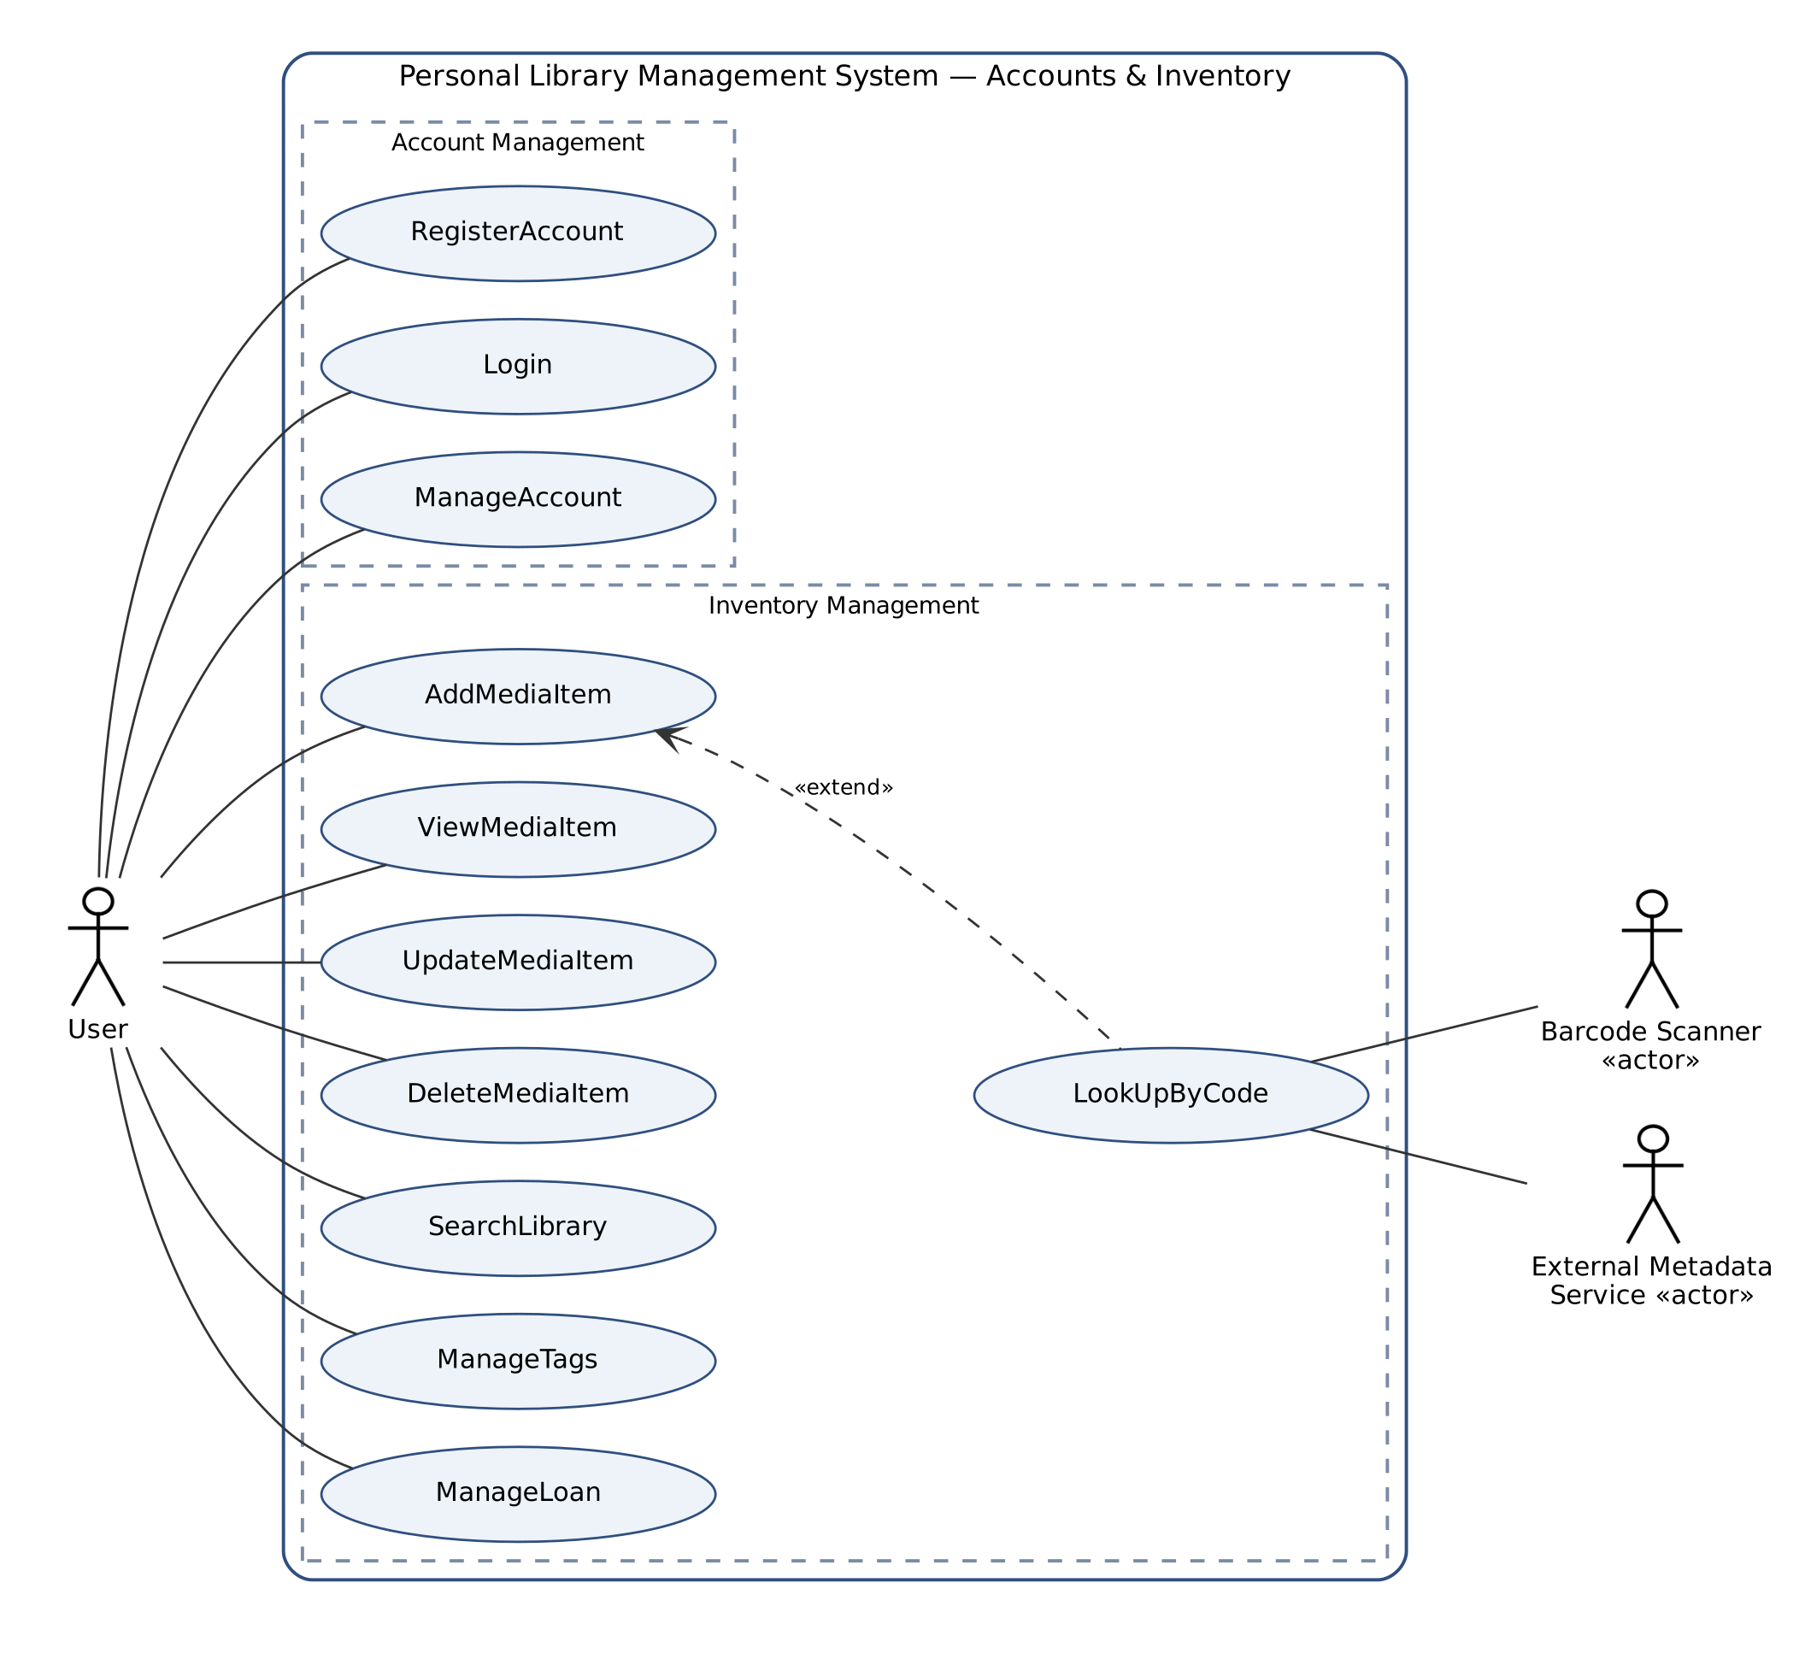
Figure 1: Use case diagram – Account and Inventory Management
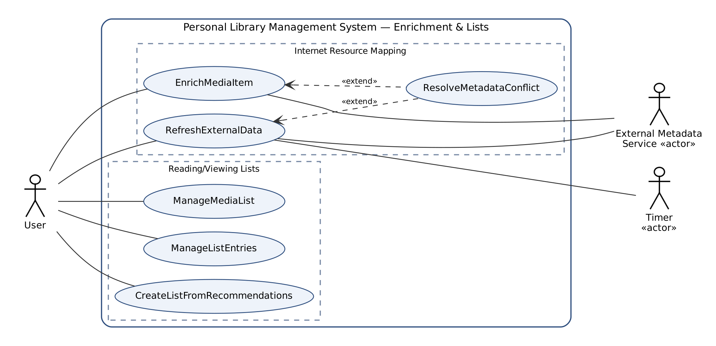
Figure 2: Use case diagram – Internet Resource Mapping and Reading/Viewing Lists
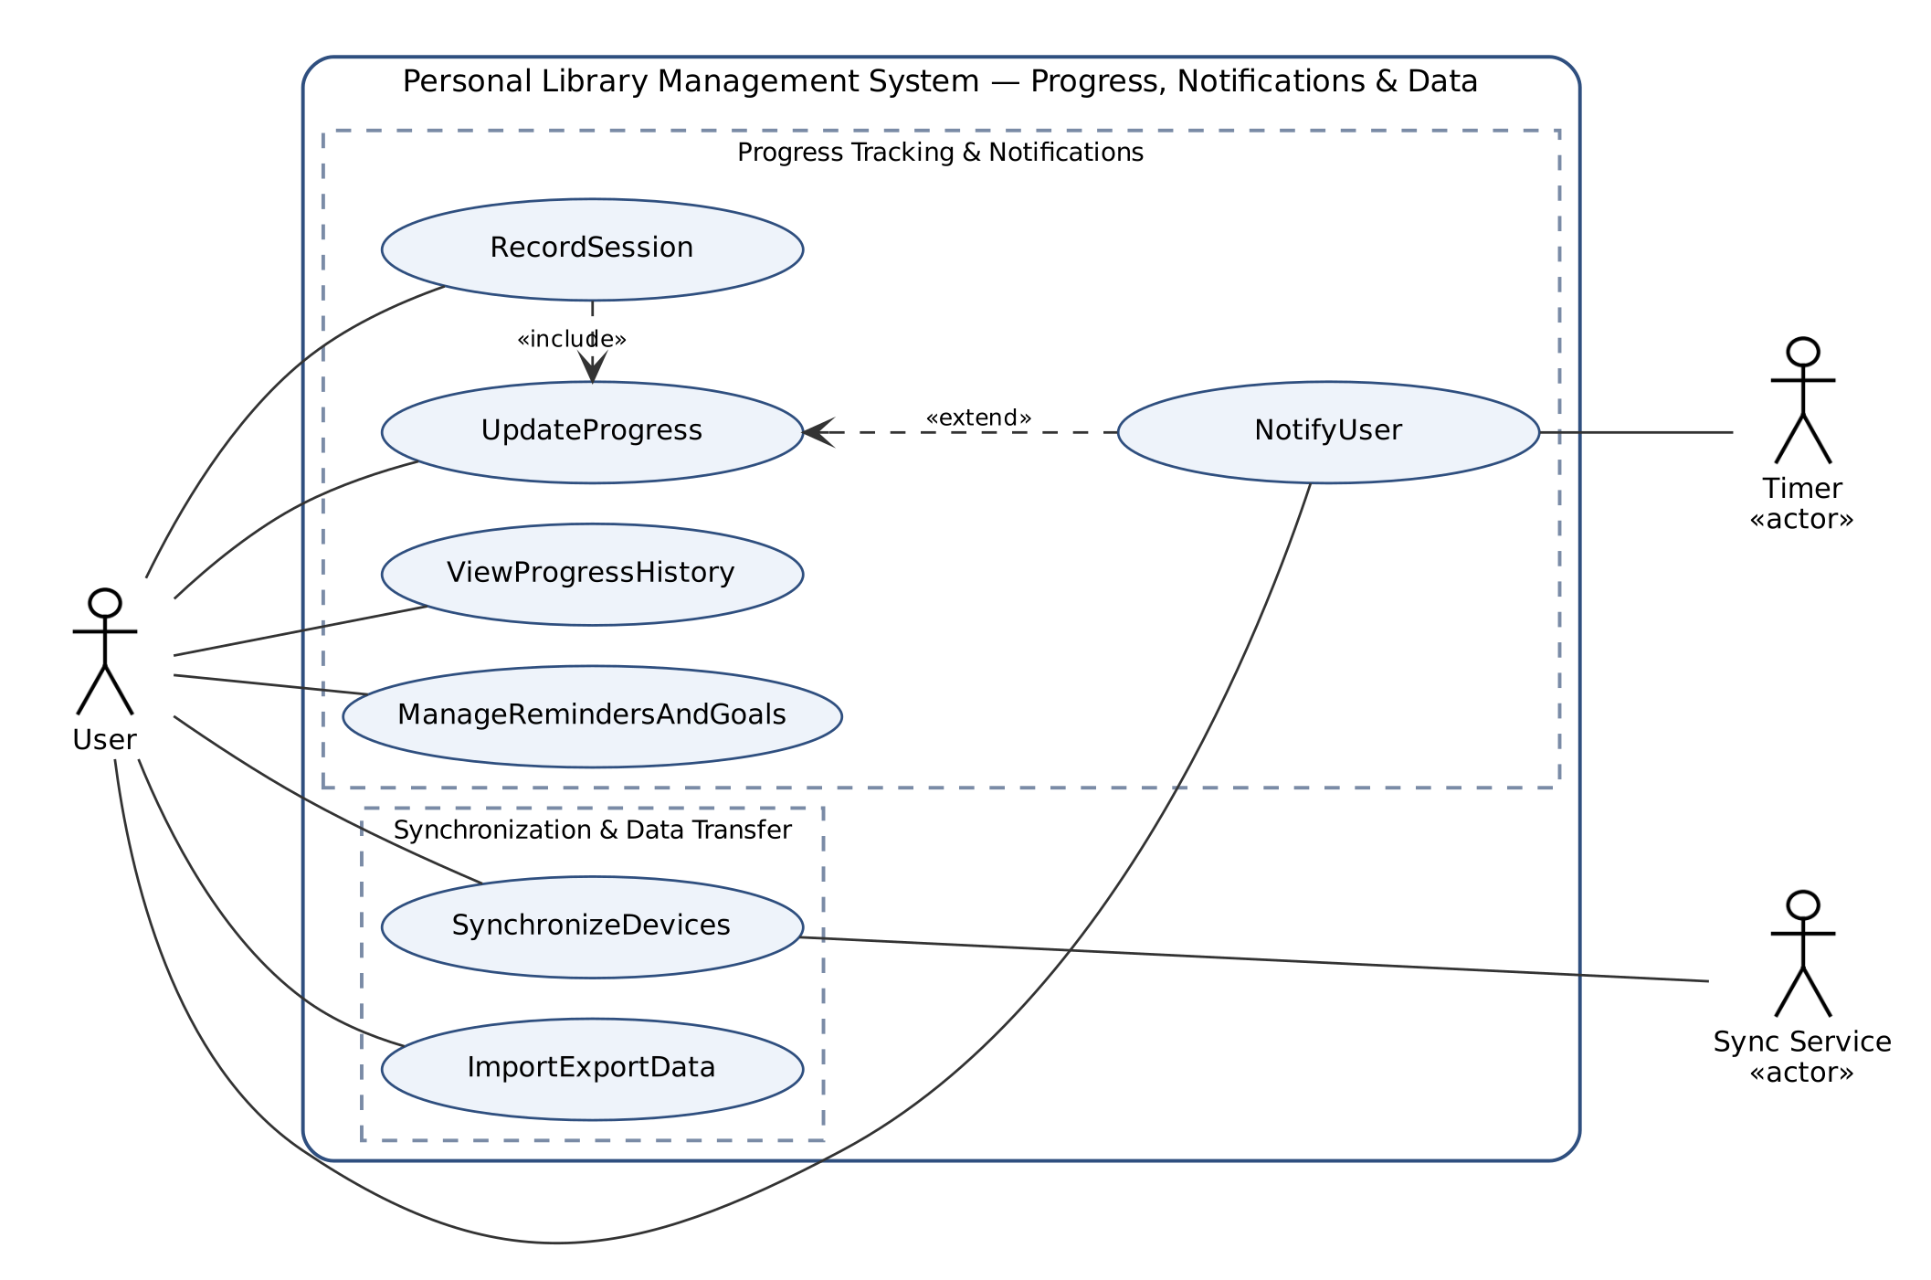
Figure 3: Use case diagram – Progress Tracking, Notifications, Synchronization and Data Transfer
Table 17: Use case summary
ID | Use case | Actors | Related FRs
UC-1 | RegisterAccount | User (initiator) | FR-36, FR-61, FR-65
UC-2 | Login | User (initiator) | FR-62, FR-63, FR-66
UC-3 | ManageAccount | User (initiator) | FR-64, FR-65
UC-4 | AddMediaItem | User (initiator) | FR-1, FR-5, FR-6, FR-7, FR-8, FR-20
UC-5 | LookUpByCode | User (initiator), Barcode Scanner, External Metadata Service | FR-2, FR-3, FR-4, FR-30
UC-6 | ViewMediaItem | User (initiator) | FR-9, FR-35, FR-54
UC-7 | UpdateMediaItem | User (initiator) | FR-10, FR-11, FR-12, FR-25, FR-33
UC-8 | DeleteMediaItem | User (initiator) | FR-13, FR-14
UC-9 | SearchLibrary | User (initiator) | FR-12, FR-22, FR-23, FR-24
UC-10 | ManageTags | User (initiator) | FR-20, FR-21
UC-11 | ManageLoan | User (initiator) | FR-15, FR-16, FR-17, FR-19
UC-12 | EnrichMediaItem | User (initiator), External Metadata Service | FR-26, FR-27, FR-28, FR-29, FR-30, FR-35
UC-13 | RefreshExternalData | User or Timer (initiator), External Metadata Service | FR-31, FR-33, FR-34
UC-14 | ResolveMetadataConflict | User | FR-32, FR-33
UC-15 | ManageMediaList | User (initiator) | FR-36, FR-37, FR-38, FR-39
UC-16 | ManageListEntries | User (initiator) | FR-40, FR-41, FR-42, FR-43
UC-17 | CreateListFromRecommendations | User (initiator) | FR-37, FR-44
UC-18 | UpdateProgress | User (initiator) | FR-45, FR-46, FR-47, FR-48, FR-49, FR-53, FR-54, FR-55
UC-19 | RecordSession | User (initiator) | FR-50, FR-51
UC-20 | ViewProgressHistory | User (initiator) | FR-49, FR-52
UC-21 | ManageRemindersAndGoals | User (initiator) | FR-56, FR-58, FR-60
UC-22 | NotifyUser | Timer (initiator), User | FR-18, FR-57, FR-59
UC-23 | SynchronizeDevices | User (initiator), Sync Service | FR-67, FR-68, FR-69
UC-24 | ImportExportData | User (initiator) | FR-70, FR-71, FR-72

The detailed use case descriptions follow. Steps performed by the actor are marked (A), steps performed by the system (S).
UC-1: RegisterAccount
Use case name | RegisterAccount (UC-1)
Participating actors | User (initiator)
Entry condition | The application is started and no User is logged in.
Flow of events | 1. (A) The User selects “Create account” on the Login Form.  2. (S) The system displays the Registration Form.  3. (A) The User enters a username, an e-mail address and a password (twice) and submits the form.  4. (S) The system validates that the username is unique and the password meets the password policy.  5. (S) The system creates the User Account with the default Media Lists and generates a one-time Recovery Key.  6. (S) The system displays the Recovery Key and asks the User to store it safely.  7. (A) The User confirms that the Recovery Key has been stored.
Alternative flows | 4a. The username already exists or the password is too weak: the system shows the reason and returns to step 3.
Exit condition | A new User Account exists and the Login Form is shown.
Quality requirements | The password is stored only as a salted hash (NFR-9).
Related requirements | FR-36, FR-61, FR-65

UC-2: Login
Use case name | Login (UC-2)
Participating actors | User (initiator)
Entry condition | A User Account exists and no User is logged in.
Flow of events | 1. (A) The User enters the username and password on the Login Form and submits them.  2. (S) The system checks the credentials.  3. (S) The system opens the Library View of the User Account.
Alternative flows | 2a. The credentials are invalid: the system shows an error and increases the failed-attempt counter.  2b. Five consecutive failed attempts: the system blocks login for this account for five minutes.
Exit condition | The User is logged in and sees only the data of the own User Account.
Quality requirements | Login takes less than 2 seconds.
Related requirements | FR-62, FR-63, FR-66

UC-3: ManageAccount
Use case name | ManageAccount (UC-3)
Participating actors | User (initiator)
Entry condition | The User is logged in (change password) or on the Login Form (reset password).
Flow of events | 1. (A) The User opens Account Settings and selects “Change password”.  2. (A) The User enters the current password and the new password twice.  3. (S) The system verifies the current password, stores the new password hash and confirms the change.
Alternative flows | 1a. Forgotten password: on the Login Form the User selects “Reset password”, enters the username and the Recovery Key and sets a new password; the system generates a new Recovery Key.  3a. The current password is wrong: the system rejects the change.
Exit condition | The password of the User Account has been changed.
Quality requirements | NFR-9 applies.
Related requirements | FR-64, FR-65

UC-4: AddMediaItem
Use case name | AddMediaItem (UC-4)
Participating actors | User (initiator)
Entry condition | The User is logged in and the Library View is displayed.
Flow of events | 1. (A) The User selects “Add item” and chooses the media type (Book or DVD).  2. (S) The system displays an empty Item Form for the chosen media type.  3. (A) The User fills in the details (title, creators, release date, format, condition, location, purchase details, tags) or scans a code (extension point: LookUpByCode).  4. (A) The User submits the Item Form.  5. (S) The system validates the mandatory fields and checks for duplicates.  6. (S) The system stores the Media Item with status Available and shows it in the Library View.
Alternative flows | 5a. The title or media type is missing: the system highlights the missing fields (FR-7).  5b. A possible duplicate is found: the system shows the existing item; the User cancels or saves anyway (FR-8).
Exit condition | The new Media Item is part of the Library.
Quality requirements | NFR-1, NFR-2.
Related requirements | FR-1, FR-5, FR-6, FR-7, FR-8, FR-20

UC-5: LookUpByCode
Use case name | LookUpByCode (UC-5)
Participating actors | User (initiator), Barcode Scanner, External Metadata Service
Entry condition | The Item Form is open (extends AddMediaItem at step 3).
Flow of events | 1. (A) The User scans the ISBN/EAN/UPC with the Barcode Scanner or types it.  2. (S) The system validates the check digit and sends a lookup request to the External Metadata Service.  3. (S) The system receives the metadata and pre-fills the Item Form (title, creators, date, publisher/studio, page count or runtime, cover).  4. (A) The User checks and completes the pre-filled data and returns to AddMediaItem step 4.
Alternative flows | 2a. The code is invalid: the system asks the User to scan again.  3a. No record is found or the service is unavailable: the system informs the User and keeps the Item Form open for manual entry (FR-4, FR-30).
Exit condition | The Item Form contains the retrieved metadata.
Quality requirements | Result within 5 seconds in 95% of cases (NFR-15).
Related requirements | FR-2, FR-3, FR-4, FR-30

UC-6: ViewMediaItem
Use case name | ViewMediaItem (UC-6)
Participating actors | User (initiator)
Entry condition | The User is logged in.
Flow of events | 1. (A) The User selects a Media Item in the Library View, a List View or a search result.  2. (S) The system displays the Item Detail View with attributes, Enriched Content with provider and date, list memberships, loan status and Progress.
Exit condition | The Item Detail View is displayed.
Quality requirements | The view opens within 1 second.
Related requirements | FR-9, FR-35, FR-54

UC-7: UpdateMediaItem
Use case name | UpdateMediaItem (UC-7)
Participating actors | User (initiator)
Entry condition | The Item Detail View of a Media Item is displayed.
Flow of events | 1. (A) The User selects “Edit”.  2. (S) The system shows the Item Form with the current values.  3. (A) The User changes attributes (e.g., condition, location, status Lost, rating, tags) and saves.  4. (S) The system validates and stores the changes and marks changed fields as user-entered.
Alternative flows | 4a. Validation fails: the system highlights the invalid fields.
Exit condition | The Media Item is updated.
Quality requirements | NFR-6.
Related requirements | FR-10, FR-11, FR-12, FR-25, FR-33

UC-8: DeleteMediaItem
Use case name | DeleteMediaItem (UC-8)
Participating actors | User (initiator)
Entry condition | The Item Detail View of a Media Item is displayed.
Flow of events | 1. (A) The User selects “Delete”.  2. (S) The system asks for confirmation and shows which lists, progress and reminders will also be removed.  3. (A) The User confirms.  4. (S) The system removes the Media Item and all dependent List Entries, Progress, Session Logs, Reminders and External Resource Links.
Alternative flows | 3a. The User cancels: nothing is deleted.
Exit condition | The Media Item no longer exists in the Library.
Quality requirements | NFR-4.
Related requirements | FR-13, FR-14

UC-9: SearchLibrary
Use case name | SearchLibrary (UC-9)
Participating actors | User (initiator)
Entry condition | The Library View is displayed.
Flow of events | 1. (A) The User types a keyword in the Search Panel and/or selects filters (media type, tag, status, condition, location, progress status).  2. (S) The system shows the matching Media Items.  3. (A) The User selects a sort criterion.  4. (S) The system re-orders the results.
Alternative flows | 2a. No item matches: the system shows an empty-result message and a shortcut to AddMediaItem.
Exit condition | The matching Media Items are displayed.
Quality requirements | Results within 1 second for 10,000 items (NFR-13).
Related requirements | FR-12, FR-22, FR-23, FR-24

UC-10: ManageTags
Use case name | ManageTags (UC-10)
Participating actors | User (initiator)
Entry condition | The User is logged in.
Flow of events | 1. (A) The User opens the Tag Manager.  2. (A) The User creates, renames or deletes a custom Tag.  3. (S) The system updates the Tag and all Media Items that use it.
Alternative flows | 2a. The tag name already exists: the system rejects the name.
Exit condition | The set of Tags is updated.
Quality requirements | -
Related requirements | FR-20, FR-21

UC-11: ManageLoan
Use case name | ManageLoan (UC-11)
Participating actors | User (initiator)
Entry condition | The Item Detail View of an Available Media Item is displayed.
Flow of events | 1. (A) The User selects “Lend” and enters the borrower name, loan date and due date.  2. (S) The system records the Loan and sets the status of the Media Item to On Loan.  3. (A) Later, the User selects “Mark as returned”.  4. (S) The system closes the Loan with the return date, sets the status to Available and adds the Loan to the loan history.
Alternative flows | 2a. The due date is earlier than the loan date: the system rejects the input.
Exit condition | The loan status and loan history of the Media Item are up to date.
Quality requirements | -
Related requirements | FR-15, FR-16, FR-17, FR-19

UC-12: EnrichMediaItem
Use case name | EnrichMediaItem (UC-12)
Participating actors | User (initiator), External Metadata Service
Entry condition | The Item Detail View of a Media Item is displayed and enabled External Providers exist.
Flow of events | 1. (A) The User selects “Find online information”.  2. (S) The system queries the enabled External Providers with the title, creators and code of the Media Item.  3. (S) The system displays the candidate External Resource Records ranked by match confidence.  4. (A) The User confirms the correct candidate.  5. (S) The system creates an External Resource Link and fetches the summary/synopsis, creator biographies, cover image and reviews.  6. (S) The system shows the Enriched Content with provider name and retrieval date.
Alternative flows | 2a. No network connection: the request is queued (FR-29).  2b. A provider fails or times out: the system informs the User and leaves local data unchanged (FR-30).  5a. Fetched values differ from user-entered values: ResolveMetadataConflict extends this use case.
Exit condition | The Media Item is linked to at least one External Resource Record.
Quality requirements | Requests run asynchronously (NFR-14).
Related requirements | FR-26, FR-27, FR-28, FR-29, FR-30, FR-35

UC-13: RefreshExternalData
Use case name | RefreshExternalData (UC-13)
Participating actors | User or Timer (initiator), External Metadata Service
Entry condition | The Media Item has at least one External Resource Link.
Flow of events | 1. (A) The User selects “Refresh”, or the Timer reports that 30 days have passed since the last refresh.  2. (S) The system requests the current data of each linked External Resource Record.  3. (S) The system updates the fields that were not entered by the User and stores the refresh date.
Alternative flows | 3a. A fetched value differs from a user-entered value: ResolveMetadataConflict extends this use case.  3b. The User removes an incorrect link: the system deletes the External Resource Link (FR-34).
Exit condition | The Enriched Content is current.
Quality requirements | NFR-7, NFR-14.
Related requirements | FR-31, FR-33, FR-34

UC-14: ResolveMetadataConflict
Use case name | ResolveMetadataConflict (UC-14)
Participating actors | User
Entry condition | Extends EnrichMediaItem (step 5) or RefreshExternalData (step 3) when a fetched value differs from a user-entered value.
Flow of events | 1. (S) The system records a Metadata Conflict and shows the local and external values side by side.  2. (A) The User chooses “Keep local” or “Accept external” for each field.  3. (S) The system applies the decisions and marks the Metadata Conflicts as resolved.
Alternative flows | 2a. The User postpones the decision: the conflicts stay Pending and are marked in the Item Detail View.
Exit condition | No pending Metadata Conflict remains for the decided fields.
Quality requirements | -
Related requirements | FR-32, FR-33

UC-15: ManageMediaList
Use case name | ManageMediaList (UC-15)
Participating actors | User (initiator)
Entry condition | The User is logged in.
Flow of events | 1. (A) The User opens the Lists panel and selects “New list”, “Rename” or “Delete”.  2. (A) The User enters a name and optional description (create/rename) or confirms the deletion.  3. (S) The system creates, renames or deletes the Media List; on deletion only its List Entries are removed.
Alternative flows | 3a. A default Media List cannot be deleted: the system disables the delete action.
Exit condition | The Media Lists are updated.
Quality requirements | -
Related requirements | FR-36, FR-37, FR-38, FR-39

UC-16: ManageListEntries
Use case name | ManageListEntries (UC-16)
Participating actors | User (initiator)
Entry condition | At least one Media List exists.
Flow of events | 1. (A) The User adds a Media Item to a Media List (from the Item Detail View or by drag and drop) or removes it.  2. (S) The system creates or removes the List Entry.  3. (A) The User sets the priority of an entry, chooses a sort criterion or reorders entries manually.  4. (S) The system stores the priority and order and shows the updated List View.
Alternative flows | 2a. The Media Item is already in the Media List: the system shows a message.
Exit condition | The List Entries are updated.
Quality requirements | -
Related requirements | FR-40, FR-41, FR-42, FR-43

UC-17: CreateListFromRecommendations
Use case name | CreateListFromRecommendations (UC-17)
Participating actors | User (initiator)
Entry condition | The Library contains unfinished Media Items.
Flow of events | 1. (A) The User selects “Recommend” and chooses a goal or mood Tag.  2. (S) The system generates Recommendations from the unfinished Media Items and shows them with the reason for each.  3. (A) The User removes unwanted recommendations and selects “Save as list” with a name.  4. (S) The system creates a new Media List with the selected items.
Alternative flows | 2a. No item fits: the system informs the User.
Exit condition | A new Media List of type Recommended exists.
Quality requirements | Recommendations are produced within 2 seconds.
Related requirements | FR-37, FR-44

UC-18: UpdateProgress
Use case name | UpdateProgress (UC-18)
Participating actors | User (initiator)
Entry condition | The Item Detail View of a Media Item is displayed.
Flow of events | 1. (A) The User enters the current page/chapter (Book) or minute/scene (DVD).  2. (S) The system validates the value against the total of the Media Item.  3. (S) The system stores the Progress, recalculates the percentage and the remaining time and updates the progress indicators.  4. (S) If 100% is reached, the system sets the progress status to Completed with the completion date.
Alternative flows | 2a. The value exceeds the total: the system rejects it (FR-55).  3a. Automatic list maintenance is enabled and the status becomes In Progress: the system moves the item to Currently Reading/Watching (FR-45).  3b. A milestone is reached: NotifyUser extends this use case.
Exit condition | The Progress of the Media Item is updated.
Quality requirements | -
Related requirements | FR-45, FR-46, FR-47, FR-48, FR-49, FR-53, FR-54, FR-55

UC-19: RecordSession
Use case name | RecordSession (UC-19)
Participating actors | User (initiator)
Entry condition | The Item Detail View of a Media Item is displayed.
Flow of events | 1. (A) The User selects “Start session”.  2. (S) The system records the start time and start position and shows the running session timer.  3. (A) The User selects “End session” and enters the end position.  4. (S) The system stores a Session Log (date, start, end, duration, start and end position) and includes UpdateProgress with the end position.
Alternative flows | 3a. The application is closed while the timer runs: the system stores the session with the closing time as end time and asks for the end position at the next start.
Exit condition | A new Session Log exists and the Progress is updated.
Quality requirements | NFR-6.
Related requirements | FR-50, FR-51

UC-20: ViewProgressHistory
Use case name | ViewProgressHistory (UC-20)
Participating actors | User (initiator)
Entry condition | The Media Item has at least one Session Log.
Flow of events | 1. (A) The User opens the History tab of the Item Detail View.  2. (S) The system shows the Session Logs in chronological order with totals and the average reading or viewing speed.
Exit condition | The history is displayed.
Quality requirements | -
Related requirements | FR-49, FR-52

UC-21: ManageRemindersAndGoals
Use case name | ManageRemindersAndGoals (UC-21)
Participating actors | User (initiator)
Entry condition | The User is logged in.
Flow of events | 1. (A) The User opens the Reminder Settings Form for a Media Item, or the Goals panel.  2. (A) The User creates, edits or deletes a Reminder (date, time, recurrence) or a Goal (amount, unit, period), and enables or disables Notification types.  3. (S) The system stores the settings and schedules the Reminders.
Alternative flows | 2a. The reminder time is in the past: the system rejects it.
Exit condition | Reminders, Goals and notification settings are stored.
Quality requirements | -
Related requirements | FR-56, FR-58, FR-60

UC-22: NotifyUser
Use case name | NotifyUser (UC-22)
Participating actors | Timer (initiator), User
Entry condition | The application is running and a Reminder time, an overdue Loan, a milestone or a Goal completion occurs.
Flow of events | 1. (S) The Timer signals the event to the system (or NotifyUser extends UpdateProgress when a milestone is reached).  2. (S) The system checks that the Notification type is enabled.  3. (S) The system creates a Notification and displays it in the Notification Popup.  4. (A) The User opens or dismisses the Notification.
Alternative flows | 2a. The Notification type is disabled: nothing is shown.
Exit condition | The Notification is shown and marked as read when opened.
Quality requirements | The Notification is shown within 1 minute of the scheduled time.
Related requirements | FR-18, FR-57, FR-59

UC-23: SynchronizeDevices
Use case name | SynchronizeDevices (UC-23)
Participating actors | User (initiator), Sync Service
Entry condition | Cloud synchronization is enabled and the Device is registered to the User Account.
Flow of events | 1. (A) The User selects “Sync now” or the application starts with network access.  2. (S) The system sends the local changes recorded since the last synchronization to the Sync Service.  3. (S) The system receives the changes of the other Devices and applies them.  4. (S) The system updates the last-synchronization time of the Device.
Alternative flows | 2a. The Device is offline: changes stay queued (FR-68).  3a. The same record was changed on two Devices: the most recent change wins, the other version is logged and the User is notified (FR-69).
Exit condition | The Device holds the same data as the Sync Service.
Quality requirements | NFR-10.
Related requirements | FR-67, FR-68, FR-69

UC-24: ImportExportData
Use case name | ImportExportData (UC-24)
Participating actors | User (initiator)
Entry condition | The User is logged in.
Flow of events | 1. (A) The User opens the Import/Export Dialog and selects Export, Import, Backup or Restore.  2. (A) The User chooses the file and format (CSV, JSON or backup file).  3. (S) The system performs the operation and shows a summary (number of items exported/imported, rows not imported with reason).
Alternative flows | 3a. Restore: the system asks for confirmation because current data will be replaced.
Exit condition | The selected data transfer is completed.
Quality requirements | NFR-26, NFR-31.
Related requirements | FR-70, FR-71, FR-72

Object model
The object model is kept at the conceptual (analysis) level as required: classes show attributes and associations with multiplicities but no operations and no database elements (no keys, tables or foreign keys). Derived attributes are marked with “/”. The domain model is divided into two class diagrams that share the classes UserAccount and MediaItem; enumeration types are shown separately.
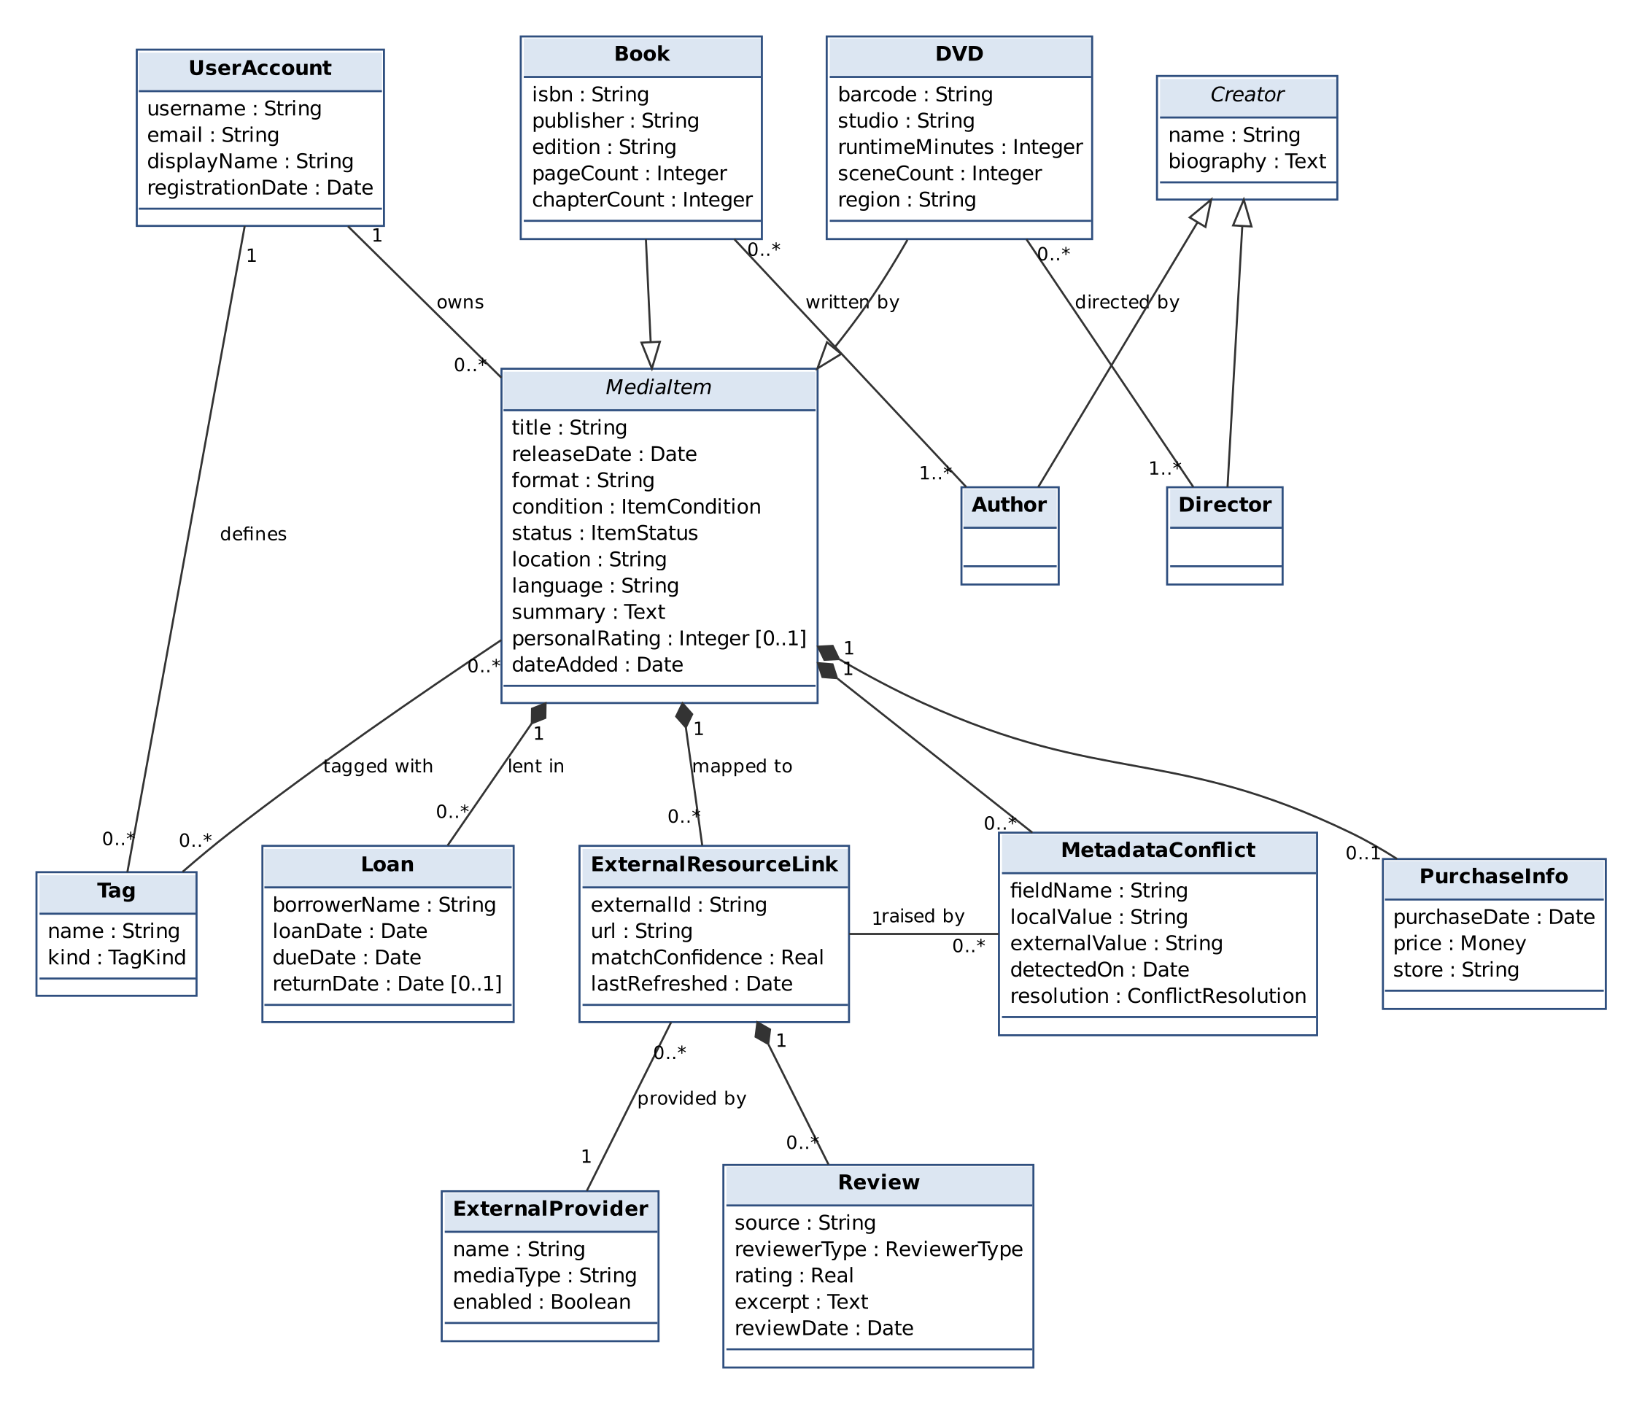
Figure 4: Domain class diagram – Inventory and Internet Resource Mapping
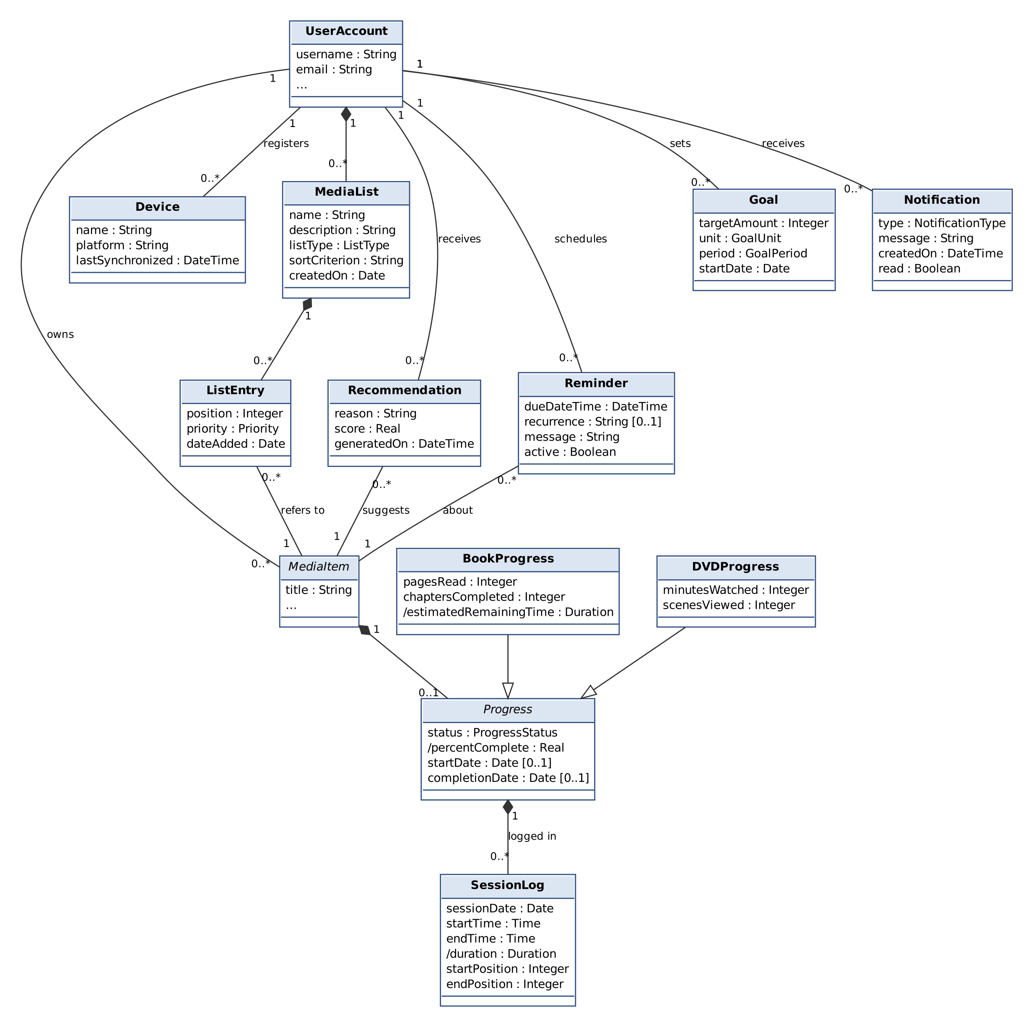
Figure 5: Domain class diagram – Lists, Progress, Notifications and Devices (MediaItem attributes as in Figure 4)
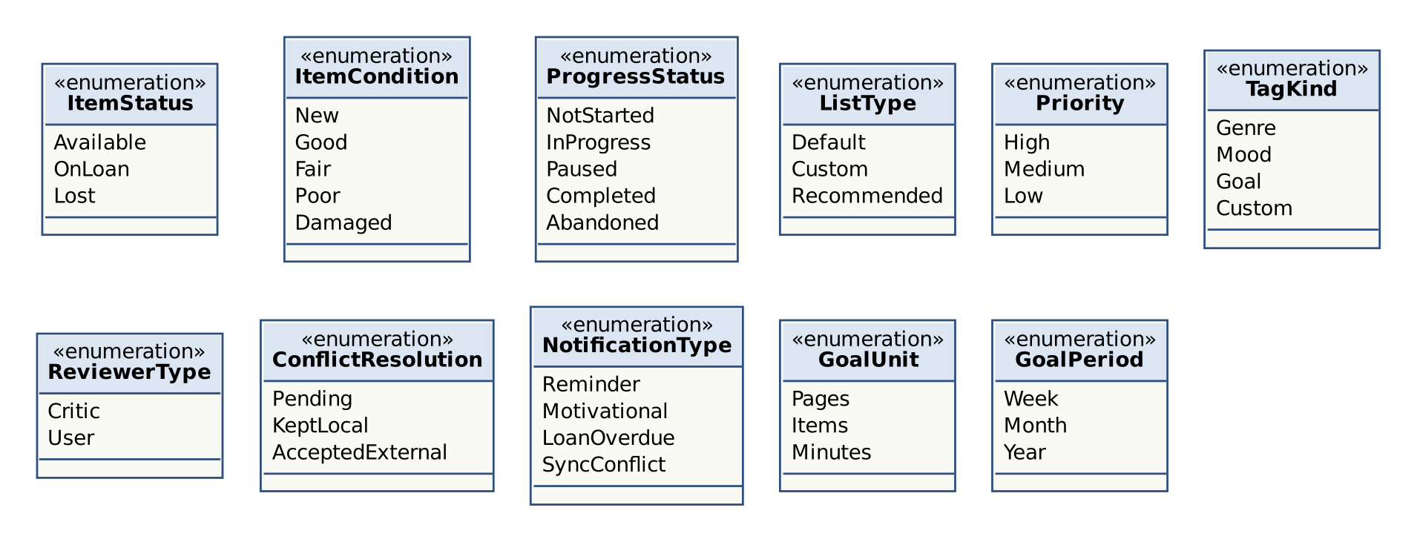
Figure 6: Enumeration types used by the domain classes
Entity objects. Table 18 is the data dictionary of the entity classes.
Table 18: Entity objects (data dictionary)
Class | Description | Main associations
UserAccount | A registered user of the installation and owner of a Library. | owns MediaItem; has MediaList, Goal, Reminder, Notification, Device
MediaItem {abstract} | A physical item of the Library; generalization of Book and DVD. | tagged with Tag; has PurchaseInfo, Loan, ExternalResourceLink, Progress, MetadataConflict
Book | A printed book identified by an ISBN. | written by 1..* Author
DVD | A video disc identified by an EAN/UPC barcode. | directed by 1..* Director
Creator {abstract}, Author, Director | A person who created a Media Item; biography is enriched from external sources. | Author – Book, Director – DVD
PurchaseInfo | Date, price and store of the purchase of a Media Item. | part of MediaItem
Tag | A user-defined label such as a genre, mood, goal or “favorite”. | many-to-many with MediaItem
Loan | The lending of a Media Item to a borrower, with due and return dates. | part of MediaItem
ExternalProvider | A supported external data source (Google Books, Open Library, OMDb, TMDb). | provides ExternalResourceLink
ExternalResourceLink | The mapping of a Media Item to one External Resource Record of a provider. | has Review; raises MetadataConflict
Review | A critic or user review fetched from an External Provider. | part of ExternalResourceLink
MetadataConflict | A difference between a user-entered value and an external value, with its resolution. | belongs to MediaItem
MediaList | A default, custom or recommended reading/viewing list. | composed of ListEntry
ListEntry | The membership of a Media Item in a Media List, with position, priority and date added. | refers to MediaItem
Recommendation | A suggested unfinished Media Item with a reason and score. | suggests MediaItem
Progress {abstract}, BookProgress, DVDProgress | The consumption state of a Media Item (pages/chapters or minutes/scenes, status, dates). | part of MediaItem; logged in SessionLog
SessionLog | One reading or viewing session with start/end time and positions. | part of Progress
Reminder | A scheduled reminder about a Media Item. | about MediaItem
Goal | A target amount (pages, items or minutes) for a period. | set by UserAccount
Notification | A message shown to the User (reminder, motivational, overdue loan, sync conflict). | received by UserAccount
Device | A computer on which the User Account is registered for synchronization. | registered by UserAccount

Boundary and control objects. Following the analysis method of Bruegge and Dutoit [4], the use cases were also analysed into boundary objects (interaction with actors) and control objects (coordination of a use case). These objects appear in the sequence diagrams of Section 3.4.4.
Table 19: Boundary objects
Boundary object(s) | Responsibility | Use cases
LoginForm, RegistrationForm, AccountSettings | Login, registration, password change/reset. | UC-1, UC-2, UC-3
LibraryView, SearchPanel, TagManager | Main window with the item table, search/filter/sort and tag management. | UC-6, UC-9, UC-10
ItemForm | Form for adding and editing Media Items, including code look-up. | UC-4, UC-5, UC-7
ItemDetailView | Details, enriched content, progress, history, loans and conflicts of one item. | UC-6, UC-8, UC-18, UC-20
LoanDialog | Entering and closing loans. | UC-11
EnrichmentDialog, ConflictResolutionDialog | Candidate selection and conflict resolution. | UC-12, UC-13, UC-14
ListView, RecommendationDialog | Lists, entries, priorities and recommendations. | UC-15, UC-16, UC-17
SessionTimerView | Running session timer. | UC-19
ReminderSettingsForm, GoalsPanel, NotificationPopup | Reminders, goals, notification settings and display. | UC-21, UC-22
ImportExportDialog, SyncStatusView | Import, export, backup, restore and synchronization status. | UC-23, UC-24
BarcodeScannerInterface, MetadataServiceInterface, SyncServiceInterface | Interfaces to the Barcode Scanner, the External Metadata Service and the Sync Service actors. | UC-5, UC-12, UC-13, UC-23

Table 20: Control objects
Control object(s) | Responsibility | Use cases
AccountControl | Registration, authentication, lockout, password management. | UC-1, UC-2, UC-3
ItemManagementControl | Creating, validating, updating and deleting Media Items; duplicate check; code look-up. | UC-4–UC-8, UC-10
SearchControl | Keyword search, filtering and sorting. | UC-9
LoanControl | Loans, returns and overdue detection. | UC-11
EnrichmentControl | Querying providers, linking, refreshing and conflict handling. | UC-12, UC-13, UC-14
ListControl, RecommendationControl | Media Lists, entries, automatic maintenance and recommendations. | UC-15, UC-16, UC-17
ProgressControl | Progress validation and calculation, sessions, remaining time, completion. | UC-18, UC-19, UC-20
NotificationControl | Scheduling reminders, goals and displaying notifications. | UC-21, UC-22
SyncControl, DataTransferControl | Synchronization, import/export, backup and restore. | UC-23, UC-24

Dynamic model
The dynamic model shows how the analysis objects collaborate in the most important use cases (sequence diagrams), the life cycle of the objects with non-trivial behaviour (state machine diagrams), and the control flow of the external data refresh (activity diagram). Message names are descriptive and are not yet design-level operations.
Sequence diagrams
Figure 7 shows AddMediaItem extended by LookUpByCode. The alt fragment covers the case in which the External Metadata Service does not return a record or does not answer within 10 seconds (FR-4, FR-30).
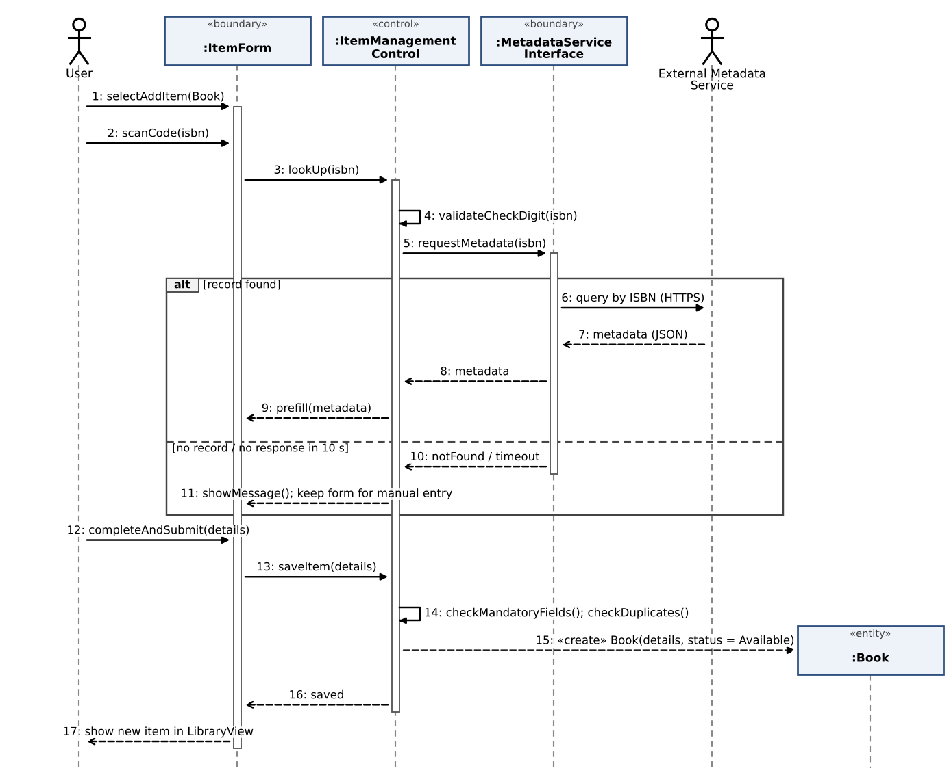
Figure 7: Sequence diagram – AddMediaItem with LookUpByCode (UC-4, UC-5)
Figure 8 shows EnrichMediaItem. If a fetched value differs from a user-entered value, a MetadataConflict is created and the User decides (ResolveMetadataConflict, UC-14); otherwise only values that were not entered by the User are updated (FR-33).
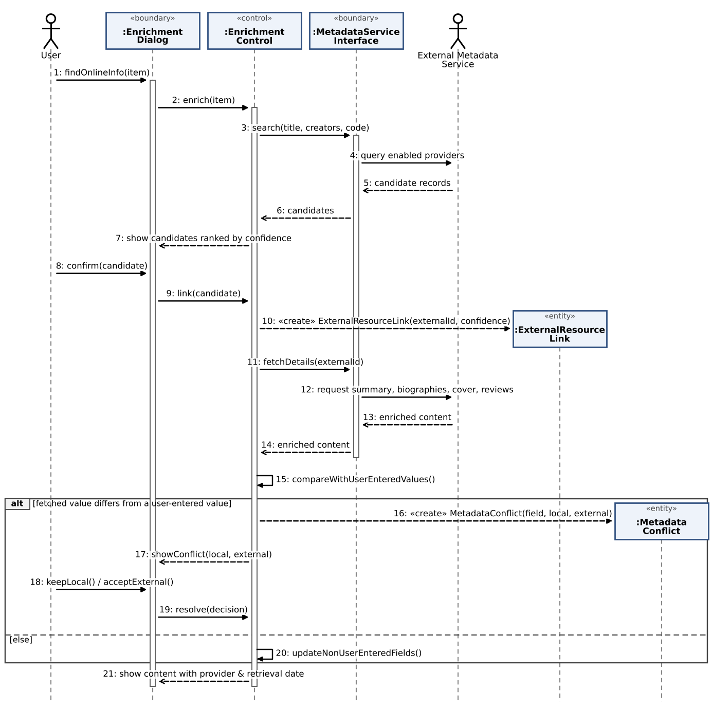
Figure 8: Sequence diagram – EnrichMediaItem with ResolveMetadataConflict (UC-12, UC-14)
Figure 9 shows RecordSession, which includes UpdateProgress; NotifyUser extends it when a milestone is reached.
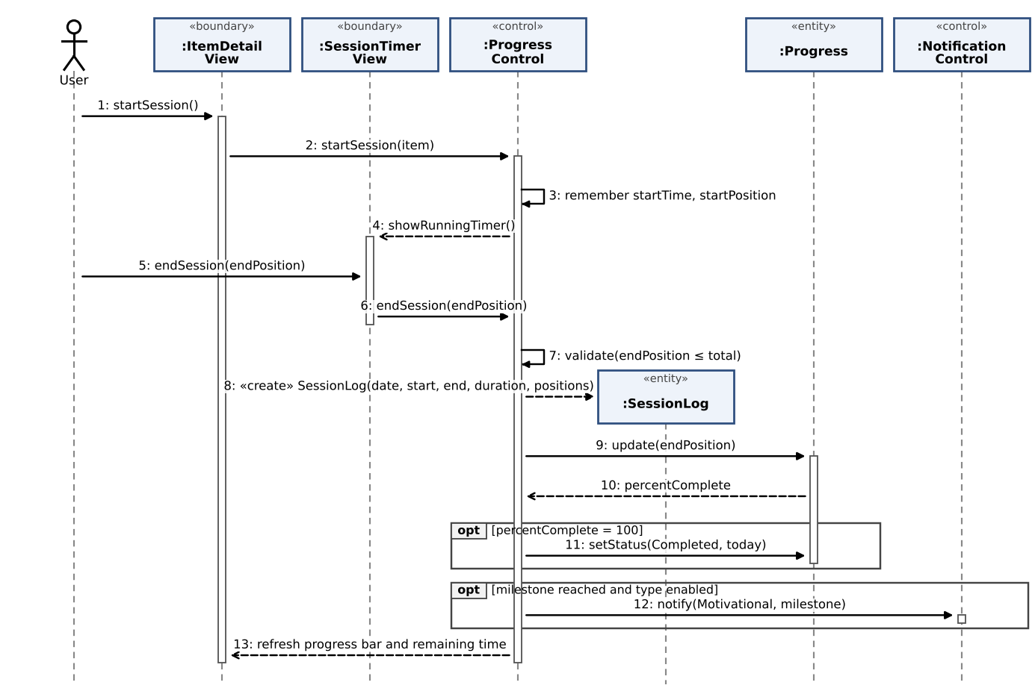
Figure 9: Sequence diagram – RecordSession including UpdateProgress (UC-19, UC-18, UC-22)
State machine diagrams
The status of a Media Item (ItemStatus) changes through loans and loss (FR-12, FR-15–FR-18). Deletion is possible in every state except On Loan, so that the loan is closed first.
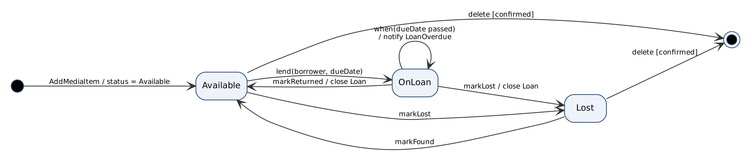
Figure 10: State machine diagram – MediaItem status
The Progress of a Media Item follows the ProgressStatus life cycle (FR-48, FR-53). A Completed item can be restarted when it is re-read or re-watched.
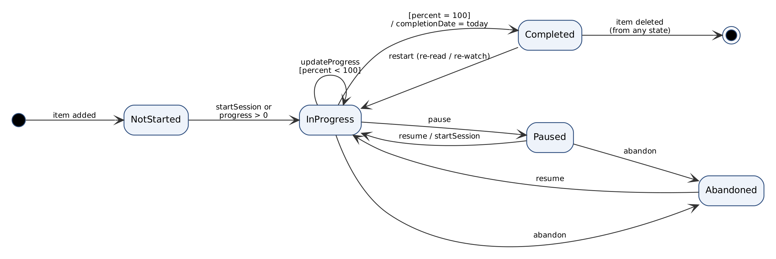
Figure 11: State machine diagram – Progress status
Activity diagram
Figure 12 shows the control flow of RefreshExternalData, including offline queuing (FR-29), provider failures (FR-30) and the conflict handling of FR-32 and FR-33.
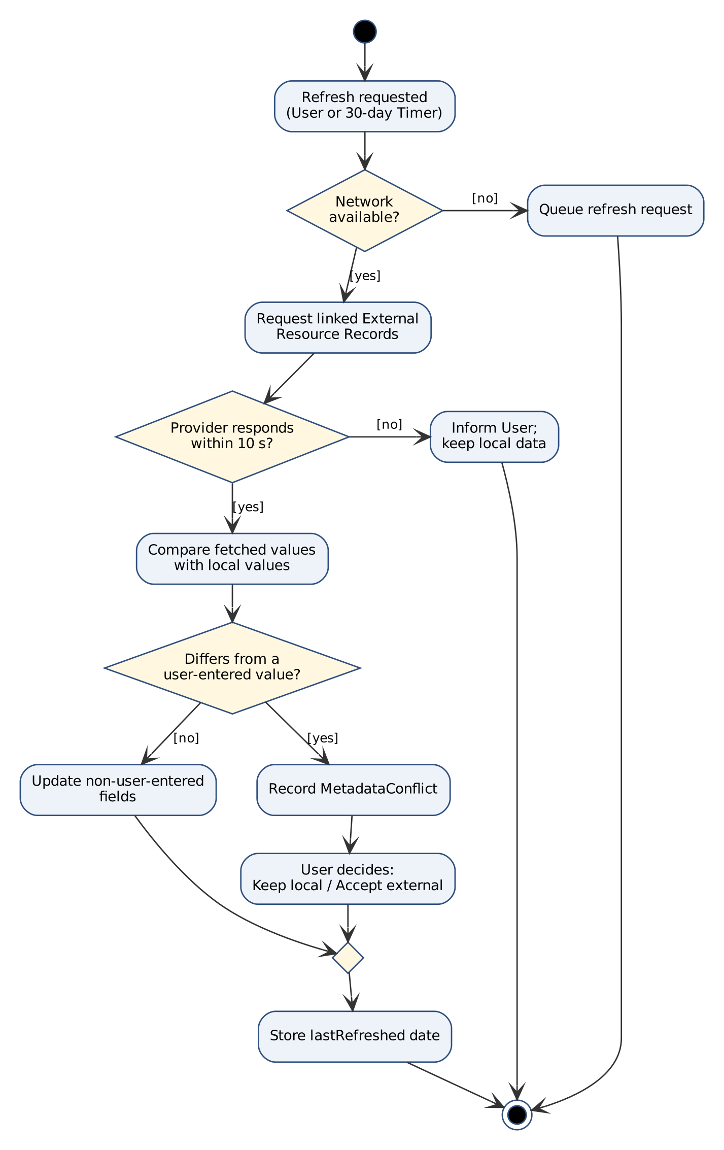
Figure 12: Activity diagram – RefreshExternalData with conflict handling

User interfaces and Mock-ups
The mock-ups below are low-fidelity wireframes of the desktop client; colours, icons and exact layout will be decided in the design phase. Numbered markers refer to the explanations under each figure. The navigational paths between the screens are shown first.
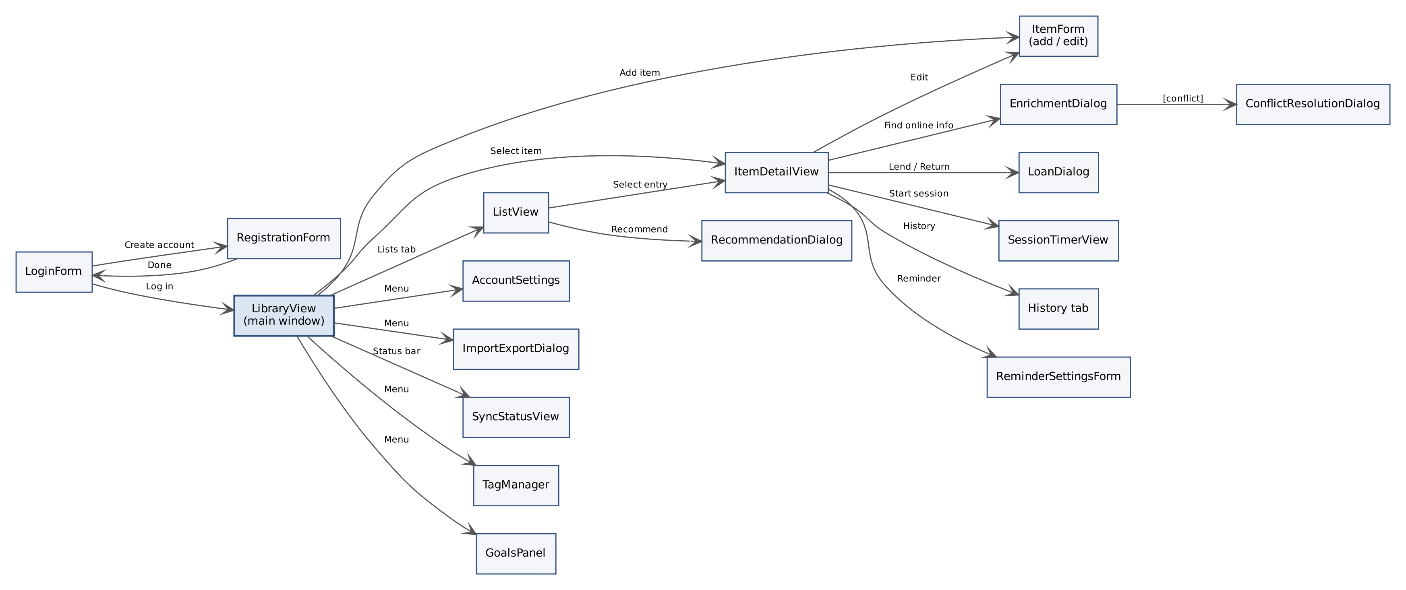
Figure 13: Navigational paths between the screens (boundary objects)
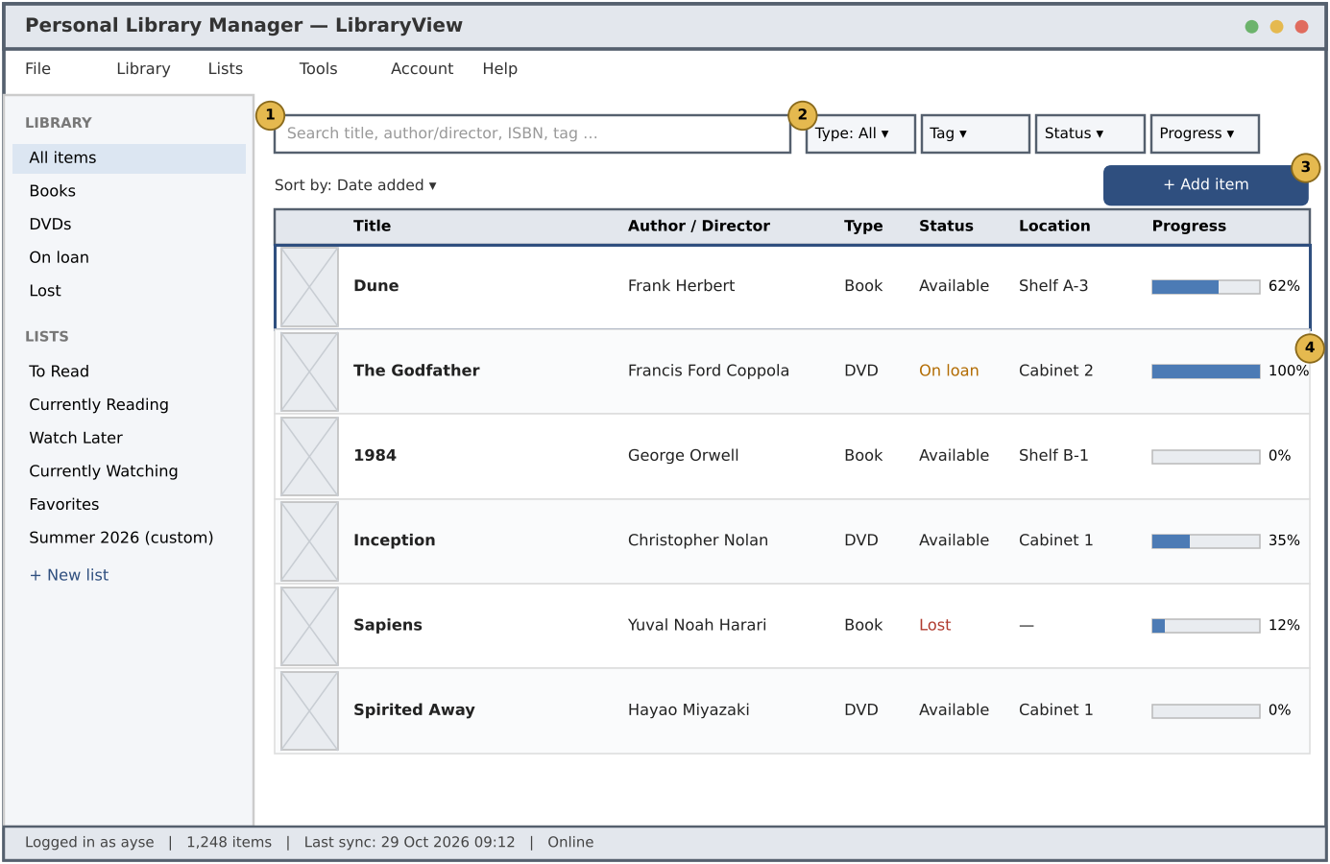
Figure 14: Mock-up – LibraryView (main window)
- (1) Search Panel for keyword search (FR-22).
- (2) Combinable filters for type, tag, status and progress (FR-23); sort selector (FR-24).
- (3) “Add item” starts AddMediaItem (UC-4).
- (4) Item table with status colours (On Loan, Lost) and progress bars (FR-54).

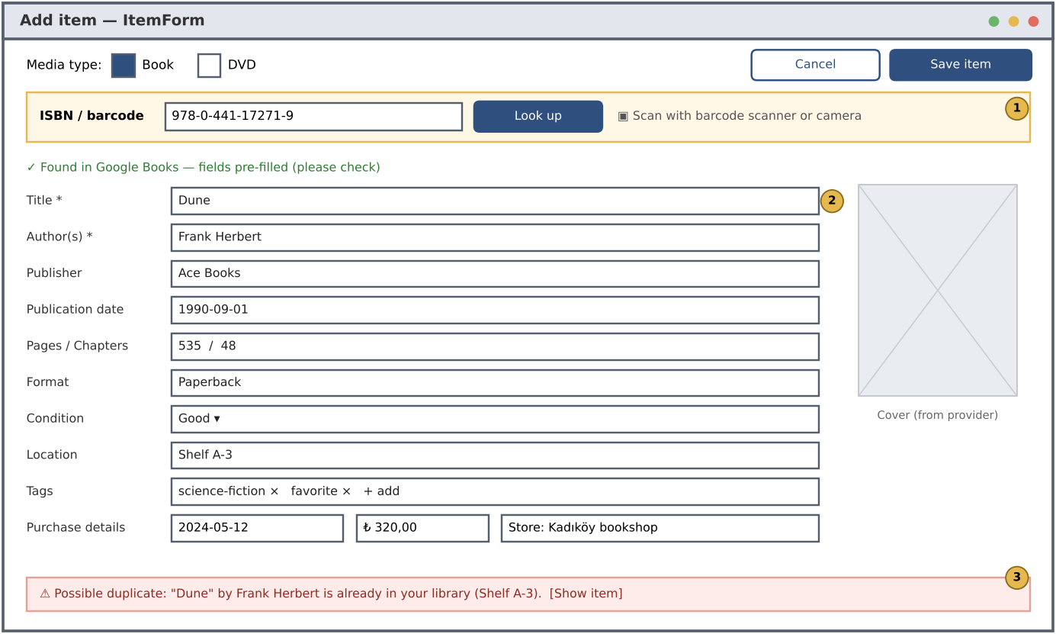
Figure 15: Mock-up – ItemForm with ISBN look-up and duplicate warning
- (1) ISBN/barcode field; look-up by scanner or keyboard (FR-2, FR-3).
- (2) Pre-filled fields; mandatory fields are marked with * (FR-6, FR-7).
- (3) Duplicate warning before saving (FR-8).

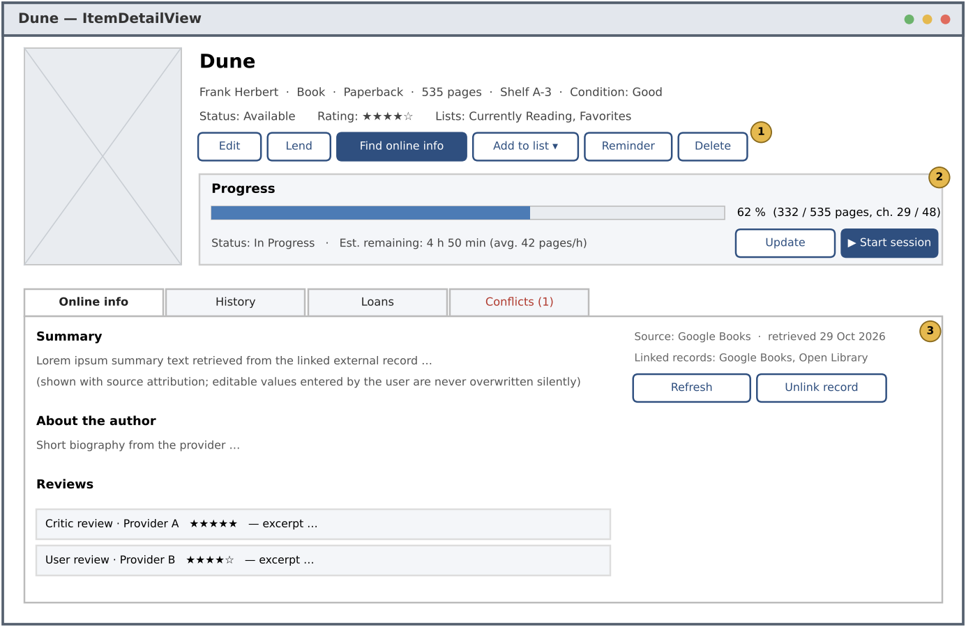
Figure 16: Mock-up – ItemDetailView with progress and enriched content
- (1) Actions: edit, lend, enrichment, add to list, reminder, delete (UC-7, UC-11, UC-12, UC-16, UC-21, UC-8).
- (2) Progress card with percentage, remaining time and session start (FR-48, FR-49, FR-50).
- (3) Enriched content with provider name and retrieval date, refresh and unlink (FR-31, FR-34, FR-35); the Conflicts tab lists pending Metadata Conflicts (FR-32).

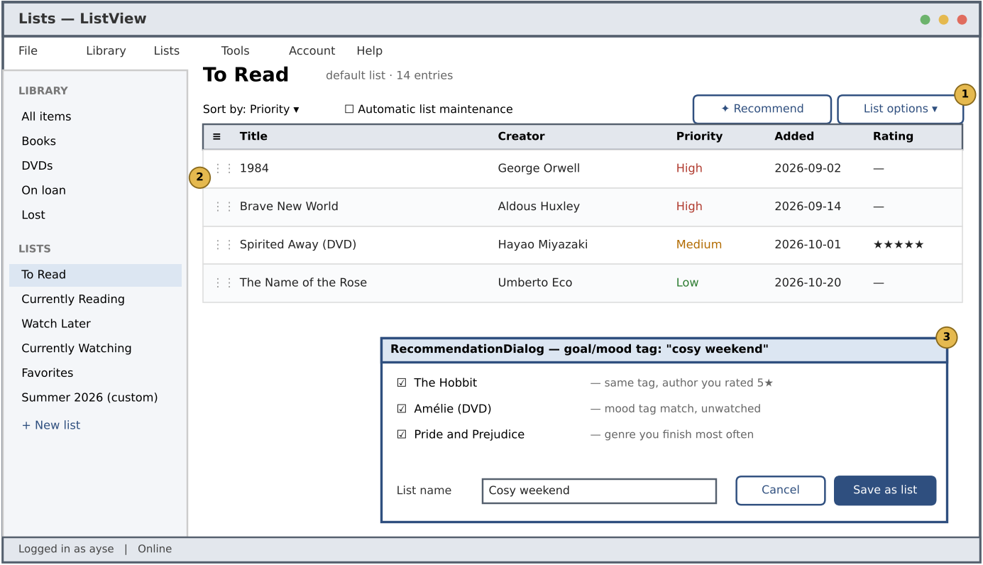
Figure 17: Mock-up – ListView with RecommendationDialog
- (1) Recommendation and list options; the default lists cannot be deleted (UC-15).
- (2) Entries with drag handle, priority and sort (FR-42, FR-43).
- (3) Recommendations with reasons, saved as a new Media List (FR-44).

Glossary of Terms
The following terms are used with exactly these meanings in all requirements, use cases, diagrams and in the user interface.
Table 21: Glossary
Term | Definition
Author | A Creator who wrote a Book.
Backup | A file that contains all data of one User Account and can be used to restore it.
Barcode Scanner | Device (USB scanner or camera) that reads ISBN, EAN or UPC codes.
Book | A Media Item that is a printed book, identified by its ISBN.
Creator | A person who created a Media Item: an Author of a Book or a Director of a DVD.
Default Media List | One of the Media Lists every User Account has from the start: To Read, Currently Reading, Watch Later, Currently Watching, Favorites. It can be used but not deleted.
Device | A computer on which a User Account is used and that takes part in Synchronization.
Director | A Creator who directed the film on a DVD.
DVD | A Media Item that is a video disc, identified by its EAN/UPC barcode.
Enriched Content | Information fetched from External Providers for a Media Item: summary or synopsis, Creator biographies, cover image and Reviews.
External Metadata Service | The REST service of an External Provider; an actor of the system.
External Provider | A supported source of external data: Google Books, Open Library, OMDb or TMDb.
External Resource Link | The stored mapping between a Media Item and an External Resource Record, with match confidence and last refresh date.
External Resource Record | The record that describes a book or film in the catalogue of an External Provider.
Goal | A target amount of pages, items or minutes for a week, month or year.
Item Detail View / Item Form / Library View / List View | The main screens (boundary objects) of the user interface, see Section 3.4.5.
Library | All Media Items owned by one User Account.
List Entry | The membership of a Media Item in a Media List, with position, priority and date added.
Loan | The lending of a Media Item to a borrower (a person who does not need to be a User) with loan, due and return dates.
Match Confidence | A value between 0 and 1 that expresses how well an External Resource Record matches a Media Item.
Media Item | A physical book or DVD that belongs to the Library; the central concept of the system.
Media List | A named, ordered collection of List Entries (e.g., “To Read” or a custom thematic list).
Metadata Conflict | A difference between a user-entered value of a Media Item and the value delivered by an External Provider, together with the User's decision.
Milestone | Reaching 25%, 50%, 75% or 100% of a Media Item, or reaching a Goal; triggers a motivational Notification.
Notification | A message displayed by the system: reminder, motivational message, overdue loan or synchronization conflict.
Progress | How much of a Media Item has been read or watched (pages and chapters, or minutes and scenes), its progress status and dates.
Progress Status | Not Started, In Progress, Paused, Completed or Abandoned.
Recommendation | An unfinished Media Item of the Library suggested by the system for a selected goal or mood Tag, with a reason.
Recovery Key | A one-time key shown at registration that allows the User to reset a forgotten password.
Reminder | A scheduled message about a Media Item, optionally recurring.
Review | A critic or user review of a Media Item fetched from an External Provider.
Session / Session Log | One continuous period of reading or watching a Media Item / the stored record of it (date, start and end time, duration, start and end position).
Sync Service / Synchronization | Optional cloud service / the process that makes the data of a User Account identical on all registered Devices.
Tag | A label assigned by the User to Media Items, e.g., a genre, a mood, a goal or “favorite”.
Timer | The system clock as an actor that triggers time-based behaviour.
User | A person who uses the PLMS through a User Account.
User Account | The registration of a User (username, e-mail, password) that owns a Library, Media Lists, Progress and settings.
User-entered value | An attribute value of a Media Item that the User typed or changed manually; it is protected from automatic overwriting.

Priority
Requirements are prioritized with the MoSCoW scheme together with the customer's goals in the problem statement. The priority determines the order of implementation in three increments.
Table 22: Priority levels
Priority | Meaning | Increment
Must | Essential for the core purpose (inventory, enrichment, lists, progress, accounts). The release is not acceptable without it. | Increment 1
Should | Important and expected by the customer, but the system is still usable without it (loans, refresh, conflicts, reminders, import/export). | Increment 2
Could | Desirable; implemented if time allows (recommendations, goals, motivational notifications, cloud synchronization). | Increment 3
Won't (this time) | Agreed to be outside this release (see Section 1.2), e.g., native mobile clients and social features. | Future release

Table 23: Requirements by priority
Priority | # FR | Functional requirements | # NFR
Must | 37 | FR-1, FR-2, FR-4, FR-5, FR-6, FR-7, FR-9, FR-10, FR-11, FR-13, FR-14, FR-20, FR-22, FR-23, FR-26, FR-27, FR-28, FR-30, FR-33, FR-35, FR-36, FR-37, FR-38, FR-39, FR-40, FR-41, FR-46, FR-47, FR-48, FR-51, FR-52, FR-53, FR-55, FR-61, FR-62, FR-64, FR-66 | 19
Should | 25 | FR-3, FR-8, FR-12, FR-15, FR-16, FR-17, FR-21, FR-24, FR-25, FR-29, FR-31, FR-32, FR-42, FR-43, FR-49, FR-50, FR-54, FR-56, FR-57, FR-60, FR-63, FR-65, FR-70, FR-71, FR-72 | 12
Could | 10 | FR-18, FR-19, FR-34, FR-44, FR-45, FR-58, FR-59, FR-67, FR-68, FR-69 | 1
Total | 72 |  | 32

Use cases inherit the highest priority of their related functional requirements. Accordingly, Increment 1 realizes UC-1, UC-2, UC-3, UC-4, UC-5, UC-6, UC-7, UC-8, UC-9, UC-10, UC-12, UC-13, UC-14, UC-15, UC-16, UC-17, UC-18, UC-19, UC-20; Increment 2 adds UC-11, UC-21, UC-22, UC-24; Increment 3 adds UC-23. Lower-priority requirements of an earlier use case (e.g., FR-45 in UpdateProgress) are added in the increment of their own priority.

Traceability
Traceability is given in both directions: (a) from the items of the problem statement [1] to the functional and non-functional requirements and the use cases that realize them, (b) from each use case to its functional requirements and analysis objects, and (c) from each functional requirement back to the use cases, which shows that every functional requirement is covered by at least one use case.
(a) Problem statement → requirements → use cases
Table 24: Traceability from the problem statement
PS | Problem statement item | FRs | NFRs | Use cases
PS-1 | Create items manually or by scanning barcodes/ISBNs with automatic lookup | FR-1, FR-2, FR-3, FR-4, FR-7 | NFR-1, NFR-25 | UC-4, UC-5
PS-2 | Read: view title, author/director, date, format, condition, location, purchase details | FR-6, FR-9 | – | UC-4, UC-6
PS-3 | Update status, condition and metadata; delete disposed or sold items | FR-10, FR-11, FR-12, FR-13, FR-14 | – | UC-7, UC-8, UC-9
PS-4 | Avoid duplicated purchases and lost items | FR-8, FR-12, FR-15, FR-16, FR-17, FR-18, FR-19 | – | UC-4, UC-7, UC-9, UC-11, UC-22
PS-5 | Categorization (books vs DVDs), tagging, searching and filtering | FR-5, FR-20, FR-21, FR-22, FR-23, FR-24, FR-25 | NFR-13 | UC-4, UC-7, UC-9, UC-10
PS-6 | Fetch metadata, summaries, biographies and reviews from external APIs | FR-27, FR-28, FR-35 | NFR-24, NFR-31 | UC-6, UC-12
PS-7 | Link local items to their internet counterpart records | FR-26, FR-34 | – | UC-12, UC-13
PS-8 | Synchronize external updates; handle discrepancies between local and external data | FR-31, FR-32, FR-33 | – | UC-7, UC-13, UC-14
PS-9 | Asynchronous fetching, API key management, error handling for service interruptions | FR-29, FR-30 | NFR-11, NFR-14, NFR-15, NFR-7, NFR-17 | UC-5, UC-12
PS-10 | Create, modify and delete multiple customized lists (To Read, Favorites, ...) | FR-36, FR-37, FR-38, FR-39 | – | UC-1, UC-15, UC-17
PS-11 | Lists from recommendations; add/remove items; sort and prioritize | FR-40, FR-41, FR-42, FR-43, FR-44, FR-45 | – | UC-16, UC-17, UC-18
PS-12 | Book progress: pages, chapters, estimated remaining time | FR-46, FR-48, FR-49, FR-53, FR-55 | – | UC-18, UC-20
PS-13 | DVD progress: minutes watched, scenes viewed, percentage | FR-47, FR-48, FR-53, FR-55 | – | UC-18
PS-14 | Historical logs of reading/viewing sessions with dates and durations | FR-50, FR-51, FR-52 | – | UC-19, UC-20
PS-15 | Visual progress indicators, reminders and motivational notifications | FR-54, FR-56, FR-57, FR-58, FR-59, FR-60 | NFR-4 | UC-6, UC-18, UC-21, UC-22
PS-16 | User account management: registration, login, password management | FR-61, FR-62, FR-63, FR-64, FR-65, FR-66 | – | UC-1, UC-2, UC-3
PS-17 | Synchronization across devices; robustness in offline scenarios | FR-67, FR-68, FR-69 | NFR-7, NFR-10 | UC-23
PS-18 | Data import/export for migration and backup | FR-70, FR-71, FR-72 | NFR-8, NFR-26 | UC-24
PS-19 | Secure storage/transmission of personal data; privacy | – | NFR-9, NFR-10, NFR-11, NFR-30 | all
PS-20 | Desktop (and later mobile) platforms; intuitive, responsive UI | – | NFR-2, NFR-3, NFR-12, NFR-21, NFR-22, NFR-27 | all

(b) Use cases → requirements and analysis objects
Table 25: Traceability from use cases to requirements and analysis objects
UC | Use case | Functional requirements | Analysis objects (boundary, control, entity)
UC-1 | RegisterAccount | FR-36, FR-61, FR-65 | RegistrationForm, AccountControl, UserAccount, MediaList
UC-2 | Login | FR-62, FR-63, FR-66 | LoginForm, AccountControl, UserAccount
UC-3 | ManageAccount | FR-64, FR-65 | AccountSettings, LoginForm, AccountControl, UserAccount
UC-4 | AddMediaItem | FR-1, FR-5, FR-6, FR-7, FR-8, FR-20 | ItemForm, ItemManagementControl, MediaItem, Book, DVD, Tag, PurchaseInfo
UC-5 | LookUpByCode | FR-2, FR-3, FR-4, FR-30 | ItemForm, BarcodeScannerInterface, MetadataServiceInterface, ItemManagementControl
UC-6 | ViewMediaItem | FR-9, FR-35, FR-54 | LibraryView, ItemDetailView, MediaItem, ExternalResourceLink, Progress
UC-7 | UpdateMediaItem | FR-10, FR-11, FR-12, FR-25, FR-33 | ItemForm, ItemManagementControl, MediaItem, Tag
UC-8 | DeleteMediaItem | FR-13, FR-14 | ItemDetailView, ItemManagementControl, MediaItem
UC-9 | SearchLibrary | FR-12, FR-22, FR-23, FR-24 | SearchPanel, SearchControl, MediaItem, Tag
UC-10 | ManageTags | FR-20, FR-21 | TagManager, ItemManagementControl, Tag
UC-11 | ManageLoan | FR-15, FR-16, FR-17, FR-19 | LoanDialog, LoanControl, Loan, MediaItem
UC-12 | EnrichMediaItem | FR-26, FR-27, FR-28, FR-29, FR-30, FR-35 | EnrichmentDialog, EnrichmentControl, MetadataServiceInterface, ExternalResourceLink, Review
UC-13 | RefreshExternalData | FR-31, FR-33, FR-34 | ItemDetailView, EnrichmentControl, MetadataServiceInterface, ExternalResourceLink
UC-14 | ResolveMetadataConflict | FR-32, FR-33 | ConflictResolutionDialog, EnrichmentControl, MetadataConflict
UC-15 | ManageMediaList | FR-36, FR-37, FR-38, FR-39 | ListView, ListControl, MediaList
UC-16 | ManageListEntries | FR-40, FR-41, FR-42, FR-43 | ListView, ListControl, ListEntry, MediaItem
UC-17 | CreateListFromRecommendations | FR-37, FR-44 | RecommendationDialog, RecommendationControl, Recommendation, MediaList
UC-18 | UpdateProgress | FR-45, FR-46, FR-47, FR-48, FR-49, FR-53, FR-54, FR-55 | ItemDetailView, ProgressControl, Progress, BookProgress, DVDProgress
UC-19 | RecordSession | FR-50, FR-51 | SessionTimerView, ProgressControl, SessionLog, Progress
UC-20 | ViewProgressHistory | FR-49, FR-52 | ItemDetailView, ProgressControl, SessionLog
UC-21 | ManageRemindersAndGoals | FR-56, FR-58, FR-60 | ReminderSettingsForm, GoalsPanel, NotificationControl, Reminder, Goal
UC-22 | NotifyUser | FR-18, FR-57, FR-59 | NotificationPopup, NotificationControl, Notification
UC-23 | SynchronizeDevices | FR-67, FR-68, FR-69 | SyncStatusView, SyncServiceInterface, SyncControl, Device
UC-24 | ImportExportData | FR-70, FR-71, FR-72 | ImportExportDialog, DataTransferControl, MediaItem, MediaList, Progress

(c) Functional requirements → use cases (coverage check)
Table 26: Coverage of functional requirements by use cases
FR | Use cases | FR | Use cases | FR | Use cases
FR-1 | UC-4 | FR-25 | UC-7 | FR-49 | UC-18, UC-20
FR-2 | UC-5 | FR-26 | UC-12 | FR-50 | UC-19
FR-3 | UC-5 | FR-27 | UC-12 | FR-51 | UC-19
FR-4 | UC-5 | FR-28 | UC-12 | FR-52 | UC-20
FR-5 | UC-4 | FR-29 | UC-12 | FR-53 | UC-18
FR-6 | UC-4 | FR-30 | UC-5, UC-12 | FR-54 | UC-6, UC-18
FR-7 | UC-4 | FR-31 | UC-13 | FR-55 | UC-18
FR-8 | UC-4 | FR-32 | UC-14 | FR-56 | UC-21
FR-9 | UC-6 | FR-33 | UC-7, UC-13, UC-14 | FR-57 | UC-22
FR-10 | UC-7 | FR-34 | UC-13 | FR-58 | UC-21
FR-11 | UC-7 | FR-35 | UC-6, UC-12 | FR-59 | UC-22
FR-12 | UC-7, UC-9 | FR-36 | UC-1, UC-15 | FR-60 | UC-21
FR-13 | UC-8 | FR-37 | UC-15, UC-17 | FR-61 | UC-1
FR-14 | UC-8 | FR-38 | UC-15 | FR-62 | UC-2
FR-15 | UC-11 | FR-39 | UC-15 | FR-63 | UC-2
FR-16 | UC-11 | FR-40 | UC-16 | FR-64 | UC-3
FR-17 | UC-11 | FR-41 | UC-16 | FR-65 | UC-1, UC-3
FR-18 | UC-22 | FR-42 | UC-16 | FR-66 | UC-2
FR-19 | UC-11 | FR-43 | UC-16 | FR-67 | UC-23
FR-20 | UC-4, UC-10 | FR-44 | UC-17 | FR-68 | UC-23
FR-21 | UC-10 | FR-45 | UC-18 | FR-69 | UC-23
FR-22 | UC-9 | FR-46 | UC-18 | FR-70 | UC-24
FR-23 | UC-9 | FR-47 | UC-18 | FR-71 | UC-24
FR-24 | UC-9 | FR-48 | UC-18 | FR-72 | UC-24

