Fatih Sultan Mehmet Vakıf University
Faculty of Engineering · Department of Software Engineering
SEN22321E Database System Design – Term Project
ScoutIQ
Football Scouting and Transfer Analysis System
Project Documentation
Group Member (Full Name) | Student ID
Mehmet Rıdvan Vatansever | 2321051038
Batuhan Özcan | 2321051037
Tarık Emir Yılmaz | 2321051014
Instructor: Dr. Öğr. Üyesi Abdulkerim Mohammed YIBRE
November 2026

Table of Contents
1. Introduction
2. Tools and Data Source
3. Conceptual Design and ER Diagrams
4. Relational Schema and Normalization
5. Table Descriptions
6. Description of Relationships Between Tables
7. Business Rules
8. Indexes and Views
9. Transaction Management
10. Software Design (Class Diagrams, Architecture, Authorization)
11. Data Preparation and Loading
12. Installation and Running
13. Conclusion and Future Work

1. Introduction

1.1 Project objective
ScoutIQ is a database-driven web application built to simplify the player research process of football clubs' scouting and transfer departments. Scouts can search thousands of players by country, league, position, age and market value, compare players side by side, add them to a watchlist, and keep rated reports and notes about them. Administrators manage player data and users.
The main goal of the project is to practice every stage of relational database design on real-world data: identifying entities and relationships, drawing the ER diagram, mapping it to a relational schema, creating tables and constraints with SQL, manipulating data, managing transactions and integrating the database with an application.

1.2 Scope
- Storage of player, club, league, country and position data (Kaggle "Transfermarkt" dataset).
- The site lists players who played at least one match in 2024; goals and assists are all-time totals.
- Multi-criteria player search, sorting and pagination; player and club detail pages.
- Per-user watchlist, rated scout report, free-text note, player comparison and search history.
- Role-based authorization (admin / scout) and an audit log for administrator actions.

1.3 User roles
Role | Description
Scout | The default role. Searches and compares players, manages a watchlist, writes reports and notes.
Admin | In addition to all scout permissions: adds / edits / deletes players, updates market values, changes user roles, deletes users and views the audit log. The first registered user automatically becomes admin.

1.4 How the project requirements are met
Requirement in the project guidelines | Where it is met in ScoutIQ
At least 15 tables | 17 tables (Section 5)
ER diagram and relational schema | Section 3 and Section 4
Creating tables, constraints and relationships with SQL | sql/schema.sql (PK, FK, UNIQUE, NOT NULL, CHECK, CASCADE)
Modeling business rules | Section 7
Data insert / update / delete (DML) | Admin and scout operations (Section 10.3)
Transaction management | Section 9
Integrating the database with a programming language | Python (Flask) + PostgreSQL (psycopg2)
Interface according to user privileges | Section 10.4 (role–permission matrix)
Class diagram, table and relationship descriptions, tools used | Sections 2, 5, 6 and 10

2. Tools and Data Source
Tool / Technology | Purpose
PostgreSQL | Relational database management system (JSONB, window functions, views, COPY support)
Python 3 | Application and data-loading scripts
Flask | Web framework: routing, session management, Jinja2 templates
psycopg2 | Python ↔ PostgreSQL connection, parameterized queries, bulk loading with COPY
pandas | Cleaning and transforming the Kaggle CSV files
Werkzeug (security) | Password hashing and verification
Bootstrap 5.3 | Responsive user interface
Graphviz | Generating the ER and class diagrams in this document

2.1 Data source
The data comes from the "Transfermarkt Dataset" (davidcariboo/player-scores) on Kaggle. The files players.csv, clubs.csv, competitions.csv and appearances.csv are used. The raw data is cleaned, normalized and loaded into the 17-table schema (Section 11).

3. Conceptual Design and ER Diagrams

3.1 Entities
The system consists of two logical modules: the data module (7 tables) holding player data and the system module (10 tables) holding user interaction. The purpose of each entity and junction table is summarized below; the detailed column list of each table is in Section 5.
Entity (table) | Module | Purpose
countries | Data | Country reference table. Used both for a player's citizenship and for the country a league belongs to; avoids storing country names repeatedly.
positions | Data | Playing positions. Stores (main position, sub-position) pairs such as Defender / Centre-Back.
competitions | Data | Leagues / competitions. Clubs are linked to a league.
clubs | Data | Football clubs.
players | Data | The central table of the system: a player's identity, physical attributes and market value.
player_stats | Data | A player's total goals and assists. One-to-one with players; the primary key is also a foreign key.
club_squads | Data | Junction table resolving the many-to-many relationship between clubs and players: how many matches a player played for a club in a given year.
roles | System | User roles (admin, scout). The basis of authorization.
users | System | Registered users. Passwords are stored as hashes, never as plain text.
watchlists | System | Users' watchlists (the interface currently uses a single 'Favoriler' list).
watchlist_players | System | Resolves the many-to-many relationship between watchlists and players. The 'most starred players' ranking is computed from this table.
scout_reports | System | A scout's rated (1-10) report about a player.
comparisons | System | Header record of the player comparisons a user has saved.
comparison_players | System | Resolves the many-to-many relationship between comparisons and players.
search_history | System | The filters of a user's searches (stored as JSONB).
player_notes | System | Free-text notes (without a rating) a scout takes about a player.
audit_log | System | Audit trail of administrator operations (insert, update, delete).

3.2 Relationships and cardinalities
Figure 1 shows all entities and relationships (crow's foot notation) together with primary and foreign keys. In the notation, || means exactly one (1), o| means optional one (0..1) and o< means zero or many (0..N). Three junction tables (yellow) resolve many-to-many (N:M) relationships: club_squads (club–player), watchlist_players (list–player) and comparison_players (comparison–player). The meaning of each relationship is explained in Section 6.

3.3 Overall ER diagram
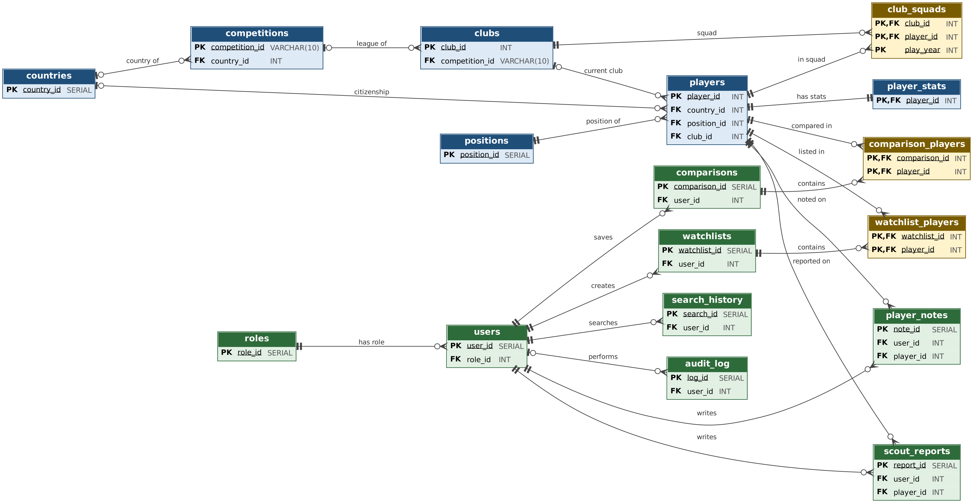
Figure 1: ScoutIQ overall ER diagram (key columns only; green: system module, blue: data module, yellow: junction tables)

3.4 Data module – detailed ER diagram
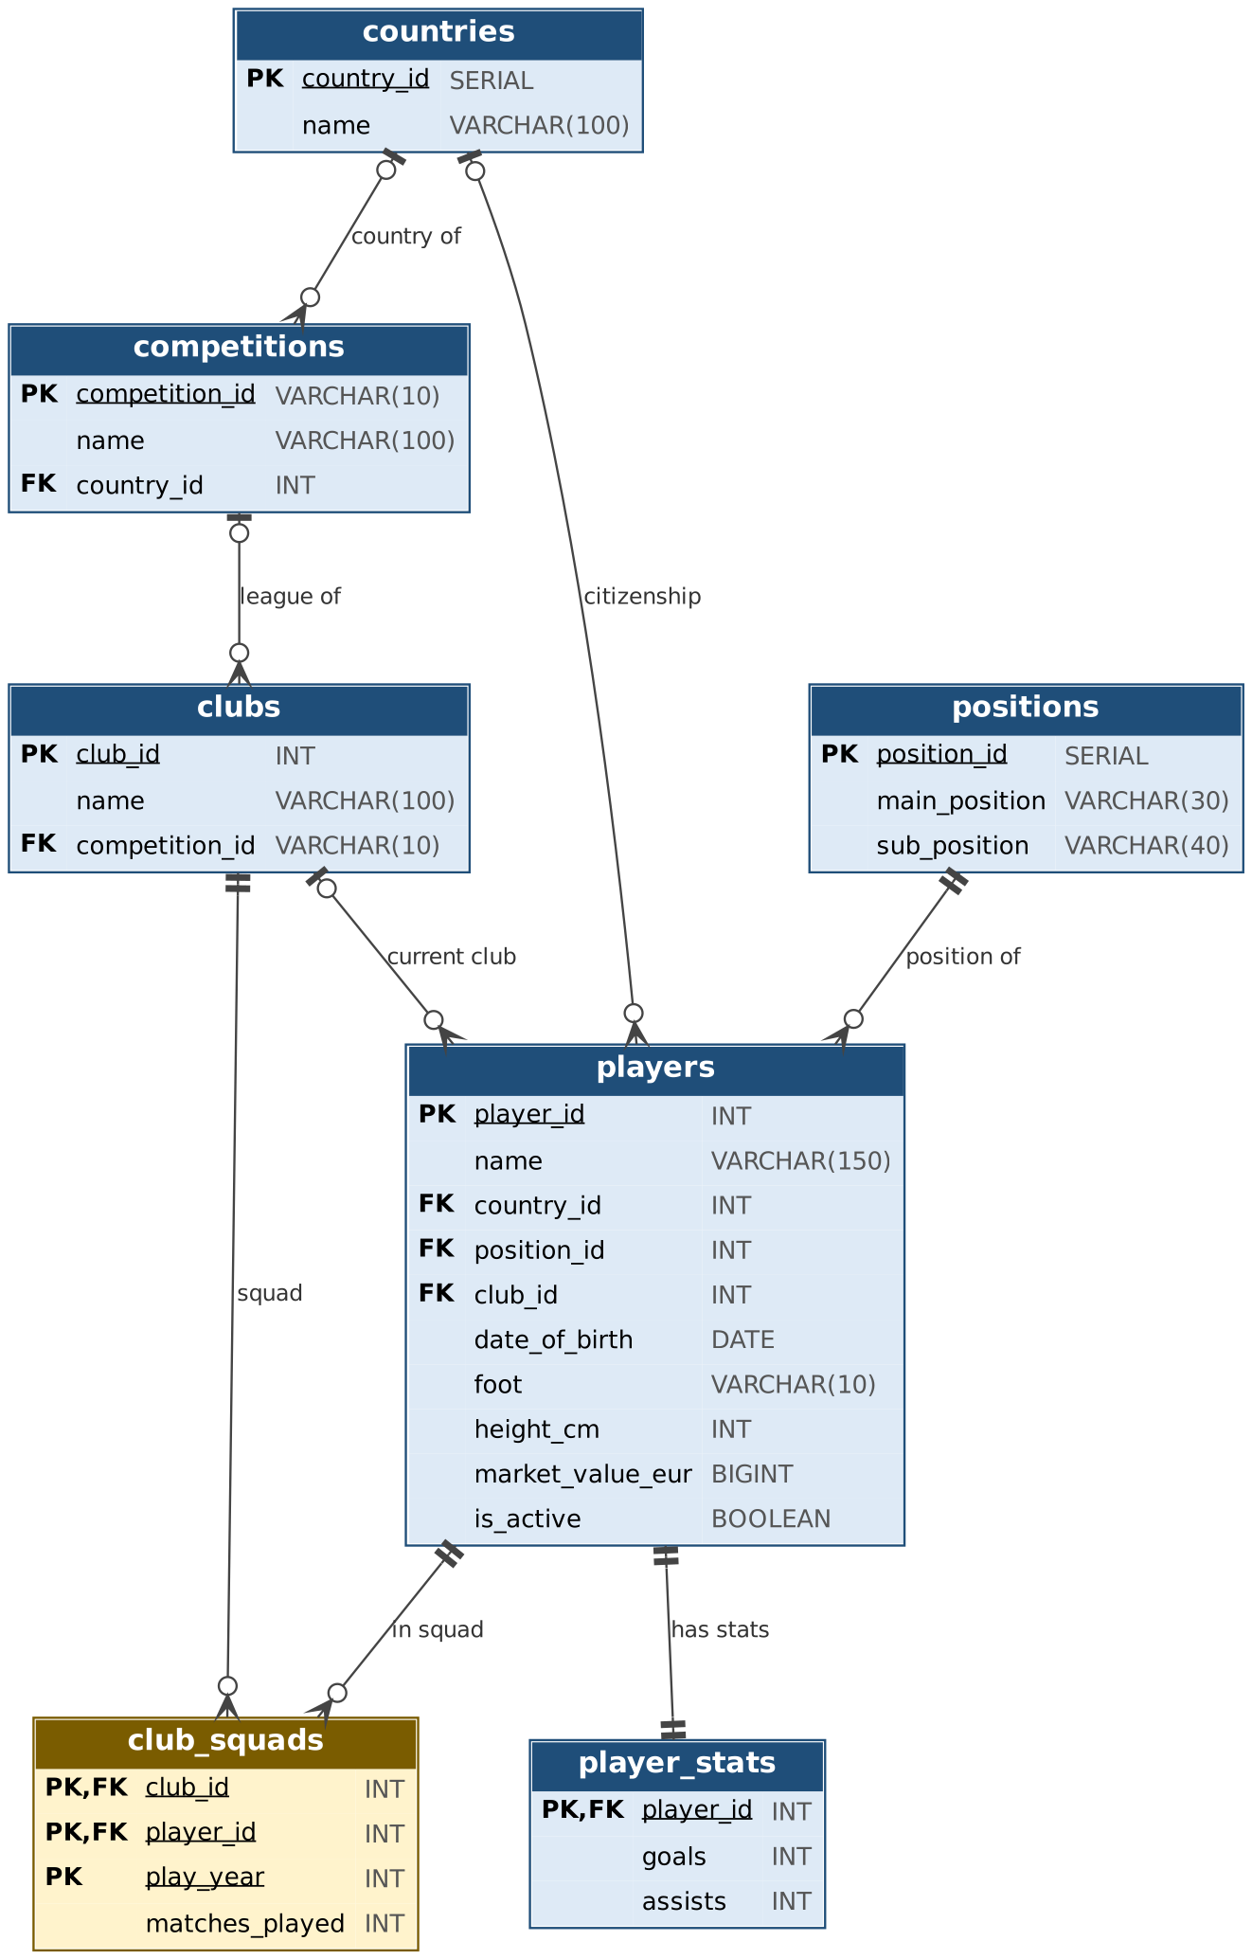
Figure 2: Data module (player, club, league, country, position, statistics, squad)

3.5 System module – detailed ER diagram
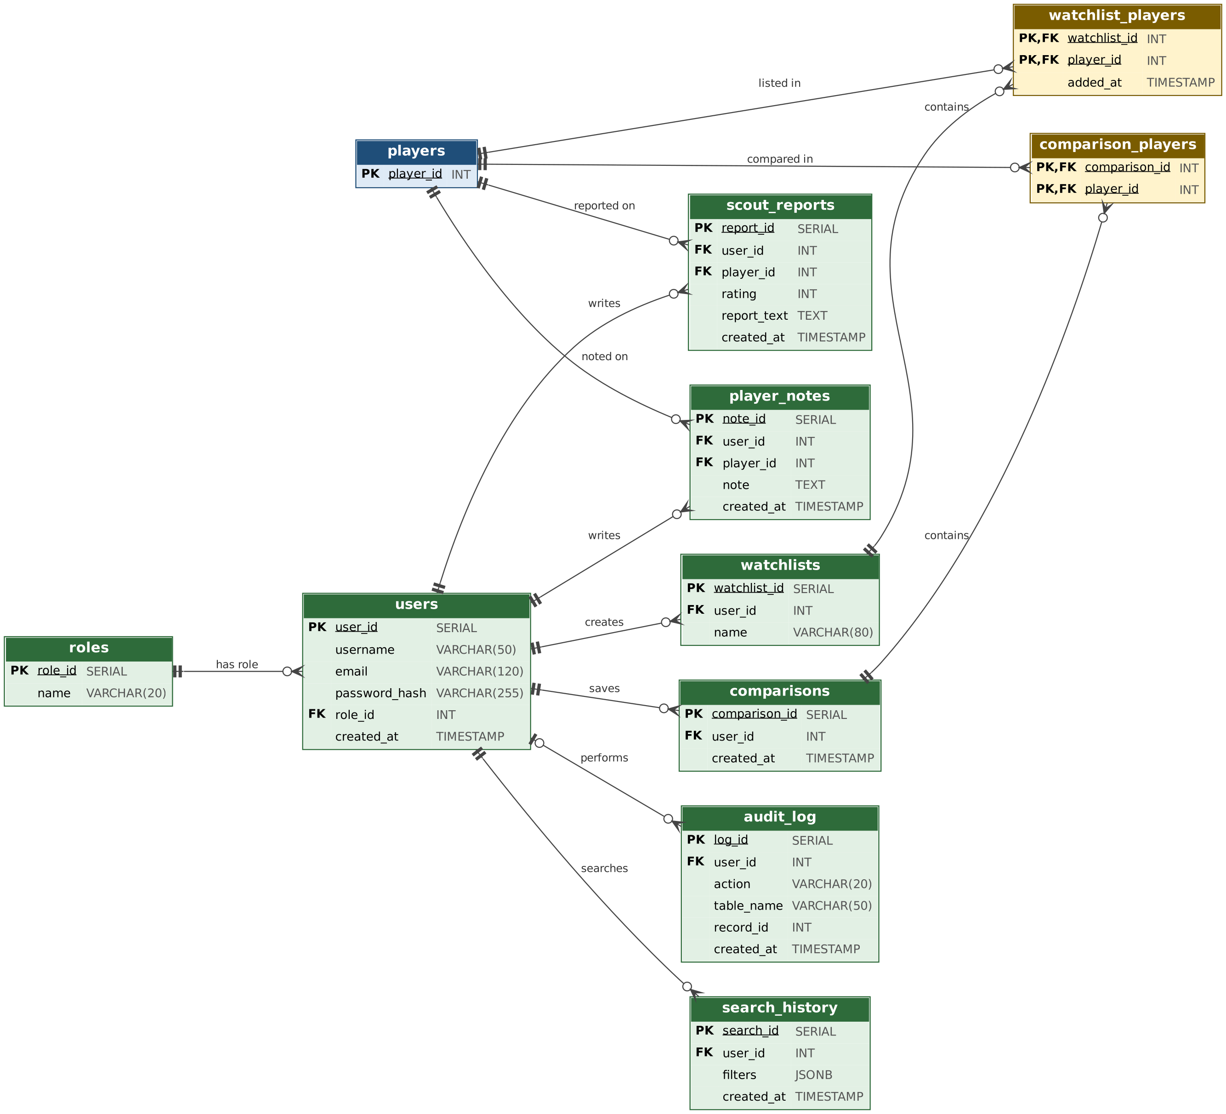
Figure 3: System module (user, role, watchlist, report, note, comparison, search history, audit log)

4. Relational Schema and Normalization

4.1 ER → relational schema mapping
The ER diagram was mapped to a relational schema with these rules: every entity becomes a table; in 1:N relationships the foreign key is added on the "many" side; N:M relationships become junction tables with composite primary keys; in the 1:1 relationship (players–player_stats) the child table's primary key is also a foreign key. In the notation below, underlined columns are primary keys and columns marked (FK) are foreign keys.

Data module
countries ( country_id, name )
positions ( position_id, main_position, sub_position )
competitions ( competition_id, name, country_id (FK) )
clubs ( club_id, name, competition_id (FK) )
players ( player_id, name, country_id (FK), position_id (FK), club_id (FK), date_of_birth, foot, height_cm, market_value_eur, is_active )
player_stats ( player_id (FK), goals, assists )
club_squads ( club_id (FK), player_id (FK), play_year, matches_played )

System module
roles ( role_id, name )
users ( user_id, username, email, password_hash, role_id (FK), created_at )
watchlists ( watchlist_id, user_id (FK), name )
watchlist_players ( watchlist_id (FK), player_id (FK), added_at )
scout_reports ( report_id, user_id (FK), player_id (FK), rating, report_text, created_at )
comparisons ( comparison_id, user_id (FK), created_at )
comparison_players ( comparison_id (FK), player_id (FK) )
search_history ( search_id, user_id (FK), filters, created_at )
player_notes ( note_id, user_id (FK), player_id (FK), note, created_at )
audit_log ( log_id, user_id (FK), action, table_name, record_id, created_at )

4.2 Normalization
- 1NF: All columns are single-valued. The only exception is search_history.filters (JSONB), which is used deliberately because it stores a variable number of filters as one unit and is never queried column by column.
- 2NF: In tables with composite keys (club_squads, watchlist_players, comparison_players) the non-key columns depend on the whole key (e.g. matches_played depends on the club_id + player_id + play_year triple).
- 3NF: Country, position, league and club information is moved into separate tables, removing transitive dependencies and repetition (a player row stores country_id, not the country name). A player's age is not stored because it can be derived from the date of birth; it is computed in the player_overview view, so stale data cannot occur.
- Deliberate separation: Total goals/assists are moved out of players into the player_stats table (1:1); raw match records are not stored because they are large, only the totals are kept.

5. Table Descriptions
Below, the purpose, columns, data types and constraints of each of the 17 tables are given. All definitions match the real DDL in sql/schema.sql.

5.1 countries
Country reference table. Used both for a player's citizenship and for the country a league belongs to; avoids storing country names repeatedly.
Column | Type | Constraint | Description
country_id | SERIAL | PK | Auto-increment identifier
name | VARCHAR(100) | UNIQUE, NOT NULL | Country name

5.2 positions
Playing positions. Stores (main position, sub-position) pairs such as Defender / Centre-Back.
Column | Type | Constraint | Description
position_id | SERIAL | PK | Auto-increment identifier
main_position | VARCHAR(30) | NOT NULL | Main position
sub_position | VARCHAR(40) | NOT NULL | Sub-position
(main_position, sub_position) | – | UNIQUE | The same pair cannot be added twice

5.3 competitions
Leagues / competitions. Clubs are linked to a league.
Column | Type | Constraint | Description
competition_id | VARCHAR(10) | PK | League code (e.g. TR1)
name | VARCHAR(100) | NOT NULL | League name
country_id | INT | FK → countries | Country of the league (nullable)

5.4 clubs
Football clubs.
Column | Type | Constraint | Description
club_id | INT | PK | Club identifier (from source data)
name | VARCHAR(100) | NOT NULL | Club name
competition_id | VARCHAR(10) | FK → competitions | League the club plays in (nullable)

5.5 players
The central table of the system: a player's identity, physical attributes and market value.
Column | Type | Constraint | Description
player_id | INT | PK | Player identifier
name | VARCHAR(150) | NOT NULL | Player name
country_id | INT | FK → countries | Country of citizenship
position_id | INT | FK → positions, NOT NULL | Player's position
club_id | INT | FK → clubs | Current (main 2024) club
date_of_birth | DATE | – | Date of birth; age is computed in a view
foot | VARCHAR(10) | – | Preferred foot
height_cm | INT | CHECK (> 0) | Height (cm)
market_value_eur | BIGINT | CHECK (>= 0) | Market value (€)
is_active | BOOLEAN | NOT NULL, DEFAULT FALSE | Played at least one match in 2024

5.6 player_stats
A player's total goals and assists. One-to-one with players; the primary key is also a foreign key.
Column | Type | Constraint | Description
player_id | INT | PK, FK → players (CASCADE) | Player identifier
goals | INT | NOT NULL, DEFAULT 0, CHECK (>= 0) | Total goals
assists | INT | NOT NULL, DEFAULT 0, CHECK (>= 0) | Total assists

5.7 club_squads
Junction table resolving the many-to-many relationship between clubs and players: how many matches a player played for a club in a given year.
Column | Type | Constraint | Description
club_id | INT | PK, FK → clubs (CASCADE) | Club
player_id | INT | PK, FK → players (CASCADE) | Player
play_year | INT | PK, NOT NULL | Season year (2024)
matches_played | INT | NOT NULL, CHECK (> 0) | Matches played that year

5.8 roles
User roles (admin, scout). The basis of authorization.
Column | Type | Constraint | Description
role_id | SERIAL | PK | Auto-increment identifier
name | VARCHAR(20) | UNIQUE, NOT NULL | Role name

5.9 users
Registered users. Passwords are stored as hashes, never as plain text.
Column | Type | Constraint | Description
user_id | SERIAL | PK | Auto-increment identifier
username | VARCHAR(50) | UNIQUE, NOT NULL | Username
email | VARCHAR(120) | UNIQUE, NOT NULL | E-mail
password_hash | VARCHAR(255) | NOT NULL | Password hash
role_id | INT | FK → roles, NOT NULL | User's role
created_at | TIMESTAMP | NOT NULL, DEFAULT now() | Registration time

5.10 watchlists
Users' watchlists (the interface currently uses a single 'Favoriler' list).
Column | Type | Constraint | Description
watchlist_id | SERIAL | PK | Auto-increment identifier
user_id | INT | FK → users (CASCADE), NOT NULL | Owner of the list
name | VARCHAR(80) | NOT NULL | List name
(user_id, name) | – | UNIQUE | A user cannot have two lists with the same name

5.11 watchlist_players
Resolves the many-to-many relationship between watchlists and players. The 'most starred players' ranking is computed from this table.
Column | Type | Constraint | Description
watchlist_id | INT | PK, FK → watchlists (CASCADE) | List
player_id | INT | PK, FK → players (CASCADE) | Player
added_at | TIMESTAMP | NOT NULL, DEFAULT now() | Time added

5.12 scout_reports
A scout's rated (1-10) report about a player.
Column | Type | Constraint | Description
report_id | SERIAL | PK | Auto-increment identifier
user_id | INT | FK → users (CASCADE), NOT NULL | Report author
player_id | INT | FK → players (CASCADE), NOT NULL | Player being reported
rating | INT | NOT NULL, CHECK (1-10) | Rating
report_text | TEXT | NOT NULL | Report text
created_at | TIMESTAMP | NOT NULL, DEFAULT now() | Time written

5.13 comparisons
Header record of the player comparisons a user has saved.
Column | Type | Constraint | Description
comparison_id | SERIAL | PK | Auto-increment identifier
user_id | INT | FK → users (CASCADE), NOT NULL | User who saved the comparison
created_at | TIMESTAMP | NOT NULL, DEFAULT now() | Time saved

5.14 comparison_players
Resolves the many-to-many relationship between comparisons and players.
Column | Type | Constraint | Description
comparison_id | INT | PK, FK → comparisons (CASCADE) | Comparison
player_id | INT | PK, FK → players (CASCADE) | Player

5.15 search_history
The filters of a user's searches (stored as JSONB).
Column | Type | Constraint | Description
search_id | SERIAL | PK | Auto-increment identifier
user_id | INT | FK → users (CASCADE), NOT NULL | User who searched
filters | JSONB | NOT NULL | Filters used (name, country, league, age...)
created_at | TIMESTAMP | NOT NULL, DEFAULT now() | Time of search

5.16 player_notes
Free-text notes (without a rating) a scout takes about a player.
Column | Type | Constraint | Description
note_id | SERIAL | PK | Auto-increment identifier
user_id | INT | FK → users (CASCADE), NOT NULL | Note author
player_id | INT | FK → players (CASCADE), NOT NULL | Related player
note | TEXT | NOT NULL | Note text
created_at | TIMESTAMP | NOT NULL, DEFAULT now() | Time written

5.17 audit_log
Audit trail of administrator operations (insert, update, delete).
Column | Type | Constraint | Description
log_id | SERIAL | PK | Auto-increment identifier
user_id | INT | FK → users (SET NULL) | User who performed the action; the record stays if the user is deleted
action | VARCHAR(20) | NOT NULL | INSERT / UPDATE / DELETE
table_name | VARCHAR(50) | NOT NULL | Affected table
record_id | INT | – | Identifier of the affected record
created_at | TIMESTAMP | NOT NULL, DEFAULT now() | Time of action

6. Description of Relationships Between Tables
The table below lists the 21 foreign-key relationships. "Card." shows the participation at the parent and child ends; "ON DELETE" states what happens to child rows when the parent row is deleted (— : default behavior, i.e. deletion is blocked while dependent rows exist).
Parent | Child | Card. | Foreign key | ON DELETE | Description
countries | competitions | 0..1 : 0..N | competitions.country_id | — | A country can host several leagues. The country of a league may be left empty if unknown.
countries | players | 0..1 : 0..N | players.country_id | — | Many players can be citizens of one country. A player's country is optional.
competitions | clubs | 0..1 : 0..N | clubs.competition_id | — | Many clubs play in one league. If the league is not in the dataset, the club's league stays empty.
clubs | players | 0..1 : 0..N | players.club_id | — | The player's current club (the club they played most matches for in 2024). A club has many players.
positions | players | 1 : 0..N | players.position_id | — | Every player must have a position; many players share one position.
players | player_stats | 1 : 1 | player_stats.player_id (PK=FK) | CASCADE | Every player has exactly one statistics record (1:1). Deleting a player also deletes their stats.
clubs | club_squads | 1 : 0..N | club_squads.club_id | CASCADE | Club side of the club ↔ player N:M relationship. A club has many squad records.
players | club_squads | 1 : 0..N | club_squads.player_id | CASCADE | Player side of the club ↔ player N:M relationship. A player can appear in squads of different clubs/years.
roles | users | 1 : 0..N | users.role_id | — | Every user has exactly one role; a role is held by many users.
users | watchlists | 1 : 0..N | watchlists.user_id | CASCADE | A user can create several watchlists; deleting the user deletes their lists.
watchlists | watchlist_players | 1 : 0..N | watchlist_players.watchlist_id | CASCADE | List side of the watchlist ↔ player N:M relationship.
players | watchlist_players | 1 : 0..N | watchlist_players.player_id | CASCADE | Player side of the watchlist ↔ player N:M relationship. A player can be on many lists (the star count is computed from here).
users | scout_reports | 1 : 0..N | scout_reports.user_id | CASCADE | A user can write many reports.
players | scout_reports | 1 : 0..N | scout_reports.player_id | CASCADE | Many reports can be written about one player.
users | comparisons | 1 : 0..N | comparisons.user_id | CASCADE | A user can save many comparisons.
comparisons | comparison_players | 1 : 0..N | comparison_players.comparison_id | CASCADE | Comparison side of the comparison ↔ player N:M relationship.
players | comparison_players | 1 : 0..N | comparison_players.player_id | CASCADE | Player side of the comparison ↔ player N:M relationship.
users | search_history | 1 : 0..N | search_history.user_id | CASCADE | Every search is stored linked to the user who made it.
users | player_notes | 1 : 0..N | player_notes.user_id | CASCADE | A user can take many notes.
players | player_notes | 1 : 0..N | player_notes.player_id | CASCADE | Many notes can be taken about one player.
users | audit_log | 0..1 : 0..N | audit_log.user_id | SET NULL | Administrator actions are linked to the user; the record is kept even if the user is deleted (user_id becomes NULL).

7. Business Rules
Wherever possible, business rules are enforced with database constraints (PK, FK, UNIQUE, CHECK, ON DELETE). Rules that cannot be expressed as a database constraint or that depend on the session are checked in the application layer; when both are used, the database constraint is the final safety net.
No | Rule | Enforced in | Mechanism
BR1 | Every player must have a position. | Database | players.position_id NOT NULL + FK
BR2 | The same (main position, sub-position) pair cannot be defined twice. | Database | UNIQUE (main_position, sub_position)
BR3 | Market value cannot be negative and height cannot be zero or negative. | Database + Application | CHECK; min=0 in the admin form and server-side validation
BR4 | Goal and assist counts cannot be negative. | Database | CHECK (goals >= 0), CHECK (assists >= 0)
BR5 | Every player has exactly one statistics record. | Database + Application | player_stats.player_id PK=FK; when a player is added both rows are inserted in one transaction
BR6 | A player has a single squad record per club per year; matches played must be positive. | Database | Composite PK (club_id, player_id, play_year), CHECK (matches_played > 0)
BR7 | Only players who played at least one match in 2024 (active players) are visible on the site. | Database (view) | player_overview view with WHERE is_active
BR8 | A club's roster = players who played for it in 2024 + active players currently registered to it. | Database (view) | club_roster view (UNION)
BR9 | Username and e-mail are unique. | Database + Application | UNIQUE; UniqueViolation is caught and a message is shown
BR10 | Every user has a single role; roles can only be admin or scout. | Database + Application | users.role_id NOT NULL FK; the role value is validated with a whitelist on change
BR11 | The first registered user becomes admin, later ones become scouts. | Application | register route (user count = 0 check)
BR12 | Username must be at least 3 and password at least 6 characters; e-mail must contain @. | Application | register validation
BR13 | An administrator cannot change their own role or delete their own account. | Application | admin_role, admin_user_delete
BR14 | A user cannot have two watchlists with the same name; a player can be added to a list only once. | Database + Application | UNIQUE (user_id, name); composite PK; ON CONFLICT DO NOTHING
BR15 | A report rating must be between 1 and 10 and the report text cannot be empty. | Database + Application | CHECK (rating BETWEEN 1 AND 10); form validation
BR16 | Reports, notes and watchlists are private; a user sees only their own records. | Application | WHERE user_id = session user in queries
BR17 | A comparison can contain at most 4 players; at least 2 are needed to save it. | Application | compare_add, compare_save
BR18 | A comparison header and its players are saved together or not at all. | Application (transaction) | compare_save: single transaction, ROLLBACK on error
BR19 | When a user is deleted, their lists, reports, notes, comparisons and search history are deleted; audit records are kept. | Database | ON DELETE CASCADE; ON DELETE SET NULL for audit_log.user_id
BR20 | When a player is deleted, their stats, squad, list, report, note and comparison records are deleted too. | Database | ON DELETE CASCADE
BR21 | Administrator actions (insert, update, delete, role change) are written to the audit log in the same transaction as the action. | Application (transaction) | audit() + transaction()
BR22 | Adding/editing/deleting players, user management and the audit log are available to admins only. | Application | @admin_required (HTTP 403 for unauthorized access)
BR23 | Every search that uses filters is saved in the user's search history. | Application | search route (search_history)

8. Indexes and Views

8.1 Indexes
To speed up search and filter queries, 9 indexes are defined in sql/indexes_views.sql:
Index | Column | Query it speeds up
idx_players_name | lower(name) | Search by name
idx_players_value | market_value_eur | Filter/sort by value
idx_players_birth | date_of_birth | Age filter
idx_players_country | country_id | Country filter and join
idx_players_pos | position_id | Position filter and join
idx_players_club | club_id | Club page and join
idx_clubs_comp | competition_id | League filter
idx_wp_player | watchlist_players(player_id) | Star count (GROUP BY)
idx_squads_player | club_squads(player_id) | A player's squad records

8.2 Views
Four views collect repeated complex joins in one place and simplify the application queries.
View | Description
player_overview | Player + country + position + club + league + goals/assists (6-table join). Age is computed here. Returns only active players. Search, player detail, watchlist and comparison all read from this view.
top_starred_players | Players found on the most watchlists. Uses a subquery + GROUP BY + RANK() OVER (window function).
club_roster | Club roster: UNION of "players who played for the club in 2024" and "active players currently registered to the club".
club_overview | Club summary: player count, total market value, average age (COUNT, SUM, AVG + GROUP BY).

Example – `player_overview` view definition:
CREATE OR REPLACE VIEW player_overview AS
SELECT p.player_id, p.name,
EXTRACT(YEAR FROM age(p.date_of_birth))::int AS age,
c.name AS country,
pos.main_position, pos.sub_position,
cl.name AS club,
comp.name AS league,
p.market_value_eur,
s.goals, s.assists,
p.club_id
FROM players p
LEFT JOIN countries c ON c.country_id = p.country_id
JOIN positions pos ON pos.position_id = p.position_id
LEFT JOIN clubs cl ON cl.club_id = p.club_id
LEFT JOIN competitions comp ON comp.competition_id = cl.competition_id
LEFT JOIN player_stats s ON s.player_id = p.player_id
WHERE p.is_active;

Example – `top_starred_players` view definition:
CREATE OR REPLACE VIEW top_starred_players AS
SELECT po.*,
s.star_count,
RANK() OVER (ORDER BY s.star_count DESC) AS rank
FROM (SELECT player_id, count(*) AS star_count
FROM watchlist_players
GROUP BY player_id) s
JOIN player_overview po ON po.player_id = s.player_id;

9. Transaction Management
Operations whose SQL statements must succeed together run inside a single transaction (ACID – atomicity). The transaction() helper in the application executes the statements in order; if any of them fails it performs a ROLLBACK, otherwise it COMMITs.
Operation | Statements in the transaction | Purpose
Add player (admin_player_add) | INSERT players → INSERT player_stats → INSERT audit_log | Player, stats row and audit record are created together (BR5, BR21)
Edit player (admin_player_edit) | UPDATE players → INSERT audit_log | Update and audit record stay consistent
Update value (admin_player_value) | UPDATE players → INSERT audit_log | Same
Delete player (admin_player_delete) | INSERT audit_log → DELETE players (dependent rows deleted via CASCADE) | A trace remains for the deleted record
Change role (admin_role) | UPDATE users → INSERT audit_log | Permission changes are always on record
Delete user (admin_user_delete) | INSERT audit_log → DELETE users | Deletion trace is kept (user_id SET NULL)
Save comparison (compare_save) | INSERT comparisons → N × INSERT comparison_players | Header and player rows are saved together or not at all (BR18)

Example (`app.py`):
def transaction(stmts):
conn = get_db()
try:
cur = conn.cursor()
for sql, params in stmts:
cur.execute(sql, params)
conn.commit()
except Exception:
conn.rollback()
raise
finally:
conn.close()

10. Software Design

10.1 Class diagrams
The application is written with Flask's function-based routing, so the class diagrams show the database entities as a domain model, and each class's operations correspond to real route functions in the application. For readability the diagram is split into two parts: Figure 4 shows the data module and Figure 5 the system module. User is an abstract class; Admin and Scout are not separate tables but roles determined by users.role_id. Class colors match the modules in the ER diagrams.
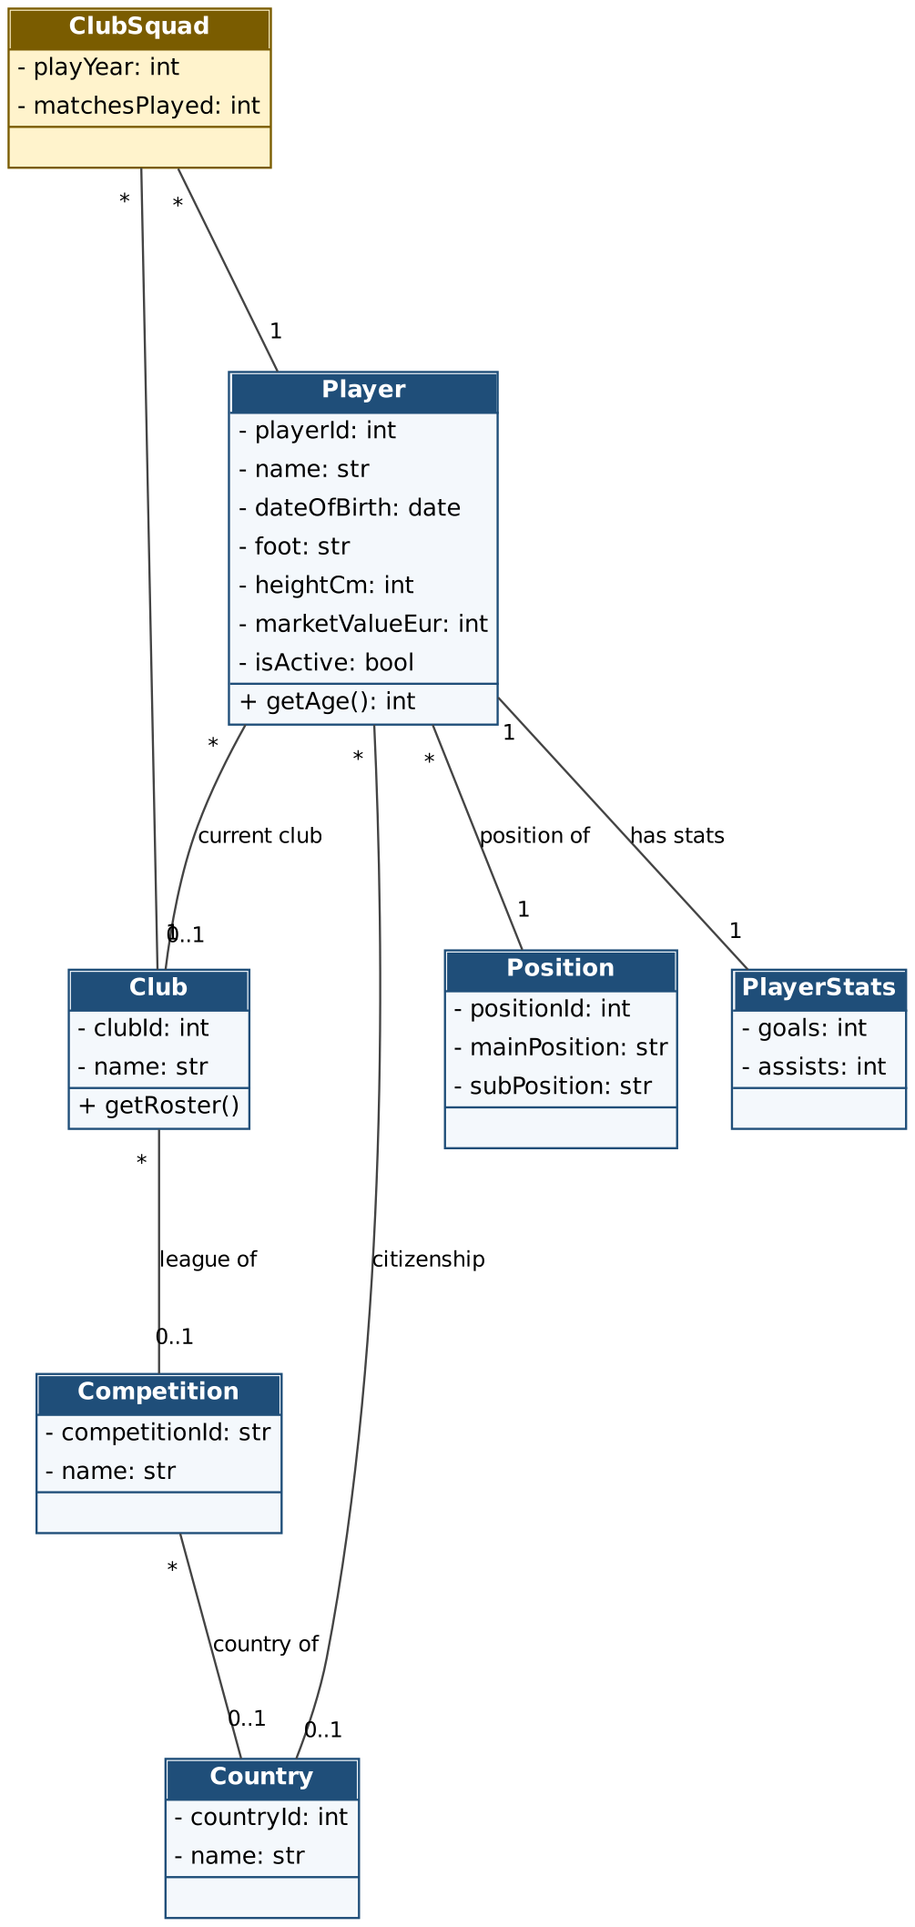
Figure 4: Class diagram – data module

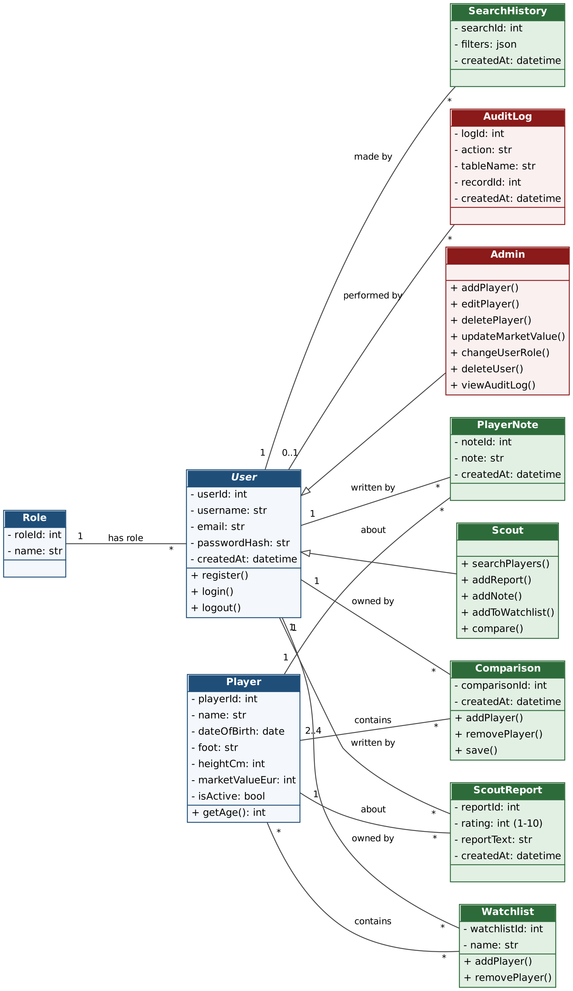
Figure 5: Class diagram – system module (role hierarchy and user interactions)

10.2 Application architecture
The application has four layers: browser → Jinja2 templates → Flask routes (with authorization) → helper functions (query, execute, transaction) → PostgreSQL via db.py. All SQL is parameterized (%s), which protects against SQL injection. Sort columns are taken from a fixed whitelist (SORTS), not from user input.
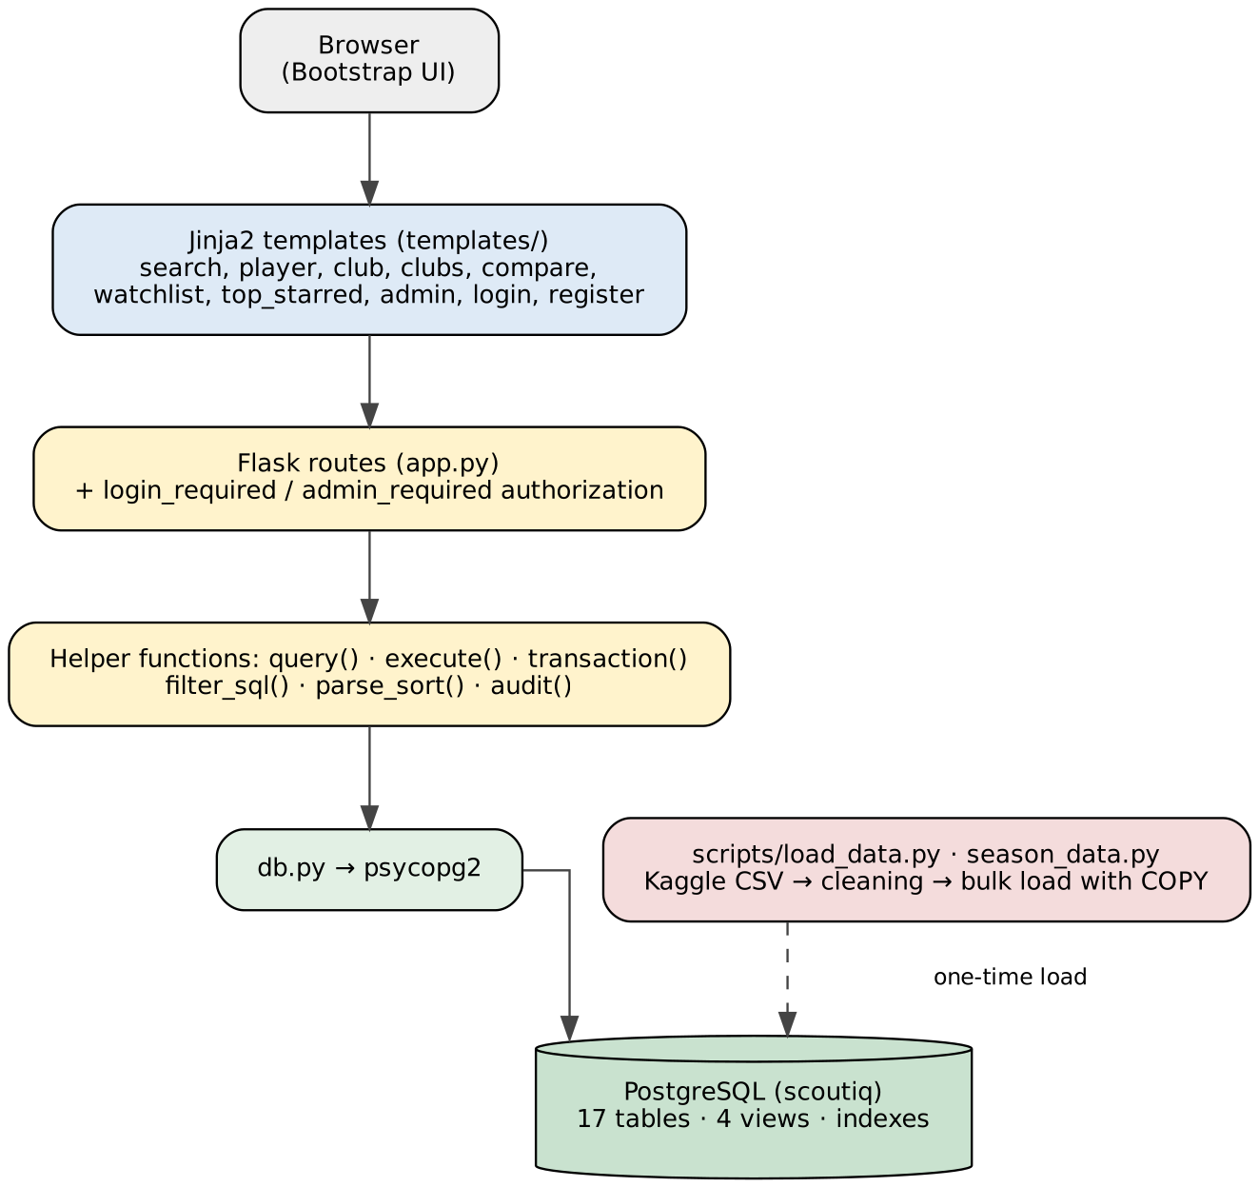
Figure 6: Application architecture

10.3 Routes and functions
Address | Access | Function
/register, /login, /logout | Everyone | Register, log in, log out
/search | Logged in | Multi-criteria player search, sorting, pagination
/player/<id> | Logged in | Player detail, own reports and notes
/report/<id>, /note/<id> (POST) | Logged in | Add report and note
/watchlist, /watchlist/add|remove/<id> | Logged in | Watchlist
/top-starred | Logged in | Most starred players
/clubs, /club/<id> | Logged in | Club list and club squad/filter page
/compare, /compare/add|remove|save | Logged in | Comparison and saving
/admin | Admin | Admin panel, user list, audit log
/admin/player/add|edit|value|delete | Admin | Add, edit, update value of, delete players
/admin/role/<id>, /admin/user/delete/<id> | Admin | Change role, delete user

10.4 Role – permission matrix
Function | Visitor | Scout | Admin
Register / log in | ✓ | ✓ | ✓
Search and view players and clubs | — | ✓ | ✓
Watchlist, starring | — | ✓ | ✓
Write reports and notes | — | ✓ | ✓
Compare and save comparisons | — | ✓ | ✓
Add / edit / delete players | — | — | ✓
Update market value | — | — | ✓
Change user roles / delete users | — | — | ✓
View the audit log | — | — | ✓

Authorization is done with the login_required and admin_required decorators. A user who is not logged in is redirected to the login page; a non-admin user receives HTTP 403 on admin addresses. The user's role is read from the roles table at login and stored in the session; the "Admin" link in the menu is shown to admins only.

10.5 Security measures
- Passwords are not stored as plain text; they are hashed with Werkzeug.
- All queries are parameterized; the sort field is validated against a whitelist.
- The cookie is set to SameSite=Lax; redirect targets are restricted to in-site addresses by safe_next.
- Secrets (DB_PASSWORD, SECRET_KEY) are not written in code; they are read from environment variables.

11. Data Preparation and Loading
The scripts/load_data.py script cleans the raw Kaggle data and loads it into the schema:
- Countries: league countries and player citizenships are merged and de-duplicated to produce the countries table.
- Positions: (main position, sub-position) pairs are de-duplicated; missing values are filled with "Unknown".
- Clubs and leagues: if a club's league is not found in competitions it is set to NULL (referential integrity is preserved).
- Players: rows without a name are dropped; date of birth, height and market value are converted to proper types; invalid club references are set to NULL.
- 2024 season (`season_data.py`): from appearances.csv, the players who played in 2024 (is_active), the club squads (club_squads) and the club each player played most matches for are computed.
- Statistics: each player's all-time total goals and assists are written to the player_stats table.
- Loading: the schema is executed, data is bulk-loaded with PostgreSQL COPY, the SERIAL sequences are set with setval, and indexes and views are created.

12. Installation and Running
- Create an empty PostgreSQL database named scoutiq.
- Put players.csv, clubs.csv, competitions.csv and appearances.csv from Kaggle into the data/ folder.
- Install the dependencies with pip install -r requirements.txt (flask, psycopg2-binary, pandas).
- Define the database password as an environment variable (PowerShell: $env:DB_PASSWORD="password").
- Run python scripts/load_data.py to create the 17 tables and load the data (existing data is deleted).
- Start the application with python app.py and open http://127.0.0.1:5000.
- The first registered user becomes admin; later registrations are created with the scout role.
Optional environment variables: DB_NAME, DB_USER, DB_HOST, DB_PORT, SECRET_KEY.

12.1 Project folder structure
scoutiq/
├── app.py Flask application (routes, authorization)
├── db.py Database connection
├── sql/schema.sql Tables and constraints (17 tables)
├── sql/indexes_views.sql Indexes and views
├── scripts/load_data.py Data cleaning and loading
├── scripts/season_data.py 2024 season calculations
├── templates/ Jinja2 templates
├── static/ CSS
└── docs/ Documentation

13. Conclusion and Future Work
ScoutIQ is a web application on a 17-table relational schema that uses real football data, with role-based authorization and transaction support. The schema protects business rules at the database level with primary/foreign key, UNIQUE, CHECK and CASCADE constraints; views and indexes improve query performance and simplicity.
Possible future improvements:
- Keeping the audit log (audit_log) with database triggers instead of in the application, and enforcing the comparison size rule (2–4 players) in the database as well.
- Detailed interface pages for search history and saved comparisons; support for multiple watchlists.
- Allowing users to edit and delete their own reports and notes.
- CSRF token protection and automated tests.

