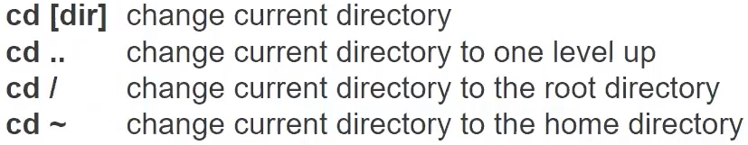











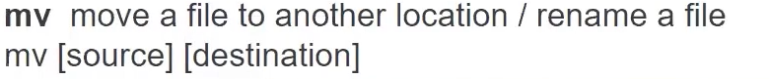



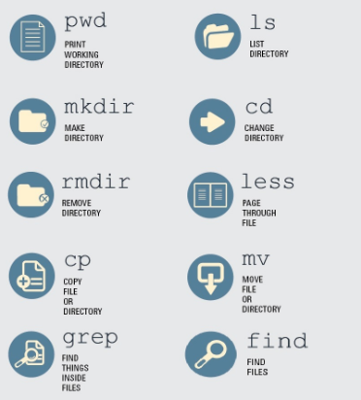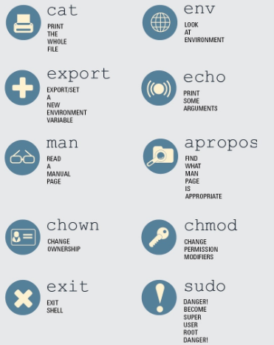



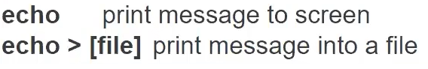

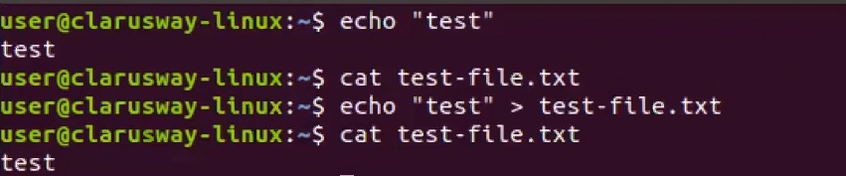

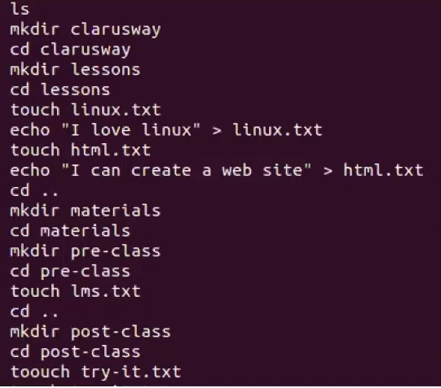

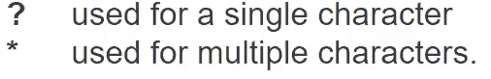

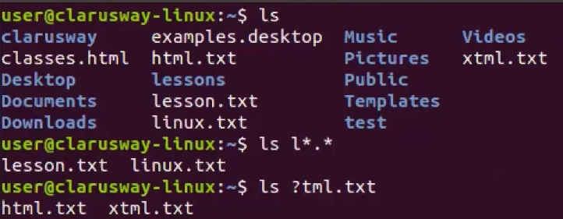

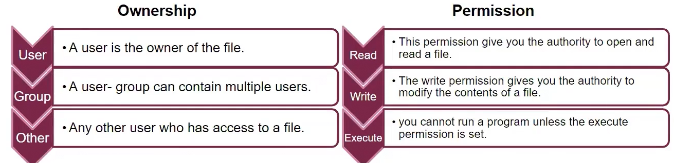

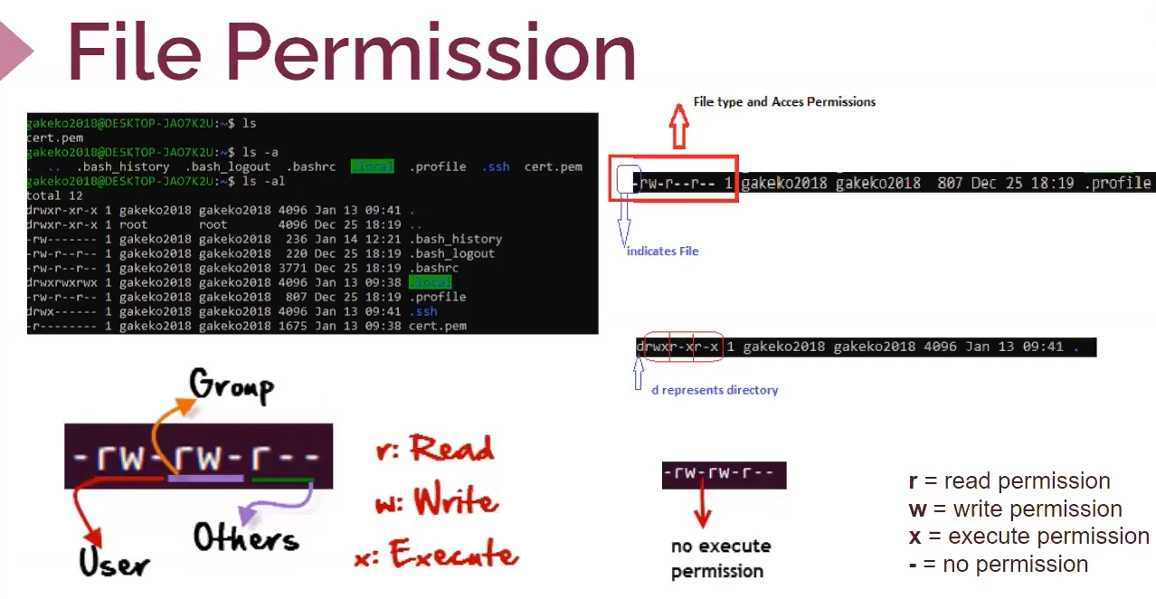

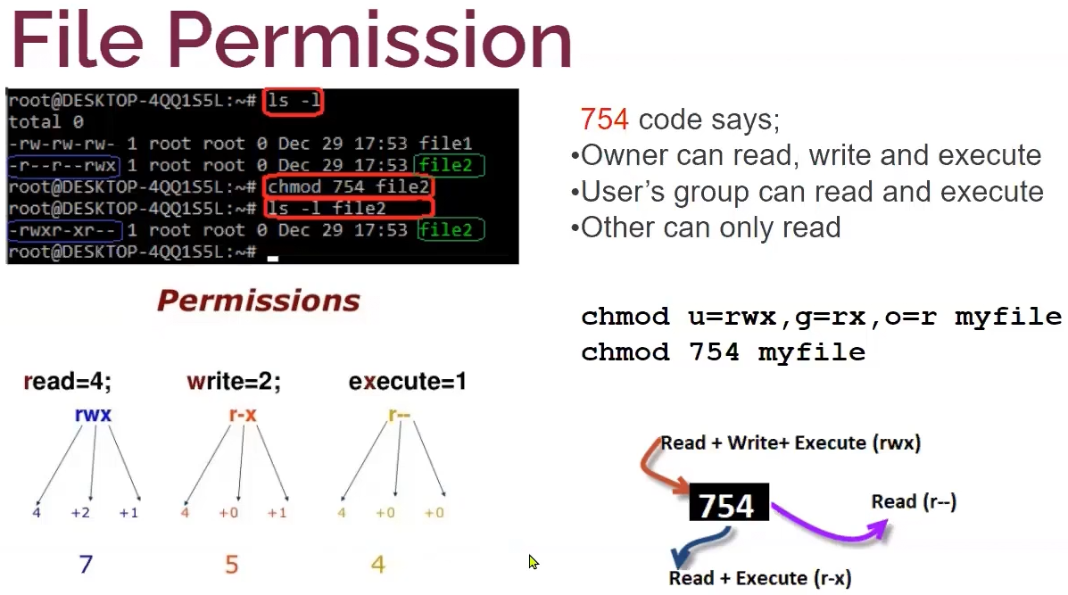

**Help Commends:**

**whatis** …(commend)

**man** …(commend) 🡪 update for man files 🡪 **sudo mandb**

**apropos** …(commend)

…(commend) **–help**

**head** …(file) 🡪 output the first ten lines of a file

**head -n**(1,2,3..) …(file) 🡪 output the n lines of a file

**tail** …(file) 🡪 output last ten lines of a file

**cat >** …(new file) 🡪 You can create a new file and write the new file content created.



**Ctrl d 🡪** You can exit the created file using this command.



