Machine Learning Midterm Project
Classification and K-Means Clustering on the Breast Cancer Wisconsin and Wine Classification Datasets
Student: Mehmethan Ural
Student ID: [STUDENT ID]
Submission date: 11 November 2026
GitHub repository: [GITHUB REPOSITORY URL]
Video walkthrough: [VIDEO LINK]

Introduction
This report summarises the work in the two executed notebooks, breast_cancer.ipynb and wine.ipynb. Both datasets were processed separately with the same numbered steps. All classifier and clustering experiments use three training/validation repetitions (seeds 42, 52 and 62) and one fixed test set per dataset. In total, 132 classifier fits and 12 K-Means fits (144 model fits) were run. Raw run tables are kept in the notebooks and in the CSV files classifier_runs.csv and kmeans_runs.csv; long descriptive tables are in the Appendix.

1. Loading the Datasets
Both datasets were loaded with scikit-learn (load_breast_cancer and load_wine). The features were stored in a pandas DataFrame with the original feature names, and the target was kept separately. The original class labels were kept.
Dataset | Samples | Features | Class labels and counts
Breast Cancer Wisconsin | 569 | 30 | 0 = malignant (212), 1 = benign (357)
Wine Classification | 178 | 13 | 0 = class_0 (59), 1 = class_1 (71), 2 = class_2 (48)

In Breast Cancer, class 0 (malignant) is used as the positive class when discussing errors. The Breast Cancer classes are moderately imbalanced (about 63% benign), while the Wine classes are fairly balanced.

2. Dataset Quality Checks
Missing values and duplicates: neither dataset contains missing values in any column, and neither contains duplicate rows. Therefore no imputation and no de-duplication was needed.
Data types: all 30 Breast Cancer features and all 13 Wine features are float64 numerical features; there are no categorical features and no data-type concerns.
Potential outliers (IQR rule): in Breast Cancer, area error has the most potential outliers (65), followed by radius error and perimeter error (38 each). Wine has only a few potential outliers (at most 4 per feature). The values were not deleted or clipped, because they are plausible measurements. Extreme values can still affect distance-based methods (KNN and K-Means), the mean and standard deviation used by StandardScaler, and the variance estimates of Gaussian Naive Bayes; Decision Trees are relatively robust to them.

3. Exploratory Data Analysis (EDA)
Descriptive statistics (mean, median, minimum, maximum, standard deviation, Q1 and Q3) for every feature are given in Appendix A. These full-dataset summaries were used for description only, not for feature selection, preprocessing or sample removal.

3.1 Breast Cancer Wisconsin
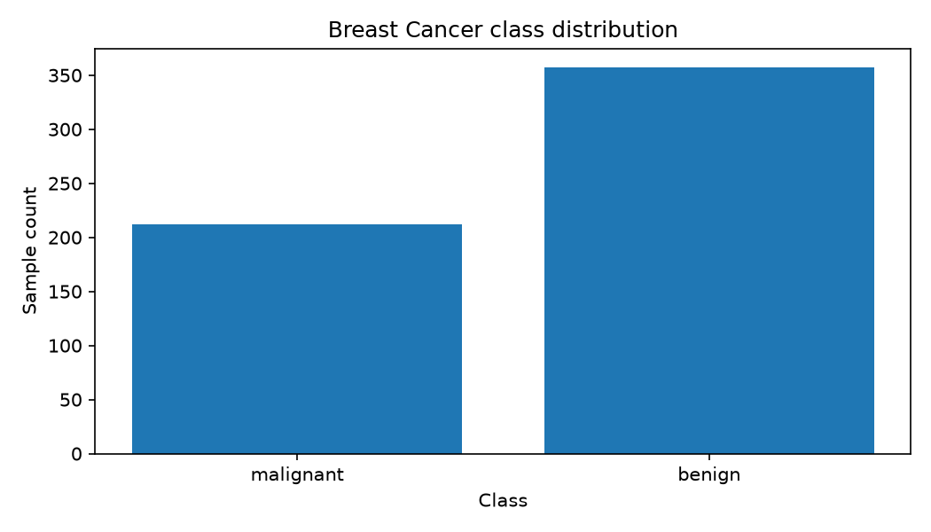
Figure 1. Breast Cancer class distribution.
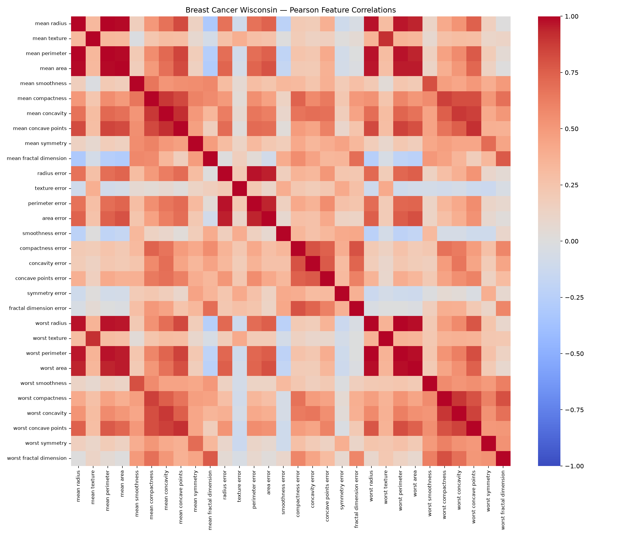
Figure 2. Breast Cancer Pearson feature-correlation heatmap.
The three strongest unique feature pairs are mean radius – mean perimeter (r = 0.998), worst radius – worst perimeter (r = 0.994) and mean radius – mean area (r = 0.987). All three are size measurements of the same nuclei, so the correlations are expected geometrically and show strong redundancy between features.
The boxplots (Appendix B, Figures B1–B5) show two important points: the feature ranges are very different (for example mean area reaches about 2,500 while smoothness and fractal-dimension features stay below about 0.4), and the standard-error features are strongly right-skewed with many large values. Without scaling, the area features would dominate Euclidean distances.

3.2 Wine Classification
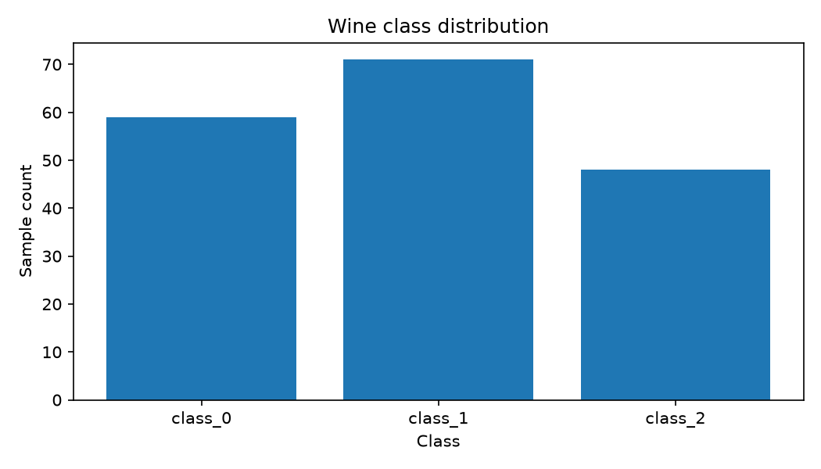
Figure 3. Wine class distribution.
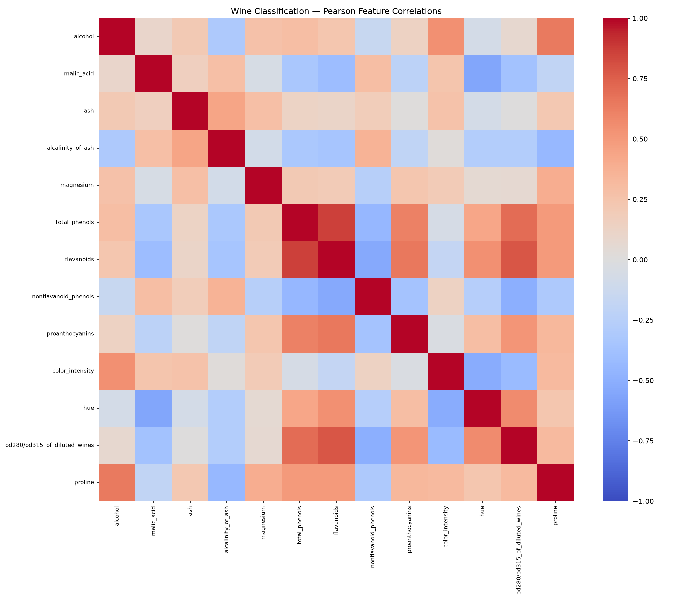
Figure 4. Wine Pearson feature-correlation heatmap.
The three strongest unique pairs are total_phenols – flavanoids (r = 0.865), flavanoids – od280/od315_of_diluted_wines (r = 0.787) and total_phenols – od280/od315_of_diluted_wines (r = 0.700). Flavanoids are a type of phenol, so the first pair is chemically expected. The correlations are weaker than in Breast Cancer.
The boxplots (Appendix B, Figures B6–B8) show very different ranges: proline lies between 278 and 1,680 and magnesium between 70 and 162, while hue lies between 0.48 and 1.71. Only a few points fall beyond the whiskers. proline would dominate unscaled distances.

4. Splitting the Datasets
For each dataset, a 20% test set was reserved once with train_test_split(test_size=0.20, stratify=y, random_state=42). For each seed in [42, 52, 62], the remaining 80% was split into training and validation with test_size=0.125, stratification and random_state=seed. Original row indices were preserved.
Dataset | Train | Validation | Test
Breast Cancer (569) | 398 (69.95%) | 57 (10.02%) | 114 (20.04%)
Wine (178) | 124 (69.66%) | 18 (10.11%) | 36 (20.22%)

The same counts apply to all three seeds; only the membership of the training and validation subsets changes. For every seed it was verified that the subsets do not overlap, that their sizes add up to the full dataset, and that the test indices are identical across seeds. The nine-row split summaries and the row indices are in the notebooks (Section 4.2) and in result/<dataset>_split_indices.csv. Seed 42 was reserved in advance as the run used for the final test evaluation.

5. Data Preprocessing and Scaling
No missing values exist, so no imputer was used. StandardScaler was chosen in advance for both datasets and all seeds. A new scaler was fitted for each dataset and seed (six scalers in total), always on that seed's training features only. Each scaler transformed the training and validation subsets of its own seed, and the fixed test set was transformed only with the seed-42 scaler. After scaling, seed-42 training features have mean 0 and standard deviation 1. For example, a Breast Cancer training row with mean area = 981.6 becomes 0.933 (about one standard deviation above the training mean). The before/after tables for seed 42 are shown in Section 5.3 of each notebook.

6. Preparing the Two Data Representations
For each dataset and seed, two representations were prepared with exactly the same samples and features: unscaled (original values) and scaled (StandardScaler). Every classifier and K-Means setting was trained on both, so differences between them can be attributed to scaling.

7. Training the Classification Models
Decision Tree (max_depth = 2, 3, 5, 10, None; random_state=seed), KNN (n_neighbors = 1, 3, 5, 7, 11; uniform weights; Euclidean distance) and Gaussian Naive Bayes (defaults) were trained with loops: 11 settings × 2 representations × 3 seeds = 66 runs per dataset and 132 in total. Each run has an ID such as wine_knn_scaled_k5_s42. Training accuracy, training macro-F1 and the five validation metrics were recorded for every run. The seed-42 fitted models were kept for the final evaluation. Environment: Python 3.11.16, scikit-learn 1.9.1, pandas 3.0.6, numpy 2.4.6, matplotlib 3.11.2, seaborn 0.13.2.

8. Measuring Validation Performance
Validation metrics are accuracy, macro precision, macro recall, macro-F1 (zero_division=0) and ROC-AUC. For Breast Cancer, ROC-AUC uses a binary target that is 1 for malignant (original class 0) together with the predicted probability of class 0. For Wine, ROC-AUC uses the probability matrix with multi_class="ovr" and average="macro". No class had undefined precision or recall in any run. The tables below show the 22-row summaries: mean over the three seeds and sample standard deviation (ddof = 1). "Gap" is mean training macro-F1 minus mean validation macro-F1; the selected configuration is marked with *.

8.1 Breast Cancer Wisconsin — 22-row summary
Configuration | Train F1 | Val acc. | Val macro-F1 (mean ± std) | Val AUC | Gap
Decision Tree, unscaled, depth=2 | 0.9527 | 0.9181 | 0.9117 ± 0.0236 | 0.9220 | 0.0410
Decision Tree, unscaled, depth=3 | 0.9739 | 0.9240 | 0.9177 ± 0.0304 | 0.9414 | 0.0562
Decision Tree, unscaled, depth=5 | 0.9946 | 0.9240 | 0.9188 ± 0.0227 | 0.9301 | 0.0758
Decision Tree, unscaled, depth=10 | 1.0000 | 0.9240 | 0.9195 ± 0.0112 | 0.9266 | 0.0805
Decision Tree, unscaled, depth=None | 1.0000 | 0.9240 | 0.9195 ± 0.0112 | 0.9266 | 0.0805
KNN, unscaled, k=1 | 1.0000 | 0.8889 | 0.8786 ± 0.0566 | 0.8757 | 0.1214
KNN, unscaled, k=3 | 0.9558 | 0.9006 | 0.8910 ± 0.0449 | 0.9299 | 0.0648
KNN, unscaled, k=5 | 0.9469 | 0.9181 | 0.9107 ± 0.0297 | 0.9480 | 0.0362
KNN, unscaled, k=7 | 0.9442 | 0.9123 | 0.9040 ± 0.0013 | 0.9581 | 0.0401
KNN, unscaled, k=11 | 0.9404 | 0.9240 | 0.9155 ± 0.0113 | 0.9605 | 0.0249
Gaussian NB, unscaled, default | 0.9323 | 0.9415 | 0.9369 ± 0.0226 | 0.9797 | -0.0046
Decision Tree, scaled, depth=2 | 0.9527 | 0.9181 | 0.9117 ± 0.0236 | 0.9220 | 0.0410
Decision Tree, scaled, depth=3 | 0.9739 | 0.9240 | 0.9177 ± 0.0304 | 0.9414 | 0.0562
Decision Tree, scaled, depth=5 | 0.9946 | 0.9240 | 0.9188 ± 0.0227 | 0.9301 | 0.0758
Decision Tree, scaled, depth=10 | 1.0000 | 0.9240 | 0.9195 ± 0.0112 | 0.9266 | 0.0805
Decision Tree, scaled, depth=None | 1.0000 | 0.9240 | 0.9195 ± 0.0112 | 0.9266 | 0.0805
KNN, scaled, k=1 | 1.0000 | 0.9415 | 0.9369 ± 0.0213 | 0.9339 | 0.0631
KNN, scaled, k=3 | 0.9793 | 0.9591 | 0.9547 ± 0.0228 | 0.9793 | 0.0246
KNN, scaled, k=5 | 0.9721 | 0.9591 | 0.9547 ± 0.0228 | 0.9795 | 0.0174
KNN, scaled, k=7 * | 0.9702 | 0.9708 | 0.9677 ± 0.0297 | 0.9782 | 0.0026
KNN, scaled, k=11 | 0.9694 | 0.9649 | 0.9608 ± 0.0395 | 0.9945 | 0.0085
Gaussian NB, scaled, default | 0.9307 | 0.9298 | 0.9248 ± 0.0201 | 0.9760 | 0.0059

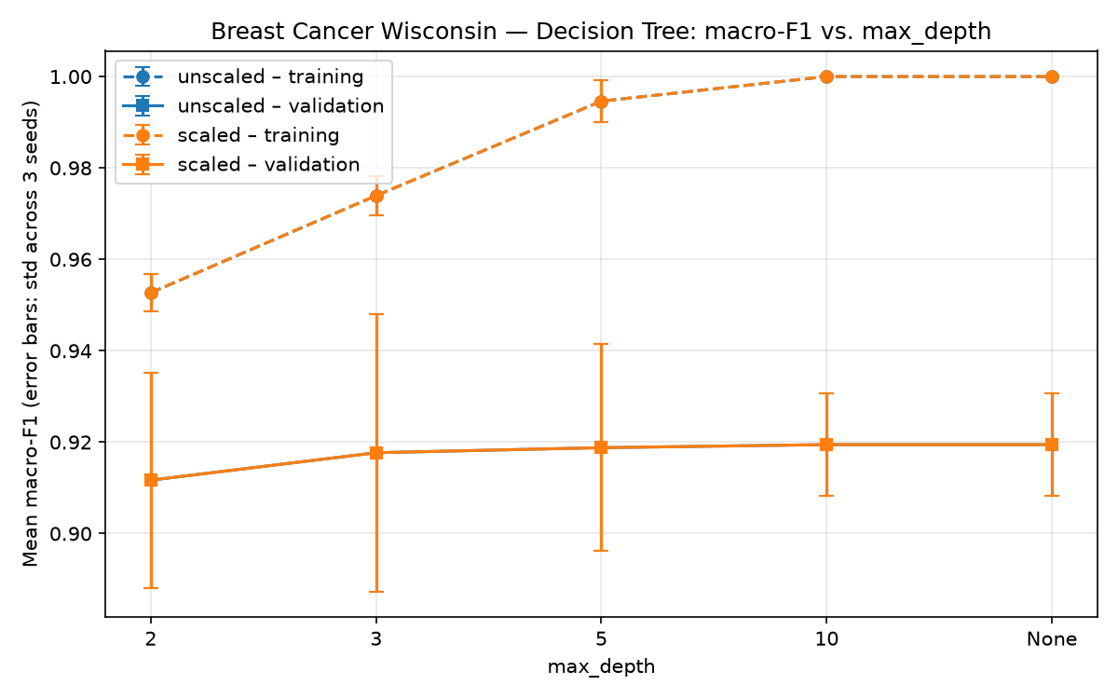
Figure 5. Breast Cancer — Decision Tree macro-F1 vs. max_depth (error bars: std across seeds).
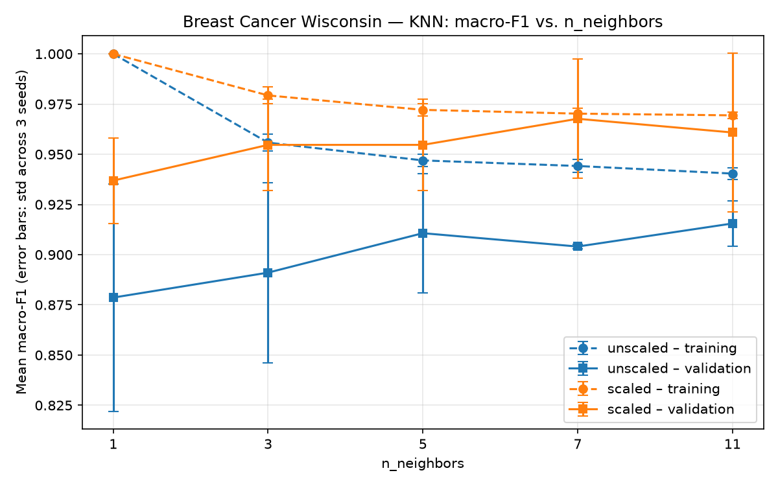
Figure 6. Breast Cancer — KNN macro-F1 vs. n_neighbors (error bars: std across seeds).
Selected configuration: KNN, scaled, k = 7 (breast_cancer_knn_scaled_k7), with the highest mean validation macro-F1 (0.9677 ± 0.0297).
- Scaling: KNN improves strongly with scaling (for example k = 7: 0.9040 → 0.9677). Decision Tree results are identical for both representations because scaling does not change the order of the values. Gaussian NB changes only slightly (0.9369 → 0.9248).
- Tree depth: training macro-F1 rises to 1.0 at depth 10/None, but validation macro-F1 only rises from 0.9117 to 0.9195, so the train–validation gap grows from 0.041 to 0.081 (overfitting).
- Neighbour count: k = 1 has perfect training F1 and the largest gap. On scaled data, validation F1 peaks at k = 7 and decreases slightly at k = 11.
- Seed variability: standard deviations reach about 0.057. With 57 validation samples, one extra error changes accuracy by 1.8 percentage points. The standard deviation describes only these three repeated splits and is not a confidence interval.

8.2 Wine Classification — 22-row summary
Configuration | Train F1 | Val acc. | Val macro-F1 (mean ± std) | Val AUC | Gap
Decision Tree, unscaled, depth=2 | 0.9365 | 0.8519 | 0.8481 ± 0.0365 | 0.9050 | 0.0883
Decision Tree, unscaled, depth=3 | 0.9926 | 0.9444 | 0.9462 ± 0.0545 | 0.9611 | 0.0464
Decision Tree, unscaled, depth=5 | 1.0000 | 0.9444 | 0.9462 ± 0.0545 | 0.9552 | 0.0538
Decision Tree, unscaled, depth=10 | 1.0000 | 0.9444 | 0.9462 ± 0.0545 | 0.9552 | 0.0538
Decision Tree, unscaled, depth=None | 1.0000 | 0.9444 | 0.9462 ± 0.0545 | 0.9552 | 0.0538
KNN, unscaled, k=1 | 1.0000 | 0.7037 | 0.6714 ± 0.0226 | 0.7654 | 0.3286
KNN, unscaled, k=3 | 0.8294 | 0.6667 | 0.6456 ± 0.0429 | 0.8333 | 0.1838
KNN, unscaled, k=5 | 0.7739 | 0.7037 | 0.6667 ± 0.0399 | 0.8645 | 0.1072
KNN, unscaled, k=7 | 0.7804 | 0.6667 | 0.6356 ± 0.0316 | 0.8459 | 0.1448
KNN, unscaled, k=11 | 0.7309 | 0.6296 | 0.6005 ± 0.0010 | 0.8216 | 0.1304
Gaussian NB, unscaled, default | 0.9840 | 0.9630 | 0.9638 ± 0.0314 | 1.0000 | 0.0201
Decision Tree, scaled, depth=2 | 0.9365 | 0.8519 | 0.8481 ± 0.0365 | 0.9050 | 0.0883
Decision Tree, scaled, depth=3 | 0.9926 | 0.9444 | 0.9462 ± 0.0545 | 0.9611 | 0.0464
Decision Tree, scaled, depth=5 | 1.0000 | 0.9444 | 0.9462 ± 0.0545 | 0.9552 | 0.0538
Decision Tree, scaled, depth=10 | 1.0000 | 0.9444 | 0.9462 ± 0.0545 | 0.9552 | 0.0538
Decision Tree, scaled, depth=None | 1.0000 | 0.9444 | 0.9462 ± 0.0545 | 0.9552 | 0.0538
KNN, scaled, k=1 | 1.0000 | 0.9630 | 0.9658 ± 0.0296 | 0.9749 | 0.0342
KNN, scaled, k=3 | 0.9687 | 0.9444 | 0.9457 ± 0.0558 | 1.0000 | 0.0230
KNN, scaled, k=5 | 0.9762 | 0.9815 | 0.9814 ± 0.0323 | 1.0000 | -0.0052
KNN, scaled, k=7 | 0.9603 | 0.9815 | 0.9814 ± 0.0323 | 1.0000 | -0.0211
KNN, scaled, k=11 * | 0.9656 | 0.9815 | 0.9814 ± 0.0323 | 1.0000 | -0.0158
Gaussian NB, scaled, default | 0.9840 | 0.9630 | 0.9638 ± 0.0314 | 1.0000 | 0.0201

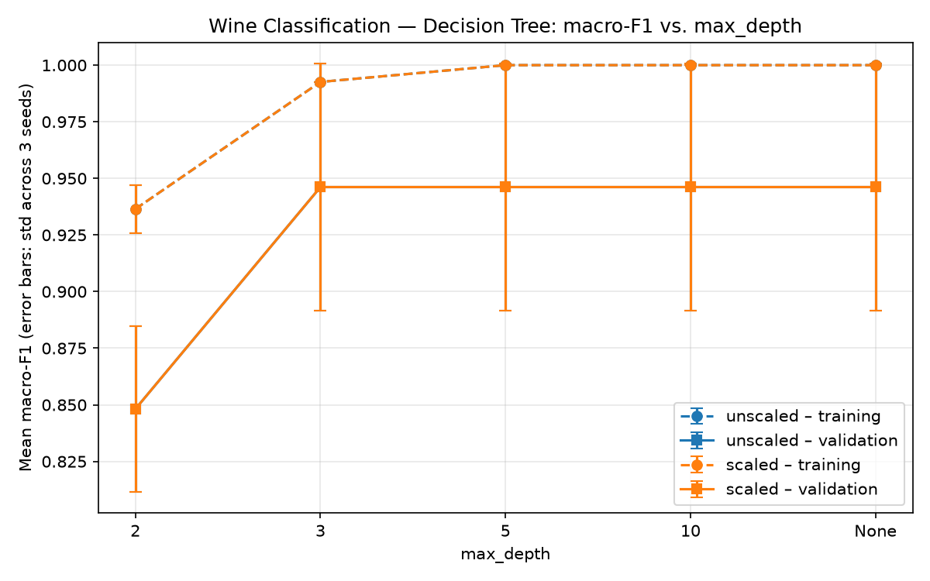
Figure 7. Wine — Decision Tree macro-F1 vs. max_depth (error bars: std across seeds).
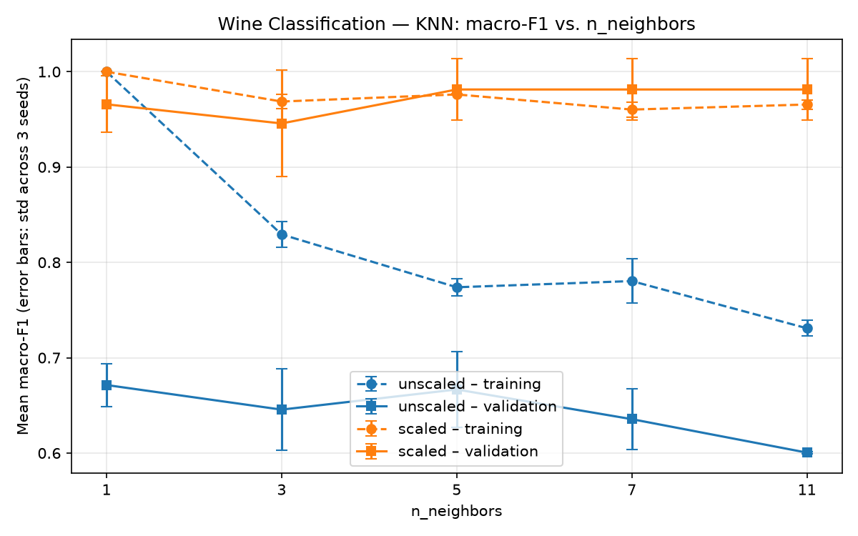
Figure 8. Wine — KNN macro-F1 vs. n_neighbors (error bars: std across seeds).
Selected configuration: KNN with scaled features and k = 5, 7 and 11 were tied on mean validation macro-F1 (0.9814), mean validation accuracy (0.9815) and macro-F1 standard deviation (0.0323). Following the predefined tie-break, the alphabetically first configuration ID, wine_knn_scaled_k11, was selected.
- Scaling: KNN is strongly affected (k = 11: 0.6005 → 0.9814), because proline dominates unscaled distances. Decision Tree and Gaussian NB are identical for both representations.
- Tree depth: depth 2 is too shallow (0.8481); from depth 3 onwards validation F1 stays at 0.9462 while training F1 reaches 1.0.
- Neighbour count: on scaled data the best values are at k = 5, 7 and 11; on unscaled data larger k does not help (0.6714 → 0.6005).
- Seed variability: with 18 validation samples, one error changes accuracy by 5.6 percentage points, and standard deviations reach about 0.055, so the top configurations are not clearly separated.

9. Evaluating the Selected Models on the Test Sets
Only the seed-42 fitted instance of each selected configuration was evaluated once on its fixed test set, using the seed-42 preprocessing. The models were not refitted and no other candidate or seed was tested.
Item | Breast Cancer | Wine
Selected configuration | breast_cancer_knn_scaled_k7 | wine_knn_scaled_k11
Evaluation seed | 42 | 42
Validation macro-F1 (mean ± std) | 0.9677 ± 0.0297 | 0.9814 ± 0.0323
Test accuracy | 0.9737 | 1.0000
Test macro precision | 0.9800 | 1.0000
Test macro recall | 0.9643 | 1.0000
Test macro-F1 | 0.9713 | 1.0000
Test ROC-AUC | 0.9888 | 1.0000

Breast Cancer test macro-F1 (0.9713) is within the validation range. Wine is classified without error on the test set, which is slightly higher than its mean validation score; with only 36 test samples a single error would lower accuracy by 2.8 percentage points. The selected models were not changed after these results.

9.1 Breast Cancer — confusion matrix and manual check
Class | Precision | Recall | F1 | Support
malignant | 1.0000 | 0.9286 | 0.9630 | 42
benign | 0.9600 | 1.0000 | 0.9796 | 72

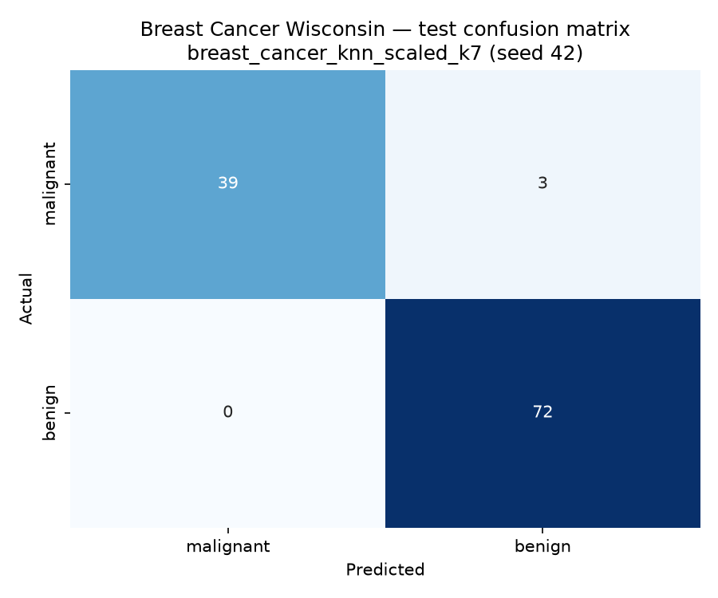
Figure 9. Breast Cancer test confusion matrix (rows: Actual, columns: Predicted).
With class order [0, 1] = [malignant, benign], the layout is [[TP, FN], [FP, TN]]: TP = 39, FN = 3, FP = 0, TN = 72. Manual malignant metrics: precision = 39 / (39 + 0) = 1.0000, recall = 39 / (39 + 3) = 0.9286, F1 = 2 · 1.0000 · 0.9286 / (1.0000 + 0.9286) = 0.9630. These match the malignant row of the classification report. All errors are false negatives (missed malignant tumours), which is the more serious error in a medical context.
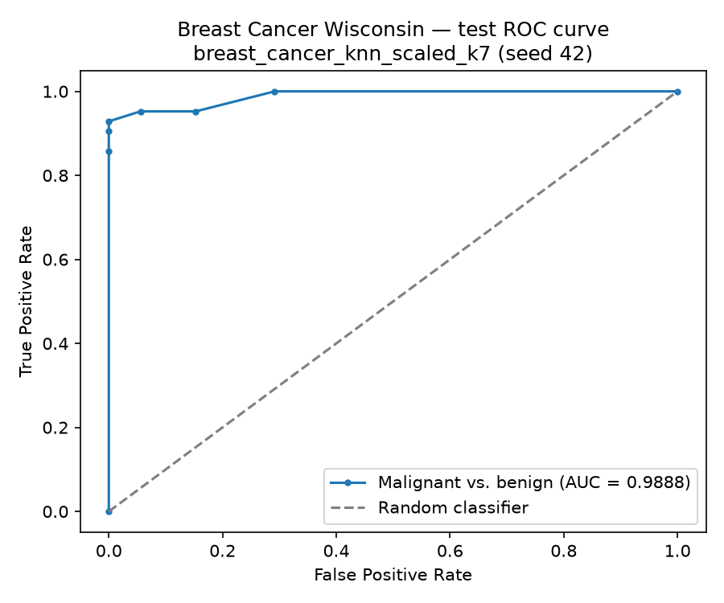
Figure 10. Breast Cancer test ROC curve (malignant positive), AUC = 0.9888.

9.2 Wine — confusion matrix and manual check
Class | Precision | Recall | F1 | Support
class_0 | 1.0000 | 1.0000 | 1.0000 | 12
class_1 | 1.0000 | 1.0000 | 1.0000 | 14
class_2 | 1.0000 | 1.0000 | 1.0000 | 10

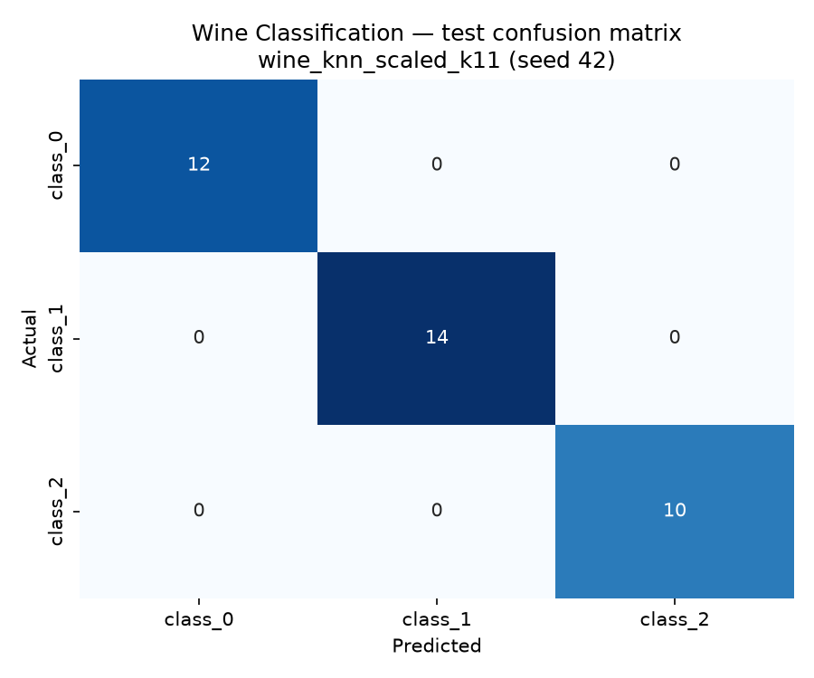
Figure 11. Wine test confusion matrix (rows: Actual, columns: Predicted).
The 3 × 3 matrix is diagonal, so there is no off-diagonal confusion. Manual check for class_1 versus the rest: TP = 14, FP = 0, FN = 0, TN = 22, giving precision = 14 / 14 = 1.0000, recall = 14 / 14 = 1.0000 and F1 = 1.0000, matching the class_1 row of the report.
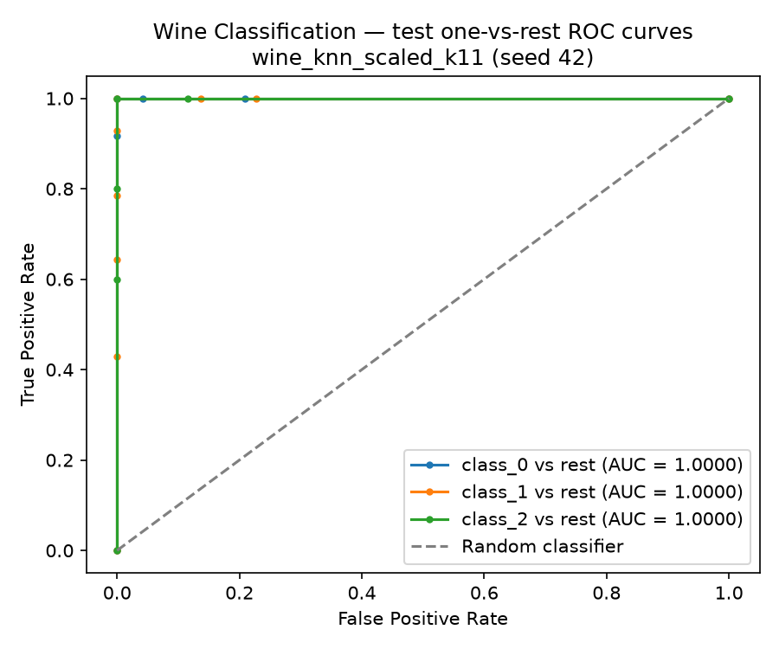
Figure 12. Wine test one-vs-rest ROC curves; all class AUCs = 1.0, macro OvR AUC = 1.0.

9.3 Thresholds and error interpretation
A classifier converts predicted probabilities into labels with a threshold. Lowering the threshold for the positive class finds more positives (fewer false negatives) but also labels more negatives as positive (more false positives); raising it does the opposite. The ROC curve shows this trade-off over all thresholds. The curves are descriptive only; no threshold was tuned on the test set.
Breast Cancer error: test row 41 is malignant but was predicted benign with P(malignant) = 0.429: 3 of its 7 nearest neighbours were malignant, so it lies close to the decision boundary. Rows 73 and 205 have only 1 malignant neighbour out of 7 and look like benign tumours in feature space.
Wine: the selected classifier makes no test errors. This does not prove perfect generalisation: the test set has only 36 samples from the same dataset, and the same configuration made errors on validation (mean validation accuracy 0.9815).
Limitations: the validation subsets are small (57 and 18 samples), the three training/validation repetitions overlap and are not independent, Wine selection depended on a tie-break, and the test results come from one predeclared seed on one fixed test set.

10. K-Means Clustering
K-Means was fitted on the training features only (no labels), with n_clusters = 2 (Breast Cancer) or 3 (Wine), random_state=seed and n_init=10: 2 representations × 3 seeds × 2 datasets = 12 fits. Validation ARI and silhouette were computed with predict on the matching validation features. Inertia is not compared across representations because the feature spaces have different units.

10.1 Validation summaries (3 seeds)
Breast Cancer:
Representation | Val ARI (mean ± std) | Val silhouette (mean ± std) | Valid seeds | Train inertia (mean)
unscaled | 0.5043 ± 0.1064 | 0.6773 ± 0.0334 | 3 | 51,270,883.7
scaled | 0.5813 ± 0.1424 | 0.3121 ± 0.0547 | 3 | 7,948.1

Wine:
Representation | Val ARI (mean ± std) | Val silhouette (mean ± std) | Valid seeds | Train inertia (mean)
unscaled | 0.3613 ± 0.0680 | 0.5765 ± 0.1014 | 3 | 1,348,308.5
scaled | 1.0000 ± 0.0000 | 0.2751 ± 0.0248 | 3 | 879.1

10.2 Final test evaluation (seed 42, no new fits)
Dataset | Representation | Test cluster counts | Test ARI | Test silhouette
Breast Cancer | unscaled | 86 / 28 | 0.5585 | 0.7120
Breast Cancer | scaled | 74 / 40 | 0.7354 | 0.3251
Wine | unscaled | 14 / 10 / 12 | 0.3733 | 0.4929
Wine | scaled | 13 / 13 / 10 | 0.9088 | 0.2711

Contingency tables (test set, rows = actual class, columns = cluster ID):
Breast Cancer | Unscaled c0 | Unscaled c1 | Scaled c0 | Scaled c1
benign | 72 | 0 | 69 | 3
malignant | 14 | 28 | 5 | 37

Wine | Unsc. c0 | Unsc. c1 | Unsc. c2 | Sc. c0 | Sc. c1 | Sc. c2
class_0 | 2 | 10 | 0 | 12 | 0 | 0
class_1 | 5 | 0 | 9 | 1 | 13 | 0
class_2 | 7 | 0 | 3 | 0 | 0 | 10

10.3 Visualisation and interpretation
Two original features were chosen per dataset, and their choice was checked with the class means in the seed-42 training data: worst radius and worst concave points for Breast Cancer, flavanoids and proline for Wine. The plots show only a two-feature projection; K-Means used all features.
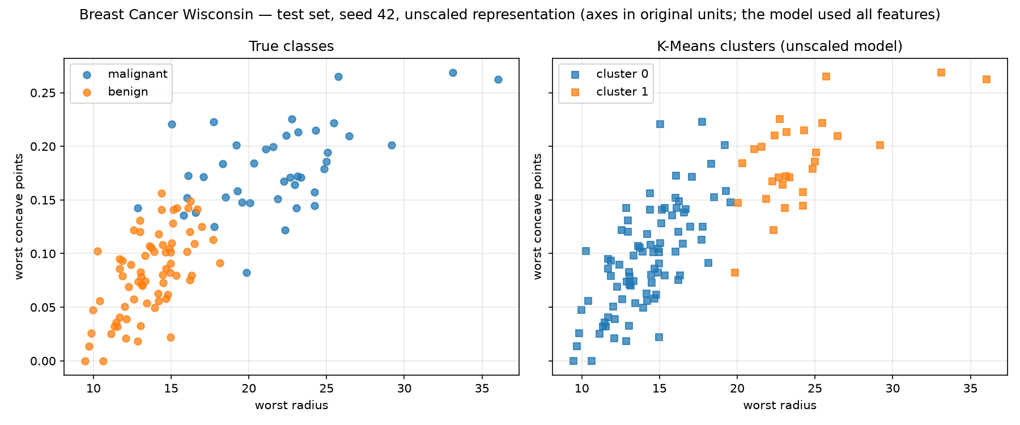
Figure 13. Breast Cancer test set — true classes vs. K-Means clusters (unscaled model).
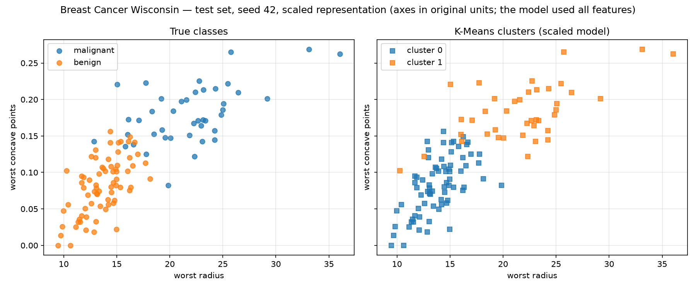
Figure 14. Breast Cancer test set — true classes vs. K-Means clusters (scaled model).
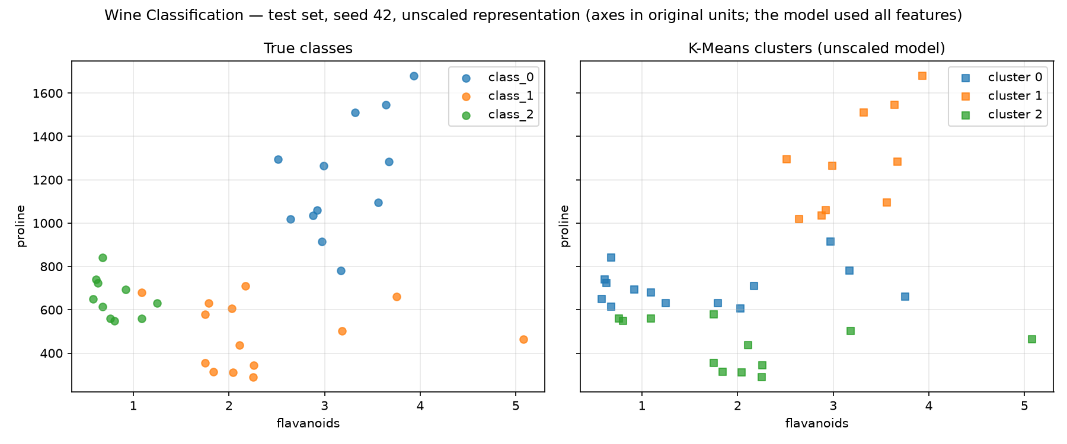
Figure 15. Wine test set — true classes vs. K-Means clusters (unscaled model).
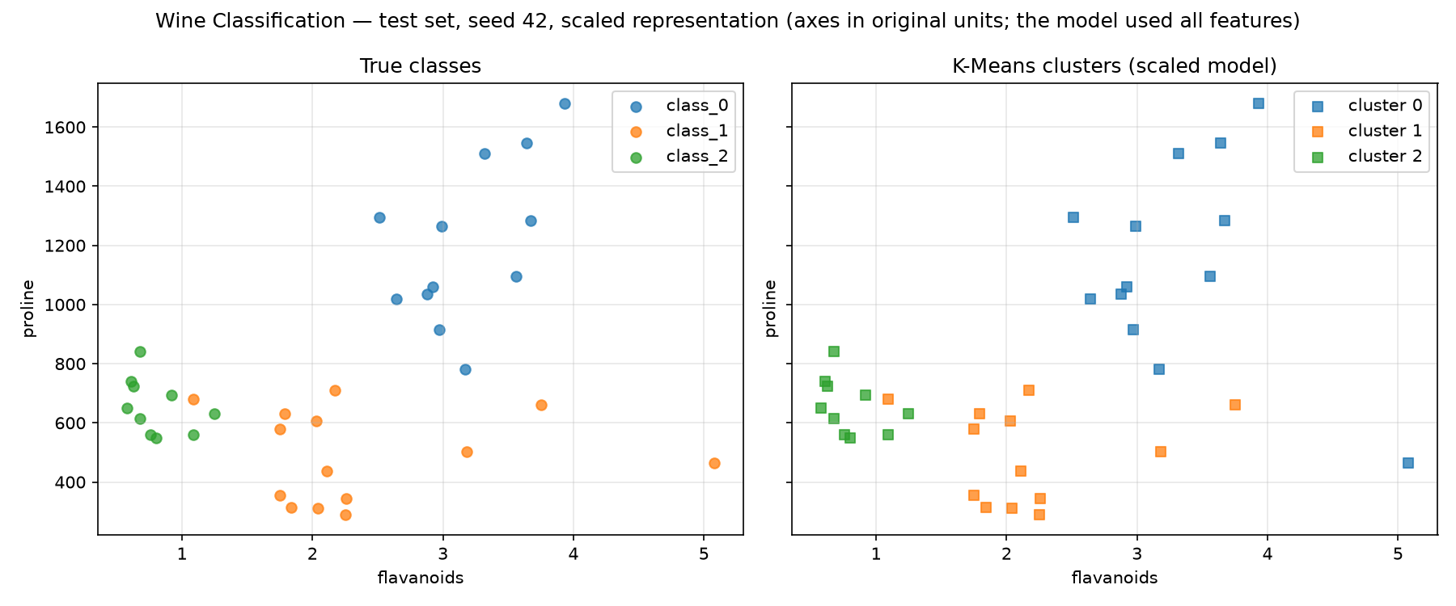
Figure 16. Wine test set — true classes vs. K-Means clusters (scaled model).
- Breast Cancer: unscaled K-Means mainly separates large tumours from smaller ones: one cluster is purely malignant (28), while the other contains all benign tumours plus 14 smaller malignant ones (test ARI 0.559). After scaling the partition is much closer to the classes (5 + 3 mixed samples, test ARI 0.735).
- Wine: unscaled K-Means is dominated by proline; it isolates class_0 (high proline) but mixes class_1 and class_2 (test ARI 0.373). After scaling, only one class_1 wine is grouped with class_0 (test ARI 0.909).
- Silhouette: silhouette is higher for unscaled features in both datasets, because distances there are dominated by one large-scale feature. Since the values come from different feature spaces, this difference alone does not show that the unscaled model is better.
- Information during fitting: the classifiers learned from the true labels, while K-Means only saw the features and a fixed number of clusters. Labels were used only afterwards to compute ARI and contingency tables. Cluster IDs are arbitrary, so ARI is not a classification accuracy.

11. Comparing the Two Datasets
Did the same classifier and representation perform best on both datasets? On validation, yes: scaled KNN was selected for both datasets, with different neighbour counts (k = 7 for Breast Cancer, k = 11 for Wine after a tie-break). On the test sets, the selected Breast Cancer model reached macro-F1 0.9713 and the selected Wine model 1.0. Only the selected models were tested, so the test results do not show whether another configuration would have been better on the test sets.
Which algorithm was most affected by scaling? KNN. In Wine, mean validation macro-F1 for k = 11 increased from 0.6005 to 0.9814 (+0.381), and for k = 5 from 0.6667 to 0.9814. In Breast Cancer, k = 7 increased from 0.9040 to 0.9677 (+0.064). Decision Tree did not change, and Gaussian NB changed by at most 0.012.
Did deeper trees or larger neighbour counts always help? No. Deeper trees increased training F1 to 1.0 but improved mean validation F1 only slightly in Breast Cancer (0.9117 → 0.9195) and not at all in Wine after depth 3. For KNN on scaled data, Breast Cancer peaked at k = 7 and decreased at k = 11, and Wine dipped at k = 3. Seed standard deviations of validation macro-F1 reached about 0.057 (Breast Cancer) and 0.056 (Wine), so many differences between neighbouring settings are smaller than the variation across splits (Figures 5–8).
How did the main classification errors differ? In Breast Cancer all three test errors were false negatives (malignant predicted as benign), with no false positives. In Wine there were no test errors.
How did K-Means agreement differ? With scaled features, agreement was higher for Wine (validation ARI 1.000, test ARI 0.909) than for Breast Cancer (validation ARI 0.581, test ARI 0.735). The contingency tables show that Wine clusters almost match the three classes, while in Breast Cancer some malignant and benign tumours overlap. ARI measures partition agreement, not classification accuracy.
Future work: I would investigate stratified k-fold cross-validation on the combined training and validation data for model selection. The validation subsets are small (18 samples for Wine), and three configurations were tied, so a more stable estimate could make the selection less dependent on a few samples. This is a proposal, not a completed result.

12. Run and Output Inventory
Model fits: 132 classifier fits + 12 K-Means fits = 144. The two classifier test evaluations and four clustering test evaluations reuse seed-42 models and add no fits. Result files: classifier_runs.csv (132 rows), classifier_summary.csv (44), classifier_test.csv (2), kmeans_runs.csv (12), kmeans_summary.csv (4) and kmeans_test.csv (4). Figures: 13 Breast Cancer and 11 Wine figure files (24 in total) in the figures/ folder.
Links: GitHub repository: [GITHUB REPOSITORY URL]. Video walkthrough: [VIDEO LINK]. AI/tool use is described in AI_DISCLOSURE.md.

Appendix A. Descriptive Statistics

A1. Breast Cancer Wisconsin (full dataset, descriptive only)
Feature | Mean | Med. | Min | Max | Std | Q1 | Q3
mean radius | 14.127 | 13.370 | 6.981 | 28.110 | 3.524 | 11.700 | 15.780
mean texture | 19.290 | 18.840 | 9.710 | 39.280 | 4.301 | 16.170 | 21.800
mean perimeter | 91.969 | 86.240 | 43.790 | 188.5 | 24.299 | 75.170 | 104.1
mean area | 654.9 | 551.1 | 143.5 | 2501.0 | 351.9 | 420.3 | 782.7
mean smoothness | 0.096 | 0.096 | 0.053 | 0.163 | 0.014 | 0.086 | 0.105
mean compactness | 0.104 | 0.093 | 0.019 | 0.345 | 0.053 | 0.065 | 0.130
mean concavity | 0.089 | 0.062 | 0.000 | 0.427 | 0.080 | 0.030 | 0.131
mean concave points | 0.049 | 0.034 | 0.000 | 0.201 | 0.039 | 0.020 | 0.074
mean symmetry | 0.181 | 0.179 | 0.106 | 0.304 | 0.027 | 0.162 | 0.196
mean fractal dimension | 0.063 | 0.062 | 0.050 | 0.097 | 0.007 | 0.058 | 0.066
radius error | 0.405 | 0.324 | 0.112 | 2.873 | 0.277 | 0.232 | 0.479
texture error | 1.217 | 1.108 | 0.360 | 4.885 | 0.552 | 0.834 | 1.474
perimeter error | 2.866 | 2.287 | 0.757 | 21.980 | 2.022 | 1.606 | 3.357
area error | 40.337 | 24.530 | 6.802 | 542.2 | 45.491 | 17.850 | 45.190
smoothness error | 0.007 | 0.006 | 0.002 | 0.031 | 0.003 | 0.005 | 0.008
compactness error | 0.025 | 0.020 | 0.002 | 0.135 | 0.018 | 0.013 | 0.032
concavity error | 0.032 | 0.026 | 0.000 | 0.396 | 0.030 | 0.015 | 0.042
concave points error | 0.012 | 0.011 | 0.000 | 0.053 | 0.006 | 0.008 | 0.015
symmetry error | 0.021 | 0.019 | 0.008 | 0.079 | 0.008 | 0.015 | 0.023
fractal dimension error | 0.004 | 0.003 | 0.001 | 0.030 | 0.003 | 0.002 | 0.005
worst radius | 16.269 | 14.970 | 7.930 | 36.040 | 4.833 | 13.010 | 18.790
worst texture | 25.677 | 25.410 | 12.020 | 49.540 | 6.146 | 21.080 | 29.720
worst perimeter | 107.3 | 97.660 | 50.410 | 251.2 | 33.603 | 84.110 | 125.4
worst area | 880.6 | 686.5 | 185.2 | 4254.0 | 569.4 | 515.3 | 1084.0
worst smoothness | 0.132 | 0.131 | 0.071 | 0.223 | 0.023 | 0.117 | 0.146
worst compactness | 0.254 | 0.212 | 0.027 | 1.058 | 0.157 | 0.147 | 0.339
worst concavity | 0.272 | 0.227 | 0.000 | 1.252 | 0.209 | 0.115 | 0.383
worst concave points | 0.115 | 0.100 | 0.000 | 0.291 | 0.066 | 0.065 | 0.161
worst symmetry | 0.290 | 0.282 | 0.157 | 0.664 | 0.062 | 0.250 | 0.318
worst fractal dimension | 0.084 | 0.080 | 0.055 | 0.207 | 0.018 | 0.071 | 0.092

A2. Wine Classification (full dataset, descriptive only)
Feature | Mean | Med. | Min | Max | Std | Q1 | Q3
alcohol | 13.001 | 13.050 | 11.030 | 14.830 | 0.812 | 12.362 | 13.678
malic_acid | 2.336 | 1.865 | 0.740 | 5.800 | 1.117 | 1.603 | 3.083
ash | 2.367 | 2.360 | 1.360 | 3.230 | 0.274 | 2.210 | 2.558
alcalinity_of_ash | 19.495 | 19.500 | 10.600 | 30.000 | 3.340 | 17.200 | 21.500
magnesium | 99.742 | 98.000 | 70.000 | 162.0 | 14.282 | 88.000 | 107.0
total_phenols | 2.295 | 2.355 | 0.980 | 3.880 | 0.626 | 1.742 | 2.800
flavanoids | 2.029 | 2.135 | 0.340 | 5.080 | 0.999 | 1.205 | 2.875
nonflavanoid_phenols | 0.362 | 0.340 | 0.130 | 0.660 | 0.124 | 0.270 | 0.438
proanthocyanins | 1.591 | 1.555 | 0.410 | 3.580 | 0.572 | 1.250 | 1.950
color_intensity | 5.058 | 4.690 | 1.280 | 13.000 | 2.318 | 3.220 | 6.200
hue | 0.957 | 0.965 | 0.480 | 1.710 | 0.229 | 0.782 | 1.120
od280/od315_of_diluted_wines | 2.612 | 2.780 | 1.270 | 4.000 | 0.710 | 1.938 | 3.170
proline | 746.9 | 673.5 | 278.0 | 1680.0 | 314.9 | 500.5 | 985.0

Appendix B. Boxplots
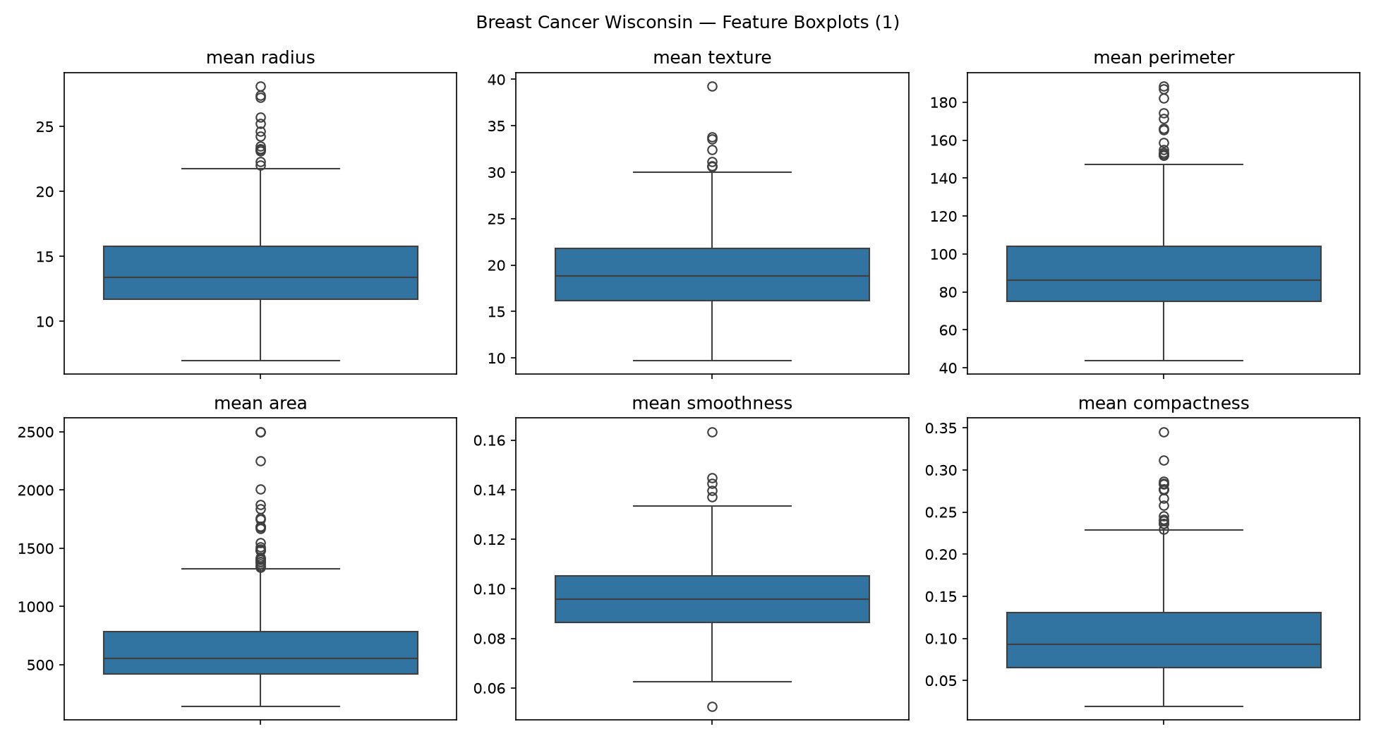
Figure B1. Breast Cancer feature boxplots (1/5).
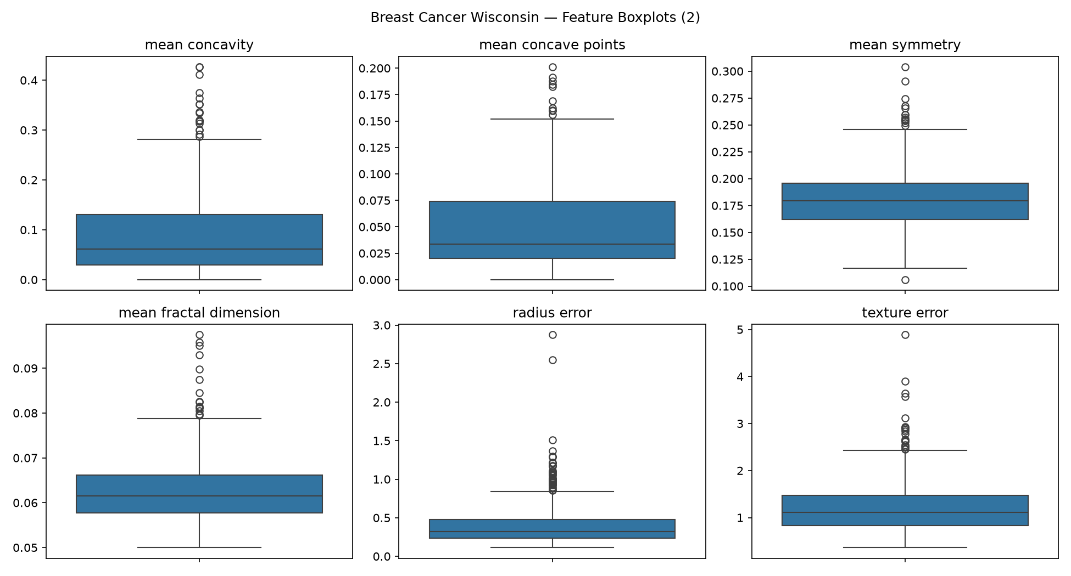
Figure B2. Breast Cancer feature boxplots (2/5).
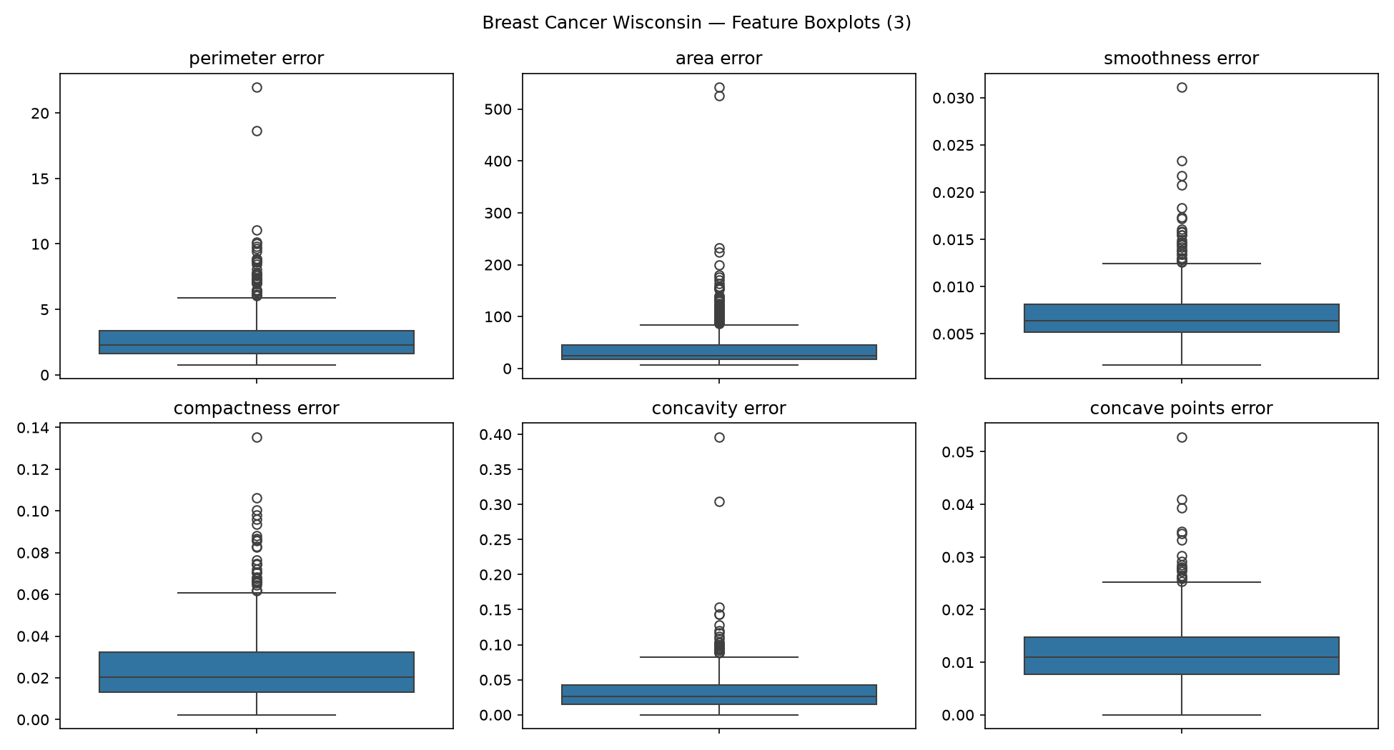
Figure B3. Breast Cancer feature boxplots (3/5).
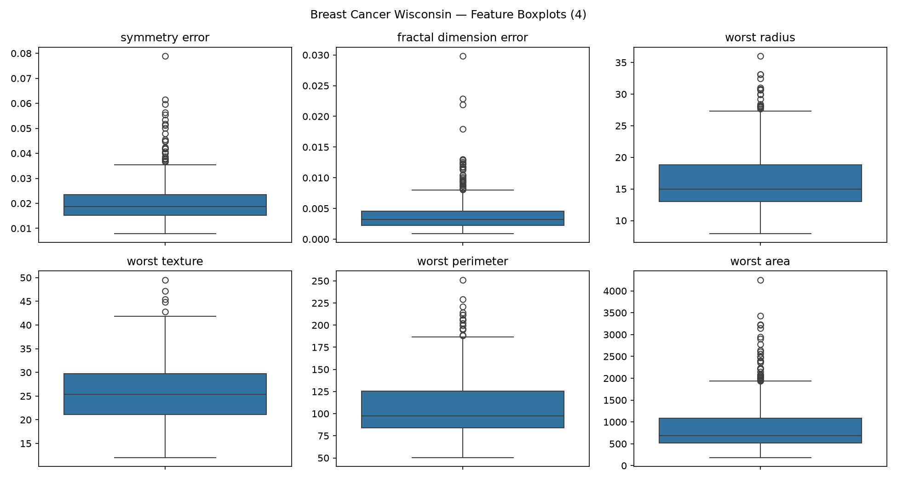
Figure B4. Breast Cancer feature boxplots (4/5).
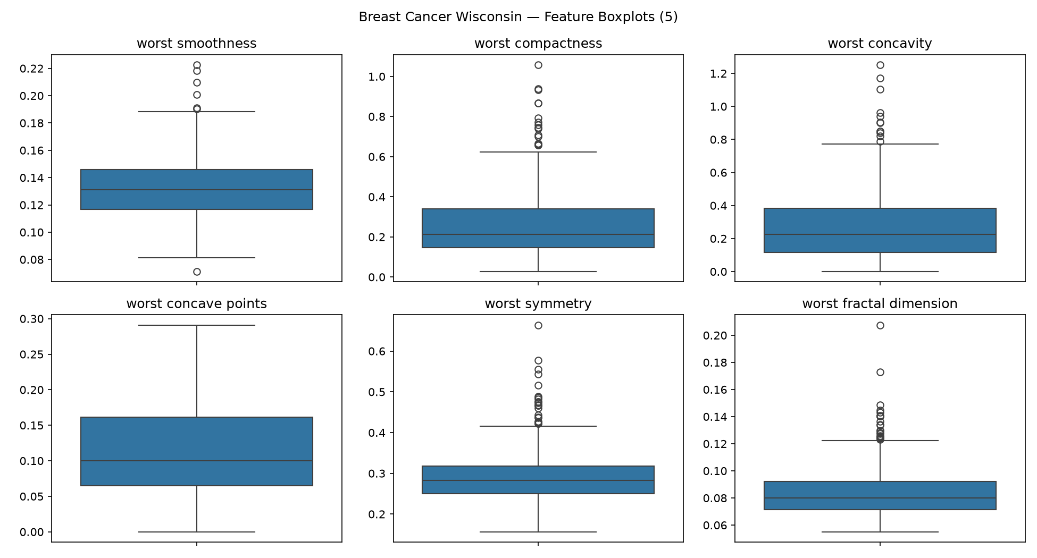
Figure B5. Breast Cancer feature boxplots (5/5).
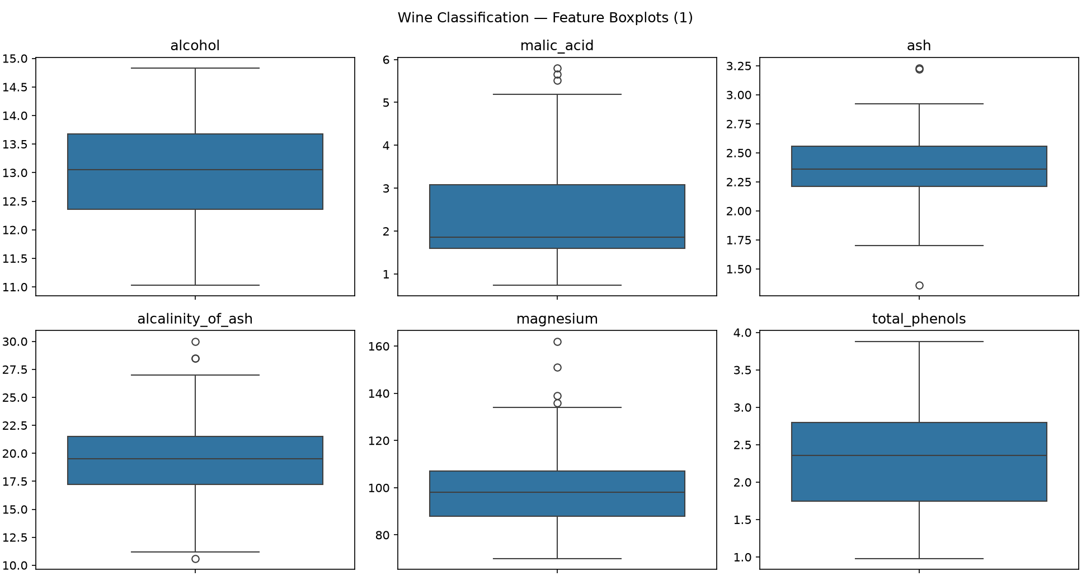
Figure B6. Wine feature boxplots (1/3).
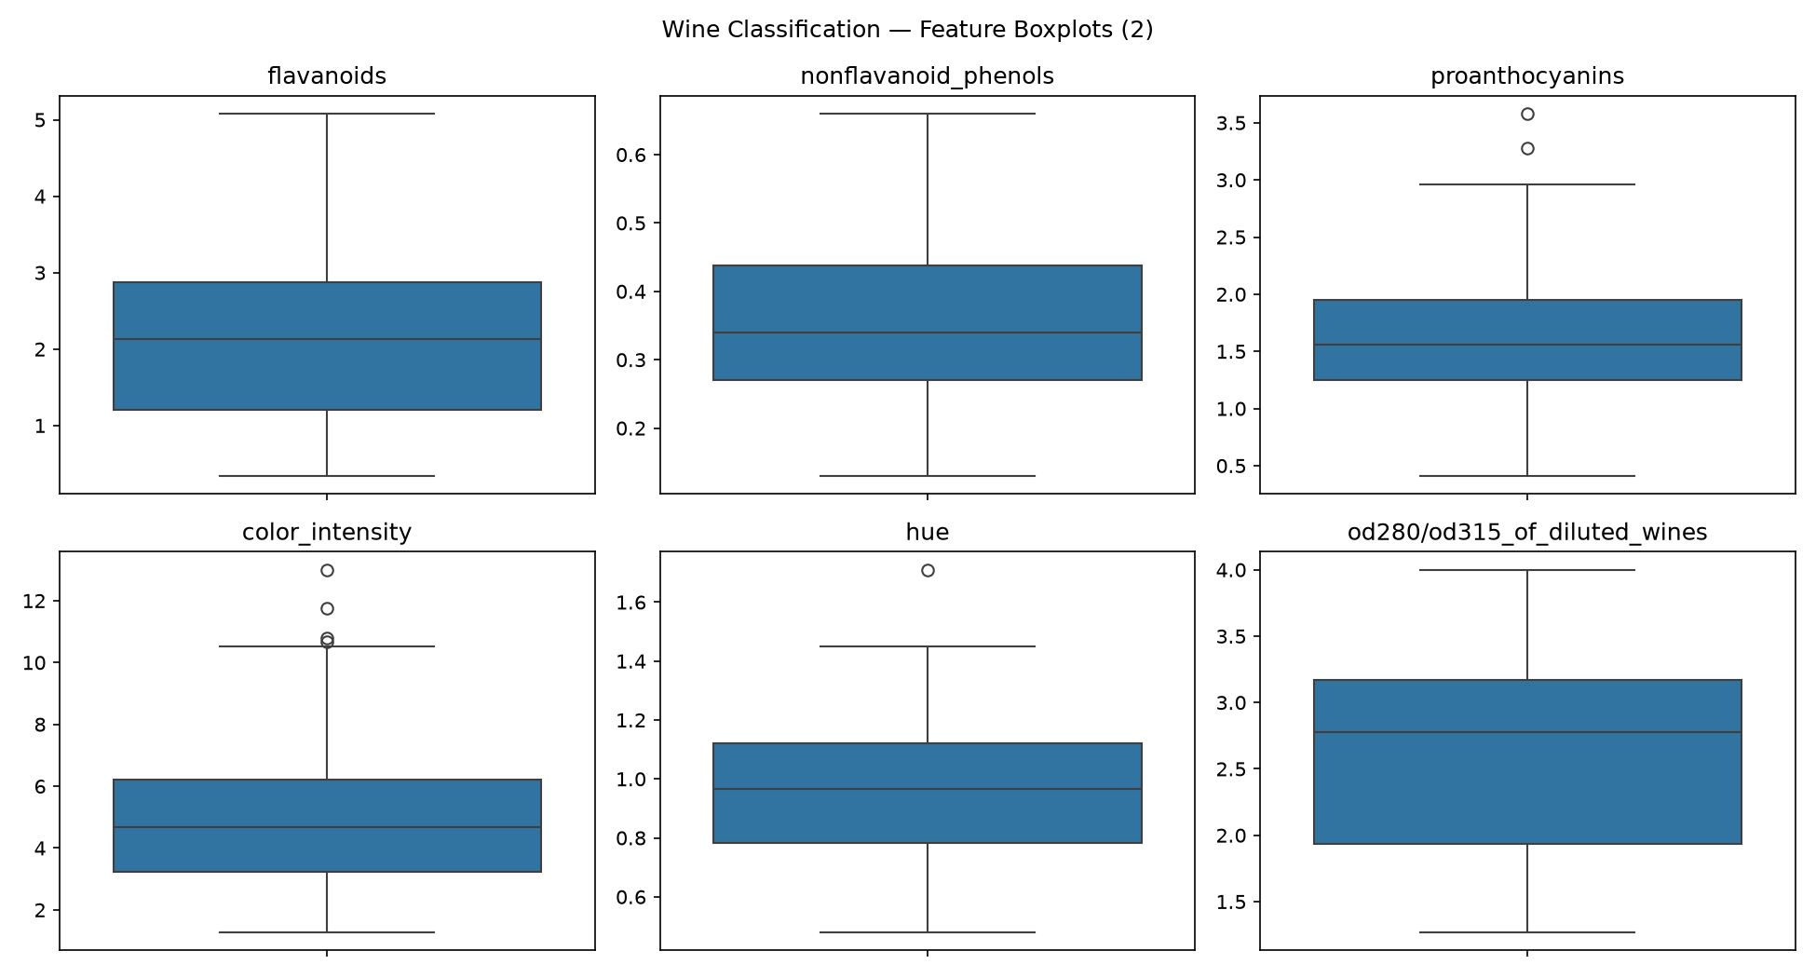
Figure B7. Wine feature boxplots (2/3).
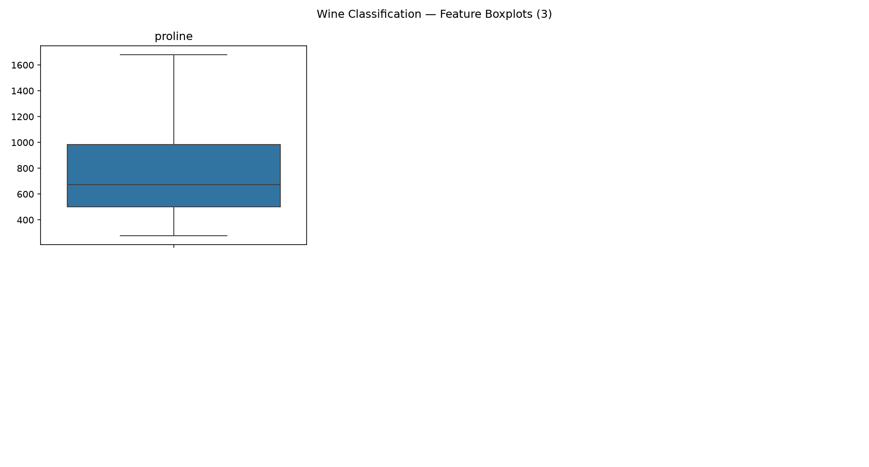
Figure B8. Wine feature boxplots (3/3).

