Interpolation

Code:
import cv2
import numpy as np
image = cv2.imread('atlet.jpg')
if image is None:
print("Error: Image not found.")
exit()
nearest_image = cv2.resize(image, (500, 500), interpolation=cv2.INTER_NEAREST)
bilinear_image = cv2.resize(image, (500, 500), interpolation=cv2.INTER_LINEAR)
bicubic_image = cv2.resize(image, (500, 500), interpolation=cv2.INTER_CUBIC)
lanczos_image = cv2.resize(image, (500, 500), interpolation=cv2.INTER_LANCZOS4)
cv2.imshow('Original Image', image)
cv2.imshow('Nearest Neighbor', nearest_image)
cv2.imshow('Bilinear Interpolation', bilinear_image)
cv2.imshow('Bicubic Interpolation', bicubic_image)
cv2.imshow('Lanczos Interpolation', lanczos_image)
cv2.waitKey(0)
cv2.destroyAllWindows()
Code Explanation:
Loading the Image The image atlet.jpg is loaded using OpenCV’s cv2.imread() function. A check is done to ensure the image is loaded correctly.
Interpolation Methods:
Nearest Neighbor (cv2.INTER_NEAREST): Fast but results in pixelated images.
Bilinear (cv2.INTER_LINEAR): Uses the average of 4 nearest pixels, resulting in smoother images.
Bicubic (cv2.INTER_CUBIC): Considers 16 pixels for a smoother, higher-quality result.
Lanczos (cv2.INTER_LANCZOS4): Uses a sinc function for the sharpest and most detailed results, especially for downscaling.
Resizing: Each interpolation method is applied to resize the image to 500x500 pixels.

Displaying Results: The original and resized images are displayed using cv2.imshow() for visual comparison.
Closing the Windows: The images are displayed until a key is pressed, after which the windows are closed with cv2.destroyAllWindows().

Output: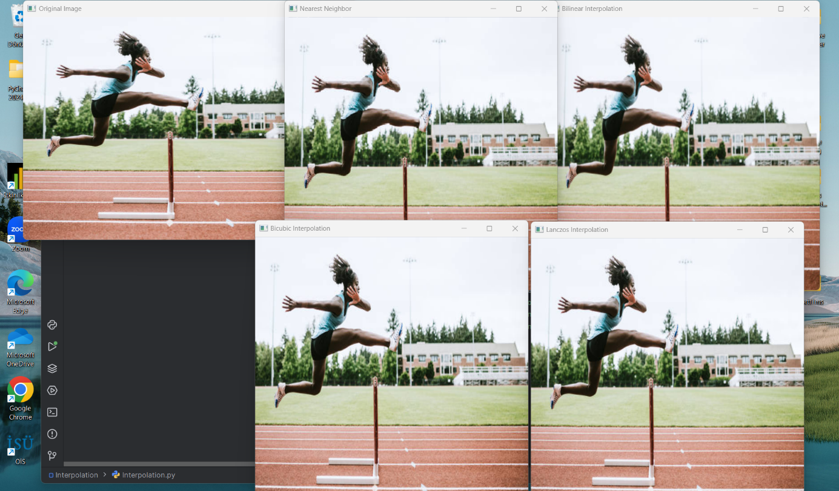

Report
Purpose:
The code demonstrates how different interpolation methods affect image quality when resizing. The methods range from fast but low-quality (Nearest Neighbor) to high-quality but computationally expensive (Lanczos).
Interpolation Techniques:
- Nearest Neighbor: Fast but pixelated.
- Bilinear: Smooth but with some blurring.
- Bicubic: Smooth and high-quality with higher computation.
- Lanczos: Best for sharp images, especially when downscaling.
Conclusion:
The choice of interpolation method depends on the application. For fast processing, Nearest Neighbor or Bilinear is ideal, while Bicubic and Lanczos are best for high-quality image processing tasks.

