Thresholding
Code:
import cv2
image = cv2.imread('zambak.jpg')
if image is None:
exit()
gray_image = cv2.cvtColor(image, cv2.COLOR_BGR2GRAY)
_, thresholded_image = cv2.threshold(gray_image, 127, 255, cv2.THRESH_BINARY)
cv2.imshow('Original Image', image)
cv2.imshow('Thresholded Image', thresholded_image)
cv2.waitKey(0)
cv2.destroyAllWindows()

Code Explanation:
- Loading the Image:
image = cv2.imread('zambak.jpg')
  - The image 'zambak.jpg' is loaded into the program using cv2.imread(). This function loads the image in color (BGR format).
- Check if Image Exists:
if image is None:
exit()
  - If the image is not found or there is an issue loading it, the program will exit.
- Convert to Grayscale:
gray_image = cv2.cvtColor(image, cv2.COLOR_BGR2GRAY)
  - The color image is converted to grayscale using cv2.cvtColor(). This reduces the image to a single channel with intensity values, simplifying the thresholding process.
- Apply Thresholding:
_, thresholded_image = cv2.threshold(gray_image, 127, 255, cv2.THRESH_BINARY)
  - A simple binary thresholding technique is applied.
    - All pixel values above 127 are set to 255 (white), and all pixel values below 127 are set to 0 (black).
    - cv2.THRESH_BINARY specifies the type of thresholding (binary thresholding in this case).
- Display the Images:
cv2.imshow('Original Image', image)
cv2.imshow('Thresholded Image', thresholded_image)
  - The original color image and the thresholded (binary) image are displayed in separate windows using cv2.imshow().
- Wait for Key Press:
cv2.waitKey(0)
cv2.destroyAllWindows()
  - The program waits for a key press to close the displayed images.
Output:
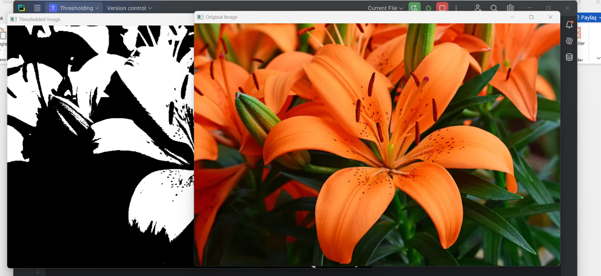
Report:
The code demonstrates thresholding, a technique used to segment an image based on pixel intensity values. In this case, a simple binary thresholding is applied to the grayscale version of the image.
Steps:
- Grayscale Conversion: The image is first converted to grayscale to simplify the thresholding operation.
- Binary Thresholding: A threshold of 127 is applied. Pixel values above this threshold become white (255), and pixel values below become black (0). This creates a binary image that highlights features in the image by separating them based on intensity.
- Display: Both the original image and the thresholded image are displayed for comparison.
Conclusion: Thresholding is useful for image segmentation tasks, such as separating objects from the background. It can be particularly useful in applications like object detection, edge detection, and image preprocessing in computer vision tasks

