612303050 Deshmukh Mehmood Rehan’s Assignment 2

Q1. Use the moviesData. Create a histogram of the object named imdb_num_votes in this file

moviesData = read.csv("moviesData.csv")  
hist(moviesData$imdb_num_votes, main = "IMDB Votes", xlab = "No. of votes")

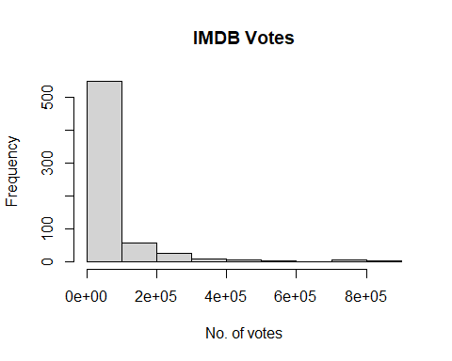

Q2. Create a pie chart of the object mpaa_rating and save the plot.

mpaa_ratings = factor(moviesData$mpaa_rating)  
mpaa_ratings_table = table(mpaa_ratings)  
pie(mpaa_ratings_table, col = 5:11, main = "MPAA Ratings", cex = 0.7)  
legend("bottomright", levels(mpaa_ratings), fill = 5:11, cex = 0.7)

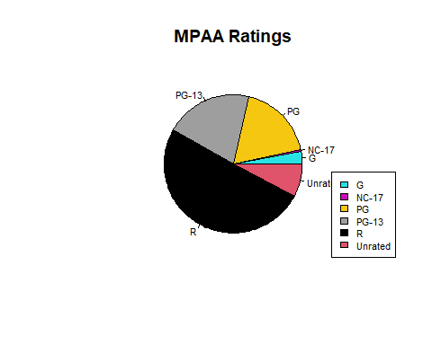

Q3. Read the file moviesData.csv Create a bar chart of critics_score for the first 10 movies.

moviesData = read.csv("moviesData.csv")  
score_of_critics = (moviesData$critics_score[1:10])  
barplot(score_of_critics, main = "Critics' Score", names.arg = 1:10, xlab = "Movie No.", ylab = "Score")

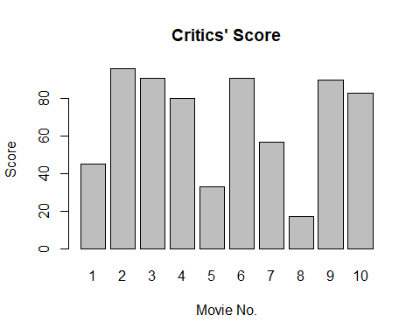

Q4. Create a scatter plot of imdb_rating and imdb_num_votes to see their relation. Also save the plot.

imdb_rating = moviesData$imdb_rating  
imdb_num_votes = moviesData$imdb_num_votes  
plot(imdb_rating, imdb_num_votes, col = c("red", "blue"), main = "IMDB Ratings and votes", xlab="IMDB Rating", ylab="No. of Votes")  
legend("topleft", legend = c("IMDB Rating", "Number of Votes"), col = c("red", "blue"), pch = 1)

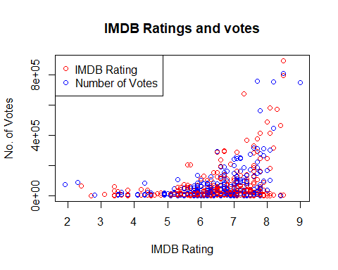

Q5. Using the mtcars dataset create a barplot using cyl variable

data(mtcars)  
cylinder_table <- table(mtcars$cyl)  
barplot(cylinder_table, main = "Cylinders",   
 xlab = "Number of Cylinders")

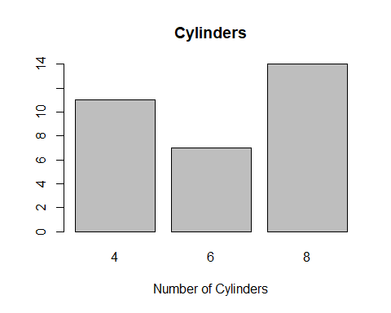

Q6. Represent the following data by pie diagram

commodity <- c("Food", "Rent", "Clothes", "Education", "Savings", "Miscellaneous")  
expenditure <- c(300, 200, 125, 110, 90, 75)  
  
pie(expenditure, labels = commodity, main = "Expenditure on Commodities")

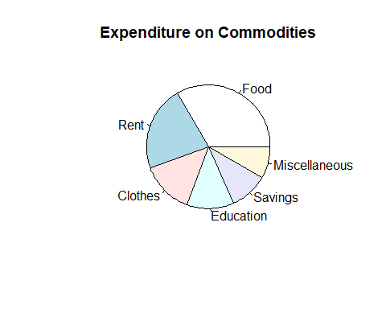

Q7. Represent the following data by subdivided bar diagram

years <- c(2002, 2003, 2004)  
raw_materials <- c(21600, 26000, 27000)  
labour <- c(5400, 7000, 8100)  
direct_expenses <- c(3600, 3000, 3500)  
office_expenses <- c(1800, 2000, 2700)  
factory_expenses <- c(3600, 2000, 3600)  
  
scooter_row_names <- c("Raw materials", "Labour", "Direct expenses","Office expenses", "Factory expenses")  
  
cost_df <- data.frame(raw_materials, labour, direct_expenses, office_expenses, factory_expenses)  
names(cost_df) <- scooter_row_names  
barplot(as.matrix(cost_df), col = 5:7, main = "Cost Per Scooter by Category and Year", ylab = "Cost (₹)",xlab = "Expenses" ,names.arg = scooter_row_names, cex.axis = 0.7, cex.names = 0.7)  
legend("topright", legend = years, fill = 5:7)

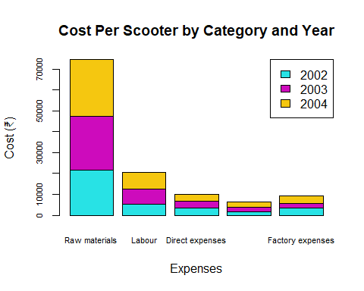

Q8. The following frequency distribution table gives age distribution gives the age of drivers who were at fault in accidents during a 1-week period in a city Draw a histogram

age_groups <- c("18-20", "20-25", "25-30", "30-40", "40-50", "50-60", "60-70")  
  
lowerbound=c(18,20,25,30,40,50,60)  
upperbound=c(20,25,30,40,50, 60, 70)  
age_freq=c(7, 12, 28, 14, 8, 3, 2)  
breaks=c(18,upperbound)  
x=(lowerbound+upperbound)/2  
x

## [1] 19.0 22.5 27.5 35.0 45.0 55.0 65.0

y=rep(x,age_freq)  
y

## [1] 19.0 19.0 19.0 19.0 19.0 19.0 19.0 22.5 22.5 22.5 22.5 22.5 22.5 22.5 22.5  
## [16] 22.5 22.5 22.5 22.5 27.5 27.5 27.5 27.5 27.5 27.5 27.5 27.5 27.5 27.5 27.5  
## [31] 27.5 27.5 27.5 27.5 27.5 27.5 27.5 27.5 27.5 27.5 27.5 27.5 27.5 27.5 27.5  
## [46] 27.5 27.5 35.0 35.0 35.0 35.0 35.0 35.0 35.0 35.0 35.0 35.0 35.0 35.0 35.0  
## [61] 35.0 45.0 45.0 45.0 45.0 45.0 45.0 45.0 45.0 55.0 55.0 55.0 65.0 65.0

hist(y,breaks,main = "Age Distribution of Drivers at Fault in Accidents", xlab = "Age")

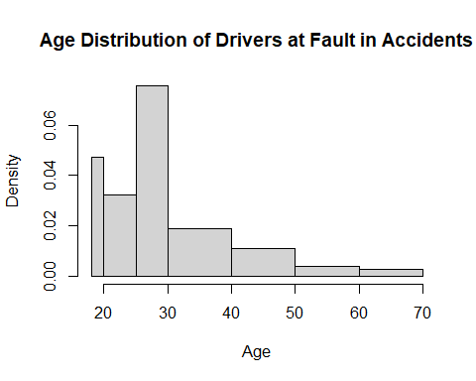

Q9.Create a heatmap using LifeCycleSavings dataset

data("LifeCycleSavings")  
data=as.matrix(LifeCycleSavings)  
heatmap(data, scale = "column", Colv = NA, Rowv = NA )

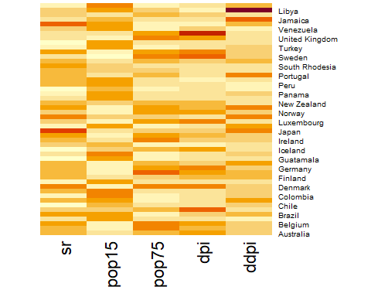

Q10. Create a heatmap using following datasets.

var1 = c(0.094, 0.1138, 0.1893, -0.0102, 0.1587, -0.4558, -0.6241, -0.227, 0.7365, 0.9761)  
var2 = c(0.668, -0.3847, 0.3303, -0.4259, 0.2948, 0.2244, -0.3119, 0.499, -0.0872, 0.4355)  
var3 = c(0.4153, 0.2671, 0.5821, -0.5967, 0.153, 0.6619, 0.3642, 0.3067, -0.069, 0.8663)  
var4 = c(0.4613, 0.1529, 0.2632, 0.18, -0.2208, 0.0457, 0.2003, 0.3289, -0.4252, 0.8107)  
dataframe = data.frame(var1, var2, var3, var4)  
rownames(dataframe) = c("measurement1", "measurement2", "measurement3", "measurement4", "measurement5", "measurement6", "measurement7", "measurement8", "measurement9", "measurement10")  
heatmap(as.matrix(dataframe))

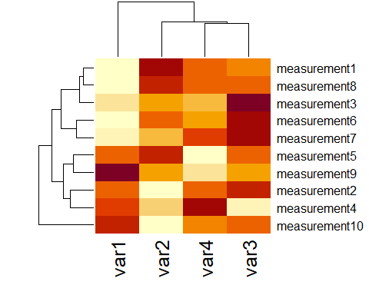

#a) Write code to remove row dendogram  
  
heatmap(as.matrix(dataframe), Rowv = NA)

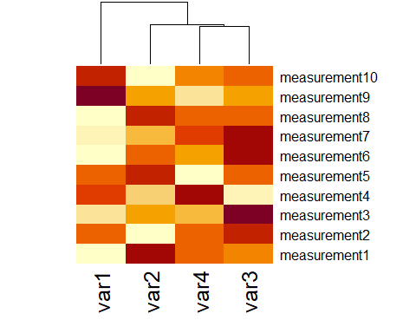

#b) Write code to remove column dendograms  
  
heatmap(as.matrix(dataframe), Colv = NA)

