POINTS THAT ARE NOT DONE
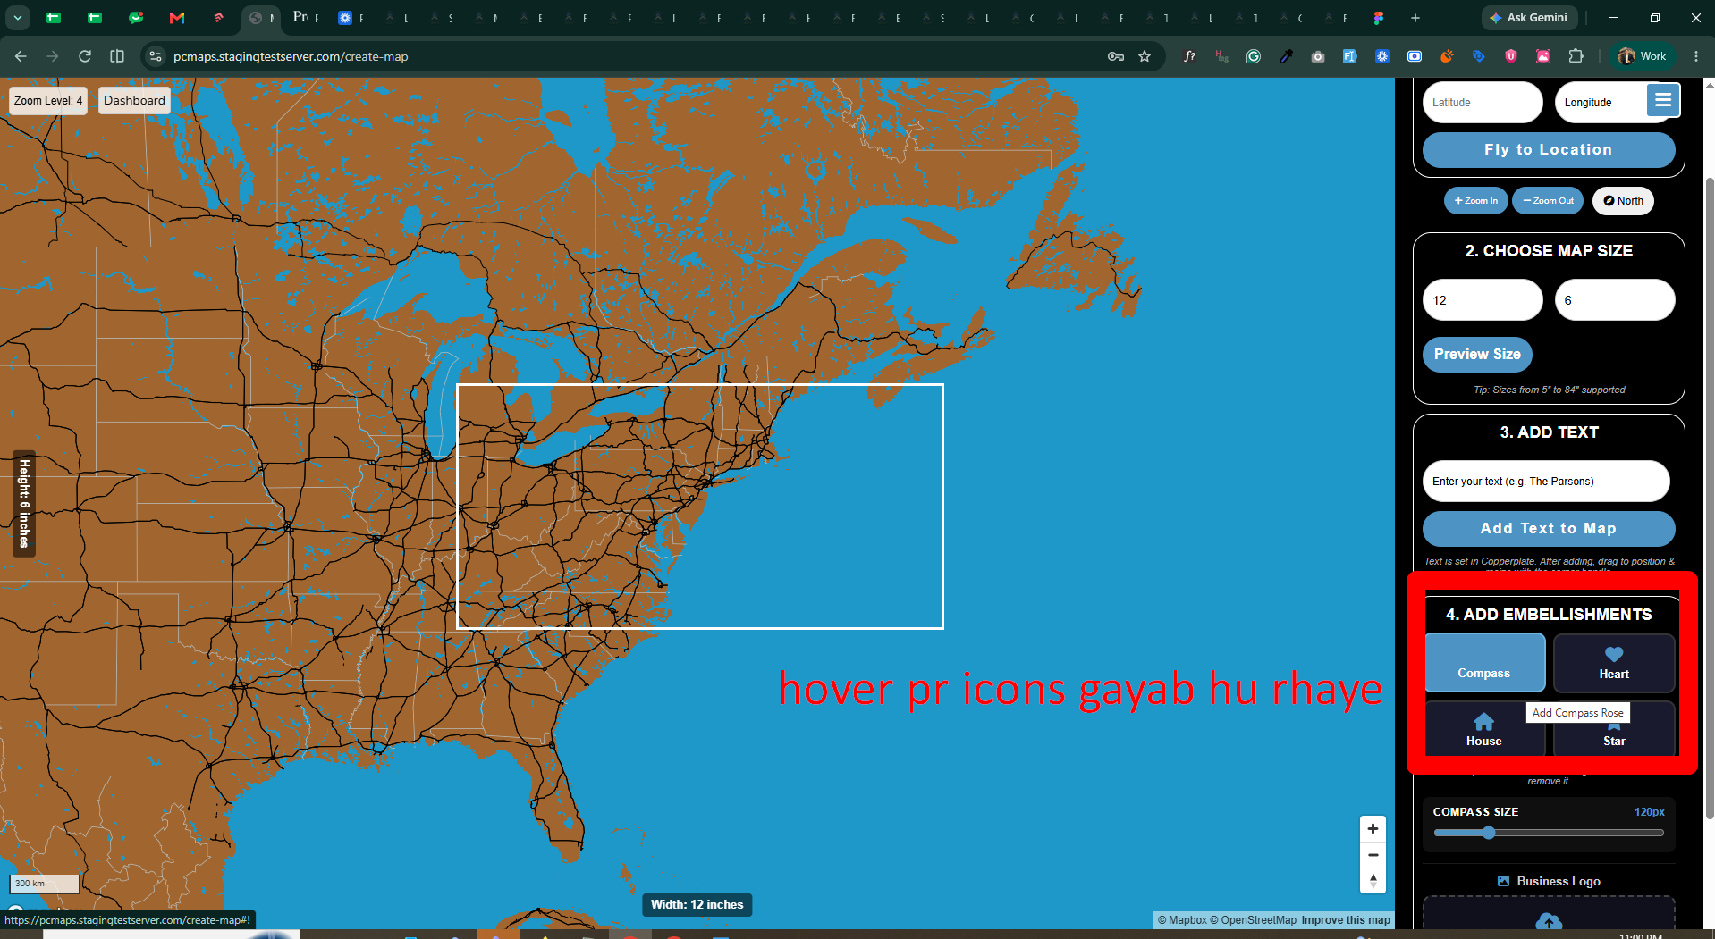
ISSUE: Hover pr icons are missing

- Zoom Level Detail: The map detail that currently appears at zoom level 11 will be adjusted to become visible earlier, at zoom level 10.6.
- Dimension Labels: The "Width and Height" labels will be moved back to the outer edges/sides so they no longer overlap and block the map design when zoomed in.
- Compass Rose: The compass rose icon under the "Add Embellishments" section will be made adjustable in size.
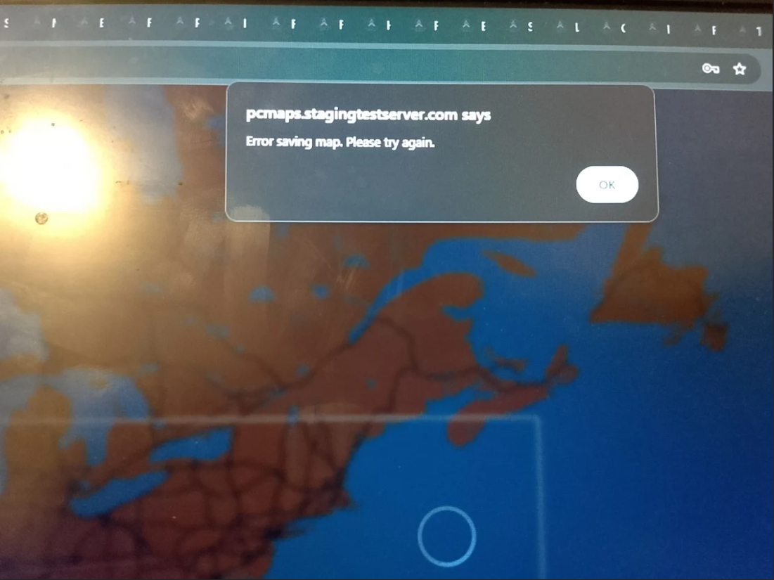
ISSUE: This error occures while saving.

Ive played in it some and some obvious things I noticed are:
I could never get the "add text" to appear or allow me to drag to the map. (Step 3). "Add text to map" doesn't seem responsive.
The scaleable Compass Rose never appeared when selecting.
Adding a business logo sometimes kind of worked, and sometimes didnt work at all. I could open a file and see it appear in the "business logo" section, but only occasionally get it to drag to the map.
When it DID drag to the map, it wasnt initially visible. I used CTRL & (+) and it became visible from the bottom of the screen and moved up as I continued to press those 2 keys.
"Save and get price" produced an "error saving map, please try again".

Images also provided by the client for frame works kindly see the email.

