

WoodStreet

**Mehmud Malek A25**

**Hasnain Quraishi B52**

**Naim Rangrej B58**

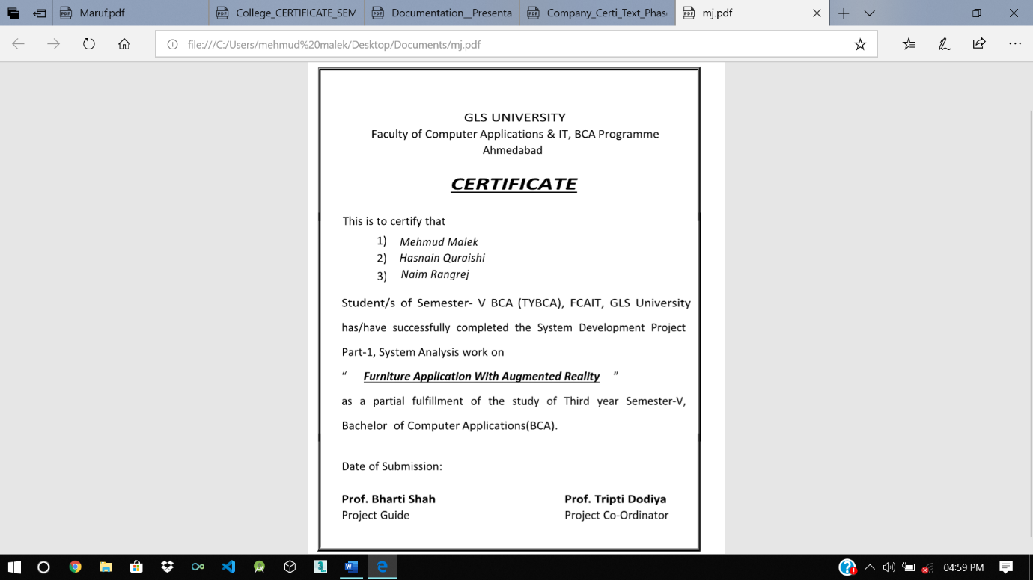

**Wood Street**

Developed For

( Jarvis Technolabs, Ahmedabad )

Report Part- I (Sem – V)

Submitted For

The Partial Fulfillment Towards

The Degree of

**Bachelor of Computer Applications (BCA)**

By

Mehmud Malek A25

Hasnain Quraishi B52

Naim Rangrej B58

**Under the Guidance of**

**External Guide**

**Internal Guide**

Jainum Jhaveri

Prof. Bharti Shah

Ahmedabad ahmedabad Ahemedabad

FCAIT, BCA

Jarvis Technolabs

Ahmedabad

**Faculty of Computer Applications & IT**

**BCA Programme**

**Ahmedabad**



# **ACKNOWLEDGEMENT**

* We are thankful to all those persons who have directly or indirectly contributed to create this project & helps us lot to make it a great success. We would get great and useful experience that will change our career.
* We grab this opportunity to introduce the project of All-In-One Application as a part of our 5th Semester BCA.
* First of all we would like to express our sincere gratitude to Prof. Bharti Shah for giving us great opportunity of Android Application development. We also like to thank her for giving guidance & constant Inspiration with the valuable suggestions during our project work.
* We are extremely thankful to each and every faculty member of GLSICA. As they share their valuable time with us for our project and solve our problem.
* We are grateful to all the member of All-In-One Application for their kind support and suggestion during all the Analysis Stage.

# **INDEX**

Company Profile ................................................................ 01

Project Profile ................................................................ 02

Usecase Diagrame ................................................................ 05

Class Diagrame ................................................................ 06

Sequence Diagrme ................................................................ 07

Data dictionary ................................................................ 09

Sample Screen

Layouts ................................................................ 11

Conclusion ................................................................ 14

# **COMPANY PROFILE**

**Company Name :-** Jarvis Technolabs

**Contact Number:-** + 91-79-48003966

**Company Address :-** E-1212, Titanium City Centre, Near Sachin Tower, 100 ft. Road, Satellite, Ahmedabad, Gujarat-380015

# 

# **PROJECT PROFILE**

**WoodStreet :-**

* In current time when you were buying a chair, a lamp, a carpet, or anything else? Remember how we excited you were about the furniture purchase, rushing home. And find out that an item did not fit in the room. And there were in two further options: either returns the goods and goes back to the start, or leave and live with it. Fortunately, with new tech advances and stuff like Augmented Reality you can place virtual furniture check whether its looks better or not. And also check the furniture information in details.
* In this application user can apply the furniture object and set the 3d object in place. So User can easily check the furniture is suitable or not. In WoodStreet App there are some Augmented Reality Features, so user is fully satisfied with this technology.

**Tools:-**

* + Android Studio
  + Unity 3D
  + MySql

**Technologies :-**

* Augmented Reality
* Vufoira
* PHP
* MySql

**System Requirement:-**

* Windows XP, Windows 7(ultimate, enterprise)
* Android SDK
* Android Device with update Version(8.0)

**Hardware Components:-**

* Processor – i3
* Hard Disk – 200 GB
* Memory – 4GB RAM

**Existing System:-**

* Currently **“ Pepperfry ”**online Furniture store is available in the market and is more popular but it do not provide Augment Reality (Virtual Reality) features that’s why customers are not able to take correct decision how furniture will look like and which colour will suit best in their area room

**Proposed System:-**

* The application will help the user to scan the place where we want to keep the furniture and it will fill the place with virtual furniture in 3D view.
* Through this system we will get rid of the difficulties of fitting the furniture in the place. Normally we buy furniture and bring home, after that we find that the furniture is not fitting in that place. So it will help the user to choose the right furniture for that particular place.
* It will also help the user to choose the look, colour and size of the furniture as we can see that place with furniture in virtual 3D view.

# USECASE DIAGRAME

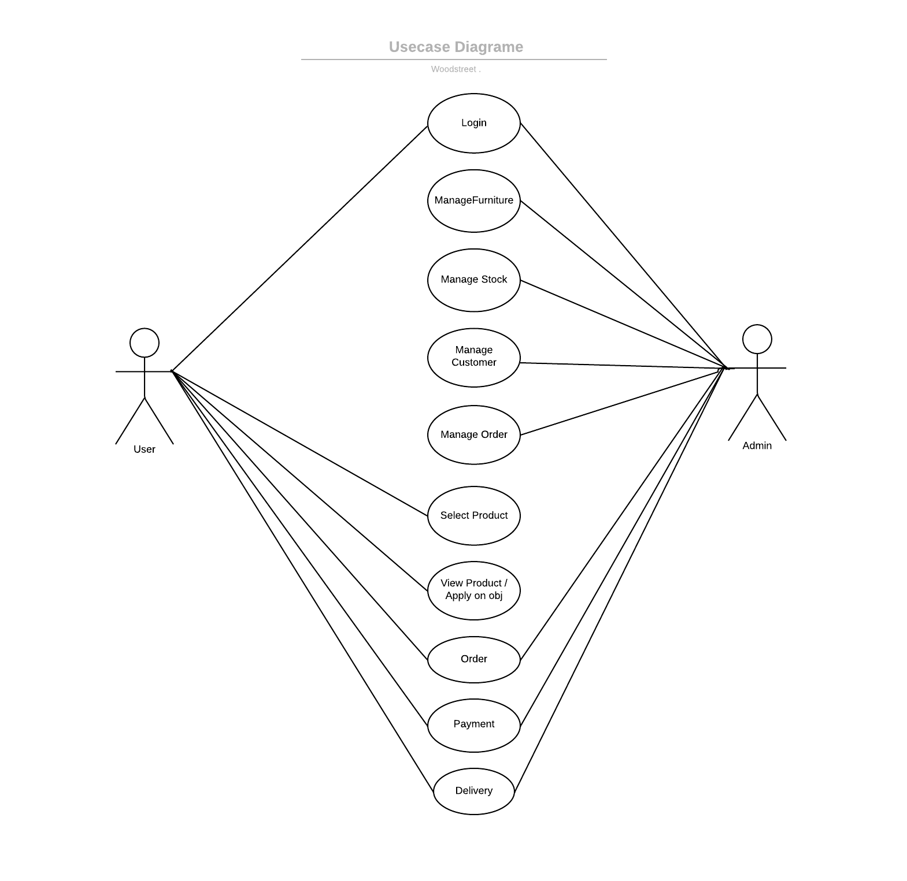

# CLASS DIAGRAME

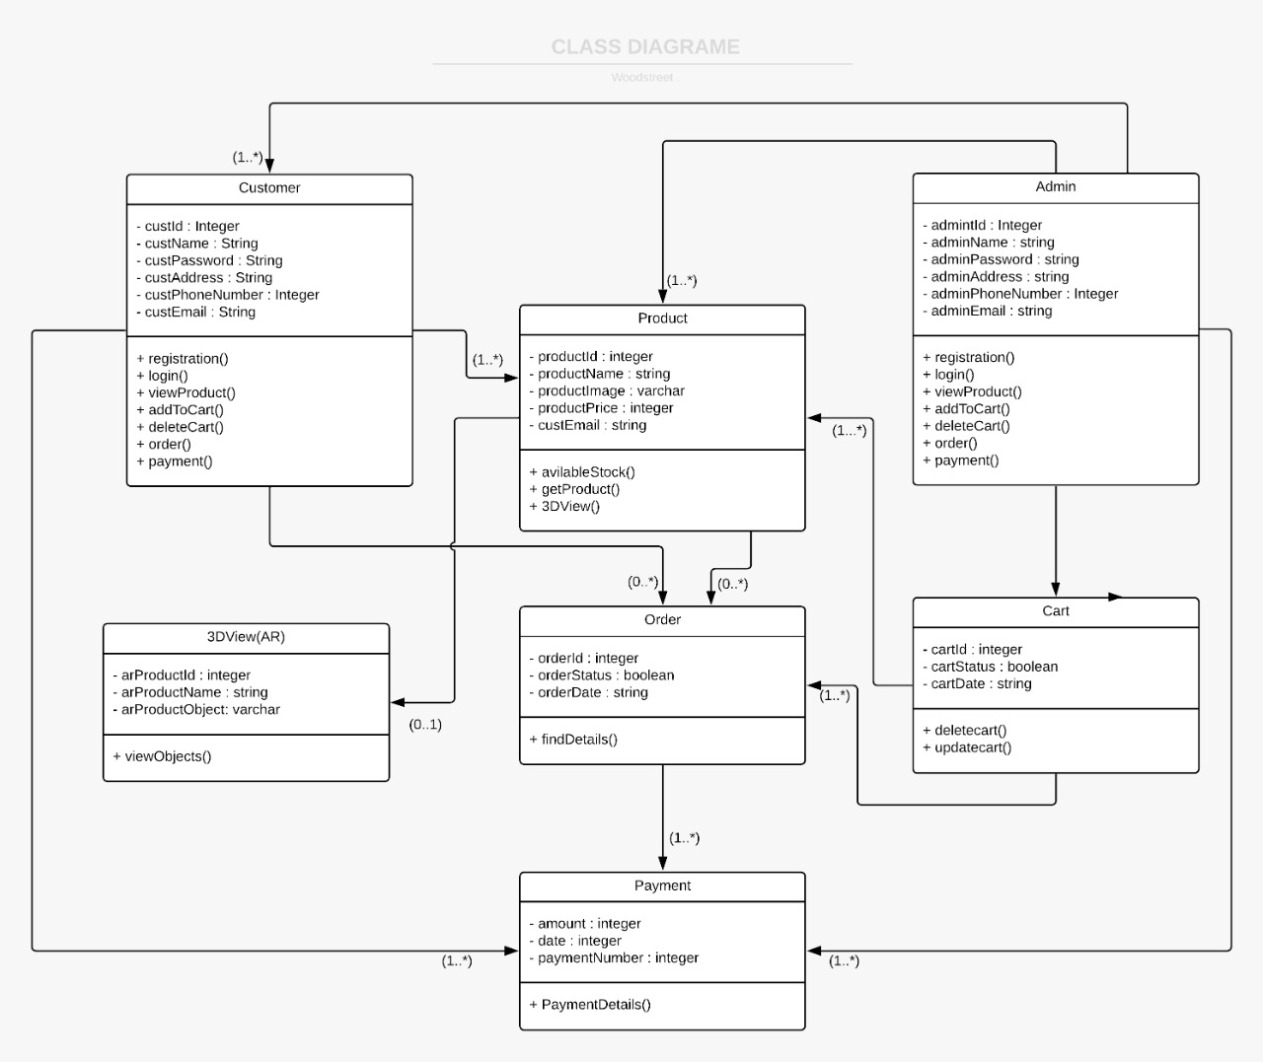

# ACTIVITY DIAGRAME

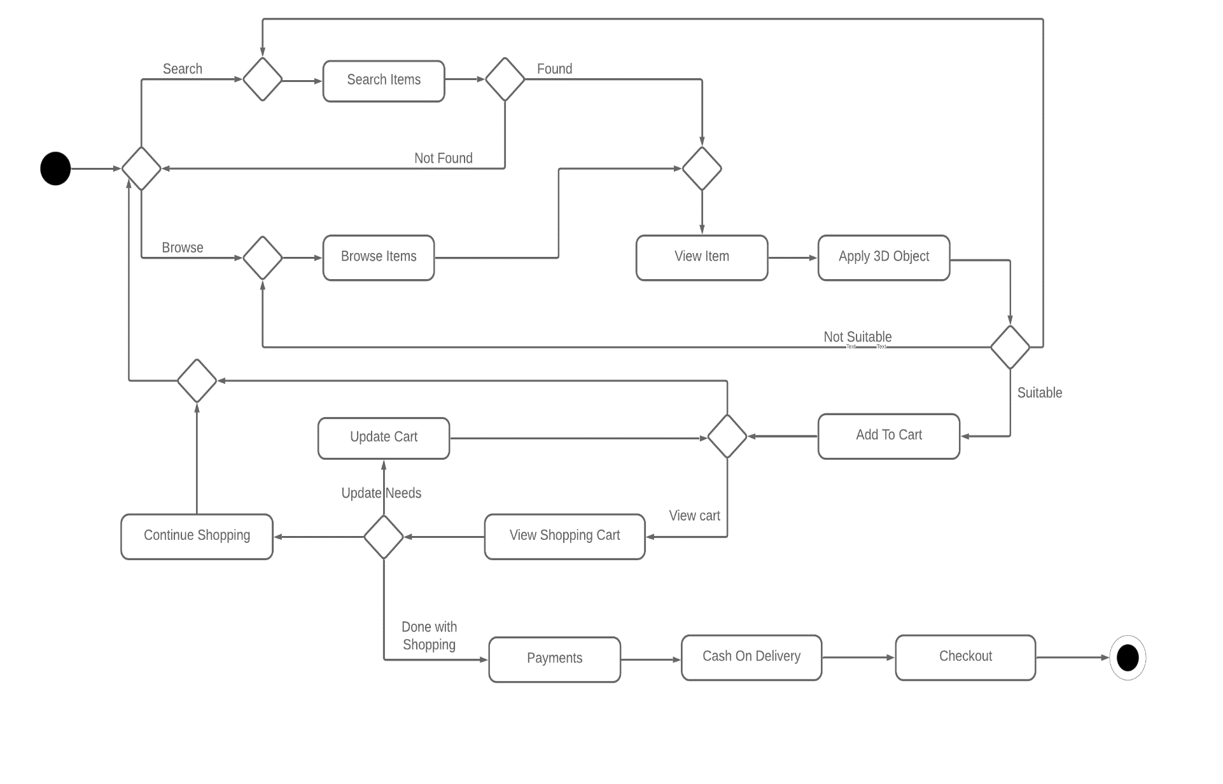

# SEQUENCE DIAGRAME (LOGIN SYSTEM)

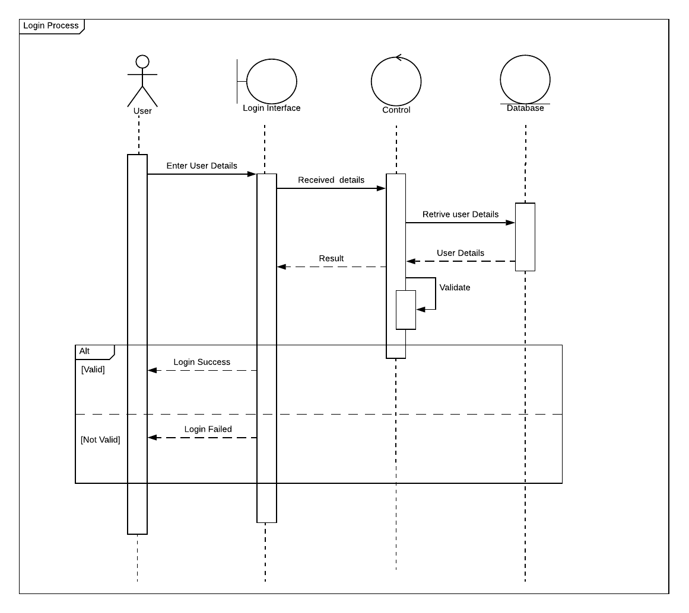

# SEQUENCE DIAGRAME (ORDER SYSTEM)

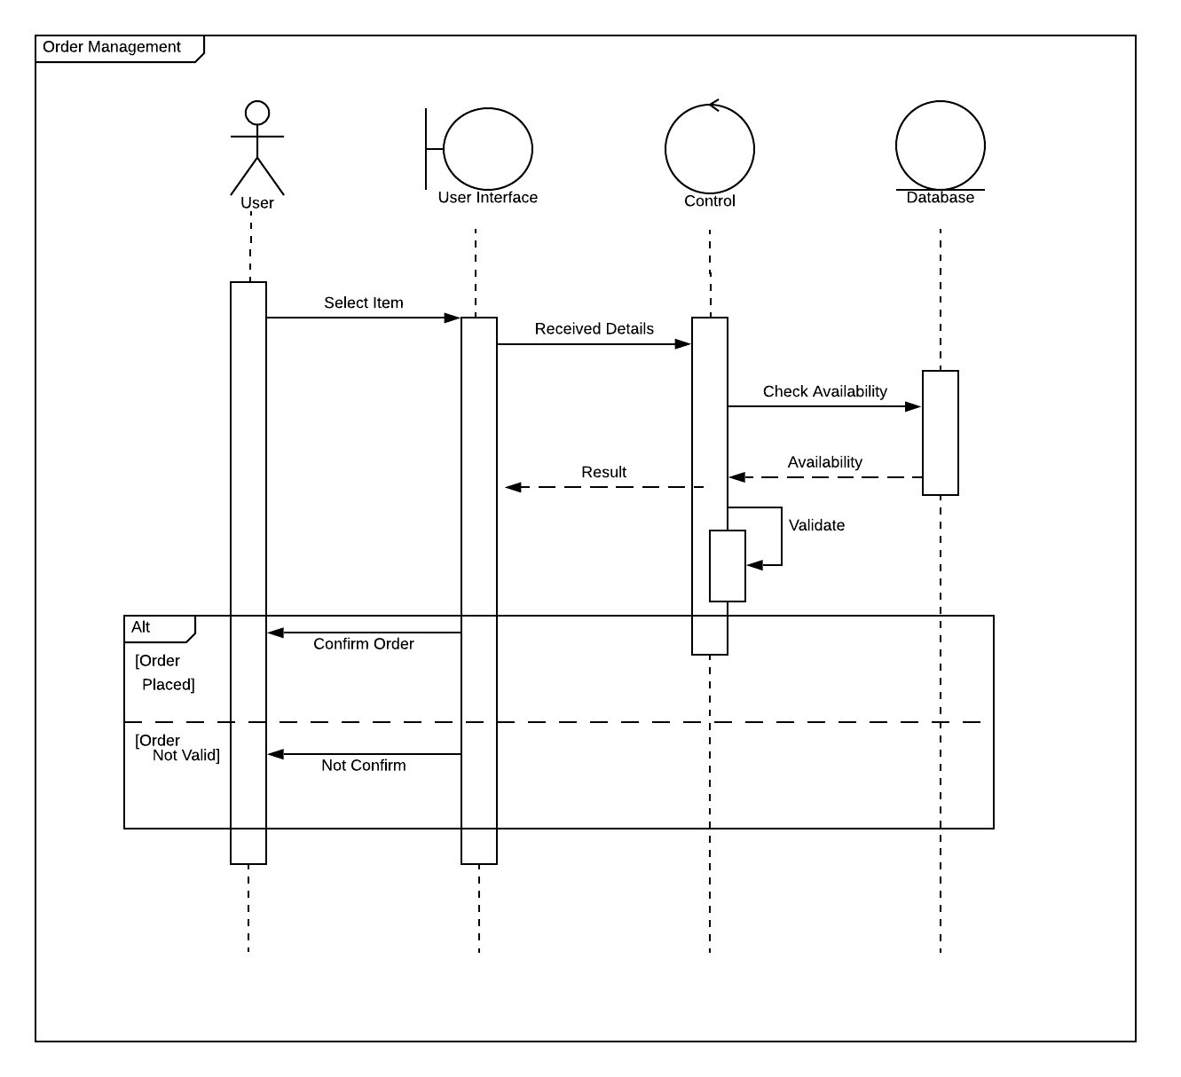

# STATECHART DIAGRAME

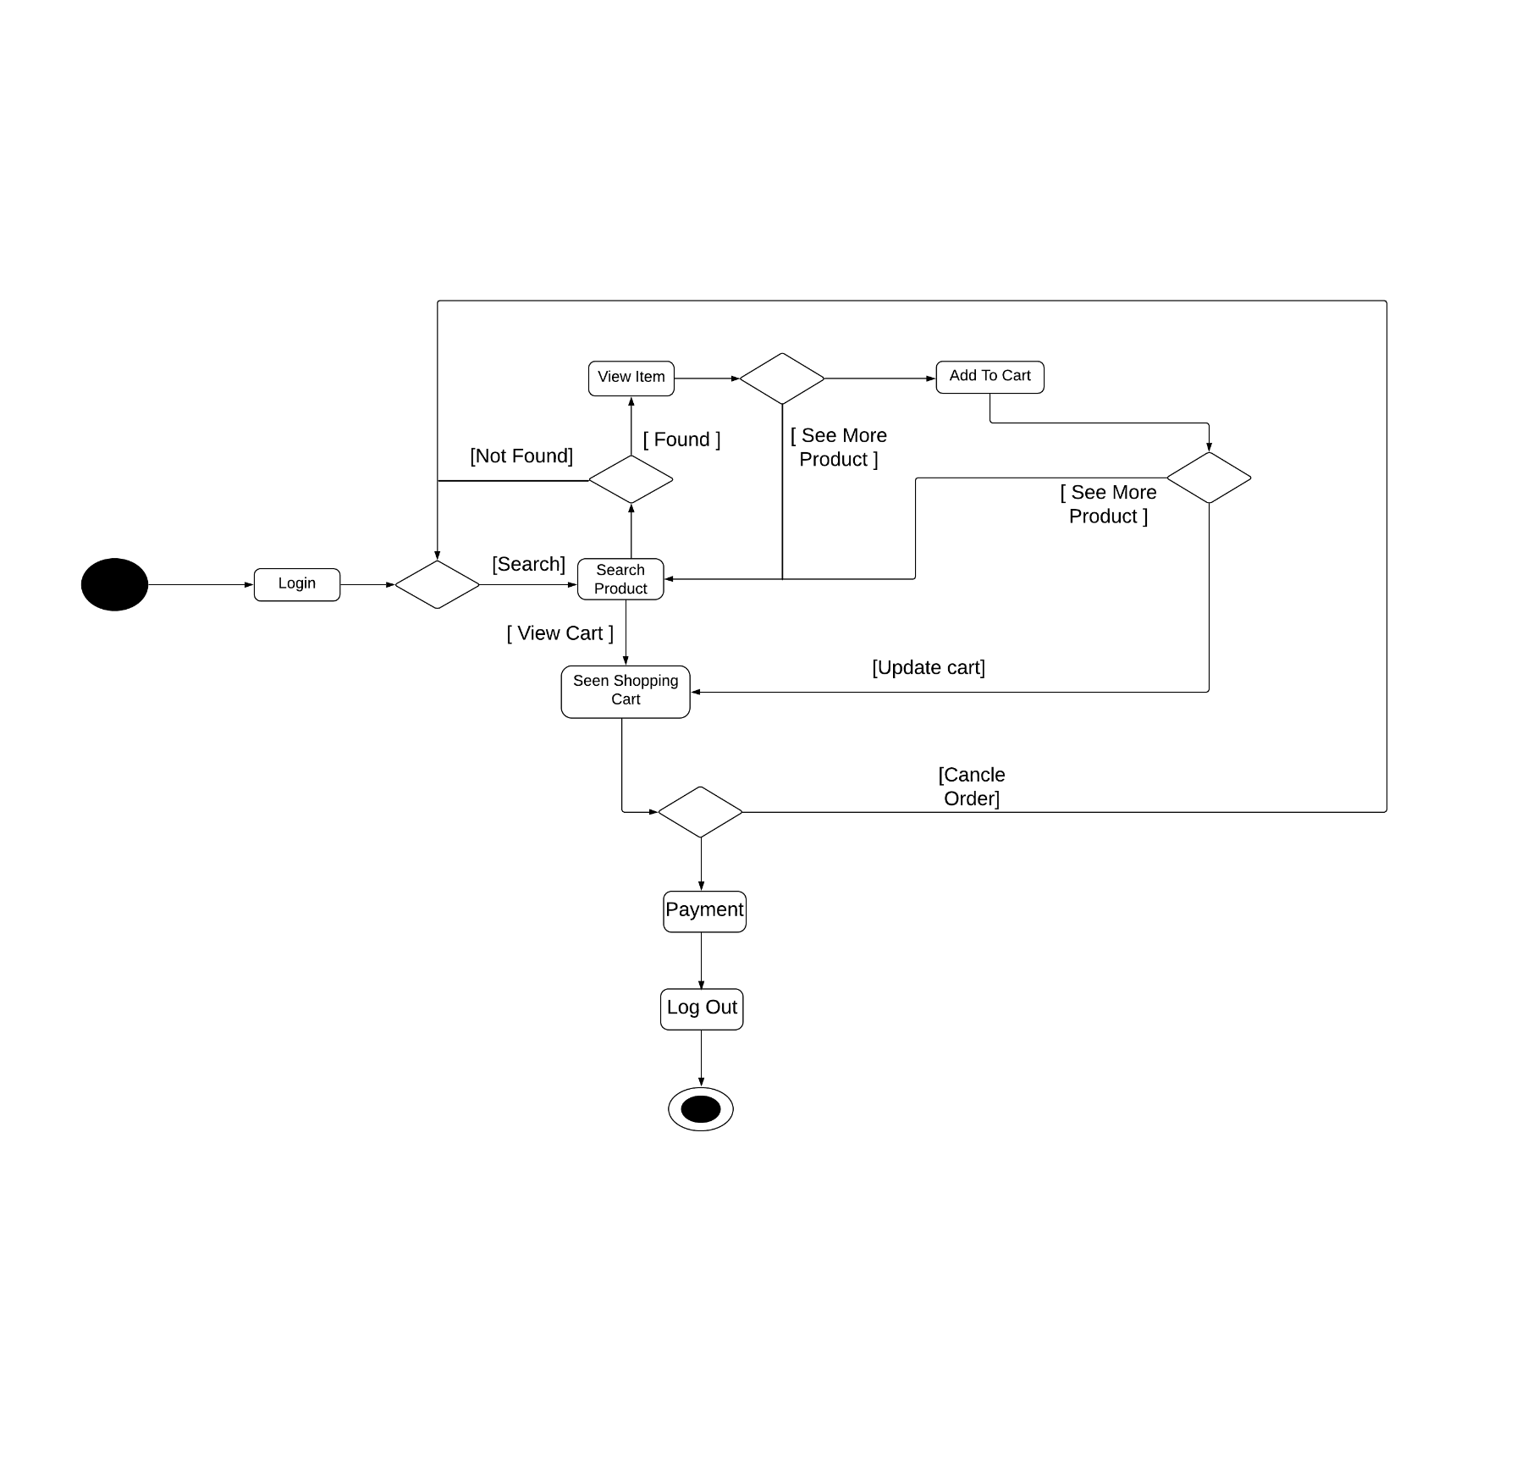

# Data Dictionary

Admin_TABLE

|  |  |  |  |
| --- | --- | --- | --- |
| FieldName | Datatype | Constraint | Description |
| Admin_id | Int(50) | Primary Key | Unique Identify |
| Admin_email | Varchar(50) | NOT NULL | Email Of Admin |
| Admin_mobile_no | Number(10) | NOT NULL | Mobile No Of Admin |
| Admin_name | Varchar(50) | NOT NULL | Name Of Admin |
| Admin_password | Varchar(50) | NOT NULL | Password of Admin |

CUSTOMER_TABLE

|  |  |  |  |
| --- | --- | --- | --- |
| Field Name | Datatype | Constraint | Description |
| User_id | Int(50) | PrimaryKey,auto increament | Identify Of User |
| First_name | Varchar(50) | NOT NULL | Name Of User |
| Last_name | Varchar(50) | NOT NULL | Family Name Of User |
| Mobile_no | Number(10) | NOT NULL | Phone No Of User |
| Password | Varchar(50) | NOT NULL | Password Of User |
| Address | Varchar(50) | NOT NULL | Address Of User |

PRODUCT_TABLE

|  |  |  |  |
| --- | --- | --- | --- |
| FieldName | Datatype | Constraint | Description |
| Product_id | Int(50) | Primary Key | Identify |
| Product_name | Varchar(50) | NOT NULL | Name of product |
| Category_id | Int(50) | ForeignKey | Identify Category |
| Product_price | Float(10) | NOT NULL | Price Allocated To Item |
| Product_img | Varchar(50) |  | Location Of Image |
| Stock | Boolean |  | Available Or Not |

CATEGORY_TABLE

|  |  |  |  |
| --- | --- | --- | --- |
| FieldName | Datatype | Constraint | Description |
| Category_id | Int(50) | Primary Key | Identify Of Category |
| Sub_category_id | Int(50) | ForeignKey | Identify of sub_category |
| Tittle | Varchar(50) | NOT NUUL | Tittle Assign to Category |

SUB_CATEGORY_TABLE

|  |  |  |  |
| --- | --- | --- | --- |
| FieldName | Datatype | Constraint | Description |
| Sub_category_id | Int(50) | PrimaryKey | Identification Of Sub_cat |
| Sub_Category_name | Varchar(50) | NOT NULL | Identification Of Sub_cat  Name |
| Category_id | Int(50) | ForeingKey | Identification Of Category_id |

CART_TABLE

|  |  |  |  |
| --- | --- | --- | --- |
| FieldName | Datatype | Constraint | Description |
| Cart_id | Int(50) | Primary Key | Unique Identify |
| Product_id | Int(50) | ForeignKey | Product Identification |
| Category_id | Int(50) | ForeignKey | Identification Of Product |
| User_id | Int(50) | ForeignKey | Identification Of User |
| Product_price | Float(10) | NOT NULL | Price of particular product |
| Product_Quantity | Int(50) |  | Total No Of Product |
| Total | Float(50) |  | Sum Of All Item In Rupee |

ORDER_TABLE

|  |  |  |  |
| --- | --- | --- | --- |
| FieldName | Datatype | Constraint | Description |
| Order_id | Int(50) | Primary Key,auto increamant | Unique Identify Of  Order |
| User_id | Int(50) | ForeignKey | User associated With  Order |
| Alternate_Address | Varchar(50) |  | Alternative Address |
| Cart_id | Int(50) | ForeignKey | Cart Associated With  Order |
| Date | Datetime | NOT NULL | Date and Time Of Order |
| Payment_type | Boolean | NOT NULL | Method Used For Payment (COD) |

# SAMPLE SCREEN LAYOUT

* Login :-

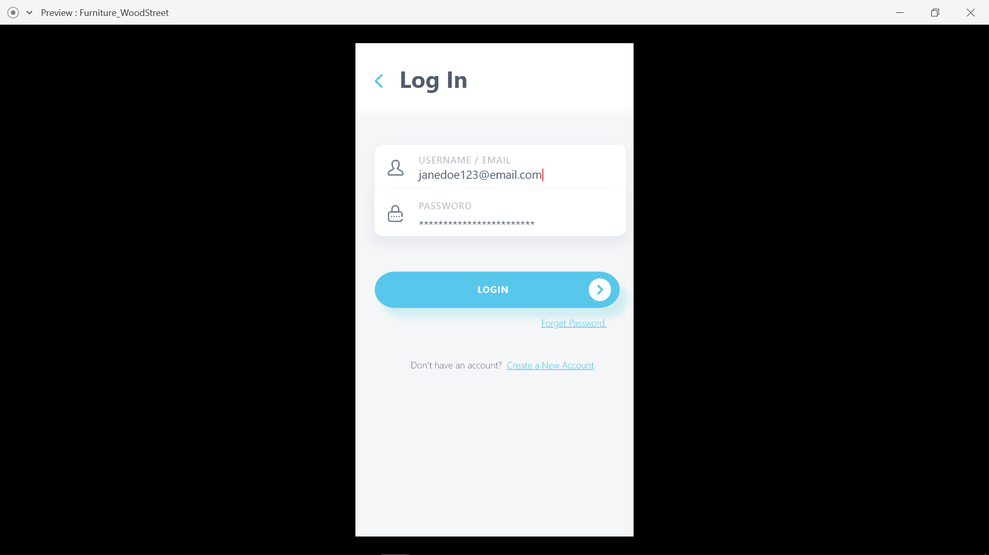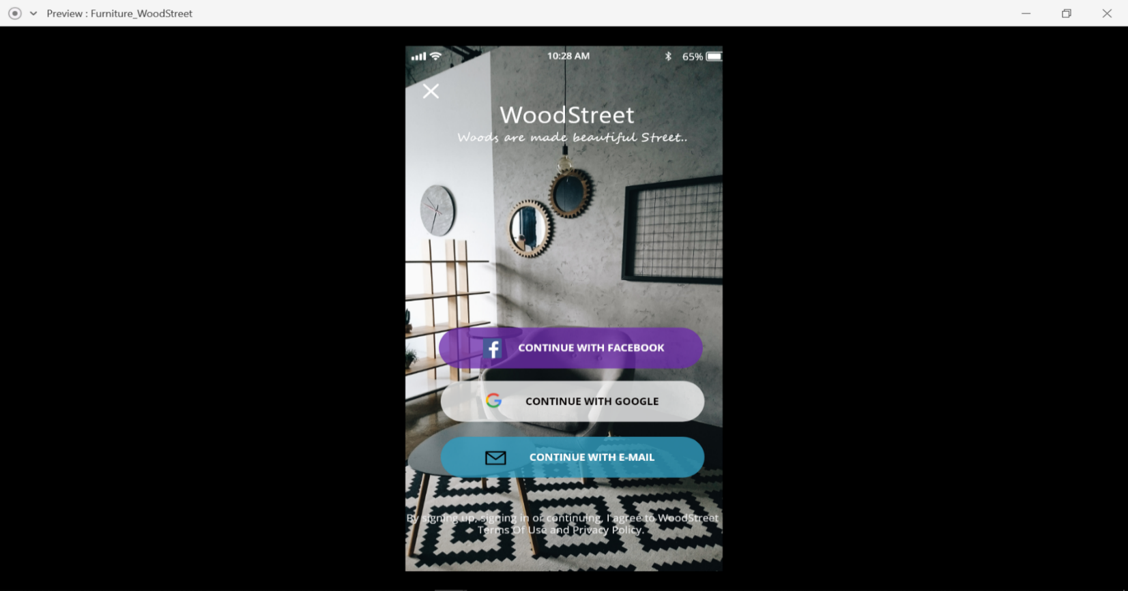

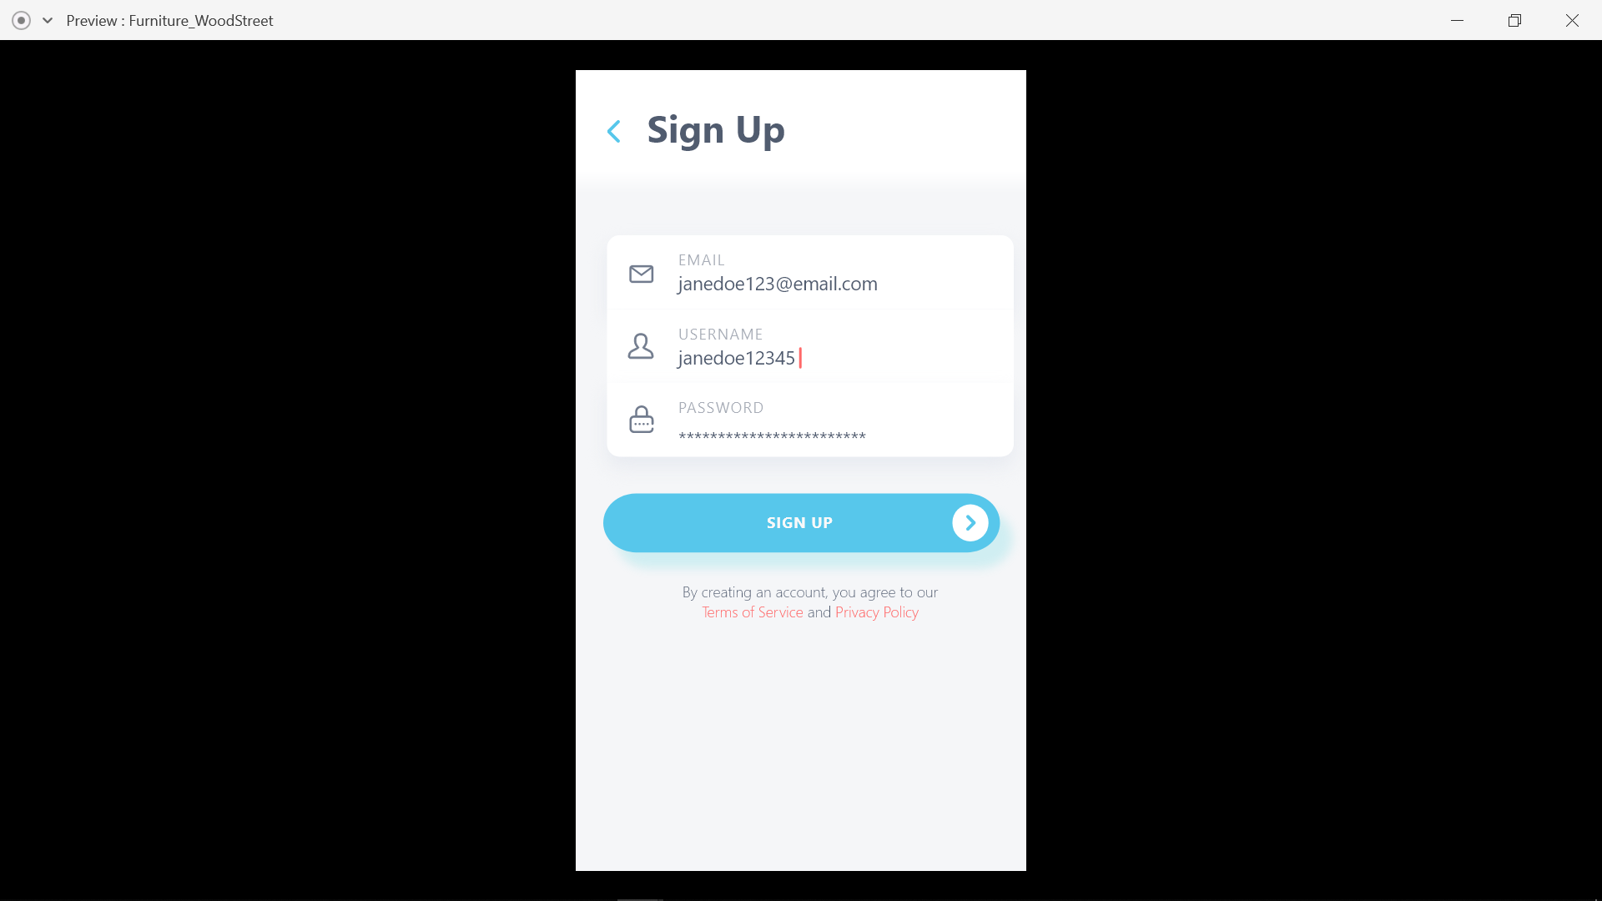

* Sign Up:-
* Home Page:-

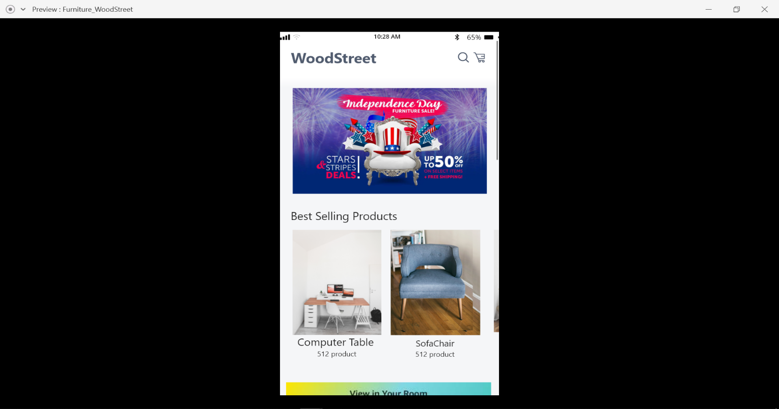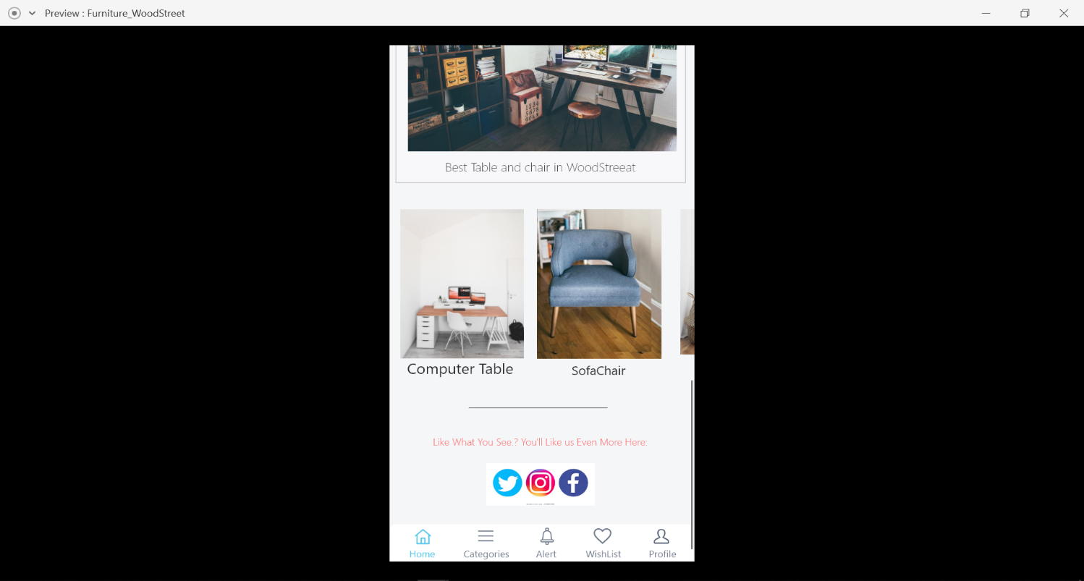

* 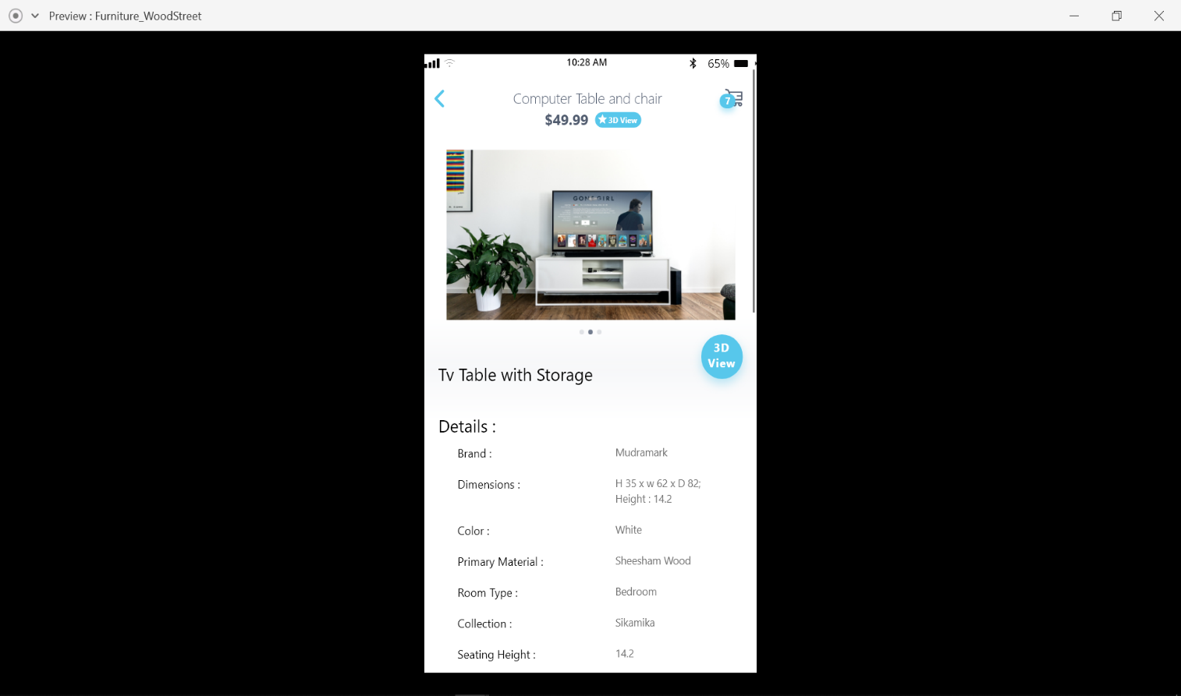Details Of Product:-
* Address Details:-

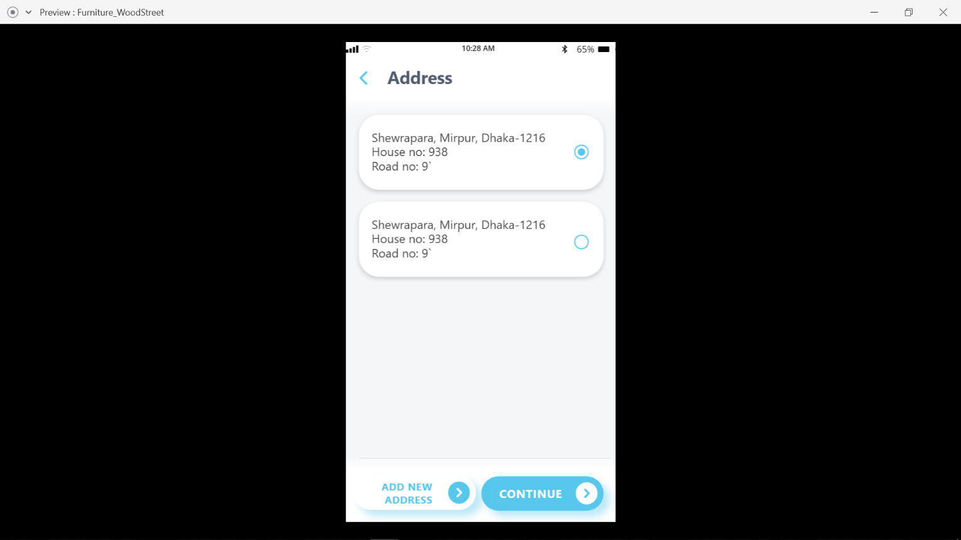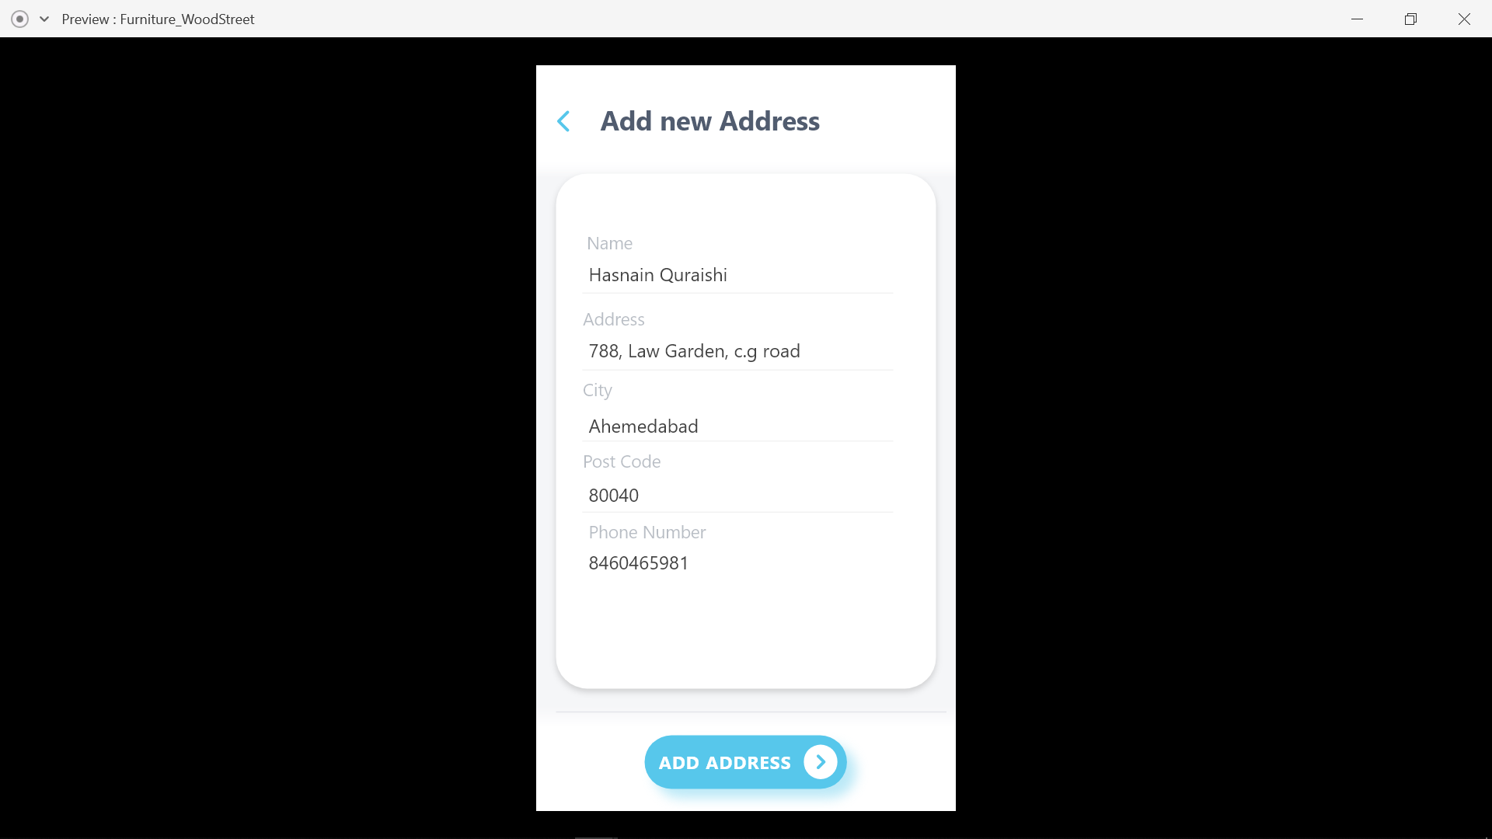

* 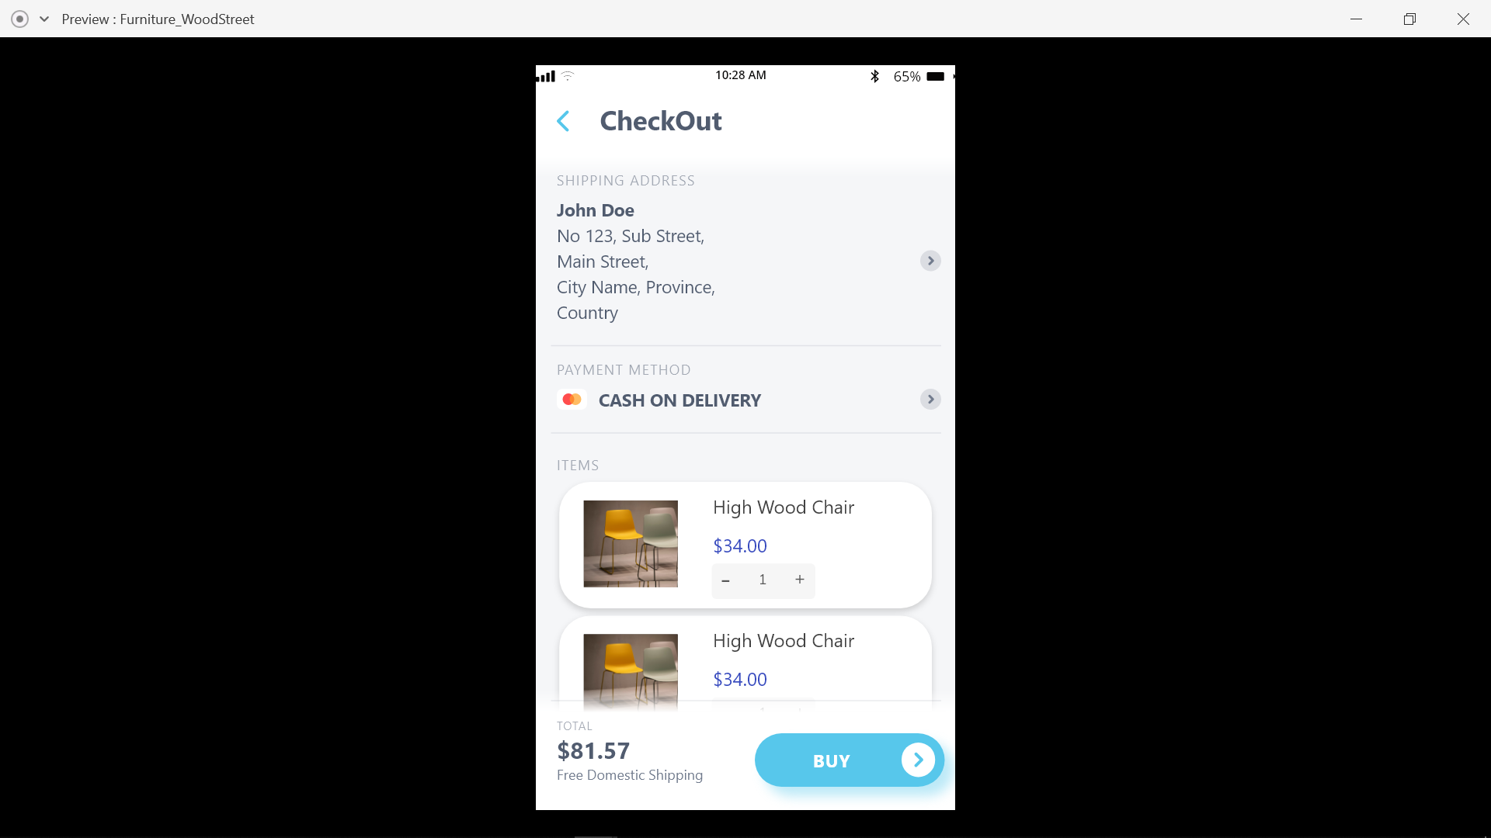Cart:-

# Conclusion

* It was a wonderful and learning experience for us while working on this project. This project took us through the various phases of project development and gave us real insight into the world of software and programming. The joy of working and the thrill involved while tackling the various problems and challenges gave us a feel of developer’s industry
* I sincerely thanks to my parents, group members, internal guide i.e. Prof. Bharti shah, external guide Jainam Jhaveriand other faculty members and GLS Faculty of Computer Applications & IT for their sole support at every step of this project.