Prof. Rafał Dreżewski (AGH): drezew@agh.edu.pl
Dr. Sylwia Kruk (UEK): kruks@uek.krakow.pl
Research topic
The use of agent-based bio-inspired algorithms for the optimization of capital and property structure of enterprises
Introduction
The goal is to use the selected machine learning models trained on historical financial data of selected companies as a mechanism for assessing individuals in an agent-based bio-inspired algorithm searching for the optimal capital and property structure of enterprises. The considered capital and property structure will include all the elements of liabilities (capital structure) and assets (property structure).
The structure considered during research is composed the percentage shares of the individual components in the whole structure. In the area of financial analysis, the internal structure is also examined, i.e. the share of individual components of current assets in their total. For example, for the first year of the attached example (assets-and-liabilities-example.xlsx file), it will look like this:
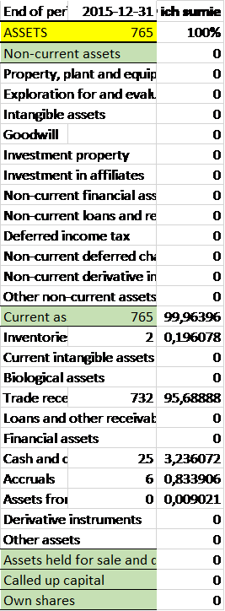
We have to assume the percentage-based structure of assets and liabilities (the percentage share of individual elements of the structure in the entire capital or property structure), because different companies have different values expressed in a given currency. So, if we use the values in PLN, we would not be able to compare them directly. The change in value of individual element of the structure will be expressed in percentage points, which is illustrated below:
 | Structure 1 | Structure 2 | Change [percentage points]
Element 1 | 20.00% | 10.00% | -10 p.p.
Element 2 | 15.00% | 15.00% | 0 p.p.
Element 3 | 35.00% | 30.00% | -5 p.p.
Element 4 | 20.00% | 10.00% | -10 p.p.
Element 5 | 0.00% | 15.00% | 15 p.p.
Element 6 | 10.00% | 20.00% | 10 p.p.
Total | 100.00% | 100.00%
The optimization of the capital and property structure involves the following tasks:
- Selection and training of machine learning algorithms for detecting outliers in financial data. The trained anomaly detection algorithm should then be used in a bio-inspired optimization algorithm to remove unacceptable capital and property structures (outliers).
- Selection and training of a machine learning model used for prediction of changes in the market value of an enterprise caused by a change in its capital and property structure.
- Developing agent-based versions of bio-inspired optimization algorithms and applying them (together with the trained machine learning models for prediction and detection of outliers) to search for the optimal capital and property structure.
Data:
- Company balance sheets in a standardized format are needed (they are available in Excel format). We are interested in the annual data (YS tab) or quarterly data (QS tab) - "Balance sheet" section, which is shown in the assets-and-liabilities-example.xlsx file.
- Market value of the enterprises will also be needed. Using the Warsaw Stock Exchange (WSE) yearbooks, it is enough to take the category Market Value. For example, in 2007 the market vasue of Budimex was PLN 2,348.77 million, and Budopol was PLN 96.98 million. The data is also available on WSE website: https://www.gpw.pl. Also, https://stooq.pl/ website or others can be used.
Bibliography
- https://www.gpw.pl
- https://stooq.pl/
- https://orbis4.bvdinfo.com/
- Thomson-Reuters - MarketLine database.
Sample tools
- https://github.com/DEAP/deap
- http://jenetics.io
- https://github.com/scikit-learn/scikit-learn
- https://www.tensorflow.org/
- https://keras.io/
- https://pytorch.org/
- https://www.r-project.org/

