

Specialisation Project 2 MTE7102

Enhancing User Confidence in Report Timeliness and Data Accuracy through Data Quality and Availability Checks

Course of study Master of Science MSc in Engineering: Profile Data Science Author Roland Angelo Roccaro

Advisor Prof. Dr. Kenneth A. Ritley

Project partner Swiss Post Version 1.0 of July 20, 2026

▶ School of Engineering and Computer Science

▶ Master of Science in Engineering

This project addresses challenges with data quality and availability at Swiss Post. The environment of postal services is highly heterogeneous due to many factors. This causes challenges in non-operative reporting, where all heterogeneity is brought into global reports, placing these differences into a homogeneous en-vironment. In this environment, both the hardware used at the operational level and the software at the reporting level are under constant change. These changes can break existing data pipelines and introduce new ways and tools of reporting. The goal of this project is to help maintain high user confidence in non-operative reporting. This is achieved by setting up rules for data quality checks and improving business and IT understanding of their respective needs in the field of data quality and availability. This topic is highly relevant to both business and IT, as it helps provide value across the entire service process. To reach this goal, research into data availability and data quality checks is conducted. This supports an understanding of what these checks do and where they should be implemented. In order to better map the challenges, both the data lineage and the reporting pipeline are researched and documented. As the main contribution towards this goal, the current data quality checks performed by the business are evaluated. This evaluation helps to ensure that business-critical values are captured in future automation. After capturing the current methods, the applied checks are translated into generalised rules and prepared for implementation.
With the main contributions of describing the data lineage and reporting pipeline, and providing a doc-umented first use case, this project contributes to future work in data quality management. It creates a solid base for the implementation of the rules in a subsequent project and for further research. With the transparency provided, the steps towards reducing manual validation efforts are established. These will be further researched during the master’s thesis, which will lay the groundwork for additional automated data quality checks in the Swiss Post DWH.

Abstract iii
- Introduction 1
  - Background 1
  - Motivation 7
  - Problem statement 8
  - Scope and boundaries 8
  - Expected outcome 8
  - Structure of the document 8
- Project management 11
  - Team constellation 11
  - Project management methodologies 15
  - Tools to support the project management 21
  - Timetracking 28
  - Risk management 29
- Topic of this Research 35
  - Problem Statement 35
  - Research gap 36
  - High level research question 36
  - Success definition 36
  - S.M.A.R.T. goals 36
- Solution landscape 37
  - The Swiss Post addresses data quality in multiple ways 37
  - Rule-Based DQM Initiative 37
  - Heterogenous sorting center environments 40
  - Data Lineage 44
  - This project as a key step towards the “future state” reporting solution 46
  - Expected benefits of this reporting solution 47
  - Existing reporting pipeline 48
  - Report visualisations and evaluations 52
  - DQM tool selection 55
  - DQM tool testing 58
- Implementation 59
  - SMART Goal 1: Setup of an Improved DQM Report 59
  - SMART Goal 2: Tool Decision 65
  - SMART Goal 3: Test of DQM Tooling 68
- Results 73
  - Introduction 73
  - Evaluation criteria 73
  - Summary 73
- Reflection and outlook 75
- Statement of Authorship 77
List of Figures 79
List of Tables 81
Glossary 81
Bibliography 89
- Amazon Athena Queries 91
  - Full DQM view query 91
  - Compact DQM view query 96
  - New Star Shema DQM view query 98
  - Testing Monitoring Query 103
- Amazon Athena Queries 107
  - Full monitoring teraform 107
- Meeting Summaries 109
- Miro usage 111
- Risk Monitoring 113
- Time Tracking 115
  - Efforts at work 115
  - Efforts outside work 115

Since mankind first began making plans, they were based on the available description of the environment. This approach continued into modern times, although the nature of the predictions has changed. People no longer plan which animal to hunt or when to produce stone tools, but instead how many people the postal service should hire for the Christmas season. These decisions require data, and in order to make the right decisions, the data must be available in the right time, in the right context, for the right people and naturally be correct. This makes data one of the most important assets in a company The Economist 2017. Data allow companies to gain an edge over competitors, analyse clients’ wishes, or improve internal processes. This is where the relevance of this project emerges.

Swiss Post requires data availability and data quality in its reporting for decision making. This project anal-yses the current state of a specific data area of Swiss Post and provides steps toward improvements. This chapter familiarises the reader with the topic. It presents the background of the project at Swiss Post and delves into the motivation behind it. It then further explains the business relevance, demonstrating why it is both important and beneficial for Swiss Post to invest in the topic. Next, the problem statement is ad-dressed, explaining what this project aims to solve. After the problem statement, the scope and limitations of the project are outlined more clearly. Finally, a brief overview of the expected outcomes of the project is provided. This chapter concludes with a preview of the document’s structure.

Background

Swiss Post is Switzerland’s national service provider, active not only in mail and parcel logistics but also in passenger transport (PostAuto), financial services (PostFinance), and various digital and e-government solutions. Its workforce of approximately 45’000 employees and nationwide infrastructure move millions of items and people every day, supported by highly automated sorting centres and extensive data flows Post 2024. In such a diversified organisation, analytical reporting is essential for strategic steering, operational planning, and maintaining service quality across business units. The organisational structure of Swiss Post is shown in the following diagram.

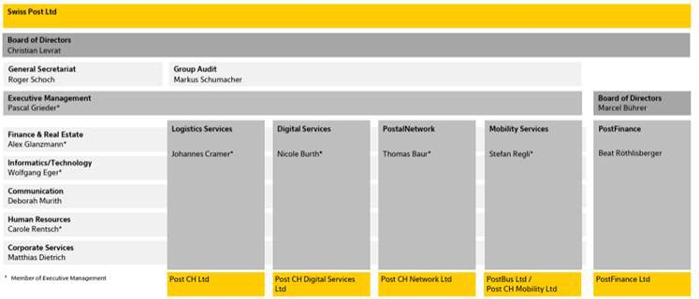

Figure 1.1.: Organisational structure of Swiss Post (online version)

The full mail piece lifecycle

Within this large organisation, the project takes place within a specialised team supporting the entire life-cycle of logistics for mail and parcel delivery. In German, this lifecycle covers every step from A to Z, ASTVZ, which stands for:

▶ Annahme: Receiving, where parcels and mail are accepted and registered by Swiss Post to be sent through its network

▶ Sortierung: Sorting, the process during which received mail pieces are separated by destination and routed to the next process step, either further sorting or delivery

▶ Transport: Transport includes the movement between sorting plants and delivery sectors

▶ Verzollung: Customs clearance handles international parcels and letters, including the required cus-toms checks and documentation

▶ Zustellung: Delivery is the final process step for every item; it is delivered by the staff of Swiss Post

However, this process is more easily visualised using the future vision of Swiss Post. In particular, the version tailored for the IT domain is well suited to describing the project environment. Starting from the top left with the A or V step, followed by S, T, and Z, the process progresses towards the bottom right.

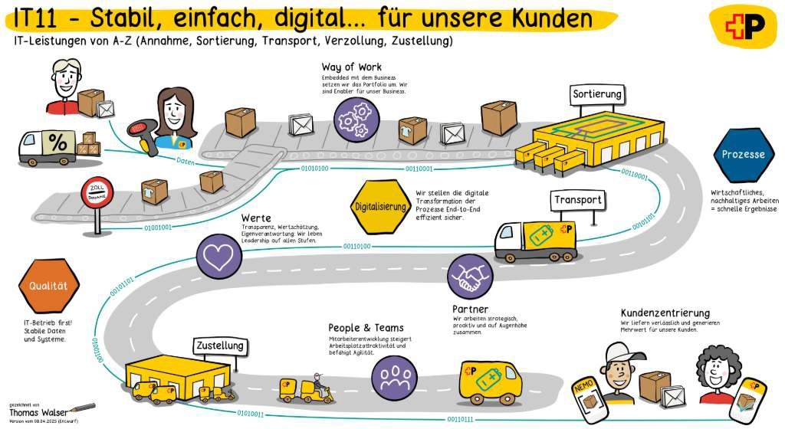

Figure 1.2.: Future way of work illustrating the full postal delivery workflow from receiving an item to delivery.

DWH LS OPS

The project team supports the Data Warehouse of Logistic Services Operations (DWH LS OPS). This Business Development Operations (BizDevOps) team is located within the organisational structure of the Logistics Services vertical and the Informatics/Technology horizontal. It represents the single source of truth for an-alytical reporting at Swiss Post. In contrast to operational reporting, which focuses on real-time guidance for operational processes, analytical reporting focuses on aggregated insights for evaluation and planning. Examples of analytical reporting include working time, process time, and aggregations of sorted items. The stakeholders of the team distribute these reports to various task groups within postal services, such as sorting and delivery.

There are two reasons why a deeper understanding of analytical reporting is currently very important. First, the infrastructure for analytical reporting is transitioning from on-premise systems to the cloud. Second, in addition to the migration of reporting, the infrastructure at all Swiss Post sorting center loca-tions for parcels is undergoing fundamental changes. These changes may include complete modifications of data pipelines, which can make comparisons with previous figures impossible. Therefore, at this criti-cal point in time, it is of utmost importance to maintain users’ trust in the data during this change process. The following figure illustrates the shift from the on-premise setup on the right-hand side to the target architecture using cloud hardware on the left-hand side.

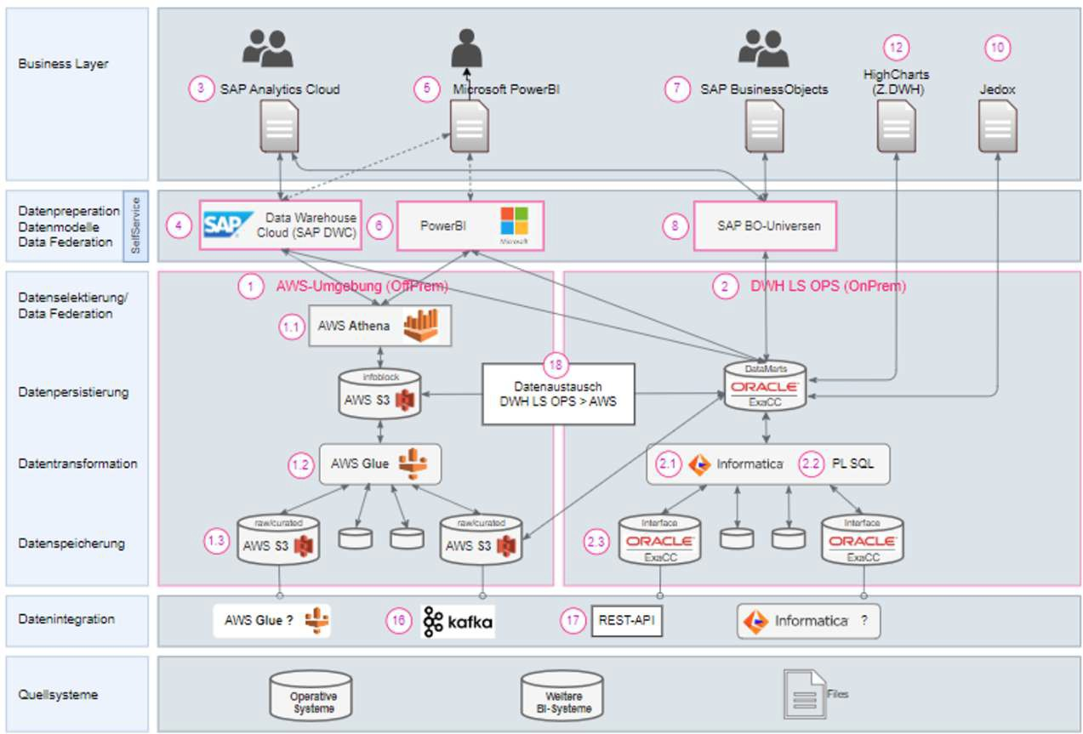

Figure 1.3.: The transition from an on-premise setup to a cloud-based target architecture.

Swiss Post sorting centers are cyber machines

Swiss Post has built and operate a number of massive sorting centers located across Switzerland. These are far more than just mechanical warehouses or factories. Rather, these sorting centers are massive “cyber facilities” that include high-tech hardware but also high-tech IT systems to keep them running.

While the team handles use cases across the entire postal delivery workflow, this project initially focuses on supporting sorting data flows. Sorting at Swiss Post is the process of consolidating received items in centralised plants, to which letters and parcels are sent from regions across Switzerland. One such plant is located in Härkingen:

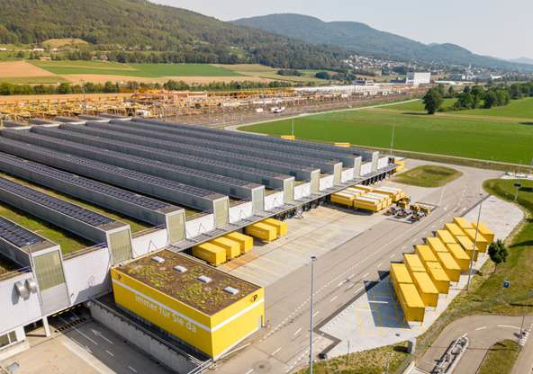

Figure 1.4.: Aerial view of the Swiss Post sorting center in Härkingen.

Mail pieces are handled by workers and placed onto the automated sorting hardware of Swiss Post. This hardware enables the handling of up to 10’000 parcels per hour Post 2023. The system scans the received items and transports them through the plant via conveyor belts to their correct destinations, where they are discharged through chutes. These chutes are shown in the second image, including staff placing the parcels into roll boxes for further processing.



Figure 1.5.: Interior view of the automated sorting system in a Swiss Post sorting center.

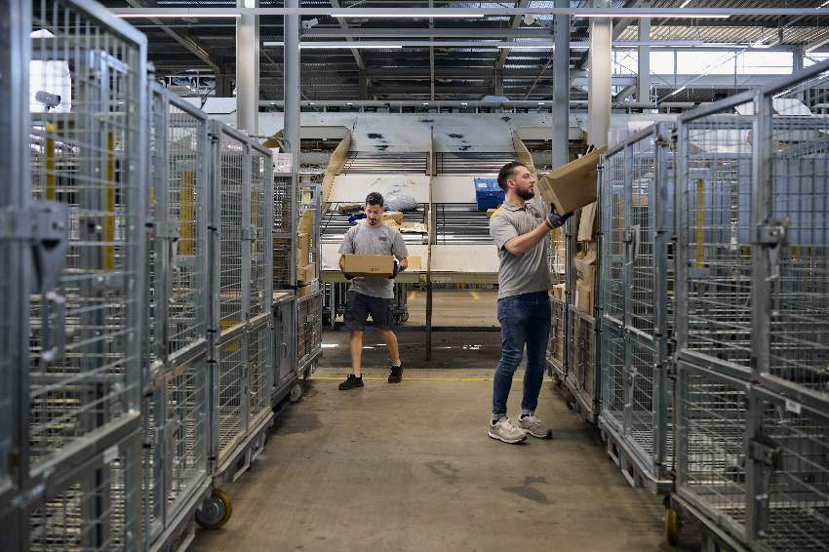

Figure 1.6.: Discharge chutes inside a Swiss Post sorting center, where parcels are released to their designated zones. Then put into rollboxes to get them to next processing steps.

Motivation

Data quality and data availability are central to the successful operations of any company. Even a com-pany working in low-tech or non-IT industries Pas 2025 has basic but essential data needs, for example, information on who is working where and the addresses of clients and staff. Not having this data in the right quality or available to the right people at the right time will cause problems whenever the data needs to be used.

In the context of ongoing changes to the Swiss Post reporting infrastructure, keeping track of data availabil-ity and data quality is challenging. These infrastructure-related changes comprise the construction of new reports, one-to-one migrations, and the re-engineering of existing reports. Since the topic of data quality in the Swiss Post operations area could be built from scratch, as if starting on a greenfield, it became an ideal subject for a master’s thesis.

Furthermore, the topic was not of the highest priority for Swiss Post, but it was still considered a valuable idea to pursue. The medium-priority nature of this project also allowed the topic to be divided into multiple steps, such as working from a PoC to an MVP setup. Additionally, the medium priority regarding feature development in this area allowed for well-grounded research on the topic. All these aspects combined made it a suitable project leading to a master’s thesis. Furthermore, due to the lack of automated data accuracy and data quality checks in the DWH LS OPS environment at the time of defining this project, this topic is highly relevant to the team responsible for both the operational and analytical reports that help guide the company. If the data is incorrect, wrong decisions are made; and if the data is unavailable, management cannot properly lead the staff. Thus, the topic is of high importance and business critical: data quality and availability help Swiss Post continue to deliver reliable services on a daily basis and enable IT to provide better assistance to staff throughout the postal process.



Figure 1.7.: Main customer touch point, delivery of a parcel

Problem statement
The two key problems addressed in this project are, first, that data quality in this area of Swiss Post has so far been handled in an ad hoc manner, without formal definitions, frameworks, or an agreed set of KPIs; and second, that data quality is handled manually by the business at a high level rather than being automated by the IT department. Both of these problems lead to issues not being detected early and to longer reaction times. As a further consequence, delays in data processing are not identified and targeted for systematic resolution, which in turn reduces management confidence in the reports. All of this prevents continuous improvement, as the current checks are neither documented nor stored in a way that allows follow-up analysis or structured refinement.

Scope and boundaries
This research focuses on the data availability and data quality challenges of the DWH LS OPS BizDevOps ASTV teams at Swiss Post described in section 1.1. To simplify the scope of this work, the first step of data retrieval, such as how data is stored from Kafka topics, is excluded. The scope begins with the curated and reporting layers in the ETL process of the retrieved data. The aim of this project is to specifically provide solutions for the mentioned teams and not to offer a general solution or framework for the entire Swiss Post.

Expected outcome
The high-level goal of this master’s thesis pre-project is to demonstrate that automated data quality checks provide additional safety and can be calibrated to the needs of the business. Automated data quality checks refer to checks executed daily or upon data load, which are always carried out by systems without the need for manual interaction. More specifically, the project focuses on establishing the foundations for this goal by analysing the current situation and developing a proof of concept (PoC). It will carefully document and explain the steps taken toward the proof of concept and, in this way, make the decisions made understand-able. The success criterion of this project is to provide a PoC, or steps toward a PoC, that help reduce the costs of manual checks.

Structure of the document
This document is intended to guide the reader through the project in meaningful steps, explaining how the project is set up and executed, and then leading into the research and conclusions. It is structured in the following way. First, the document begins with the project management chapter, which explains the methods used during the project. It provides reasoning for tool choices where applicable and lists the tools and teams with which collaboration took place. Next, the research chapter describes the problem in more detail. It clearly defines the specific and measurable goals of the project and presents the research sources used. This allows the reader to understand the decisions made and establishes the basis for the so-lution design. The subsequent solution design chapter explains how the problem statement is addressed. It describes the tools selected and how they interact with one another. This is followed by the implemen-tation chapter, which presents the implementation of this design. It contains the work carried out by the project team and outlines any issues encountered. After the implementation, the target analysis chapter compares the expected outcome with the achieved outcome, assessing how many goals were reached and listing their fulfilment status. The document concludes with the critical review and lessons learned, sum-marising what went well and what did not, and offering specific suggestions on which methods to retain

or replace. This will be valuable for forthcoming projects (PA2, Master’s thesis) that will be carried out following this project. Finally, additional materials are provided in the appendix.

Project management

The project management chapter summarises the environment of this project and how it is conducted. First, the teams in which the project staff is engaged are listed, allowing the reader to see the relevant surrounding teams. Second, the different methods for effort and task tracking are introduced, so that the project and progress management methods applied are understood, together with their reasoning. Third, the toolsets used by the different teams are described, which allows the variety of tools and their usage to be grasped. Fourth, time tracking is introduced and explained for transparency, while the tracked time is provided in the Annex. Finally, the risk management section describes the risks handled and the measures taken to counteract them.

Team constellation
This section explains the team environments in which the project takes place. This serves to provide an un-derstanding of the direct project team working on this project and other teams at Swiss Post that contribute to the goals of the project.

Relevant Swiss Post teams
At Swiss Post, three teams are active and related to this project. In what follows we elucidate their tasks at Swiss Post, how they work together, and their contributions to this project. These teams are:
▶ BizDevOps team DWH LS OPS
▶ AWS Modernisation team
▶ Data Quality Initiative (DQM team)

DWH LS OPS team
The team Data Warehouse of Logistic Services Operations (DWH LS OPS), contains the main project re-source and the author of this document is situated, namely Roland Roccaro, Business Analyst in the MPP team. The key mission of this team is to deliver accurate reports guiding decision making in the postal services of Swiss Post. The DWH LS OPS team is responsible for developing and operating the Swiss Post data warehouse DWH for logistics services, which is the business unit that handles all postal services. The DWH is used for analytical reporting, which includes reports not used in direct daily operations but used for various forms of reporting, such as productivity analyses based on volumes and working time, informed long-term decision-making, as well as daily handovers and near-term planning.

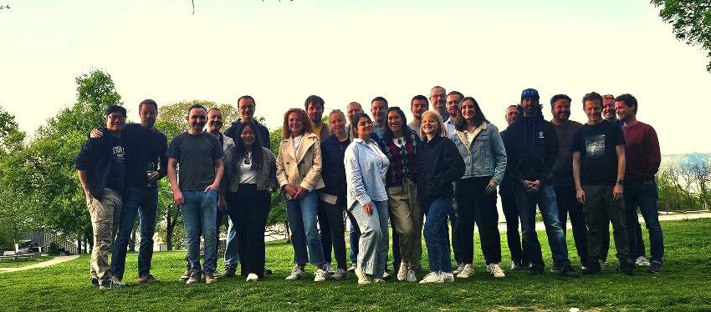

Figure 2.1.: Picture of DWH LS OPS team

Within the Swiss Post this team is also referred as a Business Development Operations (BizDevOps) team, because it contains all required personnel, to create, deploy and maintain reporting solutions. This starts with business analysts to evaluate existing reports and their usage, and to document and specify them for further updates or re-engineering. This continues through the implementation, which is carried out first by data engineers and then by business intelligence (BI) engineers. Finally, the business side is involved in testing these reports and also serves as the main source when it comes to questions of how or what to implement. Due to the size of this team and the different responsibilities, the DWH LS OPS team consists of three separate sub-teams. These teams are ordered along the process of postal services as introduced in the full mail piece lifecycle being: Receiving, Sorting, Transport, Customs clearance (German acronym is ASTV), Delivery & Finance (D & F), and finally the planning focused Parcel Volume Planning and Fore-casting (german acronym is MPP).
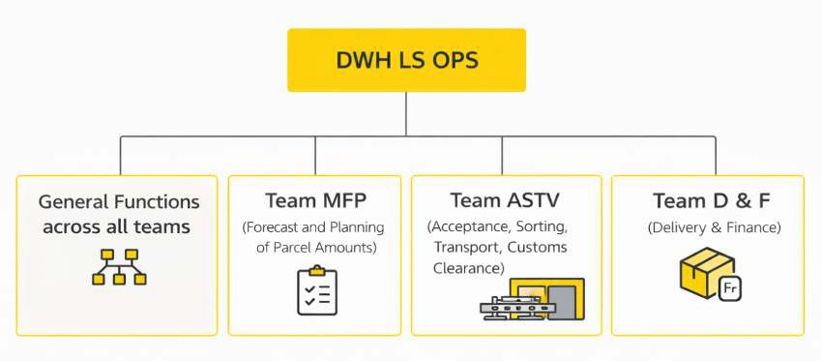

Figure 2.2.: Team and sub-team organisation

AWS modernisation team
Swiss Post is currently in a process the modernisation of the AWS cloud environment, which the Swiss Post itself describes as follows:
Swiss Post is currently pursuing a strategic modernisation of its AWS-based data lake with the objective of improv-

ing developer efficiency, increasing operational reliability, and establishing a modern, data-driven architecture. According to internal documentation, the initiative is aligned with deftned key performance indicators and aims for completion by the end of the ftrst quarter of 2026 Swiss Post 2025.

This modernisation is performed with the assistance of consultants as part of improving AWS usage in DWH LS OPS. The improvements are detailed in 15 KPIs across topics such as AWS Glue job optimisation and deployment pipeline improvements. With the assistance of the consultants, best practices are applied to the development of ETL, as well as general improvements to deployment pipelines. Most importantly for this project, the initiative also includes DQM improvements. As a reference, a screenshot of the Confluence landing page describing the initiative is shown below:

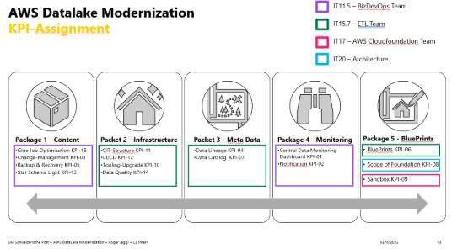

Figure 2.3.: The start page of the AWS modernisation, listing KPI and latest news

This team consists mainly of consultants with long-term experience in assisting companies in becoming proficient with AWS. They support data engineers at Swiss Post by improving existing code and reviewing it for potential enhancements. This is relevant for Swiss Post, as the development of the cloud infrastructure started without full architectural support and therefore has room for improvement.

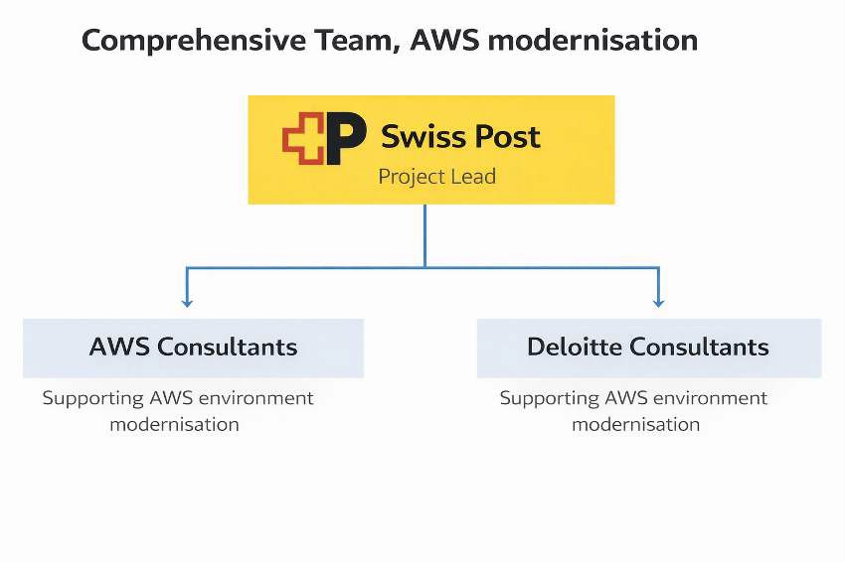

Figure 2.4.: The team setup of the AWS modernisation

DQM team
The third team relevant to the project is the DQM team. The team serves KPI 14 Data Quality within the AWS modernisation. Their goal is described on Confluence as follows: specify, review, and implement an MVP to enable data scientists and ETL engineers to forward data quality measures to a monitoring dashboard for both business users and developers.
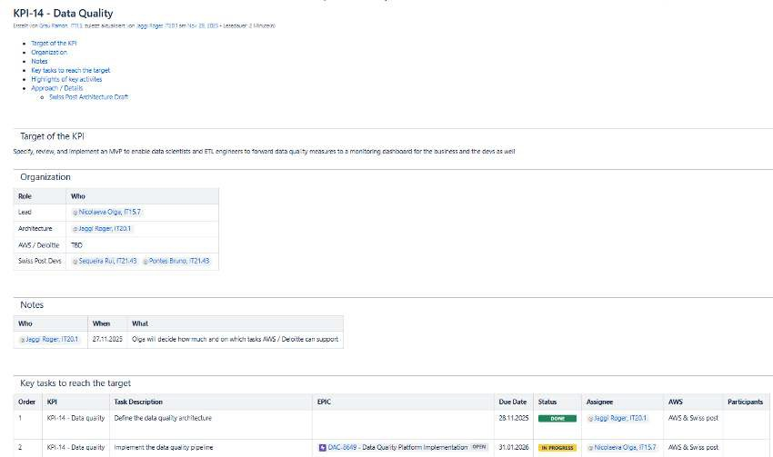

Figure 2.5.: The KPI 14 Data Quality start page on DWH LS OPS Confluence

The team consists of three developers with the assistance of a lead data engineer. This setup ensures that the developers can deliver results efficiently, while the lead data engineer provides design guidance and solution structure.
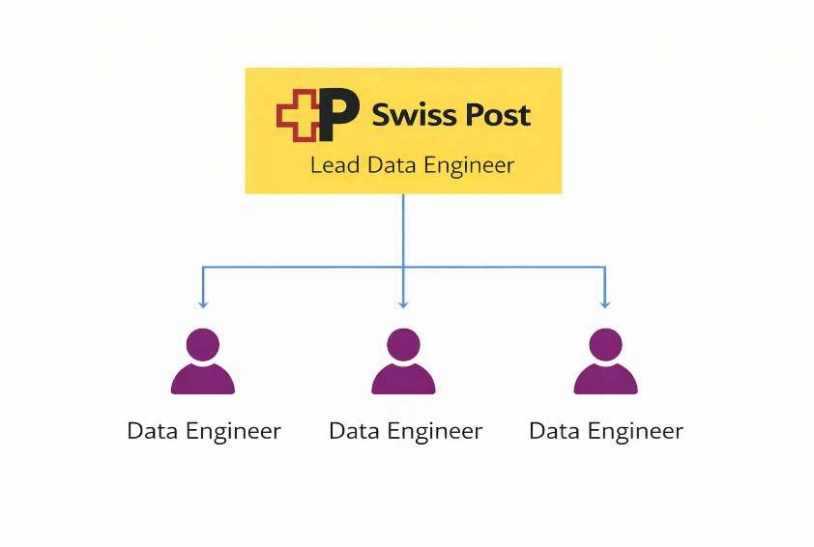

Figure 2.6.: The DQM team setup

Academic project team
The academic team consists of the author and the academic advisor. The author conducts the practical work, which includes analysis, implementation, and evaluation. The advisor provides expertise in the academic process and acts as a sparring partner regarding the writing process and project management, offering methodological and academic supervision.


Figure 2.7.: The academic team setup

Project management methodologies
This section details how the different teams manage themselves. This is done for reasons of transparency, so that the reader understands which project management methods the individual teams use. This high-lights an additional level of complexity in the working environment. Not all teams are addressed in every

subsection, as the project team was not involved in all teams’ methods to the same depth. First, project management methods are highlighted, followed by the different timeline management approaches. In the following figure, the different boards and management methods are aligned around the central academic team to illustrate the broad set of methods.

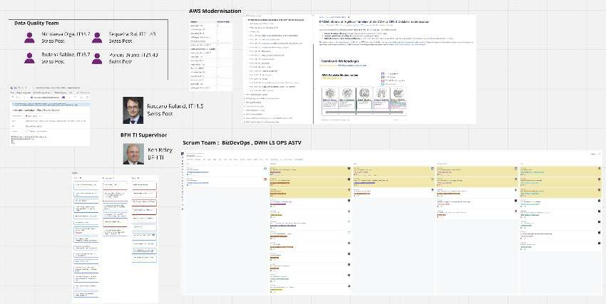

Figure 2.8.: All methods on one picture showing their diversity

Project management

Project management for this project consists of three main elements. These are Scrum, Kanban, and weekly meetings.

Scrum

The DWH LS OPS team is organised as a BizDevOps Scrum team (see Section 2.1). The AWS modernisation teams join these Scrum teams 2.1. The full set of rituals defined for Scrum is used, including daily meetings, sprint retrospectives, sprint planning held every two weeks, and reviews held every four weeks. In addition, a weekly Scrum meeting is held to maintain communication between the ASTV, D&F, and MPP teams. The meetings are shown in the first screenshot, while the second illustrates a noteworthy team definition: the rules of engagement established for collaboration, which are a result of the retrospectives.

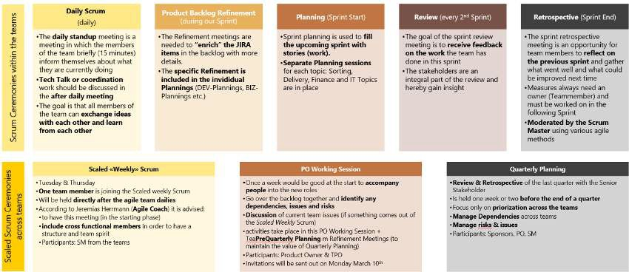

Figure 2.9.: Scrum ceremonies of DWH LS OPS BizDevOps team

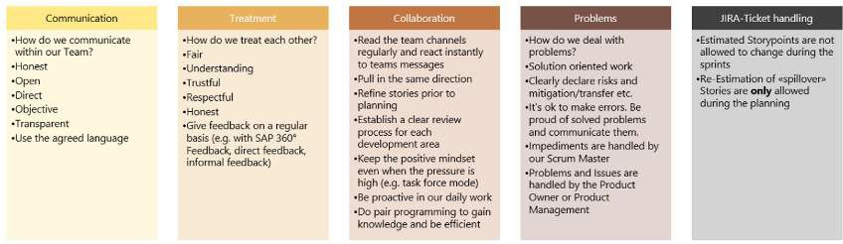

Figure 2.10.: Rules of engagement of DWH LS OPS BizDevOps team

Weekly Meetings

Contact with the DQM team is handled using weekly meetings 2.1. These serve as minimal update sessions during which weekly progress is communicated to all team members. While the developers in the DQM team are themselves also part of a Scrum team, their sprint management is out of scope.

Kanban

The academic team handles tasks using a Kanban board 2.1. The tasks are organised into three main columns. Both team members show their responsibilities on the Kanban board. The blue cards repre-sent the author’s tasks, while the red cards represent the advisor’s tasks. The board is updated frequently and is reviewed during the weekly Jour Fixe.

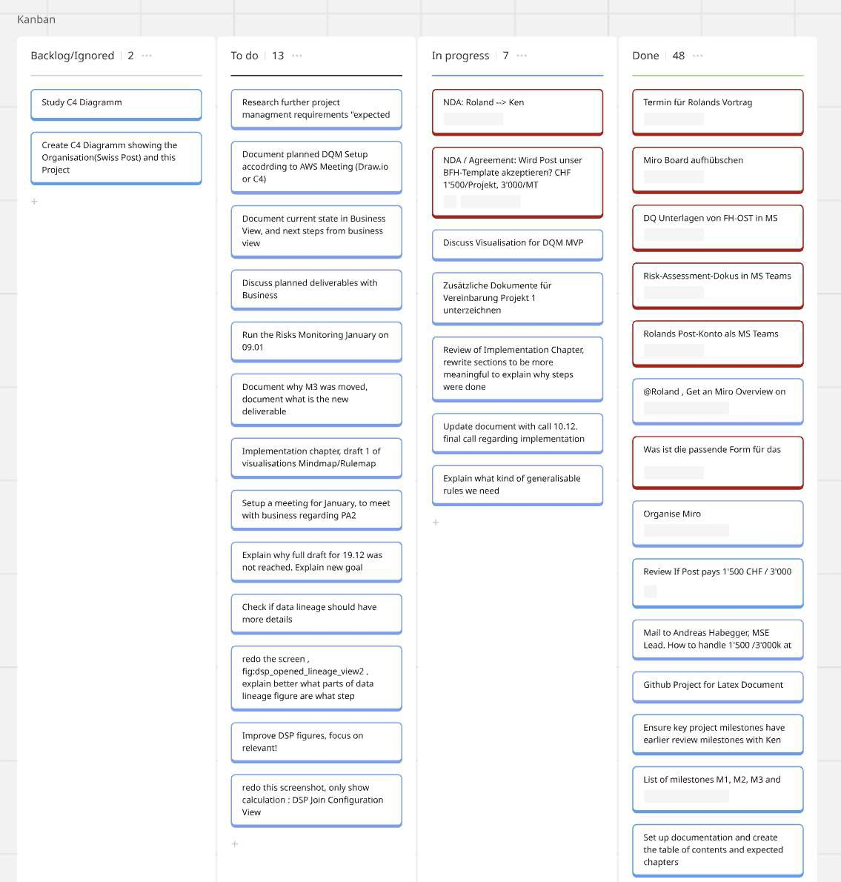

Figure 2.11.: Kanban board of Academic team

Jour Fixe
The academic team holds a Jour Fixe every week. This serves to maintain close communication and func-tions as a check-up meeting. Each meeting follows a defined structure; as an example, the meeting held on 15.12.2025 is described below.
▶ Project check-in and clarification of objectives
▶ Overview of the project and completed deliverables
▶ Current deliverable in progress
▶ Status of milestones
▶ Changes needed to the updated Project 1 description
▶ Questions regarding Project 2
▶ Other topics

First, a general introduction to the project is provided to serve as a check-in and to allow participants to fo-cus on the project. Second, the deliverables currently being worked on are listed based on the deliverables overview. Third, the status of the milestones is reviewed. Fourth, this is followed by individual agenda items, which can differ from meeting to meeting. In this meeting, these included updates to the Project 1 description required for agreement, as well as a check-in regarding topics and submission of Project 2. Finally, the meeting is closed with an open section in which any other relevant topics may be discussed. These meetings are documented in Miro (see below) and structured using a three-block template and are most often recorded using handwritten notes that are later uploaded.
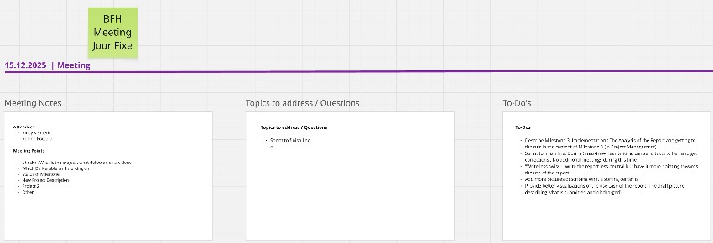
Figure 2.12.: Jour Fixe of Academic team, meeting structure and rework

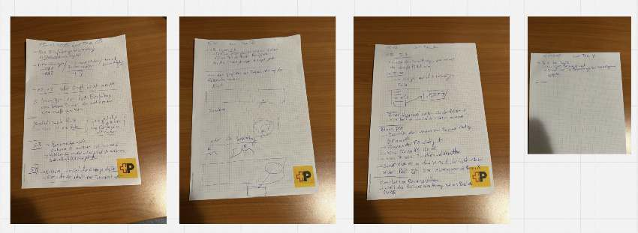

Figure 2.13.: Jour Fixe documentation of Academic team

Timeline management
Timeline management is performed in different ways by the teams. In this subsection, the planning of actions is described, as well as how staff availability is tracked.

Scrum Events
The DWH LS OPS and the AWS modernisation teams use Scrum events to manage their timelines. Progress on stories is monitored in daily meetings, during which each team member updates the team on progress and issues and indicates whether assistance is needed or deviations from the previously planned approach are required. Sprints encompass the stories the team works on during a two-week cycle. During sprint planning, the stories for the next sprint are defined. The stories added to a sprint represent the commit-ment the team makes for the sprint, together with the sprint goal. Planning over longer time horizons is

conducted through quarterly planning sessions. Every three months, all teams in DWH LS OPS plan which epics and how many story points should be completed. These quarterly planning sessions also serve to prioritise epics and allow higher management to introduce priorities.

Holidays
Holidays are noted in the calendars used; this applies to the DWH LS OPS team as well as the academic team. In both cases, every holiday must be recorded with an absence notification. This allows other team members to quickly see whether a team member is available in the future and to adjust their planning accordingly, or to confirm in daily operations that the person is not available.

Milestones
The academic team manages the planning of the overall project timeline using milestones. These mile-stones define timeframes during which a section or chapter may be worked on. For this project, the fol-lowing milestones have been defined:
▶ Milestone 1: Basics completed
▶ Milestone 2: Completion of main research
▶ Milestone 3: Code implementation completed
▶ Milestone 4: Bug fixing completed
▶ Milestone 5: Submission of the project document
▶ Milestone 6: Presentation prepared
First, the basics ready refers to all the tools required to work being available. This step includes setting up LateX, setting milestones, setup of basic tool structure and definition of way of work. Second the main research done refers to the end of the purely theoretical part and start towards the solution design and the subsequent implementation of it. This comprises the main literature research being done. Third, the code done refers to the implementation of the solution being done. After this point no new features are to be implemented. Fourth, bug fix done comprises all corrections that had to be performed so that the provided implementation works and technical debt amassed during development has been cleared. Fifth, the handin of the document is the final day according to the semester calender. Up to this date corrections to the document and finalisation can be provided. Sixth and final, the presentation must be ready latest by this date. After this some finetuning can be performed but the main content needs to be set.
The milestones were set to structure the work blocks, but primarily to define how much effort should be invested in each individual block. The time allocated per block is not estimated in terms of how long a task is expected to take. Instead, it is defined by how much time the team is willing to invest in a topic in order to ensure sufficient capacity for subsequent tasks. For example, documenting the Swiss Post environment could have taken two to three weeks; however, only three days were intentionally allocated to this task.

Deviations and Unavailabilities
The academic team tracked deviations from milestones or Jour Fixe meetings. This served transparency and traceability. For this use case, the dates of all Jour Fixe meetings were planned in advance. If a meeting had to be rescheduled, this was noted in the calendar. In the case of shifted milestones, these changes also had to be documented in the calendar, including the reasoning for why a milestone was not achieved or had to be moved. In the Results chapter, deviations from the planned milestones are documented.

Tools to support the project management
This section lists the tools used during the project for reasons of transparency. It also allows the reader to evaluate different ways in which these tools can be used.

Miro
Miro is part of the toolset of both the academic team and the Swiss Post teams. However, in this project, it was used only by the academic team. The reason for using Miro is that it is a lightweight tool that allows combining different data structures on a single board. Miro provides an infinite canvas on which a wide variety of information can be placed. The information can be structured and easily rearranged to regroup related elements. This allows the tool to be used both for early documentation of information and for later restructuring when additional ideas emerge, particularly in the context of long-term documentation. The ability to restructure information visually supports the decomposition and understanding of complex environments.
A full set of screenshots illustrating changes on the Miro board has been moved to the Annex, while the final one is included here (Appendix D). The following screenshot represents the Miro board during the fi-nalisation of the document, zoomed out so that all elements are visible. While this view prevents individual details from being seen, some relevant parts are shown in detail in the following subsubsections.
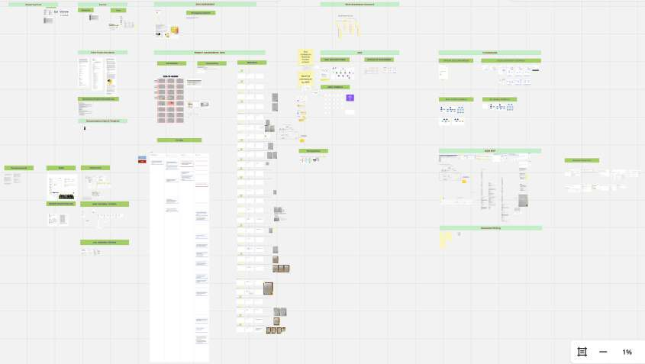

Figure 2.14.: Miro board documentation, view of 23.12.2025

Miro calendar
The calendar in Miro was primarily used to schedule the milestones. These are shown with green tiles on the corresponding dates, including their number and milestone title. Jour Fixe meetings are marked in yellow whenever they occurred, including adjustments in cases of unavailability. Actual unavailabilities at scheduled Jour Fixe meetings and other times are documented in black. Finally, holidays are marked in teal. In the case of this project, this applied only to the Christmas and New Year holiday period.

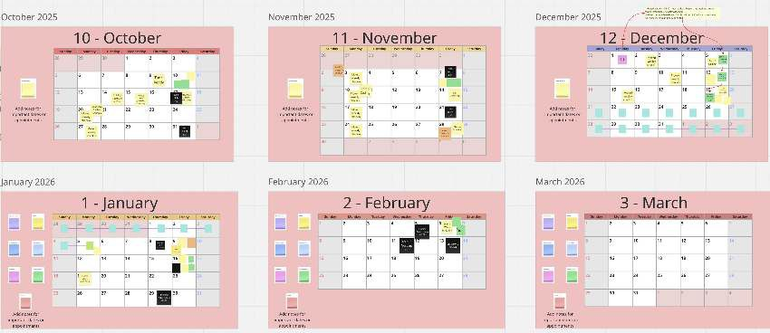

Figure 2.15.: Miro board calendar used for coordination and tracking of milestones and related events

Meetings documentation

The meetings are documented using a layout with three sections, including a coloured tag at the top in yel-low for Swiss Post meetings and green for academic ones. From left to right, these sections are structured as follows. First, the meeting points to be discussed are listed; these are copied from the Outlook invitations. Second, the topics addressed are summarised, mostly after the meeting. Third, the to-do block describes any actions that arose during the meeting. Not every meeting includes all sections. Furthermore, meetings are often documented using handwritten minutes. These are uploaded to the right of the meeting blocks without further refinement and serve as references.

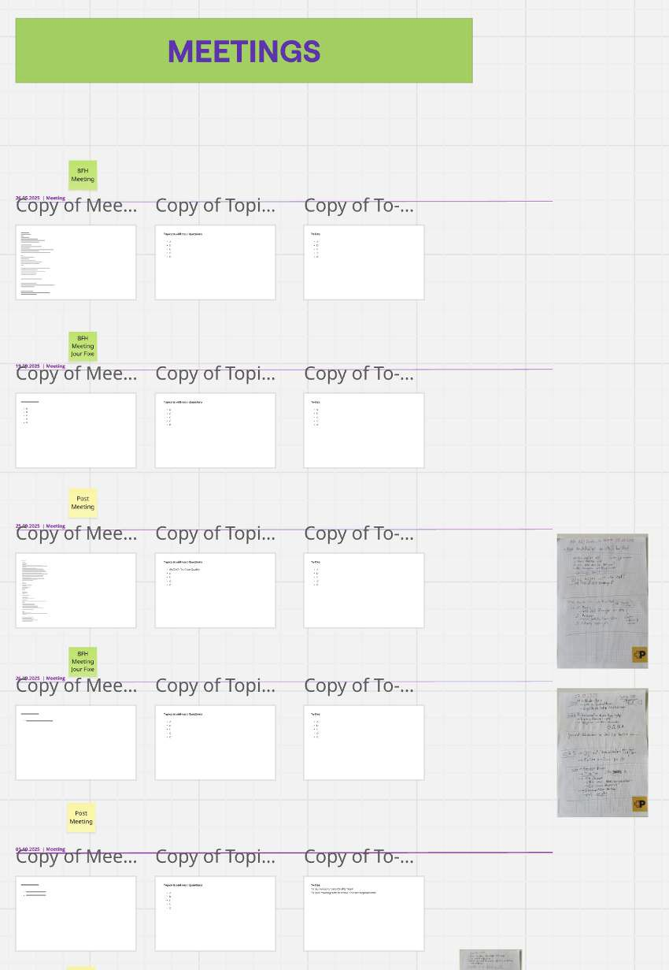

Figure 2.16.: Miro board, tracking of meetings: when, who, what

Documentation of the Implementation

The implementation was first documented in Miro, as the rapid creation of screenshots did not disturb the flow of information gathering. In the following figure, the information-gathering process can be seen, starting from the top left, moving to the right, and then restarting from the left. First, screenshots of the SAC report are shown, followed by navigation towards DSP. Further details on the tools are described in the Implementation chapter.

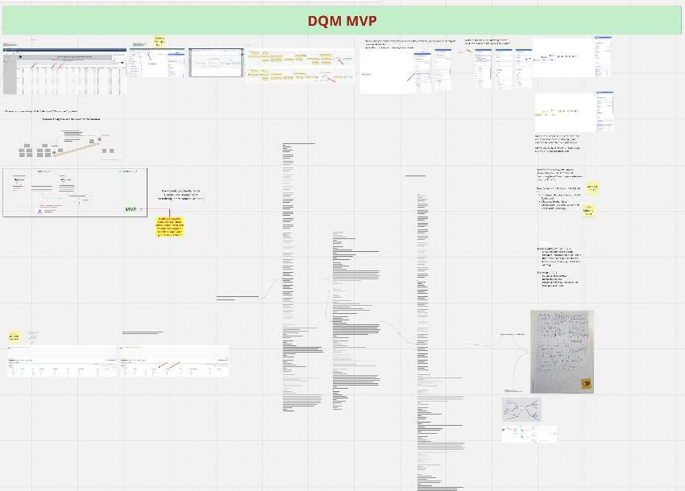

Figure 2.17.: Miro board usage for quick documentation during implementation

Jira and Confluence

Jira (mainly for issue tracking) and Confluence (mainly for documentation) are both tools provided by At-lassian and are therefore well integrated with each other. The tools are installed on-premises, which limits sharing possibilities outside the Swiss Post network. They are used by the three Swiss Post teams presented in the Teams section. The project team also used Confluence when research results had to be presented as a first use case. While Jira is used for the short-term management of Scrum artefacts, Confluence is used for long-term documentation. An example of such long-term documentation is shown in the following screenshot, illustrating the documentation of a data lineage.

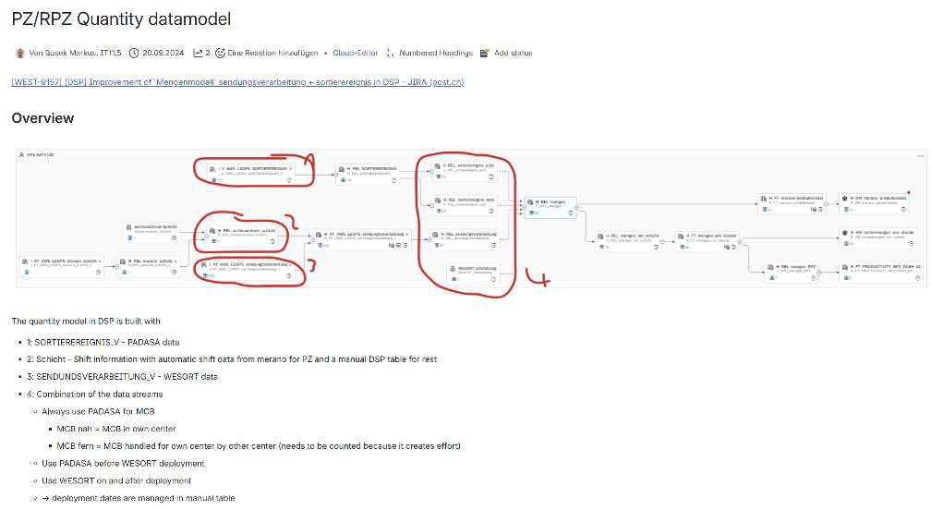

Figure 2.18.: Example of project documentation in Confluence used to record architectural decisions and their rationale for future reference

Microsoft Teams and Microsoft Outlook

MS Teams and MS Outlook are used by both the academic and Swiss Post teams. They are organisational standards at Swiss Post and are not optional. The same applies to the academic context. Both tools serve to support focused long-term (MS Outlook) and short-term (MS Teams) communication.

Shared chat

For the academic team, the chat was used for short-term communication. However, a challenge arose due to the involvement of two distinct organisations, BFH and the Swiss Post. In order to keep communication between Swiss Post accounts and BFH accounts in one place, a chat with three users was required. In this context, the cross-organisational capabilities of MS Teams proved useful. After the Swiss Post account was invited to participate in the project team, it was able to communicate directly with BFH accounts. A sample of the communication involving three accounts is shown below.

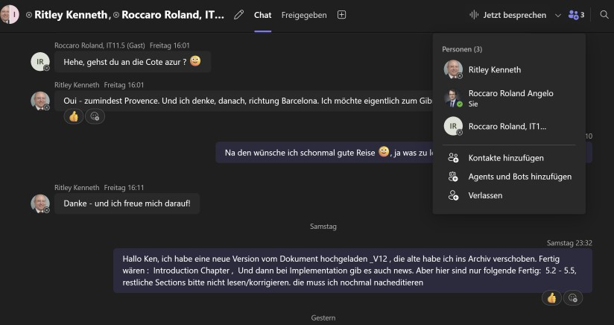

Figure 2.19.: Shared chat using Teams

A second important application of MS Teams is a document management system. This includes source doc-uments, document versions, and related materials. All relevant documents are stored within this structure, which is designed to grow as needed.
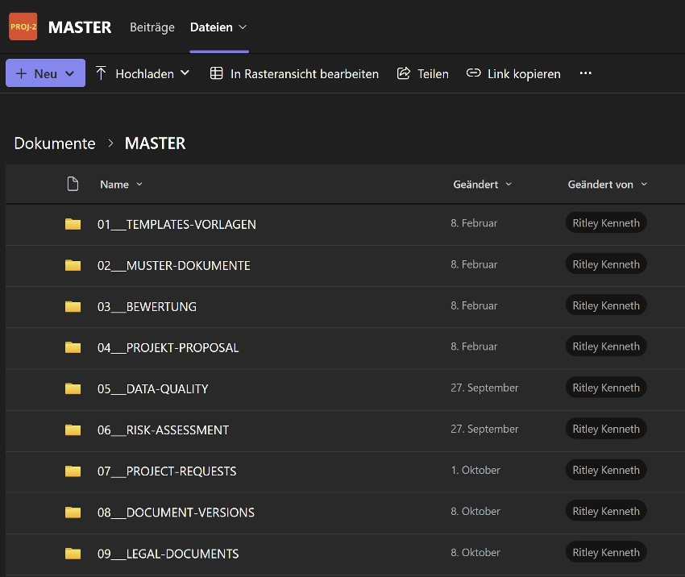

Figure 2.20.: Project document store used with Teams

LaTeX
LaTeX was the tool chosen for the main writing process by the academic team. The primary reason for selecting this tool was the consistency of the document structure. It allows changes to be made in a large document without the document becoming unstable. The tool was specifically selected for this higher consistency compared to Word. The fact that the creation of some stylistic elements takes more time than with a WYSIWYG editor such as Word was accepted, particularly as design was valued lower than document content. Finally, the consistency of being able to reference text sections within the document and the ability to automatically generate lists of figures and tables were seen as additional benefits. Furthermore, the automatic glossary and citation features using Biber were considered advantages for which the slower writing process without a WYSIWYG editor was accepted.

GitHub
For maintaining version control of any created artifacts, the public GitHub was used with the private ac-count of the academic team. It was mainly used as a repository. This Git distribution was chosen because it is free to use and already well known to the team, with all required accounts in place, so no additional adop-tion or learning effort was required before starting. GitHub was not only used to store the document and track its progress, but also to manage all required sources such as tables and images used in the document.
For the writing process, the use of GitHub as a backup mechanism was particularly important. As all sources are stored in GitHub, the project was safeguarded against hardware failures of the working device, which is one risk mitigation measure. Continuously committing and pushing changes made the progress of the writing process traceable and supported the iterative writing approach which was chosen. This proved useful when the document PDF could no longer be generated, as the last version that compiled without errors could be identified. Finally, storing the sources on GitHub allowed access from different devices, which was useful when transferring materials such as screenshots from the work device to the study device.

ChatGPT
LLMs are now an indispensable part of work. To note how ChatGPT was used in this project, it was given the following prompt:
Hi ChatGPT, please look at the other chats I have with you and tell me in which ways you sup-ported me during my academic project over the past months since September 2025. Please create a subsection for my scientific work which I can reference.
The following subsection was completely AI generated content by ChatGPT, without further editing.

ChatGPT
To document the support provided by ChatGPT, a summary of the assistance received during the academic project was generated directly by the tool itself: The request asked ChatGPT to review prior interactions and describe the ways inwhich it supported the academic project over the past months since September 2025. The resulting subsection is intended for inclusion in the scientiftc work and can be referenced accordingly OpenAI 2025.
The following subsection is entirely AI-generated content produced by ChatGPT, without further editing OpenAI 2025.

Use of AI Assistance in the Research Process
Since September 2025, the author has used the AI language model ChatGPT as a supportive tool during the devel-opment of this academic project. The assistance provided did not replace independent scientiftc work but comple-mented it in the following ways:

Conceptual Clarification and Structuring ChatGPT was used to support the clariftcation of complex theo-retical concepts, the reftnement of research questions, and the improvement of the logical structure of arguments. This included exploring alternative formulations, identifying conceptual gaps, and supporting the organization of sections and chapters.

Language and Academic Writing Support The tool assisted in improving the clarity, coherence, and aca-demic tone of the manuscript. This included rephrasing passages for precision, adjusting wording to meet scientiftc standards, and supporting grammatical accuracy and stylistic consistency across the text.

Methodological Reflection ChatGPT supported reflective discussions regarding methodological choices, in-cluding the articulation of research design, limitations, and the justiftcation of selected approaches. All method-ological decisions, interpretations, and ftnal formulations remained the sole responsibility of the author.

Iterative Feedback and Revision Throughout the research process, ChatGPT was used as an iterative feedback instrument to review draft sections, explore alternative explanations, and identify areas requiring further reftne-ment or clariftcation.

Ethical and Responsible Use ChatGPT did not generate original empirical data, conduct analyses indepen-dently, or make autonomous scientiftc claims. All AI-generated content was critically evaluated, revised, and inte-grated by the author in accordance with principles of academic integrity and responsible research practice.

Timetracking
As part of the need for transparency and the ability to review the efforts committed to this project, time tracking was performed from the start to the end of this documentation. The tracked time was recorded in two separate ways. Work efforts carried out within Swiss Post were captured directly from the Swiss Post MIAR system, noting only the time spent per day without further details on the specific tasks performed. This information was saved in an Excel file and marked as work effort.
Second, academic efforts committed to the project outside the Swiss Post context were recorded directly in an Excel file. For each work block, a separate entry was created. A block represents continuous work on project-related tasks, including short breaks; however, longer breaks, such as lunch, resulted in a new block being created. Excel was used because the Office suite was already in use for other purposes, and the information did not justify storage in a more complex database such as MariaDB. The tracked time is not intended for billing or performance measurement, nor is it used to assess milestone performance.
The full documentation of the time tracking has been moved to the annex in order not to disrupt the doc-ument flow and is available in Appendix F.

Risk management
In this section, the approach taken to risk management is described. Risk management is essential to the success of any project, as it enables planning for and potentially preventing dangers that may occur during its course. When such risks are not handled, they can endanger the progress of the project. The risk management process consists of several steps Wikipedia 2025. First, the risks are identified and classified as to their nature. Next, they are weighted according to how they might impact this project; this includes a consideration of the probability that the risks may arise, and the level of damage that may occur. After this, the specific handling of each risk is defined; these are the concrete measures that are taken to lower how the risk may impact the project. Finally, ongoing monitoring and review of the risks is carried out on a regular basis throughout the project.

Risk identification and classification
The identification of risks has been carried out for this project, following an extensive brainstorming ap-proach. Each risk has been grouped into a category (e.g. goal, time and organization, etc.), and each risk has been classified according to the likelihood of is occurance and severity it would cause to the project. Both criteria are evaluated based on the project team’s risk appetite and ranked according to the following definitions.
▶ Likelihood: What is the expected likelihood of a risk coming into effect
- 1 Rare
- 2 Unlikely
- 3 Possible
- 4 Likely
- 5 Almost Certain
▶ Severity: How severe are the consequences of the risk coming into effect
- 1 Insignificant
- 2 Minor
- 3 Moderate
- 4 Major
- 5 Severe
The identified risks, along with their likelihood and severity, are listed in Table 2.1.

Table 2.1.: Project Risk Overview

No. Group Risk Likelihood Severity
    - Goal Unclear question 2 2
    - Goal Unclear goals 2 3

    - Time and Organisation
    - Time and Organisation
Insufficient expertise 4 2
Underestimated time/effort 4 3
Continued on next page

No. Group Risk Likelihood Severity

5 Time and | Other study projects | 3 | 3
Organisation
6 Time and | Work projects | 4 | 3
Organisation
7 Time and | Procrastination | 3 | 2
Organisation
8 Human Resources | Unavailability of main project staff (e.g., due to | 4 | 4
 | illness)
9 Human Resources | Unavailability of advisor (e.g., due to illness, | 3 | 4
 | accident, etc.)
10 Tech and | Software Version/Library/Dependency | 4 | 3
Infrastructure
11 Tech and | Hardware is damaged | 2 | 5
Infrastructure
12 Data and Research | Data related | 4 | 3
13 Data and Research | Not reproducible work | 2 | 5
14 Ethical and Legal | Plagiarism or wrong citation | 2 | 5
15 Ethical and Legal | Copyright | 1 | 5
16 Communication | Bad communication with stakeholder or | 2 | 4
and Cooperation | advisor
17 Communication | Insufficient exchange with external partners | 1 | 5
and Cooperation
18 Force Majeure | Unforeseen family crisis | 2 | 5
19 Force Majeure | General force majeure | 1 | 5

Risk heat map
After carrying out the initial identification and classification, it is not always easy to determine which risks require the most attention. To support this task, a Risk Heat Map is used, in which each risk is plotted in a two-dimensional matrix according to its likelihood and severity. This visualisation highlights the risks that pose the greatest threat to the project and should be considered for priority treatment. The colours in the Risk Heat Map 2.5 correspond to these descriptions.
▶ Green Low
▶ Yellow Medium
▶ Orange High
▶ Red Very High
As can be seen in the Risk Heat Map, one risk is classified as red and therefore requires special attention, namely, the unavailability of the main project staff. How this risk, as well as the others, is addressed will be described in the following section.

Risk strategies and mitigation strategies
Risk strategies are the high level approaches to dealing with the risks, and the risk mitigations are the con-crete plans developed to manage identified risks. In the following table, an overview of the individual risks is provided, including their selected treatment and a brief justification. BNaturally, it is neither practical

Risk Matrix Severity

 |  | 1:  Insignificant | 2: Minor | 3: Moderate | 4: Major | 5: Severe
verity | 5: Almost Certain | 15 17 19 | 11 14
Se | 4: Likely |  | 16 | 9 | 8
 | 3: Possible |  |  | 5 | 4 6 10 12
 | 2: Unlikely |  | 1 | 2 7 | 3
 | 1: Rare
Table 2.2.: Risk Matrix (Likelihood × Severity)

nor feasible to completely eliminate every risk; therefore, based on likelihood and severity, as well as the team’s risk appetite, each risk was assigned one of the following strategies:
▶ Accept – the risk and its potential impact are acknowledged, but no measures are taken
▶ Reduce – the risk is mitigated by applying additional measures to lower its impact or probability
▶ Transfer – the responsibility for handling the risk is assigned to another party
▶ Avoid – the project is adapted in a way that prevents the risk from materialising

Table 2.3.: Risk Strategy and Treatment Plan
No. | Risk | Risk Description | Treatment | Treatment Description
1 | Unclear | The topic description is | Reduce | Define SMART goals
 | question | too vague or contains too
 |  | many goals
2 | Unclear goals | The goals are not clearly | Reduce | Describe which goals are
 |  | defined or cannot be |  | part of scope
 |  | measured
3 | Insufficient | Not knowing required | Accept
 | expertise | tools or programming
 |  | languages
4 | Underestimated | Some tasks take more | Accept | Document end of tasks in
 | time/effort | time than initially |  | Miro calendar; re-evaluate
 |  | expected |  | after project
5 | Other study | Other classes demand | Accept | Use minimum time for
 | projects | more attention, less time |  | projects/classes
 |  | for project
6 | Work projects | Other projects at work | Reduce | Reduction of risk due to
 |  | demand urgent attention, |  | starting early; defining
 |  | less time for project |  | blockers for study work
7 | Procrastination | Tasks are pushed back | Reduce | Start early
Continued on next page

No. | Risk | Risk Description | Treatment | Treatment Description
8 | Unavailability | One or multiple project | Accept | Document in case it happens
 | of main | staff are not available
 | project staff
9 | Unavailability | The advisor is not | Transfer | Advisor to define emergency
 | of advisor | available |  | replacement
10 | Software | Mismatch in versions; | Accept | Run the code multiple times;
 | Version/Li- | new library versions |  | have test cases (e.g., unit
 | brary/Depen- | break the code |  | tests)
 | dency
11 | Hardware is | The laptops or other | Reduce | Second laptop; code on
 | damaged | material are damaged and |  | GitHub/Miro/Teams/Outlook
 |  | need repairs or
 |  | replacement
12 | Data related | Bias in data; not enough | Accept
 |  | data
13 | Not | The work provided cannot | Reduce | Document steps; upload
 | reproducible | be reproduced |  | versions on GitHub
 | work
14 | Plagiarism or | Unallowed or undeclared | Reduce | Use citation; bibliography
 | wrong citation | usage of sources
15 | Copyright | Used literature or | Accept
 |  | materials which are
 |  | restricted
16 | Bad commu- | Advisor or stakeholders | Reduce | Weekly advisor meetings
 | nication with | are not heard; their inputs
 | stakeholder or | are ignored
 | advisor
17 | Insufficient | External partners do not | Reduce | Stakeholders in Scrum team
 | exchange with | react, are delayed, or
 | external | communication towards
 | partners | them is late or poor
18 | Unforeseen | Unexpected crisis in | Accept | To be documented in Miro
 | family crisis | family |  | calendar in case it happens
19 | General force | Events which cannot be | Accept | To be documented in Miro
 | majeure | influenced are very rare |  | calendar in case it happens
 |  | and very disruptive

Implementation of risk mitigation strategies
Identifying the key risks is the first step in the overall risk management approach; this is followed by defin-ing measures for each of the risks. In the following table, the implementation of these measures is doc-umented. The measures have been implemented according to the strategies and descriptions outlined above. Table 2.4 provides an overview of the actions taken and when they were carried out.

Table 2.4.: Risk Strategy and Action Overview
No. | Risk | Strategy Decision / What | When
1 | Unclear question | In the research section SMART goals have been | 23.10.2025
 |  | setup
2 | Unclear goals | The introduction describes which parts of the initial
 |  | project description are part of this document
3 | Insufficient | Accept: Nothing done | 23.10.2025
 | expertise
4 | Underestimated | Accept: Nothing done | 23.10.2025
 | time/effort
5 | Other study projects | Accept: Nothing done | 23.10.2025
6 | Work projects | Added blockers in Work calendar, Work account | 10.10.2025
 |  | invited to meeting series (Jour Fixe); study account:
 |  | set blockers on weekend; researched with ChatGPT
 |  | for optimal/minimal study plan
7 | Procrastination | Work on the project started 25.09.2025 when | 17.10.2025
 |  | attending data quality meeting at AWS, being part of
 |  | AWS Modernisation initiative
8 | Unavailability of | Contact of partner provided in Teams and added to | 23.10.2025
 | main project staff | Miro board
 | (e.g., due to illness)
9 | Unavailability of | Asked for contact, confirmed to be Jürgen Vogel | 23.10.2025
 | advisor (e.g., due to
 | illness, accident,
 | etc.)
10 | Software Version/Li- | Accept: Nothing done | 23.10.2025
 | brary/Dependency
11 | Hardware is | Second laptop is available at home; the LaTeX | 23.10.2025
 | damaged | document is a GitHub project; documentation is on
 |  | Miro. Work laptop can also be used for most tasks,
 |  | but has no LaTeX installed
12 | Data related | Accept: Nothing done | 23.10.2025
13 | Not reproducible | GitHub project for LaTeX document | 10.10.2025
 | work
14 | Plagiarism or wrong | JabRef used as GUI for bibliography; Biber used for | 17.10.2025
 | citation | build
15 | Copyright | Accept: Nothing done | 10.10.2025
16 | Bad communication | Jour Fixe setup | 26.09.2025
 | with stakeholder or
 | advisor
17 | Insufficient | Keep exchange channels active when changing team | 26.09.2025
 | exchange with
 | external partners
18 | Unforeseen family | Accept: Nothing done | 23.10.2025
 | crisis
19 | General force | Accept: Nothing done | 23.10.2025
 | majeure

Ongoing risk monitoring
A critical step in the risk management process is ongoing monitoring. Monitoring the risks ensures that the defined measures remain valid and that any risks that may materialise are identified. If a new risk is identified or causes a disruption to the project, it will be documented. Additionally, an appropriate measure to handle its impact will be defined. Monitoring of the risks will be performed every second Friday of each month. Detailed information about the risk monitoring process is provided in the appendix E. These risk check-ins will contain the following information:
▶ Number of risk: same as in the tables above
▶ Name of risk: same as in the tables above
▶ Occurred: did the risk occur (yes or no)?
▶ Details: what happened?
▶ Cause: brief analysis of why it happened
▶ Measures taken: what measures have been taken?
▶ Measure date: on what date were measures taken?

Risk review at project completion
Finally, a review of the risks will be held at the end of the project. This will address which risks came into effect and which did not. Additionally, changes to the perception of the risks will be documented. Because this current project is the first part of a three project series(Project 1, Project 2, Master Thesis) any suggestions to improve the following project will to be described.

Topic of this Research

This chapter establishes the research foundation for the project. It first presents the problem addressed and derives the research question. Based on this, the project’s SMART goals are defined to provide clear guidance for the subsequent work. The chapter then identifies the research gap that motivates the project. Finally, core definitions related to data quality and data availability are introduced to provide the theoretical basis for the analysis and implementation presented in the following chapters.

Problem Statement
This work builds upon the previous research Roccaro 2026, which analysed the existing data pipelines at Swiss Post with regard to operational reporting. Based on this groundwork, the next logical step was to adapt the existing reports to the new reporting platforms. However, in the meantime, the reporting data pipelines were updated. The old data pipelines remained available, but all further updates were performed only on the new pipelines. As a result of this development, the focus of this project shifted towards sup-porting these changes and helping the team to improve the monitoring and assessment of the existing data. Furthermore, an important objective was to establish the groundwork for the upcoming master’s thesis by evaluating whether the available tools could serve as the basis for a use case to be explored in greater depth during the thesis.
Explain new data pipelines explain new data structure Change in reporting pipelines and data structure setup of data quality management at swiss post not yet defined usage of the dataquallity management to be tested for usage in future work

Problem generalisation
This project is the important step towards setting the groupwork for the upcomming master thesis. It is confirming possible tools being available for ....
When taking a step back from the very specific problem statement, it is observed that the problem is more generally known as missing formalisation. While initial steps towards running data quality checks with the report mentioned in the business criticality section have been initiated, the rules according to which data quality checks are to be executed, for example when data is considered acceptable or not, were not available at the start of this project. This also applies to the methods by which data quality should be measured, which are not defined. Furthermore, within IT it is not defined who is responsible for running these checks. This situation is a common problem occurring in data-driven companies that lack clear definitions of responsibilities for data quality management. Such definitions need to clarify who performs data quality checks, how data quality checks are performed, which dimensions are checked by data quality checks, and which data quality dimensions exist that could be assessed.

Research gap
Given this problem statement, the following questions are to be researched in more detail within the next two chapters. First, a theoretical introduction of the terms is provided; in later chapters, their specific meaning in the context of this project is discussed:

High level research question
What is the next meaningful step to take in order to improve data availability and data quality within the DWH LS OPS team at Swiss Post? How can the Business and IT be supported in achieving their objectives? While the solutions should be as simple as possible, they should be based on best practices and verified through scientific research. The research gap is addressed in the solution and implementation chapters. The main goal is to ensure that the conducted research provides tangible benefits to the team and con-tributes to future improvements. It is particularly important for the team that the research results are presented continuously, so that progress, as well as potential deviations and changes, can be discussed.

Success definition
The success criteria of this project are threefold and are defined based on the research gap as well as the initial project hand in, which describes the business requirements.
First, the primary business objective is to achieve automation for the existing report. However, the goal of this project is not to replace the report immediately, but rather to establish concrete steps toward automa-tion.
Second, communication with the business is another important success factor. The results from research and implementation must be presented on a regular basis to the product owner (PO).
Third, the documentation of the data lineage and the reporting pipeline is required, as it forms an impor-tant theoretical and practical foundation for future projects and further implementation of DQM.

S.M.A.R.T. goals
The Goals of this project are now defined here as “SMART goals”, as shown in the following list. They are all Specific: the goal is clearly formulated; Measurable: there are measurable criteria defining when the goal is reached; Achievable: they are realistic given the available resources; Relevant: the goal is directly linked to the project’s success; and Time-bound: there is a defined timeframe for achievement.

1) Identification of initial data quality metrics
WHY: This helps to ensure that checks focus on business-relevant issues.
By the end of the analysis phase, the initial data quality measures suitable for automated projects in the DWH LS OPS environment are identified and defined. At least three dimensions should be covered, such as completeness and consistency.
Success is measured by the documented metrics, which include a specific metric definition with calculation logic, data scope, and business relevance.

Solution landscape

In order to enable the reader to understand the complexity of the Swiss Post DWH LS OPS, the data lineage must be presented at a high level. This chapter provides an overview of this lineage while deliberately omitting details that are not relevant to this project. It further explains the scope of this project within the data lineage and describes the reporting lineage with relevant tools. Furthermore, it is important to note that the solution landscape reflects the current state of knowledge and is limited to the project scope. Any additional knowledge acquired during implementation is discussed in the Results and Target Analysis chapters.

The Swiss Post addresses data quality in multiple ways
At the start of this project, the objective was to develop a minimal viable product (MVP) to replace a manual data quality check performed by the business with a more robust solution, including automation, the de-livery of reports, as well as an appropriate notification and alerting. However, after beginning this project, Swiss Post management assigned a new priority to the topic of data quality management (DQM) overall; therefore, quite unexpectedly, this project acquired an additional set of key stakeholders, located in differ-ent teams as discussed in chapter 2.1.
Fortunately, this project as originally conceived fit very well into the larger DQM picture. Coordination with these teams although not originally envisioned (such as the DQM team described in chapter 2.1) therefore became an important task. This coordination was essential for several reasons: first and most obviously, the project must avoid reinventing existing solutions or overlapping in an unplanned way with other new initiatives. Second, it must ensure that methods and deliverables of this project conform to any new data architecture standards; for example, data quality dimensions have already been defined and documented by other teams. Finally, it must ensure that ongoing work by other teams is taken into account.

Rule-Based DQM Initiative
The current architectural goal pursued by the DQM team is shown in the following visualisation. The rule evaluation engine, shown at the top centre, executes defined rules on target data and stores the corre-sponding rule results in a database. In this context, a rule represents a data quality check for a defined dataset, and many different rules can be defined. These rules may, for example, specify allowed values, such as restricting the gender attribute to the three values male, female, and not stated. Alternatively, they may define expected data types, such as requiring dates to be stored in UTC format, or specify valid value ranges depending on the weekday.
Although the rule evaluation engine was a major topic during the weekly exchanges with the DQM team, it was not implemented by the project team. Nevertheless, its development progress was regularly monitored and discussed during these meetings. Furthermore, the ASTV team used this tool for its intended purpose. However, this usage was outside the scope of this project.

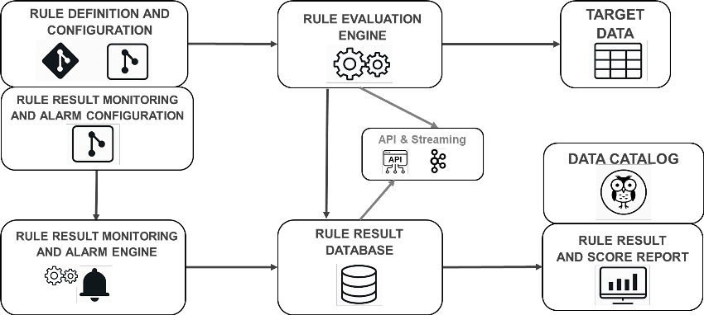

Figure 4.1.: The rule check engine architecture for future DQM

High-Level Target

From the complete target solution architecture, the first component to be implemented is a rule-based DQM suite. Its objective is to define generic data quality checks that can be applied across different datasets. This is achieved either by abstracting the check from the underlying data or by providing an SQL query that returns the data in a format allowing the same check to be applied to different datasets. The technology used to implement this solution is not discussed in this document, as the implementation was carried out by another team and is therefore outside the scope of this project. This approach consists of four main steps:

▶ Configuration: Configuration defines the tables to be checked, the execution frequency, and the type of check.

▶ Data preparation: An SQL query prepares the data in a format suitable for the check.

▶ Rule execution: An application executes the defined checks on the prepared data.

▶ Result persistence: The results are stored in a database, which enables reporting.

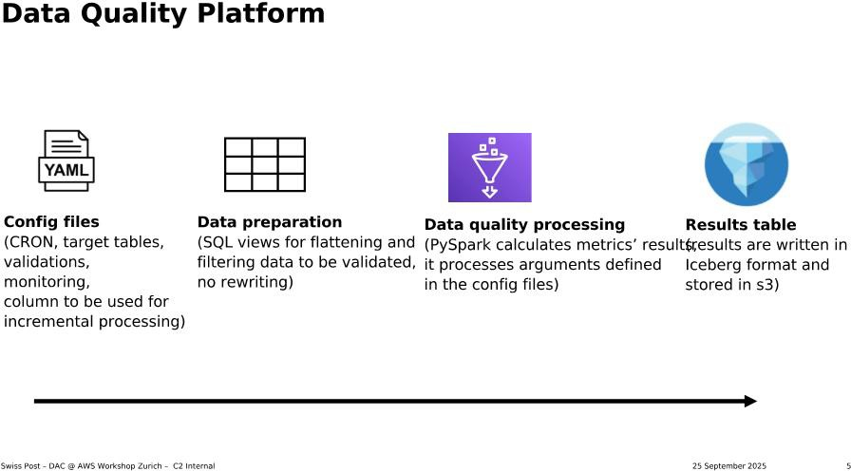

Figure 4.2.: Intention of a DQM platform, high level

Discarded Solutions
This initiative is of high importance to the project, as it creates a major organisation-wide constraint to fol-low the DQM team’s choice of tool. The rationale for developing a rule-based DQM solution is that existing tools, such as AWS Glue Data Quality, do not support views with complex data types, while PyDeequ does not provide row-level results. These limitations in the evaluated tools led to the decision to develop a ded-icated solution at Swiss Post, as described above. The following section provides a brief overview of the tools and approaches that were evaluated but ultimately discarded as unsuitable. The following screen-shot shows the presentation in which the DQM team summarised the evaluated tools and explained the reasoning behind their decision.

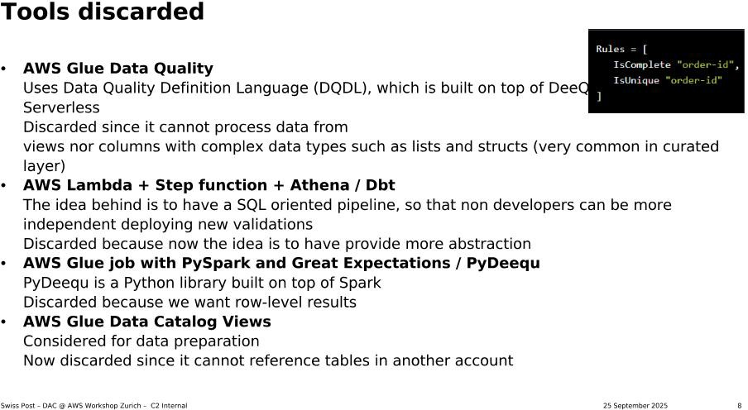

Figure 4.3.: The list of tools discarded and the reasons for their exclusion

State at the end of this project
By the end of 2025, the DQM team set up a PoC of the rule check engine based on the design shown at the start of this section 4.1. It allows running a check on a database view for specific target data source and storing the rule results in a designated rule result database. However many details were still not defined or implemented. Such as the location where the results check database is to be installed which has not been defined. Also the alerting and the setup of dashboards are currently out of scope, as are later additions such as deriving expected value ranges from historical data or holiday calendars.

Heterogenous sorting center environments

Before turning to the data lineage, an important constraint must be highlighted. The hardware used by Swiss Post in their high-tech “cyber” postal sorting centers differs in two main ways: across different providers and across different sizes and organisational structures of sorting centers. Which, in turn, also led to a diversity of processes to perform similar actions. This diversity on different levels brings certain benefits but also introduces additional synchronisation effort in other areas.

Different sorting hardware providers
The hardware used by Swiss Post in its sorting centers is sourced from different providers. This is an es-sential risk management measure to reduce dependency on a single vendor. To mitigate this risk, Swiss Post decided to rely on at least two providers for essential hardware, not only to avoid dependency but also to protect against delivery issues or even the bankruptcy of individual providers. From a risk management perspective, this approach supports business continuity. However, from an IT perspective, it introduces challenges, as different hardware providers deliver data in different formats or with varying characteris-tics.

Different sorting center sizes and structure
The Swiss Post parcel sorting centers are distinguished into two categories. There is one large PC parcel center per region, which is supplemented by smaller RPC regional parcel centers. Regions encompass multiple cantons and may split cantons into the four current regions: west, middle, east, and south. The organisation into larger parcel centers and smaller regional parcel centers helps to optimise processes and reduce the carbon footprint of postal services. However, each PC and RPC differs from the others.

First, due to differences in size, processes differ between small and large centers, and the way of work also varies as organisational structures are different. Second, beyond the distinction between small and large centers, each center has a unique layout. Third, tasks can differ between centers; for example, some also handle letters. While these differences are reasonable from an operational perspective, they introduce challenges for centralised reporting, where all variations need to be harmonised. The following figure shows selected PC and RPC locations distributed across Switzerland.

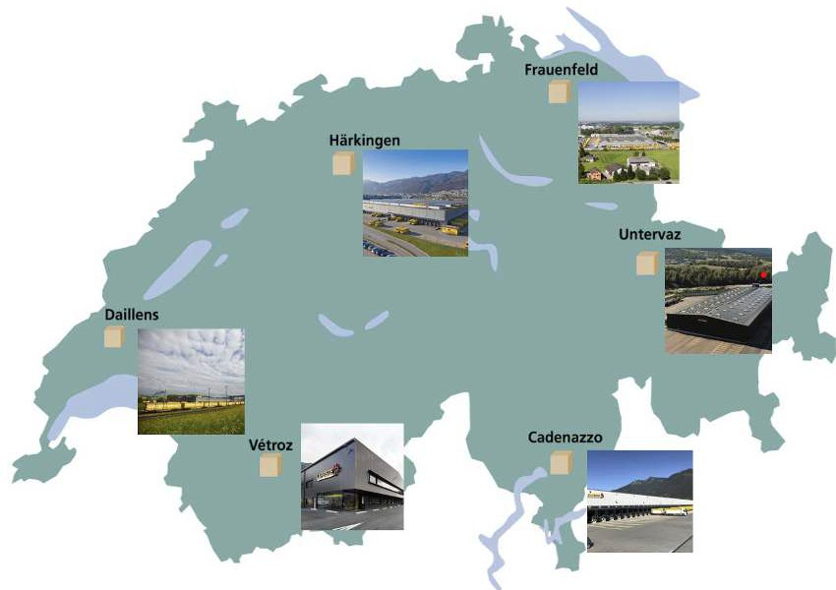

Figure 4.4.: Selection of parcel sorting centers distributed over Switzerland

Different sorting processes

To go one step further, the different size and equipment at the sorting centers lead to different actions performed in the sorting centers. The same event in a sorting center can be caused by different previ-ous actions making reporting on them difficult. As an example, the submitted and discharged events are described further.

Submitted event

The submitted event is the first automatic scan that occurs after a mail piece is placed onto the automatic sorting machine. In the context of this project, a mail piece refers to a parcel. However, parcels are not always placed onto the sorting machine in the same way. This can occur via roll boxes (RX), which are automatically emptied by robots. An RX is a container, as depicted in the following figures, that is used to transport different mail pieces through sorting and delivery facilities. Alternatively, parcels can be placed onto the automatic machine manually by staff, either by removing them from RX units or by emptying truck containers onto conveyor belts, as shown in the subsequent figures.



Figure 4.5.: Parcel sorting, parcels submitted by robot

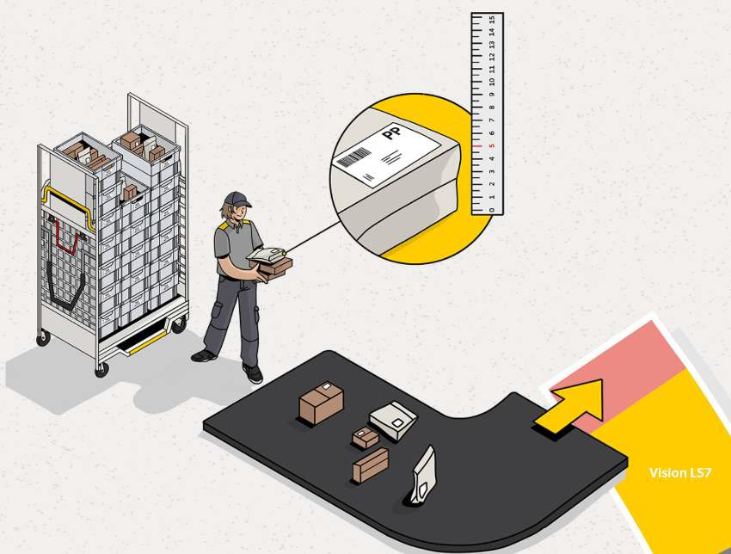

Figure 4.6.: Parcel sorting, smaller items submitted manually

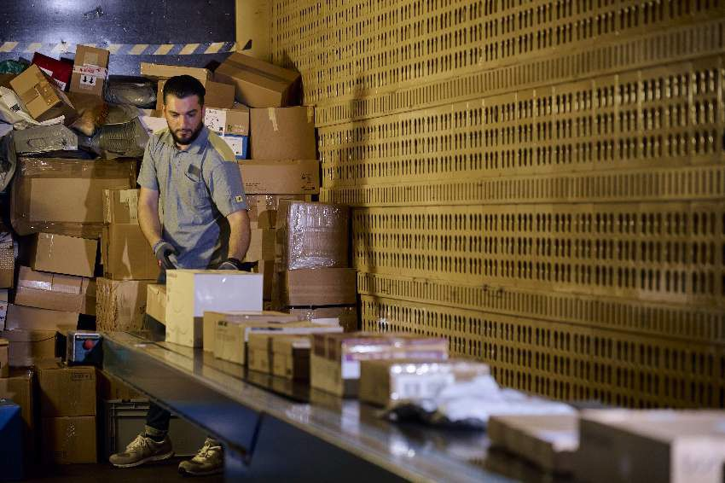

Figure 4.7.: Manual parcel onloading from a truck

Discharged event
The discharged event is complementary to the submitted event. It is the last automatic scan event of a parcel when it leaves the automated sorting machine. This can happen in different ways, such as when the parcel is discharged via a chute where staff load it into an RX, when it is discharged directly into an RX automatically by the machine, or when it is automatically ejected after completing a defined number of cycles through the machine. All of these possibilities trigger different follow-up actions. However, in all mentioned cases, a discharged scan is performed after the parcel is removed from the automatic sorting machine. This is the important aspect for reporting, as these two events (submitted and discharged) occur once per complete cycle that a parcel runs through the automatic sorters.
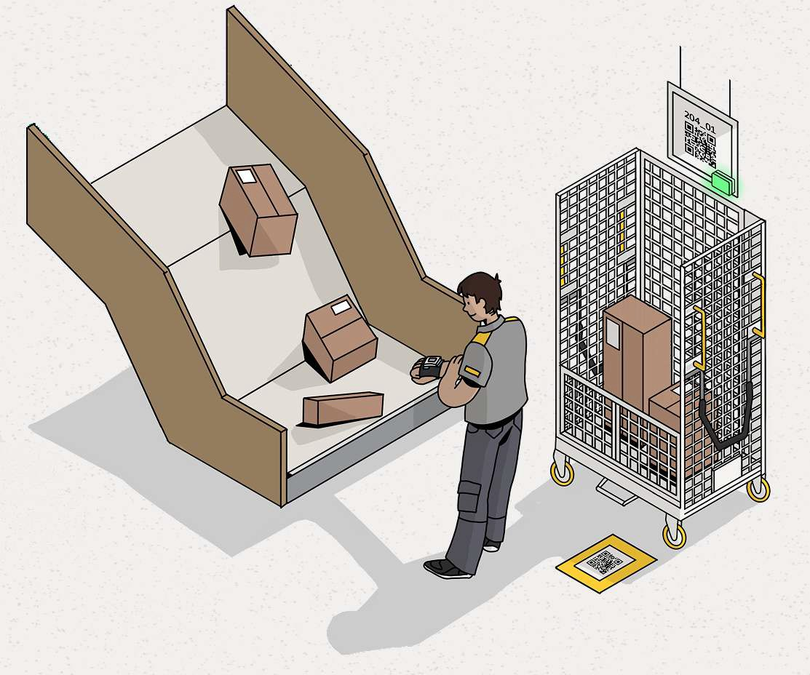
Figure 4.8.: Parcel discharged, manual loading into RX

Data Lineage
The data relevant to this project are those used by the DWH LS OPS team. They consist of cleaned and deduplicated data stored in the curated database layer. However, these data originate from sensor data and arrive in the data warehouse (DWH) in a raw format. Before reaching the curated layer, the data pass through four main processing steps, which are also shown in the following figure:
▶ Physical data source: Parcels are scanned by different scanners in the sorting centres. As described above, Swiss Post uses a variety of devices from different hardware vendors, which naturally results in a large number of data entities that must be stored. Each parcel passes through multiple scanners during its journey across the Swiss Post’s 13 sorting centres, generating multiple data entities that are

transferred to the data warehouse. Determining the exact number of generated events was outside the scope of this project.
▶ Initial data storage: The scan events are first saved in AWS S3. At first glance this might be a very unusual choice, but the reasons make sense. First, the Swiss Post has a cloud strategy which includes AWS as a service provider; hence the choice of AWS is no surprise. But more importantly, Amazon S3 (Simple Storage Service) is the object storage service of AWS. Exactly which data are stored here and how is addressed in a following section.
▶ Kafka ingestion: Apache Kafka is an open-source distributed event streaming platform designed for high-throughput, fault-tolerant, real-time data pipelines and event-driven architectures.The Swiss Post [ operates a Kafka environment in its down data centers ] [ uses the Amazon MSK Managed Streaming for Kafka ]. With this, so-called “producers” read the data from the initial storage and ingest it into Kafka “topics,” to which other systems can “subscribe” and obtain the data.
▶ Data delivery to DWH: Kafka consumers ingest the events into the DWH LS OPS raw data layer. Which is the first storage layer in this teams AWS S3 account, saving the data as recieved from Apache Kafka.
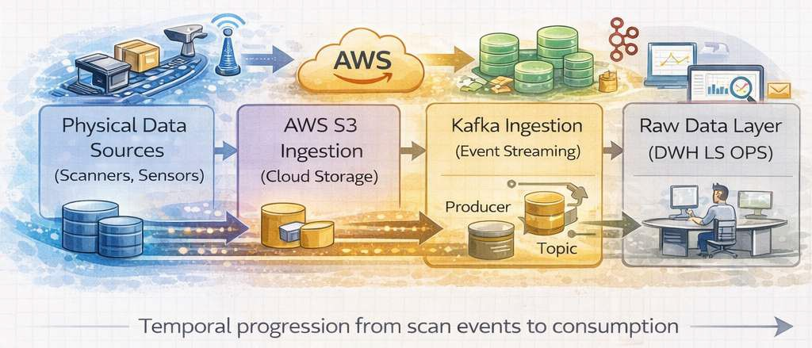

Figure 4.9.: An artistic high-level view of the DWH LS OPS data lineage

KEY POINT: From the data creating stage until the data arrives at the DWH, it passes through four IT system steps discussed here. This results in four potential sources of failure, in which each system is counted only once and by ignoring different possible errors per step. This landscape makes it difficult to trace errors that can occur at any step. Additionally, the variety of errors is large, as they may alter data values or result in no data being transmitted at a given step, even though the operation of the sorting center itself continues without issues. Therefore, at a technical level, providing clarity especially during the operational aspect is an important key aspect of this project.
Finally, to complete the picture of the data lineage, one more step is relevant. After the data has arrived in the raw layer at DWH LS OPS, it must be cleaned and deduplicated. At this step, differences in hardware providers and the structural differences of sorting centers come into effect, and the unification of the data takes place. All of this is performed in the step towards the curated database layer, after which a reporting layer serves as the final layer from which reporting tools retrieve data as introduced in chapter ??. This is illustrated here with a focus on the central step from the raw layer to the curated layer. Even after the curated layer, there is one additional layer, namely the reporting layer.
The different layers in the cloud are set up according to a structure similar to that used in the classical on-premises DWH at Swiss Post. This similarity to the on-premises DWH stems from deliberate architectural

alignment. The cloud infrastructure was built with the guidance of on-premises developers using their domain knowledge. In this way, functional and structural consistency was maintained, as the architec-ture continues to follow the Kimball star schema and the layered architecture as defined in the Kimball technical architecture Kimball Group n.d.
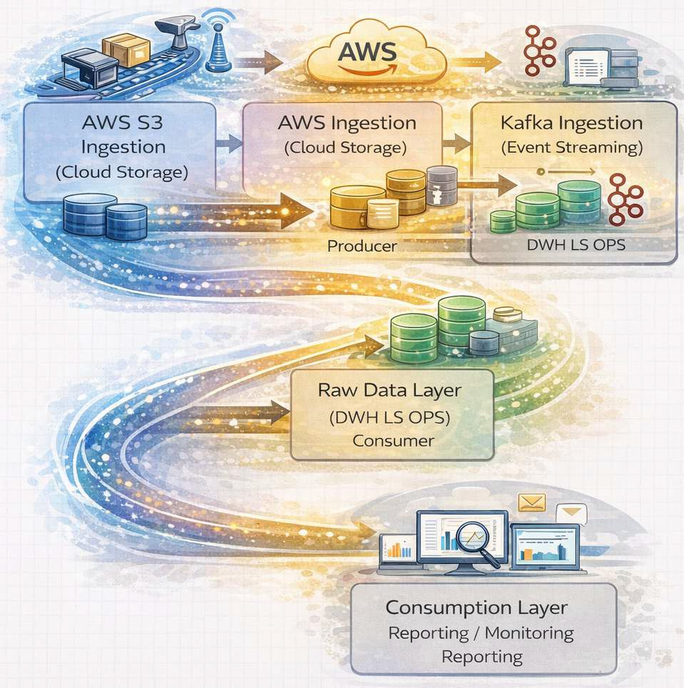
Figure 4.10.: An artistic high-level view of the full DWH LS OPS data lineage up to reporting

This project as a key step towards the “future state” reporting solution
As stated earlier the solutional goal of this project and its follow up is to provide an MVP for DQM, from which the key learnings will enable the full “future state” reporting solution. This MVP should implement an automatic data quality check, replacing an occasional, non automated check performed by the business. This is important, as the DQM check is currently executed by the business instead of IT, which creates challenges with regard to the desired target state. The expected situation would be that IT executes data quality checks and defines thresholds together with the business. At present, however, the knowledge about thresholds and other relevant information resides solely with the business.
In summary, having IT run the data checks would enable continuous follow-up of data quality. For example,

a report based on automatically executed checks could show system uptime over a longer period of time. This information would later allow IT to extrapolate standard value ranges, which in turn would enable the definition of alerting thresholds. In short, having DQM checks executed automatically rather than occasionally by the business provides multiple benefits for both IT and the business.
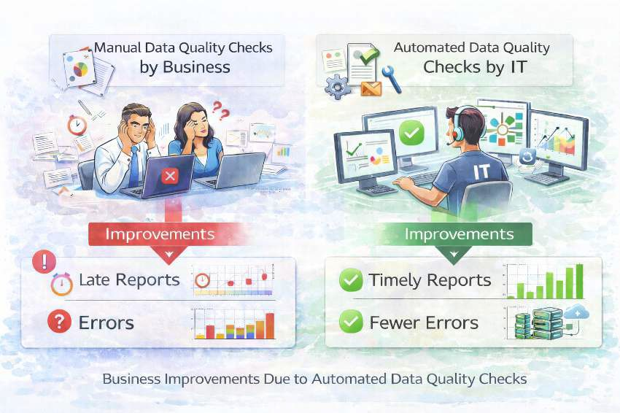

Figure 4.11.: DQM manual checks against automated checks by IT

Expected benefits of this reporting solution
A single visualisation does not explain the full benefit of the intended solution. For instance, the question arises as to why the business should stop performing data quality checks when it has the most detailed knowledge of the data. This is quickly clarified by taking a step back. The question should not be why checks are removed from the business, but why the reports are performed by the business in the first place. The benefits of this shift are therefore outlined in more detail in the following.

Benefit 1: Automation over manual processes to reduce effort
The business currently spends 30 to 45 minutes per day on a single data quality check, according to the initial project hand in description. From the duration of the check, it can be inferred that anyone requiring the data quality check before a report based on it is approved must wait until it is finished, resulting in a waiting time of 30 to 45 minutes. This fact provides the basis for understanding why manual processes are not suitable at scale. When scaling up to ten data quality checks, five to seven and a half hours are spent by the business on data quality checks. The waiting time for the last reports to be approved increases accordingly to five to seven and a half hours. When increasing to 20 checks per day, ten to 15 hours are spent, and the waiting time rises accordingly, accounting for more than one full-time position and long delays in report data release. It should be noted that this amount of time is spent solely to determine whether the defined check passes or not. If the same initial check is executed by an automated data quality process, the expectation is that execution takes less than one minute; for simplicity, an execution time

of one minute is assumed. As no manual initiation is required, no human time is spent performing the check. For comparison, the one minute waiting time for report approval and release is still considered. The business can then be informed whether the check returned an OK or not OK result, and the outcome can be stored for future reference.
When scaling this approach to ten checks, the total execution time remains ten times one minute. How-ever, as the IT system can execute these checks in parallel, the waiting time for results remains at one minute. When increasing to 20 checks per day, the IT systems likewise execute the checks in parallel, and the execution and waiting time remain unchanged.

Benefit 2: Scalability to further reduce overall time required
In summary, manual data quality checks cannot be scaled and lead to excessive use of human resources for repetitive tasks, as well as long waiting times for approved datasets. Automated data quality checks, by contrast, allow many checks to be executed in parallel within the same overall time frame. It should be noted that this comparison assumes all checks have similar complexity.

Benefit 3: Rule changes without query changes
The current manual reports, which are business driven, have their logic built directly into the queries executed on the data. If any rule changes or a part of the data processing is modified, these queries need to be adapted. Thus, the check is deeply tied to the data source. To illustrate this with an example, a data quality check may confirm that 30% of the data is category A and 70% is category B, as this is considered the expected and valid distribution. If changes to processing pipelines or client behaviour cause the share of A to increase to 45% and B to decrease to 55%, the query performing the check must be adapted. However, when the check is performed by an application that injects these thresholds into a query, the query itself does not need to change, and only the parameters must be adjusted.

Benefit 4: Reusability to improve stability and performance
By moving the responsibility for checks from manual, business-driven processes to automated checks exe-cuted by IT, the checks can be designed to be more generic. Generic checks can be reused across different use cases. This separation of responsibilities and concerns leads to improved stability and performance when applying the checks, which in turn enables strong reusability. The same check type can be applied to different data sources by adapting parameters such as the query and thresholds, while the underlying check logic remains unchanged.

Existing reporting pipeline
The current reporting pipeline at DWH LS OPS team consists of four main components as shown in follow-ing figure and introduced in chapter ??. First, the storage layer (in figure : Datenspeicherung), where data is retrieved, cleaned, and saved to Amazon S3. Second, the query and processing layer, where cleaned data is queried using Amazon Athena and DSP(in figure : Datenselektierung, Datenpreparation Datenmodelle Data Federation), and where data is passed and persisted in data models for reports. Third, the reporting and consumption layer, in which data from DSP is used in SAC reports (in figure : Business Layer).

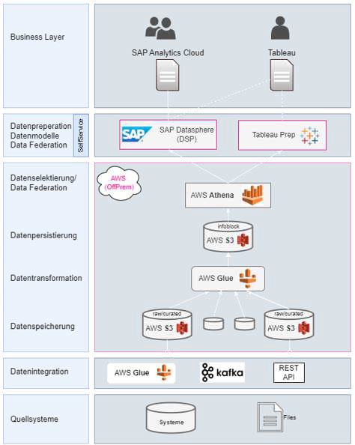

Figure 4.12.: The DWH LS OPS reporting layers

AWS S3
As described by Amazon: “Amazon Simple Storage Service (Amazon S3) is an object storage service that offers industry-leading scalability, data availability, security, and performance. Customers of all sizes and industries can use Amazon S3 to store and protect any amount of data for a range of use cases, such as data lakes, websites, mobile applications, backup and restore, archive, enterprise applications, IoT devices, and big data analytics. Amazon S3 provides management features so that you can optimize, organize, and conftgure access to your data to meet your speciftc business, organizational, and compliance requirements.” Amazon Web Services 2025b.
This is relevant for Swiss Post, as Amazon S3 serves as the central storage for data from mail piece events,

which include all scans of parcels and mail in sorting centers, as well as later stages up to the delivery process. This storage is used by the DWH LS OPS team. All data entering the data lineage pipeline, for example through Kafka or through direct database connections, is stored in Amazon S3. Thus, it represents the first persistence point in the reporting pipeline.

Layered architecture It is important to note that the data is not only initially saved to Amazon S3 in a raw layer, but is also cleaned and prepared for reporting in two additional layers. To separate the storage of raw data from the cleaning process, multiple layers are used. This ensures that all data in its original format is saved first before processing, modification, augmentation, and checks for completeness or correctness are performed. Each step can therefore be reproduced and repeated, which is useful whenever data needs to be reloaded, for example when data was incomplete for a day or when new processing methods are developed. After the raw layer, data is deduplicated and cleaned, and then saved into the curated layer. The final top layer, the reporting layer, mainly adds translations of fields into business terminology, for example by changing column labels. This is useful for the business, as it enables consistent naming of columns across tables or data products.

Infoblock On this level infoblock’s are generated, this is a Swiss Post internal term used for report ready data products. An infoblock is cleaned, deduplicated, curated data which features joined datasets that use business naming, e.g. post day and processing, priority types. Basically the infoblocks are the final layer employed on the reporting layer, making them accessible to the reporting tools such as DSP and SAC, which are described in detail below. A more comon term for infoblock know trough out the industry is data product What is a Data Product? N.d.(a); What is a Data Product? N.d.(b).

AWS Athena query
The next step is Amazon Athena as the query layer, which Amazon describes as follows: “Amazon Athena is an interactive query service that makes it easy to analyze data directly in Amazon Simple Storage Service (Amazon S3) using standard SQL. With a few actions in the AWS Management Console, you can point Athena at your data stored in Amazon S3 and begin using standard SQL to run ad-hoc queries and get results in seconds. “ Amazon Web Services 2025a. Amazon Athena is used by Swiss Post DWH LS OPS for all queries on Amazon S3, which is the next step in the reporting pipeline. Athena is the tool designed by AWS for use with S3, making it the logical choice for querying the stored data. The data is queried for reporting purposes by selecting the relevant subsets.

DQM relevance The querying layer is relevant to DQM, since data quality issues may become apparent first at this earliest checkpoint, for example when errors occur in the data itself and counts or joins become invalid. While the data is queried at this layer for reporting purposes, it is also queried here for data quality checks. Such checks typically address missing data and data completeness, but can also extend to data plausibility, for example when postal codes are compared to cities. In cases where issues occur at this layer, they are passed downstream towards DSP and SAC, provided they do not already break the pipeline at this stage.

SAP Datasphere (DSP) and SAP Analytics Cloud (SAC)
At Swiss Post, the next step in the reporting pipeline uses the two dependent tools SAP Datasphere (DSP) and SAP Analytics Cloud (SAC). These are described as follows by SAP:

SAP Datasphere enables organizations to combine, harmonize, and model data from multiple SAP and non-SAP sources within a semantically rich, cloud-based data environment. SAP Analytics Cloud can directly consume these governed and business-ready data models via live connections, enabling interactive reporting, analytics, planning, and forecasting. In addition, planning and forecast data created in SAP Analytics Cloud can be written back to SAP Datasphere, allowing analytical and planning data to coexist in a single, integrated data foundation SAP SE 2024.
SAP Datasphere (DSP) is SAP’s cloud-based data platform for integrating, modeling, and analyzing data across SAP and non-SAP systems while preserving business semantics. It enables federated access to dis-tributed data without full replication and supports end-to-end data lineage and governance. DSP at Swiss Post is used as the analytical backbone for reporting, analytics, and data-driven decision-making in SAP landscapes.
SAP Analytics Cloud (SAC), in turn, uses the data model provided by DSP to present this information on the business layer to end users. More information on this is provided in the separate section introducing the tool.

DSP data model
After querying, the data is persisted in DSP, where it is made available in data models. This persistence and processing layer is essential in the current pipeline, as data can be made available to SAC only through DSP. At Swiss Post, data persistence has proven essential to improving the response time of the reporting pipeline as a whole. With this persistence, DSP does not pass queries back to Amazon Athena, creating a clear separation between the two layers. Due to this separation, DSP is not responsible for DQM, which is handled in lower layers. Finally, DSP is the layer in which business logic is applied in a semantic form, defining what the data represents. At Swiss Post, this is done by applying business oriented naming and calculations. Different report consumers may require the same values to be structured in different ways; for example, productivity in a sorting center may be measured using total working hours against the num-ber of mail pieces handled, or calculated using only time spent on sorting-related tasks, excluding breaks, training, and other activities.

DSP use case The data models in DSP are useful not only as a bridge to SAC (discussed below). They allow different data sources to be modelled and combined into unified data models. This is also relevant to Swiss Post, as it operates not only Amazon Athena data sources but also other database- or file-based sources. This combination of data inevitably inherits data quality issues from the underlying sources, which can affect joins, data loading, and further processing. Nonetheless, DSP is the sole source of data provided to SAC, which is the next logical step in the reporting pipeline. This also means that any unhandled data quality issues are passed directly to users consuming reports in SAC and may therefore affect confidence in the reporting pipeline depending on data quality.

SAP Analytics Cloud (SAC) report
SAC is the final step in the reporting pipeline and represents the reporting and consumption layer. As the last layer, it inherits the data from previous layers and is responsible only for its visualisation. The data is displayed passively, and no further transformations are performed at this stage. Consequently, any errors in data preparation or data quality issues from upstream layers are propagated to this layer together with the data itself.
As described earlier, SAC is dependent on DSP and cannot operate independently, nor does it provide native DQM capabilities. The reports generated by SAC are therefore fully dependent on the preceding layers, and

any issues or delays are reflected directly in the reports. This is particularly relevant for Swiss Post, as one report provided by DWH LS OPS is used daily at 07:00 for shift handover, which takes place one hour after the end of the post day. Some data sources required for this report become available only after 06:00, the end of the postday. If any upstream step is delayed, the report delivery is delayed accordingly.

Consumption layer As the consumption layer for reports, this is the point at which users with read access have their first and only interaction with the reporting pipeline. It is at this stage that user confidence is either established or lost, making it particularly critical. Users do not see the upstream processing steps and typically do not differentiate whether missing or delayed information is caused by AWS S3, Athena, or DSP.

Report visualisations and evaluations
After the basic solution landscape this project now dives deeper into the more specific context of report visualisations and evaluation of automatisation.

Power BI
At Swiss Post in the environment of the DWH LS OPS, Power BI is the set business intelligence tool. It is to replace the currently used tools over time. The main reasons for this shift are the lower license cost in comparision with the previous SAC and furthermore it has performed faster in direct comparision tests with its predesessor. Therefore, Power BI served as BI tool in this project, as it is specifically replacing an old report in SAC.

Architectural position
When considering the data lineage, Power BI is replacing both the DSP on the data model side, as well as the front end part of SAC. So in total it is replacing the work areas of the business stakeholders coworking with the DWH LS OPS team. This is so because they are involved both in the generation of testing and updating the reports on the reporting and monitoring layer.

Star shema
During the speed tests and comparisions with the old business intelligence tool, the star shema as a data architecture was tested. It showed that Power BI was performing better with this new structure. Therefore as Power BI was designated as new business intelligence tool, the architecture was changed to this.

Basic architectureof star shema
When looking at data base architecture, a star shema is basically a partly denormalised database which has been optimised for fast OLAP processing. In computing, online analytical processing (OLAP), is an approach to quickly answer multi-dimensional analytical (MDA) queries. This describes the ground work that reporting has to perform in the DWH LS OPS team.
A star shema is described by wikipedia in the following way Wikipedia contributors 2025:

In computing, the star schema or star model is the simplest style of data mart schema and is the ap-proach most widely used to develop data warehouses and dimensional data marts. The star schema consists of one or more fact tables referencing any number of dimension tables. The star schema is an important special case of the snowflake schema, and is more effective for handling simpler queries. The star schema gets its name from the physical model’s resemblance to a star shape with a fact table at its center and the dimension tables surrounding it representing the star’s points.

Basic architectureof Wide table
In contrast to a star shema, a wide table is storing all the data in one big, very wide table. This concept of wide table was introduced at Swiss Post, together with SAC. In a wide table, the data is not split in differ-ent tables, but instead for every dataset all measures existing are repeated. For example every data point measurement that happened at the same factory, would have the same identifying measures of an address repeated rather than only 1 key pointing to a adresses table.
A short concise description of the concept can be found at enwiki:QuestDBWideTable:
Wide tables are the opposite of narrow tables, storing multiple related attributes horizontally rather than vertically. In time-series applications, a wide table typically has a timestamp column followed by numerous metric columns, making it efficient to retrieve multiple metrics for a given time point.

Reporting idea
When considering the previous report generated trough SAC, it can be seen that is is not very visual. The data is only shown as a table without color highlights or additional indications. Without sufficient business knowhow it did not allow a user to see wether the data quality was ok or not for a specific day. The current report is shown in the following.
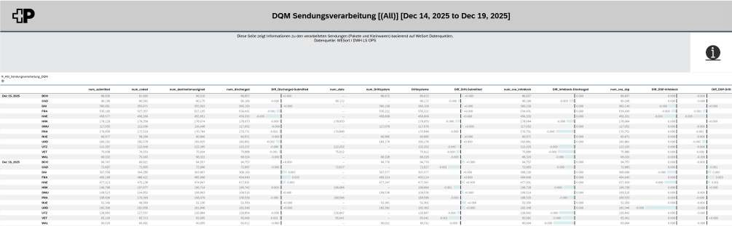

Figure 4.13.: Existing plain DQM dashboard used as the baseline for the redesigned Power BI report

To improve this situation, a report which hast to replace it, must be more visual. And apply some of the most basic business knowledge allowing to see its results faster. As the previous research has already defined which rules must be applied in an automatic check, those rules are the basis for the reports visualisation.

Business stakeholder feedback
During meetings with the business their requirements were accumulated. Those were simple, the report had to be upgraded to use the new data source. Since with the adoption of Power BI, also a more efficient

reporting datastructure was possible, it had to be again measurable. As the data itself was only rearranged but not radically new, the checks and the way they had to be shown in a table stayed the same. Regarding additional improvements of the report no direction was given, however an OK was provided to improve the report with useful information.

DevOps
At Swiss Post deployments are done by the software engineers effectively turning their field of operations to DevOps.
The field of DevOps is described by Wikipedia as follows enwiki:1362982395: DevOps is the integration and automation of software development and information technology operations. DevOps encompasses the tasks necessary for software development and can lead to both shortening development time and improv-ing the development life cycle. According to American software architect Neal Ford, DevOps, particularly through continuous delivery, employs the "bring the pain forward" principle by tackling challenging tasks early, fostering automation, and enabling swift issue detection.
Although debated, DevOps is generally characterized by three key principles: shared ownership, work-flow automation, and rapid feedback. From an academic perspective, Len Bass, Ingo Weber, and Liming Zhu—three computer science researchers from the CSIRO and the Software Engineering Institute—defined DevOps as "a set of practices intended to reduce the time between committing a change to a system and the change being placed into normal production, while ensuring high quality". However, the term is used in multiple contexts. At its most successful, DevOps is a combination of specific practices, culture change, and tools.

DevOps at Swiss Post
At Swiss Post this the DevOps process is already defined and is not changed by this project, it will apply all defined tools and rules. To name the general rules:
▶ GitHub is used as CodeRepository using SSO with post accounts
▶ The access to repositories is limited and managed by a permission system
▶ Separate repositories exist for development and productive environments
▶ Repositories are also separated by function, e.g. repositories for teraform IaC or sql scripts for Athena
▶ Development is performed on branches
▶ To merge branches a pull request is required, this triggeres GitHub actions
▶ The Github actions are performing checks depending on repository and function
▶ To merge code on production environments a review by another developer is required in addition to successful Github actions
▶ In addition to this deployment pipeline, DevOPS engineer continue maintaining and support their code

Frontend deployment pipelines
Regarding frontend reports a similar process is already defined and also applie, not adapted by this project. When deploying front end reports using Power BI, the process is happening entirely on the microsoft en-vironments.

▶ Reports are initially created on Power BI desktop
▶ Development and testing happens on the desktop version first
▶ The report is deployed from Power BI desktop to Microsoft Fabric, development environment
▶ The code is checked in using git integration in Microsoft
▶ The report is tested first in the development environment
▶ Then it is deployed trough the defined pipeline to test environment
▶ Stakeholders are performing tests on test environment
▶ After successful tests and eventual fixes the go for productive deployment is given
▶ Productive deployment is done again trough the deployment pipeline
The deployment pipeline is shown in the below figure, showing the selection of environments from which the 3 steps process starts.
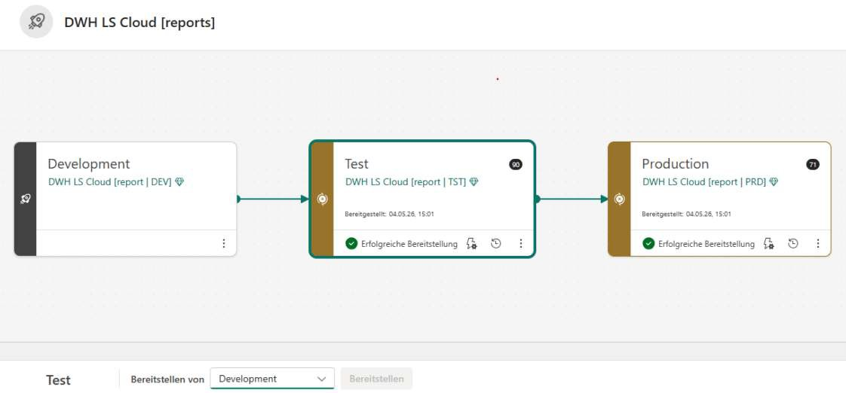
Figure 4.14.: Power BI deployment pipeline across the development, test, and production environments

DQM tool selection
The DQM tool selection required a structured approach. Such approach required to first setup a list of requirements towards a tools. Then a evaluation how well tools are fulfilling these requirements. And finally the invitation of the fulfilling providers to demos.

Tool selection principles
the first step in evaluating a tool must be to get to know, what a tools actually needs to have. Commonly those lists are called requirement lists. They have to incorporate the must have features of a tool and the nice to have requirements. With such a list, the decision together with higher management is made easier, as they allow for a scoring and easy overview of which tool scored how many points. Based on such points list, the per performing or best price can be selected.

Requirements list
At Swiss Post the DQM team setup the requirements list. It incorporates the following main principles:

▶ Data Coverage & Connectivity: The integration into the existing tool landscape. The requiements to be cloud first. Most important data sources that need to be handled.

▶ Data Quality Capabilities: What actual DQM requirements the tool must fullfill. The usability which is expected, such as NoCode environments.

▶ Reporting & Monitoring: The tool must allow exports to other tools for reporting purpose.
▶ Performance and Reliability: The tool needs to be responsive also on big datasets as Swiss Post will want to run checks on very large transaction datasets.

▶ Cost & Licensing: The cost of a tool is relevant. How is the cost structured.
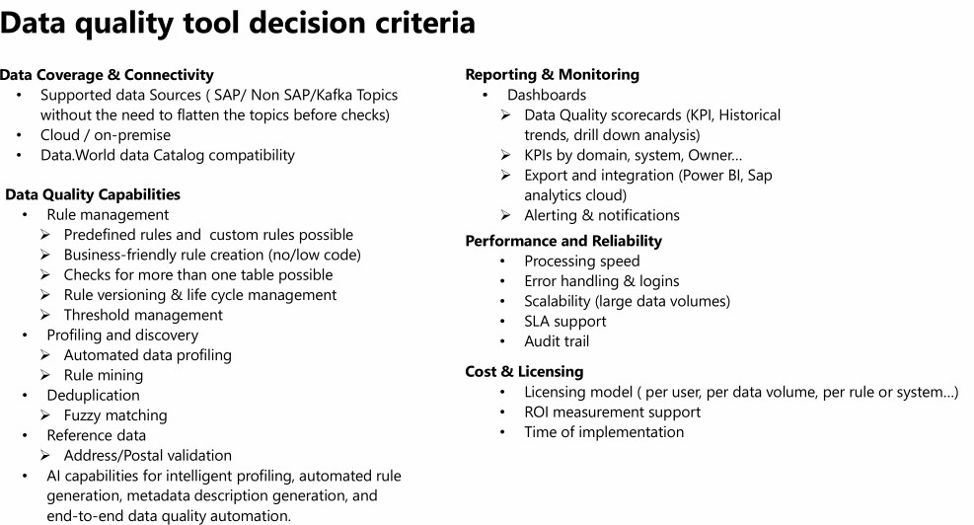

Figure 4.15.: Overview of the data quality management tool evaluation process and the assessed evaluation criteria

Additionally there are the more soft criteria which are nice to have. Soft criteria are the criteria which are not mandatory but make the usage of an application easier for users e.g. provide easy management of access roles:
▶ Usability & User experience: User permission system allowing multiple different access levels and their provisioning trough existing means.

▶ Technical requirements: The security requirements which the cloud solution has to meet. Addition-ally the connectivity options they need to support

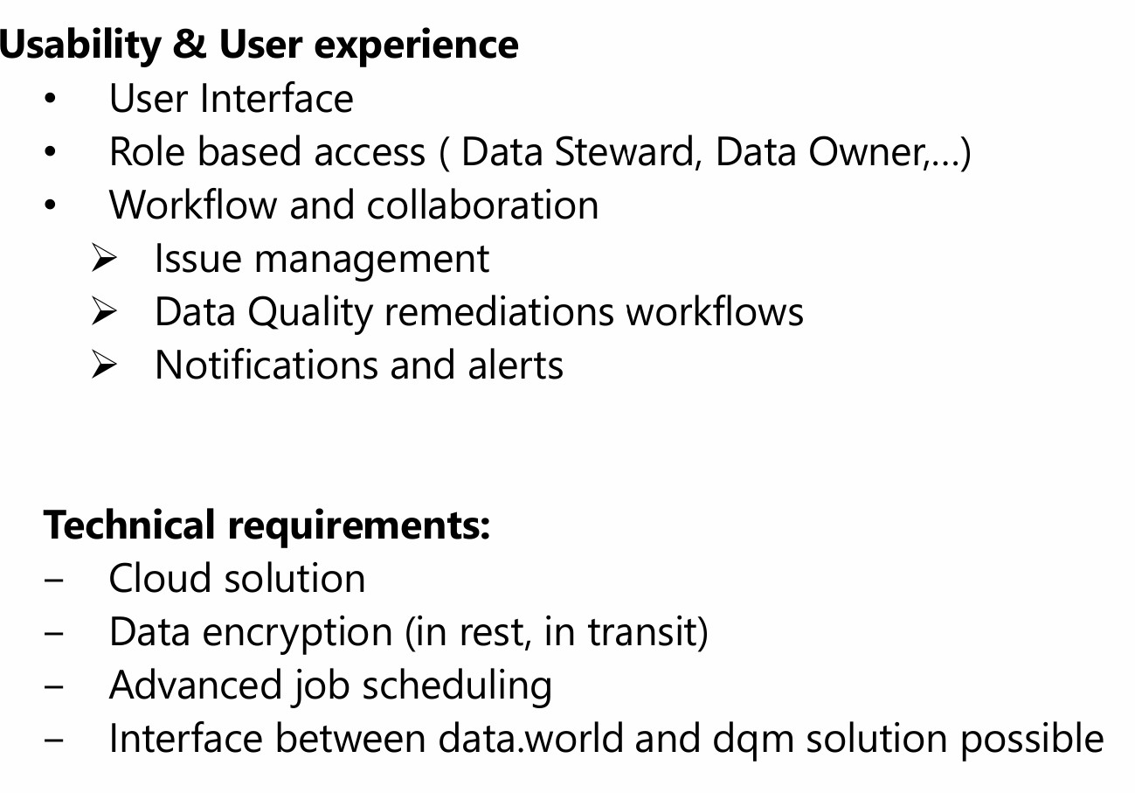
Figure 4.16.: Continuation of the data quality management tool evaluation, including the comparison of the evaluated solutions

DQM tooling selection

After having the selection criteria, the tools are researched. The research of these tools has also been done by the DQM team so its out of scope for this work. As a result of the tool research, the different found tools are evaluated against the criteria. This finally results in the table as shown below highlighting the performance of the tools against criteria. This table the serves for which tools are inivited for demos or directly excluded.

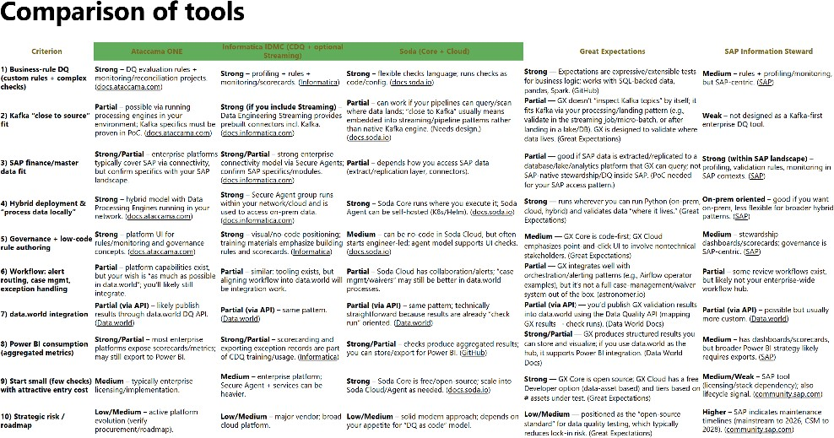

Figure 4.17.: Example of the comparative evaluation matrix used during the assessment of different data quality management tools

Design decisions
Next step after the evaluation table is to invite the succeeding tools to a demo. In this demo the providers are asked to show their performance of the tool against the defined criteria but can also show what specific benefit they bring with. The demo provides the selecting company with a more detailed view of the capa-bilities applied to their dataset or if any shortcommings are blocking the decision. Furthermore it allows the selecting company to directly ask questions on open items. After a demo the scoring can be adjusted and finally a decision made wether to go ahead with a provider into PoC or even contract negotiations or send them the information that they dropped our of the selection.

DQM tool testing
The DQM tool selection required a structured approach. Such approach required to first setup a list of requirements towards a tools. Then a evaluation how well tools are fulfilling these requirements. And finally the invitation of the fulfilling providers to demos.

BlaBla2

Implementation

This chapter uses the research findings and the solution landscape developed in the previous chapters as a basis for the implementation. With the defined SMART goals, the analysed reporting pipeline and data lineage of the previous research Roccaro 2026, dbeeing the basis of the successful completion of the SMART goals set in this project. The three goals are handled sesparately as their completion are not dependant of each other. Those three goals are:
▶ Updating the existing data quality report, using the new data products set up by the ASTV team. Thus using also the new reporting software Power BI and the new setup of data sources in star schema.
▶ Following up with the platform and data quality group regarding the tool decision for data quality management at Swiss Post in the future. This task started as the evaluation of tools, as the DQM platform described in the previous research Roccaro 2026 had shown that it would not be fit as a tool for the entire Swiss Post.
▶ As a preparation for the upcoming Master Thesis, the data quality tools to be used were checked initially. This included performing a concise test of counting data points with the defined monitoring setup.
The validation of the achieved results is performed in the next chapters.

SMART Goal 1: Setup of an Improved DQM Report
In Project 1, the groundwork for researching the reporting pipeline was completed. It provided the data lineage and described the underlying issues. Based on this work, an improved report was developed. Re-search was conducted on how to better highlight the relevant comparisons and help users identify the information more quickly. Additionally, the third-party data source, which was previously copied daily into an Excel file, was improved. The file was moved to SharePoint and is now updated whenever changes are made to Amazon S3, where it is made available to Athena. In addition, the selected data underwent a structural change, which is described at the end of this section.

Update of data source
The first step towards the new report was to improve one of the data sources used by the report. Part of the data was retrieved from a third-party system by means of an Excel table. The file resided in a shared folder and was not initially archived. As this data source did not change and was required by both the existing SAC report, which had to remain operational, and the new Power BI report, it had to be made available in a way that was accessible to both tools. Changing from a shared folder, which was not accessible to Power BI, to SharePoint was therefore a major improvement, as it added versioning to the file. Furthermore, the DWH LS OPS team has an existing method to transfer .csv data from SharePoint to Athena.
Therefore, the destination of the Excel file was updated in collaboration with the business users responsible for the manual maintenance of the Excel file. With this change in place, the first data source was made available to Power BI and all versions of it were from now on stored on Amazon S3.

Todo: Show link to guides Show issues that happened during transfer The excel was not an xlsx but xls

Setup of Power BI
Regarding the Power BI setup, Swiss Post has already defined DevOps pipelines, setup guides, and docu-mentation supporting the installation of the application and the required infrastructure, for example, for using Athena as a data source.

Setup
This setup consists of predefined templates defining areas such as report colour schemes, filter regions, and how permissions for reports are handled. Furthermore, the setup includes definitions of how to deploy reports and how to handle AWS Athena data sources. Thus, the setup was carried out in accordance with the guidelines defined by Swiss Post Swiss Post 2026c; Swiss Post 2026a; Swiss Post 2026b.

Report Definition
The initial report setup was adopted from the analysed SAC report, as the data that had to be checked remained the same. Therefore, the method followed by the business also remained unchanged, and the first tests of loading the data into Power BI produced the data in the same way.
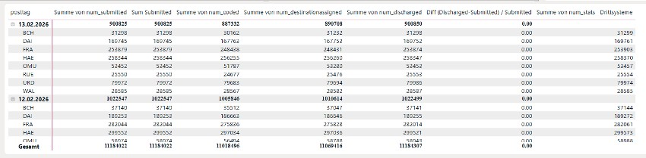
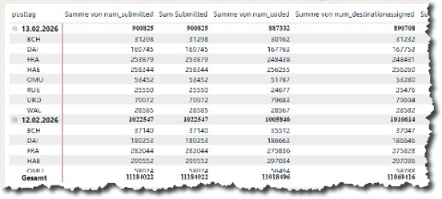
Figure 5.1.: Initial Power BI report designed to resemble the existing SAC report

Initial Data Setup
As this was the first report developed by the project team, the initial implementation was carried out locally without deploying the report to Microsoft Fabric. As a first report, the variety of available approaches for implementing features such as links between data sources naturally led to a report setup that performed some tasks twice, for example, linking the two data sources using both Power Query M and DAX. These de-ficiencies in the initial implementation were eliminated throughout the subsequent implementation steps of the report.

Differences Between Local and Cloud
Once the linkage of the two data sources was working and the data was displayed in the same way as in the SAC report, the Power BI report was published to the cloud. However, the report showed issues when loading data from Athena. Power BI automatically applied a transformation that attempted to cast a column containing date values into a date format. This resulted in issues with empty values.
According to the initial research using Microsoft Copilot, the issue could be resolved in Athena. However, discussions with the wider DWH LS OPS team showed that similar issues had occurred for other team

members. Therefore, before making changes in Athena, the possible solutions identified by the team were investigated. After consulting the team and checking the view in Athena, it became clear that the issue did not originate in Athena and therefore could not be resolved there. As the tests showed that the query ran correctly in Athena, the issue had to be located in the report. Since no proper checkpoints had been established up to this point, it was not possible to determine at which stage the applied data transforma-tions caused the issue. Therefore, the report had to be recreated, and after each transformation, a test deployment was performed to verify that the data loaded and was displayed correctly in the cloud version.

Model Data Setup

After the initial data from the SAC report were integrated, the model contained information from two tables sourced from AWS. However, for the further checks, more data sources had to be included. Thus, the data model had to be refined by connecting the tables through the data model view rather than through Power Query M and DAX. Initially, only two tables had to be linked through the postal codes and dates. This new model setup was a requirement defined by the team, as was separating the measures into a dedicated table in Power BI.

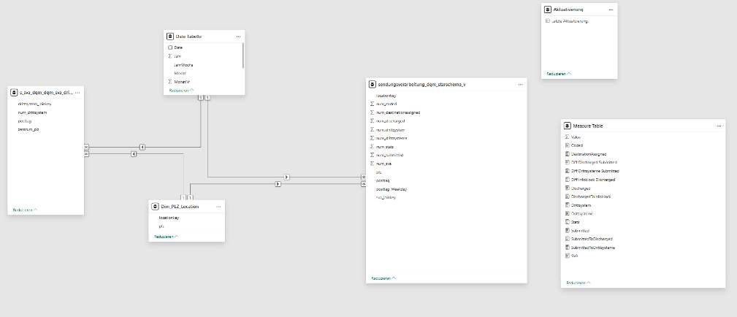

Figure 5.2.: Initial Power BI data model containing the core tables required for the first report prototype

The data model was extended towards the end of this SMART goal by integrating the full data model used by the business. This was mandatory to perform the final check, comparing the infoblock data in Athena with the aggregation table in Power BI. The aggregation table was set up by the ASTV team and was used by the project team.

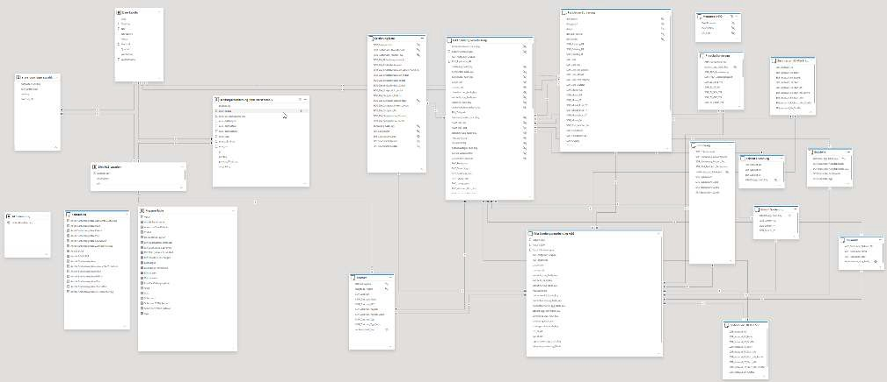

Figure 5.3.: Final Power BI data model after integrating additional data sources, calculated tables, and supporting information

New Visuals to Support Faster Interpretation by Stakeholders
As the task of this SMART goal was not only to copy the existing report but also to improve it, the content was made more visual and easier to interpret. Thus, having only one table containing all data would not improve the situation. However, according to the checks defined in Project 1, the thresholds were already known. These thresholds allowed warnings to be displayed. Therefore, the report was divided into three different views.
▶ a detailed table containing the daily event counts and all relevant information
▶ a traffic light dashboard showing whether the values satisfy the defined validation checks
▶ a line chart showing the development of the values over time
The first visual is a detailed table showing the daily event counts per event and sorting centre. This allows the business to confirm completeness based on the absolute values. The table was enhanced with traffic light indicators showing green or red according to the defined thresholds.
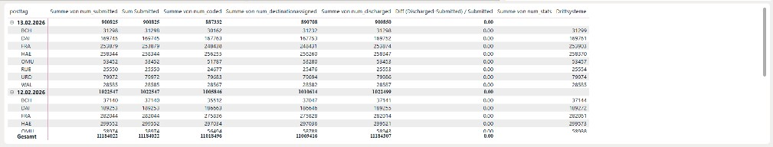
Figure 5.4.: Power BI table visualising daily event counts and data quality indicators

The second visual consists of traffic light indicators summarising the four data quality checks. For each check, the values are compared and displayed as green when the difference is below 1% and at least 10’000 events are available. This allows users to quickly determine whether the latest values are valid, reducing the time required to decide whether further investigation is necessary.

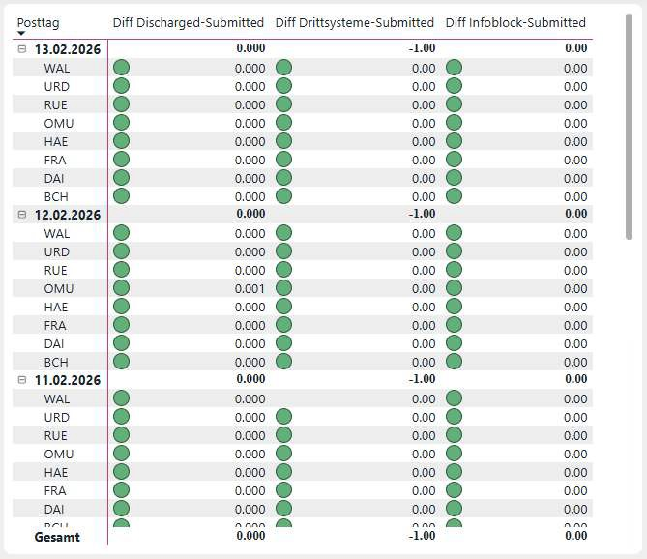

Figure 5.5.: Power BI traffic light indicators summarising the four data quality checks

The third visual is a line chart that allows users to identify recurring patterns in the data, for example whether errors regularly occur on Fridays or Mondays. The centre line represents 0% deviation, while the dashed lines indicate the threshold of 1%. The four coloured lines represent the different events. Note: this graph looks time-oriented but in fact each time block contains the list of the sorting centers; this graphical approach was deliberately chosen to make it easy for business stakeholders to use.

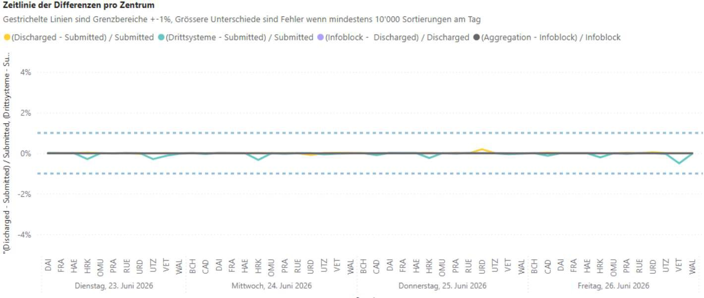
Figure 5.6.: Power BI line chart showing historical data quality trends

In total, the report was updated to the following dashboard. It integrates the three visualisations together with a header providing filters that apply across all visuals, allowing users to filter by weekdays, date ranges, or selected sorting centres.
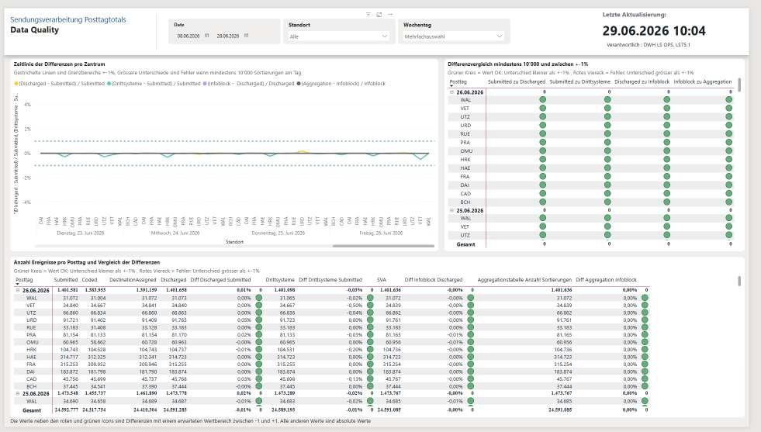
Figure 5.7.: Final Power BI dashboard integrating all implemented data quality visualisations

New View Athena
To highlight some of the testing and improvement loops during the development of the report, the follow-ing example describes a change to one of the data sources. During testing, the business pointed out that

small differences in the number of events occurred between the new Power BI report and the data source it was intended to monitor. This issue was reported during a meeting between the project team and the product owner of the ASTV team. The product owner identified that the new Power BI report was still using the old data source.
While the data source remained largely the same, the data lineage changed slightly. Business and IT de-cided in late 2025 that the data should be consumed as a star schema to improve performance compared to the existing wide table. Consequently, the DQM dashboard for message processing needed to follow this change in the data source. In order not to disturb the previous report, the data had to be gathered into a separate view in Athena. The separate view was also required in order to validate the new star schema infoblocks rather than those of the previous wide table. Thus, separating the views was necessary to main-tain clean, high-performing code, as adding the new query parts for the star schema to the wide table query would have slowed the query down and intertwined two different use cases.

DevOps Process
After the issue with the new view was reported, the DevOps process was started. To create a new view:
▶ The developer first tests the query for the new view in Athena, confirming that it is valid.
▶ Next, the developer navigates to GitHub, selecting the corresponding test repository for the account used.
▶ A new branch is created, followed by a file containing the CREATE VIEW SQL statement.
▶ After this, a build is attempted. If it is successful, the process continues; otherwise, the developer returns to the first step and fixes the issue.
▶ If the build is successful, a pull request can be created and the new branch merged.
▶ Once this is completed, a branch is created in the production repository.
▶ The build in the production environment must be successful.
▶ Furthermore, a review by another developer is required.
▶ Once both the build and the review are successful, the merge can be performed.
The full query for the new view can be found in Appendix A.3.

SMART Goal 2: Tool Decision
As part of SMART Goal 2, the DQM team was followed during its evaluation of a suitable tool for DQM. This work took place in parallel with SMART Goal 1. For the project team, this goal served to identify the tool to be used in the subsequent master’s thesis and allowed its capabilities to be evaluated directly within SMART Goal 3.

Tool Evaluation
While the previous research Roccaro 2026 described a DQM tool being developed, other initiatives at Swiss Post were evaluating a company-wide solution. First, the tool selection process for the company as a whole is examined, followed by the DWH-specific solution.

Tool Selection for Swiss Post
However, for Swiss Post as a whole, the tool developed for the DWH was considered too specialised. The main considerations against this initiative were:
▶ The DWH initiative was considered too specialised for its use case and therefore not suitable for company-wide deployment.
▶ The developed tool did not address the broader system landscape of Swiss Post.
▶ The evaluation followed the principle of buy before build, favouring solutions available on the market rather than developing specialised tools that are difficult to maintain.
▶ Support for SAP data sources was a key requirement, as they contain critical accounting-related data with a high potential impact in the event of data loss.
This led to the evaluation of tools available on the market. These included Soda, Informatica, Collate, and Atacamma.

Demo
One of these presentations was provided by Soda, which was invited to perform a demonstration for Swiss Post. Soda presented its tooling in an online meeting, focusing on the following key features:
▶ Machine learning supports the identification of fluctuations, which are visualised as graphs.
▶ A no-code interface allowing the business to define rules.
▶ Rules can be defined using sliders to specify acceptable and failure ranges.
▶ An LLM chatbot allowing the definition of rules and data contracts.
▶ Data contracts: a schema defined at column level according to client-specific definitions.
▶ Support for row-level checks.
▶ Detection of missing master data links.
▶ On failure of a data check, queries are executed automatically to help identify the missing data.

Decision
Shortly after the presentation, the decision regarding the tool was communicated. The tool did not provide direct support for SAP data, which was considered an essential requirement. Therefore, it was rejected and the evaluation continued.
The following internal message describes the reasoning:
Hi everyone,
I wanted to share a quick update on our data quality tool evaluation process.
After reviewing the recent demo of Soda and considering our requirements, we have decided not to continue with this particular vendor. The main reason is the lack of a direct connection to SAP data, which is a critical component of our data landscape.
We will instead proceed with the remaining vendors (Collate, Informatica and Ataccama) and continue our evaluation process with them.
Thank you all for your participation and valuable input so far. I’ll keep you updated on the next steps.

Best regards

Tool Selection for DWH
The DWH LS OPS team continued its work together with the platform team as defined in the KPIs of the AWS modernisation initiative. As this initiative was launched by the DWH team, its requirements were the main driver of the development. During the course of this project, the tool developed from PoC status to being capable of running initial tests and subsequently being configured to validate real data.

DQM Platform Tool
After continued work by the AWS modernisation team together with the platform team, the DQM platform was ready. During a meeting, the current state was presented to the project team. The following excerpts are taken from the meeting minutes:
Meeting on: 18.05.2026
Participants: DQM team and project team
The rule-based DQM platform is ready for testing by the business.
The use case checking the master data for missing links has been implemented.
Checks are run on a schedule and the results are saved to Amazon S3 in the DWH account. The results can be queried using Athena.
A visual report should be created using Power BI.
Ownership should now be assigned for the checks and the data.
It should be investigated why the data are only available in one account, as they should also be available in another AWS account.

Discussion with Solution Architect
During discussions with the designated solution architect of DWH LS OPS, possible approaches for contin-uing the project were evaluated. This meeting took place after the decision to pursue different tools for the DWH and for Swiss Post as a whole had been announced. The meeting is summarised below using excerpts from the meeting minutes:
Participants: DWH solution architect and project team
The Swiss Post-wide DQM solution will not be based on the DWH solution.
The purpose of the meeting was to determine which tool the project team should use.
The solution architect referred to KPI 1, Monitoring, from the AWS modernisation initiative.
The goal of this KPI was to provide monitoring capabilities for jobs such as AWS Glue jobs, which are widely used for ETL processing, including information about their uptime and execution time.
However, the monitoring functionality had been extended to also support data quality checks and data counts.
The next task assigned was to check the status of the data quality checks together with the AWS mod-ernisation team.

Create a data quality check and test the functionality.

Acquire as much knowledge as possible before the end of the initiative, when the consultants and their expertise will no longer be available.

Conclusion

On 1 June 2026, the conclusion of the tool evaluation was communicated. The rule-based DQM platform developed by the platform team was selected for use within the DWH LS OPS environment. For Swiss Post as a whole, a different tool would continue to be evaluated.

Consequently, the weekly coordination meetings of the DQM team were cancelled. Furthermore, the mon-itoring functionality developed as part of the AWS modernisation initiative was selected as the tool to be evaluated in SMART Goal 3.

SMART Goal 3: Test of DQM Tooling

This SMART goal follows the testing of the designated DQM tool, with which a use case leading towards the master’s thesis can be implemented. The use case was defined during a discussion with the solution architect, as described in the previous section. It uses one of the deliverables of the AWS modernisation initiative, namely a monitoring solution for jobs. However, the monitoring solution was also designed in a way that allows selected data to be checked. As this functionality had only been developed in a basic form, it first had to be confirmed that it was suitable for performing the checks required during the master’s thesis.

Knowledge Transfer Sessions

As the AWS modernisation team was developing this functionality, knowledge transfer sessions were held to show the DWH LS OPS team how to use it. Furthermore, extensive documentation was written describing the interaction between the different AWS Service.

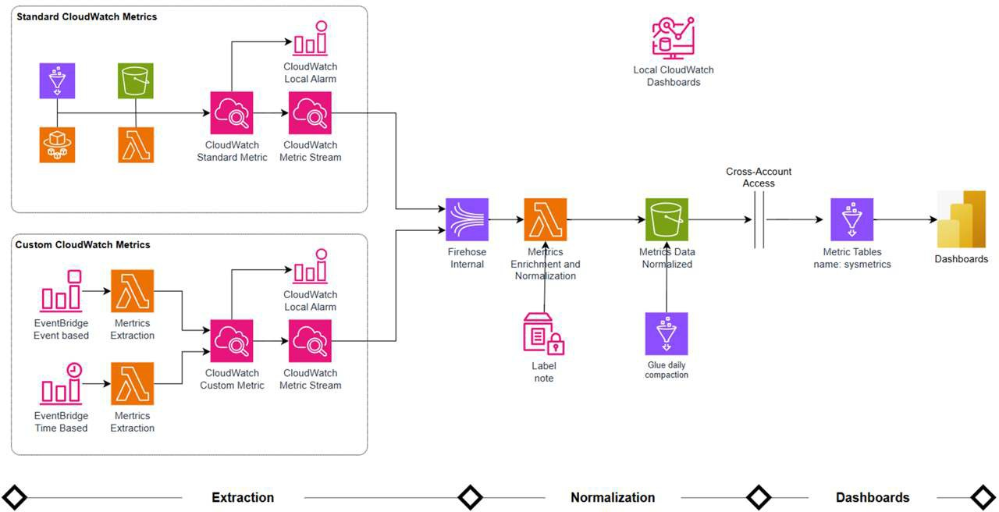

Figure 5.8.: AWS monitoring architecture showing the extraction, normalization, and dashboarding pipeline implemented using AWS services

First Step: Design a Measurable Use Case
First, a measurable use case had to be identified. Based on the DQM test and the dashboard created in SMART Goal 1, the daily event count was selected as the example. The existing basic monitoring code was able to perform a row count. However, the query used for the dashboard returned daily counts per sorting centre. For testing purposes, the existing monitoring code had to be used. Therefore, the SQL query had to be adapted so that, instead of returning counts per sorting centre, it returned the number of events for a defined sorting centre and date.

Testing and Creating a View for Testing
The first attempt was to return all applicable events while removing only the daily counts from the query. As this resulted in timeouts in Athena, the query had to be redesigned. Consequently, several attempts were made to reduce the amount of data processed. This process continued until only a single event was checked. The resulting query after this initial testing can be found in Appendix A.4. As with the previous view queries, this query also had to be committed to the corresponding GitHub repository.

Creating New Resources
Another process defined at Swiss Post for AWS is that resources such as a CloudWatch metric stream cannot be created directly in the AWS console. Instead, all such resources have to be defined in Terraform. At Swiss Post, teraform is the designated infrastructure-as-code solution. It is used to define, deploy, destroy, and manage AWS resources through configuration files. Furthermore, each AWS account has its own GitHub repository in which the Terraform files are stored.
As defined in the code, the Terraform locals specify which queries are executed and with which parameters. The following excerpt shows the query together with its WHERE parameters, while the full code can be found in Appendix B.1.

Listing 5.1: Excerpt of the Terraform configuration defining scheduled data quality monitoring queries
queries = [
{
" table " : " sendungsverarbeitung_dqm_starschema_no_aggregation_small_v " , " where_clause " : [
{
" column" : " location Key " , " operation " : " = " ,
" value " : "HRK"
} ,
{
" column" : " relevant_submitted " , " operation " : " = " ,
" value " : 1
}
]
} ,
{
" table " : " curated_lsops_submitted_dqm "
}
]

Code Execution Testing
After the resources had been created using Terraform, the code execution could be tested manually. This was done by logging into the AWS Management Console, selecting the correct AWS account, and then open-ing Amazon EventBridge. The newly created schedule shows the payload required for the next testing step. The payload is shown at the bottom of the following screen, followed by the detailed JSON code extracted and copied as the input for the linked Amazon EventBridge.
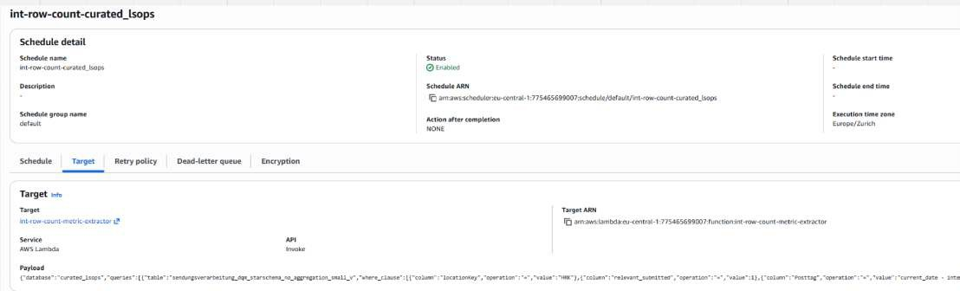
Figure 5.9.: Amazon EventBridge console showing the scheduled monitoring rule and the corresponding JSON event payload configuration

Listing 5.2: AWS EventBridge event payload used to trigger the data quality monitoring workflow
{
" database ": " curated_lsops ", " queries": [
{

" table ": " sendungsverarbeitung_dqm_starschema_no_aggregation_small_v ",
" where_clause ": [
{
" column ": " location Key ", " operation ": " =",
" value ": " HRK "
},
{
" column ": " relevant_submitted ", " operation ": " =",
" value ": 1
},
{
" column ": " Posttag ",
" operation ": " =",
" value ": " current_date - interval ’35 ’ day "
}
]
},
{
" table ": " curated_lsops_submitted_daily_dqm "
}
]
}

After the execution of the Lambda, an execution error was observed, as shown below. After investigating this error, it became clear that the condition injected into the SQL query by the team was not valid. The underlying data monitoring code automatically modified the SQL condition checking for the previous 35 days by escaping parts of the query, causing the SQL statement to be executed incorrectly. After discussions with the AWS modernisation team, this bug was addressed by the consultants.

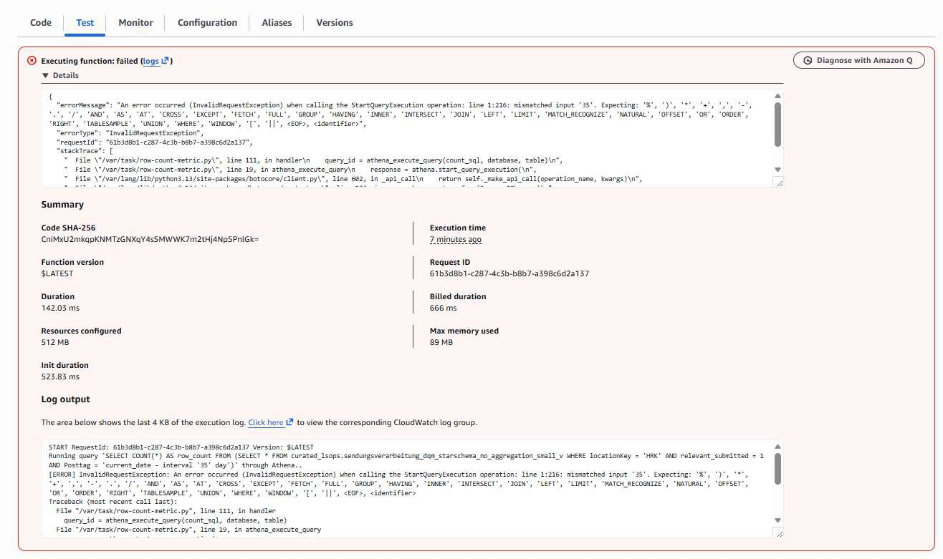

Figure 5.10.: AWS Lambda execution details showing debug information after a failed execution of the data quality monitoring function

After they resolved the bug, the data monitoring now allowed to enter a date range for the count as seen in the following figure. With this fix, the feasability of DQM checks based on row counts using the monitoring setup was proofen to work.
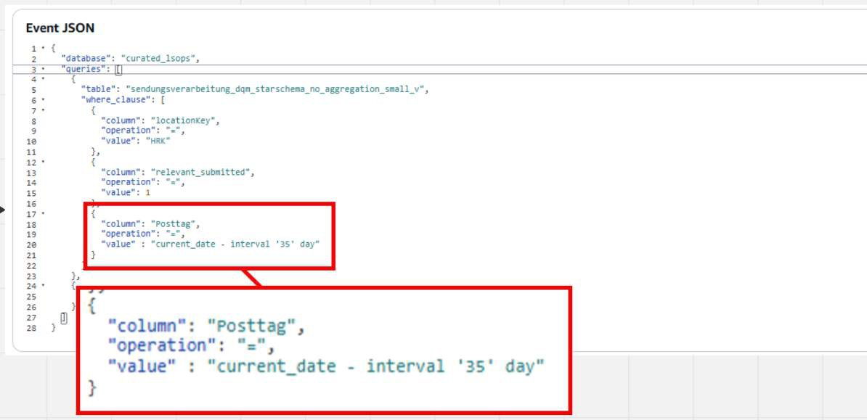
Figure 5.11.: Successful execution of the monitoring workflow after correcting the configuration, showing the validated monitor-ing metrics being forwarded to the AWS monitoring pipeline

Results

Todo Write the results chapter
This is the key chapter that reflects on the initial goals, the work carried out to achieve the goals, and the degree to which they were achieved. This chapter is structured around each goal, and special attention is paid to the key learnings that will be useful for subsequent phases of this work.

Introduction
The results presented here are part of a structured process that began step by step with the research ques-tion and led to the solution architecture and its implementation. Before delving further into the results of this project, a brief reminder of its scope helps to maintain focus. The project supports the Data Warehouse of Logistic Services Operations (DWH LS OPS) with the goal of improving data availability and data quality management by replacing manual checks performed by the business with automated checks executed by IT. Through this change, data about these checks can become more consistent and enable the business to monitor them more easily. To achieve this, the existing reporting pipeline from raw data to the final report had to be re-engineered and documented.

Evaluation criteria
First, a result is defined as every piece of information that helps the reader become familiar with the con-text of the work. Second, it includes all information that supports understanding of the methods used dur-ing the project. Third, it comprises the main goal of this work, the SMART goals and their results. While the supporting results help to understand the environment, only the SMART goal results are the effectively relevant results of this work.
These SMART goals have been defined in the research chapter at 3.5:

▶ 1) Identification of initial data quality metrics

▶ 2) Investigation of IT systems for DQM metrics

▶ 3) Investigation of data lineage for metrics

▶ 4) Design and testing of an automated DQM algorithm

▶ 5) Implementation and validation of an automated DQM check

Revisiting the benefits discussion

In Section 4.6 we discussed concrete benefits….

Summary
With this chapter, the SMART goals defined in the research chapter have been analysed for completion. Two goals were completely fulfilled, two were partially fulfilled, and one was not achieved. The partially fulfilled second goal was limited due to time constraints related to project deadlines and highlights the importance of obtaining confirmations from external teams as early as possible. The goal without results

points towards the need for more realistic planning, as the project concluded within the defined timelines while providing the foundation for implementing a DQM check, but without allowing sufficient time for the actual implementation. However, it is important to note that although the goals leading towards the implementation of the DQM rules were not fully realised, the results of this project serve as a solid basis for subsequent projects and the continuation towards the master’s thesis.

Reflection and outlook

Todo Rewrite this chapter
The reflection chapter concludes the epic quest of the academic team towards the improvement of data quality and data availability at Swiss Post. It evaluates the project with regard to methodology, content, and personal learnings, and then concludes with an outlook on how the project may be followed up.


Figure 7.1.: Reflections with the lords of DQM

The author hereby declares that this work is the result of their own independent effort and that no sources other than those listed in the bibliography and identified as references have been used. Glossary entries have been partially written by the author using public descriptions (e.g., product homepages), copied from Wikipedia, or generated by ChatGPT based on provided bullet points. Further details regarding the use of LLM is decribed within the project management chapter.

  - Organisational structure of Swiss Post (online version) 2
  - Future way of work illustrating the full postal delivery workflow from receiving an item to delivery 3
  - The transition from an on-premise setup to a cloud-based target architecture 4
  - Aerial view of the Swiss Post sorting center in Härkingen. 5
  - Interior view of the automated sorting system in a Swiss Post sorting center 6
  - Discharge chutes inside a Swiss Post sorting center, where parcels are released to their des-ignated zones. Then put into rollboxes to get them to next processing steps 6
  - Main customer touch point, delivery of a parcel 7
  - Picture of DWH LS OPS team 12
  - Team and sub-team organisation 12
  - The start page of the AWS modernisation, listing KPI and latest news 13
  - The team setup of the AWS modernisation 14
  - The KPI 14 Data Quality start page on DWH LS OPS Confluence 14
  - The DQM team setup 15
  - The academic team setup 15
  - All methods on one picture showing their diversity 16
  - Scrum ceremonies of DWH LS OPS BizDevOps team 17
  - Rules of engagement of DWH LS OPS BizDevOps team 17
  - Kanban board of Academic team 18
  - Jour Fixe of Academic team, meeting structure and rework 19
  - Jour Fixe documentation of Academic team 19
  - Miro board documentation, view of 23.12.2025 21
  - Miro board calendar used for coordination and tracking of milestones and related events . 22
  - Miro board, tracking of meetings: when, who, what 23
  - Miro board usage for quick documentation during implementation 24
  - Example of project documentation in Confluence used to record architectural decisions and
their rationale for future reference 25
  - Shared chat using Teams 26
  - Project document store used with Teams 26
  - The rule check engine architecture for future DQM 38
  - Intention of a DQM platform, high level 39
  - The list of tools discarded and the reasons for their exclusion 39
  - Selection of parcel sorting centers distributed over Switzerland 41
  - Parcel sorting, parcels submitted by robot 42
  - Parcel sorting, smaller items submitted manually 43
  - Manual parcel onloading from a truck 43
  - Parcel discharged, manual loading into RX 44
  - An artistic high-level view of the DWH LS OPS data lineage 45
  - An artistic high-level view of the full DWH LS OPS data lineage up to reporting 46
  - DQM manual checks against automated checks by IT 47

  - The DWH LS OPS reporting layers 49
  - Existing plain DQM dashboard used as the baseline for the redesigned Power BI report 53
  - Power BI deployment pipeline across the development, test, and production environments 55
  - Overview of the data quality management tool evaluation process and the assessed evalua-
tion criteria 56
  - Continuation of the data quality management tool evaluation, including the comparison of
the evaluated solutions 57
  - Example of the comparative evaluation matrix used during the assessment of different data quality management tools 58
  - Initial Power BI report designed to resemble the existing SAC report 60
  - Initial Power BI data model containing the core tables required for the first report prototype 61
  - Final Power BI data model after integrating additional data sources, calculated tables, and supporting information 62
  - Power BI table visualising daily event counts and data quality indicators 62
  - Power BI traffic light indicators summarising the four data quality checks 63
  - Power BI line chart showing historical data quality trends 64
  - Final Power BI dashboard integrating all implemented data quality visualisations 64
  - AWS monitoring architecture showing the extraction, normalization, and dashboarding pipeline implemented using AWS services 69
  - Amazon EventBridge console showing the scheduled monitoring rule and the corresponding
JSON event payload configuration 70
  - AWS Lambda execution details showing debug information after a failed execution of the
data quality monitoring function 72
  - Successful execution of the monitoring workflow after correcting the configuration, show-
ing the validated monitoring metrics being forwarded to the AWS monitoring pipeline 72
  - Reflections with the lords of DQM 75
  - Miro board documentation, view of 10.11.2025 111
  - Miro board documentation, view of 25.11.2025 112
  - Miro board documentation, view of 23.12.2025 112

  - Project Risk Overview 29
  - Risk Matrix (Likelihood × Severity) 31
  - Risk Strategy and Treatment Plan 31
  - Risk Strategy and Action Overview 33

Aggregation Table A pre computed table that is persisted in Power BI, containing the most frequently used data so that it loads faster. Aggregation tables allow most reports to load faster in import mode, while the full detail can be retrieved via DirectQuery mode. This provides a major performance in-crease for the users.. 55
Amazon Athena Amazon Athena runs interactive queries directly against data in Amazon S3.. 47, 53–55, 59, 61, 63
Amazon EventBridge An AWS service that enables event-driven communication by routing events be-tween applications and triggering automated workflows based on defined rules. 64
Amazon S3 Amazon Simple Storage Service (S3) is a service offered by Amazon Web Services (AWS) that provides object storage through a web service interface. Amazon S3 uses the same scalable storage infrastructure that Amazon.com uses to run its e-commerce network.. 47, 53
Analytical Reporting Analytical Reporting is focusing on interpreting data. To be able to make manage-ment decisions over multiple days, weeks or months. It is fundamentally different to operational reporting which monitors the current status e.g. to check if machines are operating without errors.. 1, 3, 11
ASTV An abbreviation used at Swiss Post within the postal services. It is an acronym for the German terms: “Aufgabe” –> Receiving, “Sortierung” –> Sorting, “Transport” –> Transport, “Verzollung” –> Customs clearance. This abbreviation encompasses the entire postal process, except for the delivery step.. 8, 12, 55, 59
ASTVZ An abbreviation used at Swiss Post within the postal services. It is an acronym for the German terms: “Aufgabe” → Receiving, “Sortierung” → Sorting, “Transport” → Transport, “Verzollung” → Cus-toms clearance, and “Zustellung” → Delivery. This abbreviation encompasses the entire postal pro-cess, from receiving a mail piece until it is delivered.. 2
AWS Glue AWS Glue is a serverless data integration service that makes it easy for analytics users to dis-cover, prepare, move, and integrate data from multiple sources. You can use it for analytics, machine learning, and application development. It also includes additional productivity and data ops tooling
for authoring, running jobs, and implementing business workflows. https://docs.aws.amazon.com/glue/latest/ is-glue.html. 13
AWS Glue Data Quality AWS Glue Data Quality allows you to measure and monitor the quality of your data so that you can make good business decisions. Built on top of the open-source DeeQu framework, AWS Glue Data Quality provides a managed, serverless experience. AWS Glue Data Quality works with Data Quality Definition Language (DQDL), which is a domain specific language that you use to define data quality rules.. 39
AWS Lambda An AWS compute service that executes code in response to events without requiring the provisioning or management of servers. 64
AWS Management Console The web-based user interface of Amazon Web Services that provides central-ized access to configure, manage, and monitor AWS services and resources. 64

AWS Service A cloud service provided by Amazon Web Services that delivers a specific functionality, such as compute, storage, monitoring, or data processing. Individual AWS services can be combined to build scalable cloud architectures and applications. 62

BizDevOps BizDevOps extends DevOps by including the business side. In this constellation, the business becomes part of the team. This setup improves communication between developers and the people requesting the work.. 3, 8, 11, 12, 16
Business analyst A business analyst (BA) is a person who processes, interprets and documents business processes, products, services and software through analysis of data. The role of a business analyst is to ensure business efficiency increases through their knowledge of both IT and business function.. 12
Business intelligence Business intelligence (BI) consists of strategies, methodologies, and technologies used by enterprises for data analysis and management of business information to inform business strategies and business operations. Common functions of BI technologies include reporting, on-line analytical processing, analytics, dashboard development, data mining, process mining, com-plex event processing, business performance management, benchmarking, text mining, predictive analytics, and prescriptive analytics.. 12

Curated database layer The curated database layer is the first layer in the Swiss Post DWH setup in which data is cleaned and standardised and duplicates are removed. This occurs after the data is received in a raw format.. 43

D & F, Delivery and Finance The Delivery and Finance team is a BizDevOps team in DWH LS OPS handling requirements related to delivery and finance, including regional controlling and process controlling.. 12
Data Availability (DA) Data availability, in the context of this document, refers to whether the data is accessible e.g. whether a report can be retrieved and used when needed.. 1, 7, 36, 71
Data Quality (DQ) Data quality refers to the state of qualitative or quantitative pieces of information. There are many definitions of data quality, but data is generally considered high quality if it is "fit for [its] intended uses in operations, decision making and planning". Data is deemed of high quality if it correctly represents the real-world construct to which it refers. Apart from these definitions, as the number of data sources increases, the question of internal data consistency becomes significant, regardless of fitness for use for any particular external purpose.. 1, 7, 36, 71
Data Quality Management (DQM) Data quality management is the management of data quality topics. It describes how data quality is handled in a company. However, in this document, most references to DQM refer to the IT team working at Swiss Post on the DQM topic. This team is implementing defined software that is intended to promote improvements in data quality.. 11, 13, 14, 17, 37, 39, 59–62
DAX Data Analysis Expressions (DAX) is a formula language used in Microsoft Power BI, Analysis Services, and Power Pivot to define calculations, measures, calculated columns, and tables for data analysis and reporting.. 54, 55
DSP, SAP Datasphere DSP (SAP Datasphere) enables the creation of data models that integrate SAP and non-SAP data sources. These sources can include databases as well as Excel files. The data sources can then be further joined and aggregated.. 47, 49, 50
DWH In computing, a data warehouse (DW or DWH), also known as an enterprise data warehouse (EDW), is a system used for reporting and data analysis and is a core component of business intelligence. Data warehouses are central repositories of data integrated from disparate sources.. 11, 43, 60

DWH LS OPS A Swiss post abreviation, DWH -> "Data Warehouse", LS -> "Logistic Services", OPS -> "Op-erations". Together, this refers to the Data Warehouse that supports and manages the operational processes of the postal logistics services.. 3, 8, 11, 16, 36, 37, 53, 54, 61, 62, 71

Epic Epics are large bodies of work in Agile that are broken down into smaller user stories for incremental delivery. They help teams organize, prioritize, and track progress toward bigger goals while main-taining agility.. 20
ETL Extract, transform, load (ETL) is a three-phase computing process where data is extracted from an input source, transformed (including cleaning), and loaded into an output data container.. 8, 13

Greenfield A greenfield refers to a system landscape where no prior system exists. In IT, a greenfield project means that a new system is built from scratch, without having to consider or integrate with any existing legacy systems. Because there is no predecessor system, development can proceed more freely, without compatibility constraints — which often makes the implementation simpler and more flexible compared to a migration or redesign of an existing system (a brownfield).. 7

High Level High level refers to viewing a use case from a general or abstract perspective, rather than an-alyzing all details. It focuses on the overall picture instead of individual elements. Instead of exam-ining every single event during a day, a high-level analysis would simply check whether most events fall within the expected range during that day. 8

Infoblock Infoblock (at Swiss Post in the context of AWS data storage) An Infoblock is a standardized data product that is provided within the data architecture of Swiss Post for reporting and analysis pur-poses. It serves as a logical unit of processed and quality-assured data that is extracted from different source systems, transformed, and stored in a consistent structure in the AWS cloud. This concept is similar to data products as defined in modern data management practices.. 49, 59

Jour Fixe A Jour Fixe is a weekly meeting used in project management to provide updates on progress, issues encountered during work, and problems that remain unresolved and require assistance. It serves to maintain communication and alignment with stakeholders.. 18

Kafka Topics A Kafka topic is a core component of Apache Kafka. It is a named storage structure where producers write messages or data streams. The content of the topic can then be read and processed by consumers.. 8
Kanban Kanban (Japanese: meaning signboard) is a scheduling system for lean manufacturing (also called just-in-time manufacturing). Taiichi Ohno, an industrial engineer at Toyota, developed kanban to improve manufacturing efficiency. The system takes its name from the cards that track production within a factory.. 17
KPI, key performance indicator A performance indicator or key performance indicator (KPI) is a type of performance measurement. KPIs evaluate the success of an organization or of a particular activity (such as projects, programs, products and other initiatives) in which it engages. KPIs provide a focus for strategic and operational improvement, create an analytical basis for decision making and help focus attention on what matters most.. 13

LS, Logistics Services Logistics Services (LS) is responsible for efficient and secure logistics of letters, printed matter and newspapers, as well as parcels, goods and merchandise in Switzerland and in-ternationally. Logistics Services is the largest business unit of Swiss Post and makes a substantial contribution to the company’s success with over 21 000 employees.. 11

MIAR MIAR is the internal reporting and project effort tracking system used at Swiss Post. It is integrated with applications for working time recording, such as check-in and check-out. It allows employees to allocate worked hours to projects, which in turn enables monitoring of project efforts.. 28
Microsoft Copilot AI-assisted productivity tool by Microsoft that supports users with code generation, text generation, and problem-solving based on large language models. 54
Microsoft Fabric A cloud-based analytics platform by Microsoft that integrates data engineering, data ware-housing, data science, real-time analytics, and business intelligence in a unified environment. It is used to manage, analyse, and visualise data across different workloads.. 54
Microsoft Power BI (PBI) Microsoft Power BI (PBI) is an interactive data visualization software product developed by Microsoft with a primary focus on business intelligence (BI). It is part of the Microsoft Power Platform. Power BI is a collection of software services, apps, and connectors that work together to turn various sources of data into static and interactive data visualizations.. 53
MPP Mengenplanung und Prognose Pakete MPP Parcel Volume Planning and Forecasting is a team within Swiss Post. It is responsible for improving current planning and forecasting methods. Based on this information, important decisions are made, such as determining the personnel required for peak periods like the Christmas season with increased parcel volumes. The team analyses current data sources and aims to provide more precise methods and data sources for the process.. 12
MVP A Minimal Viable Product (MVP) is the simplest version of a system that successfully fulfils a specific use case. It is developed with just the core functionality needed to provide value to users. An MVP can serve two main purposes: to demonstrate that a concept or method is feasible (proof of concept), or as an initial implementation that will later be improved through further development and updates.. 7, 37

One to One Migrations In the context of reporting, a one-to-one migration refers to rebuilding an existing report exactly as it is, but on a different software or hardware platform. The structure, logic, and content of the report remain unchanged only the underlying technology is replaced.. 7

Parcel center A parcel center is a large sorting center for parcels at Swiss Post. Each region has one parcel center, which serves as the main hub for parcel sorting. Every parcel is first gathered at a parcel center and later distributed to smaller regional parcel centers if its delivery is not scheduled for the immediate vicinity of the center.. 40
Post day The post day starts at 06:00 AM and lasts until 05:59 AM the next day. This is the essential date format used by Swiss Post for reporting.. 49, 51
Power Query M A functional, case-sensitive programming language used by Microsoft Power Query to import, transform, combine, and prepare data from multiple data sources for analytics and report-ing.. 54, 55
Product Owner (PO) Each scrum team has one product owner. The product owner focuses on the busi-ness side of product development and spends the majority of time liaising with stakeholders and the team. The role is intended to primarily represent the product’s stakeholders, the voice of the cus-tomer, or the desires of a committee, and bears responsibility for the delivery of business results.. 36
Proof of concept (POC) Proof of concept (POC), also known as proof of principle, is a realization of a certain method or idea in order to demonstrate its feasibility, or a demonstration in principle with the aim of verifying that some concept or theory has practical potential. A proof of concept is usually small and may or may not be complete. 8, 61

PyDeequ PyDeequ is a Python API for Deequ, a library built on top of Apache Spark for defining "unit tests for data", which measure data quality in large datasets. PyDeequ is written to support usage of Deequ in Python.. 39

Region Swiss Post organises its postal services into four regions covering the whole of Switzerland. These regions are West, Middle, East, and South. The regions are not based on cantonal borders and may split cantons between regions.. 40
Regional parcel center A regional parcel center is a smaller sorting center for parcels at Swiss Post. Mul-tiple regional parcel centers are located within one region and handle parcels for smaller geographic areas.. 40
Risk Appetite Risk appetite is a term used in risk management. It describes an individual’s perception and tolerance of risk. Even when two people are facing the same risk, they may perceive its severity and probability differently, based on their personal risk appetite.. 28, 30
Rollbox (RX) The rollbox (RX) is used to temporarily transport parcels throughout the Swiss Post work-flow. It can hold many mail pieces and is used to move them between different processing areas, making it an essential component of parcel handling at Swiss Post.. 41

SAC, SAP Analytics Cloud SAC, SAP Analytics Cloud is a plattform for online analytical reporting. It al-lows to show data in tables and dashboards and allows Reporting and predictive analysis.. 47, 49, 50, 55
Scrum Scrum is an agile team collaboration framework commonly used in software development and other industries. Scrum prescribes for teams to break work into goals to be completed within time-boxed iterations, called sprints.. 16
Smart Goals S.M.A.R.T. (or SMART) is an acronym used as a mnemonic device to establish criteria for effective goal-setting and objective development. The S.M.A.R.T. criteria he proposes are as follows: Specific: Targeting a particular area for improvement, Measurable: Quantifying, or at least suggest-ing, an indicator of progress, Assignable: Defining responsibility clearly, Realistic: Outlining attain-able results with available resources, Time-related: Including a timeline for expected results. 36
Sorting Center In the postal services of Swiss Post, sorting centers are an essential part of the logistics process for handling letters and parcels. Items are first collected and sent to regional centralized facilities, where they are either: routed to sorting centers in other regions, or processed locally and dispatched to the distribution network of the current region. These centers enable efficient process-ing and routing of mail within Switzerland and across regions.. 3
Star Schema A dimensional data modelling approach following the Kimball methodology, consisting of a central fact table linked to multiple denormalised dimension tables. The denormalisation is per-formed to improve the performance of analytical queries. It is widely used in data warehouses and business intelligence systems.. 53

Terraform An infrastructure-as-code tool developed by HashiCorp that allows cloud infrastructure to be defined, deployed, and managed through configuration files. 63

WYSIWYG (what you see is what you get) In computing, WYSIWYG (what you see is what you get) is software that allows content to be edited in a form that resembles its appearance when printed or displayed as a finished product, such as a printed document, web page, or slide presentation. WYSI-WYG implies a user interface that allows the user to view something very similar to the result while the document is being created.. 26

Amazon Web Services (2025a). What is Amazon Athena? Accessed for definition and conceptual overview of Amazon Athena. Amazon Web Services. URL: https://docs.aws.amazon.com/athena/latest/ug/what-is.html (visited on 12/26/2025).
– (2025b). What is Amazon S3? Accessed for definition of Amazon S3 object storage service. Amazon Web Services. URL: https://docs.aws.amazon.com/AmazonS3/latest/userguide/Welcome.html (visited on 12/26/2025).
Kimball Group (n.d.). Kimball Technical DW/BI System Architecture. URL: https://www.kimballgroup.com/ data - warehouse - business - intelligence - resources / kimball - techniques / technical - dw - bi - system-architecture/ (visited on 12/25/2025).
OpenAI (Sept.–Dec. 2025). ChatGPT (AI Language Model) — Research Support and Writing Assistance. Used for conceptual clarification, academic writing support, methodological reflection, and iterative feedback during the research process. URL: https://chat.openai.com/ (visited on 12/23/2025).
Pas, Chiel van der (2025). “Long term availability of construction data with ddss”. In: URL: https://www. based.co.nl/en/news/long-term-availability-of-construction-data-with-ddss.
Post, Swiss (2023). Staff at Härkingen letter center now also sort parcels. Accessed: 2025-XX-XX. URL: https:
//www.post.ch/en/about-us/news/2023/staff-at-haerkingen-letter-center-now-also-sort-parcels.
– (2024). Geschäftsbericht 2024: Mitarbeitende. URL: https://geschaeftsbericht.post.ch/24/ar/de/ mitarbeitende (visited on 01/17/2025).
Roccaro, Roland Angelo (2026). “Enhancing User Confidence in Report Timeliness and Data Accuracy through Data Quality and Availability Checks”. Master of Science in Engineering, Profile Data Science. Conducted in collaboration with Swiss Post. Specialisation Project (MTE7101). Bern University of Applied Sciences.
SAP SE (2024). Integrating SAP Datasphere with SAP Analytics Cloud. Official SAP product documentation describing the integration, live data consumption, and planning data exchange between SAP Datasphere and SAP Analytics Cloud. URL: https://help.sap.com/docs/SAP_DATASPHERE (visited on 01/02/2026).
Swiss Post (2025). AWS Data Lake Modernization Initiative. Internal Confluence documentation, Swiss Post.
Access restricted.
- (2026a). DWH LS OPS Power BI Template. Internal template documentation, not publicly available.
- (2026b). Power BI – DWH LS OPS. Internal Confluence documentation, not publicly available.
- (2026c). Power BI Intro Session. Internal PowerPoint presentation, not publicly available.
The Economist (2017). “The world’s most valuable resource is no longer oil, but data”. In: The Economist
Leaders, May 6 2017. Accessed on [insert date you accessed it].
What is a Data Product? (N.d.[a]). https://www.alation.com/glossary/data-product/. Accessed 2025-12-27.
What is a Data Product? (N.d.[b]). https://www.ibm.com/think/topics/data-product. Accessed 2025-12-27.
Wikipedia (Jan. 17, 2025). Risk Management. URL: https://en.wikipedia.org/wiki/Risk_management
(visited on 01/17/2025).
Wikipedia contributors (2025). Star schema — Wikipedia, The Free Encyclopedia. [Online; accessed 12-July-2026]. URL: https://en.wikipedia.org/w/index.php?title=Star_schema&oldid=1306074452.

This appendix provides the Amazon Athena queries. They are stored here since putting them into the document would disrupt normal flow.

Full DQM view query
The full query which creates the view beeing main data source of the DQM report.
CREATE OR
WITH
key_to_plz
SELECT UNION UNION UNION UNION UNION UNION UNION UNION UNION UNION UNION UNION
),
REPLACE VIEW " sendungsverarbeitung_dqm_v "
AS
AS (
’ VET ’ AS location Key , ’ 196000 ’ AS plz
ALL
ALL ALL ALL ALL ALL ALL ALL ALL ALL ALL ALL
SELECT
SELECT SELECT SELECT SELECT SELECT SELECT SELECT SELECT SELECT SELECT SELECT
’ HRK ’,
’ CAD ’,
’ WAL ’,
’ HAE ’,
’ UTZ ’,
’ PRA ’,
’ FRA ’,
’ DAI’,
’ URD ’,
’ BCH ’,
’ RUE ’,
’ OMU ’,
’ 462150 ’
’ 659100 ’
’ 830000 ’
’ 462000 ’
’ 720000 ’
’ 413400 ’
’ 852000 ’
’ 131000 ’
’ 892000 ’
’ 503000 ’
’ 815000 ’
’ 307100 ’
plz_to_key
SELECT UNION UNION UNION UNION UNION UNION UNION UNION UNION UNION UNION UNION UNION
),
AS
(
’ 196000 ’
AS plz , ’ VET ’ AS location Key
ALL
ALL ALL ALL ALL ALL ALL ALL ALL ALL ALL ALL ALL
SELECT
SELECT SELECT SELECT SELECT SELECT SELECT SELECT SELECT SELECT SELECT SELECT SELECT
’ 462150 ’,
’ 659100 ’,
’ 830470 ’,
’ 830000 ’,
’ 462000 ’,
’ 720000 ’,
’ 413400 ’,
’ 852000 ’,
’ 131000 ’,
’ 892000 ’,
’ 503000 ’,
’ 815000 ’,
’ 307100 ’,
’ HRK ’
’ CAD ’
’ WAL ’
’ WAL ’
’ HAE ’
’ UTZ ’
’ PRA ’
’ FRA ’
’ DAI’
’ URD ’
’ BCH ’
’ RUE ’
’ OMU ’
mp_discharged_raw AS (
SELECT
CAST (
DATE_ADD (

’ hour ’, -6 ,
discharged . timestamp AT TIME ZONE ’ Europe / Zurich ’
) AS DATE
) AS Posttag ,
discharged . sortingunit. location Key AS location Key , discharged . source Id AS source Id
FROM curated_lsops . mailpiece_discharged
),

mp_discharged AS ( SELECT
Posttag , location Key , CASE
WHEN location Key IN (’ CAD ’,’ HRK ’,’ PRA ’,’ UTZ ’,’ VET ’,’ WAL ’)
AND source Id NOT LIKE ’w%’ AND source Id NOT LIKE ’W%’
AND TRIM ( source Id ) <> ’’ THEN 1
WHEN location Key IN (’ BCH ’,’ RUE ’,’ OMU ’) THEN 1
WHEN location Key IN (’ HAE ’,’ FRA ’,’ DAI’,’ URD ’) THEN 1 ELSE 0
END AS relevant_discharged FROM mp_discharged_raw
),

discharged_agg AS ( SELECT
Posttag , location Key ,
SUM ( relevant_discharged ) AS num_discharged FROM mp_discharged
GROUP BY 1 , 2
),

mp_submitted_raw AS ( SELECT
CAST (
DATE_ADD (
’ hour ’, -6 ,
submitted . timestamp AT TIME ZONE ’ Europe / Zurich ’
) AS DATE
) AS Posttag ,
submitted . sortingunit. location Key AS location Key , submitted . sorting Process AS sorting Process
FROM curated_lsops . mailpiece_submitted
),

mp_submitted AS ( SELECT
Posttag , location Key , CASE
WHEN location Key IN (’ HRK ’,’ VET ’,’ CAD ’,’ WAL ’,’ UTZ ’,’ PRA ’)
AND sorting Process = ’ AUTOMATIC ’ THEN 1 WHEN location Key IN (’ BCH ’,’ RUE ’,’ OMU ’) THEN 1
WHEN location Key IN (’ HAE ’,’ FRA ’,’ DAI’,’ URD ’) THEN 1 ELSE 0

END AS relevant_submitted FROM mp_submitted_raw
),

submitted_agg AS ( SELECT
Posttag , location Key ,
SUM ( relevant_submitted ) AS num_submitted FROM mp_submitted
GROUP BY 1 , 2
),

mp_coded_raw AS ( SELECT
coded . sorting Cycle Id AS sorting Cycle Id , CAST (
DATE_ADD (
’ hour ’, -6 ,
coded . timestamp AT TIME ZONE ’ Europe / Zurich ’
) AS DATE
) AS Posttag ,
coded . sortingunit. location Key AS location Key , coded . sorting Process AS sorting Process
FROM curated_lsops . mailpiece_coded
),

mp_coded AS (
SELECT DISTINCT
sorting Cycle Id , Posttag , location Key , CASE
WHEN location Key IN (’ HRK ’,’ VET ’,’ CAD ’,’ WAL ’,’ UTZ ’,’ PRA ’)
AND sorting Process = ’ AUTOMATIC ’ THEN 1 WHEN location Key IN (’ BCH ’,’ RUE ’,’ OMU ’) THEN 1
WHEN location Key IN (’ HAE ’,’ FRA ’,’ DAI’,’ URD ’) THEN 1 ELSE 0
END AS relevant_coded FROM mp_coded_raw
),

coded_agg AS ( SELECT
Posttag , location Key ,
SUM ( relevant_coded ) AS num_coded FROM mp_coded
GROUP BY 1 , 2
),

mp_destination Assigned_raw AS ( SELECT
destination Assigned . sorting Cycle Id AS sorting Cycle Id , CAST (
DATE_ADD (

’ hour ’, -6 ,
destination Assigned . timestamp AT TIME ZONE ’ Europe / Zurich ’
) AS DATE
) AS Posttag ,
destination Assigned . sortingunit. location Key AS location Key , destination Assigned . sorting Parameters . sorting Process AS sorting Process
FROM curated_lsops . mailpiece_destinationassigned
),

mp_destination Assigned AS ( SELECT DISTINCT
sorting Cycle Id , Posttag , location Key , CASE
WHEN location Key IN (’ HRK ’,’ VET ’,’ CAD ’,’ WAL ’,’ UTZ ’,’ PRA ’)
AND sorting Process = ’ AUTOMATIC ’ THEN 1 WHEN location Key IN (’ BCH ’,’ RUE ’,’ OMU ’) THEN 1
WHEN location Key IN (’ HAE ’,’ FRA ’,’ DAI’,’ URD ’) THEN 1 ELSE 0
END AS relevant_destination Assigned FROM mp_destination Assigned_raw
),

destinationassigned_agg AS ( SELECT
Posttag , location Key ,
SUM ( relevant_destination Assigned ) AS num_destinationassigned FROM mp_destination Assigned
GROUP BY 1 , 2
),

sendungsverarbeitung_raw AS ( SELECT
sva. datum_sort. datum AS Posttag , plz_to_key . location Key AS location Key ,
sva. sortierung . sortierprozess_typ AS sortierprozess_typ FROM infoblock_lsops . sendungsverarbeitung sva
LEFT JOIN plz_to_key
ON plz_to_key . plz = sva. zentrum . zentrum_plz
),

sendungsverarbeitung AS ( SELECT
Posttag , location Key , CASE
WHEN location Key IN (’ HRK ’,’ VET ’,’ CAD ’,’ WAL ’,’ UTZ ’,’ PRA ’)
AND sortierprozess_typ = ’ AUTOMATIC ’ THEN 1 WHEN location Key IN (’ BCH ’,’ RUE ’,’ OMU ’) THEN 1
WHEN location Key IN (’ HAE ’,’ FRA ’,’ DAI’,’ URD ’) THEN 1 ELSE 0
END AS relevant_sva
FROM sendungsverarbeitung_raw
),

sva_agg AS (
SELECT
Posttag , location Key ,
SUM ( relevant_sva ) AS num_sva FROM sendungsverarbeitung
GROUP BY 1 , 2
),

device_stats AS ( SELECT
Posttag ,
sorting_unit_location_key AS location Key , SUM ( content_value ) AS amount
FROM " reporting_lsops "." anlagestatistik_curated_v " WHERE model = ’ BEUMER ’
AND content_type = ’ INDUCTION ’ AND content_value_index = 1
GROUP BY 1 , 2
)

SELECT
submitted . Posttag , submitted . location Key , key_to_plz . plz ,
discharged . num_discharged , submitted . num_submitted , coded . num_coded ,
destinationassigned . num_destinationassigned , sva. num_sva ,
dvs. amount AS num_stats FROM submitted_agg submitted INNER JOIN key_to_plz
ON submitted . location Key = key_to_plz . location Key INNER JOIN discharged_agg discharged
ON submitted . Posttag = discharged . Posttag
AND submitted . location Key = discharged . location Key INNER JOIN coded_agg coded
ON submitted . Posttag = coded . Posttag
AND submitted . location Key = coded . location Key
INNER JOIN destinationassigned_agg destinationassigned ON submitted . Posttag = destinationassigned . Posttag
AND submitted . location Key = destinationassigned . location Key INNER JOIN sva_agg sva
ON submitted . Posttag = sva. Posttag
AND submitted . location Key = sva. location Key LEFT JOIN device_stats dvs
ON submitted . Posttag = dvs. Posttag
AND submitted . location Key = dvs. location Key WHERE submitted . location Key IN (
’ HRK ’,’ VET ’,’ HAE ’,’ CAD ’,’ WAL ’,’ UTZ ’,
’ PRA ’,’ FRA ’,’ DAI’,’ URD ’,’ BCH ’,’ RUE ’,’ OMU ’
);

Compact DQM view query
The query after removing the parts which are not needed for the MVP.
WITH
key_to_plz AS (
SELECT ’ VET ’ AS location Key , ’ 196000 ’ AS plz UNION ALL SELECT ’ HRK ’, ’ 462150 ’
UNION ALL SELECT ’ CAD ’, ’ 659100 ’ UNION ALL SELECT ’ WAL ’, ’ 830000 ’ UNION ALL SELECT ’ HAE ’, ’ 462000 ’ UNION ALL SELECT ’ UTZ ’, ’ 720000 ’ UNION ALL SELECT ’ PRA ’, ’ 413400 ’ UNION ALL SELECT ’ FRA ’, ’ 852000 ’ UNION ALL SELECT ’ DAI’, ’ 131000 ’ UNION ALL SELECT ’ URD ’, ’ 892000 ’ UNION ALL SELECT ’ BCH ’, ’ 503000 ’ UNION ALL SELECT ’ RUE ’, ’ 815000 ’ UNION ALL SELECT ’ OMU ’, ’ 307100 ’
),

plz_to_key AS (
SELECT ’ 196000 ’ AS plz , ’ VET ’ AS location Key UNION ALL SELECT ’ 462150 ’, ’ HRK ’
UNION ALL SELECT ’ 659100 ’, ’ CAD ’ UNION ALL SELECT ’ 830470 ’, ’ WAL ’ UNION ALL SELECT ’ 830000 ’, ’ WAL ’ UNION ALL SELECT ’ 462000 ’, ’ HAE ’ UNION ALL SELECT ’ 720000 ’, ’ UTZ ’ UNION ALL SELECT ’ 413400 ’, ’ PRA ’ UNION ALL SELECT ’ 852000 ’, ’ FRA ’ UNION ALL SELECT ’ 131000 ’, ’ DAI’ UNION ALL SELECT ’ 892000 ’, ’ URD ’ UNION ALL SELECT ’ 503000 ’, ’ BCH ’ UNION ALL SELECT ’ 815000 ’, ’ RUE ’ UNION ALL SELECT ’ 307100 ’, ’ OMU ’
),

mp_discharged_raw AS ( SELECT
CAST (
DATE_ADD (
’ hour ’, -6 ,
discharged . timestamp AT TIME ZONE ’ Europe / Zurich ’
) AS DATE
) AS Posttag ,
discharged . sortingunit. location Key AS location Key , discharged . source Id AS source Id
FROM curated_lsops . mailpiece_discharged
),

mp_discharged AS ( SELECT
Posttag , location Key , CASE
WHEN location Key IN (’ CAD ’,’ HRK ’,’ PRA ’,’ UTZ ’,’ VET ’,’ WAL ’)

AND source Id NOT LIKE ’w%’ AND source Id NOT LIKE ’W%’
AND TRIM ( source Id ) <> ’’ THEN 1
WHEN location Key IN (’ BCH ’,’ RUE ’,’ OMU ’) THEN 1
WHEN location Key IN (’ HAE ’,’ FRA ’,’ DAI’,’ URD ’) THEN 1 ELSE 0
END AS relevant_discharged FROM mp_discharged_raw
),

discharged_agg AS ( SELECT
Posttag , location Key ,
SUM ( relevant_discharged ) AS num_discharged FROM mp_discharged
GROUP BY 1 , 2
),

mp_submitted_raw AS ( SELECT
CAST (
DATE_ADD (
’ hour ’, -6 ,
submitted . timestamp AT TIME ZONE ’ Europe / Zurich ’
) AS DATE
) AS Posttag ,
submitted . sortingunit. location Key AS location Key , submitted . sorting Process AS sorting Process
FROM curated_lsops . mailpiece_submitted
),

mp_submitted AS ( SELECT
Posttag , location Key , CASE
WHEN location Key IN (’ HRK ’,’ VET ’,’ CAD ’,’ WAL ’,’ UTZ ’,’ PRA ’)
AND sorting Process = ’ AUTOMATIC ’ THEN 1 WHEN location Key IN (’ BCH ’,’ RUE ’,’ OMU ’) THEN 1
WHEN location Key IN (’ HAE ’,’ FRA ’,’ DAI’,’ URD ’) THEN 1 ELSE 0
END AS relevant_submitted FROM mp_submitted_raw
),

submitted_agg AS ( SELECT
Posttag , location Key ,
SUM ( relevant_submitted ) AS num_submitted FROM mp_submitted
GROUP BY 1 , 2
)

SELECT
submitted . Posttag ,

submitted . location Key ,
key_to_plz . plz ,
discharged . num_discharged , submitted . num_submitted
FROM submitted_agg submitted INNER JOIN key_to_plz
ON submitted . location Key = key_to_plz . location Key INNER JOIN discharged_agg discharged
ON submitted . Posttag = discharged . Posttag
AND submitted . location Key = discharged . location Key WHERE submitted . location Key IN (
’ HRK ’,’ VET ’,’ HAE ’,’ CAD ’,’ WAL ’,’ UTZ ’,
’ PRA ’,’ FRA ’,’ DAI’,’ URD ’,’ BCH ’,’ RUE ’,’ OMU ’
);

New Star Shema DQM view query
The for star shema DQM checks. Similar structure to the previous full query.
CREATE OR REPLACE VIEW
WITH
key_to_plz AS ( SELECT
’ VET ’ location Key
" sendungsverarbeitung_dqm_starschema_v "
AS
, ’ 196000 ’ plz
UNION ALL
SELECT
’ HRK ’ location Key
, ’ 462150 ’ plz
UNION ALL
SELECT
’ CAD ’ location Key
, ’ 659100 ’ plz
UNION ALL
SELECT
’ WAL ’ location Key
, ’ 830000 ’ plz
UNION ALL
SELECT
’ HAE ’ location Key
, ’ 462000 ’ plz
UNION ALL
SELECT
’ UTZ ’ location Key
, ’ 720000 ’ plz
UNION ALL
SELECT
’ PRA ’ location Key
, ’ 413400 ’ plz
UNION ALL
SELECT
’ FRA ’ location Key
, ’ 852000 ’ plz

UNION ALL SELECT
’ DAI’ location Key
, ’ 131000 ’ plz

UNION ALL SELECT
’ URD ’ location Key
, ’ 892000 ’ plz

UNION ALL SELECT
’ BCH ’ location Key
, ’ 503000 ’ plz

UNION ALL SELECT
’ RUE ’ location Key
, ’ 815000 ’ plz

UNION ALL SELECT
’ OMU ’ location Key
, ’ 307100 ’ plz

)
, plz_to_key AS ( SELECT
’ 196000 ’ plz
, ’ VET ’ location Key

UNION ALL SELECT ’ 462150 ’ plz
, ’ HRK ’ location Key

UNION ALL SELECT ’ 659100 ’ plz
, ’ CAD ’ location Key

UNION ALL SELECT ’ 830470 ’ plz
, ’ WAL ’ location Key

UNION ALL SELECT ’ 830000 ’ plz
, ’ WAL ’ location Key

UNION ALL SELECT ’ 462000 ’ plz
, ’ HAE ’ location Key

UNION ALL SELECT ’ 720000 ’ plz
, ’ UTZ ’ location Key

UNION ALL SELECT ’ 413400 ’ plz
, ’ PRA ’ location Key

UNION ALL SELECT ’ 852000 ’ plz
, ’ FRA ’ location Key

UNION ALL SELECT ’ 131000 ’ plz
, ’ DAI’ location Key

UNION ALL SELECT ’ 892000 ’ plz
, ’ URD ’ location Key

UNION ALL SELECT ’ 503000 ’ plz
, ’ BCH ’ location Key

UNION ALL SELECT ’ 815000 ’ plz
, ’ RUE ’ location Key

UNION ALL SELECT ’ 307100 ’ plz
, ’ OMU ’ location Key

)
, mp_discharged_raw AS ( SELECT
CAST ( DATE_ADD (’ hour ’, -6 , discharged . timestamp AT TIME ZONE ’ Europe / Zurich ’)
, discharged . sortingunit. location Key location Key
, discharged . source Id source Id FROM
curated_lsops . mailpiece_discharged_v 2 WHERE (1 = 1)

AS DAT

)
, mp_discharged AS ( SELECT
Posttag Posttag
, location Key location Key
, ( CASE WHEN (( location Key IN (’ CAD ’, ’ HRK ’, ’ PRA ’, ’ UTZ ’, ’ VET ’, ’ WAL ’)) AND ( NOT ( s FROM
mp_discharged_raw
)
, discharged_agg AS ( SELECT
Posttag Posttag
, location Key location Key
, SUM ( relevant_discharged ) num_discharged FROM
mp_discharged GROUP BY 1 , 2
)
, mp_submitted_raw AS ( SELECT
CAST ( DATE_ADD (’ hour ’, -6 , submitted . timestamp AT TIME ZONE ’ Europe / Zurich ’) AS DATE
, submitted . sortingunit. location Key location Key
, submitted . sorting Process sorting Process FROM
curated_lsops . mailpiece_submitted_v 2
)
, mp_submitted AS (

SELECT
Posttag Posttag
, location Key location Key
, ( CASE WHEN (( location Key = ’ HRK ’) AND ( sorting Process = ’ AUTOMATIC ’)) THEN 1 FROM
mp_submitted_raw
)

WHEN (

, submitted_agg AS ( SELECT
Posttag Posttag
, location Key location Key
, SUM ( relevant_submitted ) num_submitted FROM
mp_submitted GROUP BY 1 , 2
)
, mp_coded_raw AS ( SELECT
coded . sorting Cycle Id sorting Cycle Id
, CAST ( DATE_ADD (’ hour ’, -6 , coded . timestamp AT TIME ZONE ’ Europe / Zurich ’) AS DATE ) Po
, coded . sortingunit. location Key location Key
, coded . sorting Process sorting Process FROM
curated_lsops . mailpiece_coded_v 2

)
, mp_coded AS ( SELECT DISTINCT
sorting Cycle Id sorting Cycle Id
, Posttag Posttag
, location Key location Key
, ( CASE WHEN (( location Key = ’ HRK ’) AND ( sorting Process = ’ AUTOMATIC ’)) THEN 1 FROM
mp_coded_raw

WHEN (

)
, coded_agg AS ( SELECT
Posttag Posttag
, location Key location Key
, SUM ( relevant_coded ) num_coded FROM
mp_coded GROUP BY 1 , 2
)
, mp_destination Assigned_raw AS ( SELECT
destination Assigned . sorting Cycle Id sorting Cycle Id
, CAST ( DATE_ADD (’ hour ’, -6 , destination Assigned . timestamp AT TIME ZONE ’ Europe / Zurich
, destination Assigned . sortingunit. location Key location Key
, destination Assigned . sorting Parameters . sorting Process sorting Process FROM
curated_lsops . mailpiece_destinationassigned_v 2
)
, mp_destination Assigned AS ( SELECT DISTINCT
sorting Cycle Id sorting Cycle Id
, Posttag Posttag
, location Key location Key

, ( CASE WHEN (( location Key = ’ HRK ’) AND ( sorting Process = ’ AUTOMATIC ’)) THEN 1 FROM
mp_destination Assigned_raw
)
WHEN (

, destinationassigned_agg AS ( SELECT
Posttag Posttag
, location Key location Key
, SUM ( relevant_destination Assigned ) num_destinationassigned FROM
mp_destination Assigned GROUP BY 1 , 2
)
, sendungsverarbeitung_raw AS ( SELECT
post_day posttag
, plz_to_key . location Key location Key
, dim_sor. sortierprozess_typ sortierprozess_typ FROM
((( reporting_lsops . fact_sendungsverarbeitung_v sndv
LEFT JOIN reporting_lsops . dim_sortierung_v dim_sor ON ( sndv . sortierung_hash_key = dim LEFT JOIN reporting_lsops . dim_zentrum_v dim_zent ON ( sndv . zentrum_hash_key = dim_zent LEFT JOIN plz_to_key ON ( plz_to_key . plz = dim_zent. zentrum_plz ))
)
, sendungsverarbeitung AS ( SELECT
Posttag Posttag
, location Key location Key
, ( CASE WHEN (( location Key = ’ HRK ’) AND ( sortierprozess_typ = ’ AUTOMATIC ’)) THEN 1 WH FROM
sendungsverarbeitung_raw
)
, sva_agg AS ( SELECT
Posttag Posttag
, location Key location Key
, SUM ( relevant_sva ) num_sva FROM
sendungsverarbeitung GROUP BY 1 , 2
)
, device_stats AS ( SELECT
Posttag Posttag
, sorting_unit_location_key location Key
, sum ( content_value ) amount FROM
" reporting_lsops "." anlagestatistik_curated_v "
WHERE ((1 = 1) AND ((1 = 0) OR (( model = ’ BEUMER ’) AND ( content_type = ’ INDUCTION ’) A GROUP BY 1 , 2
) SELECT
submitted . Posttag Posttag
, submitted . location Key location Key
, key_to_plz . plz plz
, discharged . num_discharged num_discharged
, submitted . num_submitted num_submitted

, coded . num_coded num_coded
, destinationassigned . num_destinationassigned num_destinationassigned
, sva. num_sva num_sva
, dvs. amount num_stats FROM
(((((( submitted_agg submitted
INNER JOIN key_to_plz ON ((1 = 1) AND ( submitted . location Key = key_to_plz . location Key ))) INNER JOIN discharged_agg discharged ON ((1 = 1) AND ( submitted . Posttag = discharged . Pos INNER JOIN coded_agg coded ON ((1 = 1) AND ( submitted . Posttag = coded . Posttag ) AND ( subm INNER JOIN destinationassigned_agg destinationassigned ON ((1 = 1) AND ( submitted . Postta INNER JOIN sva_agg sva ON ((1 = 1) AND ( submitted . Posttag = sva. Posttag ) AND ( submitted . LEFT JOIN device_stats dvs ON ((1 = 1) AND ( submitted . Posttag = dvs. Posttag ) AND ( submit WHERE ((1 = 1) AND ( submitted . location Key IN (’ HRK ’, ’ VET ’, ’ HAE ’, ’ CAD ’, ’ WAL ’, ’ UTZ ’,

Testing Monitoring Query
The the test of the monitoring data counts, the query for DQM had to be adapted.

CREATE OR REPLACE VIEW " sendungsverarbeitung_dqm_starschema_no_aggregation_small_v " AS WITH
key_to_plz AS ( SELECT
’ VET ’ location Key
, ’ 196000 ’ plz

UNION ALL SELECT
’ HRK ’ location Key
, ’ 462150 ’ plz

UNION ALL SELECT
’ CAD ’ location Key
, ’ 659100 ’ plz

UNION ALL SELECT
’ WAL ’ location Key
, ’ 830000 ’ plz

UNION ALL SELECT
’ HAE ’ location Key
, ’ 462000 ’ plz

UNION ALL SELECT
’ UTZ ’ location Key
, ’ 720000 ’ plz

UNION ALL SELECT
’ PRA ’ location Key
, ’ 413400 ’ plz

UNION ALL SELECT
’ FRA ’ location Key
, ’ 852000 ’ plz

UNION ALL SELECT
’ DAI’ location Key
, ’ 131000 ’ plz

UNION ALL SELECT
’ URD ’ location Key
, ’ 892000 ’ plz

UNION ALL SELECT
’ BCH ’ location Key
, ’ 503000 ’ plz

UNION ALL SELECT
’ RUE ’ location Key
, ’ 815000 ’ plz

UNION ALL SELECT
’ OMU ’ location Key
, ’ 307100 ’ plz

)
, plz_to_key AS ( SELECT
’ 196000 ’ plz
, ’ VET ’ location Key

UNION ALL SELECT ’ 462150 ’ plz
, ’ HRK ’ location Key

UNION ALL SELECT ’ 659100 ’ plz
, ’ CAD ’ location Key

UNION ALL SELECT ’ 830470 ’ plz
, ’ WAL ’ location Key

UNION ALL SELECT ’ 830000 ’ plz
, ’ WAL ’ location Key

UNION ALL SELECT ’ 462000 ’ plz
, ’ HAE ’ location Key

UNION ALL SELECT ’ 720000 ’ plz
, ’ UTZ ’ location Key

UNION ALL SELECT ’ 413400 ’ plz
, ’ PRA ’ location Key

UNION ALL SELECT ’ 852000 ’ plz

, ’ FRA ’ location Key

UNION ALL SELECT ’ 131000 ’ plz
, ’ DAI’ location Key

UNION ALL SELECT ’ 892000 ’ plz
, ’ URD ’ location Key

UNION ALL SELECT ’ 503000 ’ plz
, ’ BCH ’ location Key

UNION ALL SELECT ’ 815000 ’ plz
, ’ RUE ’ location Key

UNION ALL SELECT ’ 307100 ’ plz
, ’ OMU ’ location Key

)

, mp_submitted_raw AS ( SELECT
CAST ( DATE_ADD (’ hour ’, -6 , submitted . timestamp AT TIME ZONE ’ Europe / Zurich ’) AS DATE
, submitted . sortingunit. location Key location Key
, submitted . sorting Process sorting Process FROM
curated_lsops . mailpiece_submitted_v 2
)
, mp_submitted AS ( SELECT
Posttag Posttag
, location Key location Key
, ( CASE WHEN (( location Key = ’ HRK ’) AND ( sorting Process = ’ AUTOMATIC ’)) THEN 1 WHEN (( location Key = ’ VET ’) AND ( sorting Process = ’ AUTOMATIC ’)) THEN 1
WHEN (( location Key = ’ CAD ’) AND ( sorting Process = ’ AUTOMATIC ’)) THEN 1 WHEN (( location Key = ’ WAL ’) AND ( sorting Process = ’ AUTOMATIC ’)) THEN 1 WHEN (( location Key = ’ UTZ ’) AND ( sorting Process = ’ AUTOMATIC ’)) THEN 1 WHEN (( location Key = ’ PRA ’) AND ( sorting Process = ’ AUTOMATIC ’)) THEN 1 WHEN ( location Key IN (’ BCH ’, ’ RUE ’, ’ OMU ’)) THEN 1
WHEN ( location Key IN (’ HAE ’, ’ FRA ’, ’ DAI’, ’ URD ’)) THEN 1
ELSE 0 END ) relevant_submitted FROM
mp_submitted_raw
)

SELECT
submitted . Posttag Posttag
, submitted . location Key location Key
, key_to_plz . plz plz
, submitted . relevant_submitted relevant_submitted

FROM
( mp_submitted submitted

INNER JOIN key_to_plz ON ((1 = 1) AND ( submitted . location Key = key_to_plz . location Key ))) WHERE ((1 = 1) AND ( submitted . location Key IN (’ HRK ’, ’ VET ’, ’ HAE ’, ’ CAD ’, ’ WAL ’, ’ UTZ ’,

This appendix provides the different teraform codes used during the project.

Full monitoring teraform
Listing B.1: Excerpt of the Terraform configuration defining scheduled data quality monitoring queries
l o c a l s {
reporting_lsops = {
schedule_expression = " cron ( 0 / 1 5 * * * ? * ) "

queries = [
{
" table " : " sendungsverarbeitung_dqm_starschema_no_aggregation_small_v " , " where_clause " : [
{
" column" : " location Key " , " operation " : " = " ,
" value " : "HRK"
} ,
{
" column" : " relevant_submitted " , " operation " : " = " ,
" value " : 1
}
]
} ,
{
" table " : " curated_lsops_submitted_dqm "
}
]
}
}

Todo write some relevant meeting summaries This chapter contains the results of the key meetings with the business stakeholders held during the course of this project. This documentation is provided to ensure a historical record of the important points discussed and the decisions made, as changes or adaptations might be necessary in subsequent Master projects (PA2, Master thesis).

D. Miro usage

As a reference three screenshots of the miro board in differen stages of this project. They show the increase of information but also the restructuration of information blocks. .Three observations can be noted. First, the zoom to make a full screen of the board had to be increased 3 times due to increasing numbers of meetings and kanban cards and more. Second, bottom right the implementation and document writing section grew by a lot compared to first screen. Third, new information is added constantly which can be seen mostly bottom right. Finally, after these reference screens, some sections are highlighted to show readable parts of working on the board.

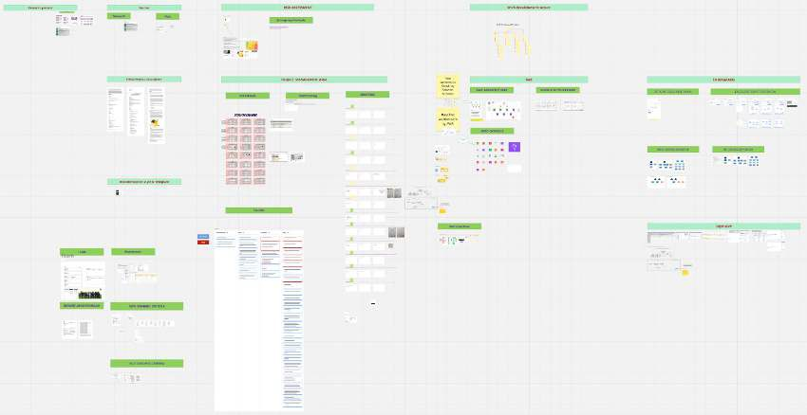

Figure D.1.: Miro board documentation, view of 10.11.2025

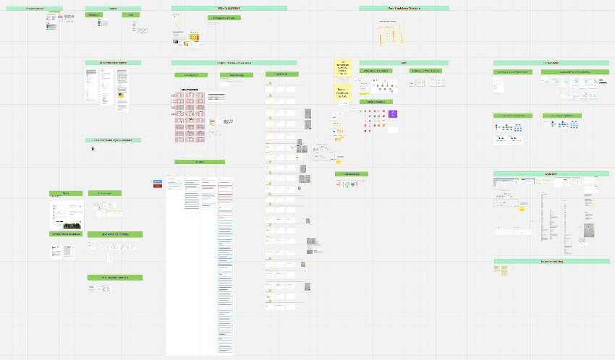

Figure D.2.: Miro board documentation, view of 25.11.2025

Figure D.3.: Miro board documentation, view of 23.12.2025

The risk Monitoring files are linked in the following tables. Todo Write this content

Todo Compare planned chapter / Milestone efforts
This annex section contains the time tracking performed during the course of the project. The content is provided in a raw form without further refinement. This section serves the purpose of transparency. Totals at 11.01.2026 when handing in the project document are: 155.35h at work and 201.28h Off work 201.28h. Total of 356.64h

Efforts at work
This listing documents efforts during work hours, describing the dates and times when work on the project was carried out, including a short description. Efforts are tracked in the time-tracking and MIAR systems, in which worked hours are allocated to projects. These records reflect the efforts undertaken as part of the professional engagement with Swiss Post.

Efforts outside work
This section provides the same type of listing as for work efforts, but for efforts carried out outside of working hours. These represent additional efforts performed beyond the engagement during office hours.

