Implementation
This chapter uses the research findings and the solution landscape developed in the previous chapters as
a basis for the implementation. With the defined SMART goals, the analysed reporting pipeline and data
lineage of the previous research Roccaro 2026, beeing the basis of the successful completion of the SMART
goals set in this project. The three goals are handled sesparately as their completion are not dependant of
each other. Those three goals are:
▶ Updating the existing data quality report, using the new data products set up by the ASTV team. Thus
using also the new reporting software Power BI and the new setup of data sources in star schema.
▶ Following up with the platform and data quality group regarding the tool decision for data quality
management at Swiss Post in the future. This task started as the evaluation of tools, as the DQM
platform described in the previous research Roccaro 2026 had shown that it would not be fit as a tool
for the entire Swiss Post.
▶ As a preparation for the upcoming Master Thesis, the data quality tools to be used were checked
initially. This included performing a concise test of counting data points with the defined monitoring
setup.
The validation of the achieved results is performed in the next chapters.

5.1. SMART goal 1, Setup of a improved DQM report
In project one, the base work researching the reporting pipeline was performed. It provided the data lineage
and described the underlying issues. With this data, an improved reportwas developed. Researchwas
conducted regarding how to better highlight the relevant comparisions and help the users see the information
even faster. Additionally the third party datasource which is still copied daily into a excel file recieved
improvements. The file was moved to sharepoint and is now updated on change to Amazon S3 where it is
made available to Athena. In addition to that the data selected recieved a change in it’s structure.
Update of data source
The Excel was updated from beeing copied to a shared folder to sharepoint. Sharepoint allowed to use an
existing interface Sharepoint to AWS.
This allowed to use the same interface also for the existing report in SAC, this setup was however done by
another member of the ASTV team
Setup of Power BI
State that for Power BI a setup existed already. This setup had to be used, however also allowing to use all
existing infrastructure. Benefitting from prework of the DWH LS OPS Team which defined.
53

Setup
This setup consists of already predefined templates defining areas such as reporting color groups, regions
for filters, how permissions for the reports are handled. Furthermore the setup included definitions how to
deploy reports and how to handle the AWS Athena data sources. Thus the setup was conducted as defined
by post.
Introduction Sessions
Power BI Intro Session.pptx
Templates are predefined
DWH LS OPS BizDevOps Team - Dokumente - PBI Template - Alle Dokumente

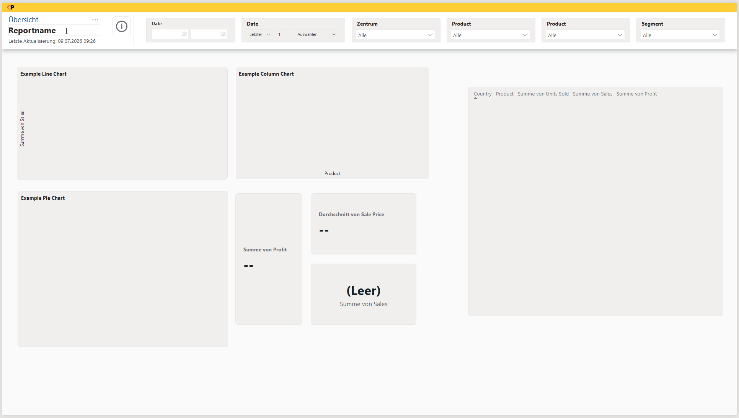

Setup guides explain how to order the software up to the setup of connections to datasources
Power BI - DWH LS OPS - Confluence

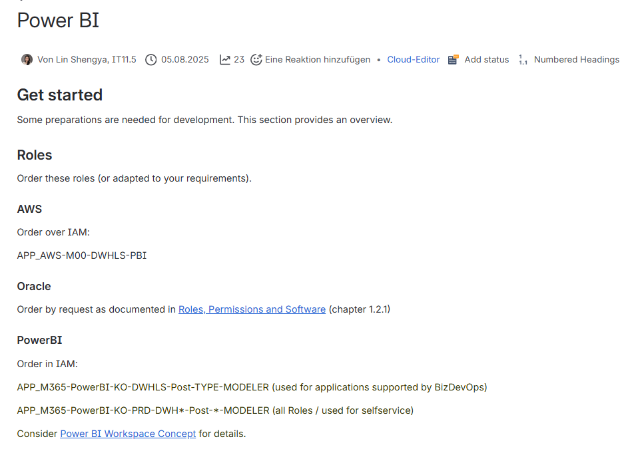
Report Definition
The setup of the report was initially overtaken from the analysed report in SAC, this decision was taken as
the data which had to be checked remained the same. Therefore also the method the business followed
stayed the same, and the first tests to get the data into Power BI returned the data in the same way.

New View Athena
While the data source remained largely the same, the data lineage changed slightly. Business and IT decided
in late 2025 that the data should be consumed as a star schema to improve performance compared
to the existing wide table. Consequently, the DQMdashboard for message processing needed to follow this
change in the data source. In order not to disturb the previous report, the data had to be gathered into a
separate view in Athena. The separate view was also required in order to validate the new star schema infoblocks
rather than those of the previous wide table. Thus, separating the views was necessary to maintain
clean, high performing code, as adding the new query parts for starshema into the widetable query would slow the query down and weave two different use cases together.

Note : This into Solution design
Steps using DevOps Process at Post:
In order to use the given
All Views are represented by a GitHub repository, and those are split into NonProd and Prod. On both environment The developer has to create a branch on GitHub from main. Into the branch the sql building the view, needs to be in the file content.
, the user has to create a file with the name of the view, and content

CREATE OR REPLACE VIEW "sendungsverarbeitung_dqm_starschema_v" AS
WITH
key_to_plz AS (
SELECT
'VET' locationKey
, '196000' plz

UNION ALL SELECT
'HRK' locationKey
, '462150' plz

UNION ALL SELECT
'CAD' locationKey
, '659100' plz

UNION ALL SELECT
'WAL' locationKey
, '830000' plz

UNION ALL SELECT
'HAE' locationKey
, '462000' plz

UNION ALL SELECT
'UTZ' locationKey
, '720000' plz

UNION ALL SELECT
'PRA' locationKey
, '413400' plz

UNION ALL SELECT
'FRA' locationKey
, '852000' plz

UNION ALL SELECT
'DAI' locationKey
, '131000' plz

UNION ALL SELECT
'URD' locationKey
, '892000' plz

UNION ALL SELECT
'BCH' locationKey
, '503000' plz

UNION ALL SELECT
'RUE' locationKey
, '815000' plz

UNION ALL SELECT
'OMU' locationKey
, '307100' plz

)
, plz_to_key AS (
SELECT
'196000' plz
, 'VET' locationKey

UNION ALL SELECT
'462150' plz
, 'HRK' locationKey

UNION ALL SELECT
'659100' plz
, 'CAD' locationKey

UNION ALL SELECT
'830470' plz
, 'WAL' locationKey

UNION ALL SELECT
'830000' plz
, 'WAL' locationKey

UNION ALL SELECT
'462000' plz
, 'HAE' locationKey

UNION ALL SELECT
'720000' plz
, 'UTZ' locationKey

UNION ALL SELECT
'413400' plz
, 'PRA' locationKey

UNION ALL SELECT
'852000' plz
, 'FRA' locationKey

UNION ALL SELECT
'131000' plz
, 'DAI' locationKey

UNION ALL SELECT
'892000' plz
, 'URD' locationKey

UNION ALL SELECT
'503000' plz
, 'BCH' locationKey

UNION ALL SELECT
'815000' plz
, 'RUE' locationKey

UNION ALL SELECT
'307100' plz
, 'OMU' locationKey

)
, mp_discharged_raw AS (
SELECT
CAST(DATE_ADD('hour', -6, discharged.timestamp AT TIME ZONE 'Europe/Zurich') AS DATE) Posttag
, discharged.sortingunit.locationKey locationKey
, discharged.sourceId sourceId
FROM
curated_lsops.mailpiece_discharged_v2
WHERE (1 = 1)
)
, mp_discharged AS (
SELECT
Posttag Posttag
, locationKey locationKey
, (CASE WHEN ((locationKey IN ('CAD', 'HRK', 'PRA', 'UTZ', 'VET', 'WAL')) AND (NOT (sourceId LIKE 'w%')) AND (NOT (sourceId LIKE 'W%')) AND (NOT (trim(BOTH FROM sourceId) = ''))) THEN 1 WHEN (locationKey IN ('BCH', 'RUE', 'OMU')) THEN 1 WHEN (locationKey IN ('HAE', 'FRA', 'DAI', 'URD')) THEN 1 ELSE 0 END) relevant_discharged
FROM
mp_discharged_raw
)
, discharged_agg AS (
SELECT
Posttag Posttag
, locationKey locationKey
, SUM(relevant_discharged) num_discharged
FROM
mp_discharged
GROUP BY 1, 2
)
, mp_submitted_raw AS (
SELECT
CAST(DATE_ADD('hour', -6, submitted.timestamp AT TIME ZONE 'Europe/Zurich') AS DATE) Posttag
, submitted.sortingunit.locationKey locationKey
, submitted.sortingProcess sortingProcess
FROM
curated_lsops.mailpiece_submitted_v2
)
, mp_submitted AS (
SELECT
Posttag Posttag
, locationKey locationKey
, (CASE WHEN ((locationKey = 'HRK') AND (sortingProcess = 'AUTOMATIC')) THEN 1 WHEN ((locationKey = 'VET') AND (sortingProcess = 'AUTOMATIC')) THEN 1 WHEN ((locationKey = 'CAD') AND (sortingProcess = 'AUTOMATIC')) THEN 1 WHEN ((locationKey = 'WAL') AND (sortingProcess = 'AUTOMATIC')) THEN 1 WHEN ((locationKey = 'UTZ') AND (sortingProcess = 'AUTOMATIC')) THEN 1 WHEN ((locationKey = 'PRA') AND (sortingProcess = 'AUTOMATIC')) THEN 1 WHEN (locationKey IN ('BCH', 'RUE', 'OMU')) THEN 1 WHEN (locationKey IN ('HAE', 'FRA', 'DAI', 'URD')) THEN 1 ELSE 0 END) relevant_submitted
FROM
mp_submitted_raw
)
, submitted_agg AS (
SELECT
Posttag Posttag
, locationKey locationKey
, SUM(relevant_submitted) num_submitted
FROM
mp_submitted
GROUP BY 1, 2
)
, mp_coded_raw AS (
SELECT
coded.sortingCycleId sortingCycleId
, CAST(DATE_ADD('hour', -6, coded.timestamp AT TIME ZONE 'Europe/Zurich') AS DATE) Posttag
, coded.sortingunit.locationKey locationKey
, coded.sortingProcess sortingProcess
FROM
curated_lsops.mailpiece_coded_v2
)
, mp_coded AS (
SELECT DISTINCT
sortingCycleId sortingCycleId
, Posttag Posttag
, locationKey locationKey
, (CASE WHEN ((locationKey = 'HRK') AND (sortingProcess = 'AUTOMATIC')) THEN 1 WHEN ((locationKey = 'VET') AND (sortingProcess = 'AUTOMATIC')) THEN 1 WHEN ((locationKey = 'CAD') AND (sortingProcess = 'AUTOMATIC')) THEN 1 WHEN ((locationKey = 'WAL') AND (sortingProcess = 'AUTOMATIC')) THEN 1 WHEN ((locationKey = 'UTZ') AND (sortingProcess = 'AUTOMATIC')) THEN 1 WHEN ((locationKey = 'PRA') AND (sortingProcess = 'AUTOMATIC')) THEN 1 WHEN (locationKey IN ('BCH', 'RUE', 'OMU')) THEN 1 WHEN (locationKey IN ('HAE', 'FRA', 'DAI', 'URD')) THEN 1 ELSE 0 END) relevant_coded
FROM
mp_coded_raw
)
, coded_agg AS (
SELECT
Posttag Posttag
, locationKey locationKey
, SUM(relevant_coded) num_coded
FROM
mp_coded
GROUP BY 1, 2
)
, mp_destinationAssigned_raw AS (
SELECT
destinationAssigned.sortingCycleId sortingCycleId
, CAST(DATE_ADD('hour', -6, destinationAssigned.timestamp AT TIME ZONE 'Europe/Zurich') AS DATE) Posttag
, destinationAssigned.sortingunit.locationKey locationKey
, destinationAssigned.sortingParameters.sortingProcess sortingProcess
FROM
curated_lsops.mailpiece_destinationassigned_v2
)
, mp_destinationAssigned AS (
SELECT DISTINCT
sortingCycleId sortingCycleId
, Posttag Posttag
, locationKey locationKey
, (CASE WHEN ((locationKey = 'HRK') AND (sortingProcess = 'AUTOMATIC')) THEN 1 WHEN ((locationKey = 'VET') AND (sortingProcess = 'AUTOMATIC')) THEN 1 WHEN ((locationKey = 'CAD') AND (sortingProcess = 'AUTOMATIC')) THEN 1 WHEN ((locationKey = 'WAL') AND (sortingProcess = 'AUTOMATIC')) THEN 1 WHEN ((locationKey = 'UTZ') AND (sortingProcess = 'AUTOMATIC')) THEN 1 WHEN ((locationKey = 'PRA') AND (sortingProcess = 'AUTOMATIC')) THEN 1 WHEN (locationKey IN ('BCH', 'RUE', 'OMU')) THEN 1 WHEN (locationKey IN ('HAE', 'FRA', 'DAI', 'URD')) THEN 1 ELSE 0 END) relevant_destinationAssigned
FROM
mp_destinationAssigned_raw
)
, destinationassigned_agg AS (
SELECT
Posttag Posttag
, locationKey locationKey
, SUM(relevant_destinationAssigned) num_destinationassigned
FROM
mp_destinationAssigned
GROUP BY 1, 2
)
, sendungsverarbeitung_raw AS (
SELECT
post_day posttag
, plz_to_key.locationKey locationKey
, dim_sor.sortierprozess_typ sortierprozess_typ
FROM
(((reporting_lsops.fact_sendungsverarbeitung_v sndv
LEFT JOIN reporting_lsops.dim_sortierung_v dim_sor ON (sndv.sortierung_hash_key = dim_sor.sortierung_hash_key))
LEFT JOIN reporting_lsops.dim_zentrum_v dim_zent ON (sndv.zentrum_hash_key = dim_zent.zentrum_hash_key))
LEFT JOIN plz_to_key ON (plz_to_key.plz = dim_zent.zentrum_plz))
)
, sendungsverarbeitung AS (
SELECT
Posttag Posttag
, locationKey locationKey
, (CASE WHEN ((locationKey = 'HRK') AND (sortierprozess_typ = 'AUTOMATIC')) THEN 1 WHEN ((locationKey = 'VET') AND (sortierprozess_typ = 'AUTOMATIC')) THEN 1 WHEN ((locationKey = 'CAD') AND (sortierprozess_typ = 'AUTOMATIC')) THEN 1 WHEN ((locationKey = 'WAL') AND (sortierprozess_typ = 'AUTOMATIC')) THEN 1 WHEN ((locationKey = 'UTZ') AND (sortierprozess_typ = 'AUTOMATIC')) THEN 1 WHEN ((locationKey = 'PRA') AND (sortierprozess_typ = 'AUTOMATIC')) THEN 1 WHEN (locationKey IN ('BCH', 'RUE', 'OMU')) THEN 1 WHEN (locationKey IN ('HAE', 'FRA', 'DAI', 'URD')) THEN 1 ELSE 0 END) relevant_sva
FROM
sendungsverarbeitung_raw
)
, sva_agg AS (
SELECT
Posttag Posttag
, locationKey locationKey
, SUM(relevant_sva) num_sva
FROM
sendungsverarbeitung
GROUP BY 1, 2
)
, device_stats AS (
SELECT
Posttag Posttag
, sorting_unit_location_key locationKey
, sum(content_value) amount
FROM
"reporting_lsops"."anlagestatistik_curated_v"
WHERE ((1 = 1) AND ((1 = 0) OR ((model = 'BEUMER') AND (content_type = 'INDUCTION') AND (content_value_index = 1))))
GROUP BY 1, 2
)
SELECT
submitted.Posttag Posttag
, submitted.locationKey locationKey
, key_to_plz.plz plz
, discharged.num_discharged num_discharged
, submitted.num_submitted num_submitted
, coded.num_coded num_coded
, destinationassigned.num_destinationassigned num_destinationassigned
, sva.num_sva num_sva
, dvs.amount num_stats
FROM
((((((submitted_agg submitted
INNER JOIN key_to_plz ON ((1 = 1) AND (submitted.locationKey = key_to_plz.locationKey)))
INNER JOIN discharged_agg discharged ON ((1 = 1) AND (submitted.Posttag = discharged.Posttag) AND (submitted.locationKey = discharged.locationKey)))
INNER JOIN coded_agg coded ON ((1 = 1) AND (submitted.Posttag = coded.Posttag) AND (submitted.locationKey = coded.locationKey)))
INNER JOIN destinationassigned_agg destinationassigned ON ((1 = 1) AND (submitted.Posttag = destinationassigned.Posttag) AND (submitted.locationKey = destinationassigned.locationKey)))
INNER JOIN sva_agg sva ON ((1 = 1) AND (submitted.Posttag = sva.Posttag) AND (submitted.locationKey = sva.locationKey)))
LEFT JOIN device_stats dvs ON ((1 = 1) AND (submitted.Posttag = dvs.Posttag) AND (submitted.locationKey = dvs.locationKey)))
WHERE ((1 = 1) AND (submitted.locationKey IN ('HRK', 'VET', 'HAE', 'CAD', 'WAL', 'UTZ', 'PRA', 'FRA', 'DAI', 'URD', 'BCH', 'RUE', 'OMU')))

Initial Data Setup
Due to this report beeing the first one developed by the project team, the first tries were performed locally
without deploying the report to Microsoft Fabric. As such first report, the abundance of ways how
to achieve e.g. links between datasources naturally lead to a report setup which performed some tasks
double. Such as linking the two data sources using scripts in two distinct methods using Power Query M and DAX. Issues.
Therefore the first tries were only performed on the desktop version of Power BI without deploying it to
Microsoft Fabric. Once the report was published, it however did not work as some ETL processes are different in fabric compared to the desktop version.

Major Issue: Kurz vor dem Deployment, bzw. nach dem deployment auf Dev ist aufgefallen dass es Probleme gibt mit dem Datenload Amazon Athena zu PowerBI
In PowerBI wurde eine Transformation beim Load gemacht.
PowerBI versuchte eine spalte mit Datumswerten in ein Datumsformat zu casten, wobei PowerBI ein Problem mit leeren Werten bekam.
Laut analyse: Ein Problem was in Athena korrigiert werden sollte

📘 Wissenschaftliche Zusammenfassung des Chatverlaufs
Diese Zusammenfassung beschreibt die im Gespräch identifizierten Problemursachen, angewendeten Analyseverfahren und die erarbeiteten Lösungsansätze zu Themen der Datenaufbereitung, Fehleranalyse, Power BI – Athena Integration, Datumstransformation, Query-Strategien und Datenqualitätsmanagement in ETL-Pipelines.
Dabei wird der Fokus ausschließlich auf die fachlich relevanten Bereiche gelegt — ohne persönliche, soziale oder nebensächliche Inhalte.

Summary Friday 20.03.2026:
* First check with Team mate if Athena is to be adapted regarding the view
* Info from call : No adaption of Athena should solve the problem,
* The connector of PowerBI uses .csv as transfer method between AWS and PowerBI
* The Query on Amazon Athena does not fail
* The issue happens entirely on the side of PowerBI when it tries to transform from string to date
* Decision : No changes in Amazon Athena, however changes to the PowerBI Report
* Due to a complex Report, without initial commits on GIT, a debugging is hardly possible
*However a rebuild from scratch would be advisable, this way early commits to PowerBI Service can establish wether the Data is ok on early stages

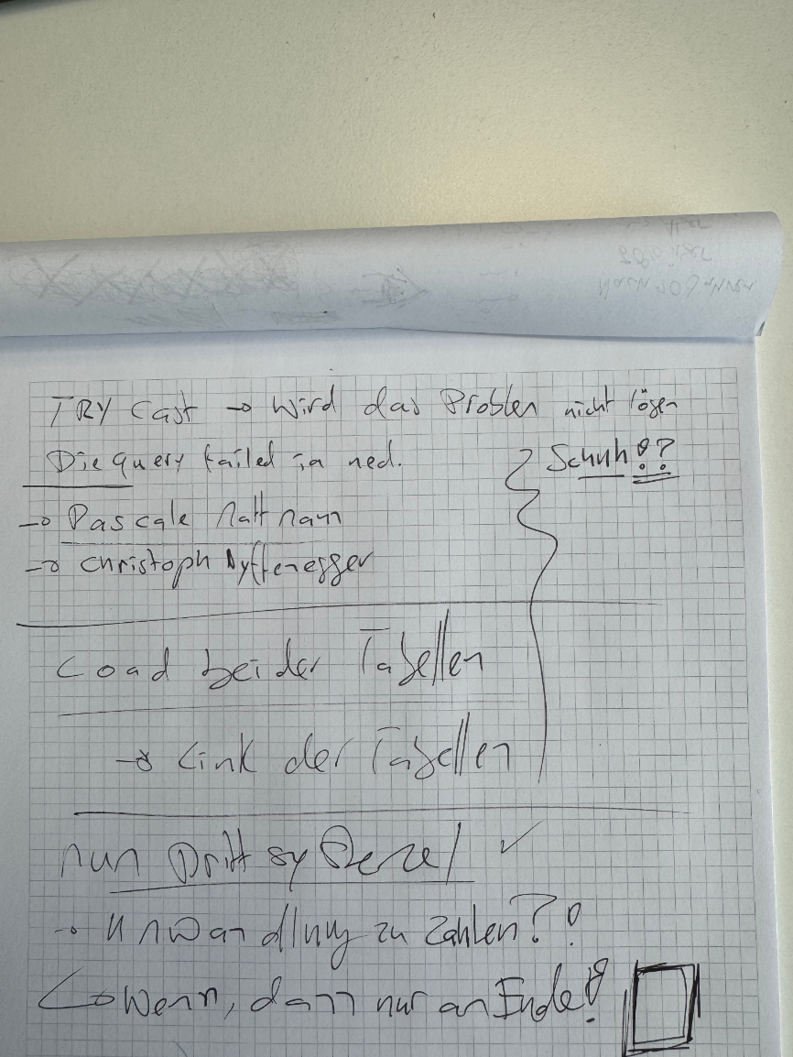

Summary Friday 20.03.2026:
* New Report was created, then first the tables are queried using powerBI Desktop
* After this was successful the report was deployed to PowerBI Service
* PowerBI Service was able to successfully update the data
* Next step was then to create the join key on both tables
* Next Join the tables
* Then deploy again, which was still able to update the data without error
* Next the data transforms in PowerQuery were reimplemented, and another deploy
* This was still ok, so cleaning of number fields was added and a simple table for data display was finalised, after deploying data was still updatin fine
* Next the DAX was added for the measures, and the table was changed to use the measures instead of the base table fields
* After Deployment data was still updating, so the further visuals were added including the measures for 0 or 1 reply depending wether its considered an error regarding the 0.01 to - 0.01 boundaries and minimum activity of 10'000 a day

Key Learning:
Environments Local or Cloud behave differently

report I first built everything local However this did not work online.. Had no proper Chain of checkins
Had to redo the setup, But now deployed it more often to find out if eventually one specific issue renders
the data non usable
Initial Data Setup
Describe that first only 1 query Then 2 queries and combine them... However later with the aggregation
table... Another data source was to be added, the semantic model
New visuals to help faster visual data reception by stakeholders
However decision taken to use 3 visuals 1 visual using trafic lights , green orange red, also using different
colors 2 using a line chart to show eventual recuring or increasing issues 3 using the existing table view of
SAC but reinforcing the data with the trafic lights same as the trafic light visual
54

Waiting for finishing of aggregation
-> To Solution LandScape Technical limits due to data amount pragmatic setup aggregating some values
while some details are only availale as direct query (slower)
Input from stakeholders
Input from team... You need to use a data model You need to move measures into a measure table You
should have filters differently Use a table for dates, link it to every other date same for PLZ -> Rendering
the Joined Key PLZ+Date non Needed
Requirement to rebuild the data model
If available show the changes to the data model
Final Version of the Report
Show how the final version looks
5.2. section 2
This chapter uses the research findings and the solution landscape developed in the previous chapters as
a basis for the implementation. With the defined SMART goals, the analysed reporting pipeline and data
lineage of the previous research, beeing the basis of the successful completion of the SMART goals set in
this project. The three goals are handled sesparately as their completion are not dependant of each other.
Those three goals are:
5.3. section 3
This chapter uses the research findings and the solution landscape developed in the previous chapters as
a basis for the implementation. With the defined SMART goals, the analysed reporting pipeline and data
lineage of the previous research Rocco, beeing the basis of the successful completion of the SMART goals
set in this project. The three goals are handled sesparately as their completion are not dependant of each
other. Those three goals are:
55

