Title: Enhancing User Confidence in Report Timeliness and Data Accuracy through Data Quality and Availability Checks
Abstract: This project aims to introduce a comprehensive framework for data quality and availability checks to ensure that reports are delivered on time and with accurate data. By implementing these checks, we aim to increase user confidence in the reliability of the reports.
1. Introduction:
- Background: The non-operative reporting at Swiss Post is undergoing a on premise to cloud migration. During which many reports are reviewed and rebuilt. In this process, the tools stack changes from the basic level of data storage up to the frontend tooling showing the reports. The migration of the reporting infrastructure goes hand in hand with a technological change of the underlying data provision methods. Meaning that the old reports are cut off from their data pipelines. Thus, the clients cannot compare the new reports with the old reports when they are introduced.
- Problem Statement: The users being subjected to a change in technology need to be bolstered in their confidence regarding the new systems. We as providers of those systems need to ensure that the reports are provided on time and that the data they provide is accurate. However, currently the reporting pipelines only have some basic checks which alarm the operating IT of jobs that did not run through. We are lacking checks whether the reports have missing data or provide data within certain expected ranges. E.g., certain workloads expected per hour, day, month. Currently the checks for missing data or data being out of the expected range are solely run by the business who perform manual comparisons between our reports and e.g., other systems. They also hold the knowledge regarding expected workload per time and different sites.
- Objectives: We want to achieve two things for two main stakeholders.
  - For IT: Add an infrastructure to the reporting systems which provide them with warnings in case Data seems to be missing. Allowing them to react faster and inform proactively when problems occur.
  - For Business: We want to relieve the business of their manual checks and comparisons of data sources. This would free up some of their time they could then invest in further tasks during the migration process.
  - Data Quality checks take approximately.
    - 30-45 minutes a day
    - 2.5-3.75 hours a week
    - 10-15 hours a month
    - 110h – 165h per year times 130CHF/hour ~ 18’000 CHF/year
This supports the main goal of the project, improving data accuracy, ensuring timely report delivery, and increasing user confidence.
2. Methodology:
- Data Quality Checks: Read into best practices adding data quality checks. Document the current setup. Read into possibilities available using the current pipeline tools. Read into additional tools fitting into the current tool stack. Perform tests with selected tool stack using nonproductive systems. Discuss with Business which checks you will implement to ensure data accuracy (e.g., validation rules, consistency checks). Have business run checks using the new possibilities before deploying integration and production systems.
- Data Availability Checks: Read into best practices by adding data availability checks. Document current setup. Read into possibilities available using the current pipeline tools. Read into additional tools fitting into the current tool stack. Perform tests with selected tool stack using nonproductive systems. Discuss with IT and Business which checks you will implement to ensure data availability (e.g., checking sources are available at processing start).
- Implementation Plan: Develop new possibilities on Development Systems or eventually external Systems before deploying to integration environments. Have the IT/business run checks using the new possibilities before deploying production systems after successful testing.
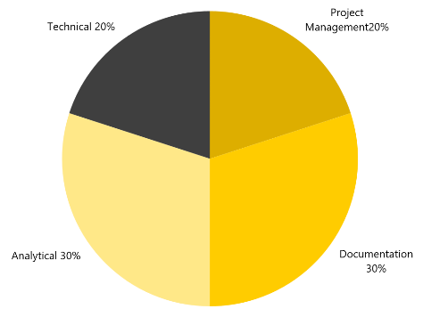
- Work types: The project will consist of four main tasks.
  - 1. Project Management: Attending Scrum Ceremonies and performing further meetings as required.
  - 2. Analytical Work: Analyze and process the current situation. Based on that, reading into the problem is finding a solution. Investigating state of the art methods to solve the issue.
  - 3. Documentation: Writing the project report to summarize the methods used during the project. The ongoing project status updates. And describing the results of the work and their follow-up.
  - 4. Technical Work: Implementation of the solutions found during the analytical phase. Analytical and technical work will be an iterative process. For example, a method failing to provide required data will lead to the analysis of another method.
3. Goal
Success in this project can be measured in three layers.
- Analysis: First step to success is documentation of business needs Before setting up an environment I must know what is required by stakeholder or IT. Because some business requirements and especially business rules are not yet documented.
- PoC: After analysis and checking how the problems could be solved, I will implement a PoC with set tools. If the PoC proofs to be too complex for this project scope, it can be part of a follow up project. However, if possible a smaller part of the PoC should be delivered.
- User Feedback: After each step, be it the analysis or the PoC, user feedback needs to be gathered. The success in this project will be measured documenting the feedback and adapting to the feedback.

4. NDA:
- The handling of this document and especially its results is governed by applicable legislation, people not working at Swiss post may sign an NDA.

Roland Roccaro Dr. Kenneth A. Ritley
Student MSE Msc Data Science Professor BFH

