Measurement of data quality - technical perspective
This page describes the technical implementation of key performance indicators (KPIs) about data quality. It refers to the following general data quality rules:
4.3 Die technisch zu messenden Datenqualitätsdimensionen - Digital Enabling - WIKIT
In a first step, we are going to measure the quality of customer data, other data products will be following. The business will define the priorities.

Requirements:
- The defined KPIs must be automated measured via Batchjob
- The results must be stored to document and evaluate the changes over time, that does mean we need a historization of the results from the quality checks

Overview
The following picture depicts all the modules composing the the Data Quality Management Platform.

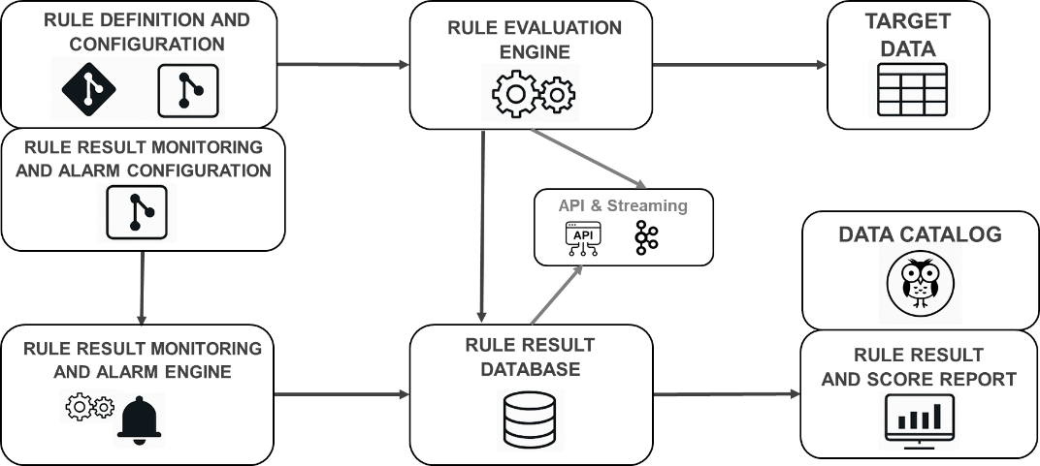

📘 1. Rule Definition and Configuration
Defines the logic and parameters for data quality checks. Rules are version-controlled and can be tailored to specific datasets or business requirements.
🛎️ 2. Rule Result Monitoring and Alarm Configuration
Specifies thresholds and alerting conditions for rule outcomes. Enables proactive monitoring by configuring when and how alarms should be triggered.
⚙️ 3. Rule Evaluation Engine
Executes the defined rules against target datasets. It processes data inputs and produces evaluation results for further analysis.
📊 4. Target Data
The actual datasets being assessed for quality. These are the inputs to the rule evaluation engine.
🦉 5. Data Catalog
Centrally captures and documents all relevant business and technical metadata and make it easily accessible throughout the company.
🔌 6. API & Streaming
Interfaces for real-time or batch access to rule results. Enables integration with external systems and dashboards.
🗄️ 7. Rule Result Database
Stores the outcomes of rule evaluations, including pass/fail statuses, scores, and timestamps for audit and reporting.
🛠️ 8. Rule Result Monitoring and Alarm Engine
Continuously checks rule results against configured thresholds. Triggers alerts if anomalies are detected.
📈 9. Rule Result and Score Report
Generates visual and tabular reports summarizing rule performance and data quality scores. Supports operational and strategic decision-making.

Revised technical architecture as result of MVP:
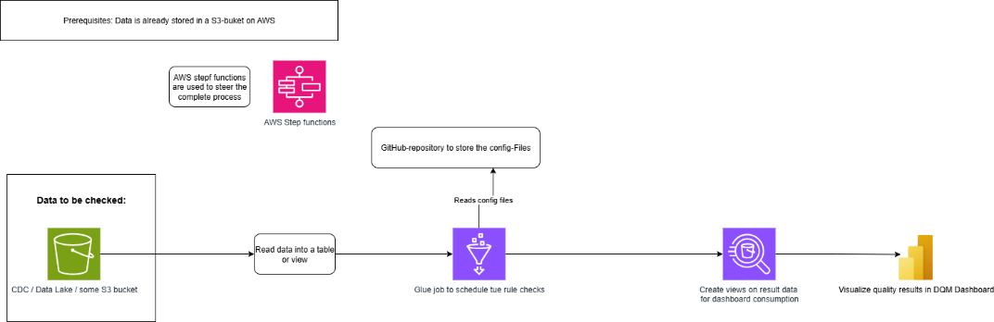

Technical components:
The following part of this documentation describes the diverse technical compondents of the solution.

Git-Hub-Repository for config-files (dac-processing-data-quality)
This repository holds the config-files for the rules and the necessary views / tables.

Import interface data.world to DQM
To calculate the DQSI for every hierarchy of the measured data product it is necessary to import the data structure from data.world.

DataQualityChecks:

DQ Rules
The implemented rules will described here: Rules catalog - Digital Enabling - WIKIT

Jobs

AWS Data Quality Platform Data Model
The model is described here: DQM Athena Data Model - Digital Enabling - WIKIT

Dashboard
The dashboard will be realized with MS Power BI. The dashboard shows exclusively meta data (results of quality checks over time). The original check data products are not showed into the dashboard. Maybe later we will implement an additional view with links to the original data.

Write back DQSI from DQM to data.world (Data catalog)
The results of the quality checks will also be showed in the data catalog (data.world) with the relevant data products. See the Subpage: Interface DataQualityManagement (AWS) to data.world - Digital Enabling - WIKIT

Necessary imports from data.world into the DQM solution:
API-Dokumentation data.world: API overview

Write back the results of the DQM check into data.world:

MVP

Purpose:
Verify proposed technical solution using a simple key figure: Completeness.
Advantage: Complete technical workflow can be tested, relatively little test data required, data can be stored in one table → Effort manageable.

Delivery items:
- Define technical architecture for MVP
- Setup environment for test purposes
- Agreement on necessary test data
- Key figures for MVP defined and agreed by sponsor
- Rules implemented in AWS Glue Dataquality
- Result data stored on AWS with simple historization
- views on result data defined, implemented and accessible von MS Power BI
- Simple dashboard in Power BI

Key figures for the MVP
A general definition of the key figures can be find here:
4.3 Die technisch zu messenden Datenqualitätsdimensionen - Digital Enabling - WIKIT
To test the proposed technical solution a simple key figure is sufficient, e.g. from the technical dimension "Completeness".
The check for completeness of transferred data is for the MVP to big, but we can test the completeness of data field.

Technical requirements:
First solution will be implemented on AWS. The following tools of the AWS palette should be used:
- Rules fronted / Rules engine: AWS Glue data quality
- Automation of check-ups: AWS Lambda
- Backend: S3 bucket
- Middleware: AWS Athena
- Frontend: Power BI
Test user must have access to the named tools, Creation of new objects must be possible, test data necessary
Environment: SandBox

MockUp DashBoard

General Layout
The following image shows the dashboard as specified. However there is a lot of optimization potential for the UX.

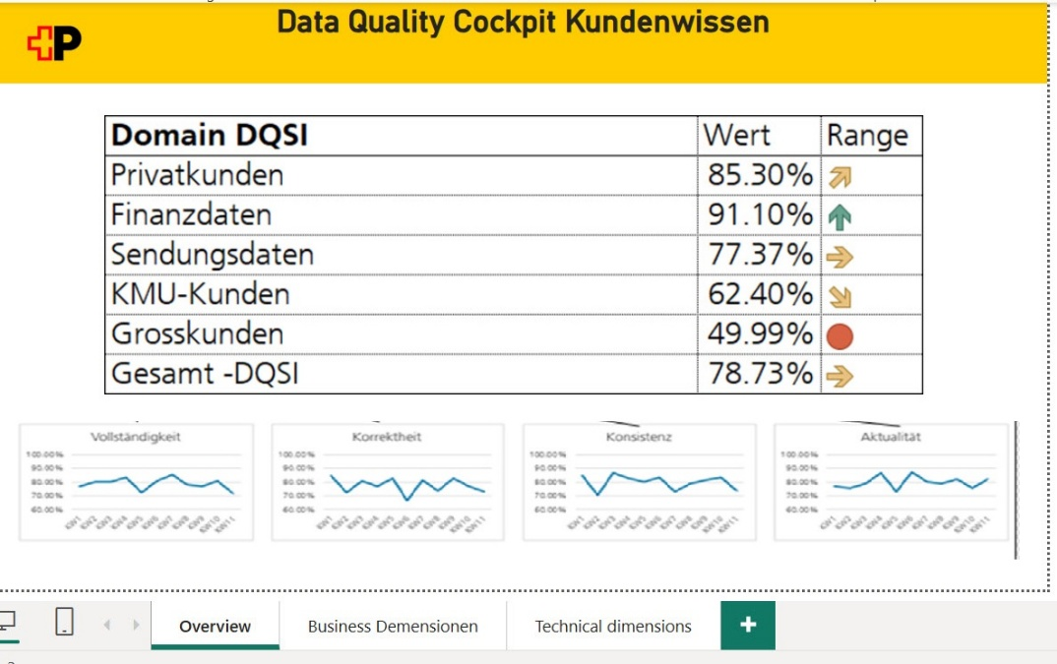

Metrics and Charttypes

Metrics
Score of completeness
Definition of completeness: https://wikit.post.ch/pages/viewpage.action?pageId=2185757323#id-4.3DietechnischzumessendenDatenqualitätsdimensionen-Vollständigkeit(Completeness)

Data quality score (DQI)
The calculation of the DQI is defined here: 4.5 Der Data Quality Score Index (DQSI) - Digital Enabling - WIKIT
The other metrices are showed with dummy data to get a look and feel of the complete dashboard.

Chart types
Metric tiles for the DQI, Line charts for changes over the time of the different metrics.

Filterelements

Authorizations and other administrative remarks
The following ressources are necessary:
- S3: Read / Write
- Glue
- Lake Formation (DQM database)
- Lambda ?
- Athena (provisioning of views for Power BI)

Work packages:

number | task | responsible | status | remarks
1 | Definition of MVP / Obtain consent from principal | Rodens Sabine, IT15.7 | DONE | got approval from Stephan Egger (13.03.25)
2 | Conception of technical architecture for MVP | Rodens Sabine, IT15.7 | DONE
3 | Organize users, workspaces etc | Rodens Sabine, IT15.7 | DONE
4 | Get instruction of Post specific procedures using AWS | Rodens Sabine, IT15.7 | DONE
5 | Setup of necessary environment (workspace, S3 buckets etc.) | Rodens Sabine, IT15.7 | DONE | SandBox done,
6 | Define table structures for results | Rodens Sabine, IT15.7 | DONE
7 | Create test data | Rodens Sabine, IT15.7 | DONE
8 | Get familiar with AWS Glue Quality Management | Rodens Sabine, IT15.7 | DONE
9 | Implement first rules | Rodens Sabine, IT15.7 | DONE
10 | Technical testing (functional testing) | Rodens Sabine, IT15.7 | IN WORK
11 | Review results (Do the rules work as expected / are the results as expected) | Rodens Sabine, IT15.7 | IN WORK
12 | Define views for dashboard consumption | Rodens Sabine, IT15.7 | IN WORK
13 | Open new SSBI use case | Rodens Sabine, IT15.7 | DONE
14 | create Mockup for dashboard and get agreement from principal | Rodens Sabine, IT15.7 | DONE
15 | implement dashboard | Rodens Sabine, IT15.7 | IN WORK
16 | Testing of the complete process | Rodens Sabine, IT15.7 | OPEN
17 | Present results to principal and get agreement | Rodens Sabine, IT15.7 | OPEN
18 | Define next steps | Rodens Sabine, IT15.7 | IN WORK
19 | Documentation | Rodens Sabine, IT15.7 | IN WORK
20 | Specify complete technical solution based on AWS Glue data quality | Rodens Sabine, IT15.7 | IN WORK
21 | Define ressources for production environment based on MVP |  | IN WORK
22 | Create necessary security documents for production (Schuban, ISDS???) | Rodens Sabine, IT15.7 | DONE
23 | Prepare Terraform for the usage of Glue Data Brew | dos Santos Hugo, IT21.43 | IN WORK

Timeline:
tbd.

