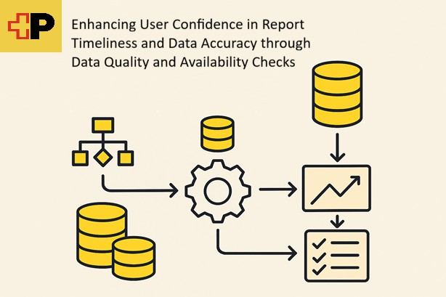

Specialisation Project 1 MTE7101

Enhancing User Confidence in Report Timeliness and Data Accuracy through Data Quality and Availability Checks
Course of study Master of Science MSc in Engineering: Profile Data Science Author Roland Angelo Roccaro
Advisor Prof. Dr. Kenneth A. Ritley
Project partner Swiss Post
Version 1.0 of December 7, 2025

▶ School of Engineering and Computer Science
▶ Master of Science in Engineering

Todo, Review the Abstract
This project aims to introduce a comprehensive framework for data quality and availability checks to ensure that reports are delivered on time and with accurate data. By implementing these checks, we aim to increase user confidence in the reliability of the reports.

Abstract iii

Introduction 1
  - Background 1
  - Motivation 1
  - Problem Statement 2
  - Limits 2
  - Expected Outcome 2
  - Structure of the Document 2

Project management 5
  - Teams 5
    - Post Teams 5
    - Team Tools 5
  - Method 5
    - Calendar Timeline 5
2.2.2. | Kanban . . . . . . . . . . . . . . . . . . . . . . . . . . . . . . . . . . . . . . . . . . | 5
2.2.3. | Weekly Jour Fixe . . . . . . . . . . . . . . . . . . . . . . . . . . . . . . . . . . . . . | 5
Tools | . . . . . . . . . . . . . . . . . . . . . . . . . . . . . . . . . . . . . . . . . . . . . . . . | 5
2.3.1. | Miro . . . . . . . . . . . . . . . . . . . . . . . . . . . . . . . . . . . . . . . . . . . . | 5
2.3.2. | Jira and Confluence . . . . . . . . . . . . . . . . . . . . . . . . . . . . . . . . . . . . | 6
2.3.3. | Teams and Outlook . . . . . . . . . . . . . . . . . . . . . . . . . . . . . . . . . . . . | 6

  - Risk Management 6

Research 13
  - Problem Statement 13
  - Research Question 14
  - Smart Goals 14
  - System Landscape 14
  - Methods of approach 15
  - Sources 15
  - What is data quality checks 15
  - What is data availability checks 15

Solution Design 17

Implementation 19
  - Current SAC Report Documentation 19
  - Business Analysis, SAC and DSP 19
  - Business Analysis, AWS Athena 25
  - Development to Get to Generalisable Rules 26

Results 31

Analysis Targets 33

Review Lessons Learned 35

Statement of Authorship 37

Bibliography 39

List of Tables 41
List of Figures 43
- Initial project description at handin 45
- Meeting Summaries 49
  - Risk Monitoring 50

Introduction
Since mankind first began making plans, they were based on the available description of the environment. This approach continued into modern times, although the nature of the predictions has changed. People no longer plan which animal to hunt or when to produce stone tools, but instead how many people the postal service should hire for the Christmas season. These decisions require data, and in order to make the right decisions, the data must be available in the right time, in the right context, for the right people - and naturally be correct. This makes data one of the most important assets in a company economist2017_dataoil. Data allow companies to gain an edge over competitors, analyse clients’ wishes, or improve internal processes. This is where the relevance of this project emerges. Swiss Post requires data availability and data quality in its reporting for decision making. This project analyses the current state of a specific data area of Swiss Post and provides steps toward improvements.
This chapter familiarises the reader with the topic. It presents the background of the project at Swiss Post and delves into the motivation behind it. It then further explains the business relevance, demonstrat-ing why it is both importand and beneficial useful for Swiss Post to invest in the topic. Next, the problem statement is addressed, explaining what this project aims to solve. After the problem statement, the scope and limitations of the project are outlined more clearly. Finally, a brief overview of the expected outcomes of the project is provided. This chapter concludes with a preview of the document’s structure.

Background
Swiss Post is Switzerland’s national service provider, active not only in mail and parcel logistics but also in passenger transport (PostAuto), financial services (PostFinance), and various digital and e-government solutions. Its 45’000 strong workforce and nationwide infrastructure moves millions of items and people every day, supported by highly automated sorting centers and extensive data flows. The organization of the Swiss Post is shown in the following diagram.
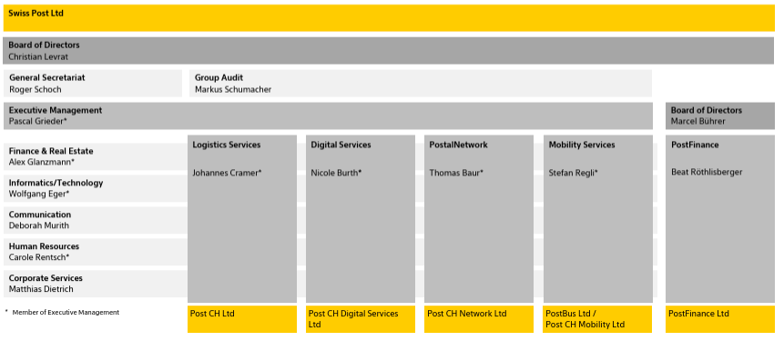

In such a diversified organization, analytical reporting is essential for strategic steering, operational planning, and maintaining service quality across business units.

This project concerns the analytical reporting of the postal services carried out by Swiss Post. The project follows the DWH LS OPS BizDevOps team, located in the organization structure within the Logistics Service horizontal and the Informatics/Technology vertical. This team handles the operations of these reports and also develops new reports. In contrast to operational reporting, which focuses on real-time guidance for operational processes, analytical reporting focuses on aggregated insights for evaluation and planning. Ex-amples of analytical reporting include working time, process time, and aggregations of sorted items. The stakeholders of the team distribute these reports to various task groups in postal services, such as sorting and delivery. The team is currently handling approximately
TODO: Number of reports
There are two reasons why a deeper understanding of analytical reporting is currently very important. First, the infrastructure for analytical reporting is transitioning from on-premise to the cloud. Second, in addition to the migration of reporting, the infrastructure at all Swiss Post sorting center locations for parcels is undergoing funda-mental changes. These changes may include complete modifications of data pipelines, which sometimes make comparisons to previous figures impossible. Therefore, at this critical point in time, it is of utmost importance to maintain users’ trust in the data during this change process.

Motivation
Data quality and data availability are central to any company. Data availability enables a company to operate its daily business. Even a company working in low-tech or non-IT industries Pas 2025 has basic but essential needs, for example, who is working where, and the addresses of clients and staff. Not having this data available for the right people at the right time will cause problems whenever the data need to be used.
In the context of ongoing changes to the Swiss Post reporting infrastructure, keeping track of data avail-ability and data quality is challenging. These infrastructure-related changes comprise the construction of new reports, one-to-one migrations, and the re-engineering of existing reports.

Furthermore, due to the lack of automated data accuracy and data quality checks in the DWH LS OPS environment at the time of defining this project, this topic is highly relevant to the team responsible

for both the operational and the analytical reports that help guide the company. If the data is incorrect, wrong decisions are made; and if the data is unavailable, management cannot properly lead the staff. Thus, the topic is of high importance and business critical.
Since the topic of data quality could be built from scratch, as if starting on a greenfield, it became an ideal subject for a master’s thesis. Furthermore, the topic was not of the highest priority for Swiss Post, but it was still considered a valuable idea to pursue. This medium-priority nature of this project also allowed the topic to be divided into multiple steps, such as working from a proof-of-concept (PoC) to an minimum viable product (MVP) setup. Additionally, the medium priority regarding feature development in this area allowed for well-grounded research on the topic. All these aspects combined the topic of data quality in the analytics reporting area a suitable project leading to a master’s thesis.

Problem Statement
The two key problems addressed in this project are, first, that data quality has been treated in an ad hoc approach, without formal definitions, frameworks, or an agreed set of KPIs; and second, that data quality is handled manually by the business on a high level rather than being automated by the IT department. Both of these problems lead to issues not being detected early and to longer reaction times. As a further consequence, delays in data processing are not identified and targeted for systematic resolution, which in turn reduces management confidence in the reports.. All of this prevents continuous improvement, as the current checks are neither documented nor saved in a way that allows follow-up analysis or structured refinement.

Limits
This document focuses on the data availability and data quality challenges of the DWH LS OPS BizDevOps ASTVteams at Swiss Post described in 1.1. To simplify the scope of this work, the first step of data retrieval, such as how data is stored from Kafka topics, is excluded. The scope begins with the curated and reporting layers in the ETL process of the retrieved data. The aim of this project is to specifically provide solutions to the mentioned teams and not to offer a general solution or framework for the entire Swiss Post

Expected Outcome
The goal of this master’s thesis project is to demonstrate that automated data quality checks provide ad-ditional safety and can be calibrated to the needs of the business. Automated data quality checks refer to checks executed daily or upon data load, which are always carried out by systems without the need for manual interaction. More specifically, this project must provide the first steps toward this goal. This doc-ument will examine the basis for the upcoming solution and then provide a PoC. It will explain the steps taken toward the proof of concept and, in this way, make the decisions made understandable. The success criterion of this project will be to provide a PoC, or steps toward a PoC, that help reduce the costs of manual checks.

Structure of the Document
This document is intended to guide the reader through the project in meaningful steps, explaining how the project is set up and executed, and then leading into the research and conclusions. It is structured in the following way. First, this document begins with the project management chapter, which explains the methods used during the project. It pro-vides reasoning for tool choices where applicable and lists the tools and teams with which collaboration took place. Next, the research chapter describes the problem in more detail. It clearly defines the specific and measurable goals of the project and presents the research sources used. This allows the reader to understand the decisions made and establishes the basis for the solution design. The subsequent solution design chapter explains how the problem statement is addressed. It describes the tools selected and how they interact with one another. This is followed by the implementation chapter, which presents the implementation of this de-sign. It contains the work carried out by the project team and outlines any encountered issues. After the implementation, the target analysis chapter compares the expected outcome to the achieved outcome, as-sessing how many goals were reached and listing their fulfilment status. The document concludes with the critical review and lessons learned, summarising what went well and what did not, offering specific suggestions on which methods to retain or replace. This will be invaluable for the forthcoming projects (PA2, Masters thesis) that will be carried out following this project. Finally, the appendix contains materials such as the initial project description

1.6. Structure of the Document

at submission, time tracking, meeting notes, and additional relevant information that does not need to be presented in a refined form.

[

NOTE FROM KEN:

VERY WELL DONE. PROBABLY ONE OF THE BEST INTRODUCTION CHAPTERS I’VE READ IN A WHILE. IT BRINGS IN THE READER, PIQUES THEIR CURIOSITY, EXPLAINS THE ENVIRONMENT AT A HIGH LEVEL, THEN EXPLAINS HOW THE DOCUMENT IS SET UP.

GOOD JOB!
]

Project management
The project management chapter summarises the environment of this project and how it is conducted. This allows to further introduce the reader into the surrounding and incrementaly increase the understanding. First, the teams are listed in which the project staff is engaged. Second, the different methods for effort and task tracking are introduced. Third, the tool sets used by the different teams are described. Finally, the risk management section describes the risks handled and measures taken to counteract them.

Teams
This section will explain the the team environments in which the project staff is engaged. First, it will describe the work setting at swiss post where different structures are working towards the goal of this project. Second, the project team itself will be presented.

Post Teams
List of post teams surounding 1. The scrum Team 2. The AWS Modernisation 3. the quality initiative

Team Tools
Jira... Confluence Outlook, weekly meetings... and different confluence? The teams use different methods to synchronize and document their efforts

Method
The method section will detail how the different teams manage themselves.. First, the post teams methods and communication lines are described. Second, the project teams is described in the same way.

Post Teams
Scrum
PAM
Weekly meeting DQM
Availabilities in calendar (Holidays, meetings) etc. trough shared calendars

Blabliblu
Project Team

Calendar Timeline
A calendar in Miro is used to set timelines The calendar also serves as a documentation as to when meetings were held.

Timeline
The time per block is not estimated as : How much time should it take to do something. But rather in : How much time do we want to invest into this topic so that we have enough for the following So, documentation of post environment could take 2-3 weeks, however we decided to only take 1 week for that task. Any data gathered in this time is either documented into miro or imediately into the document. Later the sources in miro can be added to the document if time permits it.

Mile stones
Within the calendar Milestones have been defined

Kanban
Tasks for the Project , so writing research etc. is on Kanban

Weekly Jour Fixe
Describe the weekly Jour Fixe Describe how they are useful And Describe where they are documented

Tools

Miro
Miro is used for main notes.. Create a source link Main Notes board

Jira and Confluence
Documentations at Swiss Post

Teams and Outlook
Teams for any discussions with closer team and Outlook for setup of meetings and correspondence In teams also documents

Risk Management
In this chapter, the approach taken to risk management is described. Risk management is essential to the success of any project, as it enables planning for and potentially preventing dangers that may occur during its course. When such risks are not handled, they can endanger the progress of the project. The risk management process consists of several steps “Miro Risk Mamagement Introduction” 2025. First, the risks are identified and classified as to their nature. Next, they are weighted according to how they might impact this project; this includes a consideration of the probability that the risks may arise, and the level of damage that may occur. After this, the specific handling of each risk is defined; these are the concrete measures that are taken to lower how the risk may impact the project. Finally, ongoing monitoring and review of the risks is carried out on a regular basis throughout the project.

Risk Identification and Classification
The identification of risks has been carried out for this project, following an extensive brainstorming approach. Each risk has been grouped into a category (e.g. goal, time & organization, etc.), and each risk has been classified according to the likelihood of is occurance and severity it would cause to the project. Both criteria are evaluated based on the project team’s risk appetite and ranked according to the following definitions.
▶ Likelihood: What is the expected likelihood of a risk coming into effect
- 1 Rare
- 2 Unlikely
- 3 Possible
- 4 Likely
- 5 Almost Certain
▶ Severity: How severe are the consequences of the risk coming into effect
- 1 Insignificant
- 2 Minor
- 3 Moderate
- 4 Major
- 5 Severe
The identified risks, along with their likelihood and severity, are listed in Table 2.1.

Table 2.1.: Project Risk Overview
No. | Group | Risk | Likelihood | Severity
1 | Goal | Unclear question | 2 | 2
2 | Goal | Unclear goals | 2 | 3
3 | Time and | Insufficient expertise | 4 | 2

Organisation
- Time and Organisation
- Time and Organisation
Underestimated time/effort 4 3
Other study projects 3 3
Continued on next page

Organisation
No. | Group | Risk | Likelihood | Severity
6 | Time and | Work projects | 4 | 3

- Time and Organisation

Procrastination 3 2

- Human Resources Unavailability of main project staff (e.g., due to 4 4
illness)
- Human Resources Unavailability of advisor (e.g., due to illness, 3 4
accident, etc.)

- Tech and Infrastructure
- Tech and Infrastructure
Software Version/Library/Dependency 4 3
Hardware is damaged 2 5

12 Data and Research | Data related | 4 | 3
13 Data and Research | Not reproducible work | 2 | 5
14 Ethical and Legal | Plagiarism or wrong citation | 2 | 5
15 Ethical and Legal | Copyright | 1 | 5
16 Communication | Bad communication with stakeholder or | 2 | 4
and Cooperation | advisor
17 Communication | Insufficient exchange with external partners | 1 | 5
and Cooperation
- Force Majeure Unforeseen family crisis 2 5
- Force Majeure General force majeure 1 5

Risk Heat Map
After carrying out the initial identification and classification, it is not always easy to determine which risks require the most attention. To support this task, a Risk Heat Map is used, in which each risk is plotted in a two-dimensional matrix according to its likelihood and severity. This visualisation highlights the risks that pose the greatest threat to the project and should be considered for priority treatment. The colours in the Risk Heat Map 2.4 corre-spond to these descriptions.
▶ Green Low
▶ Yellow Medium
▶ Orange High
▶ Red Very High

Risk Strategies and Mitigations
Risk strategies are the high level approaches to dealing with the risks, and the risk mitigations are the concrete plans developed to manage identified risks. In the following table 2.3, an overview of the individual risks is provided, including their selected treatment and a brief justification. BNaturally, it is neither practical nor feasible to completely eliminate every risk; therefore, based on likelihood and severity, as well as the team’s risk appetite, each risk was assigned one of the following strategies:
▶ Accept – the risk and its potential impact are acknowledged, but no measures are taken
▶ Reduce – the risk is mitigated by applying additional measures to lower its impact or probability
▶ Transfer – the responsibility for handling the risk is assigned to another party
▶ Avoid – the project is adapted in a way that prevents the risk from materialising

 |  | 1:  Insignificant | 2: Minor | 3: Moderate | 4: Major | 5: Severe
verity | 5: Almost Certain | 15 17 19 | 11 14
Se | 4: Likely |  | 16 | 9 | 8
 | 3: Possible |  |  | 5 | 4 6 10 12
 | 2: Unlikely |  | 1 | 2 7 | 3
 | 1: Rare

Table 2.2.: Risk Matrix (Likelyhood × Severity)

As can be seen in the Risk Heat Map, one risk is classified as red and therefore requires special attention, namely, the unavailability of the main project staff. How this risk, as well as the others, is addressed will be described in the following section.

Table 2.3.: Risk Strategy and Treatment Plan

No. Risk Risk Description Treatment Treatment Description

- Unclear question
The topic description is too vague or contains too many goals
Reduce Define SMART goals

- Unclear goals The goals are not clearly
defined or cannot be measured
Reduce Describe which goals are part of scope

- Insufficient expertise
Not knowing required tools or programming languages
Accept

- Underestimated Some tasks take more Accept Document end of tasks in

time/effort
- Other study projects
time than initially expected
Other classes demand more attention, less time for project
Miro calendar; re-evaluate after project
Accept Use minimum time for projects/classes

- Work projects Other projects at work
demand urgent attention, less time for project
Reduce Reduction of risk due to starting early; defining blockers for study work

- Procrastination Tasks are pushed back Reduce Start early

- Unavailability of main project staff
Risk Matrix Severity
- Unavailability of advisor
- Software Version/Li-brary/Depen-dency
- Hardware is damaged
One or multiple project staff are not available
The advisor is not available
Mismatch in versions; new library versions break the code
The laptops or other material are damaged and need repairs or replacement
Accept Document in case it happens

Transfer Advisor to define emergency replacement
Accept Run the code multiple times; have test cases (e.g., unit tests)
Reduce Second laptop; code on GitHub/Miro/Teams/Outlook

Continued on next page

No. | Risk | Risk Description | Treatment | Treatment Description
12 | Data related | Bias in data; not enough | Accept

- Not reproducible work
- Plagiarism or wrong citation
data
The work provided cannot be reproduced
Unallowed or undeclared usage of sources
Reduce Document steps; upload versions on GitHub
Reduce Use citation; bibliography

- Copyright Used literature or
materials which are restricted
Accept

- Bad commu-nication with stakeholder or advisor
- Insufficient exchange with external partners
- Unforeseen family crisis
- General force majeure
Advisor or stakeholders are not heard; their inputs are ignored
External partners do not react, are delayed, or communication towards them is late or poor Unexpected crisis in family
Events which can not be influenced are very rare and very disruptive
Reduce Weekly advisor meetings

Reduce Stakeholders in Scrum team

Accept To be documented in Miro calendar in case it happens
Accept To be documented in Miro calendar in case it happens

Implementation of Risk Mitigations
Identifying the key risks is the first step in the overall risk management approach; this is followed by defin-ing measures for each of the risks. In the following table, the implementation of these measures is doc-umented. The measures have been implemented according to the strategies and descriptions outlined above. Table 2.4 provides an overview of the actions taken and when they were carried out.

Table 2.4.: Risk Strategy and Action Overview

No. Risk Strategy Decision / What When

- Unclear question In the research section SMART goals have been
setup
- Unclear goals The introduction describes which parts of the initial
project description are part of this document
23.10.2099

- Insufficient expertise
- Underestimated time/effort
Accept: Nothing done 23.10.2025
Accept: Nothing done 23.10.2025

- Other study projects Accept: Nothing done 23.10.2025

- Work projects Added blockers in Work calendar, Work account
invited to meeting series (Jour Fixe); study account: set blockers on weekend; researched with ChatGPT for optimal/minimal study plan
- Procrastination Work on the project started 25.09.2025 when
attending data quality meeting at AWS, being part of AWS Modernisation initiative
10.10.2025

17.10.2025

Continued on next page

Table 2.4 – continued from previous page
No. Risk Strategy Decision / What When

- Unavailability of main project staff (e.g., due to illness)
Contact of partner provided in Teams and added to Miro board
23.10.2025

- Unavailability of advisor (e.g., due to illness, accident, etc.)
- Software Version/Li-brary/Dependency
Asked for contact, confirmed to be Jürgen Vogel 23.10.2025
Accept: Nothing done 23.10.2025

- Hardware is damaged
Second laptop is available at home; the LaTeX document is a GitHub project; documentation is on Miro. Work laptop can also be used for most tasks, but has no LaTeX installed
23.10.2025

12 Data related |  | Accept: Nothing done | 23.10.2025
13 Not reproducible |  | GitHub project for LaTeX document | 10.10.2025
work
14 Plagiarism or wrong |  | JabRef used as GUI for bibliography; Biber used for | 17.10.2025
citation |  | build
15 Copyright |  | Accept: Nothing done | 10.10.2025
16 Bad communication |  | Jour Fixe setup | 26.09.2025
with stakeholder or
advisor
17 | Insufficient | Keep exchange channels active when changing team | 26.09.2025
18 | exchange with  external partners Unforeseen family | Accept: Nothing done | 23.10.2025
19 | crisis  General force | Accept: Nothing done | 23.10.2025
 | majeure

Ongoing Risk Monitoring
A critical step in the risk management process is ongoing monitoring. Monitoring the risks ensures that the defined measures remain valid and that any risks that may materialise are identified. If a new risk is identified or causes a disruption to the project, it will be documented. Additionally, an appropriate measure to handle its impact will be defined. Monitoring of the risks will be performed every second Friday of each month. The planned dates are 14.11, 12.12, and 09.01. Detailed information about the risk monitoring process is provided in the appendix B.1. These risk check-ins will contain the following information:
▶ Number of risk: same as in the tables above
▶ Name of risk: same as in the tables above
▶ Occurred: did the risk occur (yes or no)?
▶ Details: what happened?
▶ Cause: brief analysis of why it happened
▶ Measures taken: what measures have been taken?
▶ Measure date: on what date were measures taken?

Risk review at project completion
Finally, a review of the risks will be held at the end of the project. This will address which risks came into effect and which did not. Additionally, changes to the perception of the risks will be documented. Because this current project is the first part of a three project series(Project 1, Project 2, Master Thesis) any suggestions to improve the following project will to be described.

Research
This chapter delves into the necessary reflection required in any project. It begins with a problem state-ment that defines the issue addressed. From this, the research question examined in this document is derived. This then leads to the SMART goals that the project aims to fulfil. The system landscape will describe the environment in which this project operates. With the methods and approach, the team will demonstrate how the research question is addressed, while the review of retrieved materials will indicate the way forward.

Problem Statement
The problem as defined in the motivation1.2 and initial project handin A: The reporting at DWH LS OPS does not have an automatic alerting system. In case of reports not beeing executed or having missing values, the IT and Business is not automatically alerted. Due to the missing automation, no data is gathered on the number of errors and outages.

Business view
In the view of the business and the endusers, the report can not be assured. Due to the missing automated checks, we can not be sure that the system has the complete data as expected on a specific day. The System could show only partial data, e.g. missing for a few hours but would not inform the users. The business needs to invest time to assure their users that the report provides correct information.

IT view
In the view of the IT, the systems can not be monitored due to the knowledge what should be monitored is missing. Only the business knows according to which rules a dataset is as expected. Therefore it is very difficult to the IT to setup data quality checks. The business is expected to document the expected standards or ranges prior to a automated check beeing possible. However the IT also lacks expertise in setting up the quality checks.

Business criticality
Due to the lack of automation, the business looses confidence in the new reporting. The IT can not react fast when the reports are not available since they are not informed by the system of any lacking data. Due to the checks beeing currently only manual, they can not be scaled. Should the business have to extend the checks to further infoblocks they will require even more of their daily time to run checks. The current situation is also not sustainable. Financially, the checks can be accounted to aproximately 30 to 45 minutes daily which results in 130.5 to 195.75 hours a year when calculating with 365days minus weekends which is 261 days, not taking public holidays into account for simplicity. Estimating with 130 CHF/hour we reach a cost of 16’965 CHF to 25’447.50 CHF per year.

Scientific relevance
Due to the lack of automated checks we do not know how reliable the reports are. We are currently lacking data stating how often the reporting system fails to provide data at all, how often it fails to provide correct data. Also a time range, when the data is available is currently only vaguely available. More basic, we lack the documentation of when exactly the data is considered correct. Thus the main problem is that we can not define with scientific calculation, when the data is ok or wrong. Therefore the current situation has to be improved employing best practices, scientific research and documentation. The basis for data linage and governance and the data quality dimensions are not known and have to be defined. The lack of all

- Research

these standards lets the swiss post not know their data quality and accuracy. We are currently lacking a tech stack with which we can scientifically measure the data availability and data quality.

Research Question
What methods exist to let the business continously monitor data availability and data quality. How can we assist the Business and the IT in reaching their wishes. While the solutions should be as simple as possible, they should be based on best practices but also verified with scientific research. The methods and tools should in the first place serve the DWH LS OPS.

Smart Goals
Goals are to be defined as SmartGoals, in the following table 3.1.
They are all Specific: The goal is clearly formulated, Measurable: There are measurable criterias defining when the goal is reached, Achievable: They are realistic given the resources, Relevant: The goal is directly linked to the projects success, Time-bound: There is a timeframe to reach it.

Table 3.1.: SMART Goals Overview

No. Type Goal Description S M A R

- Scientific research
Document current setup for ETL and Reporting at DWH Swiss Post
Yes Report available Yes Base for
improvements

- Scientific research

- Project Management
- Project Management
Conduct research on data quality and data availability, read into best practices, tools and scientific publications
Setup and hold of weekly Jour Fixe with advisor, move when needed
Setup Risk Map and decide how to handle risks.
Yes Minimum 5 Sources total

Yes At least 10 Meetings
Yes Document available
Yes Theoretical basics

Yes Secure com-munication
Yes Basic Project
Management

- Project Management
Risk monitoring and review done Yes Risk Monitoring
done, Risk Review done
Yes Basic Project
Management

- Documentation Setup of management summary Yes Completed Yes Stakeholder (max 2 pages) friendly
- Documentation Completion of Project Report Yes Hand-in done Yes Mandatory
Goal

- Technical Work
Select suitable tools (e.g., dbt, AWS Glue Data quality) for the test environment.
Yes Tools selected
and documented
Yes Feasible within scope

- Technical Work
Assist the PoC creating Team Yes Collaboration
log and notes, e.g.
Jira/Confluence
Yes Supports team
efficiency

- Technical Work
Conduct user acceptance tests (UAT) to validate usability and output relevance.
Yes UAT results documented
Yes Confirms practical value

System Landscape
The system landscape helps us to see the problem statement within the framework of the post. It allows us to see the relations we need to consider and requirements that may arrise based on the fields used.

3.5. Methods of approach

Post General
The swiss post or to be more specific, the best post of the world Post 2025a. In its totallity is a company having around 46’000 employees. Who work on such a diverse field that ranges from public transports to traditional post services to banking and more. A more detailed description of their services can best be found on their web presence Post 2025b , or on the description given at wikipedia Wikipedia contributors 2025c. However while the post is treating such a wide field, the field of this will be much narrower focusing on the non operational reporting.

PMDWH
The team DWH LS OPS handles the reporting of swiss post. To be more specific, it is the analytical re-porting, which is not treating the operative reporting needing to show in real time or near realtime e.g. if a machine is running fine. It is focused on provinding management information allowing for strategic decisions based on summaried data. It allows its clients to e.g. compare productivity figures of multiple plants and to compare them to previous years allowing them to extract trends and plan for the future.

Glue ETC
Todo What we are struggling with at the moment This can be written later In short the PMDWH Archi-
tecture

Methods of approach
Todo Has to be written before sources...

Sources
Todo List the sources I have been reading into

What is data quality checks
People using the same data can often be in disagreement what data quality means on the same dataWikipedia contributors 2025a. In general data quality can be defined as the data beeing of high quality when it is fit for decision making and planning.
For data quality official frameworks have been setup to create common understanding for the term Wikipedia contributors 2025b.
To quote the Team we are working for: Todo, have a statement of the team lead/PO, what data Quality means to them

What is data availability checks
Todo Content: What is data availability checks

Solution Design
todo, technical idea

Implementation
The implementation chapter follows the project team as it puts the solution design into practice. According to the solution design, the implementation in this project focuses on replacing the first step in the daily data quality checks, which are currently performed manually by the business in SAC. To ensure a correct setup of the replacement, this chapter follows a clear sequence of steps.
It begins with an analysis of the current methods from a business perspective. Following this, a business analysis is conducted to connect the business view with the IT perspective, documenting the relevant data sources and executed queries. The resulting information is then applied to a PoC use case in the data quality checks environment. Particular attention is given to the design of the request to ensure that the use case can be implemented in a generic manner, enabling the reuse of the approach for similar cases. Finally, the use case is implemented using Amazon Web Services (AWS), Athena, and Spark.

Current SAC Report Documentation
Bla.. we check... this against this... get some better pictures of submitted discharged
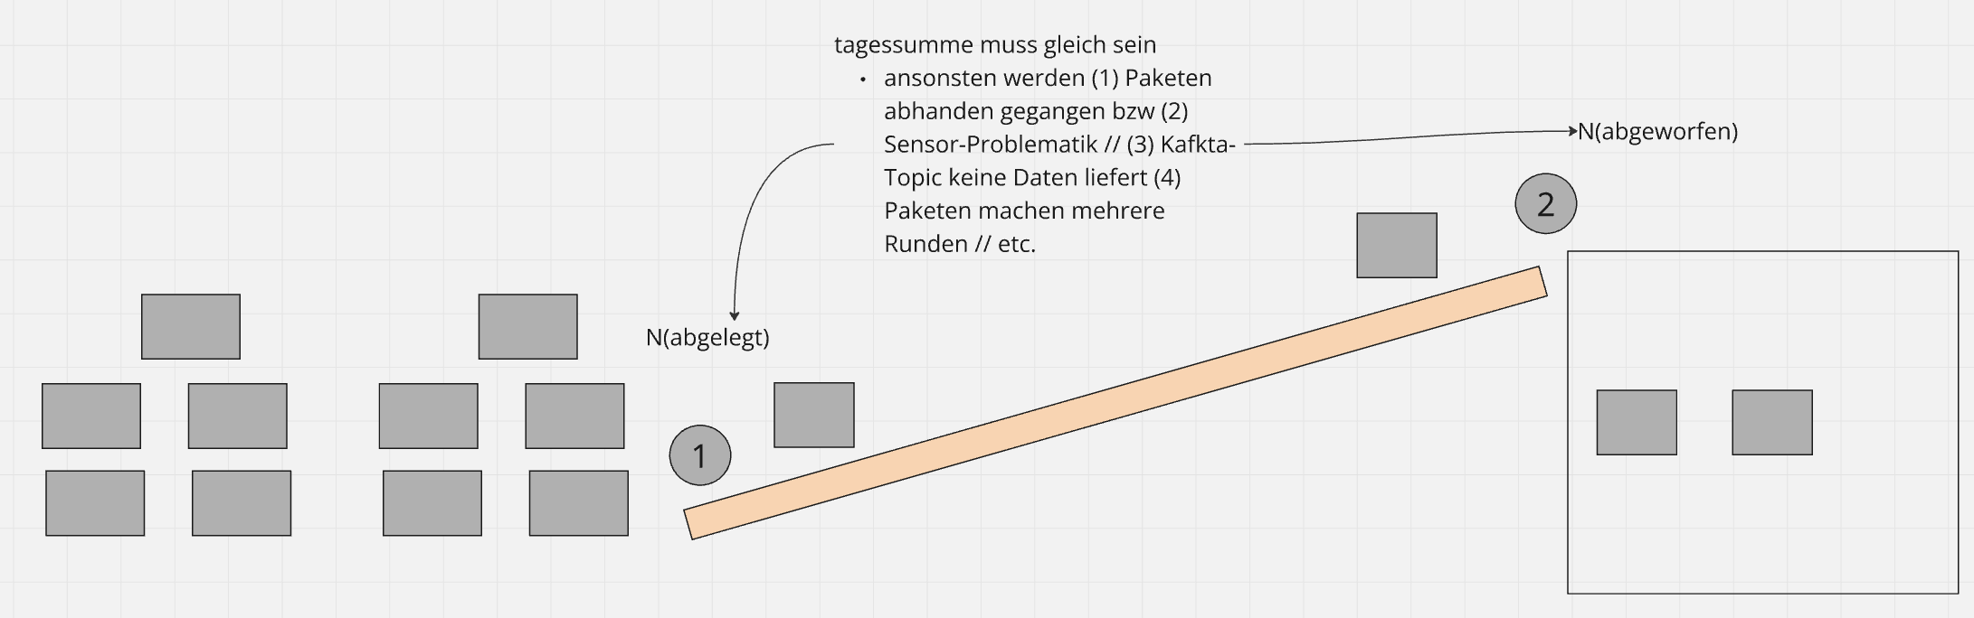
Figure 5.1.: A visualisation of the compared events submitted and discharged

The business is performing daily checks which are described in confluence. They documented their step by step checks, explaining from their perspective the usefulness describe some more what they realy
do...
Getting data daily from Splunk Entering them into Excel Then DSP loads them into a data model, and includes them together with AWS S3 data from dwh ls ops
this then allows business to check. for each sorting center the number of Discharged to the number of
submitted, then they further check... followed by then also checking dritt system
-> The business knows when a holiday is in one area... and therefore nobody working. and no data ->
They also know how to interpret values e.g. 5k to 10k or only 1-2k are as if nobody worked

Business Analysis, SAC and DSP
Since the current report documentation is performed by the business, the technical specifications are not described. However, the project team requires this information in order to rebuild the report and its warn-ings in an automated manner. Thus, the next step involves business analysis to identify the data sources of the report and their queries, including any transformations and aggregations. With this information, the project team can refine the queries by removing or adding details as required for the subsequent imple-mentation steps. The business analysis involves collaboration with both the business side, for information confirmation, and the IT side, for verification of the correct sources.

SVA DQM Report
The current report on SAC allows the Business to quickly see the differences in submitted and discharged parcels. In this report, the project team focused on the first step that will be replaced by an automated check and subsequent automatic reports of success and error.
The report is showing sorting data per day, from left to right the columns relevant for the upcomming work are.

▶ Column 1 - Date: The post date starting 06:00 and lasting till 05:59 the next day
▶ Column 2 - Abbreviation of the sorting centers location: e.g., CAD = Cadenazzo
▶ Column 3 (First red arrow) - num_submitted: Number of parcels put onto the sorter
▶ Column 6 (Second red arrow) - Num_discharged: Number of parcels that were removed from the sorter
▶ Column 7 (Third red arrow) - Diff_Discharged-Submitted: The difference between discharged and submitted parcels in a percentual figure

In this screenshot of the report on SAC, we can see some sample values 5.2. The picture shows multi-ple days during which the difference in Column 7 are between 0 and -0.002. These values are below the threshhold the business considers an issue.
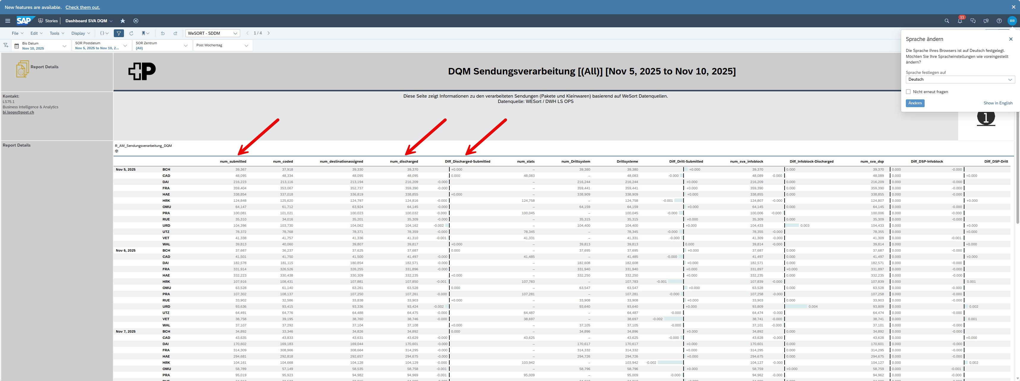
Figure 5.2.: SAC DQM Submitted discharged

To identify the data model related to the report, domain-specific knowledge was required. During a dedicated meeting, the business stakeholders outlined the steps needed to locate the linked data model. Administrative access is required in SAC in order to edit the data model in use. With the information pro-vided, the project team was able to continue with the model evaluation in DSP.

SVA DSP Datamodel
SAC and DSP are products that coexist. SAC requires a DSP data model to receive its data. SAP Datasphere allows the creation of data models based on which reports can be generated. The data models are used to connect different data sources by joining and aggregating them.
The screenshot below 5.3 shows the starting point of the Analytic Model – R_AM_Sendungsverarbeitung_DQM. This is the data model used in the SAC report in the previous Section 5.2. On the right-hand side, the mea-sures are listed, which can be used in SAC reports. The red arrow points to the components of the data model; it opens the data lineage view, which leads further into the model analysis. In the upcoming analy-sis, the focus is set on the three measures corresponding to the number of submitted, discharged, and the percentage difference between the two.

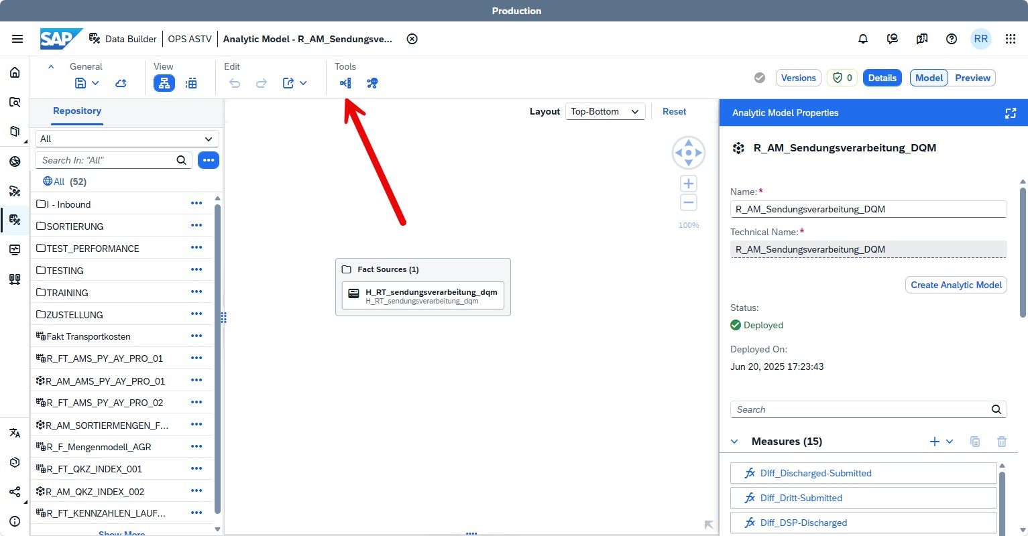
Figure 5.3.: DSP SVA DQM Board, Data Impact and Lineage Analysis

In the Impact and Lineage Analysis 5.4 for R_AM_Sendungsverarbeitung_DQM, each box represents a step in the creation of the summarising data model. Each box allows further progression down the data lineage and enables the user to open additional views.
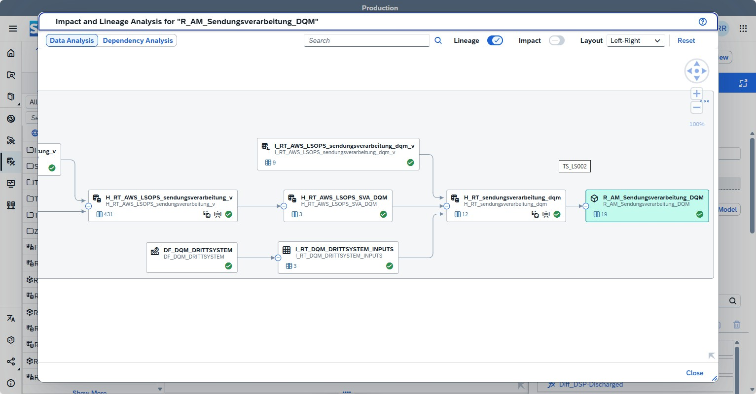
Figure 5.4.: DSP opened Lineage view

Selecting one item earlier 5.5 starts highlighting and shows in yellow all items that affect the selected item. For example, when selecting an item further to the left, the yellow highlight only shows the ones linked to those 5.6. This allows the easy identification of sources contributing to the current selection. While working down the tree, it is observed that the number of connected items decreases.

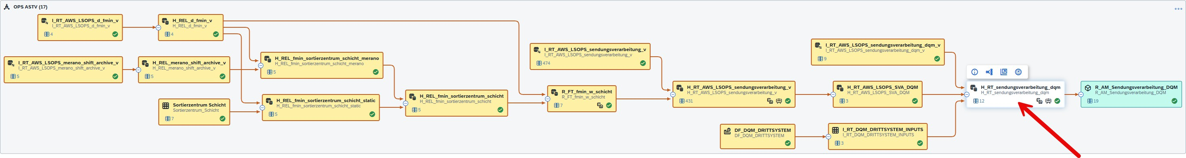
Figure 5.5.: DSP Lineage View with Selected Node

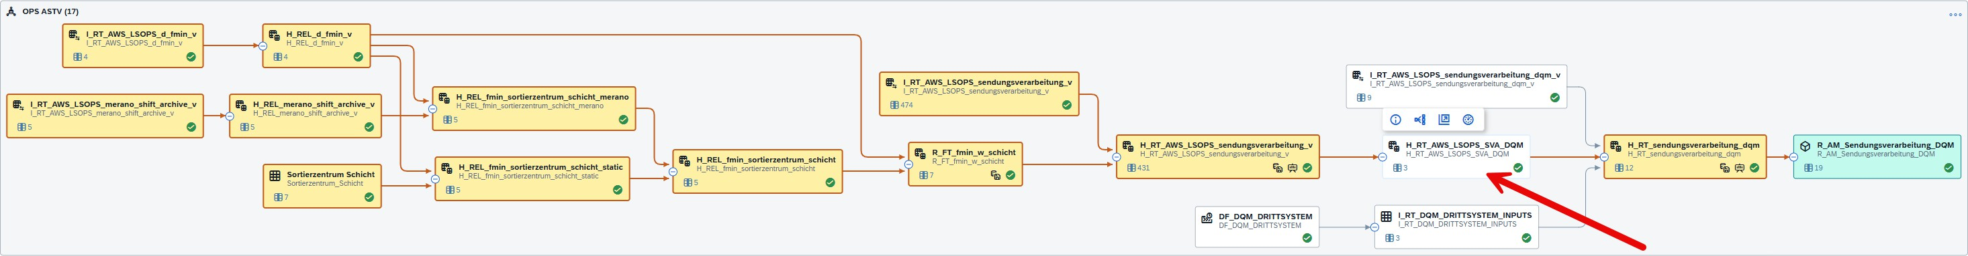

Figure 5.6.: DSP Lineage View with Reduced Source Dependencies

In the first view, the right-hand menu allows the selection of every measure the model provides 5.7.

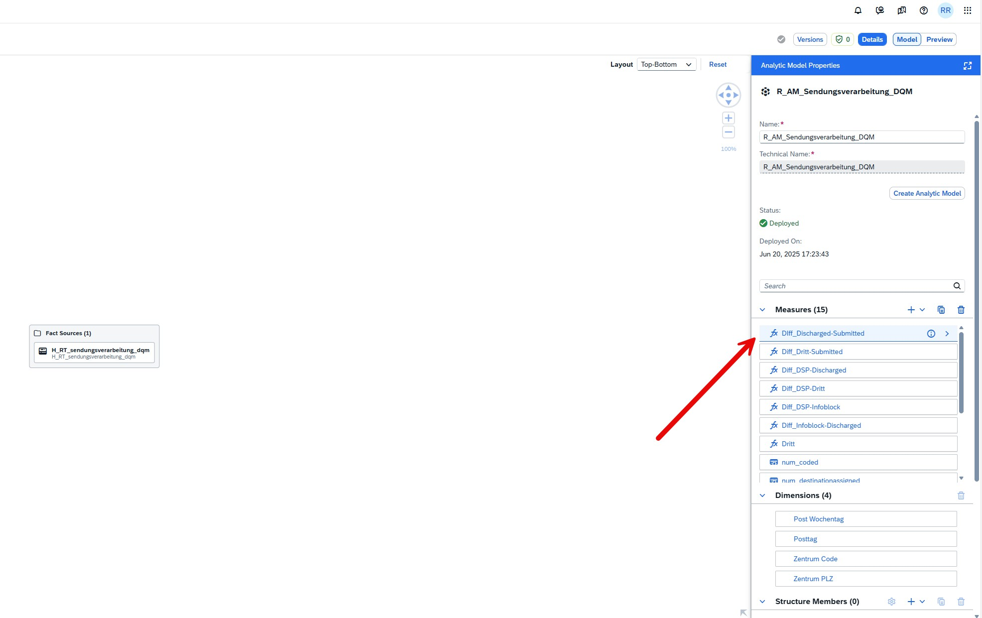
Figure 5.7.: DSP Lineage View Initial Overview

After clicking on a measure, the edit menu opens on the right side of the selected line 5.8.

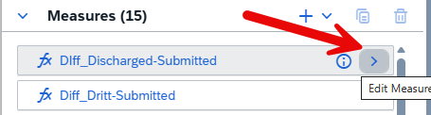
Figure 5.8.: DSP Data Source Overview

The edit menu shows how the measure is calculated. The selected measure is a percentage calculation, showing the difference between two other measures 5.9.

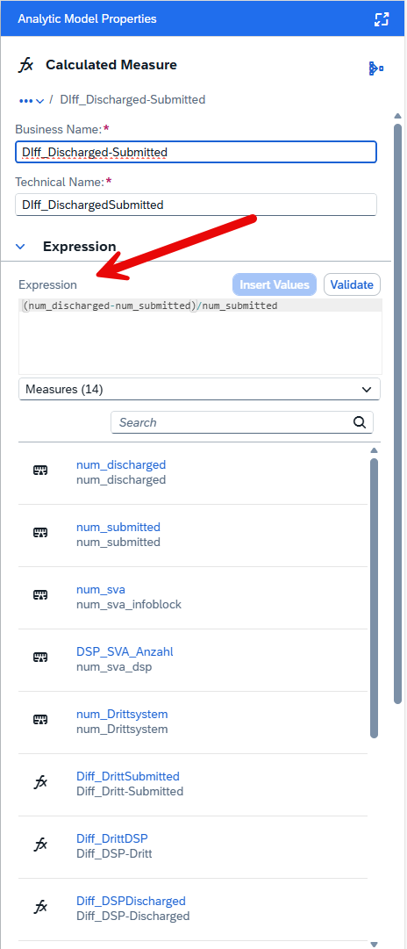
Figure 5.9.: DSP Join Configuration View

A click on the num_discharged measure shows its source, the aggregation, and the possible name change from technical name to business name 5.10.

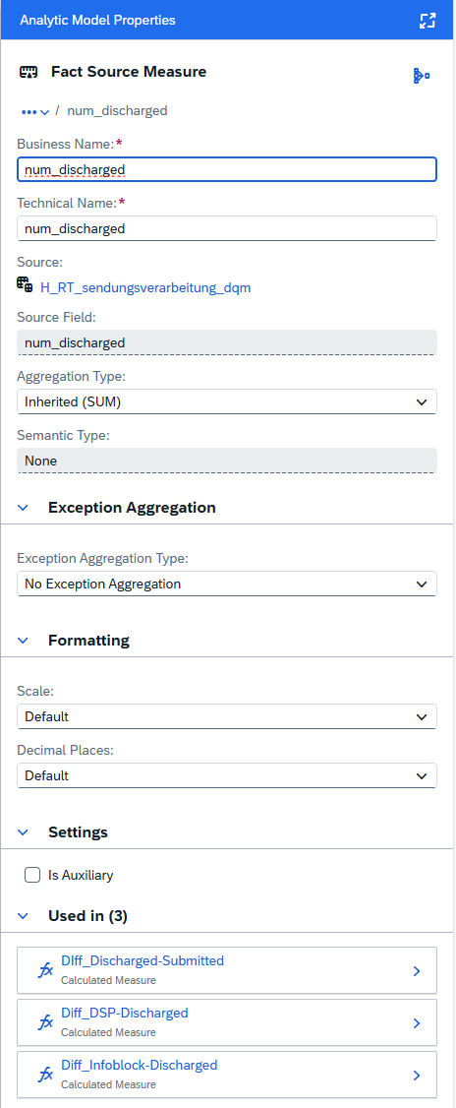
Figure 5.10.: DSP Aggregation Settings

The screenshot 5.11 shows the source, which can be clicked to jump into a view displaying this item directly in the data lineage view.

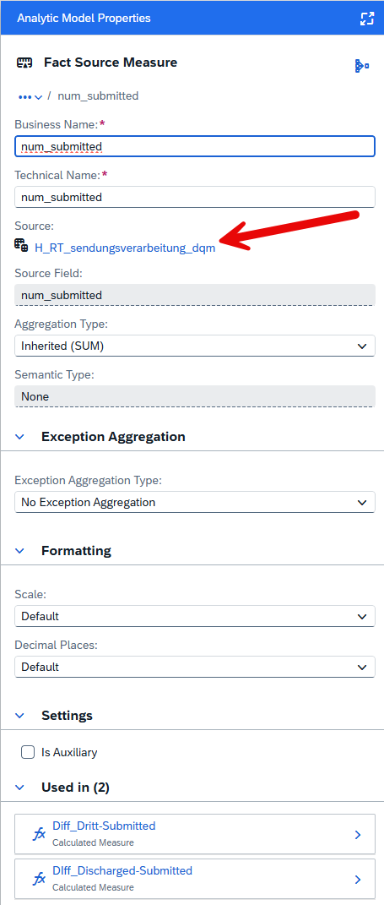
Figure 5.11.: DSP Preview of Transformed Data

This view allows the user to select the measures in the items shown on the right 5.12.

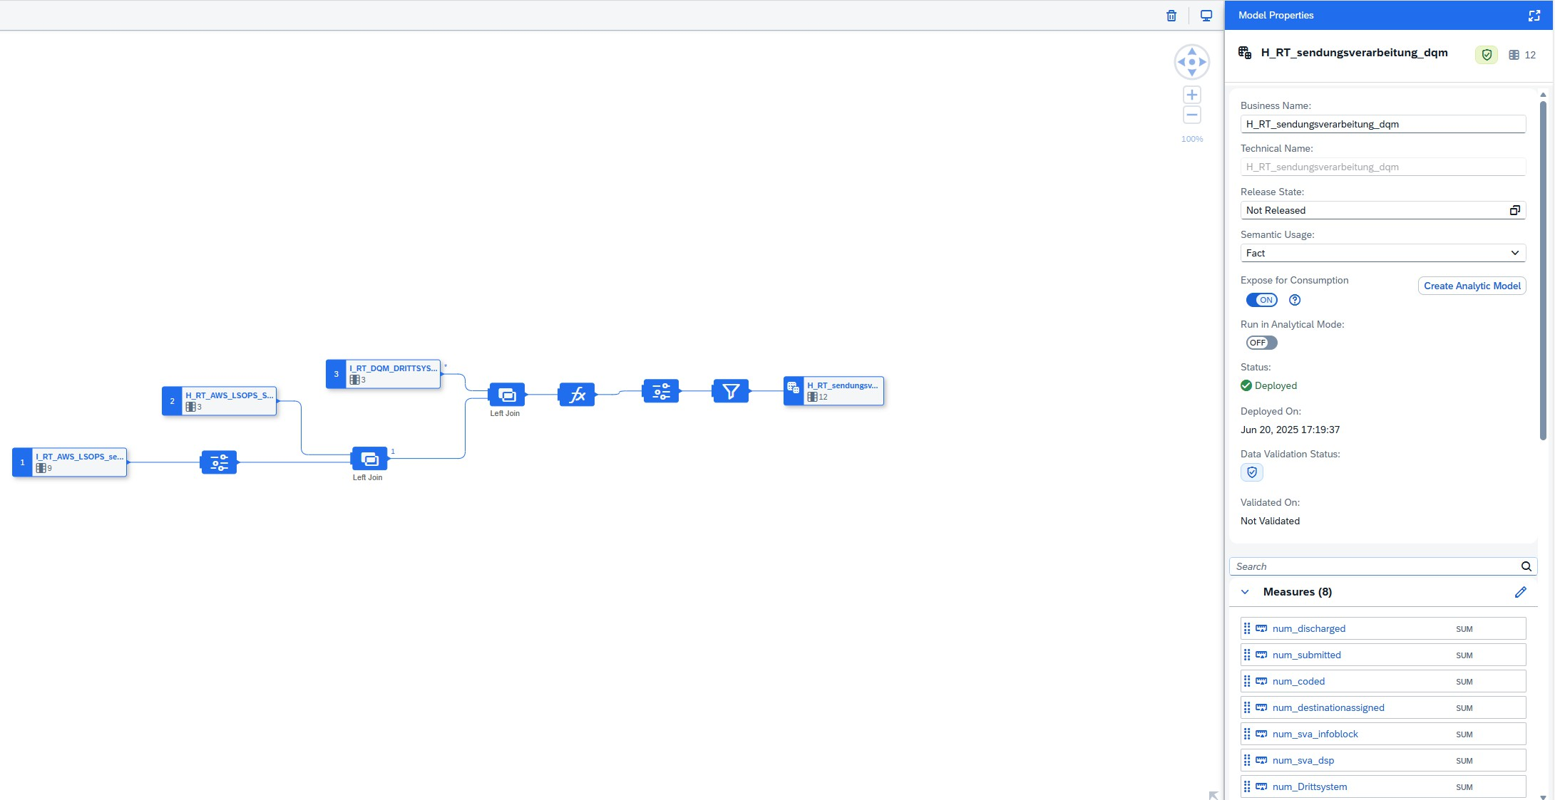
Figure 5.12.: DSP Final Output Node in Lineage View

Selecting a measure in the right-side menu again highlights the items connected to it in the main view window 5.13. In the case of num_submitted, it is observed that the only source is I_RT_AWS_LSOPS_se....

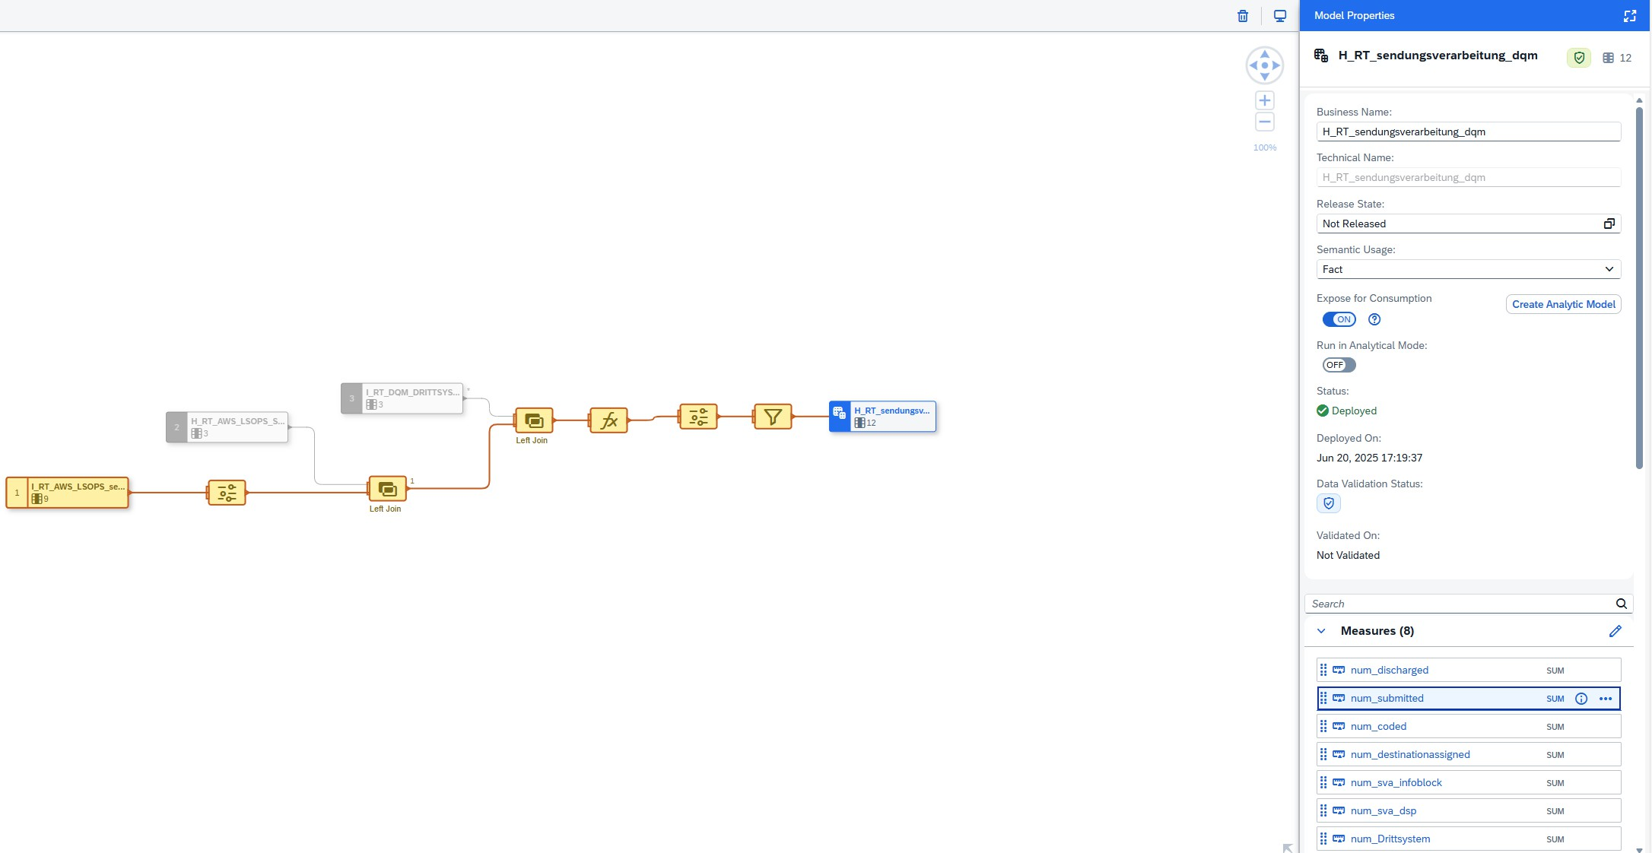
Figure 5.13.: DSP Data Model Detailed View

This is the query on AWS S3 using Athena, which is followed up in the next section. However, first a meeting with the business is held to update them on the current state and to obtain confirmation that the identified query is the correct one.

Business Analysis, AWS Athena
First, After identifying that only AWS Athena is the source for the submitted and discharged values, this information was confirmed with the business in a meeting. Second, the query was evaluated in more detail and described as needed. Third, it is then reduced to the esential values needed in the PoC.

Business Meeting
A business meeting was held, to update the PO on the current state of the project and next steps. Addition-ally, to get the confirmation that the analysed data sources match with the current used. Furthermore it was used to get further ideas from the business and ensure their vision of DQM is implemented.
The main goals of the meeting are:
▶ providing a status update of the project
▶ confirm data sources identified are correct
▶ inform stakeholder on next steps
▶ collect feedback and ideas from PO
The meetings documentation is in the apendix at B
Main result of the meeting was the confirmation that the found data source in AWS Athena matches. Next, the query was evaluated and then a documentation for the DQM team created explaining the use case.

Confluence Documentation
Once all relevant information to present this case to the DQM team was available, it had to be brought into a consumable state. Therefore, all information was documented in Confluence as a first use case. The use case was then presented to the DQM team B, which led to some updates in the documentation, e.g. adding the exact IAM roles required for access. Furthermore, to establish a generalisable rule and to ensure that the query only shows the required data, further investigation of the query had to be conducted.
..... TODO Screenshot of Confluence page Link to confluence documentation in Anex .....

Athena Query
AWS Athena allows to query data on AWS S3, which is the saving method for the big data the DWH LS OPS is creating reports on. The query used for DSP is in fact a database view. The views query can be obtained from Athena. The SQL view used for DSP and confirmed in business meeting was identified as only source for the sum of discharged and submitted. The following query is showing a sample of the data which is used in the SAC report.
SELECT *
FROM " reporting_lsops"." sendungsverarbeitung_dqm_v " LIMIT 10;
The query is selecting a subset of the result, using LIMIT 10. The data recieved First
Screenshot ..............................
Out of this query result, all values left of num_discharged and num_submitted are required for the iden-tification of the values, such as sorting centers and date. The values to the right of the two red arrows are suplements which are not needed for the PoC, and are therefore removed.
.............................. Second Screenshot ..............................
The first query is showing contents of a database view. Athena allows to display the query which is executed for this view. Next the full query which builds the view. It is combining multiple tables and aggregates their entries into sums per day and sorting centers. Due to the size of the full query, it has been moved to the appendix.

Hi Roland! I think putting the code into a box like this is brilliant and EXACTLY the right approach. I know you are using LaTeX, so that this:

SELECT *
FROM " the_longest"." query_ever_for_a_view " LIMIT 10;

Looks like this:

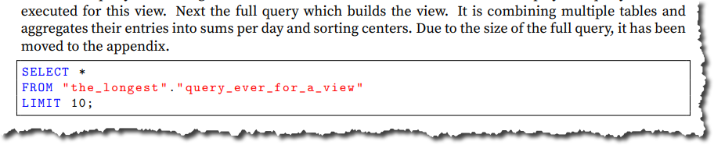

It’s not bad – but I think it could be improved a little bit – would it be possible for you – as a test – to print out this table, but then an identical copy where the font is reduced a tiny bit?

I know it is “Geschmacksache” but I think if the font were just a tiny bit smaller, it would someone look a bit better.

But . . . don’t go to any trouble. I don’t know LaTeX so if it is not easy, OK to leave “as is.”

Development to Get to Generalisable Rules
The development of the generalisable rule, which was the requirement of the DQM team to proceed, was the next task. The next step was therefore to remove the unnecessary aggregations from the full query. Then, the checks to be executed on the query results had to be brought into a generalisable format.

Shorter Query
To reduce the data queried for the MVP, many aggregations had to be removed. Only the aggregations for submitted and discharged were kept. Thus, the following query is much shorter.
WITH
key_to_plz AS (
SELECT ’ VET ’ location Key , ’ 196000 ’
SELECT ’ HRK ’ location Key , ’ 462150 ’ SELECT ’ CAD ’ location Key , ’ 659100 ’ SELECT ’ WAL ’ location Key , ’ 830000 ’ SELECT ’ HAE ’ location Key , ’ 462000 ’ SELECT ’ UTZ ’ location Key , ’ 720000 ’ SELECT ’ PRA ’ location Key , ’ 413400 ’ SELECT ’ FRA ’ location Key , ’ 852000 ’ SELECT ’ DAI’ location Key , ’ 131000 ’ SELECT ’ URD ’ location Key , ’ 892000 ’ SELECT ’ BCH ’ location Key , ’ 503000 ’ SELECT ’ RUE ’ location Key , ’ 815000 ’ SELECT ’ OMU ’ location Key , ’ 307100 ’
plz
plz plz plz plz plz plz plz plz plz plz plz plz
UNION ALL
UNION ALL UNION ALL UNION ALL UNION ALL UNION ALL UNION ALL UNION ALL UNION ALL UNION ALL UNION ALL UNION ALL
),

plz_to_key AS (
SELECT ’ 196000 ’ plz , ’ VET ’ location Key UNION ALL SELECT ’ 462150 ’ plz , ’ HRK ’ location Key UNION ALL SELECT ’ 659100 ’ plz , ’ CAD ’ location Key UNION ALL SELECT ’ 830470 ’ plz , ’ WAL ’ location Key UNION ALL

SELECT | ’ 830000 ’ | plz , | ’ WAL ’ | location Key | UNION ALL
SELECT | ’ 462000 ’ | plz , | ’ HAE ’ | location Key | UNION ALL
SELECT | ’ 720000 ’ | plz , | ’ UTZ ’ | location Key | UNION ALL
SELECT | ’ 413400 ’ | plz , | ’ PRA ’ | location Key | UNION ALL
SELECT | ’ 852000 ’ | plz , | ’ FRA ’ | location Key | UNION ALL
SELECT | ’ 131000 ’ | plz , | ’ DAI’ | location Key | UNION ALL
SELECT | ’ 892000 ’ | plz , | ’ URD ’ | location Key | UNION ALL
SELECT | ’ 503000 ’ | plz , | ’ BCH ’ | location Key | UNION ALL
SELECT | ’ 815000 ’ | plz , | ’ RUE ’ | location Key | UNION ALL
SELECT | ’ 307100 ’ | plz , | ’ OMU ’ | location Key
),
mp_discharged_raw AS ( SELECT
CAST ( DATE_ADD (’ hour ’, -6 ,
discharged . timestamp AT TIME ZONE ’ Europe / Zurich ’) AS DATE ) Posttag , discharged . sortingunit. location Key location Key ,
discharged . source Id source Id
FROM curated_lsops. mailpiece_discharged WHERE (1 = 1)
),

mp_discharged AS ( SELECT
Posttag , location Key , CASE
WHEN location Key IN (’ CAD ’,’ HRK ’,’ PRA ’,’ UTZ ’,’ VET ’,’ WAL ’)
AND NOT ( source Id LIKE ’w%’) AND NOT ( source Id LIKE ’W%’)
AND NOT ( TRIM ( BOTH FROM source Id ) = ’’) THEN 1 WHEN location Key IN (’ BCH ’,’ RUE ’,’ OMU ’) THEN 1
WHEN location Key IN (’ HAE ’,’ FRA ’,’ DAI’,’ URD ’) THEN 1 ELSE 0
END AS relevant_discharged FROM mp_discharged_raw
),

discharged_agg AS ( SELECT
Posttag , location Key ,
SUM ( relevant_discharged ) num_discharged FROM mp_discharged
GROUP BY 1 ,2
),

mp_submitted_raw AS ( SELECT
CAST ( DATE_ADD (’ hour ’, -6 ,
submitted . timestamp AT TIME ZONE ’ Europe / Zurich ’) AS DATE ) Posttag , submitted . sortingunit. location Key location Key , submitted . sorting Process sorting Process
FROM curated_lsops. mailpiece_submitted
),

mp_submitted AS ( SELECT
Posttag , location Key , CASE
WHEN location Key = ’ HRK ’ AND sorting Process = ’ AUTOMATIC ’ THEN 1 WHEN location Key = ’ VET ’ AND sorting Process = ’ AUTOMATIC ’ THEN 1

WHEN location Key = ’ CAD ’ AND sorting Process = ’ AUTOMATIC ’ | THEN | 1
WHEN location Key = ’ WAL ’ AND sorting Process = ’ AUTOMATIC ’ | THEN | 1
WHEN location Key = ’ UTZ ’ AND sorting Process = ’ AUTOMATIC ’ | THEN | 1
WHEN location Key = ’ PRA ’ AND sorting Process = ’ AUTOMATIC ’ | THEN | 1
WHEN location Key IN (’ BCH ’,’ RUE ’,’ OMU ’) THEN 1

Generalisable Rule
WHEN location Key IN (’ HAE ’,’ FRA ’,’ DAI’,’ URD ’)
ELSE 0
END AS relevant_submitted FROM mp_submitted_raw
THEN
1
),

submitted_agg AS ( SELECT
Posttag , location Key ,
SUM ( relevant_submitted ) num_submitted FROM mp_submitted
GROUP BY 1 ,2
)
SELECT
submitted . Posttag submitted . location Key key_to_plz . plz discharged . num_discharged submitted . num_submitted
FROM submitted_agg submitted INNER JOIN key_to_plz
ON submitted . location Key =
Posttag ,
location Key , plz , num_discharged ,
num_submitted
key_to_plz . location Key
INNER JOIN discharged_agg discharged
ON submitted . Posttag = discharged . Posttag
AND submitted . location Key = discharged . location Key
WHERE submitted . location Key IN (’ HRK ’,’ VET ’,’ HAE ’,’ CAD ’);
After reducing the query into a more concise structure, the rules to be executed on it had to be defined. The DQM team defined that the rules are to be as general as possible. Thus, the design of a more general rule started.
To move towards a more generalisable rule, the comparison steps requested in the check can be split into multiple individual ones. The starting point was the non-generalised check.

Pseudocode not generalised
▶ If submitted or discharged is at least 10 000:
- Compute percent difference between submitted and discharged.
- If difference is greater than 0.01, error.
- Else, do nothing.
▶ Else, do nothing.
To generalise this check, it can be deconstructed into two individual checks of a value against a threshold. This allows the definition of a threshold and the comparison type, as a threshold can be a minimum or maximum value.

Generalized Pseudocode Rule
▶ Compare A to the threshold T .
▶ Compare B to the threshold T .
▶ If either A or B meets the threshold:

- Compute the percentage difference between A and B.
- If the percentage difference exceeds the threshold X, raise an error.
- Otherwise, no action is taken.
In order to make the idea more explainable, the code was also visualised. First, in the form of a mind map. This connects the different checks and shows them as a check landscape.
.............................. Mindmap screen ..............................
Second as two individual rules showing that they can exist individually and be connected.
.............................. Query view ..............................
Next... Code the check

Results
todo, results of work... research + implementation

Analysis Targets
todo, did i reach targets

Review Lessons Learned
todo, personal review and lessons learned

The author hereby declares that this work is the result of their own independent effort and that no sources other than those listed in the bibliography and identified as references have been used. Glossary entries have been partially written by the author using public descriptions (e.g., product homepages), copied from Wikipedia, or generated by ChatGPT based on provided bullet points.

AI Use
In this project, generative AI was used occasionally for idea generation and for styling support, such as the creation of tables OpenAI 2025. The texts in this document were written by the author and corrected by ChatGPT while preserving the author’s writing style. The corrections were applied to ensure grammatical accuracy and to address limitations related to English not being the author’s native language.

“Miro Risk Mamagement Introduction” (Oct. 17, 2025). In: Selfstudy guide to risk management. URL: https:
//miro.com/app/board/uXjVPNj_5FQ=/.
OpenAI (2025). ChatGPT (June 2025 version). Large language model. Output used for table generation in Section ??. URL: https://chat.openai.com/.
Pas, Chiel van der (2025). “Long term availability of construction data with ddss”. In: URL: https://www. based.co.nl/en/news/long-term-availability-of-construction-data-with-ddss.
Post, Swiss (Oct. 26, 2025a). The Best Post Article. URL: https://www.post.ch/de/ueber- uns/aktuell/ 2023/175-jahre-alt-und-immer-noch-weltklasse.
- (Oct. 26, 2025b). The Swiss Post Homepage. URL: https://www.post.ch/en.
Wikipedia contributors (2025a). Data quality — Wikipedia, The Free Encyclopedia. [Online; accessed 17-October-2025]. URL: https://en.wikipedia.org/w/index.php?title=Data_quality&oldid=1316970467.
- (2025b). ISO 8000 — Wikipedia, The Free Encyclopedia. [Online; accessed 17-October-2025]. URL: https :
//en.wikipedia.org/w/index.php?title=ISO_8000&oldid=1316394786.
- (2025c). Swiss Post — Wikipedia, The Free Encyclopedia. [Online; accessed 26-October-2025]. URL: https:
//en.wikipedia.org/w/index.php?title=Swiss_Post&oldid=1311289869.

  - Project Risk Overview 6
  - Risk Matrix (Likelyhood × Severity) 8
  - Risk Strategy and Treatment Plan 8
  - Risk Strategy and Action Overview 9
  - SMART Goals Overview 14

  - A visualisation of the compared events submitted and discharged 19
  - SAC DQM Submitted discharged 20
  - DSP SVA DQM Board, Data Impact and Lineage Analysis 21
  - DSP opened Lineage view 21
  - DSP Lineage View with Selected Node 21
  - DSP Lineage View with Reduced Source Dependencies 22
  - DSP Lineage View Initial Overview 22
  - DSP Data Source Overview 22
  - DSP Join Configuration View 23
  - DSP Aggregation Settings 23
  - DSP Preview of Transformed Data 24
  - DSP Final Output Node in Lineage View 24
  - DSP Data Model Detailed View 25
  - Workparts distribution of the project 46

Abstract
This project aims to introduce a comprehensive framework for data quality and availability checks to en-sure that reports are delivered on time and with accurate data. By implementing these checks, we aim to increase user confidence in the reliability of the reports.

Introduction

Background
The non-operative reporting at Swiss Post is undergoing an on-premise to cloud migration. During this process, many reports are reviewed and rebuilt. The tool stack changes from the basic level of data storage up to the frontend tooling showing the reports. The migration of the reporting infrastructure goes hand in hand with a technological change of the underlying data provision methods. Old reports are cut off from their data pipelines, preventing clients from comparing new reports with the old ones when introduced.

Problem Statement
Users subjected to a change in technology need to be bolstered in their confidence regarding the new sys-tems. We, as providers, must ensure timely and accurate report delivery. Currently, reporting pipelines only have basic checks that alert IT when jobs fail. We lack checks for missing data or data outside expected ranges (e.g., workloads per hour, day, month). These checks are manually performed by the business, which holds the knowledge of expected workloads.

Objectives
We aim to achieve two goals for two main stakeholders:
For IT: Add infrastructure to reporting systems to provide warnings when data seems missing, enabling faster reactions and proactive communication.
For Business: Relieve manual checks and comparisons, freeing time for other migration tasks. Estimated time savings:
▶ 30–45 minutes/day
▶ 2.5–3.75 hours/week
▶ 10–15 hours/month
▶ 110–165 hours/year at 130 CHF/hour ≈ 18,000 CHF/year
This supports the main goal: improving data accuracy, ensuring timely report delivery, and increasing user confidence.

Methodology

Data Quality Checks
▶ Study best practices for data quality checks.
▶ Document current setup.

▶ Explore current pipeline tools and additional compatible tools.
▶ Test selected tools in nonproductive systems.
▶ Collaborate with Business to define checks (e.g., validation rules, consistency checks).
▶ Have Business test new checks before production deployment.

Data Availability Checks
▶ Study best practices for data availability checks.
▶ Document current setup.
▶ Explore current pipeline tools and additional compatible tools.
▶ Test selected tools in nonproductive systems.
▶ Collaborate with IT and Business to define checks (e.g., source availability at processing start).

Implementation Plan
▶ Develop solutions on development or external systems.
▶ Test with IT/Business before deploying to production.

Work Types

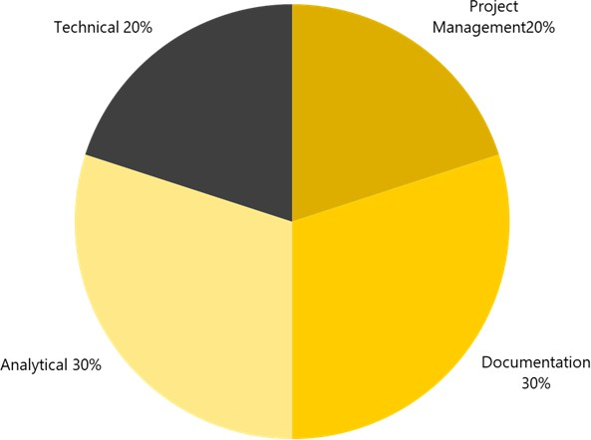

Figure A.1.: Workparts distribution of the project

The project consists of four main tasks:
- Project Management: Attend Scrum ceremonies and other meetings.
- Analytical Work: Analyze current situation, research solutions, and investigate state-of-the-art meth-ods.
- Documentation: Write project report, provide status updates, and describe results.
- Technical Work: Implement solutions iteratively based on analytical findings.

Goal
Success is measured in three layers:

Analysis
Document business needs before setting up the environment. Some requirements and rules are not yet documented.

Proof of Concept (PoC)
Implement a PoC with selected tools. If too complex, it may become a follow-up project. Deliver a smaller part if possible.

User Feedback
Gather feedback after each step (analysis, PoC). Document and adapt based on feedback.

NDA
Handling of this document and its results is governed by applicable legislation. Non-Swiss Post personnel may sign an NDA.

Meeting Summaries
This chapter contains a subsection of the meetings held during the course of this project. All relevant meetings are documented on the miro board, however their documentation is done on paper, sometimes including some summaries. While only the following meetings have been documented in detail.

Meeting Summary – Business Perspective on DQM
Meeting held on : 11.11.2025 Participants : PO, Project Staff First, an update on the research in SAC and DSP was given. It was confirmed that the identified reports and data models are correct. Then, the discussion around DQM started. From the business perspective, the checks are currently only on the most basic level, comparing the number of events on a daily basis. This comparison is only seen as a very basic entry point. The analysed values currently originate from only one infoblock.
As a possible next step, the values could also be compared to third-party systems or to different in-foblocks. The infoblock Processing of Shipments (Sendungsverarbeitung) could be compared to the in-foblock Plant Statistics (Anlagestatistik).
Further checks would include data verification:
▶ Verification that the values are of the expected type, e.g. dates in date columns
▶ Validation of ranges
An example of validation would be the comparison of parcel dimensions to expected dimensions. For instance, a length of 3 meters is not possible on the automatic sorter engines, or a weight above 30 kilo-grams exceeds the machine limits. These dimension values are provided by the DWS scanners, which are positioned directly on the sorter after the submit areas where parcels are added.
Furthermore, the current daily checks may be increased to hourly checks; however, for this it is neces-sary to know how long it takes for the data to be available in the DWH after the initial scanning event.

Meeting Summary – Data Quality Team Use Case Presentation (19.11.2025)
Meeting held on: 19.11.2025 Participants: DQM Team, Project Staff
A meeting with the DQM team was held on 19.11.2025. The goal was to present a first use case with business value. The meeting served to confirm whether the use case is valid for the DQM MVP setup.
The use case was presented based on Confluence documentation. First, an introduction explained the current situation for the business running manual checks. Then, the data source for the checks was pre-sented.
The meeting covered the following main points:
▶ Presentation of the use case
▶ Involved systems and data flow
▶ Possibility to run the check automatically and write data back to S3
▶ Real-time alarming is out of scope for the MVP of the DQM team
The meeting was initially scheduled for an earlier date but was postponed. The meeting confirmed the feasibility of the use case but pointed out that the checks need to be generalised so that rules created for these checks can be reused in further checks.

Risk Monitoring
B. Meeting Summaries
50
The risk Monitoring files are linked in the following tables. First monitoring performed on 14.11.2025, following performed in same fashion.

Number | Risk | Occured | Detail | Why | Measures taken | Measure date
1 | Unclear question | No |  | Measures taken
2 | Unclear goals | No |  | Team Members,  PO in team
3 | Insufficient expertise | Yes | At usage of SAC  and DSP | Unknown tools | Asked team for  help, received  help | 10.11.2025
4 | Underestimated time/-  effort | No
5 | Other study projects | Yes | Reviewing takes  time | retaken 2 classes | Split of time | 11.10.2025
6 | Work projects | Yes | Efforts and inci-  dents | less than 50% of  expected time  available for  study project | None
7 | Procrastination | Yes | Postponing work-  ing on things | Reality | Learning on  some evenings | 19.10.2025
8 | Unavailability of main  project staff (e.g., ill-  ness) | No
9 | Unavailability of advi-  sor (e.g., illness, acci-  dent) | No
10 | Software Version / Li-  brary / Dependency | No
11 | Hardware is damaged | No
12 | Data related | No
13 | Not reproducible work | No
14 | Plagiarism or wrong ci-  tation | No
15 | Copyright | No

51
Number | Risk | Occured | Detail | Why | Measures taken | Measure date
16 | Bad communication  with stakeholder or  advisor | No
17 | Insufficient exchange  with external partners | No
18 | Unforeseen familiar  crisis | No
19 | General force majeure | No

