**Machine Learning Assignment for Internship**

**@**

**Nobbas Technologies**

Contents

[**Instructions 3**](https://docs.google.com/document/d/1Bbc79d-s1e_9iXihAeqOGLtEecHdLrzpRxFwY3Qcguc/edit#heading=h.cipwvwtmzvbj)

[**Assignment 4**](https://docs.google.com/document/d/1Bbc79d-s1e_9iXihAeqOGLtEecHdLrzpRxFwY3Qcguc/edit#heading=h.o7395gvuqiuo)

[Problem Statement 4](https://docs.google.com/document/d/1Bbc79d-s1e_9iXihAeqOGLtEecHdLrzpRxFwY3Qcguc/edit#heading=h.pbpisvvznt76)

[Solution You Need to Give 4](https://docs.google.com/document/d/1Bbc79d-s1e_9iXihAeqOGLtEecHdLrzpRxFwY3Qcguc/edit#heading=h.cs4j30a9g94)

[Plus Points For 4](https://docs.google.com/document/d/1Bbc79d-s1e_9iXihAeqOGLtEecHdLrzpRxFwY3Qcguc/edit#heading=h.u7trt15xc386)

[Info about the data set provided 4](https://docs.google.com/document/d/1Bbc79d-s1e_9iXihAeqOGLtEecHdLrzpRxFwY3Qcguc/edit#heading=h.427lsagg3xe)

[Link to DataSet 4](https://docs.google.com/document/d/1Bbc79d-s1e_9iXihAeqOGLtEecHdLrzpRxFwY3Qcguc/edit#heading=h.wj1dsl2b6uh9)

[**Submission Guide 5**](https://docs.google.com/document/d/1Bbc79d-s1e_9iXihAeqOGLtEecHdLrzpRxFwY3Qcguc/edit#heading=h.ombc9q15htwo)

[Pre-requisites for submission 5](https://docs.google.com/document/d/1Bbc79d-s1e_9iXihAeqOGLtEecHdLrzpRxFwY3Qcguc/edit#heading=h.hi9o5392nl57)

[What to submit and How? 5](https://docs.google.com/document/d/1Bbc79d-s1e_9iXihAeqOGLtEecHdLrzpRxFwY3Qcguc/edit#heading=h.bttxqufzenvd)

[**Answer To Some Questions You May Have 6**](https://docs.google.com/document/d/1Bbc79d-s1e_9iXihAeqOGLtEecHdLrzpRxFwY3Qcguc/edit#heading=h.s364nu87jjbn)



# **Instructions**

* **Deadline for submission of the assignment is 11th March 2019 9 am IST.**
* You are free to choose any technology or tools for your assignment.
* You are free to take help of online resources, provided you share the reference links in your submission.
* We are strictly against plagiarism and your code would go through our plagiarism checker and copy pasted code without the references would get your application rejected right away without even a look at your code.
* Your assignment is to be submitted through GitHub. Ensure to have proper commits marking your progress with the assignment.
* Make sure your code is clean and well documented. If you have referred to some blog for help with your code, do share the link in your comments.
* Follow the submission guide to submit your assignment for review. We’ll be in touch as soon as we are done with reviewing your submissions and provide you with the next steps in the selection process.
* In case you are unable to complete all parts of the assignment, you can still submit your assignment with whatever you were able to get done. We will acknowledge your efforts and the process you followed to solve the given problem.
* Focus on quality rather than quantity.

# **Assignment**

### Problem Statement

Probe the given data set to figure out:

1. What kind of classifications would help a real estate platform like Nobbas irrespective of the data that has been provided to you? Categorize these as following:
   1. Mark a classification “Achievable” if it can be implemented using the provided data.
   2. Mark it as “Unachievable” if data provided is insufficient.

You would need the generated list from the question above to answer the following questions:

1. Answer the following for a **maximum** of 3 classifications from the Achievable category:
   1. Program them and add it to your GitHub repo.
2. Answer the following for a **maximum** of 3 classifications from the Unachievable category:
   1. What data would you need to achieve the classification?
   2. How would you implement it if you get the data? (Brief answer. Not more than 5 lines)

### Info about the data set provided

* You will have 3 CSV files in the zip that you can download from the link given below. All the data in different CSV files are interrelated in a particular fashion.
* Information on data in CSV files
  + CSV 1: it contains all the details for a particular property with the count for the number of images available for that property. Column **id** in this CSV is used to relate data in other CSV files.
  + CSV 2: it contains id for property and number of times that property has been marked as favorite.
  + CSV 3: it contains if for property and number of collab projects that contain that property.

### Link to DataSet

# [**https://drive.google.com/drive/folders/1oR9FA8jKCeasmVVCsavPjJWCxgaLfnCz?usp=sharing**](https://drive.google.com/drive/folders/1oR9FA8jKCeasmVVCsavPjJWCxgaLfnCz?usp=sharing)

# **Submission Guide**

* Everything used for your assignment (data, code, documentation etc) should be on a public GitHub repository. Make proper commits to describe your progress with the assignment. Do not push everything in just one commit, we want to see your approach via commit history. Don’t spend too much time making it look perfect.
* When you are done with the assignment, create a screencast to show your process and results from it. Upload your screencast to any cloud service and share its publicly accessible link.

### What to submit and How?

For your submission, send us an email at **hiring**[**@nobbas.com**](mailto:admin@nobbas.com) with the subject as **NB_ML_Assignment Submission -- Internship 2019 -- {{Your Name}}**

Your email should comprise of the following details:

* Link to your GitHub repository you created for assignment.
* Link to your screencast
* Your skype id
* List of machine learning tools you have experience with
* If you are currently a student when will you finish your education?

Your drafted email should look somewhat like this:

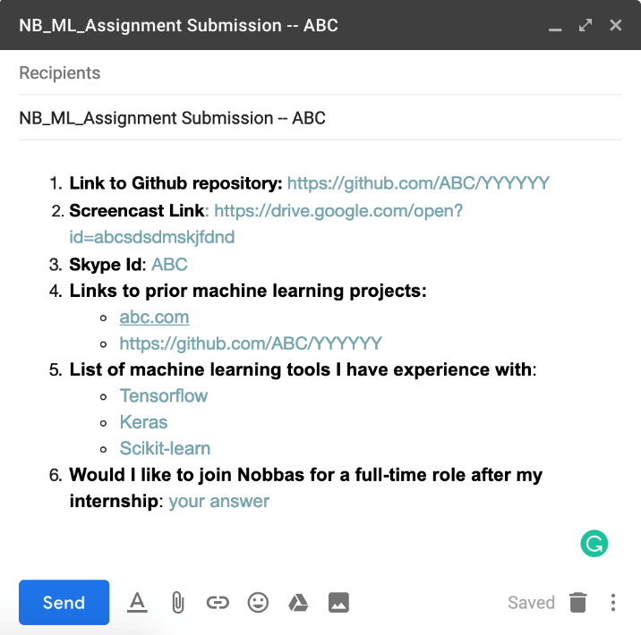

# **Answer To Some Questions You May Have**

Q: **What is the process for selection in this internship?**

A: You do the assignment mentioned in this document and submit it in the format we specified. Once we are done with reviewing all submissions, you will be contacted if your submission is selected for the follow-up interview. Date and time for the interview will be provided when you are contacted. The Interview will be on skype, so you’ll need to have a decent internet connection.

Q: **What if I don’t have a decent internet connection for the interview?**

A: No need to worry. If you have a problem with your internet connection, you are most welcome to our office in Gurgaon for a better internet connection. In case you need to come to Gurgaon office, you have to inform us beforehand so that we do expect your arrival.

Q: **Is there a possibility to join Nobbas as a full-time employee after the completion of my internship?**

A: We cannot commit anything right away but it is based on your performance during your internship and availability of an open position at the end of your internship

Q: **I don’t have any prior experience in live projects of machine learning. Can I still be offered an internship at Nobbas?**

A: Yes, of course. To offer you an internship role, we expect that you have knowledge of at least one machine learning tool, worked on at least one dummy project in which you have tried to solve a real problem.

Q: **Will there be any stipend offered during my internship?**

A: Yes, there will be a stipend of Rs 15000/month.

Q: **Where will I be working from?**

A: You will be working out of our office in WeWork, Platina Tower, Gurgaon, HR, India. It is located just next to Sikanderpur Metro Station. So you have the best possible access to the office. You’ll have access to all WeWork’s amenities and events during your internship. Tea, Coffee, Beer, and other refreshments provided in WeWork are on the house.

Q: **What will be my working hours, during the internship?**

A: Ideal working hours would be **4 pm to 1 am (IST)** in order to achieve time overlap between the North American time zone(EST) and IST. And of course, it is **5 days working**, so you have your Saturdays and Sundays Off.

Q: **Do I need to wear formals?**

A: Not at all. We want you to be relaxed. Wear shorts and a t-shirt if you want to. It is all casuals on all working days. If you want to wear formals, we have no issues, it's all up to you what to wear to the office.

Q: **Will I get a device to use from the company, during the internship?**

A: No, its BYOD type of internship. So make sure you have your own laptop to work on. The company will provide you, an extra monitor, if needed. At a later stage, we may get you a device if you are offered a full-time role at Nobbas.