پناه (Panah) — پلتفرم مدیریت بحران و هماهنگی داوطلبان
Volunteer Crisis Management Platform
Project Charter
Formal authorization to execute the Panah platform delivery

Document ID | PANAH-PC-001
Version | 1.0.0
Date | 2026-07-16
Status | Approved for Delivery
Classification | Internal — Enterprise / Government Deliverable
Vendor / Author | Investica Group
Standards Alignment | IEEE / ISO aligned

This document is derived from the production source code, configuration, and operational architecture of the Panah platform.

1. Document Control

1.1 Revision History
Version | Date | Author | Description
1.0.0 | 2026-07-16 | Documentation Team | Initial baseline from source-of-truth codebase

1.2 Approvals
Role | Name | Signature | Date
Project Sponsor | Investica Leadership
Technical Architect | Platform Architecture
Quality Assurance | QA Lead

2. Table of Contents

Note: In Microsoft Word, right-click the TOC field and select “Update Field” to refresh page numbers after opening.

3. Purpose
This Project Charter authorizes delivery of the Volunteer Crisis Management Platform (Panah / پناه), an enterprise web system for coordinating volunteers during disasters through missions, applications, assignments, reports, tickets, and notifications.

4. Business Need
Emergency response organizations require a single source of truth to register volunteers, publish field missions, review applications, assign people, track progress, and audit actions. Manual spreadsheets and ad-hoc messaging do not scale under crisis load.

5. Project Description
- Web application with React SPA and Django REST API
- Role-based access: Admin, Coordinator, Volunteer
- Disaster → Mission → Application → Assignment → Report lifecycle
- In-app notifications, tickets/messaging, audit logging
- Dockerized deployment with PostgreSQL, Redis, Nginx, Celery

6. Objectives
- Enable volunteer self-registration with skills and active status
- Enable staff to create, publish, and operate missions
- Enable volunteers to apply and complete assignments
- Provide coordinator-scoped operational dashboards
- Ensure security via JWT, RBAC, Argon2, and audit trails

7. High-Level Scope
In Scope | Out of Scope (v1)
Mission & volunteer operations | Native mobile apps
Tickets & notifications | GIS routing / fleet logistics
Reports & finished mission summaries | Multi-tenant SaaS billing
Admin RBAC & audit | Offline-first field sync

8. Key Stakeholders
Stakeholder | Interest | Influence
Investica Group / Sponsor | Delivery & brand | High
Platform Admin | Governance & security | High
Coordinators | Field operations | High
Volunteers | Participation & clarity | Medium
DevOps / Engineering | Stability & maintainability | High

9. Milestones
Milestone | Outcome
M1 Architecture baseline | Stack, RBAC, Docker compose
M2 Core domain | Disasters, missions, applications
M3 Collaboration | Tickets, notifications, reports
M4 Role UX | Coordinator dashboard & mine filters
M5 Hardening | Docs, seeds, ops runbooks

10. Budget & Authority
Delivery is owned by Investica Group. The Project Sponsor approves scope changes. Technical authority resides with the Solution Architect and Engineering Lead.

11. Constraints & Assumptions
- Persian RTL UI is a primary UX requirement
- PostgreSQL and Redis are mandatory infrastructure dependencies
- Public volunteer registration is allowed without prior admin approval (auto-active)
- Coordinator dashboards are scoped to assigned missions
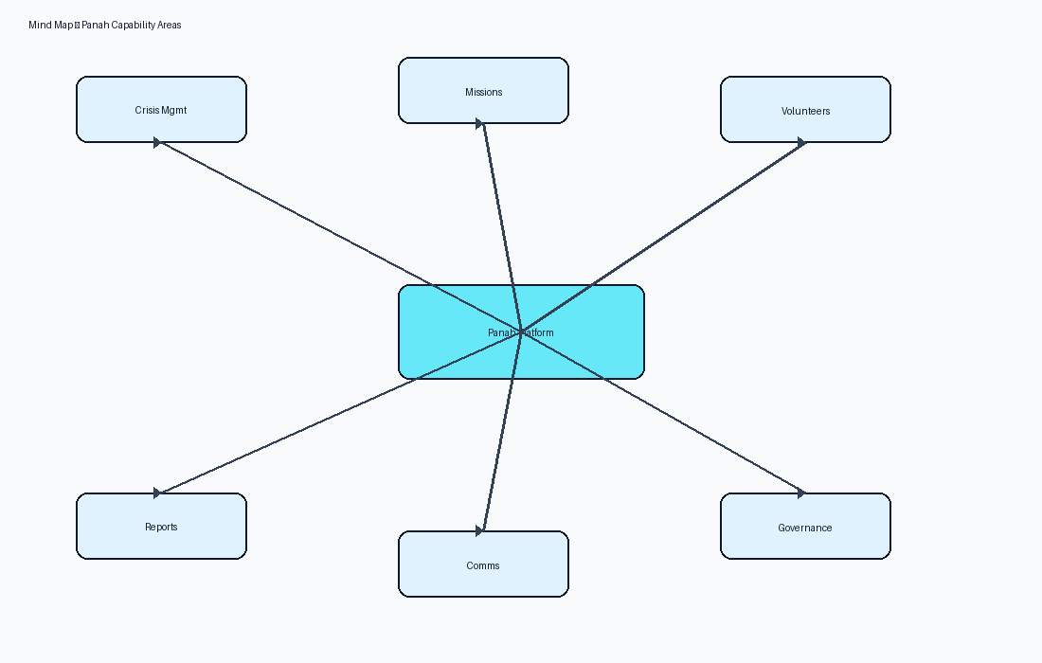
Figure 1 — Capability mind map for Panah

12. References
- IEEE 29148:2018 — Systems and software engineering — Life cycle processes — Requirements engineering
- ISO/IEC/IEEE 42010:2022 — Software, systems and enterprise — Architecture description
- UML 2.5 — Unified Modeling Language
- BPMN 2.0 — Business Process Model and Notation
- C4 Model — Context, Containers, Components, Code (Simon Brown)
- OWASP ASVS 4.0 — Application Security Verification Standard
- OWASP Top 10 (2021)
- REST API Design Rulebook / OpenAPI 3 Specification
- Django 5.2 Documentation / Django REST Framework
- React 19 Documentation / Material UI v6
- PostgreSQL 17 Documentation
- Panah Platform Source Code Repository (current workspace)
- Panah README.md and docker-compose.yml

