پناه (Panah) — پلتفرم مدیریت بحران و هماهنگی داوطلبان
Volunteer Crisis Management Platform
Software Requirements Specification (SRS)

Document ID | PANAH-SRS-001
Version | 1.0.0
Date | 2026-07-16
Status | Approved for Delivery
Classification | Internal — Enterprise / Government Deliverable
Vendor / Author | Investica Group
Standards Alignment | IEEE 29148:2018

This document is derived from the production source code, configuration, and operational architecture of the Panah platform.

1. Document Control

1.1 Revision History
Version | Date | Author | Description
1.0.0 | 2026-07-16 | Documentation Team | Initial baseline from source-of-truth codebase

1.2 Approvals
Role | Name | Signature | Date
Project Sponsor | Investica Leadership
Technical Architect | Platform Architecture
Quality Assurance | QA Lead

2. Table of Contents

Note: In Microsoft Word, right-click the TOC field and select “Update Field” to refresh page numbers after opening.

3. Introduction

3.1 Purpose
This SRS specifies functional and non-functional requirements for Panah derived from implemented behavior.

3.2 Scope
Applies to web clients, REST APIs, background workers, and supporting infrastructure described in docker-compose.

3.3 Definitions
Term | Definition
Mission | Operational task linked to a disaster
Application | Volunteer request to join a mission
Assignment | Approved binding of volunteer to mission
Coordinator | Staff user owning mission operations

4. Overall Description

4.1 Product Perspective
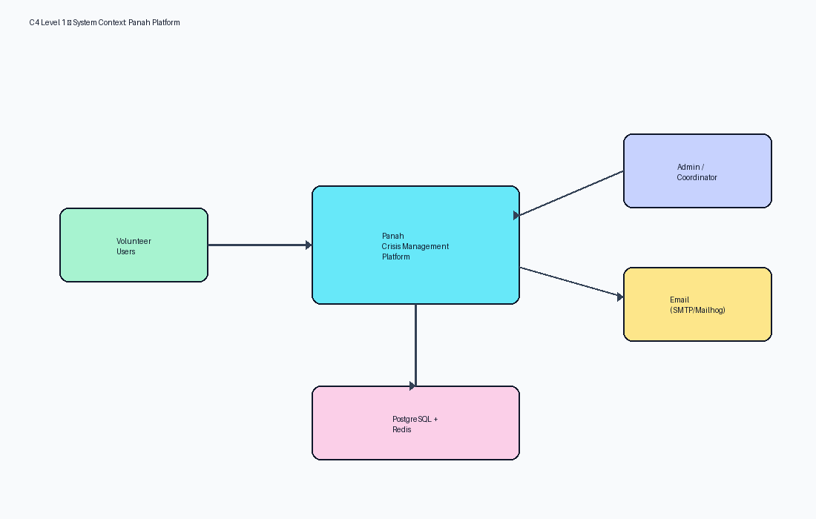
Figure 1 — Product context

4.2 User Characteristics
- Admins are technical operators
- Coordinators are operational staff
- Volunteers are field participants

5. Functional Requirements Summary
ID | Requirement | Priority
FR-AUTH-01 | System shall authenticate users via email/password JWT | Must
FR-VOL-01 | System shall allow public volunteer registration | Must
FR-DIS-01 | Staff shall create and update disasters | Must
FR-MIS-01 | Staff shall manage mission lifecycle states | Must
FR-MIS-02 | Volunteers shall apply to eligible missions | Must
FR-MIS-03 | Staff shall approve/reject/waitlist applications | Must
FR-ASG-01 | Volunteers shall accept/decline/check-in/complete assignments | Must
FR-TKT-01 | Users shall create tickets; staff may message users | Must
FR-NOT-01 | System shall create in-app notifications for key events | Must
FR-AUD-01 | System shall record audit events for sensitive actions | Must
FR-DAS-01 | Dashboards shall reflect role scope (admin/coordinator/volunteer) | Must

6. Non-Functional Requirements Summary
ID | Category | Requirement
NFR-SEC-01 | Security | Passwords hashed with Argon2; JWT blacklisting in Redis
NFR-PERF-01 | Performance | Dashboard stats cache TTL ~30s
NFR-AVL-01 | Availability | Compose healthchecks on postgres/redis/backend/nginx
NFR-USE-01 | Usability | Persian RTL primary interface
NFR-MAI-01 | Maintainability | Layered Django apps + typed React frontend

7. References
- IEEE 29148:2018 — Systems and software engineering — Life cycle processes — Requirements engineering
- ISO/IEC/IEEE 42010:2022 — Software, systems and enterprise — Architecture description
- UML 2.5 — Unified Modeling Language
- BPMN 2.0 — Business Process Model and Notation
- C4 Model — Context, Containers, Components, Code (Simon Brown)
- OWASP ASVS 4.0 — Application Security Verification Standard
- OWASP Top 10 (2021)
- REST API Design Rulebook / OpenAPI 3 Specification
- Django 5.2 Documentation / Django REST Framework
- React 19 Documentation / Material UI v6
- PostgreSQL 17 Documentation
- Panah Platform Source Code Repository (current workspace)
- Panah README.md and docker-compose.yml

