پناه (Panah) — پلتفرم مدیریت بحران و هماهنگی داوطلبان
Volunteer Crisis Management Platform
Use Cases

Document ID | PANAH-UC-001
Version | 1.0.0
Date | 2026-07-16
Status | Approved for Delivery
Classification | Internal — Enterprise / Government Deliverable
Vendor / Author | Investica Group
Standards Alignment | IEEE / ISO aligned

This document is derived from the production source code, configuration, and operational architecture of the Panah platform.

1. Document Control

1.1 Revision History
Version | Date | Author | Description
1.0.0 | 2026-07-16 | Documentation Team | Initial baseline from source-of-truth codebase

1.2 Approvals
Role | Name | Signature | Date
Project Sponsor | Investica Leadership
Technical Architect | Platform Architecture
Quality Assurance | QA Lead

2. Table of Contents

Note: In Microsoft Word, right-click the TOC field and select “Update Field” to refresh page numbers after opening.

3. UC-01 Register Volunteer
Actor: Guest. Precondition: unique email/national ID. Main flow: submit form → validate → create user/profile/skills → notify.

4. UC-02 Apply to Mission
Actor: Volunteer. Preconditions: published/visible/allow. Flow: open mission → apply → submitted.

5. UC-03 Review Application
Actor: Coordinator/Admin. Flow: inbox → approve/waitlist/reject → notify volunteer.
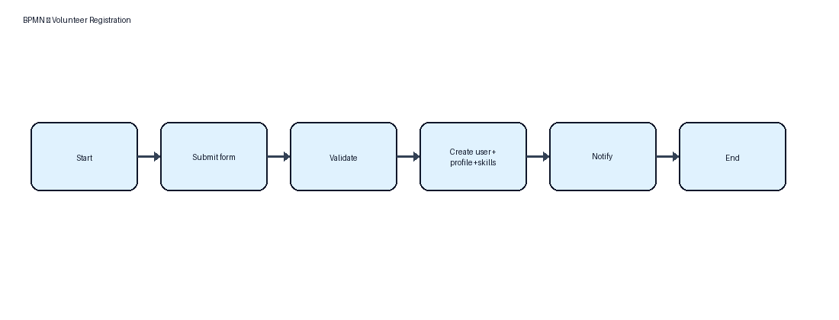
Figure 1 — Registration process
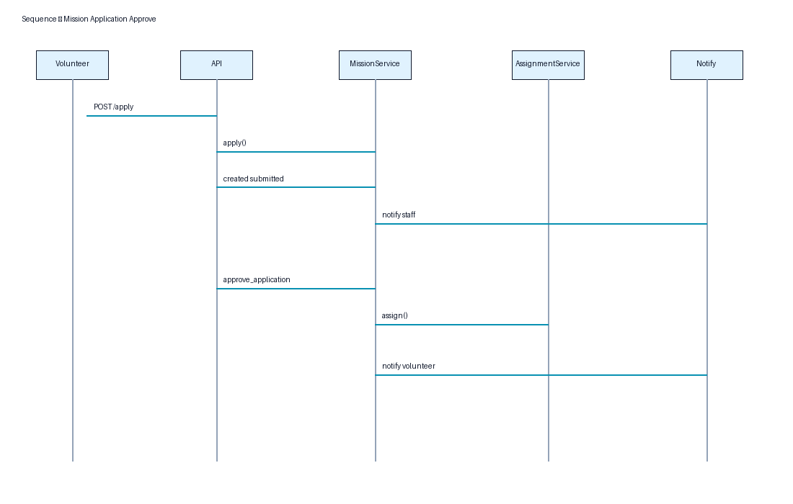
Figure 2 — Apply/approve sequence

6. References
- IEEE 29148:2018 — Systems and software engineering — Life cycle processes — Requirements engineering
- ISO/IEC/IEEE 42010:2022 — Software, systems and enterprise — Architecture description
- UML 2.5 — Unified Modeling Language
- BPMN 2.0 — Business Process Model and Notation
- C4 Model — Context, Containers, Components, Code (Simon Brown)
- OWASP ASVS 4.0 — Application Security Verification Standard
- OWASP Top 10 (2021)
- REST API Design Rulebook / OpenAPI 3 Specification
- Django 5.2 Documentation / Django REST Framework
- React 19 Documentation / Material UI v6
- PostgreSQL 17 Documentation
- Panah Platform Source Code Repository (current workspace)
- Panah README.md and docker-compose.yml

