پناه (Panah) — پلتفرم مدیریت بحران و هماهنگی داوطلبان
Volunteer Crisis Management Platform
Software Architecture Document

Document ID | PANAH-SAD-ARCH-001
Version | 1.0.0
Date | 2026-07-16
Status | Approved for Delivery
Classification | Internal — Enterprise / Government Deliverable
Vendor / Author | Investica Group
Standards Alignment | ISO/IEC/IEEE 42010 + C4 Model

This document is derived from the production source code, configuration, and operational architecture of the Panah platform.

1. Document Control

1.1 Revision History
Version | Date | Author | Description
1.0.0 | 2026-07-16 | Documentation Team | Initial baseline from source-of-truth codebase

1.2 Approvals
Role | Name | Signature | Date
Project Sponsor | Investica Leadership
Technical Architect | Platform Architecture
Quality Assurance | QA Lead

2. Table of Contents

Note: In Microsoft Word, right-click the TOC field and select “Update Field” to refresh page numbers after opening.

3. Architecture Overview
Panah follows a modular monolith backend (Django apps) with a decoupled SPA frontend, accessed through Nginx, persisted in PostgreSQL, and coordinated with Redis and Celery.

4. C4 Context
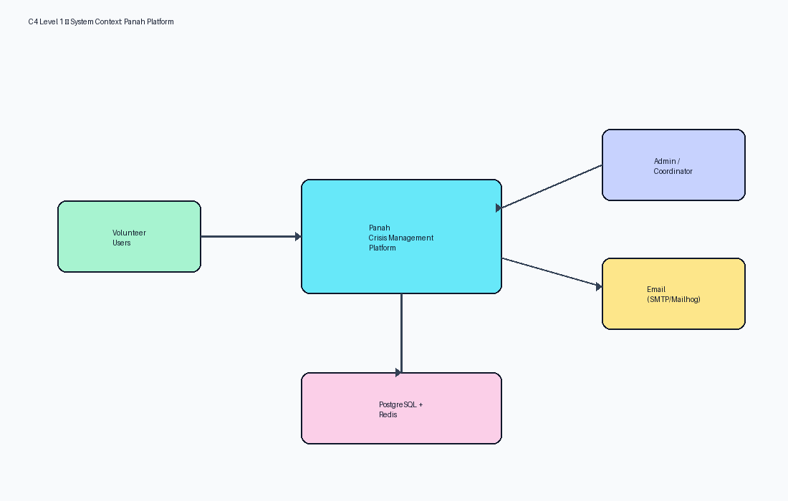
Figure 1 — C4 Context

5. C4 Containers
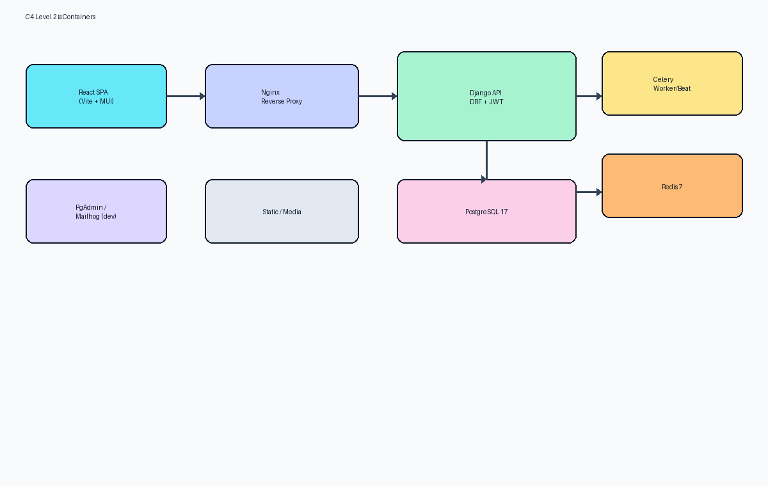
Figure 2 — C4 Containers

6. C4 Components
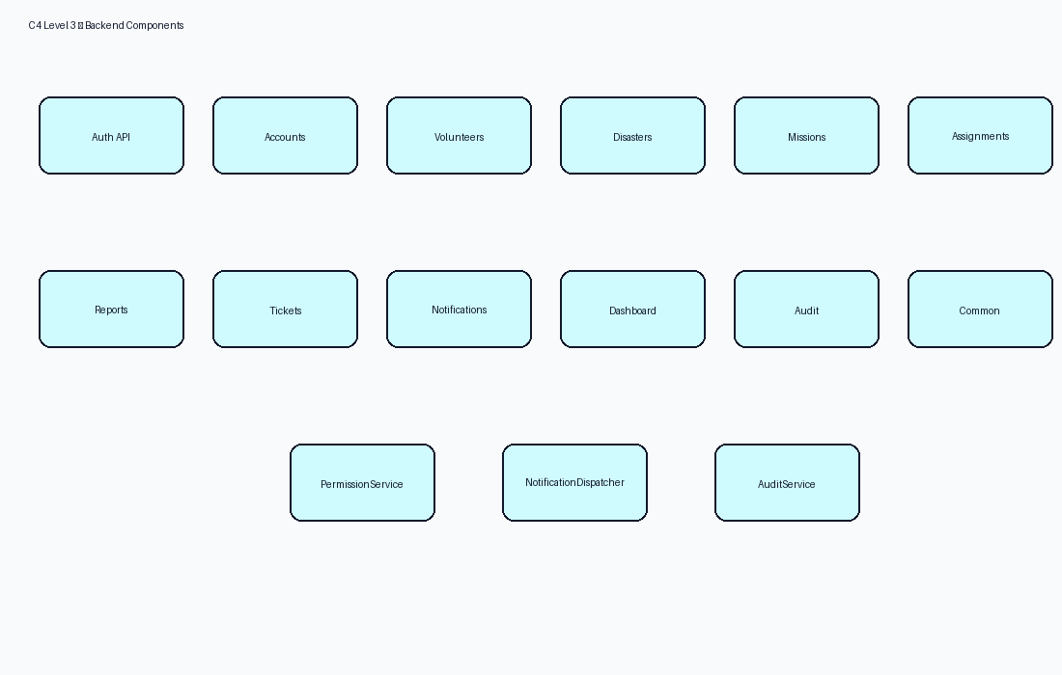
Figure 3 — Backend components

7. Deployment View
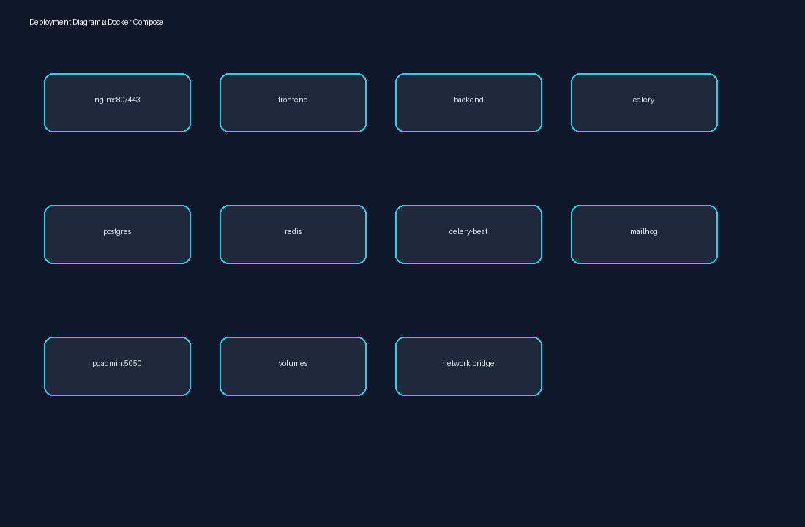
Figure 4 — Deployment diagram

8. Layered / Clean Architecture
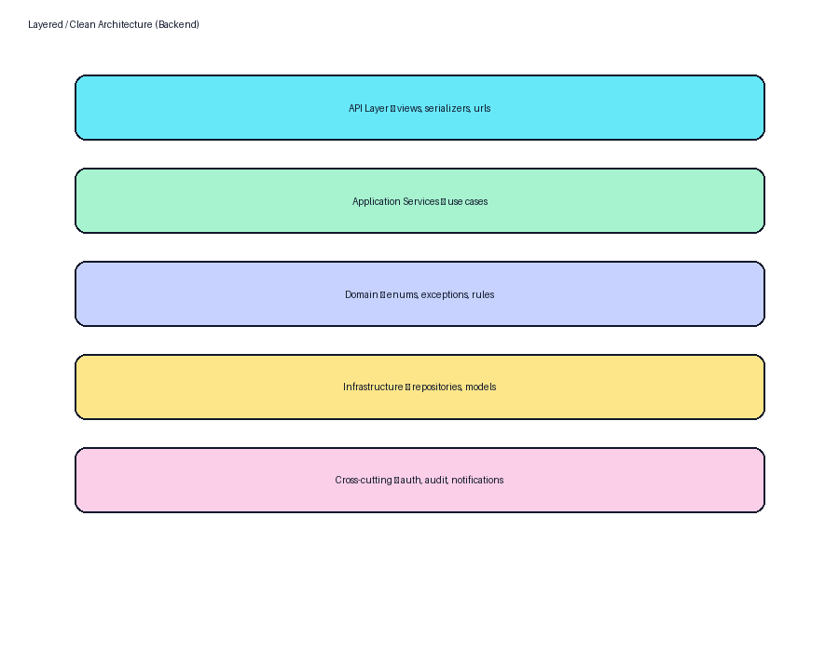
Figure 5 — Backend layering

9. Data Flow
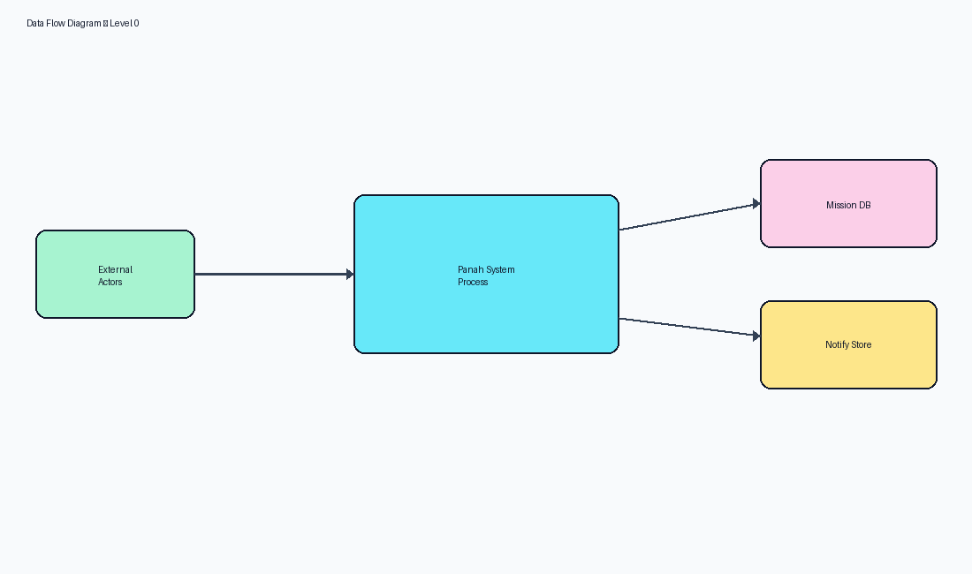
Figure 6 — Level-0 DFD

10. Technology Stack
Layer | Technology
UI | React 19, MUI 6, Redux Toolkit, TanStack Query, Vite 6
API | Django 5.2, DRF, SimpleJWT, drf-spectacular
Data | PostgreSQL 17, Redis 7
Async | Celery, django-celery-beat
Edge | Nginx
Ops | Docker Compose, Gunicorn (prod)

11. Design Decisions (ADR style)
Decision | Choice | Rationale
Auth | JWT + Redis blacklist | Stateless API with revocation
Authorization | DB-backed RBAC codenames | Flexible role seeding
Architecture style | Modular monolith | Speed + clear app boundaries
Coordinator scope | Mission.coordinator ownership | Operational clarity
Volunteer gate | Mission application review | Avoid blocking registration

12. Quality Attribute Design

12.1 Scalability
Stateless API containers can scale horizontally behind Nginx; Postgres remains primary bottleneck—index hot paths and cache dashboards.

12.2 Performance
Dashboard caching, select_related/prefetch in repositories, pagination defaults.

12.3 High Availability
Compose healthchecks + restart policies; production should add managed Postgres HA and Redis persistence.

13. Component Communication
- SPA → Nginx → Django REST JSON
- Django → PostgreSQL (system of record)
- Django → Redis (cache, broker, JWT blacklist)
- Celery worker → email notifications

14. Package Structure
- backend/src/<app>/{api,application,domain,infrastructure,models}
- frontend/src/{app,features,shared,layouts}
- infrastructure/{nginx,docker,pgadmin}

15. References
- IEEE 29148:2018 — Systems and software engineering — Life cycle processes — Requirements engineering
- ISO/IEC/IEEE 42010:2022 — Software, systems and enterprise — Architecture description
- UML 2.5 — Unified Modeling Language
- BPMN 2.0 — Business Process Model and Notation
- C4 Model — Context, Containers, Components, Code (Simon Brown)
- OWASP ASVS 4.0 — Application Security Verification Standard
- OWASP Top 10 (2021)
- REST API Design Rulebook / OpenAPI 3 Specification
- Django 5.2 Documentation / Django REST Framework
- React 19 Documentation / Material UI v6
- PostgreSQL 17 Documentation
- Panah Platform Source Code Repository (current workspace)
- Panah README.md and docker-compose.yml

