پناه (Panah) — پلتفرم مدیریت بحران و هماهنگی داوطلبان
Volunteer Crisis Management Platform
Database Design Document

Document ID | PANAH-DB-001
Version | 1.0.0
Date | 2026-07-16
Status | Approved for Delivery
Classification | Internal — Enterprise / Government Deliverable
Vendor / Author | Investica Group
Standards Alignment | IEEE / ISO aligned

This document is derived from the production source code, configuration, and operational architecture of the Panah platform.

1. Document Control

1.1 Revision History
Version | Date | Author | Description
1.0.0 | 2026-07-16 | Documentation Team | Initial baseline from source-of-truth codebase

1.2 Approvals
Role | Name | Signature | Date
Project Sponsor | Investica Leadership
Technical Architect | Platform Architecture
Quality Assurance | QA Lead

2. Table of Contents

Note: In Microsoft Word, right-click the TOC field and select “Update Field” to refresh page numbers after opening.

3. Overview
PostgreSQL 17 stores all domain data. Soft-delete is implemented via deleted_at on BaseModel.

4. ER Diagram
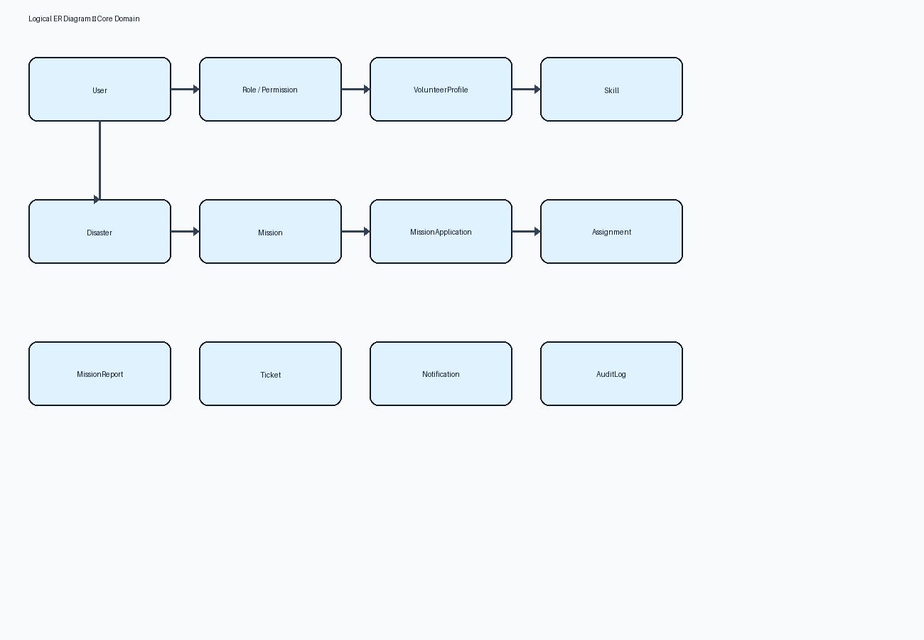
Figure 1 — Logical ERD

5. Logical Model
Entities mirror Django models: accounts, volunteers, skills, disasters, missions, assignments, reports, tickets, notifications, audit_logs.

6. Physical Model Notes
- UUID primary keys
- Timestamps created_at/updated_at
- Indexed status/priority/email fields
- Unique constraints: UserRole(user,role), Assignment(mission,volunteer), etc.

7. Data Dictionary (core)
Table | Column | Type | Notes
accounts_user | email | varchar | unique login
missions_mission | status | varchar(20) | lifecycle
missions_missionapplication | status | varchar | review pipeline
assignments_assignment | status | varchar | field progress
tickets_ticket | opened_by_id | uuid nullable | staff DM

8. Relationships
- Disaster 1—N Mission
- Mission 1—N Application/Assignment/Report
- User 1—1 VolunteerProfile
- Role N—N Permission

9. Constraints & Indexes
Referential integrity via FK; business uniqueness via UniqueConstraint; soft-delete queries filter deleted_at IS NULL through custom managers.

10. PostgreSQL Design
Database name volunteer_management; user volunteer_user; init scripts under infrastructure/docker/postgres/init.

11. Migration Strategy
- Developers create Django migrations per app
- Containers run migrate on startup/scripts
- Avoid destructive squash without backup

12. Backup Strategy
- pg_dump logical backups daily in production
- Retain volume snapshots
- Test restore quarterly
- Document restore in Maintenance manual

13. References
- IEEE 29148:2018 — Systems and software engineering — Life cycle processes — Requirements engineering
- ISO/IEC/IEEE 42010:2022 — Software, systems and enterprise — Architecture description
- UML 2.5 — Unified Modeling Language
- BPMN 2.0 — Business Process Model and Notation
- C4 Model — Context, Containers, Components, Code (Simon Brown)
- OWASP ASVS 4.0 — Application Security Verification Standard
- OWASP Top 10 (2021)
- REST API Design Rulebook / OpenAPI 3 Specification
- Django 5.2 Documentation / Django REST Framework
- React 19 Documentation / Material UI v6
- PostgreSQL 17 Documentation
- Panah Platform Source Code Repository (current workspace)
- Panah README.md and docker-compose.yml

