پناه (Panah) — پلتفرم مدیریت بحران و هماهنگی داوطلبان
Volunteer Crisis Management Platform
REST API Design & Reference

Document ID | PANAH-API-001
Version | 1.0.0
Date | 2026-07-16
Status | Approved for Delivery
Classification | Internal — Enterprise / Government Deliverable
Vendor / Author | Investica Group
Standards Alignment | OpenAPI 3 / REST best practices

This document is derived from the production source code, configuration, and operational architecture of the Panah platform.

1. Document Control

1.1 Revision History
Version | Date | Author | Description
1.0.0 | 2026-07-16 | Documentation Team | Initial baseline from source-of-truth codebase

1.2 Approvals
Role | Name | Signature | Date
Project Sponsor | Investica Leadership
Technical Architect | Platform Architecture
Quality Assurance | QA Lead

2. Table of Contents

Note: In Microsoft Word, right-click the TOC field and select “Update Field” to refresh page numbers after opening.

3. API Overview
Base path: /api/v1/. Interactive schema: /api/schema/ and /api/docs/ (drf-spectacular).

4. Authentication
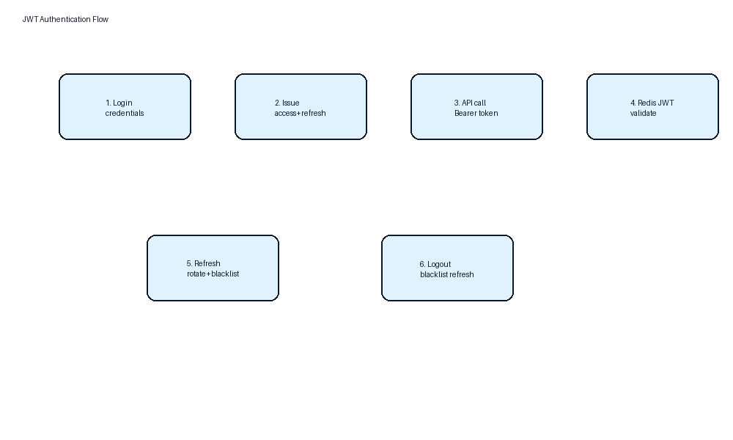
Figure 1 — JWT flow
Header: Authorization: Bearer <access>.

5. Authorization (RBAC)
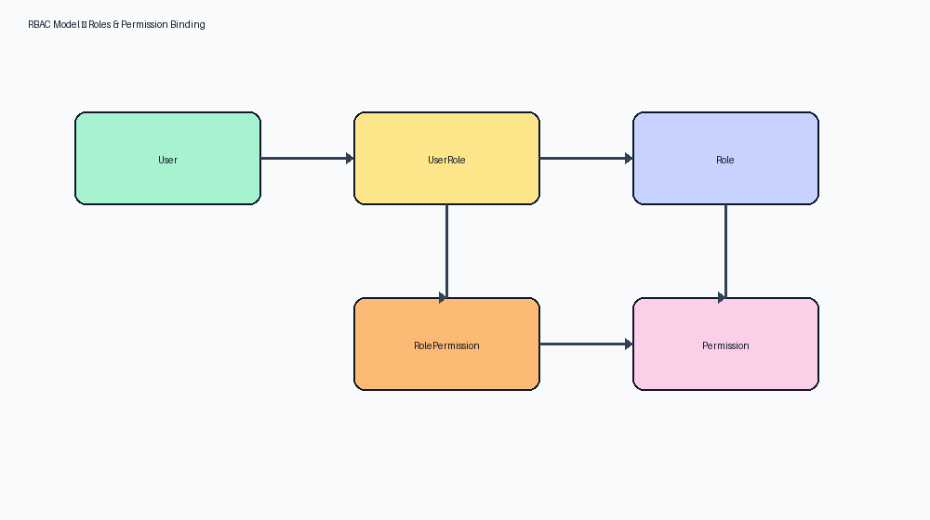
Figure 2 — RBAC
Views declare required_permission codenames enforced by HasPermission.

6. Endpoint Map
Prefix | Examples
/auth/ | login, logout, refresh, me
/accounts/ | users, roles, permissions
/volunteers/ | register, list, approve/reject
/disasters/ | CRUD
/missions/ | CRUD, publish, apply, applications inbox
/assignments/ | my, accept, decline, check-in, complete
/reports/ | CRUD, submit, review, finished-missions
/tickets/ | CRUD, replies, status
/notifications/ | list, mark read
/dashboard/ | stats
/audit-logs/ | list

7. Error Model
Custom exception handler returns {success:false, error:{code,message,details}}.
HTTP | Meaning
400 | Validation / business rule
401 | Unauthenticated / invalid token
403 | Permission denied
404 | Not found
409 | Conflict (duplicate application/assignment)

8. Samples

8.1 Login Request
POST /api/v1/auth/login/ {"email":"user@example.com","password":"..."}

8.2 Apply Request
POST /api/v1/missions/{id}/apply/ {"message":"آماده همکاری هستم"}

8.3 Dashboard Response (coordinator)
{"scope":"coordinator","kpis":{"my_missions_total":N,"pending_applications":N,...},"charts":{...}}

9. References
- IEEE 29148:2018 — Systems and software engineering — Life cycle processes — Requirements engineering
- ISO/IEC/IEEE 42010:2022 — Software, systems and enterprise — Architecture description
- UML 2.5 — Unified Modeling Language
- BPMN 2.0 — Business Process Model and Notation
- C4 Model — Context, Containers, Components, Code (Simon Brown)
- OWASP ASVS 4.0 — Application Security Verification Standard
- OWASP Top 10 (2021)
- REST API Design Rulebook / OpenAPI 3 Specification
- Django 5.2 Documentation / Django REST Framework
- React 19 Documentation / Material UI v6
- PostgreSQL 17 Documentation
- Panah Platform Source Code Repository (current workspace)
- Panah README.md and docker-compose.yml

