پناه (Panah) — پلتفرم مدیریت بحران و هماهنگی داوطلبان
Volunteer Crisis Management Platform
UI/UX Design Document

Document ID | PANAH-UI-001
Version | 1.0.0
Date | 2026-07-16
Status | Approved for Delivery
Classification | Internal — Enterprise / Government Deliverable
Vendor / Author | Investica Group
Standards Alignment | IEEE / ISO aligned

This document is derived from the production source code, configuration, and operational architecture of the Panah platform.

1. Document Control

1.1 Revision History
Version | Date | Author | Description
1.0.0 | 2026-07-16 | Documentation Team | Initial baseline from source-of-truth codebase

1.2 Approvals
Role | Name | Signature | Date
Project Sponsor | Investica Leadership
Technical Architect | Platform Architecture
Quality Assurance | QA Lead

2. Table of Contents

Note: In Microsoft Word, right-click the TOC field and select “Update Field” to refresh page numbers after opening.

3. Design Principles
- Persian RTL first
- Role-aware navigation
- Operational clarity over decoration
- Glass/gradient visual language consistent with MUI theme

4. Navigation Map
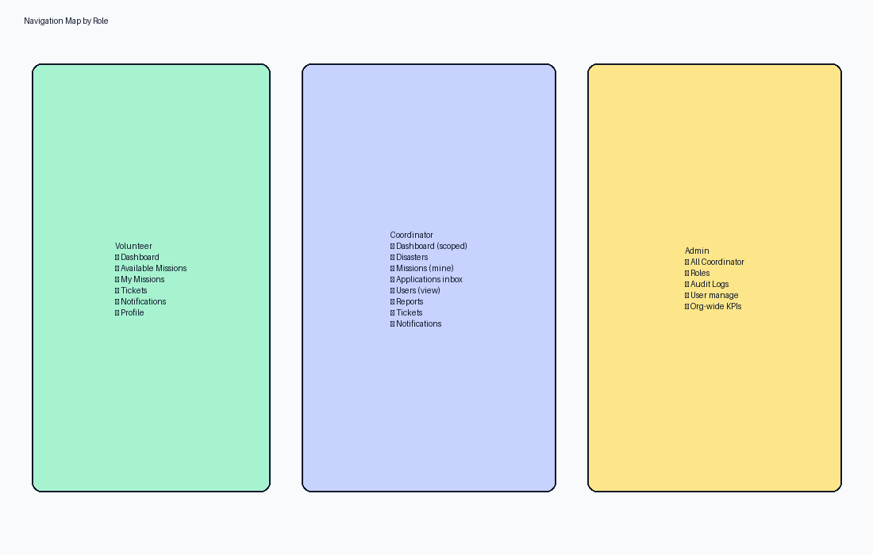
Figure 1 — Navigation by role

5. Key Screens
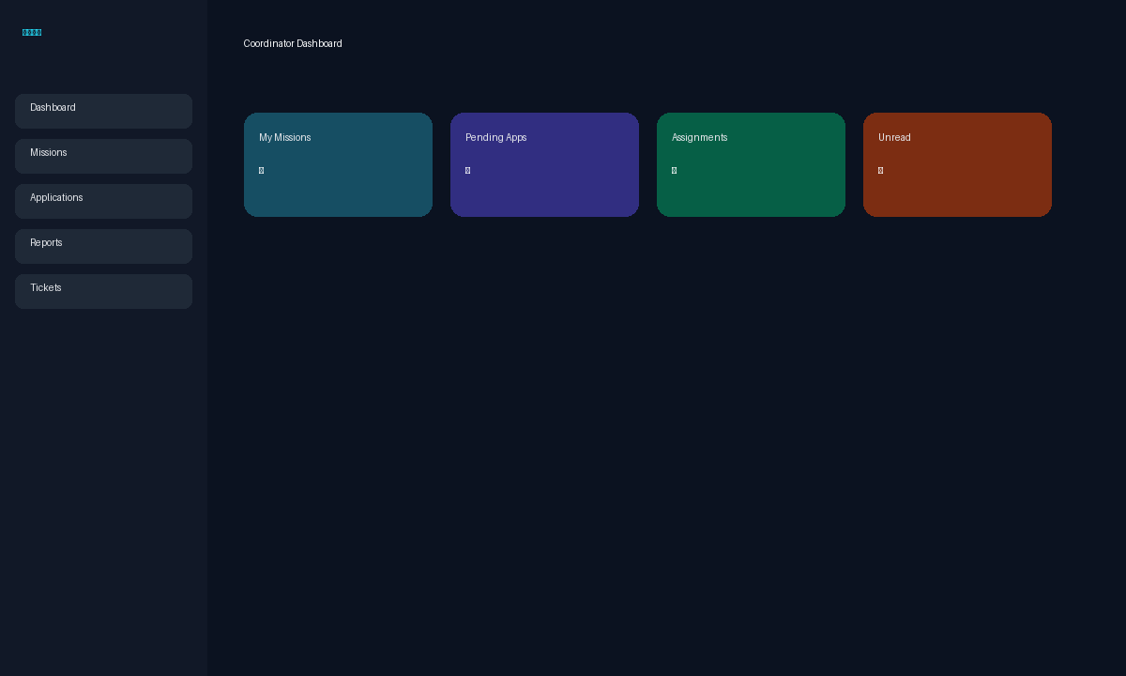
Figure 2 — Coordinator dashboard mock
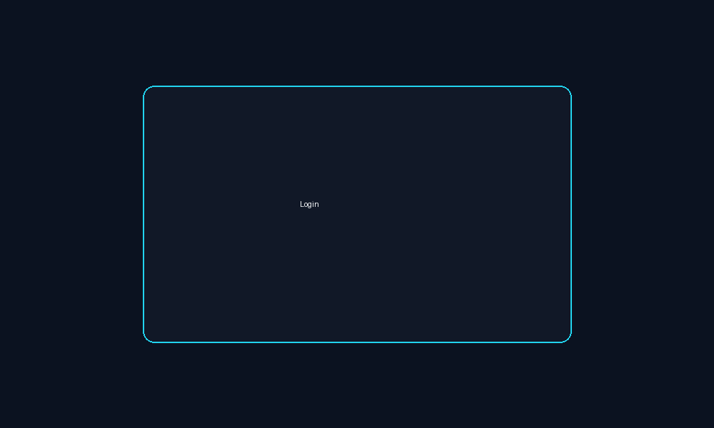
Figure 3 — Login mock

6. Design System
Token | Value/Notes
Primary accent | Cyan/teal (#22D3EE family)
Typography | Calibri/system with MUI typography scale
Components | GlassCard, GradientButton, StatusChip, JalaliDateField
Charts | Recharts

7. Responsive Strategy
Stack layouts collapse via MUI Grid2 breakpoints; drawers become temporary on mobile.

8. References
- IEEE 29148:2018 — Systems and software engineering — Life cycle processes — Requirements engineering
- ISO/IEC/IEEE 42010:2022 — Software, systems and enterprise — Architecture description
- UML 2.5 — Unified Modeling Language
- BPMN 2.0 — Business Process Model and Notation
- C4 Model — Context, Containers, Components, Code (Simon Brown)
- OWASP ASVS 4.0 — Application Security Verification Standard
- OWASP Top 10 (2021)
- REST API Design Rulebook / OpenAPI 3 Specification
- Django 5.2 Documentation / Django REST Framework
- React 19 Documentation / Material UI v6
- PostgreSQL 17 Documentation
- Panah Platform Source Code Repository (current workspace)
- Panah README.md and docker-compose.yml

