
Lab Assignment/Task Report
Only for course Teacher
 |  | Needs Improvement | Developing | Sufficient | Above Average | Total Mark
Allocate mark & Percentage |  | 25% | 50% | 75% | 100%
Clarity
Content Quality
Spelling & Grammar
Organization and Formatting
Total obtained mark
Comments

Semester: Spring 2026 / Fall ………
Student Name: Mehrab Hossain Opi
Student ID:26010117
Batch: 46th Section:A
Course Code: CSE 124 Course Name: Object Oriented Programming
Course Teacher Name: Debabarata Mallick
Designation: Lecturer
Submission Date: 29/07/2026

- Write a Java program to print 'Hello' on screen and your name on a separate line.
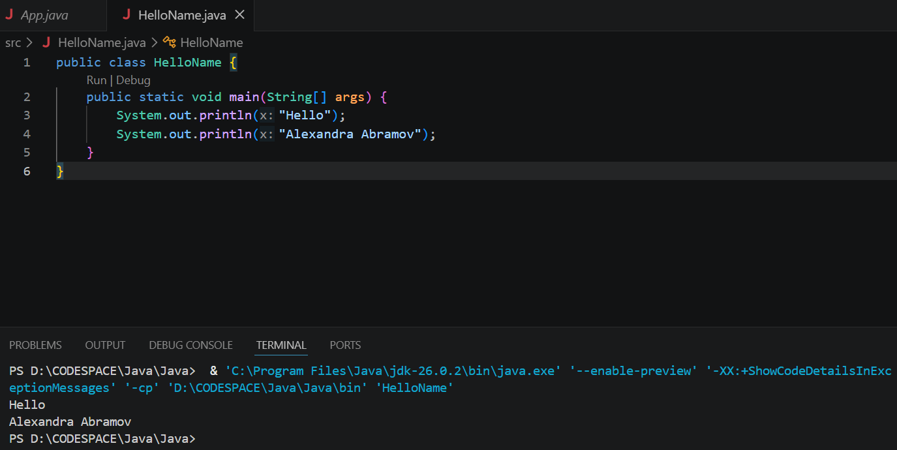
Comments: We learn to use println to print any thing we want , here we use println to automatically go to a newline .

2. Write a Java program to print the sum of two numbers.
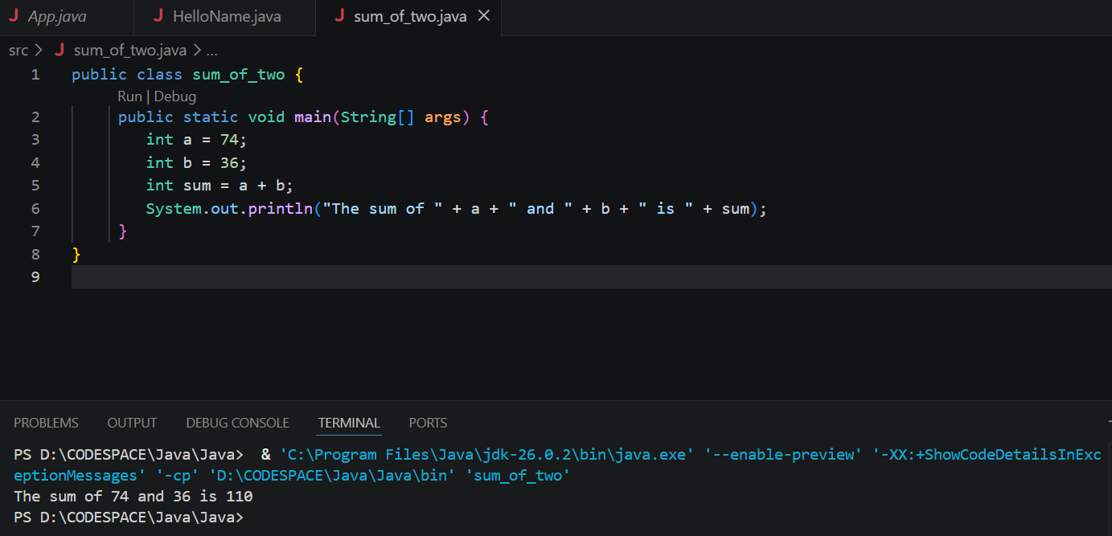
Comment: Variable were used two store the values and we used “sum” variable to store the summation of the two value
3. Write a Java program to divide two numbers and print them on the screen.
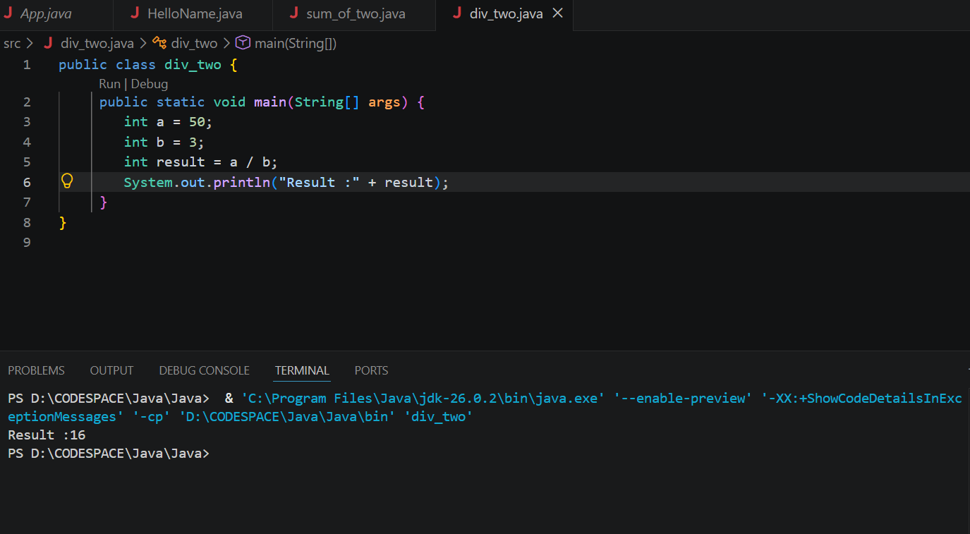
Comment: Variable were used two store the values and we used “result” variable to store the result of dividing the two value.

4. Write a Java program to print the results of the following operations.
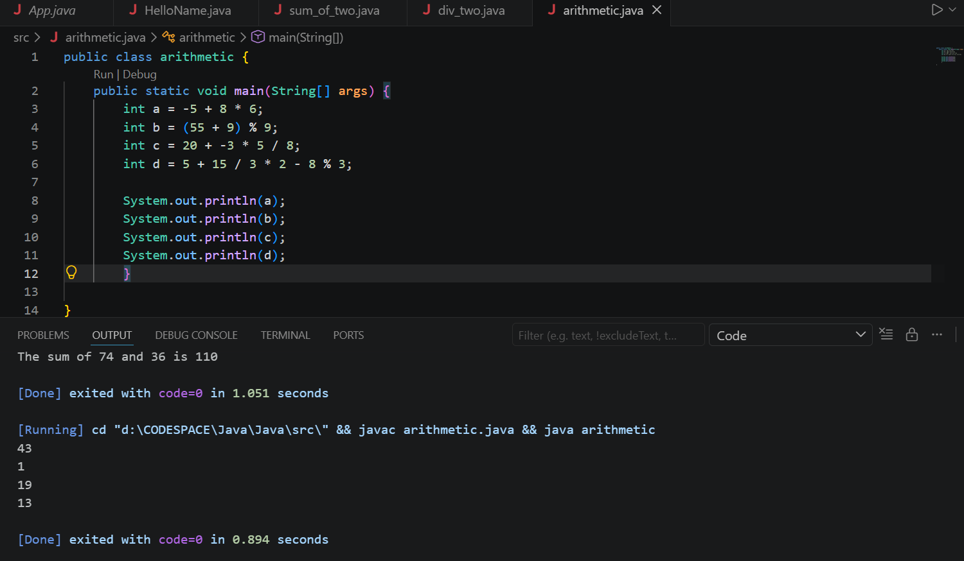
Comment: We get to know how to do basic arithmetic operations using java.

5. Write a Java program that takes two numbers as input and displays the product of two numbers.
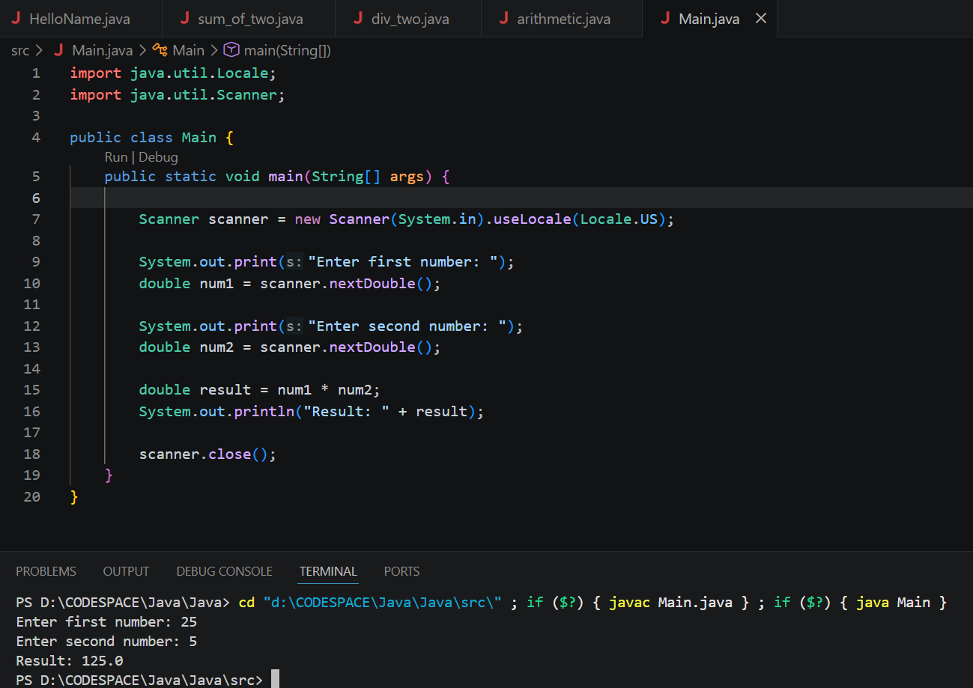
Comment: Two libraries were imported to take and input from the user, after taking the user it was stored in two variable . Then the the terminal took those two variable and multiplied them

