23/9/26
GENETIC ALGORITHM FOR OPTIMISATION PROBLEMS
import random
items = [(10, 5), (40, 4), (30, 6), (50, 3), (35, 2)]
capacity = 10
population_size = 8
generations = 10
def fitness(gene):
total_value, total_weight = 0, 0
for bit, (value, weight) in zip(gene, items):
if bit == 1:
total_value += value
total_weight += weight
return total_value if total_weight <= capacity else 0
def random_gene():
return [random.randint(0,1) for _ in items]
def crossover(parent1, parent2):
point = random.randint(1, len(items)-1)
return parent1[:point] + parent2[point:]
def mutate(gene):
i = random.randint(0, len(gene)-1)
gene[i] = 1 - gene[i]
return gene
population = [random_gene() for _ in range(population_size)]
for gen in range(generations):
population = sorted(population, key=fitness, reverse=True)
best = population[0]
print(f"Gen {gen+1}: Best gene {best}, Value = {fitness(best)}")
new_pop = [best[:]]
while len(new_pop) < population_size:
p1, p2 = random.sample(population[:4], 2) # select parents
child = crossover(p1, p2)
if random.random() < 0.3: # mutation chance
child = mutate(child)
new_pop.append(child)
population = new_pop
print("\nOptimal Solution Found:")
print("Gene:", best)
print("Value:", fitness(best))

OUTPUT:
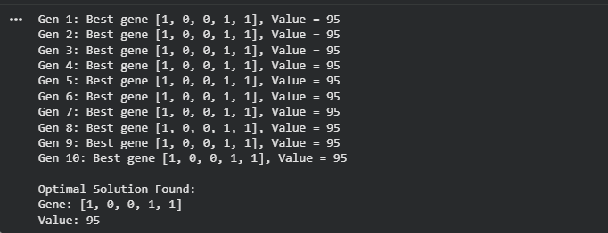

30/09/2026
PARTICLE SWARM OPTIMISATION - SWARM OF BIRDS
import random, math
random.seed(1)
food = (8, 8)
birds = [[random.uniform(0,10), random.uniform(0,10)] for _ in range(5)]
velocity = [[0,0] for _ in birds]

def distance(p):
return math.sqrt((p[0]-food[0])**2 + (p[1]-food[1])**2)

pbest = [b[:] for b in birds]
pbest_dist = [distance(b) for b in birds]
gbest = pbest[pbest_dist.index(min(pbest_dist))][:]

for iteration in range(5):
for i in range(len(birds)):
r1, r2 = random.random(), random.random()
for j in range(2):
velocity[i][j] = (0.5*velocity[i][j] + 0.8*r1*(pbest[i][j]-birds[i][j])
+ 1.2*r2*(gbest[j]-birds[i][j]))
birds[i][j] = max(0, min(10, birds[i][j] + velocity[i][j]))
d = distance(birds[i])
if d < pbest_dist[i]: pbest[i], pbest_dist[i] = birds[i][:], d
gbest = pbest[pbest_dist.index(min(pbest_dist))][:]
print(f"Iteration {iteration+1}: Best distance = {min(pbest_dist):.2f}")

print("\nFood location:", food)
print("Best bird position:", [round(x,2) for x in gbest])
print("Distance:", round(min(pbest_dist),2))

OUTPUT:
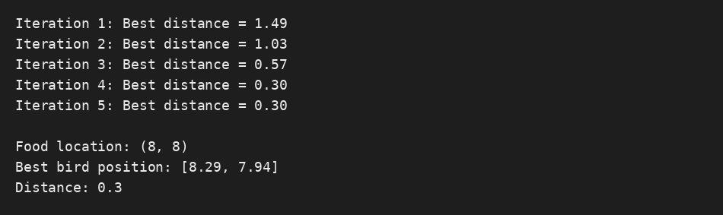

07/10/2026
UNIVERSITY TIME TABLE MANAGEMENT USING GENETIC ALGORITHM
import random
random.seed(7)
courses = [("AI","Dr Rao"),("DBMS","Dr Khan"),("OS","Dr Rao"),
("CN","Dr Mehta"),("SE","Dr Iyer"),("ML","Dr Khan")]
slots = ["Mon 9AM","Mon 11AM","Tue 9AM","Tue 11AM","Wed 9AM"]
rooms = ["R101","R102"]
def fitness(g):
penalty = sum(2 for i in range(6) for j in range(i+1,6)
if g[i]==g[j] and courses[i][1]==courses[j][1])
penalty += sum(max(0,g.count(s)-2)*3 for s in range(5))
return 100 - penalty
population = [[random.randrange(5) for _ in courses] for _ in range(10)]
for _ in range(20):
population.sort(key=fitness, reverse=True)
new = [population[0][:]]
while len(new) < 10:
a,b = random.sample(population[:4],2)
p = random.randint(1,5)
child = a[:p] + b[p:]
if random.random() < 0.3:
child[random.randrange(6)] = random.randrange(5)
new.append(child)
population = new
best = max(population, key=fitness)
print("Best fitness:", fitness(best))
for s in range(5):
ids = [i for i,x in enumerate(best) if x==s]
for r,i in enumerate(ids):
print(slots[s], rooms[r], courses[i][0], "-", courses[i][1])

OUTPUT:


