HTTPS: What are the differences? **HTTPS is HTTP with encryption and verification**. The only difference between the two protocols is that HTTPS uses TLS (SSL) to encrypt normal HTTP requests and responses, and to digitally sign those requests and responses. As a result, HTTPS is far more secure than HTTP.

[link](https://www.cloudflare.com/learning/ssl/why-is-http-not-secure/#:~:text=HTTPS%3A%20What%20are%20the%20differences,far%20more%20secure%20than%20HTTP.)

**Backend development**

The backend is the server side of the website. It stores and arranges data, and also makes sure everything on the client side of the website works fine. It is the part of the website that you cannot see and interact with. It is the portion of software that does not come in direct contact with the users. The parts and characteristics developed by backend designers are indirectly accessed by users through a front-end application. Activities, like writing APIs, creating libraries, and working with system components without user interfaces or even systems of scientific programming, are also included in the backend.

**frontend development**

The part of a website that the user interacts with directly is termed the front end. It is also referred to as the ‘client side of the application. It includes everything that users experience directly: text colors and styles, images, graphs and tables, buttons, colors, and a navigation menu. HTML, CSS, and JavaScript are the languages used for Front End development. Responsiveness and performance are the two main objectives of the Front End. The developer must ensure that the site is responsive i.e. it appears correctly on devices of all sizes no part of the website should behave abnormally irrespective of the size of the screen.

[**link2**](https://www.geeksforgeeks.org/frontend-vs-backend/)

A **web framework** (**WF**) or **web application framework** (**WAF**) is a [software framework](https://en.wikipedia.org/wiki/Software_framework) that is designed to support the development of [web applications](https://en.wikipedia.org/wiki/Web_application) including web services, [web resources](https://en.wikipedia.org/wiki/Web_resource), and web [APIs](https://en.wikipedia.org/wiki/API). Web frameworks provide a standard way to build and deploy web applications on the [World Wide Web](https://en.wikipedia.org/wiki/World_Wide_Web). Web frameworks aim to automate the overhead associated with common activities performed in [web development](https://en.wikipedia.org/wiki/Web_development). For example, many web frameworks provide [libraries](https://en.wikipedia.org/wiki/Library_(computing)) for [database](https://en.wikipedia.org/wiki/Database) access, [templating](https://en.wikipedia.org/wiki/Template_processor) frameworks, and [session](https://en.wikipedia.org/wiki/Session_(computer_science)) management, and they often promote [code reuse](https://en.wikipedia.org/wiki/Code_reuse).[[1]](https://en.wikipedia.org/wiki/Web_framework#cite_note-1) Although they often target development of [dynamic web sites](https://en.wikipedia.org/wiki/Dynamic_web_page), they are also applicable to [static websites](https://en.wikipedia.org/wiki/Static_web_page).

[**link3**](https://en.wikipedia.org/wiki/Web_framework)

**java script**

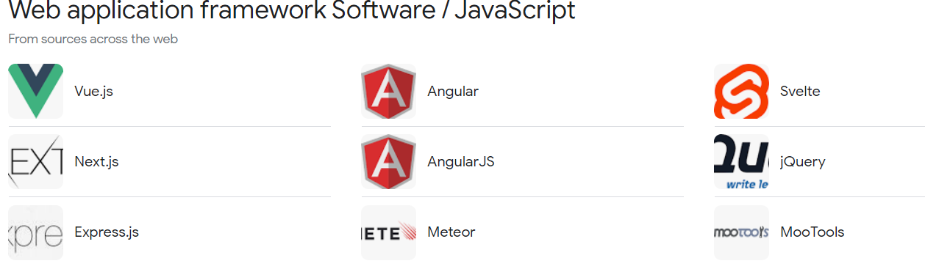

Python

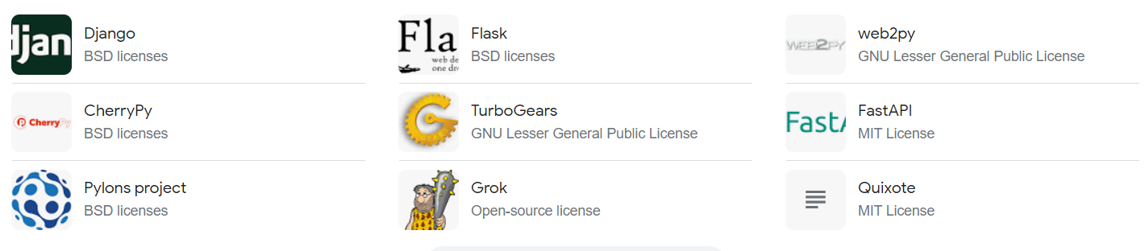

PHP

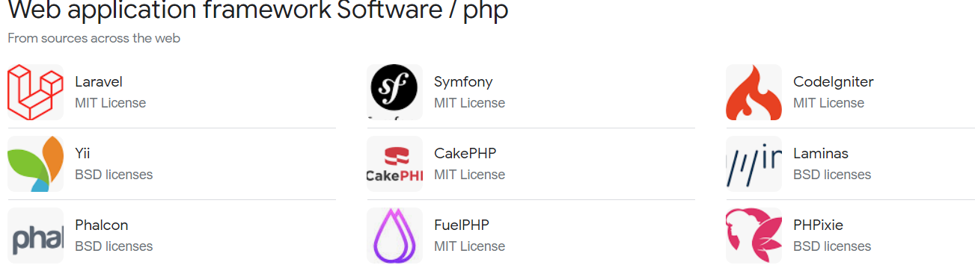

CSS

#### 1. Bootstrap

#### ****2. Tailwind CSS****

#### 3. Foundation

#### 4. Bulma

**5. Skeleton**