Game Design Document

Fill up the following document

1. Write the title of your project.

Arcade simulator

1. What is the goal of the game?

TO collect tickets and convert the ticket to prizes

1. Write a brief story of your game.

John wants to win a helicopter prize but he needs a lot of tickets. So his brother made a simulator where he can win prizes

1. Which are the playing characters of this game?

* Playing characters are the ones who respond to the user based on the input from the user.
* Cars, monkeys, dinos, wizards, etc., are the playing characters in the game.

|  |  |  |
| --- | --- | --- |
| Number | Character Name | What can this character do? |
| 1 | Bucket | Collect tickets |
| 2 |  |  |
| 3 |  |  |
| 4 |  |  |
| 5 |  |  |
| 6 |  |  |
| 7 |  |  |
| 8 |  |  |

1. Which are the Non-Playing Characters of this game?

* Non-Playing characters are the ones that don't have an action or behavior when the user interacts with the game.
* Hurdles, stones, bananas, coins, etc., are non-playing characters in the game.

|  |  |  |
| --- | --- | --- |
| Number | Character Name | What can this character do? |
| 1 | Tickets | Move down from the top so it can be collected |
| 2 | Button | It will convert tickets to points |
| 3 |  |  |
| 4 |  |  |
| 5 |  |  |
| 6 |  |  |
| 7 |  |  |
| 8 |  |  |

Draw your imagination to this game. What does this game look like?

* Draw the game either on your computer or on paper.
* Add images of the game scenes to show each of the playing and non-playing characters at least once.

This photo shows where the objects will be. There will be an arcade background and also many sound effects. I could upload images to this drawe

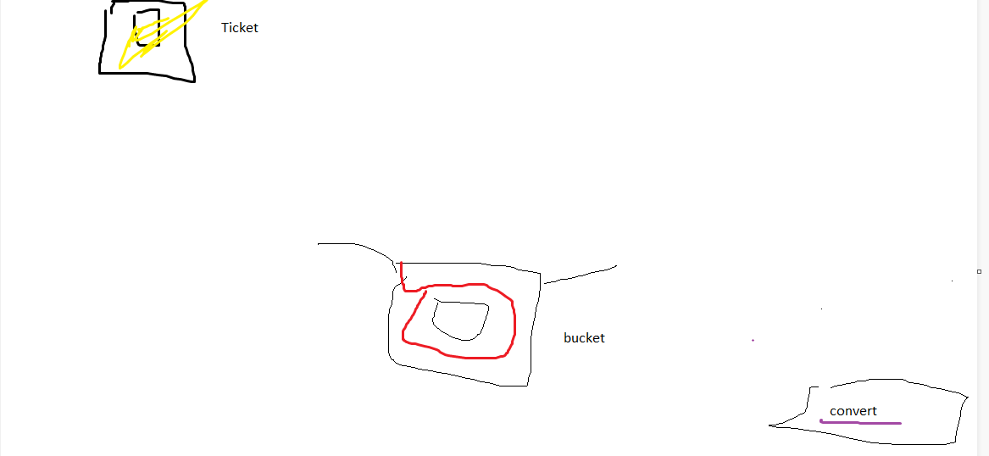

How do you plan to make your game engaging?

There will be many types of tickets bundles, single, and jackpot. There will also be debuffs. So it will be a balance. Also there will sound effects to capture their attention