# **Tasks**

**Learners have to come up with a dashboard in order to support the answers to the following questions and suggestions for places for newer restaurants.**

**Objective Questions**:

1. The data consists of some inconsistent and missing values so ensure that the data used for further analysis is cleaned.

*We have checked the entire data and found missing values in the Cuisines column of restaurants in the United States of America , we have replaced the blank values with N/A . However there are no missing values apart from that in the entire data.*

*Datekey_Opening column is not formatted as per date also so we have extracted the year from this date column using function LEFT.*

1. Using the LookUp functions, fill up the countries in the original data using the country code.

=VLOOKUP($C2,'country description'!$A$2:$B$16,2,)

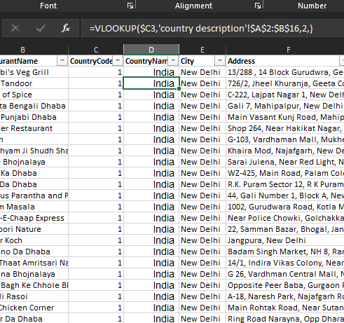

1. Create a table to represent the number of restaurants opened in each country.

*We have created a PIVOT TABLE here and put the country name in rows field while the count of Restaurant IDs in values.*

*Now we have the numbers of restaurants in each country .*

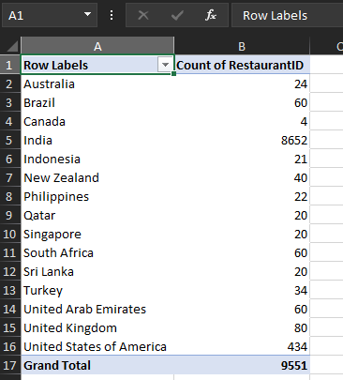

1. Also, the management wants to look at the number of restaurants opened each year, so provide them with something here.

*We will be using a slicer here to filter the number of the restaurants with year.*

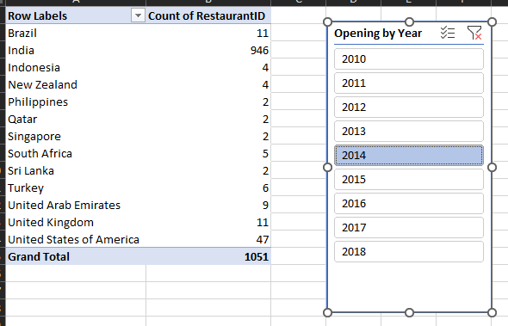



1. What is the total number of restaurants in India in the price range of 4?

*As we are already having the PIVOT TABLE for the total number of restaurants against the country ,we can simply add Price-range in the Filter section of the PIVOT TABLE and by doing that ,we will have the exact number of restaurants in India in the price range of 4.*

388 are the total restaurants in India in the price range of 4

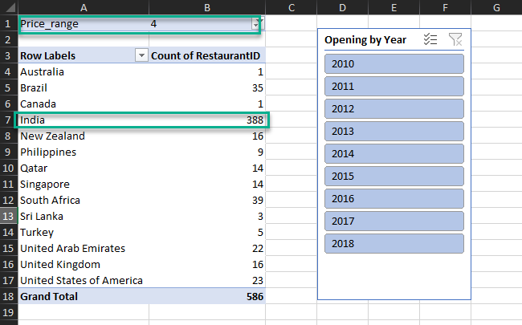

1. According to the data, what is the average number of voters for the restaurants in each country?

We have used the votes column and aggregated it with average to find the answer to the above mentioned question .

Below is the average number of voters for the restaurants in each country.

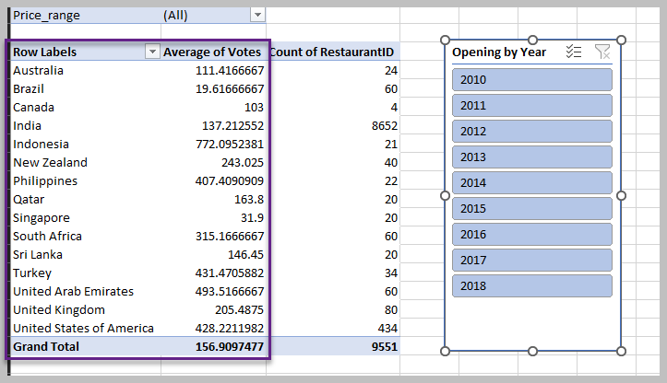

**Subjective Question:**

1. Suggest a few countries where the team can open newer restaurants with lesser competition. Which visualization/technique will you use here to justify the suggestions?

*In order to proceed with this problem, we have created 3 different pivot tables with respect to Country vs rating, Country vs Count of Restaurant and Country vs Average cost of Two.*

*As we can see in the provided data, we have different countries and similarly their currencies are also different, so we have to consolidate it one particular currency, so we have taken Indian currency into account and put the exchange rates of these currencies with respect to Indian currency.*

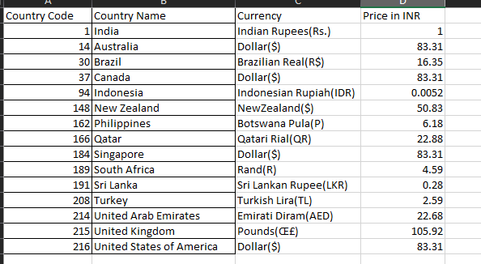

*Afterwards, we used the XLOOKUP formula to fetch the exchange rates in the raw data and multiplied it with the Average cost of two and created another column “Average Cost of Two in INR”.*

*All the three charts we have created using this are attached below.*

*We have sorted these pivot tables in ascending order already to easily identify the countries.*

From the data we can clearly say that in these below countries we can opt for opening new restaurants with lesser competition. We have used column charts over here to come to conclusion.

|  |  |  |  |
| --- | --- | --- | --- |
| Country Name | Average Cost of two in INR | Rating | Restaurant’s Count |
| Turkey | 219.76 | 4.3 | 34 |
| Sri Lanka | 665 | 3.87 | 20 |
| Indonesia | 1462.19 | 4.29 | 21 |
| |  |  | | --- | --- | | South Africa |  | | 1926.57 | 4.21 | 60 |
| Australia | 2006.38 | 3.65 | 24 |
| United States of America | 2178.72 | 4.01 | 434 |

|  |  |  |
| --- | --- | --- |
| **Rating** | **Average Cost in INR** | **Restaurant Count** |
| India | Turkey | Canada |
| Canada | India | Qatar |
| Singapore | Sri Lanka | Singapore |
| Australia | Indonesia | Sri Lanka |
| Brazil | South Africa | Indonesia |
| Sri Lanka | Australia | Philippines |
| United States of America | United States of America | Australia |
| Qatar | Brazil | Turkey |
| United Kingdom | Canada | New Zealand |
| South Africa | New Zealand | Brazil |
| United Arab Emirates | United Arab Emirates | United Arab Emirates |
| New Zealand | United Kingdom | South Africa |
| Indonesia | Qatar | United Kingdom |
| Turkey | Philippines | United States of America |
| Philippines | Singapore | India |

1. Come up with the names of States and cities in the suggested countries suitable for opening restaurants.
2. According to the countries you suggested, what is the current quality regarding ratings for restaurants that are open there?
3. Also, what is the current expenditure on food in the suggested countries, so we can keep our financial expenditure in control?

*In order to answer the above three questions, we have used the same pivot table and added the locality in the row in all those three pivots table and got the below data. Certainly, there can be more restaurants in the below countries but we have took 5-6 states in consideration.*

*The below table has the data like in which state/City the team can open new restaurants in the given countries along with their ratings ,restaurants count and average cost for two in those states.*

*Also we can include votes as well to further elaborate.*

|  |  |  |  |  |
| --- | --- | --- | --- | --- |
| Country Name | Average Cost of two in INR | Average of Votes | Rating | Restaurant’s Count |
| **Turkey** | **219.76** | **431.47** | **4.3** | **34** |
| Armada AVM, Sí_Ûôí_tí_zí_, Yenimahalle | 181.3 | 134 | 4.2 | 1 |
| Bebek | 77.7 | 1042 | 4.9 | 1 |
| Caddebostan | 336.7 | 522 | 4.9 | 1 |
| Dikmen | 259 | 231 | 4.5 | 1 |
| AsmalÛ±mescit | 129.5 | 1311 | 4.7 | 1 |
| **Sri Lanka** | **665** | **146.45** | **3.87** | **20** |
| Dehiwala, Colombo | 420 | 80 | 3.5 | 1 |
| Bambalapitiya, Colombo 04 | 532 | 179 | 2.9 | 2 |
| Rajagiriya, Colombo | 560 | 58 | 4.1 | 1 |
| Cinnamon Gardens, Colombo 07 | 665 | 140.75 | 3.82 | 4 |
| Havelock Town, Colombo 05 | 672 | 113.5 | 4.15 | 2 |
| Old Dutch Hospital, Fort | 1120 | 293 | 4.9 | 1 |
| **Indonesia** | **1462.19** | **772.09** | **4.29** | **21** |
| Bogor Timur | 364 | 783 | 3.7 | 1 |
| Tebet | 520 | 331 | 4 | 1 |
| Dago | 780 | 22 | 4.2 | 1 |
| Fatmawati | 858 | 1476 | 4.6 | 1 |
| Pondok Aren | 1040 | 2212 | 4.9 | 1 |
| |  |  | | --- | --- | | **South Africa** |  | | **1926.57** | **315.16** | **4.21** | **60** |
| Newlands | 504.9 | 328 | 4.5 | 1 |
| Sea Point | 814.72 | 238 | 4.6 | 2 |
| Greenlyn Village, Menlopark, Near Lynnwood | 918 | 301 | 4.4 | 1 |
| De Waterkant | 918 | 185 | 4 | 1 |
| Linden | 918 | 618 | 4.3 | 1 |
| **Australia** | **2006.38** | **111.41** | **3.65** | **24** |
| Dicky Beach | 583.17 | 29 | 3.6 | 1 |
| Inverloch | 583.17 | 100 | 3.7 | 1 |
| Lakes Entrance | 583.17 | 97 | 3.8 | 1 |
| Hepburn Springs | 1124.68 | 142.5 | 3.8 | 2 |
| **United States of America** | **2178.72** | **428.22** | **4.01** | **434** |
| Albany | 1688.12 | 87.15 | 3.56 | 19 |
| Ames | 2082.75 | 797.5 | 4.7 | 2 |
| Athens | 1582.89 | 637.5 | 4.2 | 20 |
| Blackfoot | 833.1 | 104 | 3.7 | 1 |
| |  | | --- | | Clarkesville | |  | | 833.1 | 235 | 4.1 | 1 |
| Clatskanie | 833.1 | 96 | 4.3 | 1 |
| Fernley | 833.1 | 83 | 3.7 | 1 |
| Kenwood | 833.1 | 1424 | 4.9 | 1 |

1. Come up with the names of restaurants from the recommended states that are our biggest competitors and also those that are rated in the lower brackets, i.e. 1-2 or 2-3.

We have suggested few restaurants in some countries ,now in order to come up with the competitors names and also the restaurants which are rated in lower category of under 3. We will be using the same pivot tables and adding the rating in the filter and selecting the values under 3 and below are the results we got .

|  |  |
| --- | --- |
| **Row Labels** | **Average of Average Cost for two by INR** |
| **India** | **424.5517755** |
| **Sri Lanka** | **532** |
| Bambalapitiya, Colombo 04 | 504 |
| Kollupitiya, Colombo 03 | 560 |
| **Brazil** | **885.625** |
| Asa Sul | 490.5 |
| Shopping Morumbi, Santo Amaro | 817.5 |
| Itaim Bibi | 899.25 |
| Asa Norte | 899.25 |
| Shopping MetríÇ Santa Cruz, Vila Mariana | 1062.75 |
| Madureira | 1144.5 |
| **United Kingdom** | **1588.8** |
| Alum Rock | 1059.2 |
| Moseley | 2118.4 |
| **United Arab Emirates** | **1814.4** |
| Al Nahda | 1814.4 |
| **United States of America** | **1832.82** |
| Mc Millan | 833.1 |
| Helen | 2082.75 |
| Davenport | 2082.75 |
| Pocatello | 2082.75 |
| **Canada** | **2082.75** |
| Consort | 2082.75 |
| **Singapore** | **2499.3** |
| Marina Centre, Downtown Core | 2499.3 |
| **Australia** | **4720.9** |
| Mayfield | 1666.2 |
| Montville | 2499.3 |
| Paynesville | 9997.2 |
| **New Zealand** | **5083** |
| Mission Bay | 5083 |
| **Grand Total** | **433.2011855** |

1. Which cuisines should we focus on in the newer restaurants to get better feedback? Does the choice of cuisines affect the restaurant ratings?

*In order to answer this question, we have created a pivot table and put the Country name and Cuisine names in row field and their respective rating in the values field and sorted the rating from highest to lowest.*

*In Newer restaurant we can focus on cuisines which are rated very high for example above 4.5 rating.*

For restaurants in Australia, we can opt for cuisines like Pizza, Bar Food which is rated 4.6

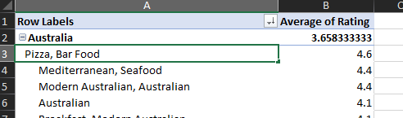

For newer restaurants in Brazil ,we can opt for these below cuisines

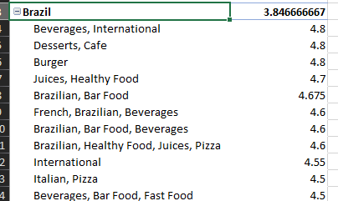

In Canadian restaurants we can go for cuisines like Italian, Mediterranean, Pizza

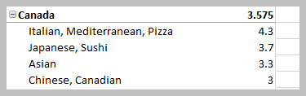

In Indonesian restaurants we can consider below cuisines.

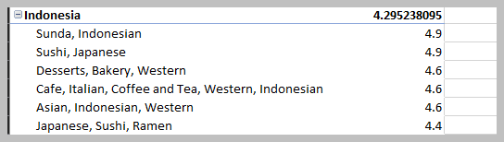

In New Zealand ,we can consider below cuisines .

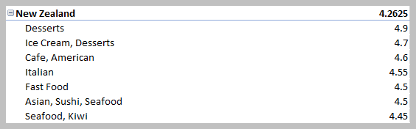

For newer restaurants in Philippines ,we can opt for these below mentioned cuisines.

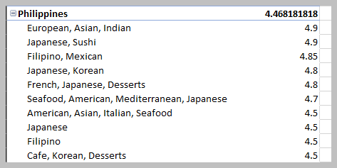

In Qatar , we can choose from these cuisines.

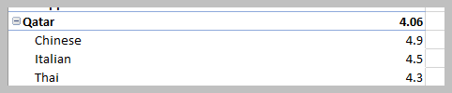

In South African restaurants, we can choose from these cuisines.

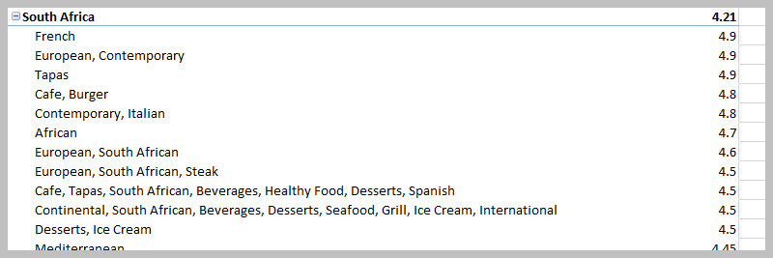

Similarly , we can go for SeaFood in Sri Lankan newer restaurants and Bar Food and World Cuisines in Turkish newer restaurants.

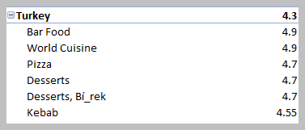

As we have noticed from the above data that cuisines choices are indeed affecting the restaurants feedback as the difference between the top rated and second position restaurant are quite huge in terms of the rating.

1. According to our current data, should we go for online delivery and table

booking? Does that affect the customer’s ratings?

In order to proceed with the above problem , we can created two pivot tables one for the online delivery and second for the table booking.

Row – Country name

Values – Ratings

Columns – Has_Online_Delivery

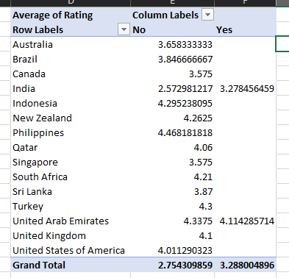

Row – Country name

Values – Ratings

Columns – Has_Table_booking

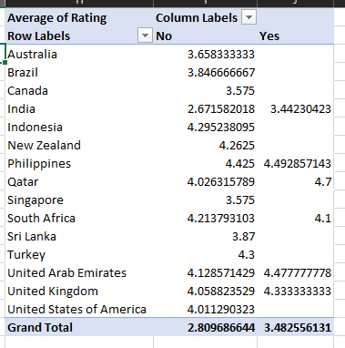

As per the rating , we see the restaurants which have neither Online Bookings nor table bookings are having the ratings while those restaurants which are offering these aren’t rated as much as the one who aren’t offering these.

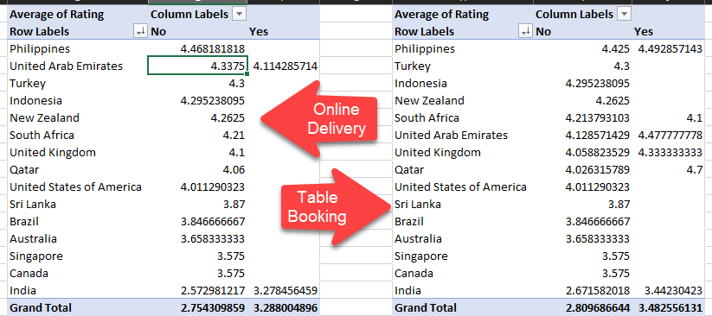

1. Should the team keep the rate of cuisines higher? Will that affect the feedback? According to our data are the rates of cuisines and ratings, correlated?

Approach used:

Created a pivot table which has Country name and Cuisines in the Row field and Average cost of two by INR and average of rating in the values field.

Now we have calculated the correlation between the average cost of two by INR and rating column using the Correlation formula in excel and found that it’s 0.310387187.

Correlation measures the relationship between two variables. A correlation coefficient of 0 means that variables have no impact on one another — increases or decreases in one variable have no consistent effect on the other.

Here in our case it’s definitely not 0. So it’s clear that it has slight impact on the rating.

Conclusion:

We shouldn’t keep the price of the Cuisines higher as it will impact the feedback from the customer and yes the rates of the cuisines and the ratings are correlated and the correation coefficient is 0.31

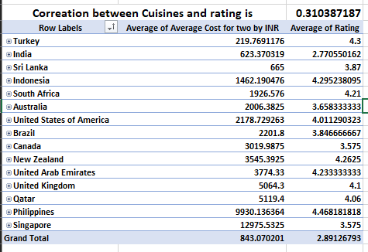

1. What is the distribution of a number of restaurants of different price ranges in all the countries?

Approach Used:

We have created a pivot table and took the country names in the row field and count of restaurants in the values field and put the Price range in the column field and got the below data.

In order to further elaborate it, we have renamed the column field so that we can easily identify it and created the borders to fine tune it.

|  |  |  |  |  |  |
| --- | --- | --- | --- | --- | --- |
| **Count of RestaurantID** | **Price Range** |  |  |  |  |
| **Country Names** | **Price range 1** | **Price Range 2** | **Price Range 3** | **Price Range 4** | **Grand Total** |
| Australia | 4 | 14 | 5 | 1 | 24 |
| Brazil | 2 | 7 | 16 | 35 | 60 |
| Canada |  | 3 |  | 1 | 4 |
| India | 4295 | 2858 | 1111 | 388 | 8652 |
| Indonesia |  | 1 | 20 |  | 21 |
| New Zealand | 3 | 4 | 17 | 16 | 40 |
| Philippines |  | 1 | 12 | 9 | 22 |
| Qatar |  | 1 | 5 | 14 | 20 |
| Singapore |  | 1 | 5 | 14 | 20 |
| Sri Lanka |  | 6 | 11 | 3 | 20 |
| South Africa |  | 4 | 17 | 39 | 60 |
| Turkey |  | 11 | 18 | 5 | 34 |
| United Arab Emirates |  | 9 | 29 | 22 | 60 |
| United Kingdom | 4 | 28 | 32 | 16 | 80 |
| United States of America | 136 | 165 | 110 | 23 | 434 |
| **Grand Total** | **4444** | **3113** | **1408** | **586** | **9551** |

**The dashboard must consist of date and country slicers.**

