Gait Analysis Report

Patient ID: _______________

Name: ____________________

Address: ____________________

Birth Date: _______________

Examination Date: __________

Height: ______ cm

Weight: ______ kg

Diagnosis: ____________________

# Spatiotemporal Parameters

Cadence: 100.5 (R), 99.9 (L) steps/min  
Speed: 0.69 (R), 0.69 (L) m/s  
Foot Off: 65.7% (R), 66.9% (L)  
Single Support: 31.8% (R), 32.8% (L)  
Double Support: 33.9% (R), 34.2% (L)

# Angles

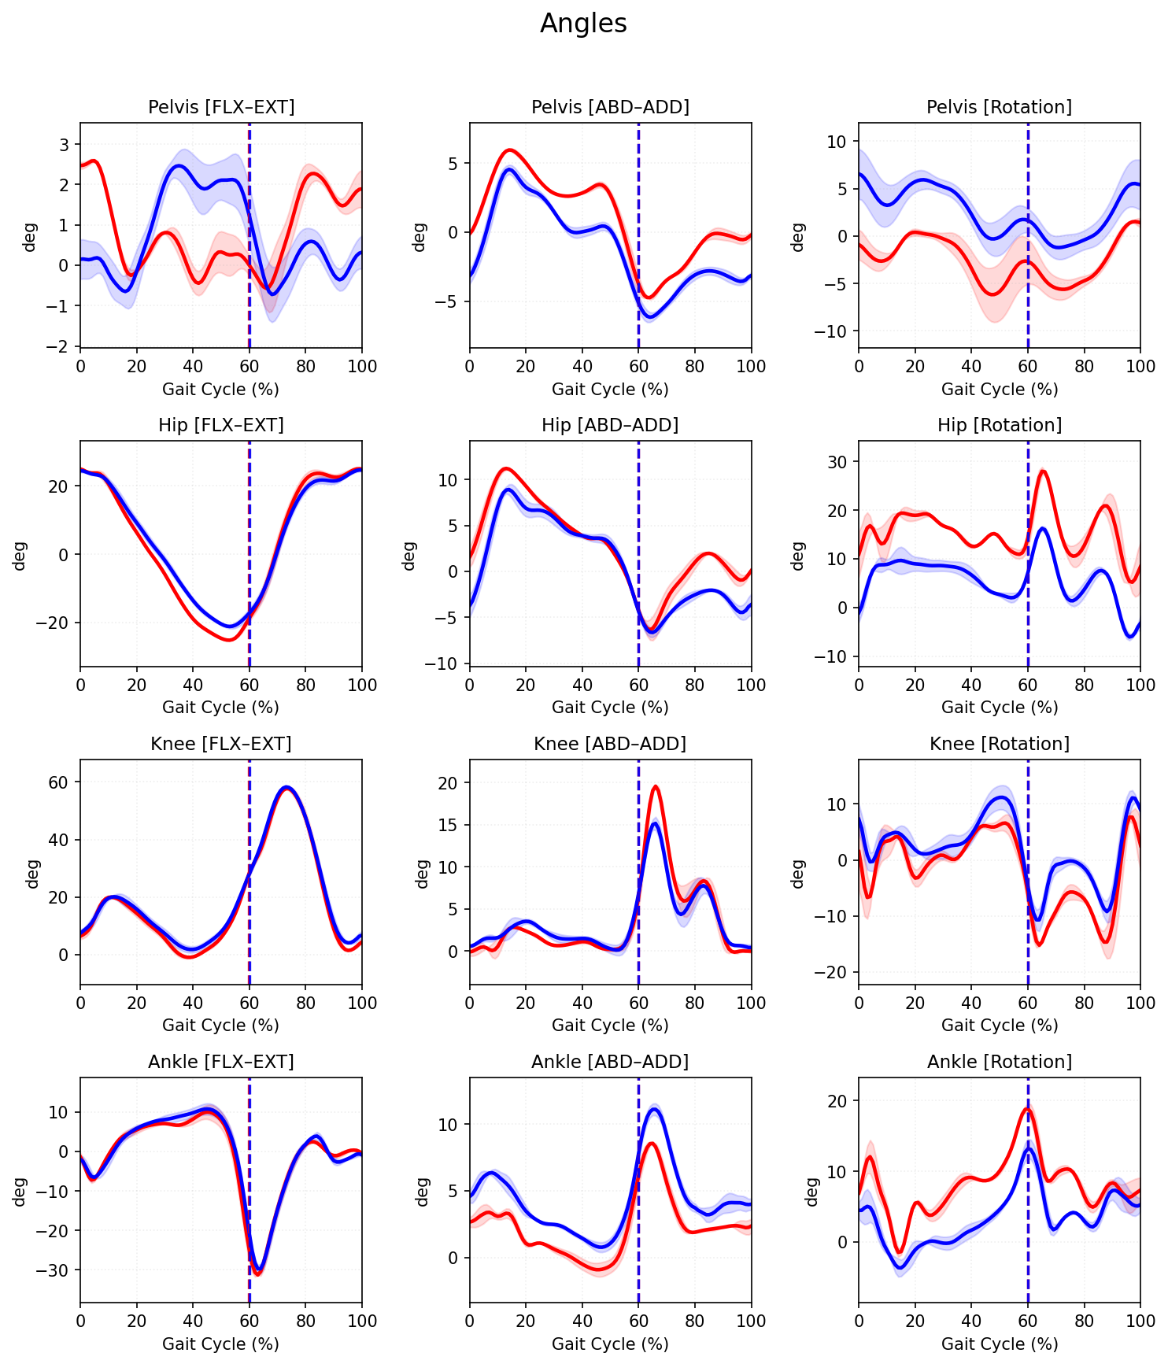

# Moments

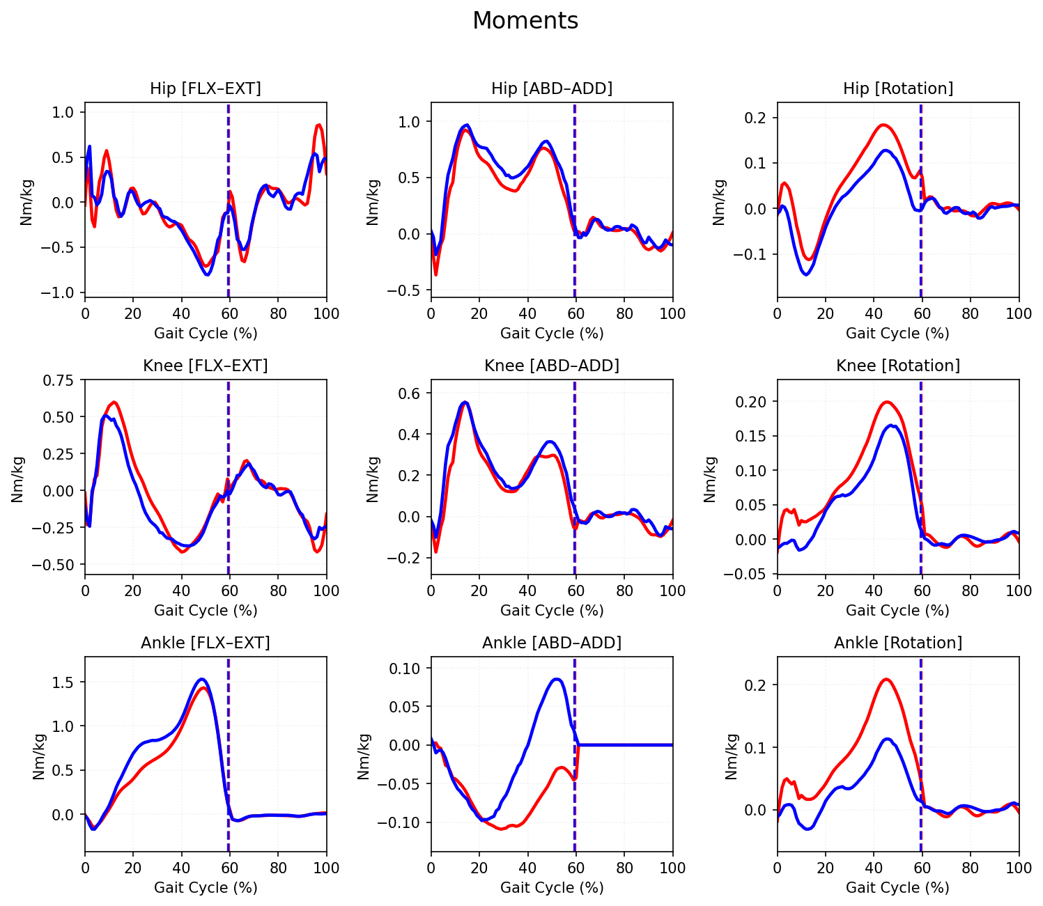

# Power

