Gait Analysis Report

Patient ID: _______________

Name: ____________________

Address: ____________________

Birth Date: _______________

Examination Date: __________

Height: ______ cm

Weight: ______ kg

Diagnosis: ____________________

# Spatiotemporal Parameters

Cadence: 100.5 (R), 99.9 (L) steps/min  
Speed: 0.69 (R), 0.69 (L) m/s  
Foot Off: 65.7% (R), 66.9% (L)  
Single Support: 31.8% (R), 32.8% (L)  
Double Support: 33.9% (R), 34.2% (L)

# Angles

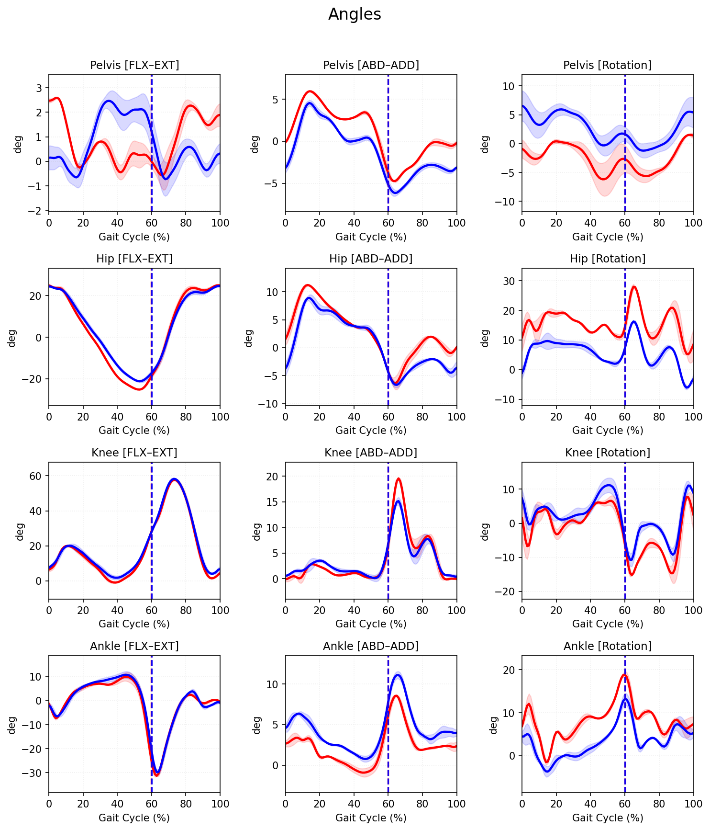

# Moments

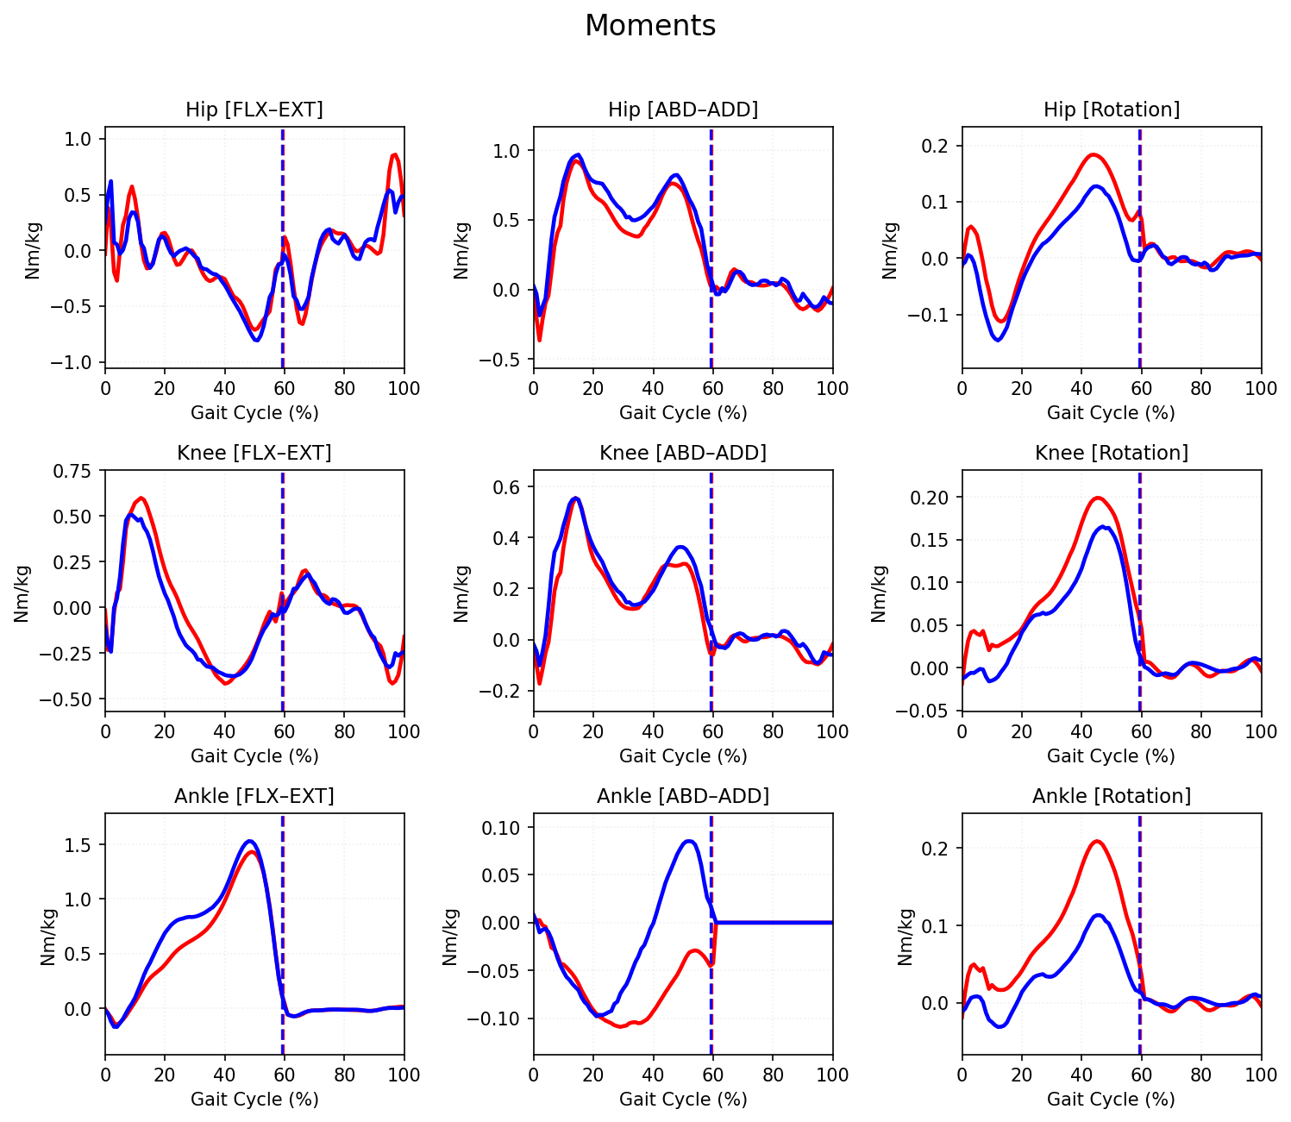

# Power

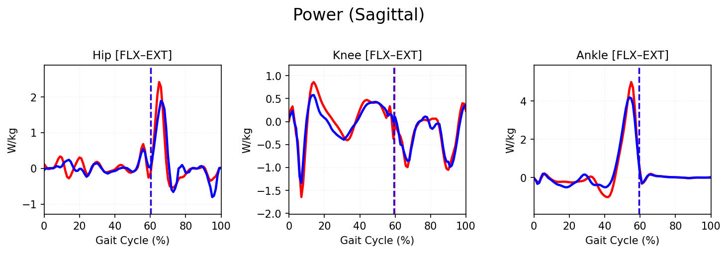

# Interpretation & Clinical Conclusion

1) Spatiotemporal Summary

- Cadence: R 100.5, L 99.9 steps/min (symmetric).

- Speed: 0.69 m/s (slow).

- Foot-off: R 65.7%, L 66.9% of gait cycle (late).

- Single support: R 31.8%, L 32.8% (reduced).

- Double support: R 33.9%, L 34.2% (elevated).

Overall: cautious, slow gait with prolonged double support and delayed transition to swing.

2) Kinematics

- Pelvis

- Sagittal tilt small and within a few degrees; variable but without a clear asymmetry.

- Frontal obliquity shows normal phasing; mild excursion.

- Transverse rotation increased with side-to-side asymmetry; pelvis rotates more in the direction of the right limb throughout stance.

- Hip

- Sagittal: IC in ~20–25° flexion; extension in late stance reaches only about neutral to ~5° extension bilaterally (reduced terminal extension).

- Frontal: adduction in loading then moves toward abduction around pre‑swing; magnitudes moderate.

- Transverse: marked asymmetry—Right hip remains internally rotated (~10–25°) through most of the cycle; Left hip is externally rotated (~5–10°), with large excursions in late swing.

- Knee

- Sagittal: typical pattern—early stance flexion (~15–20°), extension toward 0° mid‑stance, and swing flexion ~60°; fairly symmetric.

- Frontal: large coronal plane excursion with peaks ~15–18° around late stance/early swing on both sides.

- Transverse: notable internal rotation peak (~15–20°) around mid‑stance bilaterally.

- Ankle/Foot

- Sagittal: dorsiflexes to ~10–12° mid‑stance, then plantarflexes to ~20–25° at push‑off; swing returns close to neutral/ slight dorsiflexion—symmetric.

- Frontal: increased inversion/eversion excursion with a late‑stance peak (~8–10°); some side‑to‑side difference.

- Transverse: large axial rotation, with late‑stance internal rotation peaks (~15–20°); Right > Left.

3) Kinetics (Moments)

- Hip

- Sagittal: clear early‑stance extensor moment (~0.5–0.6 Nm/kg), switches to flexor (~−0.4 to −0.5 Nm/kg) mid‑late stance, then rises again to an extensor moment near pre‑swing (up to ~0.8–1.0 Nm/kg), slightly larger on the Right.

- Frontal: abductor moment present in early stance (~0.5–0.7 Nm/kg), tapering toward toe‑off; symmetric.

- Transverse: small internal‑rotation moment peaking ~0.15–0.2 Nm/kg around mid‑stance; Right > Left.

- Knee

- Sagittal: typical pattern—initial external‑flexion demand (~0.5–0.7 Nm/kg) followed by an extensor moment in mid‑stance (~−0.2 to −0.3 Nm/kg); symmetric.

- Frontal: ab/adduction moments up to ~0.4–0.5 Nm/kg; symmetric.

- Transverse: internal‑rotation moment rises to ~0.15–0.2 Nm/kg around mid‑stance; bilateral.

- Ankle

- Sagittal: strong plantarflexor moment peaking ~1.3–1.5 Nm/kg in late stance; Right and Left robust.

- Frontal and Transverse: small‑to‑moderate moments with late‑stance peaks (abd/add up to ~0.3–0.4 Nm/kg on Right; rotation up to ~0.2 Nm/kg bilaterally).

4) Power

- Hip (sagittal): large positive burst in pre‑swing/early swing (H3), peaking ~2.5 W/kg on the Right and ~1.8–2.0 W/kg on the Left—used to advance the limb. Low‑to‑moderate power elsewhere.

- Knee (sagittal): early‑stance generation (~0.6–0.8 W/kg) followed by absorption (~−0.5 to −0.7 W/kg) in mid‑stance; additional absorption in late swing (~−1.0 to −1.5 W/kg); largely symmetric.

- Ankle (sagittal): very large push‑off burst (A2) just before toe‑off—~5 W/kg Right and ~4–4.5 W/kg Left—preceded by small early‑stance absorption.

5) Key Abnormalities

1) Slow walking with prolonged double support and late foot‑off (≈66%), consistent with a cautious gait pattern.

2) Marked transverse‑plane asymmetry: Right limb persistently internally rotated while Left is externally rotated; pelvis, knee, and ankle show concordant increases in axial rotation (Right > Left).

3) Reduced terminal hip extension bilaterally (does not reach typical 10° extension).

4) Excessive coronal plane excursions at the knee (peaks ~15–18°) and increased ankle inversion/eversion motion around late stance.

5) Disproportionately large ankle plantarflexor moment and push‑off power (A2) for the slow speed, especially on the Right—suggesting reliance on ankle propulsion.

6) Large pre‑swing hip power burst (H3), Right > Left, to help initiate swing—likely compensatory for limited hip extension and slow speed.

6) Clinical Conclusion

This is a slow, cautious gait with delayed toe‑off. The dominant feature is a transverse‑plane asymmetry (Right toe‑in/limb internal rotation and Left toe‑out/external rotation), accompanied by increased axial rotation moments and motions at the knee and ankle. Hip extension in terminal stance is limited, and the patient relies on strong ankle push‑off and a pronounced pre‑swing hip power burst—more on the Right—to progress. Correlate with structural torsional alignment and hip flexor length; consider interventions targeting hip extension mobility and transverse/coronal plane control while preserving efficient ankle push‑off.