**PriceGuard Project Milestone 4**

**“**Project Brief & Needs Finding Plan”



|  |
| --- |
| **User Stories and User Journey Maps** |

**User Stories**

As a busy bank manager, I want an app that simplifies grocery shopping by providing real-time price updates and budget-friendly suggestions, so I can save both time and money without compromising on structure and planning

As a busy single mom and small business owner, I want to receive timely alerts on price changes for key household items, so that I can plan my purchases in advance and avoid budget shocks.

As a cost-conscious student managing household grocery shopping, I want an app that predicts price changes and compares costs across local and online stores so that I can plan my purchases effectively and stay within budget.

As a budget-conscious hostelite student juggling a packed schedule, I want an app that compares grocery prices across stores in real-time so that I can save money and time without compromising on essentials.

**Journey Maps**

|  |
| --- |
| **Section 2** |

|  |  |  |  |  |  |  |  |
| --- | --- | --- | --- | --- | --- | --- | --- |
| **Action** | **Create list** | **Check Prices** | **Plan Shopping** | **Travel to Store** | **Buy Groceries** | **Track Spending** | **Reflect on Experience** |
| **Task List** | A.List all the things that need to be bought  B.share with roommate to split | A. Check store apps or sites  B. Browse student WhatsApp groups  C. Note prices in a comparison sheet | A. Decide when to shop based on class schedule  B. Choose closest store with best deals  C. Allocate weekly grocery budget | A. Take the cheapest ride to the cheapest store | A. Add all the needed items in the cart  B. Proceed to checkout  C. No price tags; total exceeded  D. Skip snacks to afford essentials | A. Check the list  B. Check the bill | A. Reflect on the overspending  B. reflect on the increase in the prices |
| **Feeling Adjective** | Focused but slightly rushed | Confused by too many sources, wants simpler info | Strategic but time and budget-constrained | Resigned but determined | Hopeful when adding things to the cart. Nervous before going to the checkout Panicked + Humiliated + Defeated at checkout | Anxious, Suspicious,Regretful | Guilt Helplessness  Existential Dread |
| **Improvement Opportunities** | Allow shared lists in a budgeting app  Enable checklist with reminders | Live student-contributed price board in app  Real-time price alerts for nearby stores + online deals | Suggest best times to shop near hostel  Alert for price drops |  | Auto-budget suggestion before checkout  Highlight skipped items | Auto-populate expenses by scanning receipts | Weekly summary with savings insight and meal-planning suggestions |

|  |  |  |  |  |  |  |
| --- | --- | --- | --- | --- | --- | --- |
| **Action** | **Plan Budget** | **Research Prices** | **In-Store Shopping** | **Checkout** | **Return Home** | **Post-Purchase** |
| **Task List** | A. Review the pantry and make a list.  B. Set budget based on past prices.  C. Check ads for discounts. | A. Look up current prices online  B. Compare different stores | A. Adjust list due to price changes.  B. Decide whether to buy or leave.  C. Recalculate budget on the spot. | A. Pay at the counter.  B. Verify receipt accuracy. | A. Unpack groceries  B. Review what was missed or cost more.  C. Note overspending | A. Update budget spreadsheet  .  B. Reflect on experience.  C. Research better solutions. |
| **Feeling Adjective** | Anxious that the prices will match my budget or not    Hopeful that maybe this particular store has deals. | Frustrated that why this is time consuming  Resigned by saying I’ll just guess | Stressed – Prices changed again!  Rushed – No time to go elsewhere. | Annoyed by having to change plan on the spot | Dissatisfied due to overspending | Determined – There must be a better way  Worried – Next month will be tighter. |
| **Improvement Opportunities** | Monthly price trend alerts for staples | Real-time price comparison across local stores. | Digital shelf tags showing live prices. | Show on-screen budget alerts during checkout | Suggest alternative cheaper stores or online delivery options | Provide visual budget breakdowns and smart planning tips |

**Problem Statements**

Ahmed Khan, a 52-year-old bank manager, needs a simple tool to track and predict grocery price changes because frequent fluctuations disrupt his structured budgeting and increase costs, but his current manual planning methods are time-consuming and ineffective.

Eshaal Amir, a 23-year-old student, needs an easy-to-use app to compare grocery prices across stores because inflation and unexpected costs strain her tight budget, but her current approach of manually checking prices is inefficient and stressful.

Adeel Khan, a 22-year-old student, needs a reliable platform to compare prices and find affordable local product alternatives because exceeding his grocery budget impacts his family’s finances, but his current shopping methods lack access to real-time discounts and trustworthy options.

Saima Raza, a 35-year-old small business owner, needs real-time price alerts for bulk grocery purchases because unpredictable price surges disrupt her household and business budgeting, but her reliance on informal networks and manual tracking is unreliable and overwhelming.

**Hypothesis**

If Ahmed Khan uses a mobile app that provides real-time grocery price tracking and predictive alerts, then he will maintain his budget more effectively because the app’s automated insights reduce the time and effort needed for manual price comparisons.

If Eshaal Amir uses a user-friendly app that aggregates real-time grocery prices from local and online stores, then she will stay within her budget more consistently because the app’s simplicity aligns with her need for quick, stress-free price comparisons.

If Adeel Khan uses a platform that compares prices and recommends reliable local alternatives for imported products, then he will reduce overspending on groceries because the platform’s real-time data and curated options address his need for cost-effective choices.

If Saima Raza uses a mobile app that sends real-time price alerts for bulk grocery items, then she will optimize her purchasing decisions because the app’s timely notifications reduce her reliance on unreliable informal networks.

**Value Proposition**

**Step 1: Describe PriceGuard’s Features and Benefits**

**Real-Time Price Tracking**:

* **Feature**: Tracks grocery prices at the point of purchase and compares them across local and online stores.
* **Benefit**: Enables users to find the cheapest options instantly, saving money and reducing overspending.

**Store Comparison**:

* **Feature**: Compares prices across multiple stores (e.g., SaveMart, local vendors, online platforms).
* **Benefit**: Helps users make informed decisions without visiting multiple stores, saving time and effort.

**Inflation Trend Analysis**:

* **Feature**: Provides historical price trends and insights into how inflation impacts grocery costs.
* **Benefit**: Empowers users to anticipate price changes and plan purchases strategically, reducing financial strain.

**Personalized Shopping Recommendations**:

* **Feature**: Analyzes user shopping patterns to suggest budget-friendly products or alternatives (e.g., local brands).
* **Benefit**: Tailors advice to user preferences, ensuring nutritious choices within budget and minimizing compromises.

**Predictive Price Insights**:

* **Feature**: Forecasts potential price increases for grocery items in the near future.
* **Benefit**: Allows users to stock up before price surges, optimizing bulk purchases and saving money.

**Instantaneous Alerts**:

* **Feature**: Notifies users immediately when prices change for tracked items.
* **Benefit**: Prevents overspending by enabling timely purchasing decisions, especially for bulk or essential items.

**All-in-One Platform**:

* **Feature**: Combines tracking, comparison, analysis, recommendations, and alerts in a single app.
* **Benefit**: Simplifies grocery budgeting with a seamless, user-friendly experience, reducing complexity for middle-aged users.

**User-Friendly Design for Middle-Aged Users**:

* **Feature**: Intuitive interface tailored for users who struggle with complex tech or trend analysis.
* **Benefit**: Makes price management accessible, reducing stress and empowering confident decision-making.

**Budgeting Assistance**:

* **Feature**: Offers tools to set and track grocery budgets based on user input and spending patterns.
* **Benefit**: Helps users stay within budget, promoting financial stability and responsible consumption (UN SDG 12).

**Support for Nutritious Diets**:

* **Feature**: Recommends affordable, high-quality products to maintain healthy eating.
* **Benefit**: Ensures users can afford nutritious groceries despite inflation, supporting food security (UN SDG 2).

**Credible Information**:

* **Feature**: Sources accurate, up-to-date price data from reliable vendors and markets.
* **Benefit**: Builds trust, ensuring users rely on PriceGuard for critical financial decisions.

**Time Efficiency**:

* **Feature**: Automates price tracking, comparisons, and alerts, minimizing manual effort.
* **Benefit**: Frees up time for busy users, allowing focus on work, family, or other priorities.

**Step 2: Explain the Value of the Product**

**Cost Savings** (Addresses financial strain and budget constraints):

* Real-Time Price Tracking: Saves money by finding the cheapest options.
* Store Comparison: Reduces costs by identifying the best deals across stores.
* Personalized Shopping Recommendations: Suggests budget-friendly alternatives, minimizing compromises on essentials.
* Predictive Price Insights: Enables strategic buying to avoid price surges.
* Budgeting Assistance: Helps users stick to their financial plans.
* Support for Nutritious Diets: Ensures affordable healthy options, reducing trade-offs.

**Accessibility** (Makes price management easy, especially for middle-aged users):

* All-in-One Platform: Combines all tools in a single, streamlined app.
* User-Friendly Design for Middle-Aged Users: Simplifies complex data for non-tech-savvy users.
* Personalized Shopping Recommendations: Tailors advice to user needs, reducing learning curves.

**Time Efficiency** (Saves time for busy users):

* Real-Time Price Tracking: Eliminates manual price checks.
* Store Comparison: Avoids the need to visit multiple stores or websites.
* Instantaneous Alerts: Provides timely updates without constant monitoring.
* Time Efficiency: Automates tasks, freeing up time for other priorities.

**Trustworthiness** (Builds confidence in decision-making):

* Inflation Trend Analysis: Offers reliable historical data for informed planning.
* Predictive Price Insights: Provides credible forecasts based on market trends.
* Credible Information: Uses accurate, verified data to ensure trust.
* Personalized Shopping Recommendations: Recommends trustworthy local alternatives.

**Step 3: Connect Features and Benefits with User Needs**

1. **Ahmed Khan** (52, Bank Manager, values structure, frustrated by price fluctuations and time-consuming planning):
   * **Pain Point**: Frequent price changes disrupt his structured budgeting; manual planning is ineffective.
   * **Valuable Features/Benefits**:

**Cost Savings**: Real-time price tracking and predictive insights help him stay within budget.

**Accessibility**: User-friendly design and all-in-one platform simplify trend analysis for a non-tech-savvy user.

**Trustworthiness**: Credible inflation trend analysis ensures he trusts the data for planning.

* + **Why It Matters**: Ahmed needs tools that maintain his organized approach without wasting time, ensuring financial control.

1. **Eshaal Amir** (23, Student, budget-conscious, frustrated by inflation and manual price checks):
   * **Pain Point**: Inflation strains her tight budget; manually checking prices is inefficient and stressful.
   * **Valuable Features/Benefits**:

**Cost Savings**: Store comparison and personalized recommendations help her find affordable options.

**Time Efficiency**: Real-time tracking and alerts save time for her busy student life.

**Accessibility**: User-friendly app aligns with her tech-savvy but time-constrained lifestyle.

* + **Why It Matters**: Eshaal needs quick, affordable solutions to stretch her budget without compromising essentials.

1. **Adeel Khan** (22, Student, helps family shop, frustrated by budget overruns and lack of reliable alternatives):
   * **Pain Point**: Exceeding grocery budgets impacts family finances; finding trustworthy local alternatives is hard.
   * **Valuable Features/Benefits**:

**Cost Savings**: Store comparison and personalized recommendations (e.g., local brands) reduce overspending.

**Trustworthiness**: Credible recommendations for alternatives build confidence in purchases.

**Time Efficiency**: Automated comparisons save time during bi-monthly shopping.

* + **Why It Matters**: Adeel needs reliable, cost-effective options to support his family’s financial stability.

1. **Saima Raza** (35, Small Business Owner, overwhelmed by price surges and manual tracking):
   * **Pain Point**: Unpredictable price surges disrupt her household and business; informal networks are unreliable.
   * **Valuable Features/Benefits**:

**Cost Savings**: Predictive insights and alerts optimize bulk purchases.

**Time Efficiency**: Instant alerts eliminate the need for constant monitoring.

**Trustworthiness**: Credible price data replaces unreliable WhatsApp updates.

* + **Why It Matters**: Saima needs timely, trustworthy tools to manage her dual responsibilities efficiently.

**Step 4: Review the Official Value Proposition List**

**Saves Money with Comprehensive Price Management**:

* For users like Ahmed, Eshaal, Adeel, and Saima, PriceGuard reduces grocery costs by offering real-time price tracking, store comparisons, and personalized recommendations, ensuring budget-friendly choices unlike fragmented apps like Inflatacart or Grocery Tracker.

**Simplifies Budgeting for All Users**:

* PriceGuard’s user-friendly, all-in-one platform makes price trends and budgeting accessible, especially for middle-aged users like Ahmed and Saima, delivering a seamless experience unlike complex or incomplete competitor tools.

**Saves Time with Automated Insights**:

* Busy users like Eshaal and Saima benefit from instant alerts and automated comparisons, freeing up time for other priorities, unlike manual methods or apps lacking real-time features.

**Builds Trust with Credible Data**:

* PriceGuard empowers confident decision-making for users like Adeel and Saima with accurate price data, trend analysis, and reliable recommendations, replacing unreliable manual tracking or informal networks.

**Why This List is Focused**:

* **User-Centered**: Each proposition addresses specific pain points (cost, complexity, time, trust) validated by the personas’ needs.
* **Differentiated**: Highlights PriceGuard’s all-in-one design, personalization, and middle-aged user focus, which competitors lack.
* **Aligned with Goals**: Supports cost savings and nutritious diets (UN SDG 2) and responsible consumption (UN SDG 12).
* **Concise**: Narrows down the extensive feature list to four core value propositions that cover all personas.

**PriceGuard Value Proposition List**

1. Saves Money with Comprehensive Price Management: For users struggling with rising grocery costs, PriceGuard reduces expenses through real-time price tracking, store comparisons, and personalized recommendations, unlike fragmented apps like Inflatacart or Grocery Tracker.

2. Simplifies Budgeting for All Users: PriceGuard’s user-friendly, all-in-one platform makes price trends and budgeting accessible, especially for middle-aged users, delivering a seamless experience unlike complex or incomplete competitor tools.

3. Saves Time with Automated Insights: Busy users benefit from instant alerts and automated comparisons, freeing up time for other priorities, unlike manual methods or apps lacking real-time features.

4. Builds Trust with Credible Data: PriceGuard empowers confident decision-making with accurate price data, trend analysis, and reliable recommendations, replacing unreliable manual tracking or informal networks.

|  |
| --- |
| **Section 3** |

**Competitive Analysis/ Audit Report**

## **Overview**

This competitive audit examines how five grocery price tracking and budgeting apps—Inflatacart, Grocery Tracker, Flipp, Instacart, and Price Book—position themselves in the market, their strengths and weaknesses, and how they describe their value. PriceGuard aims to address rising grocery prices (8.5% annually) with real-time price tracking, store comparisons, personalized recommendations, predictive insights, instant alerts, and budgeting tools, tailored for middle-aged and budget-conscious shoppers. This report identifies opportunities for PriceGuard to build on competitors’ strengths and differentiate by addressing their gaps.

## **Competitor Analysis**

### **Inflatacart**

* **Market Positioning**: Niche tool for inflation-aware shoppers, emphasizing credible BLS data to track grocery prices and economic trends.
* **Self-Description**: “Track grocery prices with BLS inflation data to understand economic trends and shop smarter.”
* **Target Users**: Budget-conscious, data-driven shoppers (e.g., Ahmed).
* **Key Functionality**: BLS item tracking, monthly inflation trends, basic grocery lists; no store comparisons or real-time tracking.
* **UX Style**: Minimalist, clean, accessible; recent UI enhancements for item adding.
* **Strengths**:
  + Credible BLS data aligns with need for trustworthy insights.
  + Simple UX suits middle-aged users like Ahmed and Saima.
  + Trend analysis supports strategic planning.
* **Weaknesses**:
  + Limited to BLS items, missing broad comparisons (Adeel, Eshaal).
  + No real-time tracking or alerts (Saima).
  + Lacks personalization (Eshaal).
* **Opportunity for PriceGuard**: Expand item tracking, add real-time comparisons, and personalize budgeting tools to appeal to a wider audience.

### **Grocery Tracker**

* **Market Positioning**: Comprehensive grocery management solution, balancing price comparisons with inventory tracking for organized shopping.
* **Self-Description**: “A complete grocery management solution with price comparisons, inventory tracking, and customizable lists.”
* **Target Users**: Organized shoppers, families, bulk buyers (e.g., Saima, Ahmed).
* **Key Functionality**: Store comparisons, price history, inventory management; no real-time tracking or alerts.
* **UX Style**: Simple but customizable; settings may overwhelm non-power users.
* **Strengths**:
  + Store comparisons support cost-effective choices (Adeel).
  + Price history aids structured budgeting (Ahmed).
  + Inventory management suits bulk buying (Saima).
* **Weaknesses**:
  + No real-time tracking (Eshaal).
  + Complex settings for middle-aged users (Ahmed).
  + No alerts (Saima).
* **Opportunity for PriceGuard**: Add real-time tracking, simplify UX, and include instant alerts for broader appeal.

### **Flipp**

* **Market Positioning**: Deal-focused app aggregating weekly ads and coupons from 2,000+ retailers, prioritizing quick savings.
* **Self-Description**: “The most powerful app for grocery savings and coupons, simplifying shopping with weekly ads from thousands of stores.”
* **Target Users**: Deal-seekers, busy shoppers (e.g., Eshaal, Saima).
* **Key Functionality**: Sale item comparisons, coupon clipping, price drop notifications; no budgeting or non-sale tracking.
* **UX Style**: Clean, deal-focused; recent ad scaling issues (e.g., Harris Teeter ads cut off).
* **Strengths**:
  + Efficient deal comparisons save time (Eshaal, Saima).
  + Intuitive “clip” feature and loyalty integration.
  + Broad retailer coverage (2,000+ stores).
* **Weaknesses**:
  + Sale-only focus misses comprehensive trends (Ahmed, Adeel).
  + No budgeting tools (Eshaal).
  + Ad display bugs reduce reliability.
* **Opportunity for PriceGuard**: Track all items, add budgeting tools, and ensure reliable UX.

### **Instacart**

* **Market Positioning**: Leading grocery delivery platform with price comparison as a secondary feature, emphasizing convenience.
* **Self-Description**: “Same-day grocery delivery or pickup from 80,000+ stores, making shopping fast and convenient.”
* **Target Users**: Convenience-driven, urban shoppers (e.g., Saima, Eshaal).
* **Key Functionality**: Store comparisons, delivery, shopping lists; no budgeting or trend analysis.
* **UX Style**: Polished but cluttered with delivery options; accessibility glitches.
* **Strengths**:
  + Broad store comparisons (80,000+ stores) suit vendor options (Adeel).
  + Polished UX for tech-savvy users (Eshaal).
  + Fast delivery for time constraints (Saima).
* **Weaknesses**:
  + High fees deter budget-conscious users (Eshaal, Adeel).
  + No budgeting tools (Ahmed).
  + Accessibility issues (e.g., address deletion).
* **Opportunity for PriceGuard**: Focus on budgeting without fees and improve accessibility.

### **Price Book**

* **Market Positioning**: Frugal shopper’s tool for manual price tracking, focusing on price history for deal identification.
* **Self-Description**: “A helpful shopping tool to compare and track item prices, saving money by identifying deals.”
* **Target Users**: Detail-oriented, budget-conscious shoppers (e.g., Ahmed, Adeel).
* **Key Functionality**: Manual price tracking, price history; no real-time tracking or comparisons.
* **UX Style**: Basic, spreadsheet-like; manual entry is time-consuming.
* **Strengths**:
  + Detailed price history for meticulous budgeting (Ahmed).
  + Simple interface for frugal users (Adeel).
  + Deal tracking for bulk buying (Saima).
* **Weaknesses**:
  + Manual effort frustrates time-constrained users (Eshaal, Saima).
  + No automation or alerts (Adeel).
  + Limited comparison scope.
* **Opportunity for PriceGuard**: Automate tracking, add real-time alerts, and enhance comparisons.

## **Opportunities for PriceGuard**

* **Build on Best Practices**:
  + Adopt Inflatacart’s credible data integration for trust (e.g., real-time price APIs).
  + Emulate Flipp’s intuitive deal-saving UX but extend to all items.
  + Match Instacart’s broad store comparisons without fees.
* **Address Gaps**:
  + Offer real-time tracking and alerts, unlike Grocery Tracker and Price Book.
  + Provide personalization and budgeting, missing in Flipp and Instacart.
  + Ensure accessible, reliable UX for middle-aged users, improving on Flipp’s ad issues and Instacart’s glitches.
* **Differentiate**:
  + All-in-one platform combining all features, unlike fragmented competitors.
  + Middle-aged user focus with simple UX, addressing Ahmed and Saima’s needs.
  + Support UN SDG 2 (food security) and 12 (responsible consumption) through affordable, informed shopping.

## **Conclusion**

Competitors position themselves as niche (Inflatacart), comprehensive (Grocery Tracker), deal-focused (Flipp), convenience-driven (Instacart), or frugal (Price Book), but none offer PriceGuard’s all-in-one, all-aged user-focused approach. By building on strengths like credible data, intuitive UX, and broad comparisons, and addressing gaps like real-time tracking, personalization, and accessibility, PriceGuard can lead the market in helping shoppers manage rising grocery prices effectively.

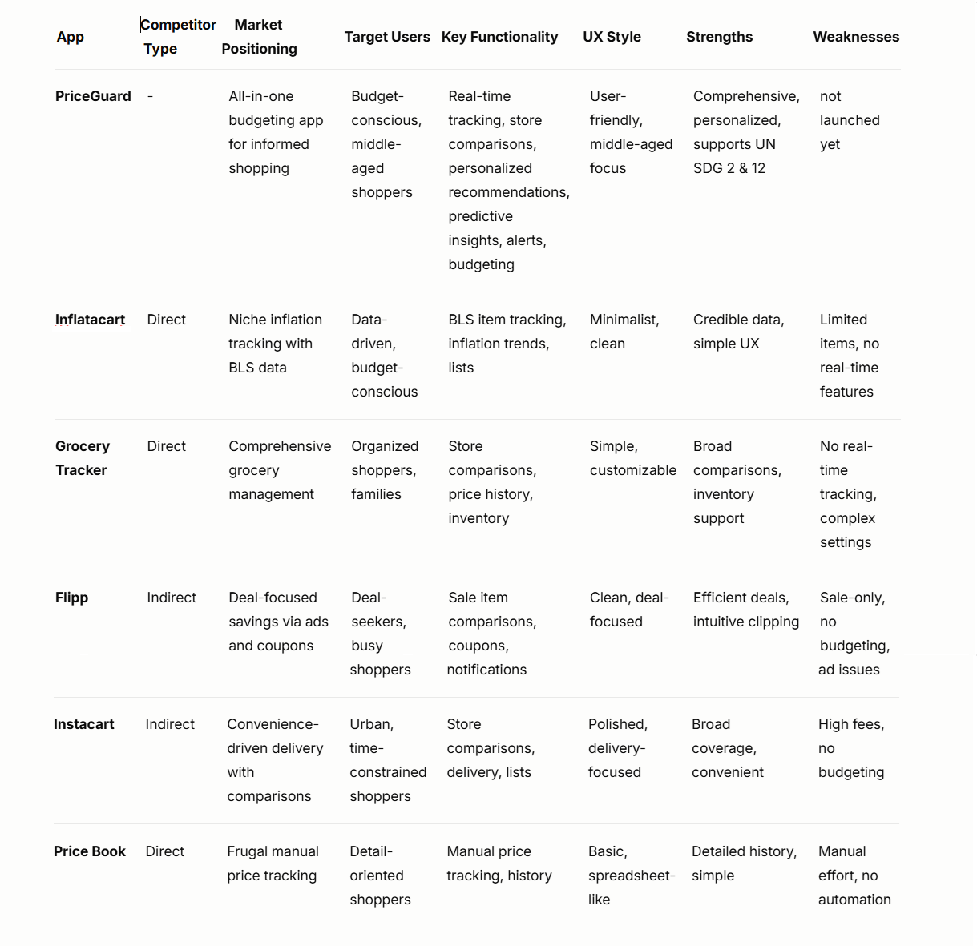

## Section:04

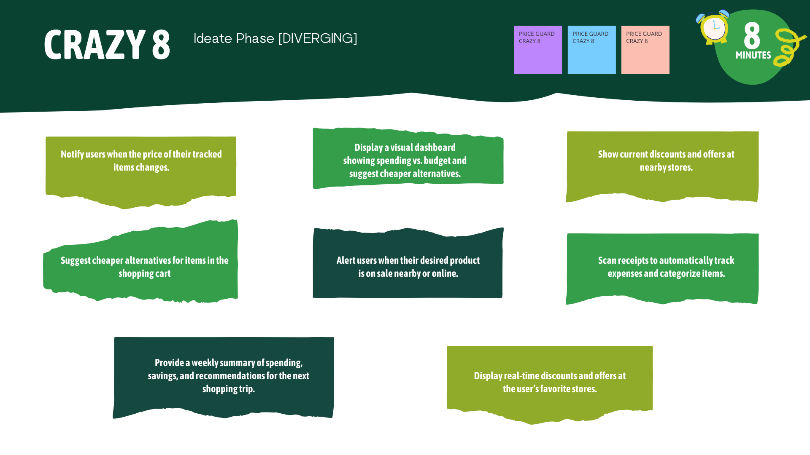

AFTER DOT VOTE:

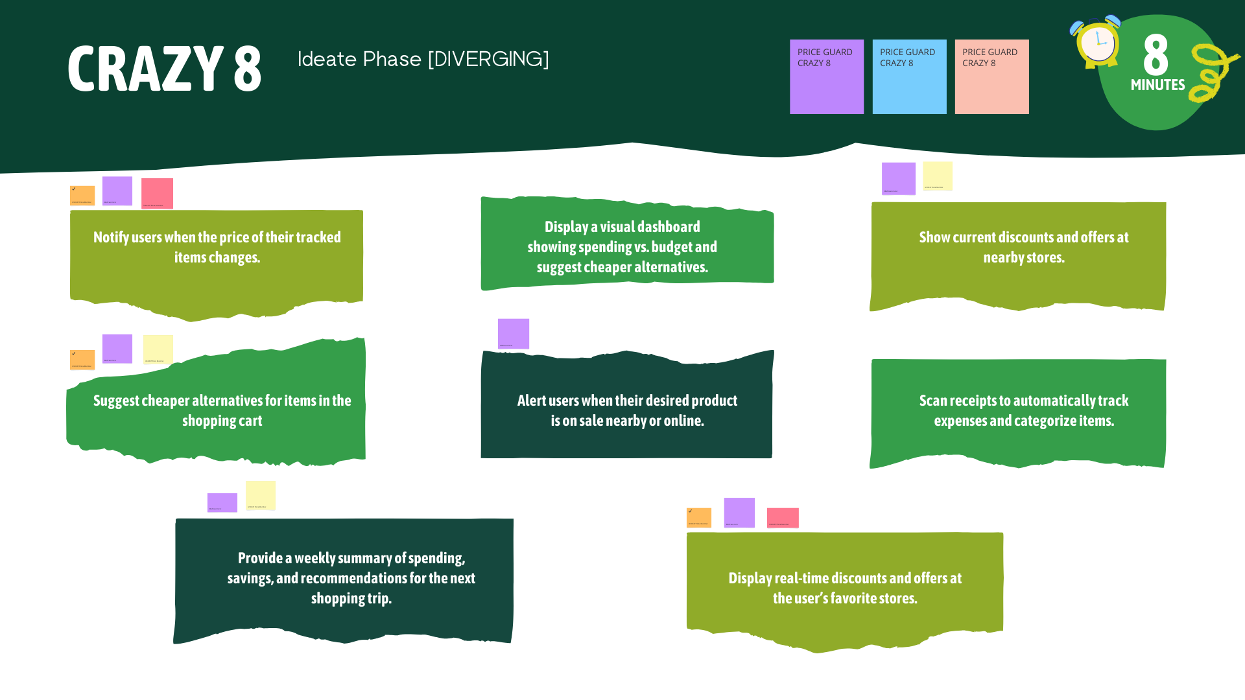

**HMW??**

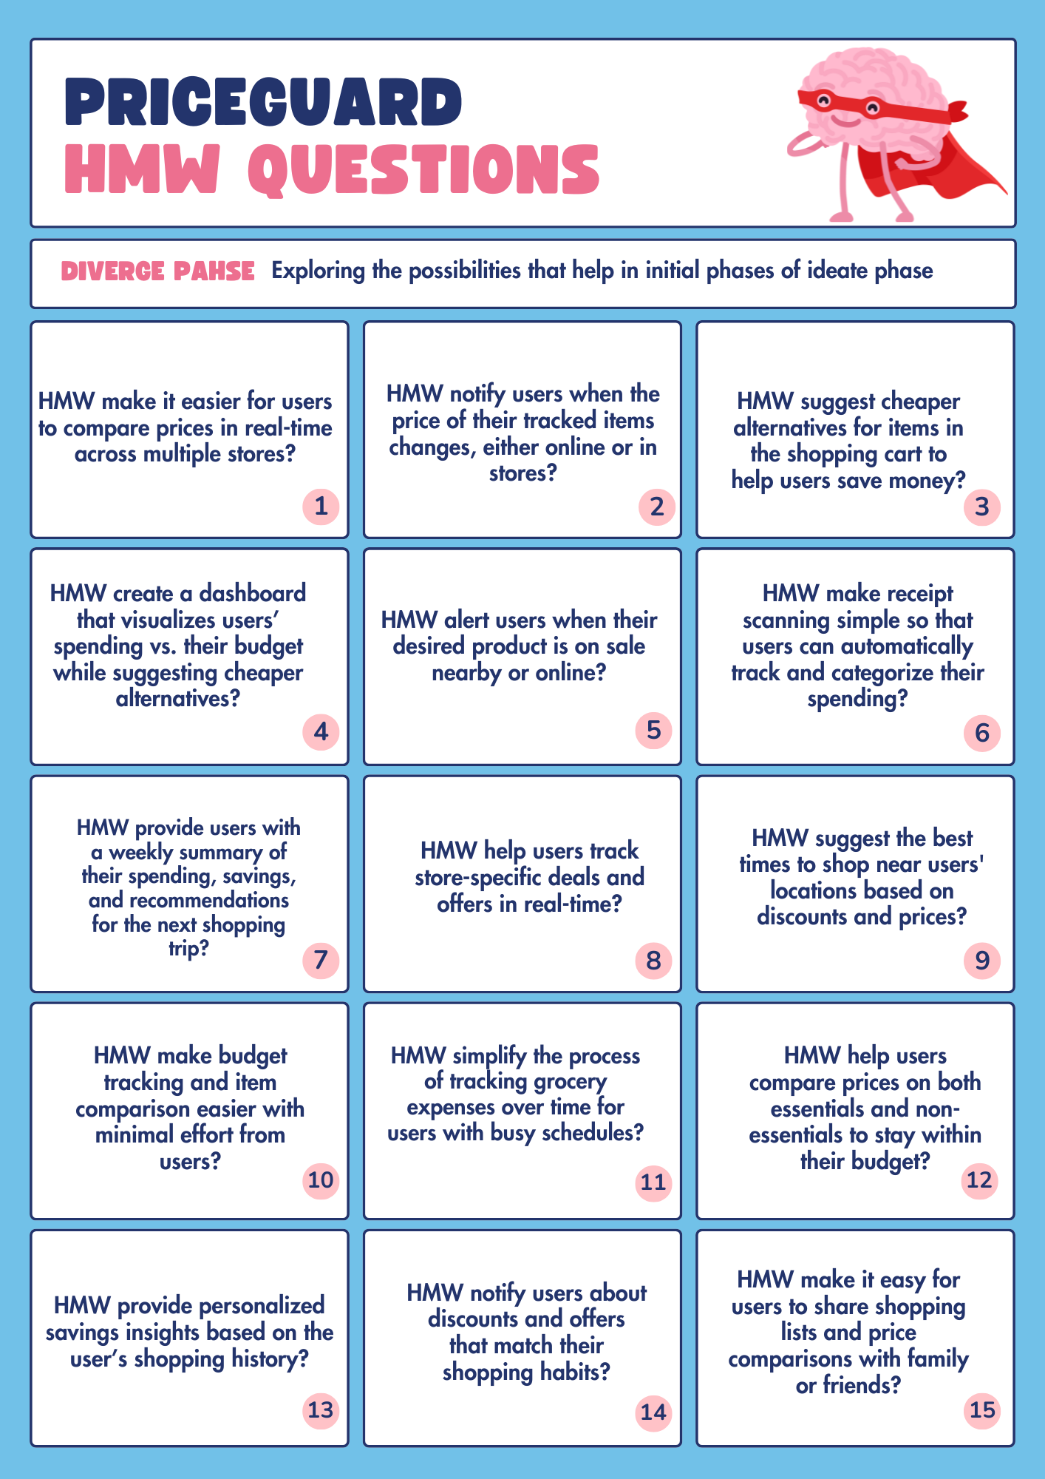

**Solution Design Sketches:**

