## horizontal line



PriceGuard Project Milestone 5 - Lo-Fi Prototype & Testing

# Wireframes

Note that we have used a different font to represent pencil-like writing.

## Screenshots

<https://www.figma.com/design/CdBOo0mBZToy0HDkvtGwjM/PriceGuard-WireFrames?node-id=0-1&p=f&t=pHBamatC50iCGma3-0>

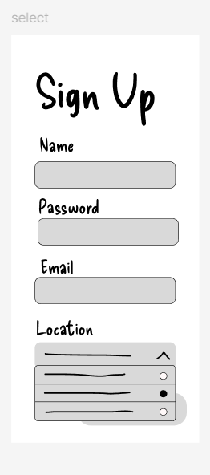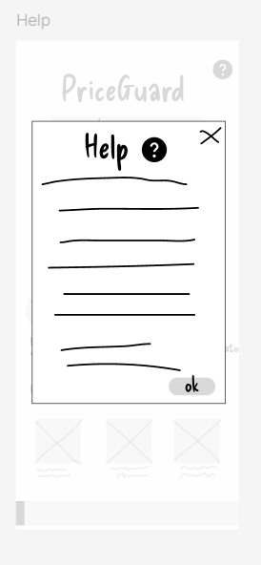

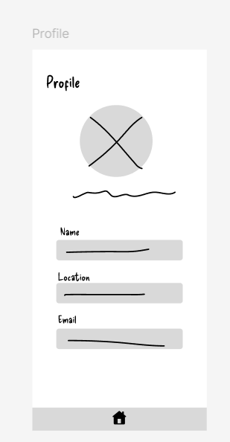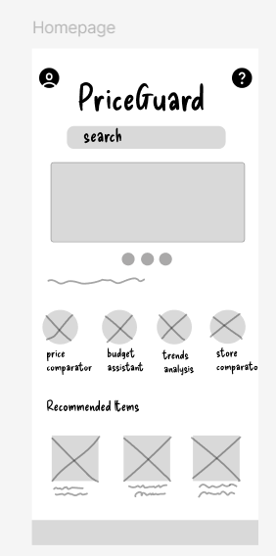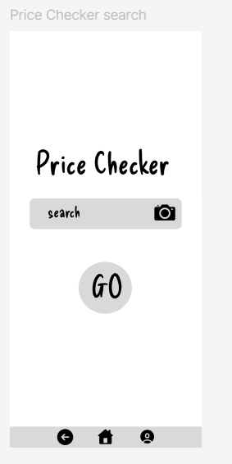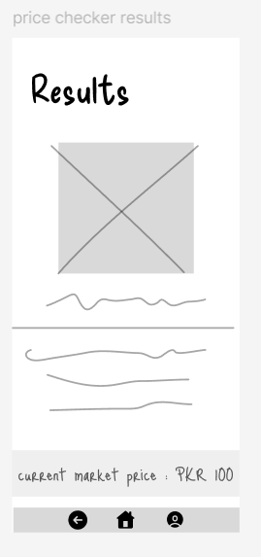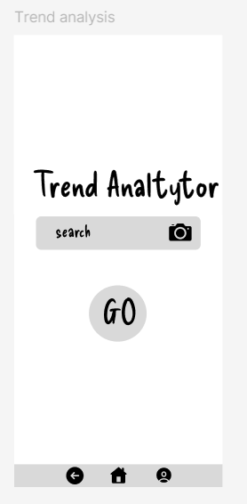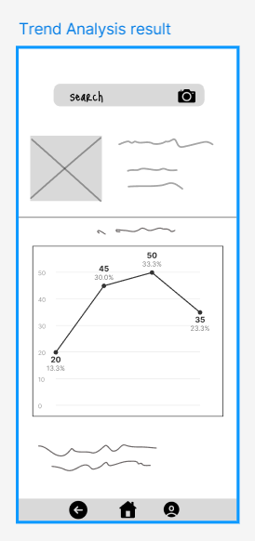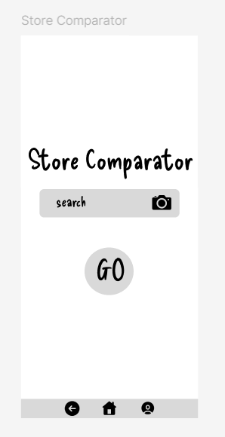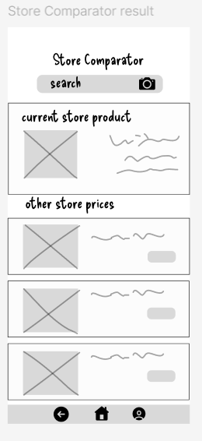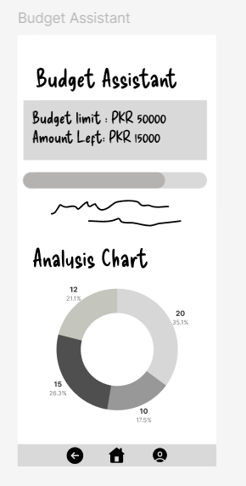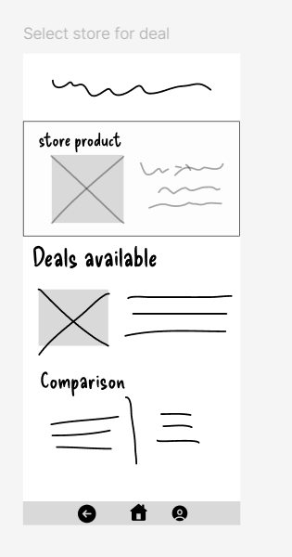

## 

## Navigation Flow

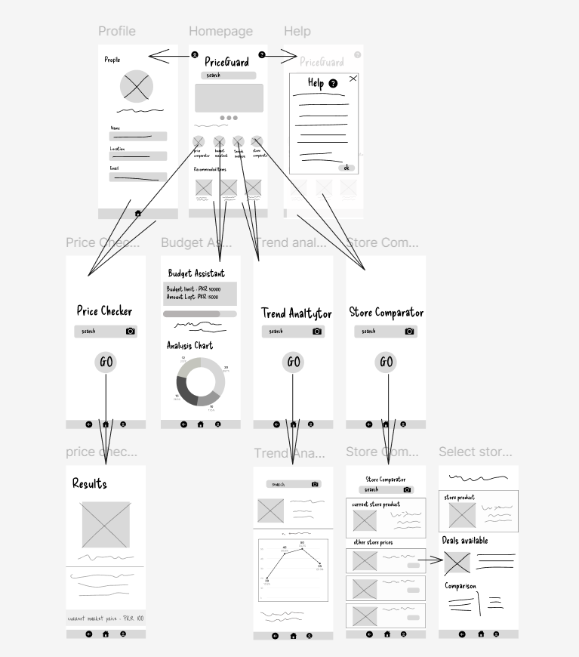

# Lo-fi Prototype

<https://www.figma.com/design/uGPH489B4qEcjBMLTnH8Qq/lo-fi_PriceGuard?node-id=0-1&p=f&t=FKYei1ILKmrh9gmv-0>

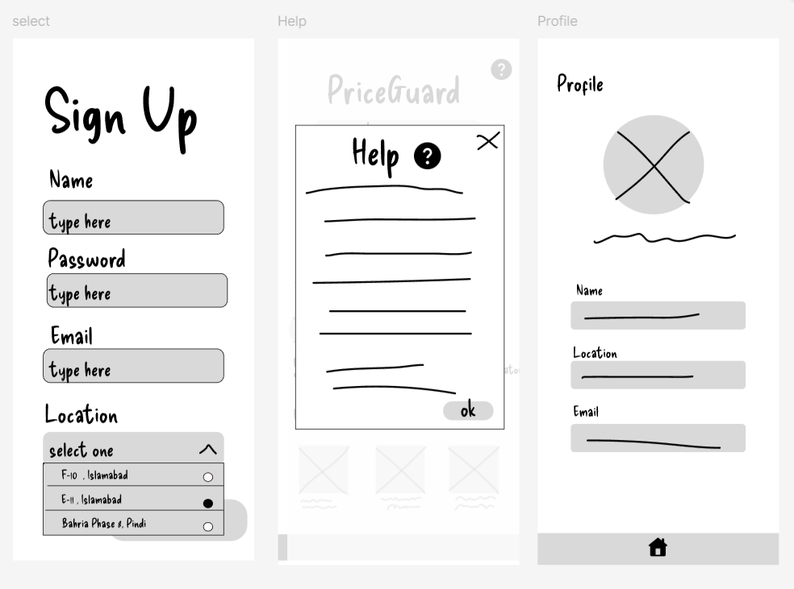

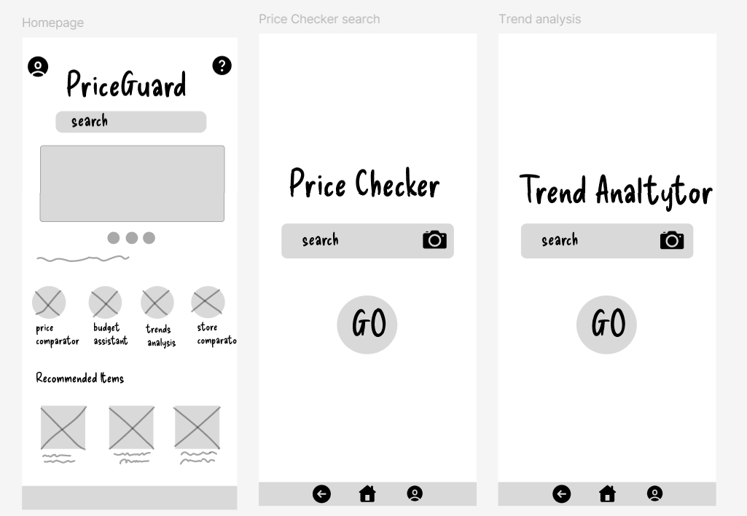

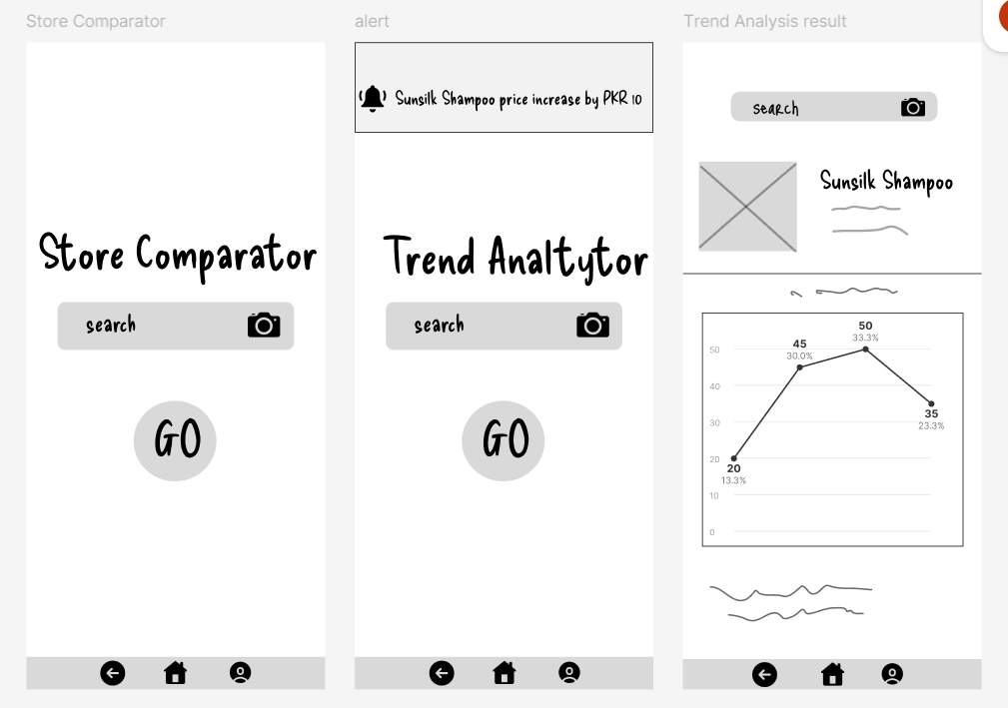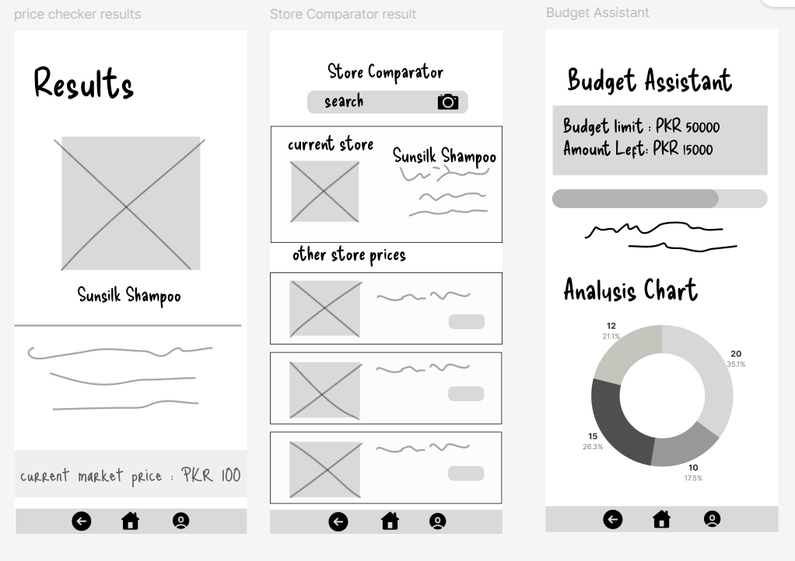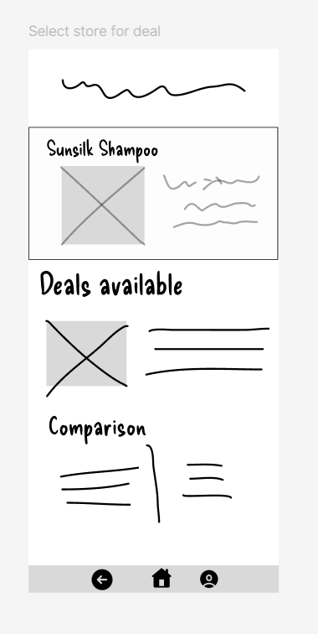

# Appendix

### **Appendix for PriceGuard Project**

### **Project Brief**

The **PriceGuard** app is a shopping assistant designed to help users track grocery prices, compare store deals, analyze price trends, assist with budgeting, and provide personalized shopping recommendations. The app aims to support budget-conscious shoppers, helping them save money and make informed shopping decisions by providing real-time price comparisons and alerts.

### **Changes to the Project Brief**

There have been **no changes** to the scope or plans of the project. The project has proceeded according to the initial plan, with a focus on:

* **Creating wireframes and low-fidelity prototypes** based on user needs.
* **Testing the app’s usability** through various scenarios, focusing on core features such as price comparison, budgeting, and price alerts.

### **Team Dynamics**

* **Javeriah Abid**: Responsible for **document organization** and **wireframes**.
* **Aliza Ibrahim**: Contributed to **wireframes** and **navigation flow**.
* **Mehreen Israr**: Worked on **prototypes**.
* **Fizza Mumtaz**: Worked on **prototypes**.

### **Links**

* **Wireframes**: [View lo-fi Prototypes on Figma](https://www.figma.com/design/CdBOo0mBZToy0HDkvtGwjM/PriceGuard-WireFrames?node-id=0-1&p=f&t=pHBamatC50iCGma3-0)
* **Lo-fi Prototype**: [View Wireframes on Figma](https://www.figma.com/design/uGPH489B4qEcjBMLTnH8Qq/lo-fi_PriceGuard?node-id=0-1&p=f&t=FKYei1ILKmrh9gmv-0)