Exploring the Differences and Similarities in Process Scheduling Algorithms

Andrew D. Hurd and Luke M. Mehring
Computer Science Department

University of Wisconsin-Eau Claire

Eau Claire, WI 54702

{hurdad, mehrinlm}@uwec.edu

Abstract

By using a program to different simulate process scheduling techniques in Operating Systems we can easily compare and contrast the efficiency of using different system variables. This enables absolute control over all variables, reducing the variance in the results. Allowing us to easily compare time quantum, number of queues used in multi-level feedback queue scheduler, and age time in a controlled environment.

Introduction

There are dozens of different techniques and algorithms to determine which process should run next in an Operating System. The three algorithms we implemented were:
- Multi-level Feedback Queue Scheduler
- Real-Time Scheduler
- Hybrid Scheduler

Within these algorithms we enabled number of queues, time quantum, and age time to be user inputted variables. This allows us to compare the average wait time and average turnaround time for different values. We also allowed user to import and add custom processes by declaring a p_id, burst time, arrival time, priority, deadline, and input and output time. These inputs allow us to have complete control over all processes and variables that the schedulers could require.

We used a script to generate random numbers using perls random number generator and an upper bound we specified. We used these random numbers to generate a list of processes that are used in our test cases. While the processes are random, by using the same set of processes for all related test, we insured consistency throughout all test cases.

In this paper, we will use a number of graphs to help illustrate the similarities and differences of different values used. All these graphs were generated directly from unedited output files from our program. The individual results for each process as well as a comparison of the different algorithms to each other will be explained and clarified in the following sections.

Multi-Level Feedback Queue Scheduler

The Multi-Level Feedback Queue Scheduler (MFQS) manages a series of round-robin queues over a “First Come, First Serve” (FCFS) bottom queue. Processes arriving to the scheduler are placed first in the topmost round-robin queue and execute in order of arrival. Based on the queue from which the process comes prior to running on the cpu, each processes has a particular time quantum for which to run, which doubles with each subsequent queue. If a process finishes its time quantum and still has a burst remaining, it is dropped down to the next queue to allow other processes waiting in the above queues to execute first before the initial process can execute a second time. If a process drops down into the final FCFS queue, it will either age back up into the last round robin queue or run until its burst is exhausted as the final queue has no time quantum.

The MFQS implemented in this study has a variable number of round-robin queues, time quantum, and aging time. The round-robin queues are bounded between 1 and 4 and the time quantum and aging time can be any integer value. The tests executed below demonstrate the changing behavior of the MFQS when these variables change.

MFQS: Variable Aging Time

First, we evaluated the effect of changes to the aging time variable on the waiting and turnaround times for a process scheduling simulation. The expectation going into these tests were that a changing aging time would only affect the results of the simulation if the processes had sufficient initial burst to fall down into the FCFS queue and become starved. The aging time value would then determine whether they were allowed to promote back into the round robin queues, or if they would remain in the FCFS queue long enough to run again.

The line graph below shows the effect of a variable aging time on a MFQS with only a single round-robin queue and a FCFS queue with processes having bursts between 0 and 32. Each individual line represents a particular base time quantum value. As the aging time increases, the average waiting time increases slightly as well.

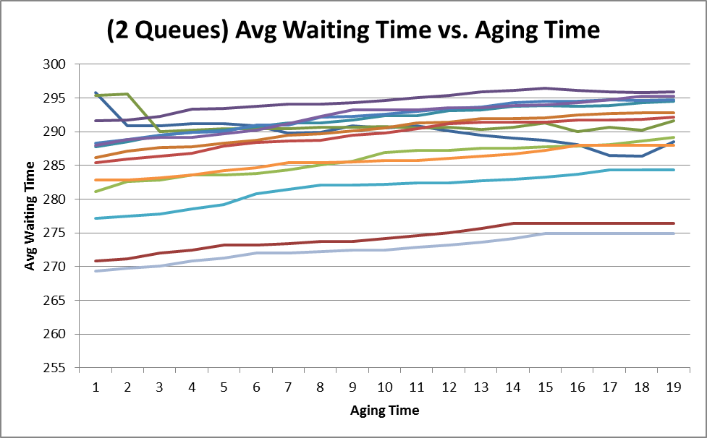
Figure 1: Effect of Aging Time on MFQS

This seems to show that an increase in aging time, though promoting fairness in allocating cpu time, can result in a longer average wait time for the algorithm as a whole.

As can be expected, as the number of queues or time quantum value increases, the effects of aging time changes diminish. Below is a graph showing the null effect as the number of queues increases.

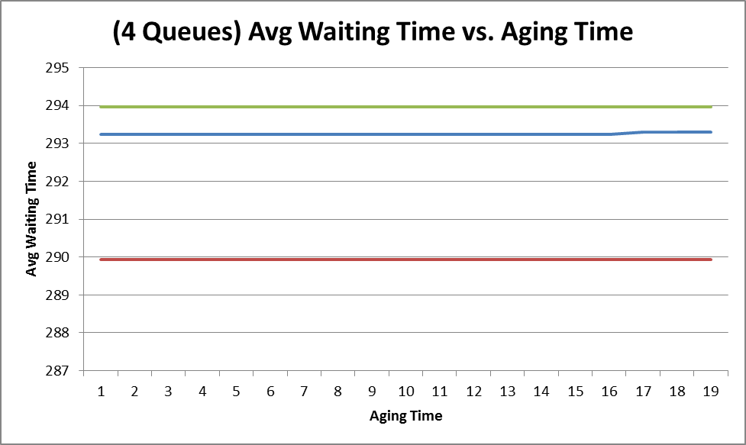
Figure 2: Effect of Queue Number and Aging Time on MFQS

This result is expected since only processes in the FCFS queue can be “aged up” and the number of processes that spend time in the FCFS queue decreases as there are a greater number of queues to traverse to reach the bottom. The above results were largely mirrored by all process batches executed.

MFQS: Variable Time Quantum

Next, we evaluated the effects of time quantum changes on the waiting and turnaround times for MFQS. Depending on the particular process group, the results of time quantum changes varied greatly. For some process groups, time quantum increases eventually resulted in a flat-lining of average waiting time. In other cases, time quantum changes forced dramatic changes upon the waiting time of the processes. For instance, with a larger process size and large time quantum size, the graph below shows that waiting times for a particular process run varied greatly, but then increased steadily after a time quantum of ten.

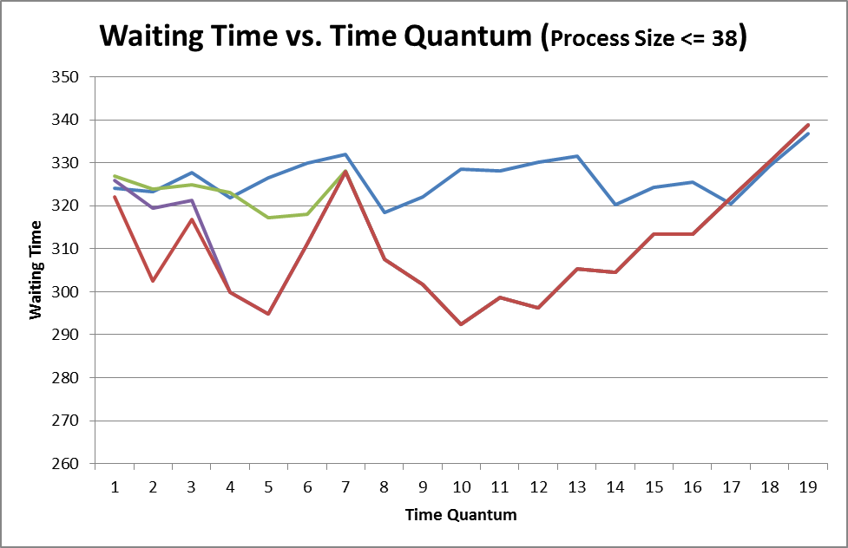
Figure 3: Effect of Time Quantum Size on MFQS

Approximately half our tests saw behavior similar to the above result in which a minimum wait time could be seen visually in our graph. However, another half of our tests showed that if the time quantum increased past a certain point, the waiting time flat-lined. This seems to be a result of very few processes actually finishing a time quantum. If the time quantum becomes large enough, eventually the MFQS can degrade to a simple FCFS implementation.

Hybrid Windows Scheduler

The hybrid windows scheduler uses dynamic priorities that are periodically updated based on amount of CPU time used. Processes that are denied use of the processor have their priorities increased, while processes that are CPU bound are penalized by having their priority decreased. The simulated scheduler does a sweep of processes ever 100 clock ticks in order to look for starving processes that have not been in the CPU recently.

We implemented I/O capability for this scheduler. This allows us to more closely simulate a real world scenario. When a process needs to do I/O it leaves the processor and goes into a wait queue until its I/O is complete. But because it missed out on his processor time it is give an increased priority to make up for it. This hopefully allows the process to get back into the CPU faster than if it simply ran out of CPU time.

While many different factors go into what the dynamic priority of an individual process is, all scheduling is done strictly biased on priority for the hybrid windows scheduler. We implemented this with the priority_queue class in C++ standard library. The priority_queue class uses a vector of processes in the background to implement its queue. We encountered a problem when we discovered that the priority_queue did not update when you changed the priority of an item in the queue already. To solve this problem we were forced to manually iterate through each item in the queue and force the priority queue to update.

HWS: Variable Time Quantum
For the Hybrid Window Scheduler, we tested the effect of a variable time quantum on waiting and turnaround times. In all tests, a similar pattern was observed. When the time quantum was very low, the waiting time shot up dramatically and then decreased and leveled out as the time quantum increased. The graph below shows the shape observed for all Hybrid Scheduler tests.
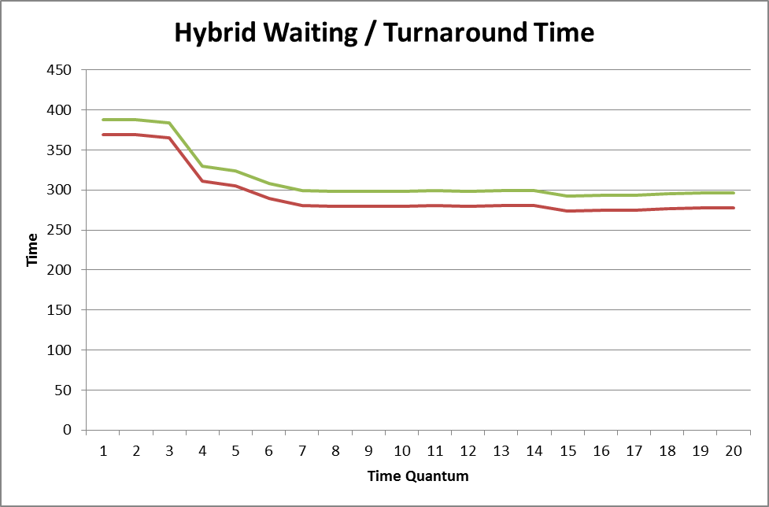
Figure 4: Effect of Time Quantum Size on Hybrid Window Scheduler Waiting and Turnaround Times
As can be seen above, after the time quantum exceeds 4 clock ticks, the average waiting and turnaround times fall dramatically from values nearing 380 to around 290. This result shows that the Hybrid Scheduler improves as the time quantum grows.

MFQS and Hybrid Windows Scheduler

Lastly, we compared the results of MFQS and the Hybrid Scheduler based upon optimal and average turnaround times. For this test, each process group was sent through both the MFQS and Hybrid Window Scheduler with varying time quantum values. Then, the optimal (minimum) and average turnaround times were found for each.

In most tests, the Hybrid Window Scheduler outperformed the MFQS by achieving the minimum turnaround time, but not by much. The results for minimum time for process groups of burst upper bound 10, 17, 25, 32, and 39 where:

MFQS: 52, 117, 148, 246, and 303 (clock ticks)

Hybrid: 68, 108, 140, 250, and 292 (clock ticks)

Based upon the results above, the two algorithms seem to perform near equally. The average turnaround time shows that the Hybrid Scheduler, however, is more consistently efficient. The matching results for the average turnaround time where as follows:

MFQS: 65, 129, 167, 287, 325 (clock ticks)

Hybrid: 70, 113, 151, 283, 314 (clock ticks)

The above shows that the Hybrid Scheduler seems to be more consistently efficient. Taken with the evidence that the Hybrid Scheduler performs more efficiently with a higher time quantum, the Hybrid Scheduler performs comparatively better with a high time quantum.

Real-Time Scheduler

The real time scheduler is also a priority scheduler. There are two main differences between hybrid scheduler and real time. Those two things being that in real-time scheduler the priority never changes and the implementation of deadlines instead of I/O.

There are two different modes for real-time to run in. The first of which is soft mode. In soft mode if a deadline is missed the scheduler simply kills that process and moves on to the next process in the priority queue. The scheduler just flags that process as missing its deadline. If this was a real operating system, it would notify whoever started the process that it failed and did not complete. This is a more common type of scheduler than the alternative which is hard mode. In hard mode if any processes miss their deadline, the operating systems stops running any processes. This is used to simulate a situation where each process is mission critical and if one fails all the other will either fail or be incorrect in some way.

While deciding on which analytical test and comparisons to make between schedulers we decided that real-time scheduler was unfair to compare to the other two. This is mainly because processes can stop processing and never complete at any time if the system clock passes its deadline. We performed some preliminary test and real time scheduler always outperformed the others. Below is a graph comparing average turnaround and average wait times of the real-time scheduler and multi-level feedback queue scheduler when identical test data are entered.

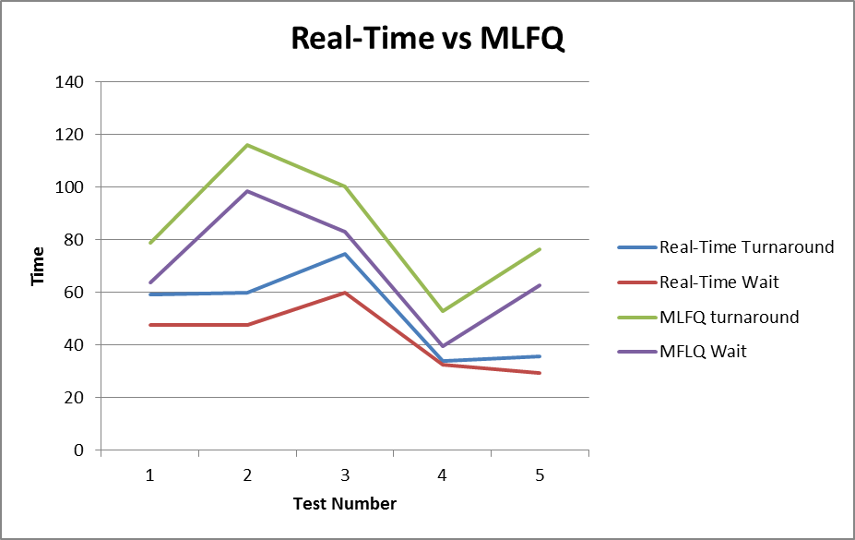
Figure 5: Difference between Real Time and Multi-Level Feedback Queue schedulers

While it is obvious that this comparison completely depends upon how many processes do not meet their deadline, it makes a clear point that MLFQ can approach the efficacy of real-time, it is extremely unlikely that it will outperform it.

Summary

Out of the three schedulers it is clear that real-time scheduler is the fastest when the deadlines fail. Otherwise the other two schedulers (multi-level feedback queue and hybrid) are relatively equal overall. In certain situations one may outperform the other, but we found that in the cases we ran the differences were negligible.

