**O’ZBЕKISTON RЕSPUBLIKASI**

**OLIY TA’LIM, FAN VA INNOVATSIYALAR VAZIRLIGI**

**ZAHIRIDDIN MUHAMMAD BOBUR NOMIDAGI**

**ANDIJON DAVLAT UNIVЕRSITЕTI**



**BERILGANLAR BAZASI FANIDAN**

**MUSTAQIL ISH**

**FAN O’QITUVCHISI: JAMOLDINOV SAYDULLOH**

**TOPSHIRUVCHI: 201- GURUH TALABABSI**

**ABDULLAYEVA M.**

**ANDIJON-2024**

**Mavzu: Palikilinika uchun ma’lumotlar bazasi loyihasini tuzish**

**Palikilinika loyihasini Umumiy ko’rinishi**

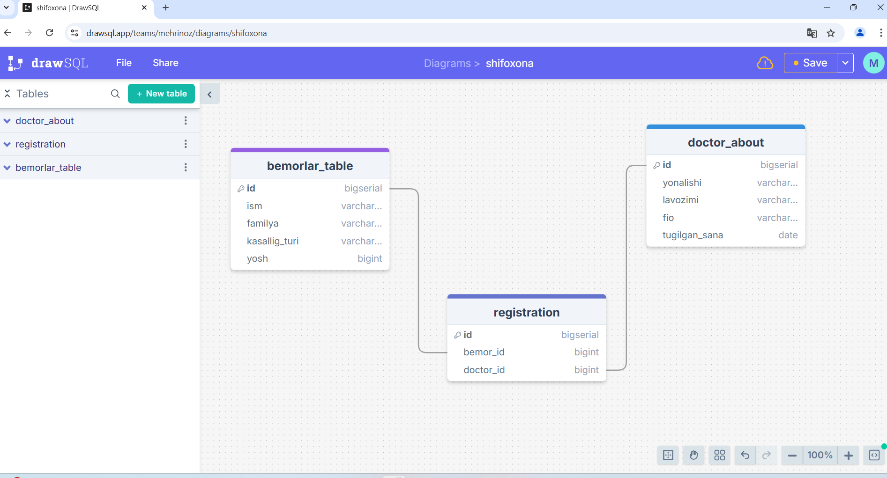

1-rasm

**Database yaratish**

postgres=# CREATE DATABASE shifoxona;

**yaratilgan databasega o’tish**

postgres=# \c shifoxona;

**TABLE YARATISH**

**1-jadval**

shifoxona=# CREATE TABLE bemorlar_table(

shifoxona(# id BIGSERIAL PRIMARY KEY,

shifoxona(# ism VARCHAR(255),

shifoxona(# familya VARCHAR(255),

shifoxona(# yosh INT,

shifoxona(# kasallig_turi VARCHAR(255));

**2-jadval**

shifoxona=# CREATE TABLE doctor_about(

shifoxona(# id BIGSERIAL PRIMARY KEY,

shifoxona(# yunalishi VARCHAR(255),

shifoxona(# lavozimi VARCHAR(255),

shifoxona(# fio VARCHAR(255),

shifoxona(# tugilgan_sana DATE);

**3-jadval**

shifoxona=# CREATE TABLE registration(

shifoxona(# id BIGSERIAL PRIMARY KEY,

shifoxona(# doctor_id INT REFERENCES doctor_about(id) ON DELETE CASCADE,

shifoxona(# bemor_id INT REFERENCES bemorlar_table(id) ON DELETE CASCADE);

CREATE TABLE

**Malumot qo’shish**

**1-jadvalga malumot qo’shish**

INSERT INTO bemorlar_table (ism, familya, yosh, kasallig_turi) VALUES

('Ali', 'Valiyev', 30, 'Gripp'),

('Zarina', 'Saidova', 25, 'Opka yalliglanishi'),

('Jasur', 'Toshbekov', 40, 'Diabet'),

('Nodira', 'Xamidova', 35, 'Gipertoniya'),

('Aziz', 'Raxmonov', 50, 'Yurak kasalliklari');

**2-jadvalga malumot qo’shish**

INSERT INTO doctor_about (yunalishi, lavozimi, fio, tugilgan_sana) VALUES

('Terapevt', 'Bosh shifokor', 'Otabek Qodirov', '1985-03-15'),

('Pediatr', 'Shifokor', 'Dilnoza Karimova', '1990-07-20'),

('Hirurg', 'Oliy toifali shifokor', 'Jasur Murodov', '1982-11-05'),

('Kardiolog', 'Shifokor', 'Zarina Rahmonova', '1978-09-10'),

('Nevrolog', 'Shifokor', 'Azizbek Tashkentov', '1988-01-25');

**3-jadvalga malumot qo’shish**

insert into registration values(1,1,1);

insert into registration values(2,2,2);

insert into registration values(3,3,3);

insert into registration values(4,4,4);

insert into registration values(5,5,5);

**Yaratilgan jadvallarni ko’rish**

select * from bemorlar_table;

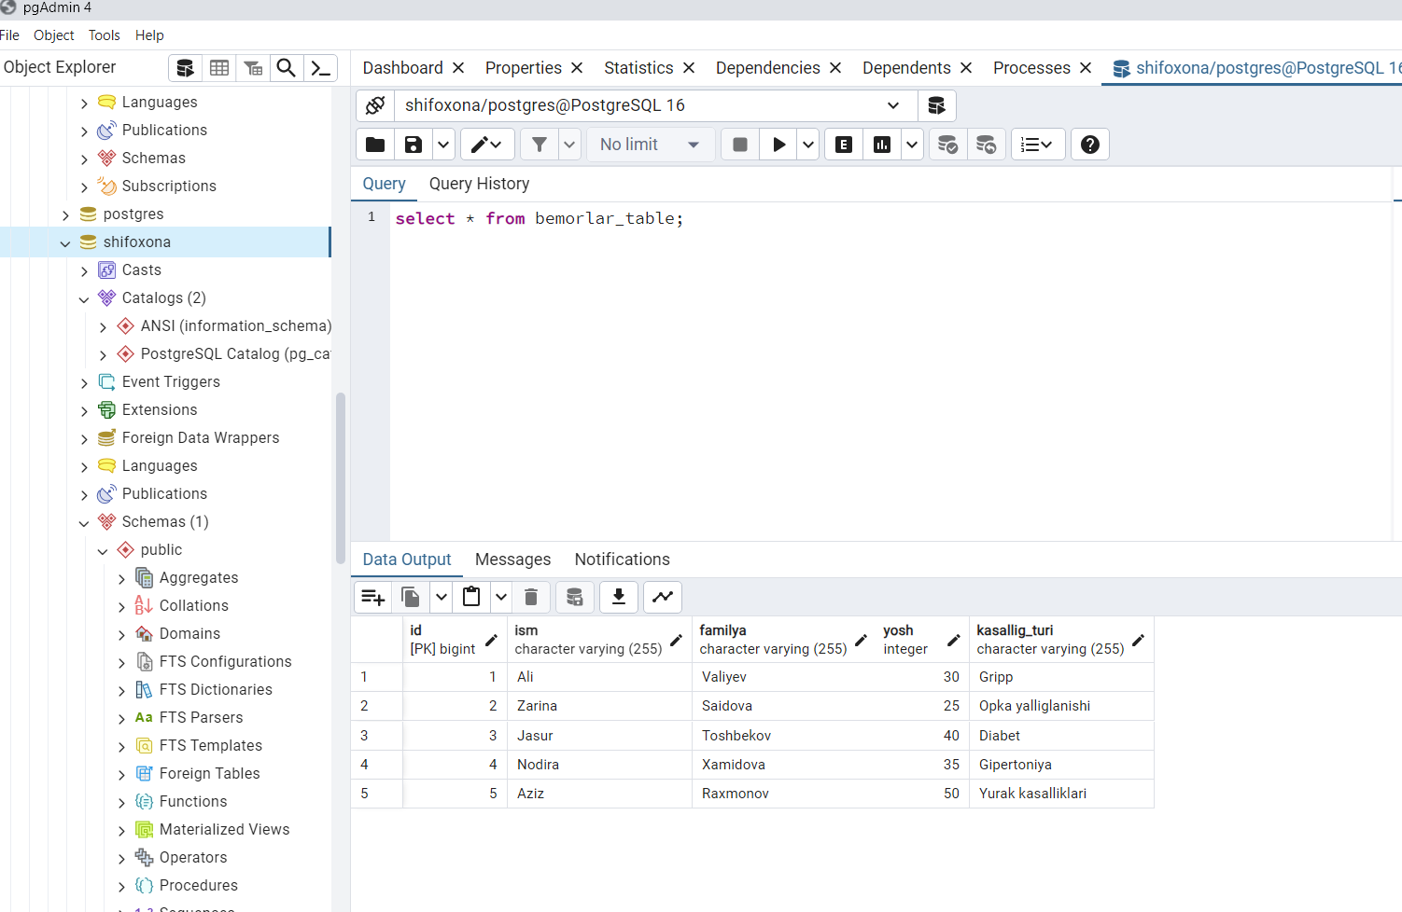

2-rasm

select * from doctor_about;

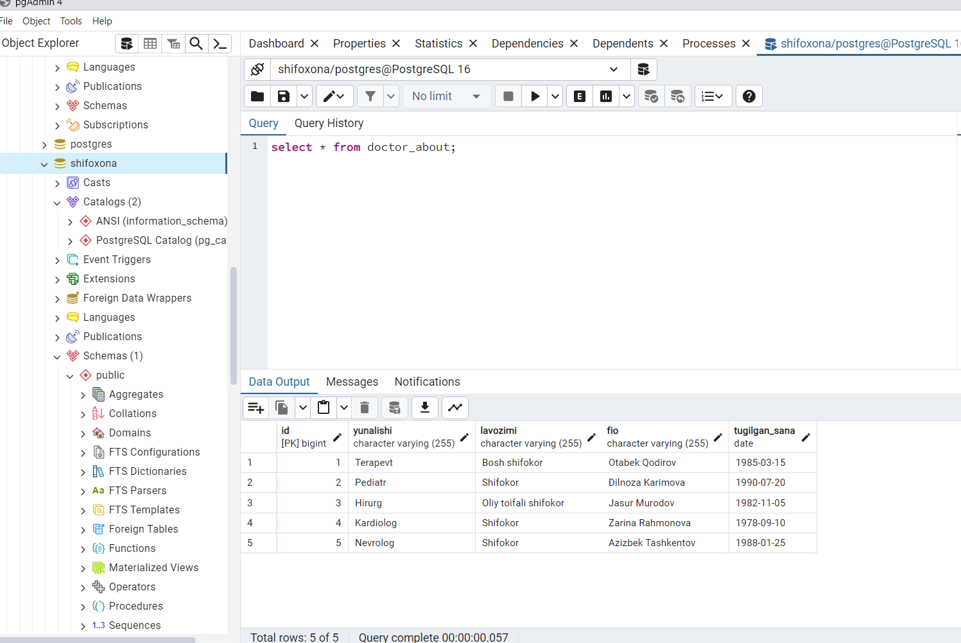

3-rasm

SELECT

r.id AS registration_id,

d.id AS doctor_id,

d.fio AS doctor_name,

b.id AS bemor_id,

b.ism AS bemor_ism,

b.familya AS bemor_familya,

b.yosh AS bemor_yosh,

b.kasallig_turi AS bemor_kasalligi

FROM

registration r

JOIN

doctor_about d ON r.doctor_id = d.id

JOIN

bemorlar_table b ON r.bemor_id = b.id;

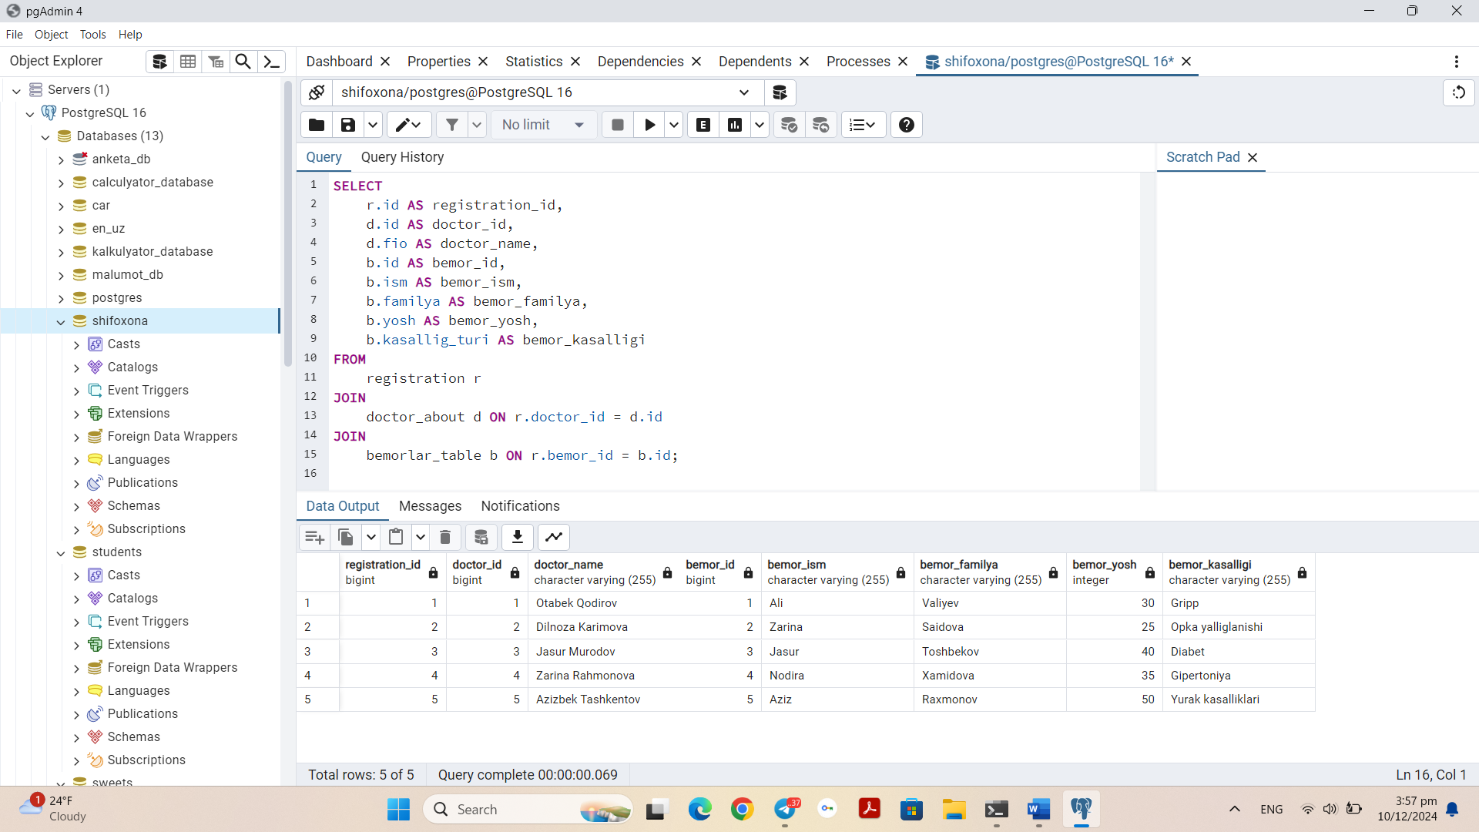

4-rasm

**1ta doctor nechta bemor ko’rgani bilish**

SELECT

d.id AS doctor_id,

d.fio AS doctor_name,

COUNT(r.bemor_id) AS bemorlar_soni

FROM

doctor_about d

LEFT JOIN

registration r ON r.doctor_id = d.id

GROUP BY

d.id, d.fio

ORDER BY

bemorlar_soni DESC;

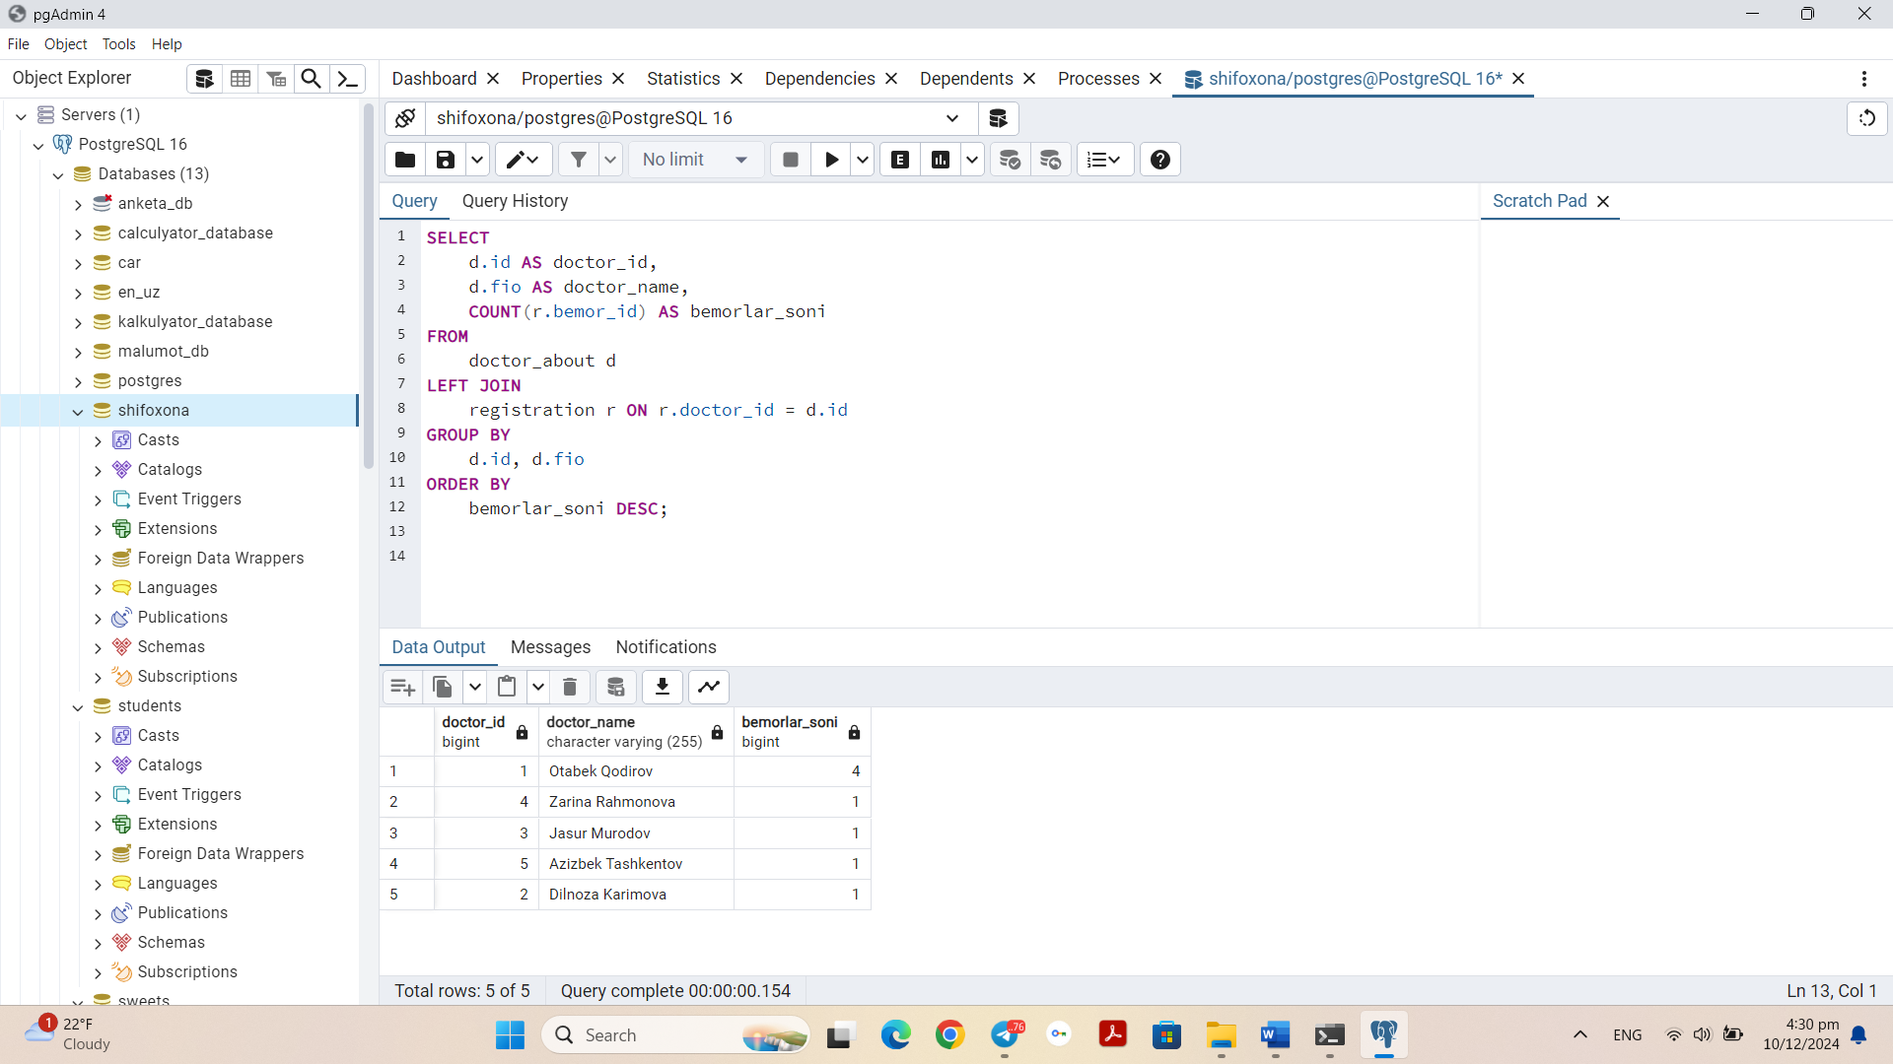

5-rasm

**Bemorlar sonini ko’rish**

SELECT

COUNT(DISTINCT b.id) AS bemorlar_soni

FROM

registration r

JOIN

bemorlar_table b ON r.bemor_id = b.id;

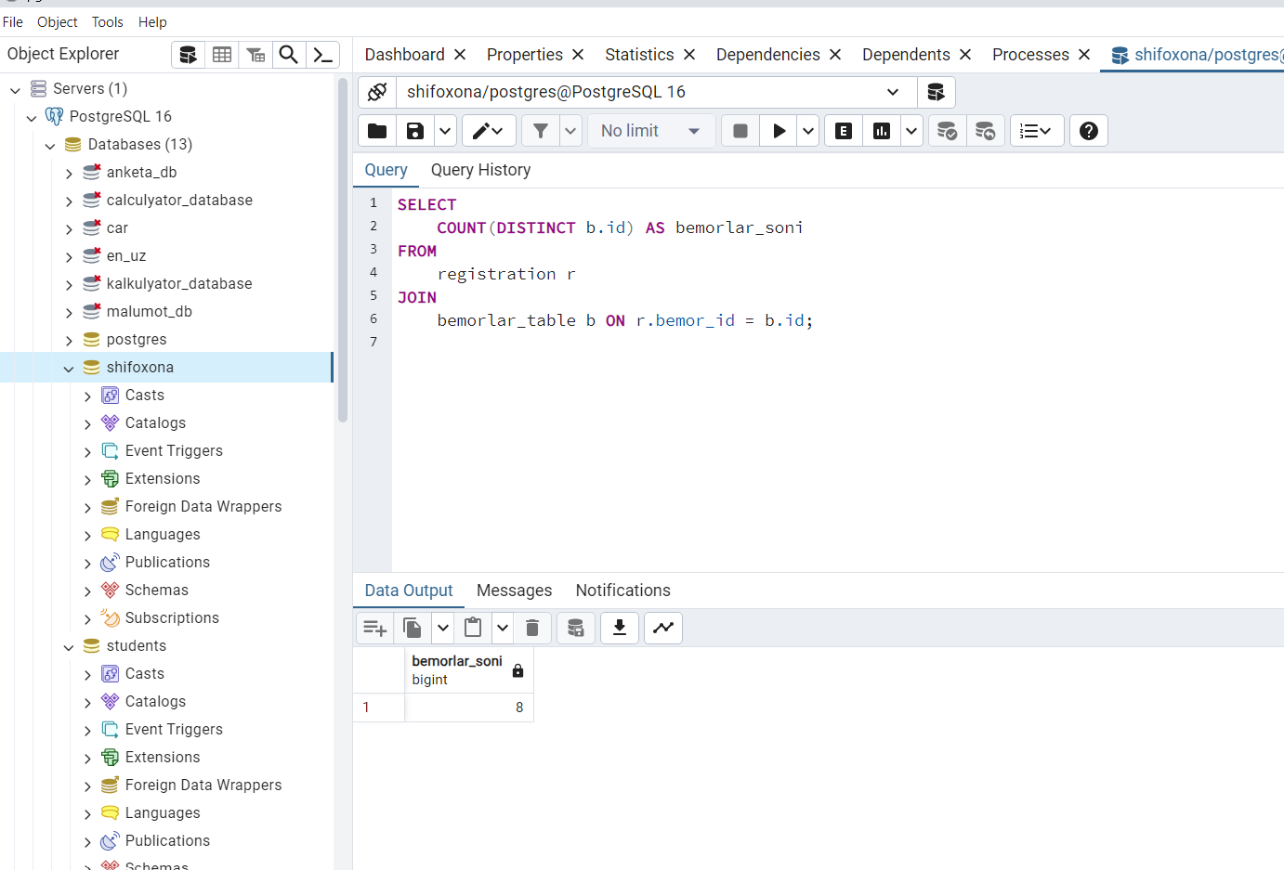

6-rasm

**Doctorlar sonini ko’rish**

SELECT

COUNT(DISTINCT d.id) AS doctorlar_soni

FROM

registration r

JOIN

doctor_about d ON r.doctor_id = d.id;

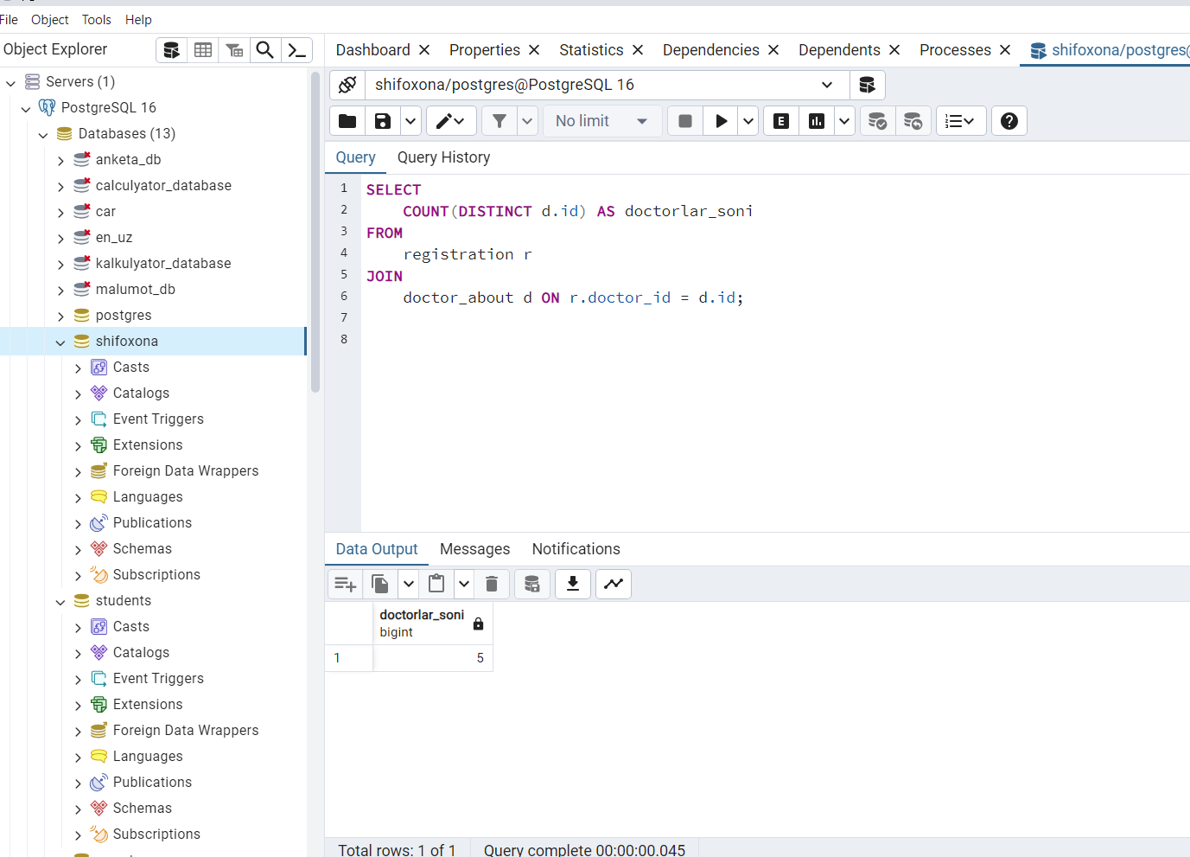

7-rasm