“Next Generation sequencing for the
Genetic Diagnosis of Intellectual Disability and
Developmental Delay in a Consanguineous Family”

Analyzed by | Mehrnaz Ohadi
Affiliation | Genomics Laboratory of Iran (https://www.genomicslaboratory.ir/) &  Helix, USA (www.helix.com)
Dataset | Annotated WES variants (GRCh37/hg19)
Date | 25 August 2026

Summary
Whole-exome sequencing (WES) produces a large number of variants that require systematic filtering and interpretation to identify plausible disease-associated candidates. An annotated WES dataset containing 386,518 variants was filtered by functional region, predicted consequence, population frequency, genotype/inheritance, and variant-call quality. Surviving variants were evaluated using computational prediction scores, ClinVar annotations, gene–disease evidence, and phenotype concordance. The analysis reduced the dataset to 71 working variants, of which 54 were PASS calls. Four genes were prioritized: YY1AP1, PUS10, DOCK11, and SLC6A6 out of which, YY1AP1 was the strongest overall clinical candidate; PUS10 carried the strongest research-level splice candidate; DOCK11 had strong variant-level evidence but weaker phenotype concordance; and SLC6A6 primarily matched the retinal phenotype. In conclusion, no definitive causal variant could be established from the supplied data alone. The project demonstrates an evidence-based workflow for WES variant prioritization and highlights the importance of integrating variant-level evidence with gene–disease validity and phenotype fit.

1. Clinical and Pedigree Context
The case describes a consanguineous family with two affected individuals and no reported prior family history of the disorder. Both affected individuals showed developmental delay. Additional reported features included visual impairment and poorly intelligible speech; cleft palate was reported in individual V:1. At examination, V:1 was 32 years old with a head circumference of 51 cm (-2.77 SD), and V:4 was 30 years old with a head circumference of 50 cm (-4.07 SD). The family also included an unaffected son and an unaffected grandchild.
The combination of consanguinity and multiple affected siblings made an autosomal-recessive model a major prioritization hypothesis. However, X-linked and phenotype-specific candidates were not automatically excluded during later interpretation.

2. Introduction
Next-generation sequencing, particularly WES, enables simultaneous analysis of most protein-coding regions of the genome. Because each exome contains many sequence variants, a reproducible filtering strategy is needed to reduce common or low-priority variants and retain variants with plausible functional and disease relevance.
Variant interpretation should integrate multiple evidence types rather than relying on a single pathogenicity score. The ACMG/AMP framework emphasizes population data, computational evidence, functional evidence, segregation, and other evidence categories, and uses the terms pathogenic, likely pathogenic, uncertain significance, likely benign, and benign for Mendelian variant classification [1].

3. Objective
The objective of this project was to analyze the supplied annotated WES dataset and prioritize candidate variants potentially related to the phenotype and inheritance pattern of the case. The analysis was restricted to the supplied data and public databases; pedigree info, raw read files and family segregation data were not available.

4. Methods

4.1 Dataset and annotation fields
The starting annotated dataset contained 386,518 variants aligned/annotated to GRCh37/hg19. Available fields included chromosome and genomic position, reference and alternate alleles, functional region, gene, exonic consequence, transcript-level cDNA/protein annotation, population-frequency fields, computational prediction scores, dbSNP/ClinVar annotations, VCF quality fields, and the sample genotype field (GT:AD:DP:GQ:PL).

4.2 Stepwise filtering strategy
1. Functional-region filtering. Variants in potentially relevant functional regions were retained, reducing 386,518 variants to 24,601.
2. Variant-consequence filtering. Protein-altering and potentially relevant consequences were prioritized, including frameshift, nonframeshift, nonsynonymous, stopgain/stoploss, splice, and selected unknown annotations. This reduced the dataset to 12,734 variants.
3. Population-frequency filtering. Rare or unreported variants were retained. The practical spreadsheet criterion used for population fields was allele frequency <0.01 OR a missing value represented by “.”. Missing frequency was therefore not treated as evidence that a variant was common.
4. Inheritance/genotype prioritization. Because the pedigree strongly suggested recessive inheritance, homozygous alternate calls (1/1) received priority. Combined rarity, genotype, and subsequent prioritization produced a 71-variant working set.
5. Variant-call quality. The FILTER field included PASS, LowQual, my_snp_filter, and combinations of caller filters. PASS calls were retained for the principal high-confidence set, reducing 71 variants to 54. The excluded calls were later reviewed to check that no clearly superior candidate had been lost.
6. Candidate interpretation. The remaining variants were evaluated using population rarity, predicted molecular consequence, DP/GQ and other call metrics, in-silico prediction scores, ClinVar status, gene–disease validity, inheritance, and phenotype concordance.
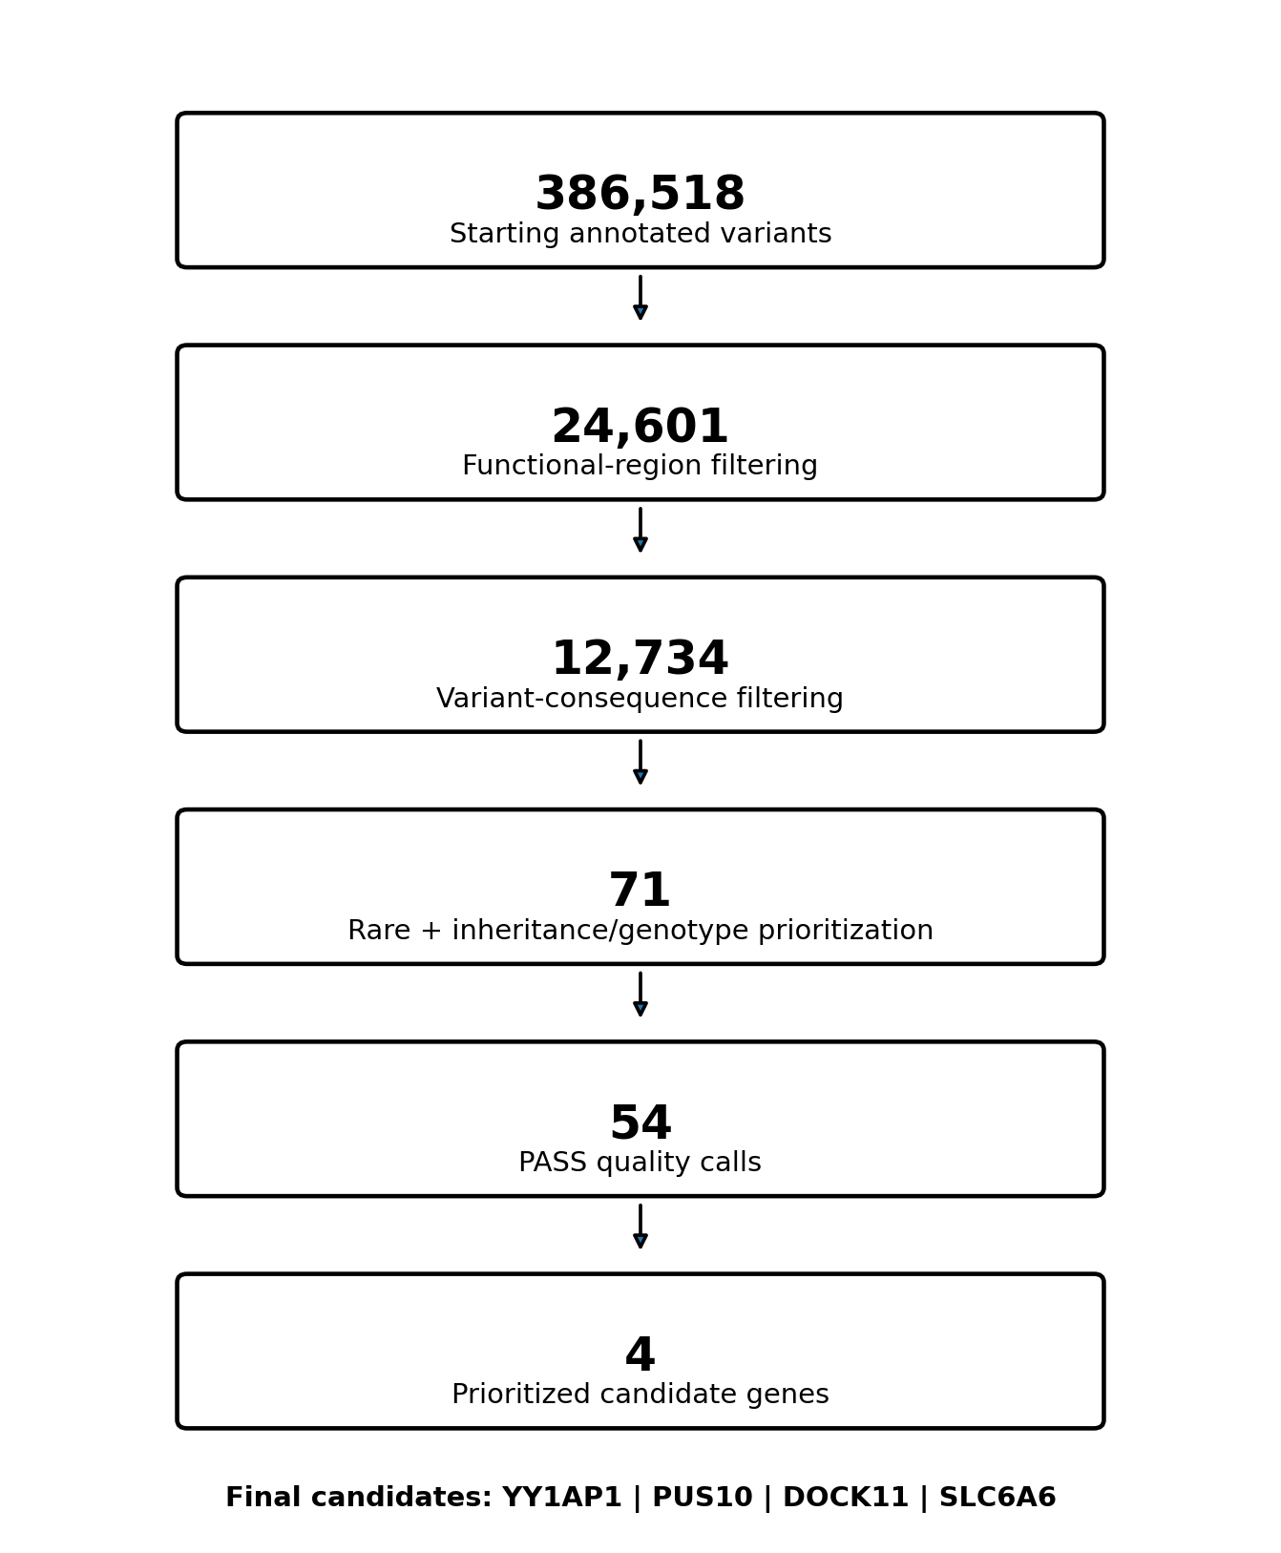
Figure 1. Stepwise filtering workflow used in the project. Intermediate spreadsheet counts generated while testing/correcting filters were not treated as independent biological filtering stages.

4.3 Interpretation principles
- Population rarity: variants with low reported allele frequency or no reported frequency were prioritized.
- Functional consequence: canonical splice, frameshift, stop, and damaging missense/in-frame changes were reviewed, while recognizing that predicted severity alone does not establish disease causality.
- Computational evidence: SIFT, PolyPhen-2, PROVEAN, CADD, MutationTaster, splice-prediction scores, and other available annotations were treated as supporting evidence only.
- Clinical databases and literature: ClinVar, NCBI/OMIM-linked information, and primary literature were used to assess exact-variant evidence and gene–disease relationships.
- Phenotype concordance: known manifestations of each gene-associated disorder were compared with the course phenotype.

5. Results

5.1 Filtering results
Stage | Main criterion | Variants remaining
Starting dataset | All annotated variants | 386,518
Functional region | Relevant coding/splicing/functional regions | 24,601
Consequence | Selected variant-effect categories | 12,734
Rarity + inheritance | AF <0.01 or “.”; genotype/inheritance prioritization | 71
Quality | PASS calls | 54
Integrated interpretation | Gene/disease/phenotype + variant evidence | 4

5.2 Final prioritized candidates
Rank | Gene | Variant (dataset annotation) | Consequence | GT / DP / GQ | Overall interpretation
1 | YY1AP1 | NM_001198899:c.T1373G; p.L458R | Missense | 1/1; 79; 99 | Strongest overall clinical candidate; VUS
2 | PUS10 | NM_144709:c.678-1G>T | Canonical splice acceptor | 1/1; 46; 99 | Strongest research-level splice candidate
3 | DOCK11 | NM_144658:c.C5188T; p.R1730C | Missense | 1/1*; 47; 99 | Strong variant-level evidence; phenotype mismatch
4 | SLC6A6 | NM_001134367:c.229+1T>- / c.230-1T>- | Splice-site deletion | 1/1; 23; 69 | Strong retinal relevance; incomplete overall fit
*The DOCK11 genotype is reported exactly as supplied by the caller. Because DOCK11 is on chromosome X, biological interpretation depends on sample sex and caller ploidy conventions.

5.3 Evidence details for the four candidates

YY1AP1
The YY1AP1 variant is a homozygous PASS missense call with DP 79 and GQ 99. The supplied annotation reports ExAC_ALL 8.26×10⁻⁶, CADD 23.2, SIFT damaging (0.005), PolyPhen-2 HDIV damaging (0.988), PolyPhen-2 HVAR damaging (0.975), and PROVEAN damaging (-2.94). The dataset ClinVar field is “Uncertain significance.” YY1AP1 is an established autosomal-recessive Grange syndrome gene; recent reports continue to describe Grange syndrome as caused by biallelic loss-of-function variants and emphasize vascular, skeletal, cardiac, and variable neurodevelopmental features [2,3]. Because the project variant is missense rather than an established loss-of-function allele, it was retained as the leading candidate but not considered proven pathogenic.

PUS10
PUS10 c.678-1G>T is a homozygous canonical splice-acceptor variant with PASS, DP 46, GQ 99, and CADD 27.3. The supplied splice-prediction scores are dbscSNV ADA 1.000 and RF 0.948, strongly supporting predicted splice disruption. However, current NCBI resources describe PUS10 primarily as a pseudouridine synthase involved in RNA modification and do not establish a Mendelian syndrome matching this case [4]. It was therefore retained as a high-priority research candidate rather than a diagnostic candidate.

DOCK11
DOCK11 p.R1730C is a rare homozygous-called PASS missense variant with DP 47, GQ 99, CADD 34, damaging SIFT/PolyPhen/PROVEAN predictions, and localization within the DHR-2 domain. Human DOCK11 deficiency is an established X-linked immune-related actinopathy characterized mainly by early-onset autoimmunity/immune dysregulation, with some reports also noting developmental delay [5,6]. The strong variant-level evidence therefore contrasts with weaker overall phenotype concordance in this course case.

SLC6A6
The SLC6A6 call is a homozygous PASS splice-site deletion with DP 23 and GQ 69. The annotation reports rs67559364 and a Kaviar allele frequency of approximately 1.15×10⁻⁴. Biallelic SLC6A6 defects cause taurine transporter deficiency with early retinal degeneration; cardiomyopathy and very low taurine levels have also been reported [7,8]. This gene therefore provides a strong explanation for the visual component but a less complete explanation for the overall developmental phenotype.

6. Discussion
The filtering strategy reduced a very large annotated WES dataset to four biologically interpretable candidates. The exercise demonstrates why variant prioritization cannot be based on predicted consequence or CADD score alone. A convincing candidate should combine variant-level evidence with a credible gene–disease relationship, compatible inheritance, and phenotype concordance.
YY1AP1 ranked first because it provided the best overall combination of rarity, homozygous genotype, high call quality, damaging predictions, and an established autosomal-recessive disease association. Nevertheless, the exact missense allele remains uncertain, and the known YY1AP1 disease mechanism is dominated by biallelic loss-of-function variants. Accordingly, the available evidence supports prioritization but not causal assignment.
PUS10 illustrates the opposite situation: the variant itself is highly compelling because it disrupts a canonical splice acceptor and has excellent technical and splice-prediction support, but gene-level disease validity is insufficient. This makes it an appropriate research candidate but not a clinically established explanation.
DOCK11 demonstrates that a strong molecular prediction profile can be outweighed by phenotype mismatch. Conversely, SLC6A6 has a clear established disease relationship and strong retinal relevance, but it does not readily account for the entire developmental presentation. These contrasts justify retaining several candidates rather than forcing a single definitive answer from the available data.

6.1 Why other variants were downgraded
Other variants were reviewed but ranked lower because of one or more of the following: excessive population frequency, benign/conflicting database evidence, weak or unestablished gene–disease validity, phenotype mismatch, low sequencing depth/quality, or occurrence in repetitive/difficult genomic regions. Examples considered during the analysis included PCARE/C2orf71, WDR13, ARHGAP4, AHNAK2, BLZF1, KRTAP5-5, FADS6, LINC00649, and low-depth HLA-DRB5 calls. This review supported the conclusion that the PASS filter had not obviously removed a superior candidate.

7. Limitations
- Raw sequencing reads and BAM/CRAM files were not available, so read-level alignment and artifact review could not be performed.
- Family sequencing/segregation data were not available, preventing confirmation that candidate genotypes segregated with affected status.
- Computational prediction scores are supporting evidence and cannot independently establish pathogenicity.
- WES SNV/small-indel analysis may not comprehensively detect or interpret copy-number variants, structural variants, repeat expansions, deep intronic variants, and poorly covered regions.

8. Conclusion
A stepwise WES analysis reduced 386,518 annotated variants to 71 prioritized working variants and then to 54 high-confidence PASS calls. Integrated interpretation of rarity, genotype, quality, computational predictions, clinical databases, gene–disease validity, inheritance, and phenotype resulted in four prioritized genes: YY1AP1, PUS10, DOCK11, and SLC6A6.
YY1AP1 p.L458R was considered the strongest overall clinical candidate from the supplied dataset, while PUS10 c.678-1G>T was the strongest research-level splice candidate. DOCK11 showed strong variant-level evidence but weaker phenotype concordance, and SLC6A6 most strongly matched the retinal component. No definitive disease-causing variant could be established from the supplied data alone. The final result is therefore a ranked candidate list rather than a molecular diagnosis.

References
1. Richards S, et al. Standards and guidelines for the interpretation of sequence variants: a joint consensus recommendation of the ACMG and AMP. Genetics in Medicine. 2015;17(5):405-424. PMID: 25741868. DOI: 10.1038/gim.2015.30. PubMed/NCBI
2. Akalın AA, et al. A Novel YY1AP1 Variant in Grange Syndrome: Clinical and Molecular Findings in Eight Individuals. American Journal of Medical Genetics Part A. 2026. PMID: 41998823. PubMed/NCBI
3. Unsel-Bolat G, et al. A novel compound heterozygous YY1AP1 variant in Grange syndrome: importance of early signs in preventing life-threatening vascular complications. Journal of Human Genetics. 2026. PMID: 41882341. PubMed/NCBI
4. NCBI Gene. PUS10 pseudouridine synthase 10 (Gene ID 150962). Accessed August 2026. PubMed/NCBI
5. Boussard C, et al. DOCK11 deficiency in patients with X-linked actinopathy and autoimmunity. Blood. 2023. PMID: 36952639. PubMed/NCBI
6. Block J, et al. Systemic Inflammation and Normocytic Anemia in DOCK11 Deficiency. New England Journal of Medicine. 2023. PMID: 37342957. PubMed/NCBI
7. Preising MN, et al. Biallelic mutation of human SLC6A6 encoding the taurine transporter TAUT is linked to early retinal degeneration. FASEB Journal. 2019. PMID: 31345061. PubMed/NCBI
8. Ansar M, et al. Taurine treatment of retinal degeneration and cardiomyopathy in a consanguineous family with SLC6A6 taurine transporter deficiency. Human Molecular Genetics. 2020;29(4):618-623. PMID: 31903486. PubMed/NCBI

Appendix A. Key Variant Evidence From the Supplied Dataset
Gene | Population / rarity | Prediction evidence | Quality | Dataset classification
YY1AP1 | ExAC_ALL 8.26×10⁻⁶ | SIFT D 0.005; PolyPhen HDIV D 0.988; HVAR D 0.975; PROVEAN D -2.94; CADD 23.2 | PASS; DP79; GQ99 | Uncertain significance
PUS10 | No frequency reported in available ExAC/1000G fields | Canonical -1 splice; CADD 27.3; dbscSNV ADA 1.000; RF 0.948 | PASS; DP46; GQ99 | No ClinVar classification in supplied annotation
DOCK11 | ExAC_ALL 2.30×10⁻⁵; Kaviar 1.94×10⁻⁵ | SIFT D 0; PolyPhen HDIV D 1.0; HVAR D 0.913; PROVEAN D -6.49; CADD 34 | PASS; DP47; GQ99 | Uncertain significance
SLC6A6 | Kaviar ~1.15×10⁻⁴ | Canonical splice-boundary deletion; no missense scores applicable | PASS; DP23; GQ69 | No ClinVar classification in supplied annotation

Data provenance note: Variant counts, genotypes, quality metrics, population annotations, and in-silico scores in this report were taken from the supplied course dataset and the filtered variant table. Disease/gene context was cross-checked against the cited public sources as of August 2026.

