Methods: Machine learning-based classification of peak candidates
Peak candidates were classified as peaks or artifacts using a two-branch (time- and frequency-domain) machine learning (ML) model (Fig. 1), which extends our previously published convolutional neural network (CNN) classifier for DiFC [1]. The t-DiFC laser was pulsed (~10 s on and ~40 s off; 50 s period), so the collected two-channel time series alternated between laser-on and laser-off intervals. Laser-on segments were identified by Otsu thresholding of the channel 1 (Ch1) intensity [2], and each segment was pre-processed independently with our established pipeline [1]: sliding-median background subtraction (2 s window) and peak-candidate detection in Ch1. Unlike [1], where peak candidates were detected with a fixed threshold, peak candidates were defined here as local maxima exceeding an adaptive threshold of 4.5 times the local background standard deviation (4.5σ), updated every 2 s; candidates closer than 100 ms were merged, keeping the larger one. The processed laser-on segments were re-assembled at their original time positions with laser-off intervals set to zero. For each candidate, a ~1 s window of 2,001 samples (1,000 samples on each side of the candidate plus the candidate sample) was extracted from both channels. Each window was standardized with a single mean and standard deviation computed jointly over the valid (non-zero) samples of Ch1 and Ch2. This per-window joint-channel standardization replaces the per-scan [0, 1] min–max normalization used in [1]; it removes differences in signal scale between scans and laser-on segments while preserving the relative amplitude of the two channels within each window.
Each standardized window was processed by two parallel branches. In the temporal branch, a 1D CNN with five convolutional blocks followed by global average and max pooling encoded the full 2 × 2,001 window into a 128-dimensional feature vector (z_{t}). In the spectral branch, the background of each channel was removed by asymmetric least squares (ALS) [3], Ch2 was rescaled to match the background noise level of Ch1, and the Fourier transform of the central 0.2 s of both channels was computed. Three features were computed for each frequency bin from 0 to 300 Hz (61 bins): the log-magnitudes of Ch1 and Ch2 and the cosine of the Ch1-Ch2 phase difference. A second 1D CNN encoded this 61 × 3 array into a 64-dimensional feature vector (z_{s}). The two vectors were concatenated (192 features) and passed to a fully connected decision head (32 ReLU units followed by one sigmoid unit, with dropout) that outputs the probability that a candidate is a peak. Both branches and the head were trained together with binary cross-entropy loss, label smoothing, and weight decay. Five models trained with different random seeds were averaged to give the final probability, and candidates with probability ≥ 0.6 were classified as peaks. The model was developed using manually labeled windows from scans of control mice and of MM-, LLC-, and L1210A-bearing mice, split into training, validation, and test sets at the scan level.
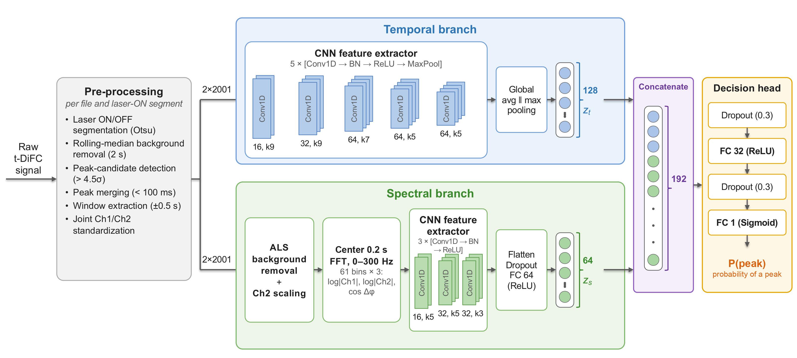
Fig. 1. Two-branch ML model for classifying t-DiFC peak candidates as peaks or artifacts. Each laser-on segment of the raw signal undergoes sliding-median background removal, detection of peak candidates exceeding 4.5σ, and merging of candidates closer than 100 ms. A 2 × 2,001-sample (±0.5 s) window centered on each candidate is extracted and standardized jointly across both channels. In the temporal branch, a CNN feature extractor (five Conv1D–batch normalization–ReLU–max-pooling blocks) followed by global average and max pooling encodes the window into a 128-dimensional vector, z_{t}. In the spectral branch, the window undergoes ALS background removal and Ch2 scaling, and the FFT of its central 0.2 s gives a 61 × 3 array (0–300 Hz; log|Ch1|, log|Ch2|, and cos Δφ, the cosine of the Ch1–Ch2 phase difference). A second CNN feature extractor (three Conv1D–batch normalization–ReLU blocks) followed by a fully connected layer encodes this array into a 64-dimensional vector, z_{s}. The two vectors are concatenated (192 features), and the decision head outputs the probability that the candidate is a peak.

Supplementary Methods

S1. Signal pre-processing
S1.1 Laser-on segmentation. Both channels were acquired at a sampling rate of 2,000 Hz; durations below are given with the corresponding number of samples. Ch1 collects fluorescence from the target fluorophore, and channel 2 (Ch2) is a reference channel that collects autofluorescence and motion-related signal outside the emission band of the target fluorophore. Each recording file was processed independently. Files acquired with the pulsed laser (~10 s on and ~40 s off) were identified from the distribution of the raw Ch1 intensity. For these files, a threshold separating laser-on from laser-off samples was computed from the raw Ch1 intensity by Otsu's method [2] (20-bin histogram), and laser-on segments were delimited by the upward and downward crossings of this threshold. The start of each segment was moved 5 samples (2.5 ms) later and its end 5 samples earlier to exclude laser switching transients. Segments shorter than the 2 s background window were treated as laser-off. Files acquired with continuous illumination were processed as a single laser-on segment.
S1.2 Background subtraction and peak-candidate detection. Within each laser-on segment, the background of each channel was estimated with a centered 2 s (4,001-sample) sliding median and subtracted. Peak candidates were defined as transient events in Ch1 whose amplitude exceeded 4.5 times the local background standard deviation (4.5σ). In contrast to [1], where peak candidates were detected with a fixed threshold, this threshold was adaptive. The local background standard deviation σ_{k} at sample k was computed over a centered 1 s (2,000-sample) window of the background-subtracted Ch1. A smoothed estimate s_{k} was then obtained recursively as s_{k} = 0.5s_{k−1} + 0.5σ_{k}, except that s_{k} = s_{k−1} whenever σ_{k} exceeded s_{k−1} by more than 5%. Each segment was divided into consecutive 2 s intervals, and the threshold of each interval was set to 4.5 times the mean of s_{k} within that interval. Local maxima of Ch1 that exceeded this threshold and had a prominence of at least the threshold value were retained as peak candidates (scipy.signal.find_peaks). Candidates separated by fewer than 200 samples (100 ms) were merged by keeping the one with the larger amplitude. Because detection was performed within each segment, the sample index of each candidate was offset by the start index of its segment to give its position in the full recording.
S1.3 Re-assembly, window extraction, and joint-channel standardization. The processed segments were placed back at their original positions, and all laser-off samples were set to zero, so that the processed signal had the same length and time base as the raw recording. For each candidate, a ~1 s window of 2,001 samples was extracted from both channels, consisting of 1,000 samples on each side of the candidate plus the candidate sample, so that the candidate was at the center of the window. Portions of a window extending beyond the recording were zero-padded. Samples equal to zero in both channels, which occur only in laser-off intervals and in this padding, were flagged as invalid. Each window was standardized as x′ = (x − μ)/σ_{w}, where μ and σ_{w} are the mean and standard deviation of the valid samples of Ch1 and Ch2 pooled together, and the same μ and σ_{w} were applied to both channels. Excluding invalid samples prevents the standardized noise level from depending on the fraction of the window that falls in a laser-off interval. Using a single μ and σ_{w} for both channels preserves the relative amplitude of Ch1 and Ch2 within the window.

S2. Labeled dataset, data splits, and augmentation
S2.1 Labeled dataset and scan-level splits. Labeled windows were obtained from t-DiFC recordings (39 recording files, ~253 h in total) of control mice and of MM-, LLC-, and L1210A-bearing mice. After pre-processing, each peak candidate in the scans of MM-, LLC-, and L1210A-bearing mice was manually labeled as peak (1) or artifact (0) by visual inspection of both channels in its 2,001-sample window. Peak candidates in scans of control mice were labeled as artifacts, since no fluorescently labeled cells were present in circulation. The artifact class therefore includes candidates from both control scans and scans of MM-, LLC-, and L1210A-bearing mice. The data were split into training, validation, and test sets at the scan level, so that all windows from a given scan belonged to a single set. Scans were assigned separately within each group (control or MM-, LLC-, and L1210A-bearing), with target fractions of 70%, 10%, and 20% of the peak and artifact windows for the training, validation, and test sets, respectively. In total, 3,355 peak and 7,732 artifact windows were obtained.
S2.2 Augmentation and class balancing. Augmentation was applied to the training set only. With N original peak windows in the training set (N = 2,688), two disjoint random subsets of 13% and 12% of N were augmented and appended to the originals: windows in the first subset (349) were reversed in time (both channels together), and windows in the second (323) were smoothed independently in each channel with a 3-sample (1.5 ms) moving average, giving 3,360 (1.25N) peak windows. In each set, artifact windows were drawn at random without replacement from the artifact windows of all scans assigned to that set to match the number of peak windows, giving a 1:1 class ratio. The validation and test sets contain only original (non-augmented) windows. Set sizes are listed in Table S1.
Table S1. Composition of the scan-level data sets. Each window has shape 2 × 2,001 (channels × samples). The artifact windows are given as the number from control scans / the number from scans of MM-, LLC-, and L1210A-bearing mice.
Set | Peak windows | Artifact windows (control / MM, LLC, L1210A) | Total windows
Training | 3,360 (2,688 original + 672 augmented) | 3,360 (3,091 / 269) | 6,720
Validation | 234 | 234 (128 / 106) | 468
Test | 433 | 433 (315 / 118) | 866

S3. Model architecture and training
S3.1 Temporal branch. The temporal branch took the standardized 2 × 2,001 window as a sequence of 2,001 time steps with two input channels (Ch1, Ch2). It consisted of five convolutional blocks, each a 1D convolution (stride 1, same padding, no bias) followed by batch normalization, ReLU activation, and max-pooling (size 2). The blocks had 16, 32, 64, 64, and 64 filters with kernel sizes 9, 9, 7, 5, and 5. The outputs of global average pooling and global max pooling of the last block were concatenated to give the 128-dimensional temporal feature vector z_{t}.
S3.2 Spectral pre-processing. The spectral input was computed from the same standardized window (Fig. S1). First, the background of each channel was removed by ALS [3]. For the signal y of a channel, with y_{i} its value at sample i, the baseline z minimizes Σ_{i} w_{i}(y_{i} − z_{i})² + λΣ_{i}(Δ²z_{i})², where Δ² is the second-order difference, λ = 10⁷ sets the smoothness of the baseline, and w_{i} = p if y_{i} > z_{i} and 1 − p otherwise, with asymmetry p = 0.01 and 10 reweighting iterations. The small p makes the baseline follow the lower envelope of the signal, so that upward peaks are not absorbed into it. The laser-off part of the window was excluded from the fit and set to zero in the output, and the baseline-corrected signal was y − z.
Ch2 was then rescaled by the factor σ_{bg,Ch1}/σ_{bg,Ch2}, where σ_{bg} is the standard deviation of the background of a baseline-corrected channel. Because the peak candidate lies at the center of the window, σ_{bg} was computed only from samples more than 300 samples (0.15 s) from the center. Samples within 50 samples (25 ms) of the window edges, zero-valued (laser-off) segments, extreme-amplitude outliers, and flat segments were also excluded. σ_{bg} was estimated by iterative sigma clipping (three iterations, 3σ, based on the median and the median absolute deviation). If fewer than 200 samples remained, Ch2 was left unscaled. This rescaling gives the two channels the same background noise level.
The central ~0.2 s of both channels (401 samples: 200 on each side of the candidate plus the candidate sample) was then multiplied by a weighting function w equal to 0 in zero-valued (laser-off) samples and rising to 1 over a 50-sample (25 ms) raised-cosine ramp at the segment edges and at each boundary of the valid signal. This taper reduces spectral leakage from abrupt transitions while leaving the central candidate unweighted. The real FFT of each weighted channel, X_{Ch1} and X_{Ch2}, was computed and divided by Σw, so that windows with different numbers of valid samples were on a common scale. The frequency resolution is ~5 Hz (2,000 Hz / 401 samples). The 61 bins from 0 to 300 Hz were used, corresponding to the 300 Hz low-pass filter of the signal pre-amplifiers. For each bin, three features were computed: log₁₀|X_{Ch1}| and log₁₀|X_{Ch2}| (with an offset of 10⁻⁵ to avoid the logarithm of zero), and cos Δφ = cos(φ_{Ch1} − φ_{Ch2}), the cosine of the phase difference between the two channels. The log-magnitudes describe the frequency content of each channel, and cos Δφ describes the relative timing of the Ch1 and Ch2 components at each frequency. Each log-magnitude feature was standardized per frequency bin and channel with the mean and standard deviation of the training set; cos Δφ, which is bounded in [−1, 1], was not rescaled. The resulting 61 × 3 array was the input to the spectral branch.
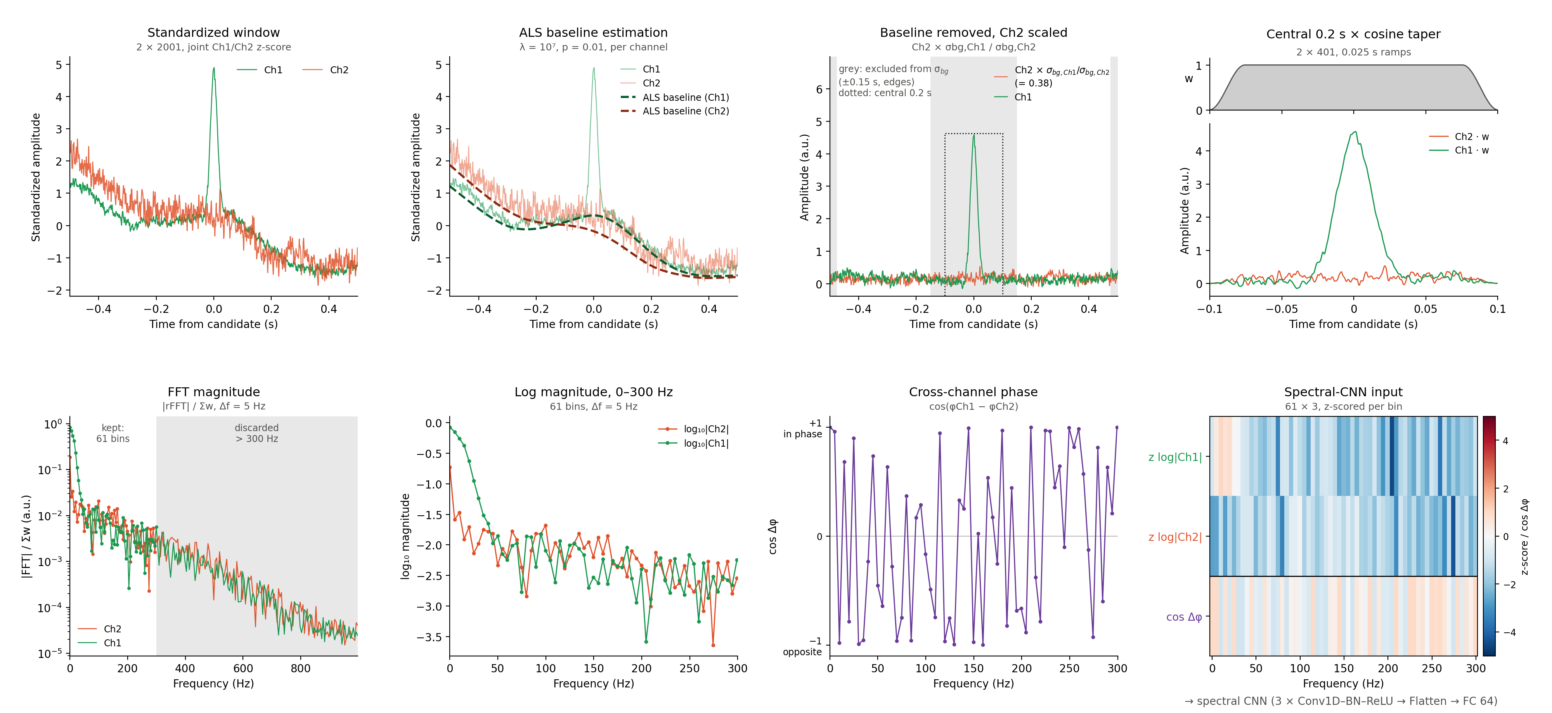
Fig. S1. Spectral-branch input preparation for a sample peak. (Top row, left to right) Standardized two-channel window (2 × 2,001 samples, ~1 s) centered on the peak candidate (t = 0); baselines (dashed) estimated for each channel by ALS (λ = 10⁷, p = 0.01); baseline-corrected Ch1 and Ch2, with Ch2 scaled by σ_{bg,Ch1}/σ_{bg,Ch2} (the grey regions, ±0.15 s around the candidate and the window edges, are excluded from the σ_{bg} estimate, and the dotted box marks the central 0.2 s); central 0.2 s (2 × 401 samples) of both channels multiplied by the cosine taper w (top strip). (Bottom row, left to right) FFT magnitude spectra normalized by Σw, with the discarded bins above 300 Hz shaded; log₁₀ magnitude of the 61 bins from 0 to 300 Hz (~5 Hz spacing); cosine of the Ch1–Ch2 phase difference per bin; the 61 × 3 array (standardized log|Ch1| and log|Ch2|, and cos Δφ) passed to the spectral-branch CNN.
S3.3 Spectral branch. The 61 × 3 spectral array was treated as a sequence of 61 frequency bins with three input channels and passed through three 1D convolutional layers (16, 32, and 32 filters; kernel sizes 5, 5, and 3; stride 1; same padding; no bias), each followed by batch normalization and ReLU. Max-pooling (size 2) followed the first and second layers. The output was flattened, which preserves the position of each feature along the frequency axis, and passed through dropout (rate 0.3) and a fully connected layer of 64 units (ReLU) to give the 64-dimensional spectral feature vector z_{s}.
S3.4 Fusion, decision head, and training. z_{t} and z_{s} were concatenated into a 192-dimensional vector, which was passed through dropout (rate 0.3), a fully connected layer of 32 units (ReLU), dropout (rate 0.3), and a single sigmoid output unit giving the probability that the candidate is a peak. All layers of both branches and the head were trained together from random initialization with binary cross-entropy loss and label smoothing of 0.05 [4] (targets of 0.025 for artifacts and 0.975 for peaks). The model was trained with the Adam optimizer [5] (initial learning rate 10⁻⁴, batch size 64, training windows shuffled every epoch) and decoupled weight decay [6] of 10⁻⁴, applied to the convolutional and fully connected kernels after each update by multiplying them by (1 − η·10⁻⁴), where η is the current learning rate. Training ran for up to 60 epochs. The validation loss (binary cross-entropy without label smoothing) was evaluated after each epoch: the learning rate was halved when it did not decrease for 4 consecutive epochs (minimum 10⁻⁶), and training was stopped when it did not decrease for 8 consecutive epochs, restoring the weights with the lowest validation loss (Fig. S2). The model was trained five times with different random seeds (0–4), which change the weight initialization, the dropout masks, and the order of the training windows; the restored epochs were 8, 12, 15, 20, and 23. The probability for each candidate was the mean of the outputs of the five models.
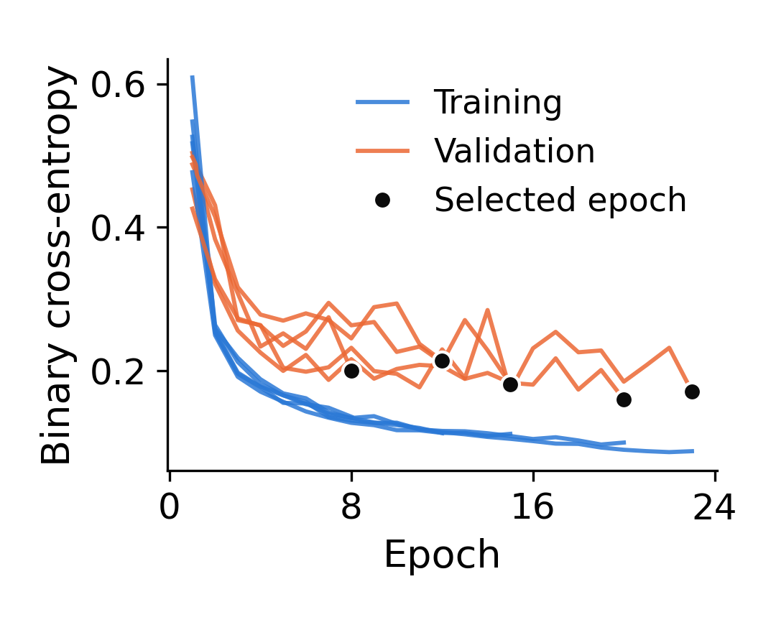
Fig. S2. Training (blue) and validation (orange) binary cross-entropy per epoch for the five seeds of the model, shown up to the epoch with the lowest validation loss (black dot), whose weights were restored.
S3.5 Probability cutoff and performance. Candidates with a probability ≥ 0.6 were classified as peaks. Performance at this cutoff was evaluated on the validation and test sets (Fig. S3; Table S2). Because windows from the same scan are not independent, 95% confidence intervals were obtained by a scan-level cluster bootstrap (2,000 resamples of scans with replacement). In the test set, 308 of the 433 peak windows come from a single scan. On the test set, the model achieved an AUC of 0.980, an accuracy of 91.5%, a sensitivity of 84.3%, a specificity of 98.6%, and a precision of 98.4%.
Table S2. Classification performance at a probability cutoff of 0.6. Values in brackets are 95% confidence intervals from a scan-level cluster bootstrap.
Set | AUC | Accuracy | Sensitivity | Specificity | Precision | TP / FN / FP / TN
Validation | 0.991 [0.960, 0.997] | 0.929 | 0.872 [0.676, 0.908] | 0.987 [0.970, 1.000] | 0.986 | 204 / 30 / 3 / 231
Test | 0.980 [0.882, 0.991] | 0.915 | 0.843 [0.297, 0.920] | 0.986 [0.964, 1.000] | 0.984 | 365 / 68 / 6 / 427

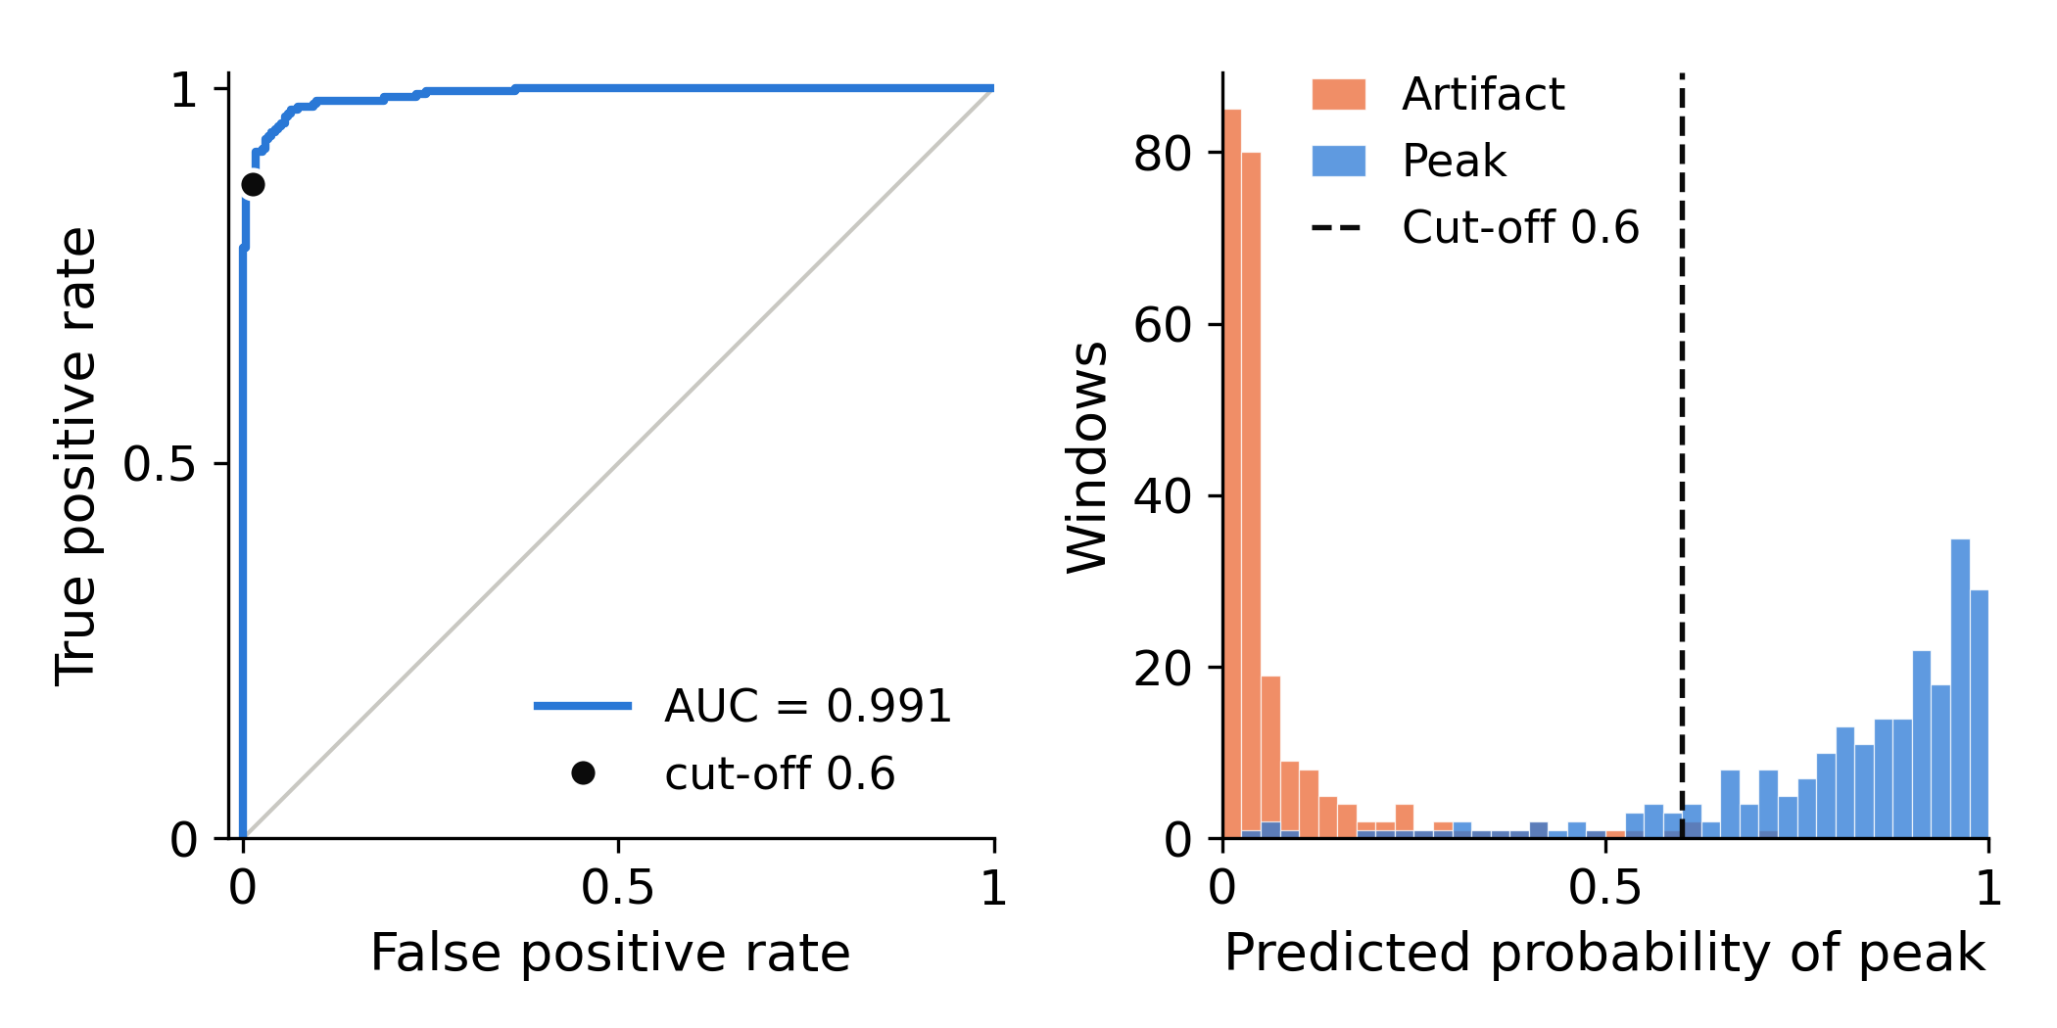
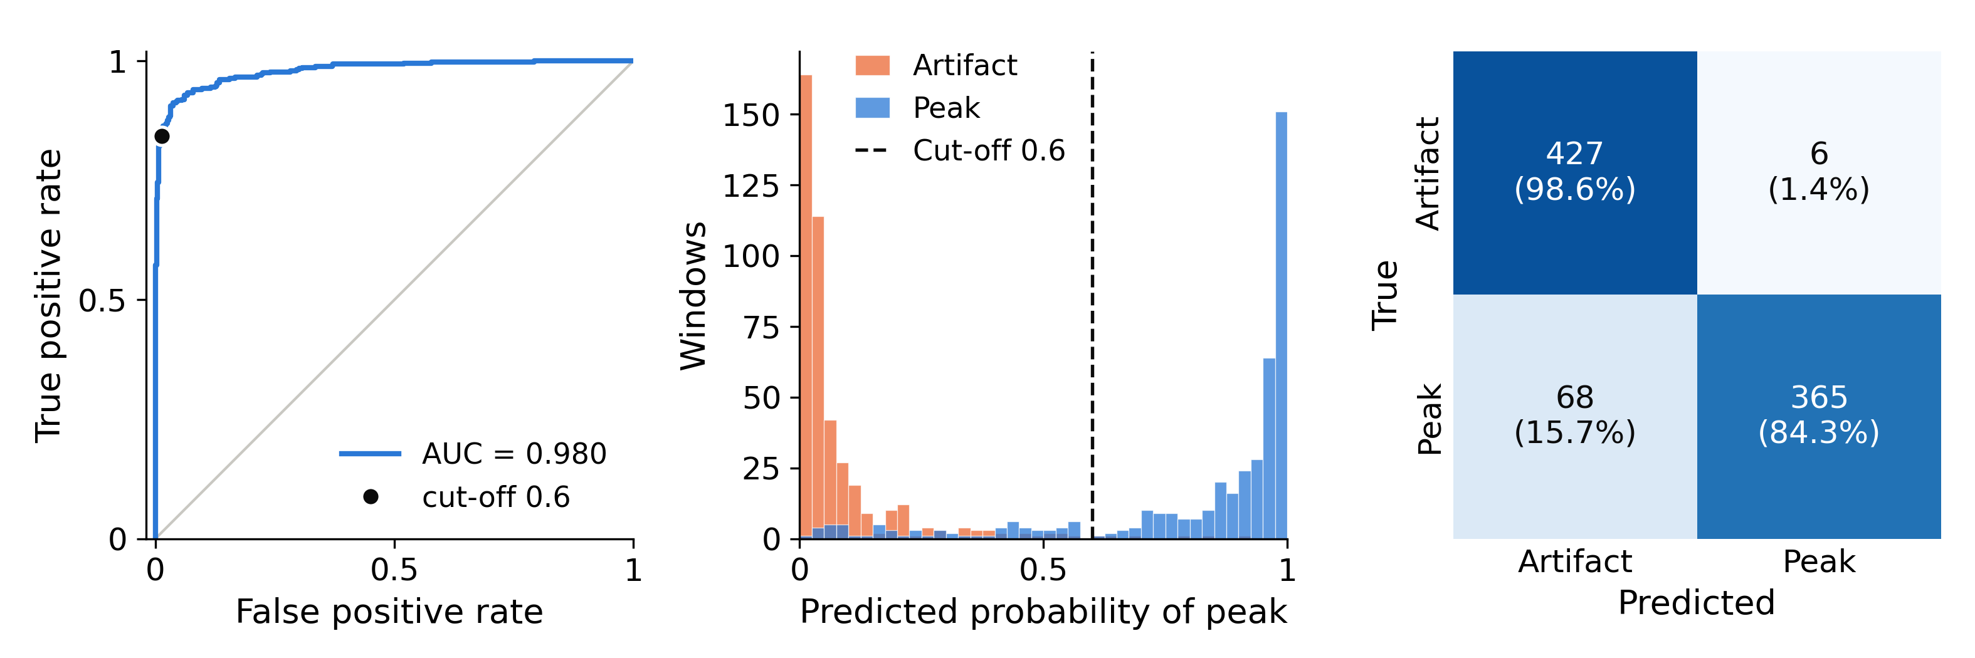
Fig. S3. Classification performance of the model at a probability cutoff of 0.6. (Top) Validation set: ROC curve (AUC = 0.991; the black dot marks the operating point at the cutoff) and distributions of predicted probability for peak and artifact windows (the dashed line marks the cutoff). (Bottom) Test set: ROC curve (AUC = 0.980), distributions of predicted probability, and confusion matrix. On the test set, 365 of 433 peaks (84.3%) and 427 of 433 artifacts (98.6%) were classified correctly.
S3.6 Feature visualization. The temporal (z_{t}, 128-dimensional) and spectral (z_{s}, 64-dimensional) feature vectors of one model (seed 0) were computed for the original (non-augmented) training windows and for the test windows, standardized, and projected to two dimensions by t-SNE [7] (perplexity 30, PCA initialization) (Fig. S4). In the temporal-branch projections, peak and artifact windows formed largely separate clusters in both sets; in the spectral-branch projections, the two classes overlapped more.
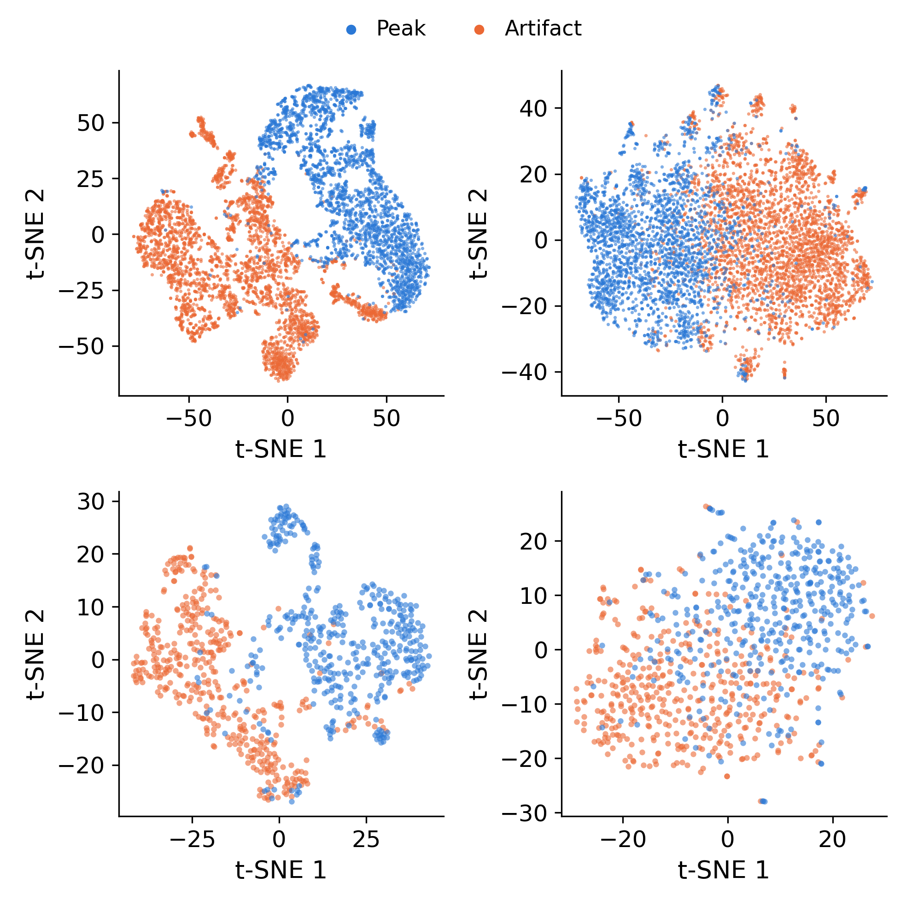
Fig. S4. t-SNE projections of the branch feature vectors of the model (seed 0), colored by class (peak, blue; artifact, orange). (Top) Training set (original windows only); (bottom) test set. (Left) Temporal branch, z_{t} (128-dimensional); (right) spectral branch, z_{s} (64-dimensional).
S3.7 Inference on full scans and implementation. For full recordings, the pre-processing, window extraction, and standardization of Section S1 were applied with the same implementation used to build the labeled sets, and spectral inputs were computed as in Section S3.2, using the training-set statistics for the standardization of the log-magnitudes. Each candidate was scored by the five models, and candidates with mean probability ≥ 0.6 were classified as peaks. Models were implemented in TensorFlow/Keras, and signal processing used NumPy, SciPy, and pandas.

References
[1] M. Emamifar, J. Lee, J. Pace, C. Bellini, M. Niedre, "Machine learning approach for enumeration of circulating cells with diffuse in vivo flow cytometry," bioRxiv 2026.04.21.719882 (2026). doi: 10.64898/2026.04.21.719882
[2] N. Otsu, "A threshold selection method from gray-level histograms," IEEE Transactions on Systems, Man, and Cybernetics, vol. 9, no. 1, pp. 62–66, 1979. doi: 10.1109/TSMC.1979.4310076
[3] P. H. C. Eilers, H. F. M. Boelens, "Baseline correction with asymmetric least squares smoothing," Leiden University Medical Centre Report (2005).
[4] C. Szegedy, V. Vanhoucke, S. Ioffe, J. Shlens, Z. Wojna, "Rethinking the Inception architecture for computer vision," Proceedings of the IEEE Conference on Computer Vision and Pattern Recognition (CVPR), pp. 2818–2826, 2016.
[5] D. P. Kingma, J. Ba, "Adam: A method for stochastic optimization," International Conference on Learning Representations (ICLR), 2015.
[6] I. Loshchilov, F. Hutter, "Decoupled weight decay regularization," International Conference on Learning Representations (ICLR), 2019.
[7] L. van der Maaten, G. Hinton, "Visualizing data using t-SNE," Journal of Machine Learning Research, vol. 9, pp. 2579–2605, 2008.

