Table of Contents
Introduction 2
Outline of topic and research questions 2
Original Aims : 3
Study one, Mobility on Isle of Eigg 4
Methodology 4
Observations and reflections from Eigg 5
Study two, Power of Knoydart 6
Observations and reflections from Knoydart 11
Study three, Zaytoun - Data and it's materialisation 11
Data, Why Twitter? 12
Study four, Personal Grids 13
What is grid 13
Personal grid 14
Reflection on the four pilot studies: 16
Plan for the next two years 17
Year two 17
Research outputs 18
Practice led outputs 18
Thesis 18
Potential chapter lists 18
Research outputs 19

Introduction
I started my PhD in September 2014 funded by University of Edinburgh. My PhD is practice based and the purpose of this review is to first summarise the original proposal and questions that I was planning to study and explore, I will then provide a brief summary of the pilot studies that I have conducted that led me to my new questions, followed by a reflection and justification of the new questions, their importance and finally my plans for the next two years.

Outline of topic and research questions
The proposed PhD by design aimed to explore inventive methodologies for breaking design out of its enclosure through an investigation of the role of networked societies within the context of “off grid” communities.

Design is a concept that spans disciplinary boundaries. Ralph and Wand (2009) identified almost twenty definitions of design. The concept of design, studio and materiality has changed dramatically through the development of digital networked society (Castells, 2011). The network contributes to a high level of complexity between actors, spaces of action, inaction and reaction (Dirksmeier and Helbrecht, 2008; Harman, 2009). This creates the possibility of multiple modes of existence and co-existence. The historical shift from common land to forced land enclosure is paralleled with ongoing debates around digital technology, physical computing and networked societies (for example Open Hardware, Free Software Foundation, Hackathon). This study will look at the ways in which digital networks are transforming mediations and narratives of the commons within the context of “off grid” communities (for example GitHub, creative commons, HebNet).
Design and the design studio are arguably also forms of enclosure and involve sets of rule bases and affordances in their traditional forms (for example as informed by the culture and peer learning as much as bounded by the physical space). The variety of methods and manifestations of design and its studio (Ralph and Wand, 2009), suggest that there are different parts of design that carry different jurisdictions and enclosures from various periods in history and modern time, which this research seeks to explore. The changes in ownership, accountability as evidenced in new open innovation models (for example Isle of Eigg, Dot rural(Tait et al., 2013), Hacklab in Edinburgh, Virtual communities: GitHub, Thingiverse) call for developing new ways of design from a perspective that offers these new sensibilities and reaches the potential of commensurability (c.f Harman, 2009; Latour, 2005; Leder et al., 2010; Martin, 2013; Mehrpouya et al., 2013; Sloterdijk, 2011; Speed, 2011; Thrift, 2012).

The proposed research will explore commons, enclosure, jurisdiction, design and computer code through design interventions in both remote rural physical communities and virtual communities and their physical counterparts.

Original Aims :
The primary aim of this research was to explore the relationships between commons, enclosure, situated practices in rural communities compared with virtual online communities, assessing the impact digital network technologies have on them.
This research will be achieved through the following:
- Examining similarities and differences between collaboration and design processes in “off grid” communities, virtual communities and design studio.
- Developing a range of interventions in the form of digital artefacts as informed by a set of ethnographic observations in order to gain insight into the relationship between digital networks, commons and enclosure.
- Studying the history of enclosure and sociology of commons.
- Reflecting on the success of the created design interventions and developing a theoretical framework that can contribute to the future of design and design studio.
- How digital technologies are transforming community narratives into the digital sphere (The similarities between, land reform and free software movements, How free software, open source and open hardware could transform the practices of communities into digital sphere?).
- How these digital spheres and spaces are being used by the community.
- How these approaches to heterogeneous and non-hegemonic modes of development, innovation and production could effect design.
The study aimed to specifically focus on “off grid” communities. This was simply because of my previous involvement with the two communities in the west coast of Scotland who live off the national energy grid.
In order to explore the questions, I conducted four pilot studies, each investigating some of the themes mentioned above. The first two studies are in the context of two “off grid” communities in the West Coast of Scotland (Isle of Eigg and Knoydart) and the other two studies, one is focused around the data and its materialisation and the final study is looking at the network and grid of individual.

Study one, Mobility on Isle of Eigg
In October 2014, I went to the Isle of Eigg to do a 10 days artist residency. The purpose of this residency was to develop more understanding of the connections between transport and energy use. One of the sponsors of my residency, Eco Travel Network (ETN), a limited company based in Wales ran a 3 months trial of their customised Renault Twizy 'Toro' (Renault, 2014) on the Isle of Eigg prior to my work. The purpose of this trial was to test “Toro” as an alternative, low-carbon road transport option (Kidd and Williams, 2014). This field trip, while being centred around mobility, also provided me with a unique opportunity to engage with many members of the Eigg community to develop further understanding of community dynamics, politics, power relations and some of the everyday challenges of living “off grid”.
Over the last few years mobility has gained more attention as its direct connection to many other fields for example in sociology ( see: Büscher et al., 2011; Urry, 2012, 2008), individual and community level dynamics (for example See: Laurier et al., 2008 ). Transport is not only limited to the study of a movement from A to B, but rather looking at its connections to many other practices (for discourses of mobilities see: Doughty and Murray, 2014). Eigg is no exception. Looking at mobility on this island opened many discussions and conversations around a variety of topics, for instance education, tourism, personal space, the relationships between the individuals and their communities and so on.

Methodology
My first method to study mobility on Eigg were Ethnographic qualitative interviews. This method is suitable for capturing and examining thought contexts, feelings and exploring relationships between different aspects of the phenomena (Arksey and Knight, 1999). Whilst the Interview method opens some insights into the research questions and creates specific realities about the concept of enquiry, it fails to ingrain other details of the context (Bagnoli, 2009; Law, 2004). In addition to the use of this Interview method, other methods such as visual ethnography and video ethnography have been used through this study, however the key central method in this research is semi-structured interviews.
By looking at a small range of articles on the recruitment process it seems recruitment is one of the challenging parts of interview method (for examples, see: McDonald et al., 2006; Newington and Metcalfe, 2014). Some of these difficulties come with the standards for evaluating the interviews, such as size of the sample, the relation between demographics, individual backgrounds and research questions.
The first couple of interviews were organised through one of the community gate keepers and then I followed Katherine Davies (2010) approach in street sampling. I decided to knock on peoples doors and use any available opportunity to speak with them and arrange a time to do the interviews. This approach allowed me to initiate a relationship with the people I was interviewing, whilst also helping me in developing a richer ethnographic observation of the process. This also gave me the opportunity to observe the recruitment phase. By the end of my trip I managed to conduct eleven interviews which was more than half of the individuals who trialled the car.

Observations and reflections from Eigg
Living on an small island in the West-coast of Scotland means the islanders have to be creative in how they manage their food supplies, access to health infrastructure, working dynamics, Education and so on. Many of the day to day practices get affected by the ferry schedule which brings goods, tourists, gasoline and also takes the islanders on and off the island. The ferry schedule depends entirely on weather conditions and demand as they are being managed by small companies. The ferry schedule and weather also affects work on the Island, for example the people who work for the forestry won't be able to work on rainy days due to the wood getting wet according to William (nick-name). Apart from seasonality, tourism is another factor affecting how people move around the island. For example at high tourism seasons, the Eigg community have to move around faster as they need to respond to the high level of demands on goods and services.
One of the cow and sheep farmers on the island told me in their interview, each year they bring 20 tonnes of food for the animals and on a daily bases they need to move about 250 kilos of them around their farm for the cattle to use. In order to do this individual job, the family over the year uses two quad bikes, a land-rover and a tractor depending on weather conditions and their daily needs. As the ferries are owned and managed by different companies, the mainland public transport system does not sync with the ferry schedule. For this reason, some of the islanders also own a car on the mainland to simplify their transport outside of the island. In addition to all the needs for food supply, Eigg also needs to bring in diesel for cars and as a backup for energy demand. Eigg can only generate a limited amount of electricity using renewable energy. This is due to limited battery capacity and the production of electricity relying on weather conditions (rain, wind and sun). Eigg roughly imports about 20000 gallons of diesel for its energy backup and this is not including the fuel for petrol and diesel cars. The majority of all the other life needs and desires also get imported to the island, for instance clothes, construction materials, etc. There is also a demand for MOT failed cars as there is no MOT on the island. MOT failed cars are an economically cheap way of getting a car and moving around the island. Most of the interviewees got their car for free or a very cheap price from a family or a friend on the mainland when the cars failing the MOT. As stated by all the interviewees, the practice of car ownership on the island is very different from the mainland UK. Many residents own the same make of car over the years. This will allow them to use the parts from previous cars, until there are no more parts to reuse. Travelling abroad for holidays or regular commutes to the mainland UK to visit family and friends or for shopping purposes is another example of “Off grid” Eigg relying on national grids and infrastructures.
These complicated and entangled practices are a few examples to show that, in the context of Eigg, producing renewable energy does not mean that the community and individuals are living off the grid. This is because one of the preconditions of modern life is connectivity to the national and international grids and infrastructures. From this perspective Eigg has never been off the grid and arguably neither have any other “off grid” communities.

Study two, Power of Knoydart
Knoydart, is a peninsula on the West-coast of Scotland. In order to get to Knoydart you need to go on a 5 day hike across the Beinn Buidhe mountains or get on a ferry from Malaig for about an hour. Similar to Eigg, Knoydart also received funding from Scottish government and bought 17,200 acre Knoydart Estate in 1999 (Ross, 2015). The community also inherited a hydro scheme that provides 180kwh of electricity to the community. These 180kwh of electricity not only provides clean and renewable energy to the local homes, it also provides for local businesses such as the pub, bunkhouse and so on.
The graph below is an screen grab of the energy consumption for a period of a month. From Friday 9th of January there's a gap on the graph until Wednesday 14th of January. This gap was due to the the Hydroelectric system getting struck by lightning, resulting in a power-cut. This is an example of a natural disruption to the Knoydart grid. Another existing energy problem on Knoydart is during high demand periods, an example of this is at Christmas time when the majority of the community are using a lot of electricity as shown in the graph (figure 1) during this period the power consumption is almost near 180kwh and when the demand passes the supply this will also result in a power cut.
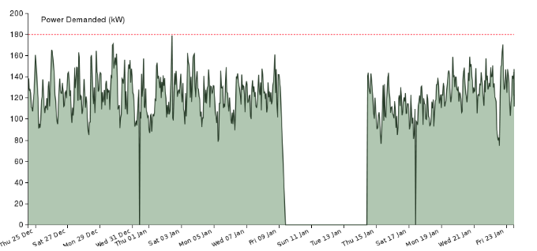
Figure 1 – Screen grab from www.Powerofknoydart.org showing community energy use between 25th of December until 25th of January
My involvement with the community on Knoydart was to work with the rest of our team from the University of Edinburgh to do the following:
- Develop new ways to visualise energy use
- Visualise ideas for future projects using the surplus energy of the grid.
- How to manage times when there's an energy shortage.
Knoydart foundation was already part of this project, which made communication and collaboration with the foundation members very easy for us.
Before my involvement in this project a similar graph had already been developed by one of our colleagues and as part of our discussion we tried to use that development to learn more about the community needs.
After our first conversation with two members of Knoydart foundation and a member of Community energy Scotland, we started to develop a few visualisations, each showing a different way to use the energy surplus.
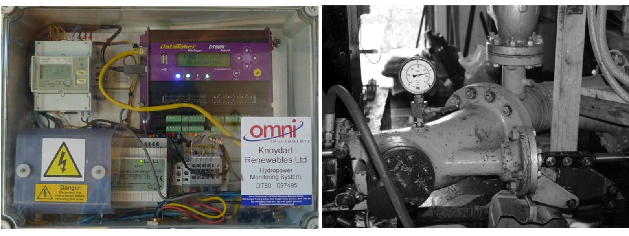
Figure 2 - Left showing data taker, collecting community energy use,
Right showing hydroelectric power system, generating electricity for the community
Finding ways to visualise energy on Knoydart was one concern amongst the community and the Knoydart foundation. The other concern was community dynamics. By community dynamics I mean how to avoid making conflicts and arguments, panics and so on. For example already as stated by Eric and Stephen, there are issues about some members blaming others for power cuts, identifying main energy consumers and having conflicts with them. The Knoydart foundation itself also runs on the funds generated from selling the generated electricity therefore the relationship that the foundation has with the community is very crucial to its sustainability.
The visualisations that we initially made (See figure 3 for examples) were based on the existing discussions and interests that we gathered from our conversations with the community members, especially the Knoydart foundation and Community Energy Scotland representatives. For example Figure 3, No 1 is showing how many electric powered boats can travel back and forth to Malaig. There was already some discussions and conflicts about the new owner of the ferry company and we thought this would give us more insights into the community and energy politics and dynamics. After developing 6 visualisations and one graph similar to figure 1.
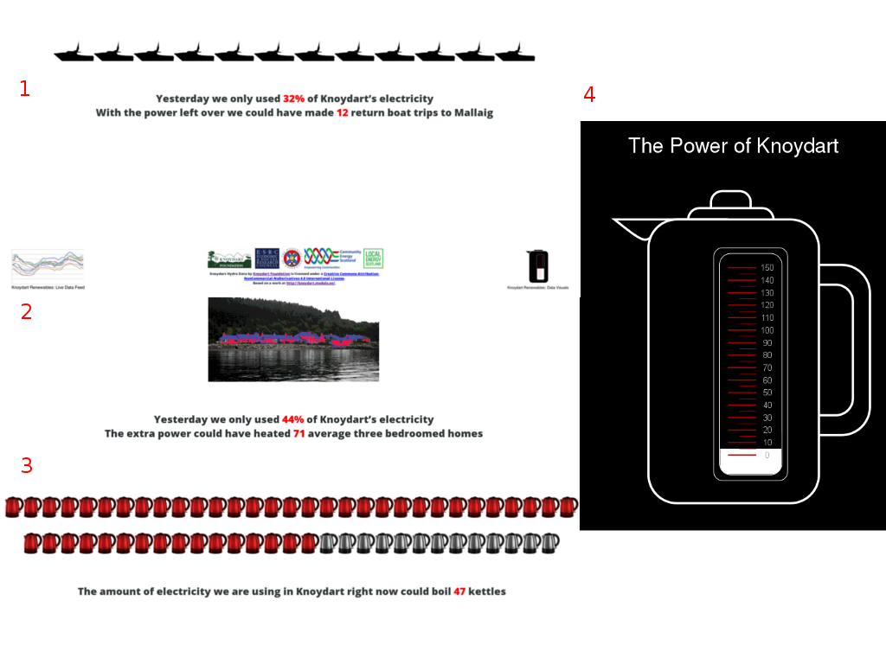
Figure 3 – Number 1 is showing energy surplus in terms of electric powered journey to Malaig
Number 2 is showing how many extra homes can be heated with the surplus energy
Number 3 is showing how many kettles could be boiled using the current energy being used
Number 4 is showing energy use by using a kettle as the medium for representing energy cunsumption

We held a gathering in the community hall. During this session we presented what we developed during our week on Knoydart. Arguably the people who attended our presentation session were individuals who were more enthusiastic about the collaboration and our project, however the energy and enthusiasm level was the opposite. One member asked us about whether it would be possible to use the surplus energy to power his Land-rover and others were not that engaged with our work.
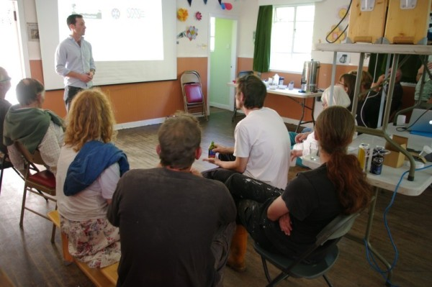

Figure 5 – Presentation session at Knoydart community hall, showing Knoydart energy visualisations.
In addition to this, we also managed to hack one of Phillips smart light bulbs. The hack allowed us to make the light bulbs change colour according to the amount of energy being consumed by the community (Between 0-100kwh range of green, 100-140 Yellow range and above 140 range of red).
Whilst the feedback we got from the gathering in the community hall was very disappointing for us and we didn't feel there would be any use or interest towards the tools we developed, a few months later one of the members of Knoydart foundation (Jimmy) got in touch with us about some new designs that they made for the graph visualisation. They also had ideas about developing a kettle widget for desktop computers, so everyone can have them on their personal computers. This was an exciting opportunity for us and also a response to our previous work, so from this point of view our previous visualisations worked in other ways. We delivered the new website and the kettle widget before Christmas.
We went back to Knoydart to collect more feedback in March 2015. We found out that not many people knew about our Power of knoydart website. Furthermore all of the smart lights in the library have been removed, and finally not many people installed our kettle on their computers. In order to fix the awareness problem about the new community website, we printed 300 waterproof stickers and sent them back to Knoydart to distribute amongst the community. Currently the visualisation is down due to some improvements on the dam and it will be back online in the next three weeks when the development are finished.

Observations and reflections from Knoydart
After one year of engaging with the Knoydart foundation and some members of its community, the feedback from the gathering session and google analytics from power of knoydart website shows that not many residents use the tools that we developed. Even with the new designs suggested by Knoydart foundation members. …..

Study three, Zaytoun - Data and it's materialisation
(Digital data, Data visualisation and issues of localisation and materialisation of information)
Networked journalism, a recent trend through the development of Web 2.0 and 3.0 technologies such as micro-blogging and social media gave birth to a new form of interaction between the traditional notion of journalism and the public (Beckett 2010). The spread of smartphones and Internet to all corners of the world has given individuals a global voice for what they see, hear and observe.
Bradshaw (2012) discusses some of the hidden practices within Data Journalism such as methods that journalists use to filter the data, vast data collection techniques and data mining methods to generate new forms of information from digitised data. The complexity of the practice and issues with data overload in the modern age also brings in concerns about data privileges. For instance, how various kinds of information such as wars, diseases and corruption compete with one another for attention.
The piece ‘Zaytoun’, was created in response to the 50 days war in the Gaza Strip of Occupied Palestine during the summer of 2014. Graphite-based conductive ink on top of an emotive illustration by artist Mina Braun affords the opportunity for direct interaction with the drawing. Touches across the textured surface trigger a change in the capacitance of the circuit, which is detected by the various analogue pins of an Arduino Mega micro controller. When a threshold of electrical current is broken, the program sends text to a pair of thermal receipt printers.
One of the thermal printers prints names of individuals who died during this war and the other prints collected local stories from twitter. The stories included within this work are collected from individuals living inside Gaza strip, Jerusalem and the West Bank, reporting the current crisis. Names of people who lost their lives, during and since the invasion are downloaded periodically from Al-Khabar (Al-Khabar 2014) website which gets the list from Gaza Ministry of Health. In order to capture this data we developed a PHP program that converted and stored it using JSON standard for use within the visualisation.
The illustration consists of families and an olive tree (see: Mehrpouya, 2014). Olive trees are internationally recognised as a symbol of peace. In Palestine they are also a symbol of unity and the relationship people have with their lands. Not only have the Palestinians been oppressed and forced to give up their lands but also vast numbers of these trees have been bulldozed or moved to occupied lands and inside Israel (See: Khoury 2013, Booth 2014).
The invasion and bombardment of Gaza coincided with the run up to a symposium on the production of data, organised by the research centre for Design Informatics at the University of Edinburgh. Submission of the drawing was not only an opportunity to bring human suffering to the fore in an academic community which can, on occasion, be isolated from the ‘real world’. There was also a desire to preserve the personal nature of the data that major events inevitably generate now.
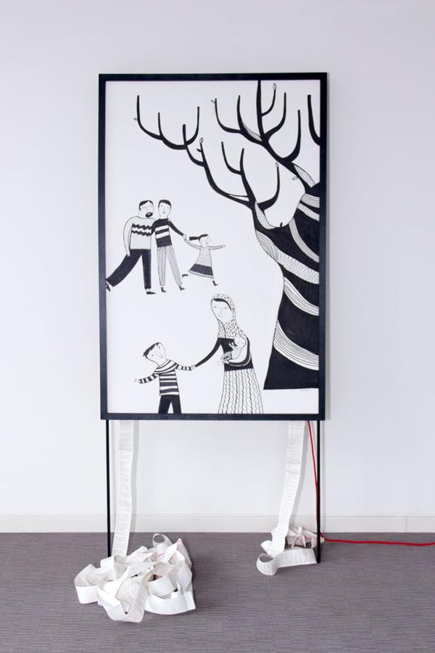

Data, Why Twitter?
Everyday over 95 million messages get shared between users and twitter as a mediator of a real-time information network among all of its users (Huberman et al. 2008). This creates a contested space, with various biases and concerns, for instance institutions who are more code-savvy and have an ability to automate and mass produce tweets. Also individuals with specific political agendas who can create various trends and biased information. The twitter system itself also tends to filter the daily 95 million tweets and tailor them to the interests of the user or perhaps the interests of twitter advertisers. This complexity, while providing an area of uncertainty and a blurred reliability (See: Stephanie 2009, Acar & Muraki 2011), in disastrous situations also allows people to communicate in a more meaningful way with the people from outside and inside their countries (for examples see: Acar & Muraki 2011, Heverin & Zach 2010, Vieweg et al. 2010) .

Talk about people's reactions....feedback and so on.

Study four, Personal Grids
(quantified self, study of personal grids)
Through my work with the two off grid communities, I became more interested in the notion of off gridness in a wider context. Off grid as a way of life that is about being more aware of your consumptions, to be a more responsible consumer.
Living a life that is more aware of it's consumption ethics (for example, Where things are coming from?, How they get produced? And so on) has always been trapped in the complexity of our modern life grids. The difficulty of tracing our products and consumptions. Digging into manufacturing practices, where products are coming from, requires a lot of time and resources. The more we consume the less time we have to learn more about the other side of the beautiful products. Marx describes this “The veil is not removed from the countenance of the social life process, ie the process of material production, until it becomes production by freely associated men and stands under their conscious and planned control” (Reference).

What is grid
Grid as a noun has many definitions and uses and therefore difficult to explain. In the field of computing grids are a way to distribute task between computers also called peer to peer, It is also defined as a rectangular array of squares. In cartography grids are a method of marking maps and lastly it is a system for delivering electricity from energy generators to end users. (References)
Grids are arguably a background or a landscape that acts as a ground for collaboration between different entities or a method to describe and understand a system, a community, internet, brain activities, maps, etc. The main known use of the word grid, however is within electricity distribution systems also called national grid.
Over the last three decades we've witnessed rise of many off grid homes and communities. Vannini (2015) describes these new off-grid practices as ways that people are trying to live a more simple life, a life that is more respectful towards the environment, very innovative and at the same time old way of life. A life that is more aware of what will happen behind their plugs. “... flicking a switch to turn on an electric lamp at my home I am in a way incorporating the kinetic power of water channelled into dams, water-wheels, and turbines by my utility provider. Someone who lives off the electrical grid had to incorporate the same essential resource (e.g., water) and assemble a tool (e.g., a turbine) to generate electricity. But the key difference relies in the way our respective bodily activities unfold...”.
Off gridness was arguably a movement in response to the energy crisis, climate change and also providing energy to parts of the world that are not economically profitable for energy companies to invest in, such as Knoydart or other small Hebrides Isles.
Off gridness is not only a way of life with no connection to the national energy grid, but it is a movement that aims to encourage and create a more conscious life towards how we consume and how we source the things we use. Reflecting from the interviews that I conducted on Eigg, work on Knoydart and study of my own personal grid, off gridness can not be achieved unless through an extensive re-evaluation of each individual's grid based on their values and community values. For example Eigg can be a community that is off the energy grid, but they still need to bring 20000 galons of Diesel for extra energy, cars on the island being fuelled by diesel and petrol, holidays and business trips around the world, clothing, food, infrastructure materials and, finally, their digital network through the Internet; none of these arguably are off the grid, therefore from this point of view Eigg has never been off grid.

Personal grid
My original plan was to study my own grid over a month, measuring how much plastic is being manufactured as a direct result of my consumption and shopping habits, food, electricity and other resources being used. Finally considering the complexity of the issue and time limitations for doing a pilot study, I decided to do the study for the duration of one hour. I didn't plan to do any particular task during that hour and it was a normal working hour. As a software engineer and designer, most of my work currently involves on using my laptop, therefore the centre of my study was through using my computer. The study consists of 2 parts, hidden consumptions, for example how much heat my laptop was producing, how much energy it was using, which parts of the internet infrastructure I used during that hour and so on. The other parts was the infrastructures and other consumables that I was using during that hour and also the services that exists but I wasn't using them at that time, for example police, NHS and so on. I also asked one of my colleagues Chris Barker to observe and take notes about other products and services that I may be using and not being aware of.

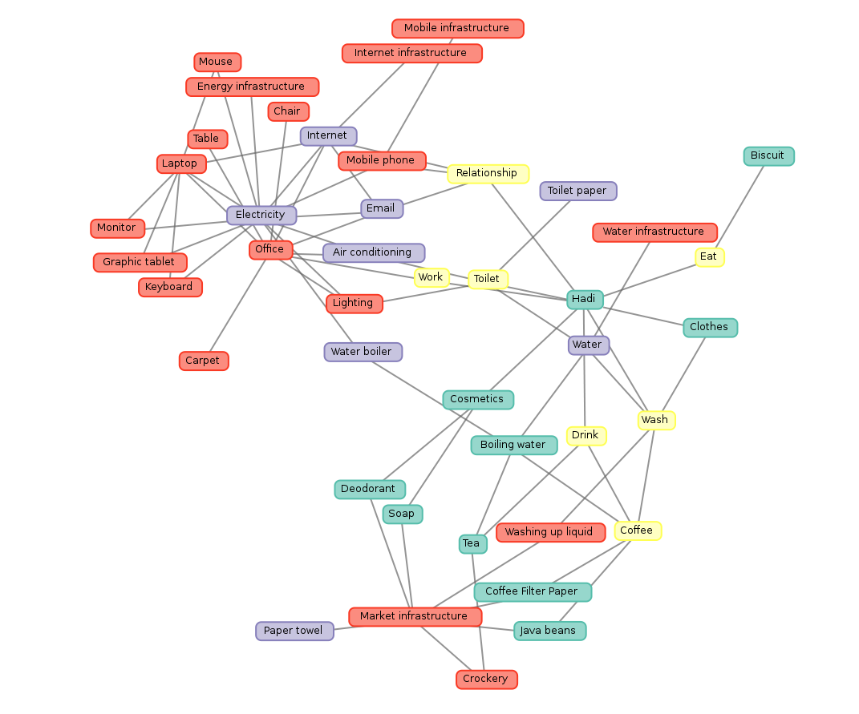
Figure 6 – A screengrab of personal grid visualisation, available from http://cyberscot.co.uk/study1/graph.php
Green: Depletables, Red: Experience, Purple: Consumable, Yellow: action
Categorising everything that we interact with in order to be able to understand our grid and connections to the world around us is a very complicated task. I decided to categorise everything into 4 major groups:
- Depletable: something that runs out and you need to get more (for example tea bags, coffee beans, coffee filter paper)
- Experience: something that you use over and over again but you don't see it being worn out or depleted (for example office carpet, office monitor)
- Consumable: something that get consumed but doesn't visibly run out (for example water, internet)
- Action: things we do to use the other three
It is important to remember that these categories changes depending on where the study is being done, for example at home since I will be in charge of replacing my own toilet paper rather than the University, they will be depletable rather than consumable.
I am also developing a further documentation and research on the details of each entity in the graph above. This includes their packaging, where they are coming from? The standards that they are following that are mentioned on products (for more details see: http://cyberscot.co.uk/study1/list.php).

Reflection on the four pilot studies:

The pilot studies helped me with developing further understanding of the contemporary condition of living off the grid in relation to the conditions of the interconnected globalised world. They also helped me with developing more concrete questions and research plan for the following two years of my research.
While my original research questions about the relationships between land reform and free software movements, role of computer code among communities and how community practices could be transformed into digital technologies and their effect on design are interesting and important questions, there is also a big gap in knowledge in off grids as seeing the complicity in national and globalised grid is often hidden and over looked.
The following questions now arise:
- How technology can assist with our undestanding of our girds and its relation to others' grids?
- What are the implications such visibility of one's grid on her/his behaviour especially in terms of consumption decisions and practices?
- What type of interactions and collective behaviours emerge among individuals due to the use such visibility technologies?

I will use a Participatory Action Research (PAR) framework of methods for exploring
personal grids and its implications. , as well as exploring digital fabrication within a
creative context and its impact upon practitioner’s acquisition of confidence in
digitally mediated environments . The use of PAR, ethnography and self-reflective
methods will offer a framework to initiate collaborations and discussion between
designers, students and craft practitioners.
Through my research I hope to gain insight into the needs of Scottish makers;
particularly, the models of technological diffusion within traditional and contemporary
crafts. I intend to identify methods and approaches that might ease the proliferation
of 3D printing among the creative sectors of Scotland by undertaking research into
craft environments and the analysis of disruptive technologies, identifying which
strategies craft might adopt to adapt to technological flows.
The interaction between developers and early adopters of 3D printing and craft
practitioners can enable a new generation of processes and methodologies based
on facilitating knowledge exchange and enhancing interdisciplinary interaction.
These creative activities seek to set the ground for engaging with the current
debates around digital media and their implications for art and craft.
To add
- How questions being changed?
- What I learned from the case studies?
- What were the findings from Knoydart and Eigg?
Talk about commercialisation of off-grid communities how they have never been off the grid. Promise of the capitalism is individualisation as Thacher famously said there is no society. So we need to look at the power of the individuals the power of the consumerist society, when class struggle get replaced by marketing and consumption then the struggle is among the consumers, the responsibility is on the consumers.
What is the relationship individual and their personal grid?
What are the consequences of knowing your personal grid? How it affects the individual?

Plan for the next two years

Year two

First half:
I will dedicate the first three months of my second year to devel ….. I will then organise three workshops using participative design methods to develop ideas for the personal grid tool. I will also continue with the development of my own grid and personal grid tool using the feedback and the workshop findings.
The second half will be dedicated to work with 5 individuals, developing their personal grid and study the affect and effect by conducting interviews over the next six months periodically. One of the individuals that I am planning to test the personal grid application with will be myself and I will use autoethnography as the method to describe the findings of this part of research.
The third year will be dedicated to refining the tools and documenting them, planning and developing my exhibition and writing up.
What am I going to read
- Follow the things litrature
- Quantified self litrature
- Marx, Hagel
- Participative design methodologies

Ideas I'm going to focus on
my own personal grid
other people grids
what is the relation between my grid and their grid?
From September to December and extensive review of the litrature
Main questions to case studies
Methods that I'm interested to explore the questions with
Auto-ethnography of personal grid
half an hour studying
future temporalities
grids of the past

Research outputs

Practice led outputs
- I will carry out an Interactive visualisation of my own personal grid in a form of physical exhibition. A similar example (http://www.spatialagency.net/database/why/political/bureau-d-etudes)
- Tool for studying and capturing your grid (paper based and digital)
- Relationship between individual personal grids
- Written thesis will include the methodology I developed for studying complex networks, documentation of the workshops, research and exhibitions.

Thesis
Explain how the thesis will be divided in two halves, 50% theory and 50% documentation and critical reflection of my own practice.

Potential chapter lists
- What is grid
- Interconnected geographies
- Complicity
- Personal grid
- Economy of Attention
- Attention vs Denial
- Materiality of person-hood / Person-hood in the global village - theory of interconnectivity
- Critical reflection of the developed work through practice
- Review of Participatory design methods
  - Documentation of workshops and reflection on participatory design
    - workshops
    - Design process
    - Documentation
  - Critical reflection and discussion
- Documentation and research findings on the development of personal grid tool
- Review and documentation of case studies
- Methods of resistance
- Exhibition design and curation

Research outputs

- Demo paper at Electronic Visualisation and the Arts London
- Zaytoun being exhibited at Design with Data Conference, UoE - 2014
- Zaytoun being exhibited at the V&A Digital Futures and demo paper at Electronic Visualisation and the Arts conference in London organised by Computer Arts Society, a specialist group of the Chartered Institute for IT (BCS) July 2015
- Power of Knoydart, Permanent installation at Knoydart information centre
- Eigg Mobility, Web-work. In Progress.

. According to Vannini and Taggart (2013) “Off the grid” or “off grid” means: “... a living condition of a household or a community lying outside the electricity infrastructure,.. or from other infrastructures such as municipal water conduits, natural gas pipelines, road networks, garbage and waste collection, food supply chains, and telecommunications ...“ This is just to provide a definition of the term which I will discuss further in more details.
. http://arduino.cc/
. https://en.wikipedia.org/wiki/Off-the-grid
. https://github.com/about
. http://creativecommons.org/about/history
.http://www.hebnet.co.uk/
. http://www.earthconnections.co.uk/
. http://isleofeigg.net/history.html
. http://edinburghhacklab.com/about/
. https://www.thingiverse.com/about
. Commons and Enclosure: Commons are lands or other resources that belongs to the community rather than an individual. Enclosure is the opposite of commons and relates to lands or resources that no longer belong to the whole community.
. Eigg is one of the inner Hebrides Islands in West coast of Scotland with currently population of around 100 people. The population of the island was completely wiped out by clan fights in the 17th century and then gone through a dramatic change in the twentieth century by landlords who found it more profitable to pasture sheep rather than renting land and homes to people which again resulted in forced immigration. In mid 90s the community managed to get funding from Scottish Government and European commission to buy out the island. Eigg is now one of the frontiers of renewable energy and also one of the contemporary examples of land reform and off grid living within the UK.
. You can find out more about the light bulb on the Corporation website about the light-bulb http://www2.meethue.com/en-gb/ also two articles about our work on Herald Scotland http://www.heraldscotland.com/news/home-news/the-power-of-knoydart-lights-up-community.127060619 and Deadlinenews http://www.deadlinenews.co.uk/2015/05/26/lightbulb-warns-remote-community-of-power-blackout/
. You can access the Knoydart energy visualisation webpage via www.powerofknoydart.org. The Kettle widget can be downloaded from http://www.powerofknoydart.org/downloads.html for Windows only.
. Power of Knoydart website: http://powerofknoydart.org
. See The Toaster Project by Thomas Thwaites (2011) as an example of complexity of goods production, also see Follow the things project available at http://www.followthethings.com and “Geographies of food: following” (Cook, 2006) For example in the Follow the things project, one author David Roberts wrote about how the production of his pair of socks relates to Palestianian and Isreali struggle in an Isreali owned factory in Bulgaria.
. To view the personal study graph see: http://cyberscot.co.uk/study1/graph.php and documentation see: http://cyberscot.co.uk/study1/list.php

