

***Lab Report***

***Of***

***CSE 471 Project***

***Submitted By***

1. **Md. Samiul Basher-16101090**
2. **Niloy Julious Rosario-16301162**
3. **Mehruz saif-19101665**
4. **Farshid Saad-16101314**
5. **Junaed Iqbal-17121014**

***Submitted To***

1. **Muhammad Iqbal Hossain**
2. **Mostafijur Rahman Akhond**

***Date of Submission***

**4th August, 2019**

***Introduction:***

Our project is an “Online based movie review and ratings platform”. Here users can register with their email then a name and password. Then he/she have to login into the system by the id name and password and he/she will see a different world of movies where he/she can find his/her favorite movie details and previous review of the movie and an average ratings out of 5. Moreover, user can submit his/her own review and comments about a movie.

***Motivation:***

Watching movie in theatre is very popular in present days. It is increasing very fast compared to few years ago. Going to Cinemas is a trend of our new generation and it is affecting our economy, society and culture remarkably. Moreover, cinemas providing us with a vast knowledge of the world or keeps memories of the past. However, people confront many difficulties to choose which movie to watch and where-when to watch. They needed to listen from other but there is obviously a risk of spoiler and they could not have the best review from listening from one person.

Keeping in mind of the situation of people all over the city, we came up with the idea of making a system where we can see our desired movie details and comments-ratings from various person around the world in “Online Movie Review and Rating System”. It is very easy and simple to use. It consists of all the movies world along with the schedule of the show. Customer information is secured and every accounts is managed by all the theatre authority and the administrator.

***Methodology:***

As it is a day to day updated system so we use “Throwaway Prototype” methodology while making the system. Here lots of things needs to be updated and in future lots of things will be added including ticketing system and others. So based on user’s comments about the system we will continuously improve our project and it is easy to error correction in this methodology and user interaction. So we use this methodology.

***System Description:***

* **Functional Requirements:**

1. User will have his/her own account in which they can log-in-

* User can create there account with a unique user name and password.

1. The system will provide the user with information of the all current movies-

* User can see details for movies.
* They can see ratings of movies.
* User can see comments on movies.

1. The system must provide the user with opportunity to ratings and comments-

* They can see the list of upcoming movies in their profile
* User can rate any movies out of 5 after login.
* User can add their personal comments on any movies after login.
* **Non-Functional Requirements:**

1. Project is based on laravel framework. So you have to use virtual apache server like (WAMPP, XAMPP) and select the php version 7.2 or up.
2. Windows 7 or higher.
3. Language- JavaScript and PHP
4. Database- MYSQL server.

***Business Value:***

We believe that this movie review, rating and ticketing system will reduce the time customers spend on finding good movies of their choice, and help them buy tickets for that movie with ease.

As, a result, with this system, the authority can be profited by intangibly and also tangibly.

Besides we estimate of tangible values of the Website:

* $60,000 a year from Premium accounts ( from 500 customers, charging $10 per month)
* $3000 a year from new accounts ( from 50customers, charging $5 as new account fee)
* $25,000 a year from advertising revenues ( with average CPC of $0.25 , 100,000 clicks per year)
* ***Use Case Diagram:***

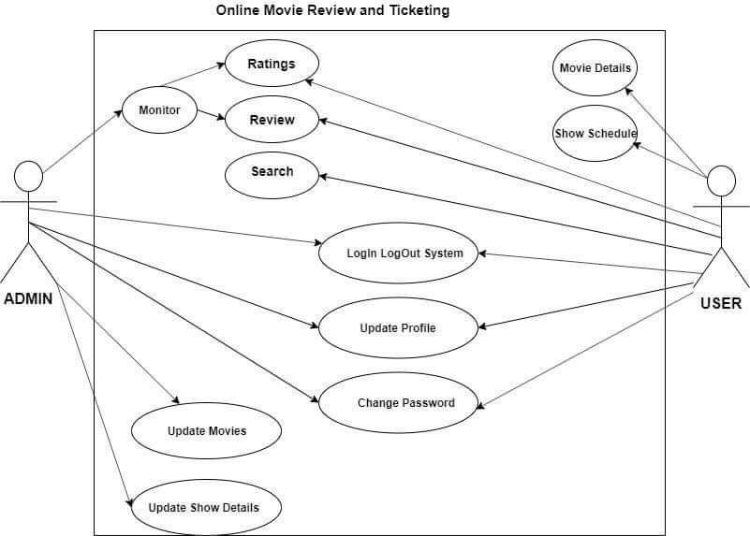

**Figure-1: Use case Diagram**

* ***Class Diagram:***

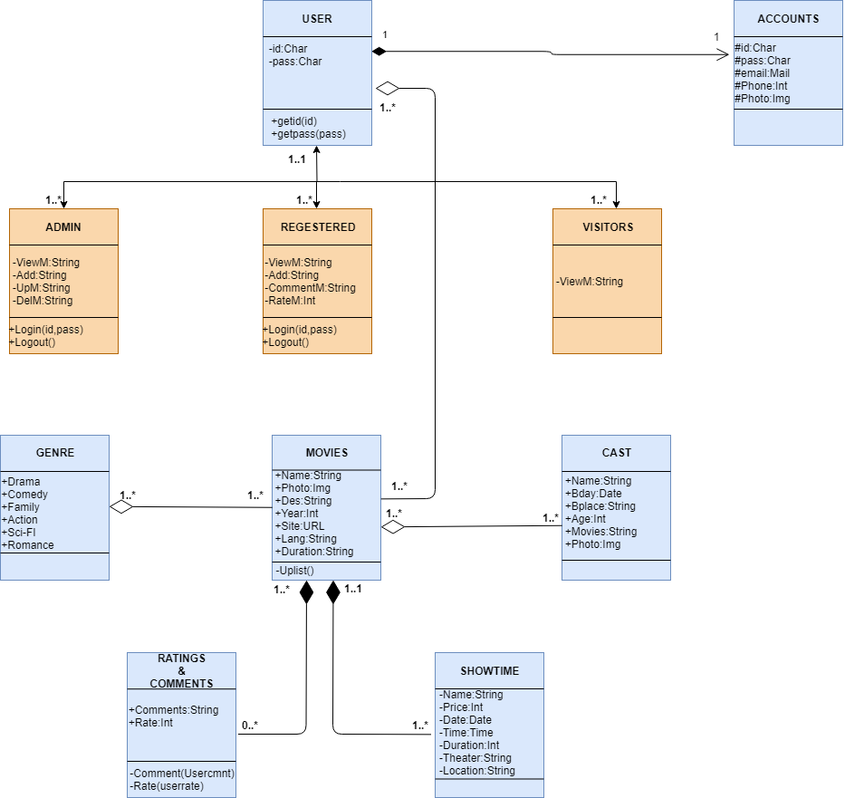

**Figure-2: Class Diagram**

* ***Sequence Diagram:***

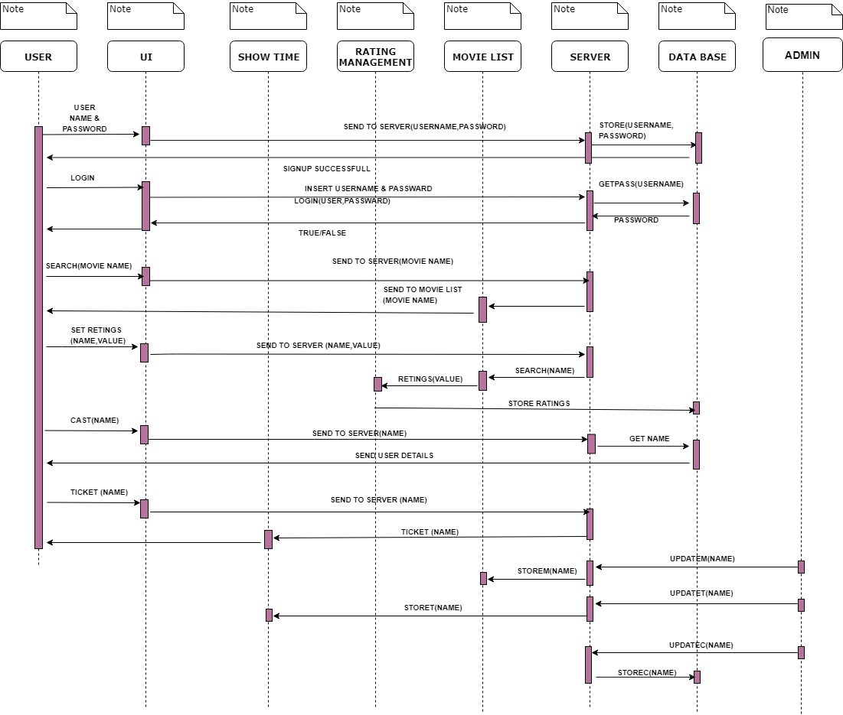

**Figure-3: Sequence Diagram**

* ***Activity Diagram:***

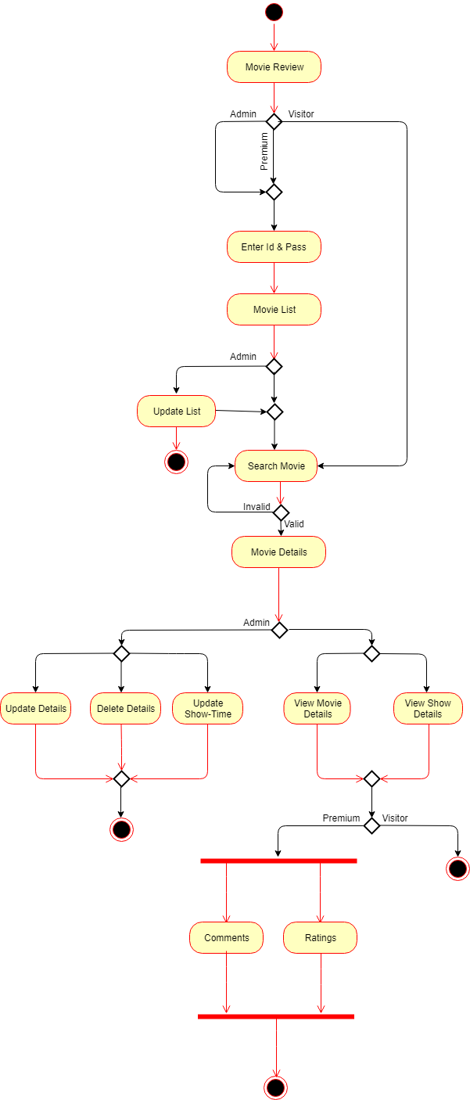

**Figure-4: Activity Diagram**

* ***E-R Diagram:***

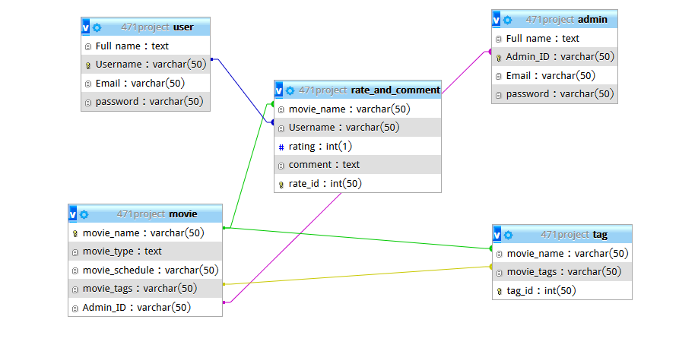

**Figure-5: E-R Diagram**

* ***Data Flow Diagram:***

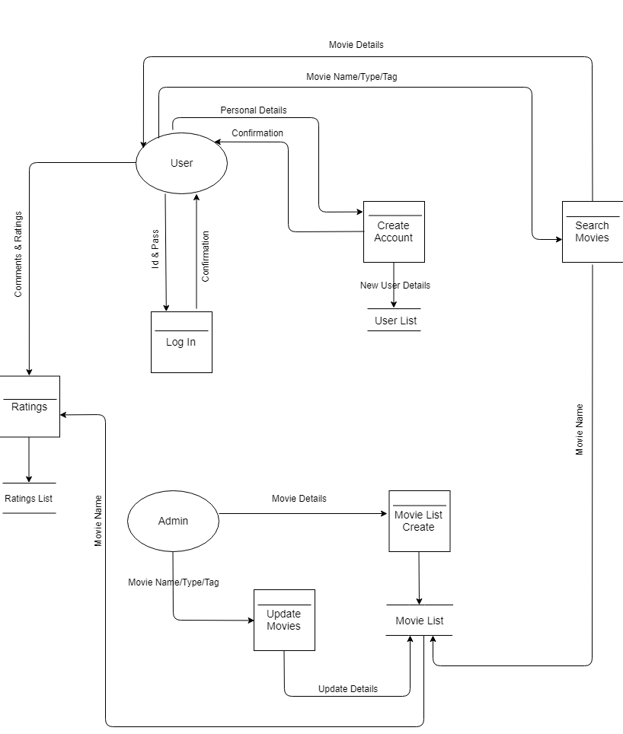

**Figure-6: Data Flow Diagram**

* ***Physical DFD:***

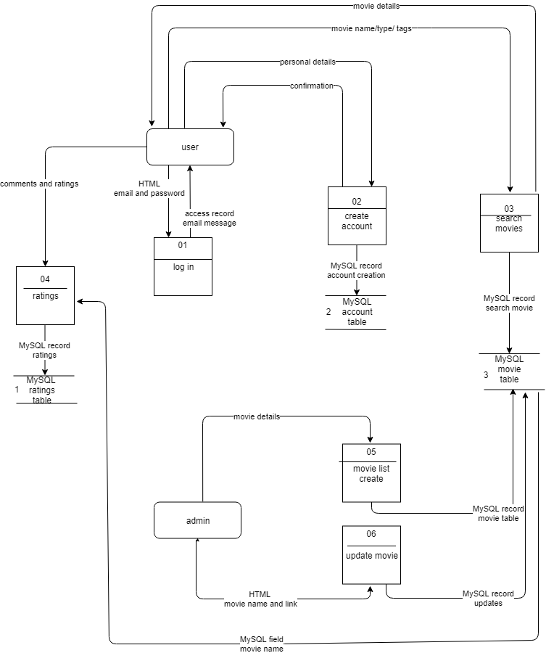

**Figure-7: Physical DFD**

* ***WND:***

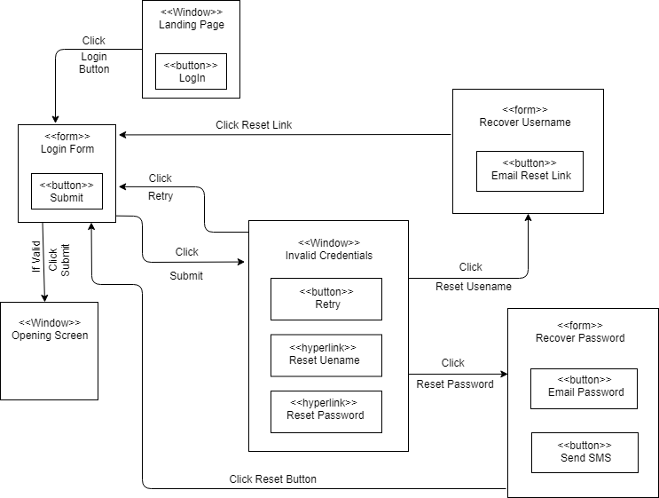

**Figure-8: WND**

***Interface Design:***

* **Homepage:**

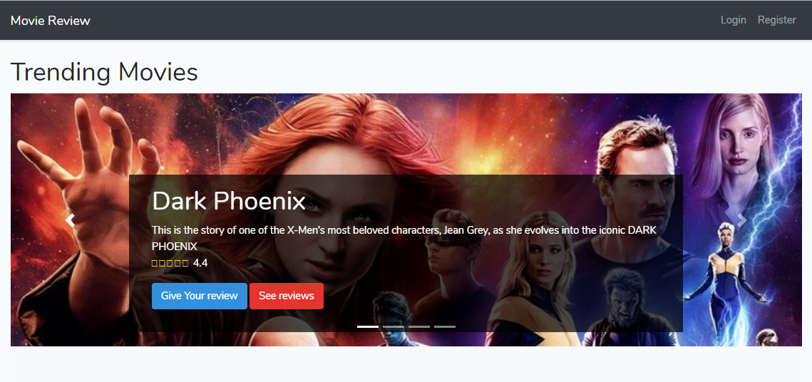

* **Other Movies:**

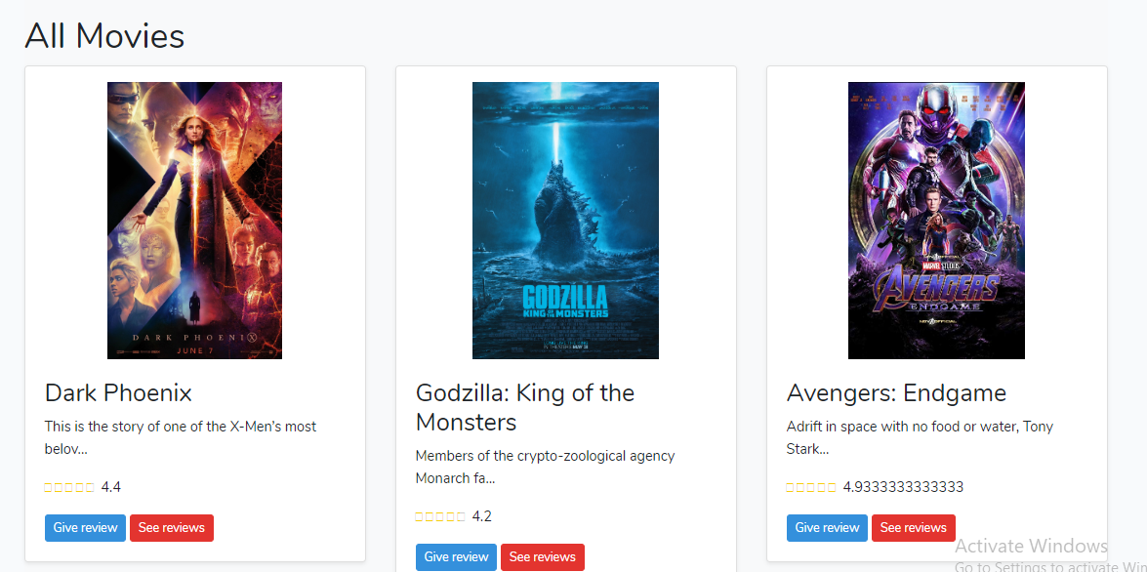

* **Register:**

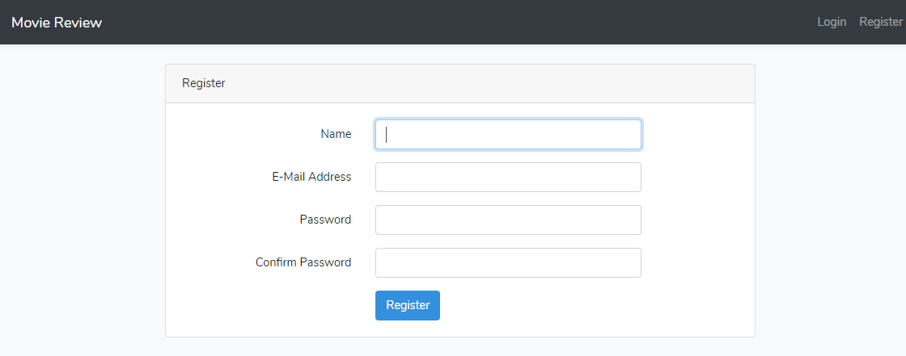

* **Login:**

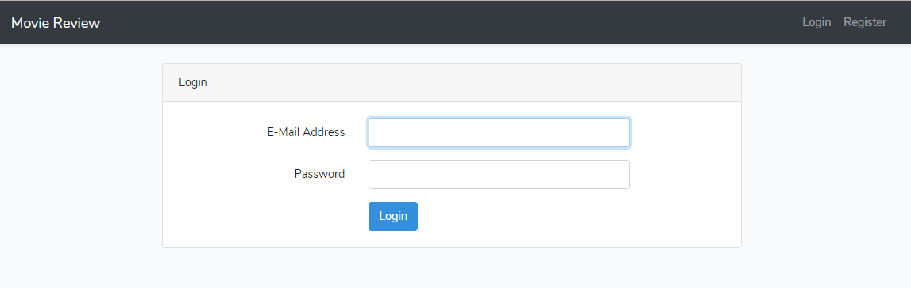

* **View Details, Ratings and Comments:**

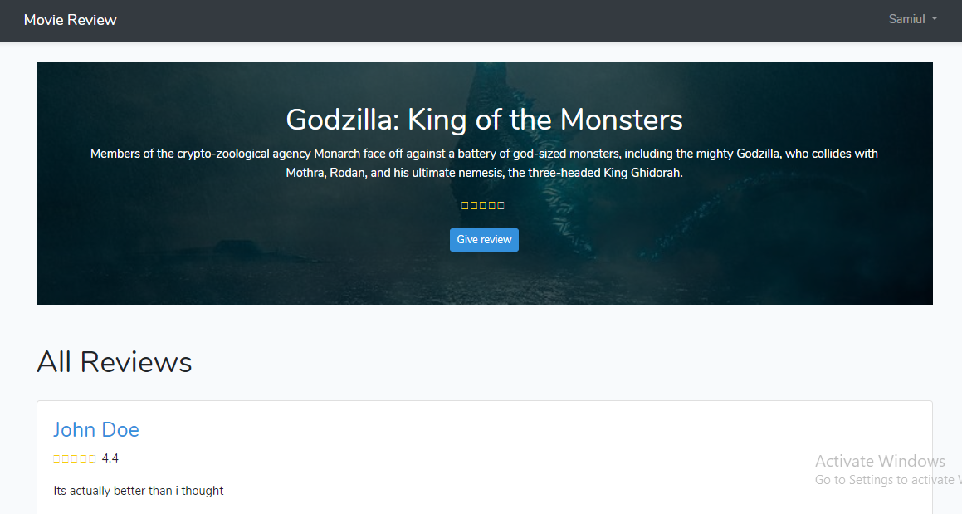

* **Give Ratings and Comments:**

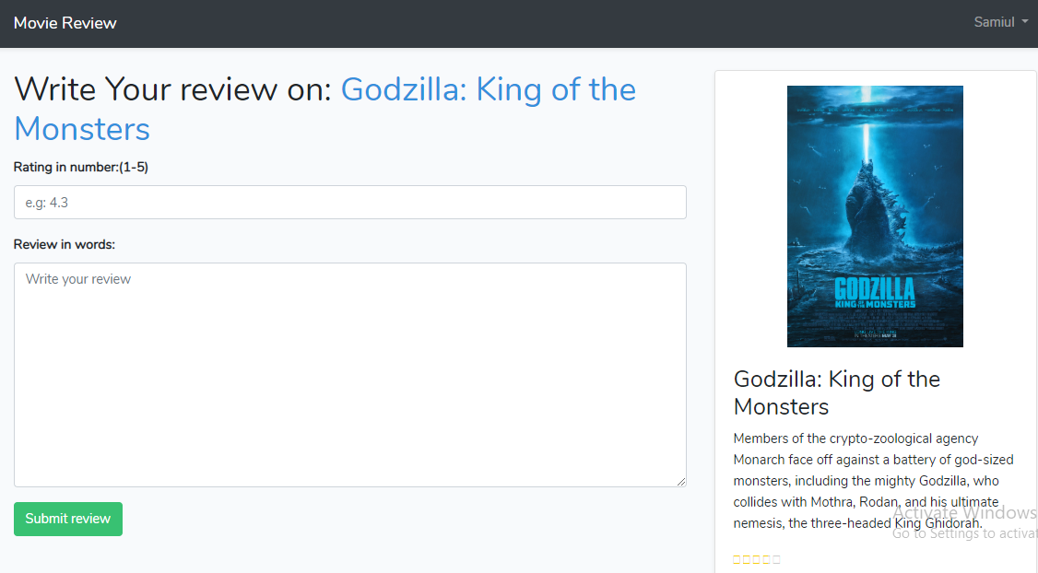

***Test Case:***

We will use “**White Box**” testing to test our system is working properly or not.

* We will first find the independent paths from the codes we written.
* Then we will consider every paths and draw a test case.
* Example: For registration- compare valid email id, at least 8 words password.
* For login- check given id and password is matched or not.
* For movie search- check if given movie name is available in our database or not.
* For ratings and comment check it is saved or not.

***Contribution Table:***

|  |  |  |  |  |
| --- | --- | --- | --- | --- |
| Student ID | Weekly Lab Work Submission | Prepare Project | Report Writing | Presentation  Slide  Making |
| 16101090 | 40% | 15% | 60% | 5% |
| 16101314 | 15% | 40% | 10% | 35% |
| 16301162 | 15% | 15% | 10% | 20% |
| 17121014 | 15% | 15% | 10% | 20% |
| 19101665 | 15% | 15% | 10% | 20% |

***Thank You***