Objective: Use SQL to pull simple sales info (like total quantity sold, total revenue), and display it using a simple bar chart.
Tools:
- SQL (MySQL): For Data Extraction
- Microsoft Excel (Pivot Table & Chart): For Visualisation
Dataset: salaries_employees_data
Table 1: employees
Table 2: Salaries



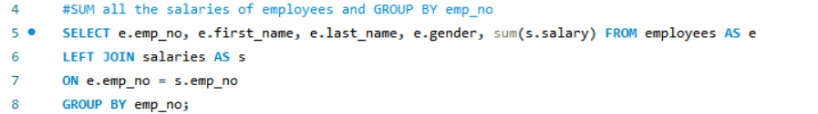

Use FINAL sheet for pivot table and chart.

