Case-Study 1
Nonlinear Sensor Calibration Using Bisection Method

1. Aim
To calibrate a nonlinear flow sensor by determining the nonlinear exponent $b$using the Bisection Method and to compute the scaling factor $A$.

2. Objective
- To model a nonlinear sensor using a power-law equation.
- To formulate a nonlinear equation for calibration.
- To solve the nonlinear equation using the Bisection Method.
- To compute the scaling constant after estimating the exponent.

3. Theory
Many real sensors are nonlinear. The output voltage of the sensor does not vary linearly with flow rate. A commonly used nonlinear model is the power-law model.
The sensor model is:
$$Q=A(V-c)^{b}$$
Where:
$Q$= Actual flow rate (L/s)
$V$= Sensor output voltage (V)
$c$= Baseline voltage at zero flow (V)
$A$= Scaling constant
$b$= Nonlinear exponent

4. Mathematical Derivation
Step 1: Volume as Integral of Flow
Flow rate is defined as the rate of change of volume:
$$Q=\frac{dV_{ol}}{dt}$$
Total volume is obtained by integrating flow:
$$V_{ol}=∫Q dt$$

Step 2: Substitute Sensor Model
$$V_{ol}=∫A(V-c)^{b} dt$$
Since $A$is constant:
$$V_{ol}=A∫(V-c)^{b} dt$$

Step 3: Define Integral Term
Let:
$$I(b)=∫(V-c)^{b} dt$$
Therefore:
$$V_{ol}=A I(b)$$

Step 4: For Multiple Trials
Five experiments are conducted using a 3-liter syringe at different speeds.
For each trial:
$$I_{1}(b)=∫(V_{1}-c)^{b} dt \\ I_{2}(b)=∫(V_{2}-c)^{b} dt \\ I_{3}(b)=∫(V_{3}-c)^{b} dt \\ I_{4}(b)=∫(V_{4}-c)^{b} dt \\ I_{5}(b)=∫(V_{5}-c)^{b} dt$$
Since the syringe volume is fixed at 3 L:
$$V_{ol1}=V_{ol2}=V_{ol3}=V_{ol4}=V_{ol5}=3$$
Thus:
$$AI_{1}(b)=AI_{2}(b)=AI_{3}(b)=AI_{4}(b)=AI_{5}(b)$$
Which implies:
$$I_{1}(b)=I_{2}(b)=I_{3}(b)=I_{4}(b)=I_{5}(b)$$

Step 5: Objective Function
To make all integrals equal, define an objective function:
$$f(b)=\text{std}\left(I_{1}(b),I_{2}(b),I_{3}(b),I_{4}(b),I_{5}(b)\right)$$
For perfect calibration:
$$f(b)=0$$
This is a nonlinear equation in $b$.

5. Numerical Solution Using Bisection Method
To solve:
$$f(b)=0$$
We use the Bisection Method.

Bisection Equations
Initial bounds:
$$b_{l}=0.5 \\ b_{u}=3.0$$
Midpoint:
$$b_{r}=\frac{b_{l}+b_{u}}{2}$$
Stopping condition:
$$∣b_{u}-b_{l}∣<0.001$$
The iteration continues until convergence.

6. Calculation of Scaling Factor
After obtaining optimal $b$:
Since syringe volume is 3 L:
$$3=AI_{1}(b)$$
Therefore:
$$A=\frac{3}{I_{1}(b)}$$
7. MATLAB code for iterations
clc; close all; clear all;

fs = 100;
dt = 1/fs;
c = 0.5;
Vsyringe = 3;

T = [2 3 4 5 6];
n = 5;

for j = 1:n
t = 0:dt:T(j);
for i = 1:length(t)
V(j,i) = c + (1.6-0.2*j)*exp(-t(i));
end
L(j) = length(t);
end

ml = 0.5;
mu = 3;
err = 0.001;
iter = 1;

fprintf('\nIter\tb_mid\tf(b)\tError\n');

while abs(mu-ml) > err

mr = (ml+mu)/2;

for j = 1:n
I(j) = 0;
for i = 1:L(j)
I(j) = I(j) + (V(j,i)-c)^mr * dt;
end
end

meanI = sum(I)/n;
f = sqrt(sum((I-meanI).^2)/n);

error_list(iter) = abs(mu-ml);
b_list(iter) = mr;

if f > 0
mu = mr;
else
ml = mr;
end

fprintf('%d\t%.4f\t%.6f\t%.6f\n',iter,mr,f,abs(mu-ml));

iter = iter + 1;
end

b_final = mr;

A = Vsyringe / I(1);

fprintf('\nFinal b = %.6f\n',b_final);
fprintf('Scaling A = %.6f\n',A);

b_vals = 0.5:0.05:3;

for k = 1:length(b_vals)
for j = 1:n
Itemp(j) = 0;
for i = 1:L(j)
Itemp(j) = Itemp(j) + (V(j,i)-c)^b_vals(k)*dt;
end
end
mtemp = sum(Itemp)/n;
f_vals(k) = sqrt(sum((Itemp-mtemp).^2)/n);
end

figure;
plot(b_vals,f_vals,'b','LineWidth',2);
hold on;
plot(b_final,0,'ro','MarkerSize',8,'LineWidth',2);
xlabel('Exponent b');
ylabel('f(b)');
title('Objective Function vs Exponent b');
legend('f(b)','Intersection (Optimal b)','Location','best');
grid on;

figure;
plot(1:length(error_list),error_list,'r','LineWidth',2);
hold on;

final_iter = length(error_list);
final_error = error_list(end);

plot(final_iter,final_error,'bo','MarkerSize',8,'LineWidth',2);

yline(err,'k--','Tolerance');

xlabel('Iteration');
ylabel('Error |b_u - b_l|');
title('Error Convergence of Bisection Method');
legend('Error','Final Converged Point','Tolerance','Location','best');
grid on;

OUTPUT: -
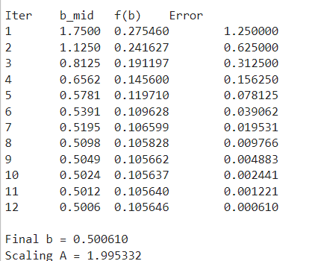

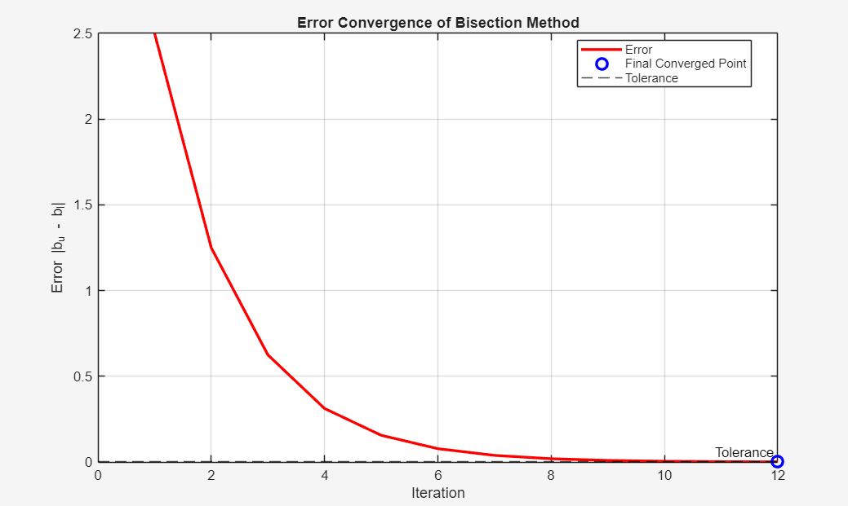

8. Final Calibrated Model
$$Q=A(V-c)^{b}$$
Where:
$b$is obtained using Bisection Method
$A$is computed using syringe volume

9. Result
The nonlinear exponent $b$was determined using the Bisection Method.
The scaling factor $A$was calculated using the known syringe volume.
The calibrated sensor equation was obtained.

10. Conclusion
The nonlinear flow sensor was successfully calibrated using numerical methods.
The experiment demonstrated practical application of:
- Numerical integration
- Nonlinear equation formulation
- Bisection Method
- Parameter estimation
This experiment shows how numerical methods are used in real-world sensor calibration problems.

