**Balanced Scorecard**

Our Project is highly influenced by the Balanced Scorecard framework as it helps us to visualize our company’s overall reporting strategy. So, this can be used by the managers to have an overview of the activities made by staff and also monitor the consequences arising from their actions.

The four pillars of BSC strategy are: Customers, Financial, Internal Business Process and Learning and growth. Where each features have their own requirements.

Objectives: An overall Organization Goal.

Initiatives: The strategic workflows and processes to achieve the objectives defined by the scope.

Measures: Includes the fundamental study of understanding if the objectives are met.

Action Items: Breaking down of tasks as achievable targets and distributed to high functional teams to get the initiatives done.

BSC Helps us to answer these fundamental questions:

* What is the customer perspective.?
* What should we do to improve our existing state?
* How to create value driven solution and improve time to time?
* What is the health of our financial state?

Banco Comercial Portugues, is primarily concerned with operational efficiency, which can be achieved by increasing its customer base with reasonable product offerings which keeps the running cost optimized. Additionally, more focus on improving the existing internal processes which lead to increased customer satisfaction and aid in the overall growth of the organization.



Figure 2: Balanced Scorecard for Banco Comercial Português

|  |  |  |  |  |
| --- | --- | --- | --- | --- |
| Strategy | | | | |
|  | **Objectives** | **Measures** | **Targets** | **Initiatives** |
| Financial | Increase Revenue | Increase in long term investments and sale of Investment products | 10% increase in revenue | Adding more products that gives a flexible model to investors |
| Customer | New customers to market | Increase percentage | 10% add of new customers by marketing | Better service and better products |
| Internal | Decisive Decisions | Ease of workflow reduce SLA | 24 hrs | SLA Implementation, Mailbox and support queues |
| Learning and Growth | Improve Training Program | Improve Internal Employee Skills | 100 employees | improving knowledge base by learning from case management |

Figure 3: Strategies for Banco Comercial Português

**Solution Development Process**

**Data Generation and Cleaning**

The initial and most important step in the solution development process of a Business Intelligence and Analytics system is the generation of the data. After a comprehensive search on the companies in the Banking domain, relevant entities and their attributes were chosen for creating the data. The random data generator software Mockaroo was chosen and data was then cleaned and prepared for analysis using various libraries in MS Excel and Python.

**Data Generation using Mockaroo**

Appropriate datasets were mocked using the online random data generator tool Mockaroo and different entities were mocked with appropriate attributes. The list of customers was generated with attributes such as first_name, last_name, City, Country, Profession, email, Contact, DOB, DOJ, Account_Type, balance, Invested Amount, Issue_start date, close date,unique IDs like Customer_ID,Account id,investment_id,Product_ID, Issue_Id etc. After generating data from Mockaroo we have used sql queries and excel to create products, leads and investments.

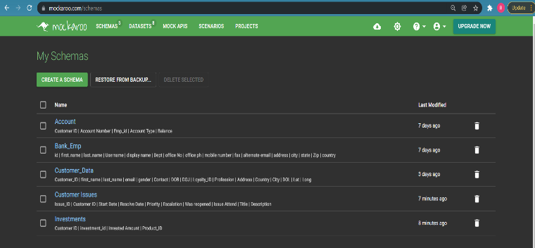

**Data Cleaning and Preparation using Excel and SQL script**

After we generated the datasets in Mockaroo we had to manipulate and clean the dataset one by one. The dataset was imported as csv in excel and then the following tasks were performed:

* A unique Id column was added for the all the data tables
* Using SQL Scripts, we joined the different schema by primary key and foreign key reference which can be seen clearly within our ER diagram.
* Generating the Leads excel sheet using queries and joins over multiple schemas to find our potential customer base.
* Created a product using excel that can be imported to our CRM system with some default cost and then calculating the revenue accordingly.
* Mockaroo generates random account balance for different customers so we had to manipulate the investment value and the account balance accordingly

**Building Cloud Based Database – Azure Database for MySQL**

For any organization the most expensive thing to start its business is handling data and its underlying infrastructure. Banking needs a huge volume of transactions aswell as the infrastructure should be scalable, portable and reliable.

Thus, considering all these challenges and requirements the best suitable infrastructure for the database we thought of going for a long-term cloud based on demand solution.

By leveraging the cloud capabilities our database is now stable, low maintenance, scalable and with improved security due to encryption and also the network had limited access which increased the protection pf the data. We also had taken the flexible plan which is pay as u go service, meaning the cost effectiveness of the solution increases to a further extent.

This cloud-based database has similar features that of a traditional Db but has the additional robust features of that of a cloud provider. Many cloud-based providers are present in the market but we have chosen Azure as our vendor as it had the best suited features for MySQL pay as you go service and offered a flexible server for our requirements.

Migration of data has also been one of our primary concerns as the banks traditional data was mostly based out of excel sheets so the adaptors and the importing wizard for MySQL Workbench has been great help and an ease to get data into the database.

The data once leaded in the Cloud Database we have used the query editor in SQL workbench to formulate the primary key and foreign key relationships aswell.

Once done we created firewall rules for our database server just by whitelisting the necessary network Ips hence stopping any external networks accesses.  
  
we also enabled the IP address for the powerbi dashboard so that the dataset could be loaded into powerbi for visualization and made it ready for the initial insights.

Here are some snapshots to explain this whole process:

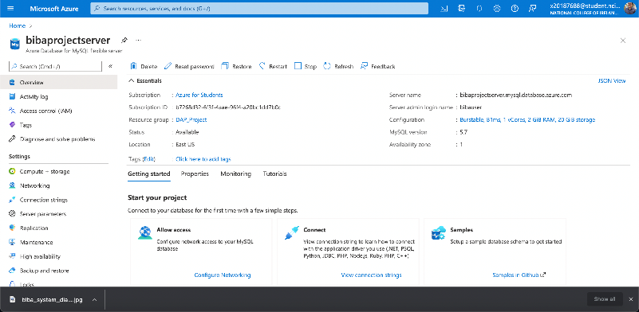

Firewall rules were added for individual project team members for their work from local machine and also PowerBI and workbench as a client.

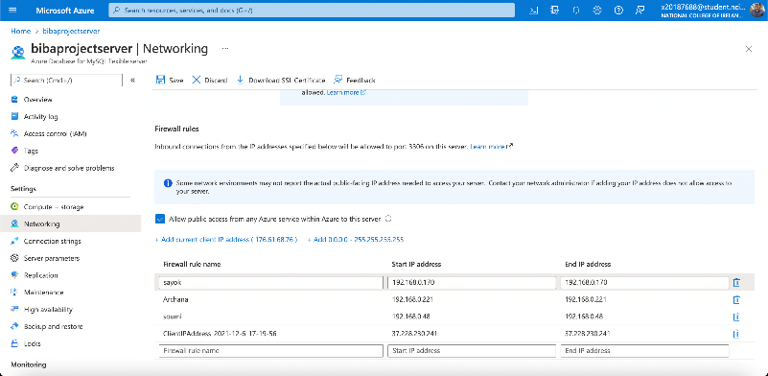

Connecting the database using the SQL Workbench and loading all the schemas into the tool for database manipulation:

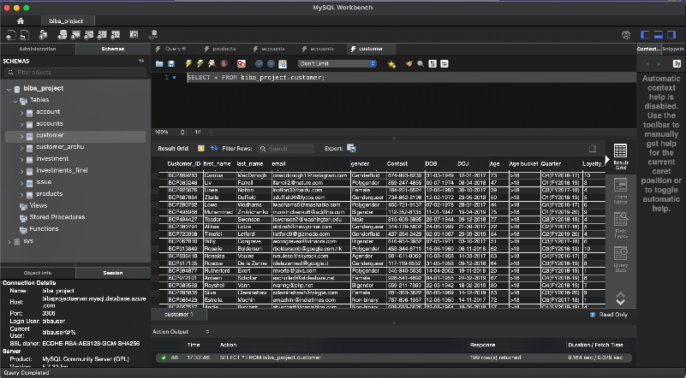

And after joining the tables with foreign key and primary key relationship here is how the current entity relationship looks like:

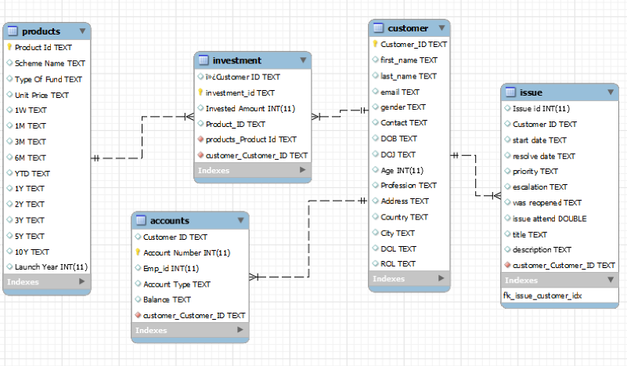

Then once the data was loaded in the MySQL DB we imported the data by connecting it to the PowerBI dashboard by providing the cloud endpoints and the credentials of the root user for the database:

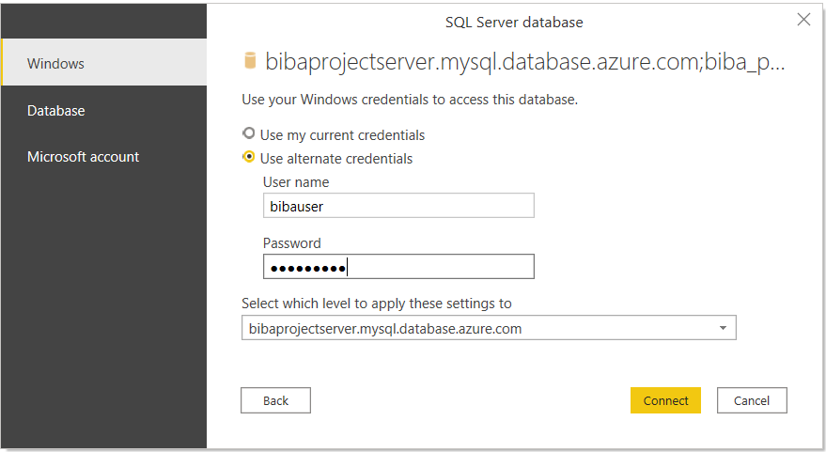

**Importing Data into Azure MySQL Database Server**

Since we were using MySQL workbench importing the CSV was quite easy, as MySQL uses the importing wizard to import all the rows into the system. Here are few snapshots to showcase how we did this:

Importing the csv that we generated using Mockaroo and putting the csv path in the SQL workbench.

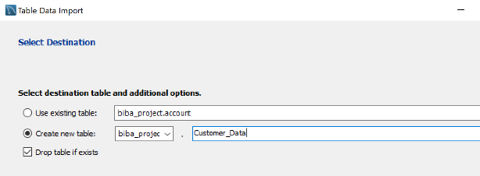

Then once the path is provided, we can either use the existing tables in workbench or drop and create new tables if needed.

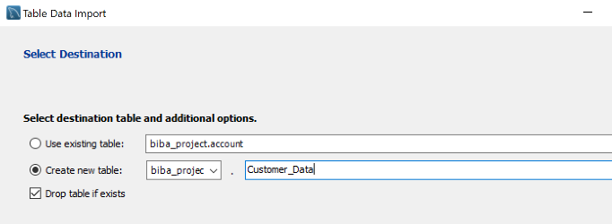

**Implementation of the Solution**

We used the following solution for all the considerations made by us during the analysis phase:

1. We considered the usage of CRM software for managing customer relations and selected MS Dynamics 365 for it.

2. created the dashboards in both Power BI and dynamics to visualize the various trends in the bank’s investment plans.

Here is the high-level solution overview diagram for our implementation:

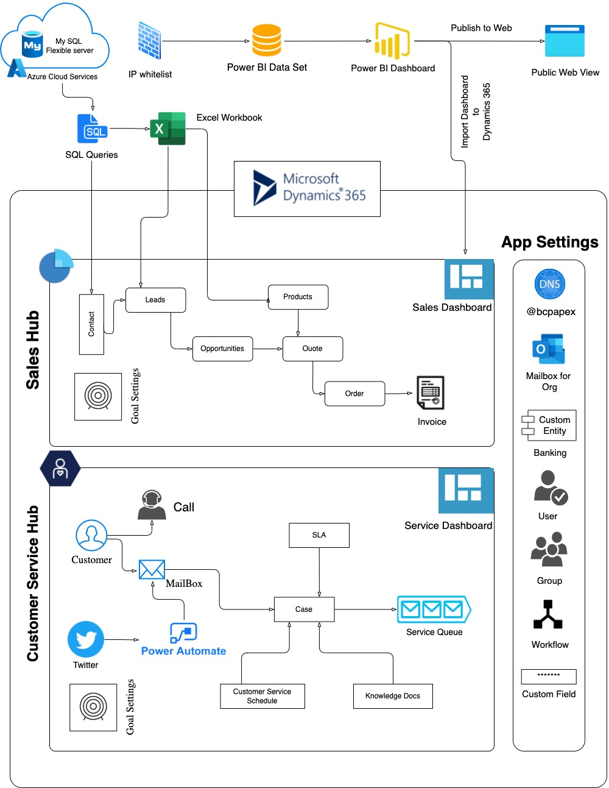

**Integrating the Data on Dynamics 365 Sales Hub**

Dynamics sales hub is used to build a holistic ecosystem around the customer and build a strong customer relationship. For our project we heavily rely on the CRM business process of Lead to Opportunity sales.

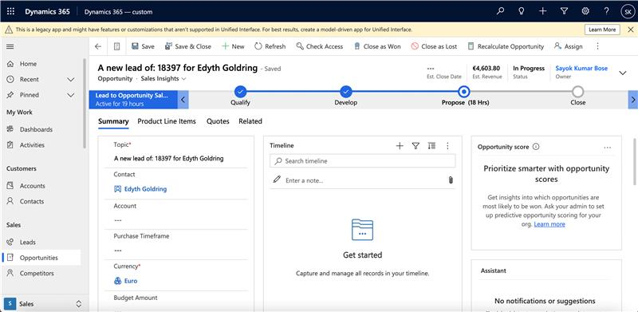

Here is an explanation of our process flow, entities and sales pipeline with their diagrams :

**Contact**: We have created the customers from the customer data table and created a custom workflow followed by an action which triggers a welcome mail to any customer who joins the bank. To give a nice customer onboarding experience. We have also created a custom view for our contacts showing the Date of Joining and city.

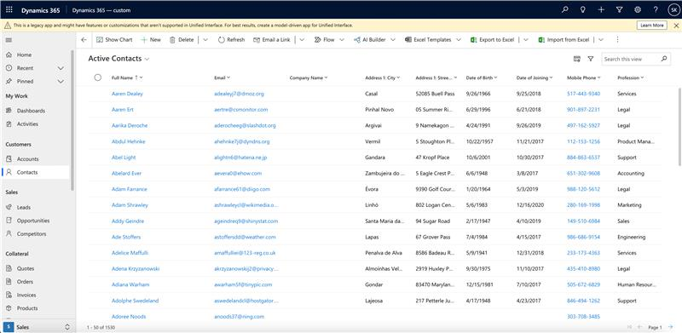

**Leads**: We created our leads by identifying the customers who have savings bank account with the bank and have no investments.

**Opportunities**: We created opportunities by making activities in CRM systems(call/mail/meetings) around leads and identifying the purchase timeframe, estimated budget and various other parameters to qualify them as an opportunity.

**Products**: We directly loaded the product from the database into the all products category of the CRM system and kept the unit group to be default and created a default price list called BCP investment plans.

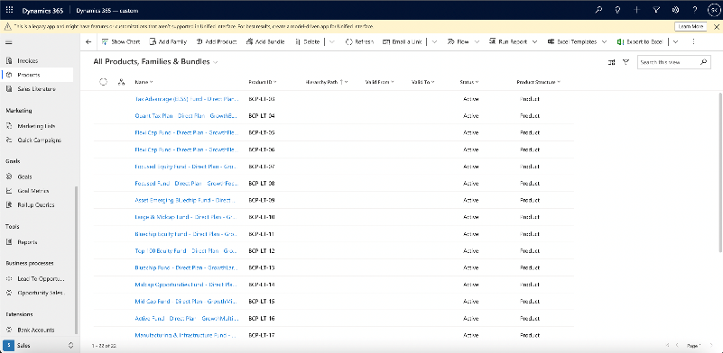

**Quote**: We created quotes directly from our Opportunities by setting the detailed amount system generated from the product list along with any discount rates provided to the customers by creating activities around the opportunity. This quote can be revised multiple times based on the workflow.

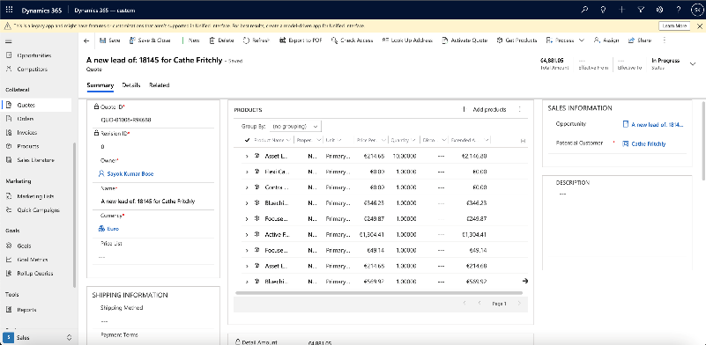

**Orders**: Orders were made once the customer has zeroed in on the final activated quote and once order is placed, we mark the opportunity as won.

**Invoice:** Once the order is made, we are creating an invoice to keep in the system and then fulfilling the order.

**Bank Accounts:** We created a custom entity called bank accounts as dynamics CRM doesn’t have any entity that supports our banking model of 1: N relationship of bank accounts to customers. We also added a custom form in the contact page that shows us this one-to-many mapping of customer to accounts.

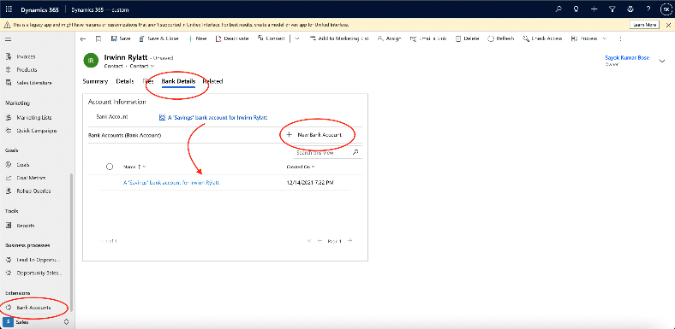

**Goal Setting**: We added a revenue-based sales goal for individual employees in the sales team so that the dashboard can clearly show the percentage of the achieved target for the custom time period.

**Sales Dashboard:** The sales dashboard includes the external powerbi dashboard which is published as we enabled the powerbi plugin in the dynamics365 more over we also added our custom dashboard called the BCP Dashboard for the sales team which shows the sales pipeline, top customers, goals for the active employee sales leader dashboard, revenue generated by month and the opportunities won/lost or open.

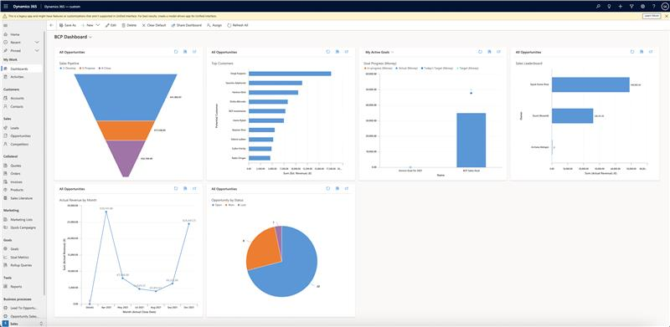

**Implementing the service management on Dynamics 365:**

In the early analysis phase of the project implementation, we figured out that the bank had lot of complains form the customers. Where the customers have complained about too long and tedious onboarding process, poor customer process and service. Which made us realsie that the bank needs a good tool to manage all of this and thus we have chosen the Service management part of dynamics to help us with the implementation of the same.

**SLA**: we have created a service level agreement for any type of case creation within the system that warns us from breaching any agreement of response time for any incidents/ tickets.

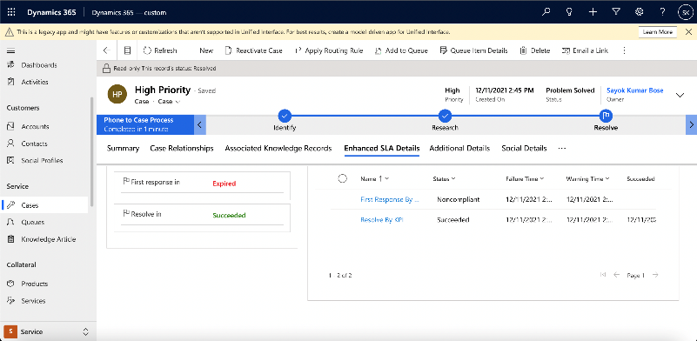

**Mailbox**: We integrated outlook 365 with dynamics 365 and created a support mailbox that is constantly monitored for any incoming mail, and once we encounter a new mail from an existing or a non-existing customer an auto case gets created in the system. Which gets the existing SLAs auto appended.

**Customer Service schedule**: we have created service window schedules updated the holiday calendar so that customers have a clear view or record of when the support engineers are available or what are working hours and holidays for the people in the bank and that’s how the SLAs are also evaluated for a case.

**Knowledge docs**: Since there are so many active reported errors on Onboarding, we created a knowledge article in the system about Onboarding that can be easily fetched and auto appended to the case if we find any case that requires help for onboarding.

**Queue**: we now have support queue dedicated for all the active case monitoring in the system which is tied up with mailbox rules and also has a mail id.

**Goal Setting**: we now have a goal for individual support engineers monitoring the support queue so that we have a good boost of moral and a clear view of number of cases getting closed in the bank.

**Social media- Power Automate**: A lot of the customers feel like using social media platforms to complain and talk about issues.so now with help of power automate we have created a flow that triggers an auto case creation from twitter based on our custom hashtag #bcpsupport. From now on no social escalations will be left unnoticed.

**Service Dashboard**: The service dashboard shows the active cases and the cases resolution by trend and the user activities pending.

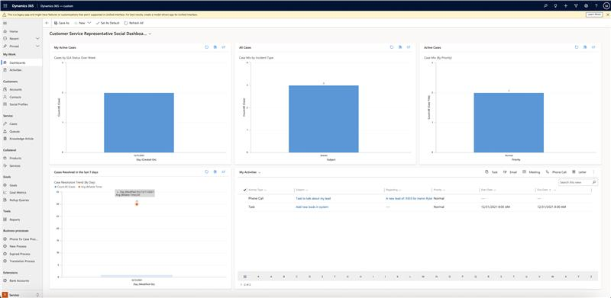

**Dashboards in Power BI**

* **Sales/Revenue Dashboard**
* **Customer Dashboard**
* **Trends Dashboard**

**Benefits of the Solution**

* A modest insight into the sales dashboard will reveal that the sales has increased substantially in comparison to previous years. This also implies the higher number of customers being qualified from the Leads stage to the Invoice stage.
* By using the same model solution, the company’s market can be expanded to other unexplored territories and serve as a new marketplace for the organisation.
* Another major benefit of the solution is its low cost and high
* flexibility.

**Conclusion**

The observation of various statistics and trends being displayed in the dashboard will infer that the implemented solution is a success and leading to boast in the business. The customer base has expanded after the implementation leading to more revenue for Banco Comercial Portugues.

**Further Work**

**Appendix: Teamwork**

* For the success of this project, suitable timelines and milestones were created for specific parts and the workload was equally divided to maximize collaboration. Microsoft teams was used as a medium for inter team communication.
* The work was divided into three verticals - Specification, implementation and the presentation.
* The successful and timely completion of this project is the result of diligent work of each and every team member and the impeccable team work.

References

[1] Wikipedia. ’balanced scorecard’. Available: <https://en.wikipedia.org/wiki/Balanced_scorecard>

[2] Robert S. Kaplan and David P. Norton. The Balanced Scorecard.. Available:

<https://hbr.org/1992/01/the-balanced-scorecard-measures-that-drive-performance-2> .

[3] Microsoft Dynamics 365 Services. Available:

<https://dynamics.microsoft.com/en-ie/> .