DC_DC Step Down Buck Converter

A DC-DC step-down (buck) converter is a power electronics device that converts a higher input voltage to a lower output voltage efficiently. Here’s a detailed description and common specifications:

**Description**

**Functionality:**

* **Buck Converter:** The buck converter uses a switching element (typically a transistor) to chop the input voltage and regulate the output voltage through an inductor, diode, and capacitor.
* **Operation Principle:** When the switch is on, current flows through the inductor and energy is stored. When the switch is off, the inductor releases energy to the output load. The output voltage is controlled by varying the duty cycle of the switching signal.

**Key Specifications**

1. **Input Voltage Range (V_in):**
   * Typical range: 5V to 60V (varies by model).
2. **Output Voltage (V_out):**
   * Adjustable or fixed output, commonly from 1.2V to 30V.
3. **Output Current (I_out):**
   * Maximum output current: Generally ranges from a few hundred milliamps to several amps (e.g., 1A, 3A, 5A, or higher).
4. **Efficiency:**
   * Efficiency rates often exceed 85% to 95%, depending on load conditions and specific design.
5. **Switching Frequency:**
   * Common frequencies: 100 kHz to 1 MHz, impacting size and performance.
6. **Ripple Voltage:**
   * Output ripple typically specified in millivolts, important for sensitive applications.
7. **Protection Features:**
   * Overcurrent protection
   * Thermal shutdown
   * Input under-voltage lockout (UVLO)
8. **Package Type:**
   * Available in various forms including through-hole and surface mount (SMD).

**Applications**

* Power supply for microcontrollers and other low-voltage devices
* Battery-powered devices where efficiency is critical
* LED drivers
* DC motor drivers

**Example Components**

* **Integrated Circuits (ICs):** Common examples include the LM2596, LM2675, and TPS54331.
* **Discrete Solutions:** Using MOSFETs and external components for custom applications.

DC_DC STEPDOWN BUCK CONVERTER COMPONENTS

1)U1 NE555p TIMER IC

**NE555P Timer Overview**

**Function:** The NE555 timer is a versatile integrated circuit used for timer, delay, pulse generation, and oscillator applications.

**Key Specifications**

* **Operating Voltage Range:** 4.5V to 15V (some versions can go up to 18V)
* **Output Current:** Can drive loads up to 200mA
* **Frequency Range:** Up to 500kHz
* **Temperature Range:** 0°C to 70°C (standard) or -40°C to 125°C (industrial versions)
* **Dissipation Power:** Typically around 600mW
* **Duty Cycle:** Adjustable from 0% to 100%

**Pin Configuration**

1. **GND:** Ground pin
2. **Trigger:** Active low input to start timing
3. **Output:** Output pin for timing signal
4. **Reset:** Active low input to reset the timer
5. **Control Voltage:** Used to adjust timing (usually connected to ground)
6. **Threshold:** Compares the voltage to reset the timer
7. **Discharge:** Discharges timing capacitor when the output goes low
8. **Supply Voltage (VCC):** Power supply input

**Applications**

* Timer circuits
* Pulse width modulation
* Oscillators
* Flip-flops
* LED flashers

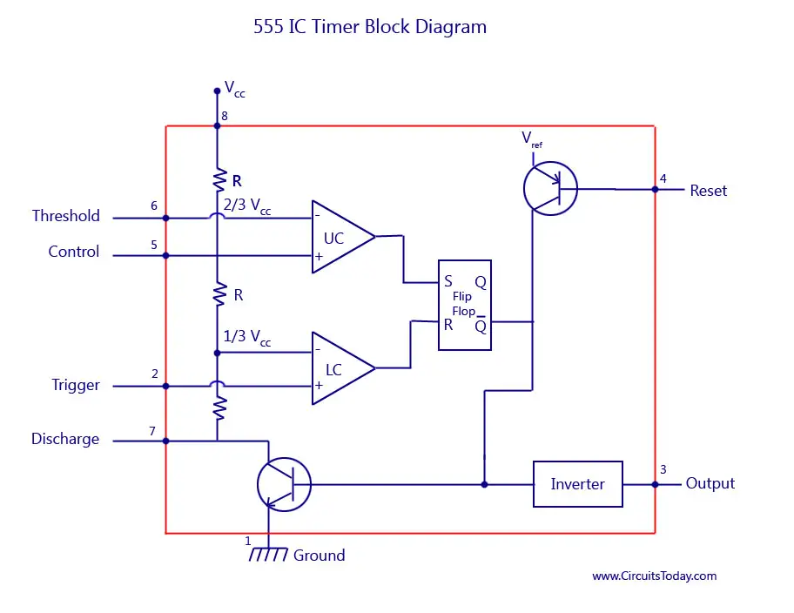

**2)Q1 IRLZ44N MOSPHET**

**IRLZ44N MOSFET Overview**

**Type:** N-channel MOSFET

**Key Specifications**

* **V_DS (Drain-Source Voltage):** 55V
* **I_D (Continuous Drain Current):** 49A (at 25°C)
* **R_DS(on) (On-Resistance):** 0.025Ω (typical at V_GS = 10V)
* **V_GS (Gate-Source Voltage):** ±20V
* **Total Gate Charge (Q_g):** 67nC (typical)
* **Switching Times:** Fast switching capability
* **Package Type:** TO-220

**Applications**

* Power management
* Motor control
* DC-DC converters
* Amplification circuits

3)DIODE

D1 D_SCHOTTKY DIODE

**Schottky Diode Overview**

**Type:** Schottky barrier rectifier

**Key Specifications**

* **Reverse Voltage (V_R):** Typically ranges from 20V to 100V, depending on the specific diode
* **Forward Current (I_F):** Commonly up to 1A to 40A
* **Forward Voltage Drop (V_F):** Low forward voltage drop (around 0.2V to 0.5V)
* **Reverse Recovery Time:** Very fast (typically in the nanosecond range)
* **Junction Temperature Range:** -55°C to +150°C
* **Package Types:** Can come in various packages like DO-41, TO-220, SMD, etc.

**Applications**

* Power supply circuits
* Switching power supplies
* Rectification in AC to DC converters
* Freewheeling diodes in inductive loads

4) CAPACITORS

C1,C4_10nf

**10 nF Capacitor Overview**

**Capacitance:** 10 nF (nanofarads)

**Key Specifications**

* **Voltage Rating:** Varies widely; common ratings include 25V, 50V, 100V, or higher.
* **Dielectric Material:** Common types include:
  + **Ceramic:** Often used for general applications; low leakage current.
  + **Film:** Good stability and low losses; used in audio and timing applications.
  + **Tantalum:** Higher capacitance in smaller sizes, though more expensive.
* **Temperature Coefficient:** Different types (C0G, X7R, etc.) indicate temperature stability.
* **Tolerance:** Typically ranges from ±5% to ±20%, depending on the application.
* **Size and Package:** Available in various sizes, including through-hole and surface mount.

**Applications**

* Filtering in power supply circuits
* Coupling and decoupling applications
* Timing circuits
* Signal processing

C2_47uF

**47 µF Capacitor Overview**

**Capacitance:** 47 µF (microfarads)

**Key Specifications**

* **Voltage Rating:** Common ratings include:
  + **Electrolytic Capacitors:** 10V, 16V, 25V, 50V, etc.
  + **Tantalum Capacitors:** Higher voltage ratings, often 25V and above.
  + **Film Capacitors:** Similar voltage ratings, typically up to 400V or more.
* **Dielectric Material:**
  + **Electrolytic:** Commonly used for power supply filtering; polarized.
  + **Tantalum:** More stable than electrolytic; smaller size for equivalent capacitance.
  + **Film:** Good for audio and precision applications; non-polarized.
* **Temperature Coefficient:** Varies by type; for electrolytic, usually specified as 85°C or 105°C ratings.
* **Tolerance:** Typically ranges from ±10% to ±20% for electrolytic capacitors.
* **Size and Package:** Available in various sizes; electrolytic capacitors are usually cylindrical, while film capacitors can be in various shapes, including rectangular.

**Applications**

* Power supply filtering
* Coupling and decoupling applications
* Signal smoothing
* Timing circuits in combination with resistors

C3_22uF

**Capacitance:** 22 µF (microfarads)

**Key Specifications**

* **Voltage Rating:** Common ratings include:
  + **Electrolytic Capacitors:** 10V, 16V, 25V, 35V, 50V, etc.
  + **Tantalum Capacitors:** Often rated 25V and higher.
  + **Film Capacitors:** Can range up to 400V or more.
* **Dielectric Material:**
  + **Electrolytic:** Polarized, typically used for bulk energy storage and power supply filtering.
  + **Tantalum:** Non-polarized, more stable, and often used in compact designs.
  + **Film:** Non-polarized, suitable for applications requiring precision and stability.
* **Temperature Coefficient:** Varies based on the type, with electrolytic typically rated for -40°C to 85°C or 105°C.
* **Tolerance:** Generally ranges from ±10% to ±20% for electrolytic capacitors.
* **Size and Package:** Available in various packages; electrolytic types are usually cylindrical, while film capacitors may be rectangular or other shapes.

**Applications**

* Power supply filtering and decoupling
* Signal coupling
* Timing circuits
* Energy storage in power electronics

5)RESISTORS

R1_1K

**Resistance:** 1 kΩ (1000 ohms)

**Key Specifications**

* **Tolerance:** Common tolerances include ±1%, ±5%, and ±10%. Precision resistors may offer ±0.1% tolerance.
* **Power Rating:** Typical power ratings are:
  + **1/8W, 1/4W, 1/2W, 1W,** etc., depending on the application and resistor type.
* **Temperature Coefficient:** Usually specified in parts per million (ppm) per degree Celsius, commonly 100 ppm/°C or lower for precision resistors.
* **Type:** Available in various types, such as:
  + **Carbon Film:** Good general-purpose resistors.
  + **Metal Film:** Better stability and lower noise; used in precision applications.
  + **Wirewound:** Used for higher power applications.
* **Size and Package:** Available in through-hole and surface mount (SMD) packages. Common through-hole sizes include 0402, 0603, 0805, etc., for SMD resistors.

**Applications**

* Voltage dividers
* Current limiting
* Biasing in circuits
* Pull-up or pull-down configurations

R2_10K

**Resistance:** 10 kΩ (10,000 ohms)

**Key Specifications**

* **Tolerance:**
  + Common tolerances include ±1%, ±5%, and ±10%. Higher precision resistors can offer ±0.1% or better.
* **Power Rating:**
  + Typically ranges from:
    - **1/8W, 1/4W, 1/2W, 1W**, etc., depending on the resistor type and application.
* **Temperature Coefficient:**
  + Common values range from 100 ppm/°C to 50 ppm/°C for precision resistors.
* **Type:**
  + **Carbon Film:** General-purpose, cost-effective.
  + **Metal Film:** Offers better stability, lower noise; suitable for precision applications.
  + **Wirewound:** Used in high-power applications, stable at high temperatures.
* **Size and Package:**
  + Available in through-hole (like axial or radial) and surface mount (SMD) formats.
  + Common SMD sizes include 0402, 0603, 0805, etc.

**Applications**

* Voltage dividers
* Signal conditioning
* Pull-up or pull-down resistors
* Current limiting

6)INDUCTOR

L1_33uH

**Inductance:** 33 µH (microhenries)

**Key Specifications**

* **Current Rating (I_max):** Maximum current the inductor can handle without saturating, typically specified in amps (A). This can range from a few hundred milliamps to several amps, depending on the design.
* **DC Resistance (DCR):** The resistance of the inductor wire, usually measured in ohms (Ω). Lower DCR is preferred for higher efficiency.
* **Saturation Current (I_sat):** The current level at which the inductor's inductance begins to decrease significantly.
* **Core Material:** Common materials include ferrite, iron powder, or air-core, affecting performance characteristics such as frequency response and saturation.
* **Frequency Rating:** Inductors can be rated for specific frequency ranges, impacting their performance in RF or power applications.
* **Size and Package:** Available in various form factors, including through-hole (axial or radial) and surface mount (SMD) types. Size specifications may vary by manufacturer.

**Applications**

* Filtering in power supply circuits
* Energy storage in DC-DC converters
* RF applications
* Inductive coupling and transformers