DC_DC STEPDOWN BUCK CONVERTER COMPONENTS

1)U1 NE555p TIMER IC

**NE555P Timer Overview**

**Function:** The NE555 timer is a versatile integrated circuit used for timer, delay, pulse generation, and oscillator applications.

**Key Specifications**

* **Operating Voltage Range:** 4.5V to 15V (some versions can go up to 18V)
* **Output Current:** Can drive loads up to 200mA
* **Frequency Range:** Up to 500kHz
* **Temperature Range:** 0°C to 70°C (standard) or -40°C to 125°C (industrial versions)
* **Dissipation Power:** Typically around 600mW
* **Duty Cycle:** Adjustable from 0% to 100%

**Pin Configuration**

1. **GND:** Ground pin
2. **Trigger:** Active low input to start timing
3. **Output:** Output pin for timing signal
4. **Reset:** Active low input to reset the timer
5. **Control Voltage:** Used to adjust timing (usually connected to ground)
6. **Threshold:** Compares the voltage to reset the timer
7. **Discharge:** Discharges timing capacitor when the output goes low
8. **Supply Voltage (VCC):** Power supply input

**Applications**

* Timer circuits
* Pulse width modulation
* Oscillators
* Flip-flops
* LED flashers

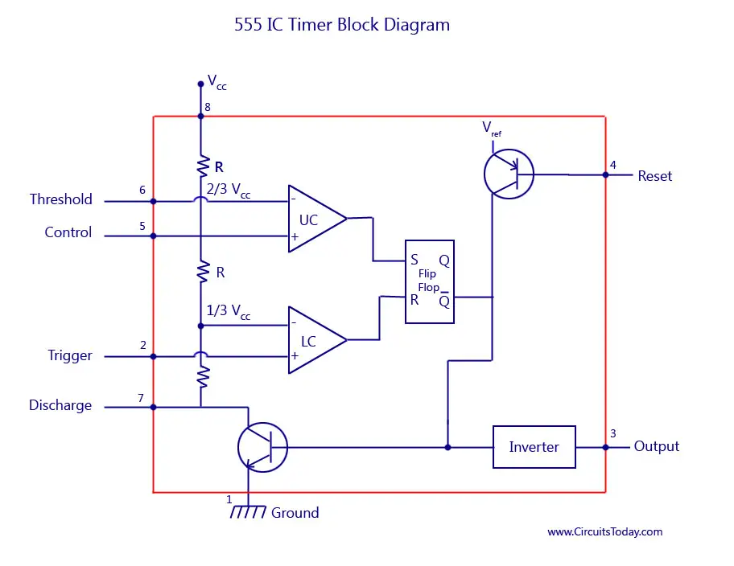

**2)Q1 IRLZ44N MOSPHET**

**IRLZ44N MOSFET Overview**

**Type:** N-channel MOSFET

**Key Specifications**

* **V_DS (Drain-Source Voltage):** 55V
* **I_D (Continuous Drain Current):** 49A (at 25°C)
* **R_DS(on) (On-Resistance):** 0.025Ω (typical at V_GS = 10V)
* **V_GS (Gate-Source Voltage):** ±20V
* **Total Gate Charge (Q_g):** 67nC (typical)
* **Switching Times:** Fast switching capability
* **Package Type:** TO-220

**Applications**

* Power management
* Motor control
* DC-DC converters
* Amplification circuits

3)DIODE

D1 D_SCHOTTKY DIODE

**Schottky Diode Overview**

**Type:** Schottky barrier rectifier

**Key Specifications**

* **Reverse Voltage (V_R):** Typically ranges from 20V to 100V, depending on the specific diode
* **Forward Current (I_F):** Commonly up to 1A to 40A
* **Forward Voltage Drop (V_F):** Low forward voltage drop (around 0.2V to 0.5V)
* **Reverse Recovery Time:** Very fast (typically in the nanosecond range)
* **Junction Temperature Range:** -55°C to +150°C
* **Package Types:** Can come in various packages like DO-41, TO-220, SMD, etc.

**Applications**

* Power supply circuits
* Switching power supplies
* Rectification in AC to DC converters
* Freewheeling diodes in inductive loads

4) CAPACITORS

C1,C4_10nf

**10 nF Capacitor Overview**

**Capacitance:** 10 nF (nanofarads)

**Key Specifications**

* **Voltage Rating:** Varies widely; common ratings include 25V, 50V, 100V, or higher.
* **Dielectric Material:** Common types include:
  + **Ceramic:** Often used for general applications; low leakage current.
  + **Film:** Good stability and low losses; used in audio and timing applications.
  + **Tantalum:** Higher capacitance in smaller sizes, though more expensive.
* **Temperature Coefficient:** Different types (C0G, X7R, etc.) indicate temperature stability.
* **Tolerance:** Typically ranges from ±5% to ±20%, depending on the application.
* **Size and Package:** Available in various sizes, including through-hole and surface mount.

**Applications**

* Filtering in power supply circuits
* Coupling and decoupling applications
* Timing circuits
* Signal processing

C2_47uF

**47 µF Capacitor Overview**

**Capacitance:** 47 µF (microfarads)

**Key Specifications**

* **Voltage Rating:** Common ratings include:
  + **Electrolytic Capacitors:** 10V, 16V, 25V, 50V, etc.
  + **Tantalum Capacitors:** Higher voltage ratings, often 25V and above.
  + **Film Capacitors:** Similar voltage ratings, typically up to 400V or more.
* **Dielectric Material:**
  + **Electrolytic:** Commonly used for power supply filtering; polarized.
  + **Tantalum:** More stable than electrolytic; smaller size for equivalent capacitance.
  + **Film:** Good for audio and precision applications; non-polarized.
* **Temperature Coefficient:** Varies by type; for electrolytic, usually specified as 85°C or 105°C ratings.
* **Tolerance:** Typically ranges from ±10% to ±20% for electrolytic capacitors.
* **Size and Package:** Available in various sizes; electrolytic capacitors are usually cylindrical, while film capacitors can be in various shapes, including rectangular.

**Applications**

* Power supply filtering
* Coupling and decoupling applications
* Signal smoothing
* Timing circuits in combination with resistors

C3_22uF

**Capacitance:** 22 µF (microfarads)

**Key Specifications**

* **Voltage Rating:** Common ratings include:
  + **Electrolytic Capacitors:** 10V, 16V, 25V, 35V, 50V, etc.
  + **Tantalum Capacitors:** Often rated 25V and higher.
  + **Film Capacitors:** Can range up to 400V or more.
* **Dielectric Material:**
  + **Electrolytic:** Polarized, typically used for bulk energy storage and power supply filtering.
  + **Tantalum:** Non-polarized, more stable, and often used in compact designs.
  + **Film:** Non-polarized, suitable for applications requiring precision and stability.
* **Temperature Coefficient:** Varies based on the type, with electrolytic typically rated for -40°C to 85°C or 105°C.
* **Tolerance:** Generally ranges from ±10% to ±20% for electrolytic capacitors.
* **Size and Package:** Available in various packages; electrolytic types are usually cylindrical, while film capacitors may be rectangular or other shapes.

**Applications**

* Power supply filtering and decoupling
* Signal coupling
* Timing circuits
* Energy storage in power electronics

5)RESISTORS

R1_1K

**Resistance:** 1 kΩ (1000 ohms)

**Key Specifications**

* **Tolerance:** Common tolerances include ±1%, ±5%, and ±10%. Precision resistors may offer ±0.1% tolerance.
* **Power Rating:** Typical power ratings are:
  + **1/8W, 1/4W, 1/2W, 1W,** etc., depending on the application and resistor type.
* **Temperature Coefficient:** Usually specified in parts per million (ppm) per degree Celsius, commonly 100 ppm/°C or lower for precision resistors.
* **Type:** Available in various types, such as:
  + **Carbon Film:** Good general-purpose resistors.
  + **Metal Film:** Better stability and lower noise; used in precision applications.
  + **Wirewound:** Used for higher power applications.
* **Size and Package:** Available in through-hole and surface mount (SMD) packages. Common through-hole sizes include 0402, 0603, 0805, etc., for SMD resistors.

**Applications**

* Voltage dividers
* Current limiting
* Biasing in circuits
* Pull-up or pull-down configurations

R2_10K

**Resistance:** 10 kΩ (10,000 ohms)

**Key Specifications**

* **Tolerance:**
  + Common tolerances include ±1%, ±5%, and ±10%. Higher precision resistors can offer ±0.1% or better.
* **Power Rating:**
  + Typically ranges from:
    - **1/8W, 1/4W, 1/2W, 1W**, etc., depending on the resistor type and application.
* **Temperature Coefficient:**
  + Common values range from 100 ppm/°C to 50 ppm/°C for precision resistors.
* **Type:**
  + **Carbon Film:** General-purpose, cost-effective.
  + **Metal Film:** Offers better stability, lower noise; suitable for precision applications.
  + **Wirewound:** Used in high-power applications, stable at high temperatures.
* **Size and Package:**
  + Available in through-hole (like axial or radial) and surface mount (SMD) formats.
  + Common SMD sizes include 0402, 0603, 0805, etc.

**Applications**

* Voltage dividers
* Signal conditioning
* Pull-up or pull-down resistors
* Current limiting

6)INDUCTOR

L1_33uH

**Inductance:** 33 µH (microhenries)

**Key Specifications**

* **Current Rating (I_max):** Maximum current the inductor can handle without saturating, typically specified in amps (A). This can range from a few hundred milliamps to several amps, depending on the design.
* **DC Resistance (DCR):** The resistance of the inductor wire, usually measured in ohms (Ω). Lower DCR is preferred for higher efficiency.
* **Saturation Current (I_sat):** The current level at which the inductor's inductance begins to decrease significantly.
* **Core Material:** Common materials include ferrite, iron powder, or air-core, affecting performance characteristics such as frequency response and saturation.
* **Frequency Rating:** Inductors can be rated for specific frequency ranges, impacting their performance in RF or power applications.
* **Size and Package:** Available in various form factors, including through-hole (axial or radial) and surface mount (SMD) types. Size specifications may vary by manufacturer.

**Applications**

* Filtering in power supply circuits
* Energy storage in DC-DC converters
* RF applications
* Inductive coupling and transformers