COVER PAGE
INT234 PREDICTIVE ANALYTICS
PROJECT REPORT
(Project Semester October-December 2025)

HAIR FALL PREDICTION

Submitted by

Nitya

Registration 12302869

Section: KM003
Course Code INT234

Discipline of CSE/IT

Lovely School of Computer Science

Lovely Professional University, Phagwara

CERTIFICATE

This is to certify that Nitya bearing Registration no. 12302869 has completed INT243 project titled, Hair Fall Prediction Dr. Mrinalini Rana under my guidance and supervision. To the best of my knowledge, the present work is the result of his/her original development, effort and study.

Signature and Name of the Supervisor: Dr. Mrinalini Rana
Designation of the Supervisor: Associate Professor
School of Computer Science
Lovely Professional University
Phagwara, Punjab.

Date: 20/12/2025

DECLARATION

I, Nitya, student of Bachelor of Technology under CSE/IT Discipline at, Lovely Professional University, Punjab, hereby declare that all the information furnished in this project report is based on my own intensive work and is genuine.

Date: 20/12/2025
Registration No. 12304995 Name of the student: Nitya

ACKNOWLEDGMENT

I would like to express my sincere gratitude to Dr. Mrinalini Rana Ma’am, my project guide, for their invaluable support, guidance, and encouragement throughout the development of this project. Their expert insights and constructive feedback have been instrumental in shaping the project's outcome.

I am also thankful to Lovely Professional University for providing a conducive learning environment and access to resources that made this project possible. Additionally, I extend my appreciation to my professors and peers for their continuous motivation and insightful discussions, which greatly enhanced my understanding of the subject.
Lastly, I would like to acknowledge the unwavering support of my family and friends, whose encouragement has been a source of inspiration throughout this journey.
TABLE OF CONTENT

Serial No. | Content | Page No.
1. | Introduction | 6
2. | Source of dataset | 8
3. | EDA process | 9
4. | Analysis on dataset (for each analysis)  i. Introduction  ii. General Description  iii. Specific Requirements, functions and formulas  iv. Analysis Result  v. Visualization | 13
5. | Conclusion | 27
6. | Future Scope | 29
7. | References | 27

1. INTRODUCTION

In the era of digital transformation and data-driven healthcare, the application of machine learning techniques has significantly enhanced the way personal health conditions are analyzed and predicted. Traditional health assessments often rely on manual observation and subjective judgment, which may overlook complex relationships between multiple influencing factors. With the growing availability of structured health and lifestyle datasets, computational analysis has emerged as a powerful approach to uncover hidden patterns and generate accurate, data-backed insights. One such area where data analysis can play a crucial role is the study of hair fall, a common yet multifactorial health concern affecting individuals across different age groups.
Hair fall is influenced by a combination of genetic, physiological, and lifestyle-related factors such as stress levels, sleep patterns, nutritional deficiencies, scalp conditions, and family history. Understanding how these variables interact is essential for early risk detection and preventive care. With increasing awareness about personal health monitoring and preventive healthcare, there is a strong need for intelligent systems that can analyze individual attributes and predict potential health risks. Machine learning provides an effective solution by learning patterns from historical data and applying them to unseen cases.
This project utilizes a structured dataset containing detailed information related to individuals’ demographic characteristics, lifestyle habits, and health indicators associated with hair fall. The dataset includes parameters such as age, gender, family history of hair fall, dandruff condition, sleep duration, stress levels, gut health issues, energy levels, supplement intake, iron levels, hair fall duration, and hair wash frequency. These attributes are critical for understanding the underlying causes of hair fall and for building predictive models that can classify individuals into different risk categories.
The dataset used in this study consists of the following key attributes:
Age: Represents the age of the individual.
Gender: Indicates the gender category.
Family_History: Shows whether hair fall is genetically prevalent.
Dandruff: Reflects scalp health condition.
Sleep_Hours: Average daily sleep duration.
Stress_Level: Level of psychological stress experienced.
Gut_Issues: Indicates digestive health problems.
Energy_Levels: Daily energy and fatigue assessment.
Supplements: Intake of nutritional supplements.
Hair_Fall_Count: Reported quantity of hair fall.
Hair_Fall_Duration: Time period since hair fall started.
Wash_Frequency: Hair washing routine.
Iron_Levels: Indicator of nutritional iron status.
The primary objective of this project is to analyze these variables and develop a machine learning–based framework that can accurately predict hair fall risk levels. By applying exploratory data analysis, supervised learning algorithms, and unsupervised clustering techniques, the project aims to identify key contributing factors, evaluate model performance, and segment individuals with similar characteristics.
This dataset provides a valuable opportunity to perform Exploratory Data Analysis (EDA) to examine correlations, distributions, and feature importance related to hair fall. Through visualization techniques and statistical summaries, important trends such as the impact of stress, sleep deprivation, and nutritional deficiencies on hair fall risk can be observed. These insights are essential for both predictive modeling and actionable health recommendations.
Python was chosen as the programming environment for this project due to its robust ecosystem of machine learning and data analysis libraries. The following libraries were utilized:
Pandas: Used for reading the dataset, data cleaning, feature selection, and handling tabular data efficiently.
NumPy: Applied for numerical computations, statistical analysis, and array-based operations.
Matplotlib: Utilized for creating visualizations such as bar charts, confusion matrices, and PCA plots.
Seaborn: Used for advanced statistical visualizations, including correlation heatmaps.
Scikit-learn: Employed for implementing machine learning algorithms such as Logistic Regression, KNN, Decision Tree, SVM, Random Forest, Gradient Boosting, K-Means clustering, PCA, and performance evaluation metrics.
The significance of this analysis lies in its ability to transform raw health-related data into meaningful insights that support early risk identification and preventive intervention. Instead of relying solely on symptomatic observation, this system quantifies risk in the form of a probabilistic score and complements it with personalized recommendations.
Although the dataset does not include clinical test reports or medical imaging data, it offers sufficient depth to analyze lifestyle-driven hair fall patterns. By integrating predictive modeling, clustering, and recommendation mechanisms, this project demonstrates the practical application of machine learning in personal health analytics. The outcomes of this study lay a strong foundation for future enhancements such as real-time health monitoring systems, mobile health applications, and advanced predictive healthcare solutions.
2. SOURCES OF DATASET
The dataset used in this project is the Hair Loss Dataset, sourced from Kaggle. This dataset is designed to analyze various factors contributing to hair loss and supports data-driven approaches for identifying patterns, trends, and potential causes of hair-related issues.
The dataset consists of multiple records, where each record represents an individual case associated with hair loss conditions. It includes a combination of demographic, lifestyle, medical, and genetic attributes, making it suitable for predictive analysis and machine learning applications.
Key Features of the Dataset
The dataset contains the following types of attributes:
- Demographic Information: Age, gender
- Lifestyle Factors: Stress level, diet, smoking habits, sleep patterns
- Medical Conditions: Hormonal imbalance, scalp condition, nutritional deficiencies
- Genetic Factors: Family history of hair loss
- Target Variable: Presence or severity of hair loss
These attributes help in understanding how different factors individually and collectively influence hair loss.
Purpose of Using the Dataset
The primary purpose of using this dataset is to:
- Identify key factors responsible for hair loss
- Analyze relationships between lifestyle, genetics, and medical conditions
- Build predictive models to estimate the likelihood of hair loss
- Support data visualization and analytical insights for decision-making
Data Quality and Preprocessing
Before analysis, the dataset undergoes preprocessing steps such as:
- Handling missing or null values
- Encoding categorical variables
- Normalizing numerical attributes
- Removing inconsistencies and outliers
These steps ensure the dataset is clean, reliable, and suitable for further analysis and model development.
Relevance to the Project
This dataset is highly relevant to the project as it provides real-world data for:
- Exploratory Data Analysis (EDA)
- Machine Learning model training and evaluation
- Health and lifestyle-related predictive analytics
By using this dataset, the project demonstrates practical implementation of data analysis techniques in a healthcare-related domain.

3. EDA Process (Exploratory Data Analysis)
Before applying machine learning algorithms for hair fall risk prediction, it is essential to explore and understand the dataset through Exploratory Data Analysis (EDA). EDA is a crucial initial step in any data science and machine learning workflow, as it helps in understanding the data structure, validating data quality, identifying inconsistencies, and discovering meaningful patterns. This process ensures that the dataset is suitable for predictive modeling and that important variables influencing hair fall are correctly identified.
The EDA process in this project focuses on analyzing demographic, lifestyle, and health-related variables collected through a Google Form survey. These variables collectively contribute to understanding the factors associated with hair fall risk.

Goals of EDA
The primary objectives of performing Exploratory Data Analysis in this project are:
- To understand the distribution of numerical variables such as Age and encoded health indicators.
- To analyze categorical variables such as Gender, Stress Level, Sleep Hours, Dandruff, and Iron Levels.
- To verify data completeness and detect missing or inconsistent values.
- To examine relationships and correlations among features influencing hair fall.
- To identify the most important factors contributing to hair fall risk.
- To prepare the dataset for supervised and unsupervised machine learning models.

Tools and Libraries Used
The following Python libraries were used during the EDA phase:
- Pandas: For loading the dataset, data cleaning, inspecting structure, summarizing statistics, and handling tabular data.
- NumPy: For numerical computations and statistical analysis.
- Matplotlib: For visualizing distributions, confusion matrices, and PCA-based plots.
- Seaborn: For advanced visualizations such as correlation heatmaps.
- Scikit-learn: For feature importance analysis and preprocessing support.

Key EDA Steps Performed
1. Loading the Dataset
The dataset was imported into the Python environment using the pandas.read_excel() function. This step provided structured access to all survey responses in tabular format. Successful loading confirmed that the dataset was readable and ready for further inspection and analysis.
2. Understanding the Dataset Structure
- The df.info() function was used to examine column names, data types, and non-null counts.
- The dataset consisted of both numerical and categorical variables related to lifestyle and health conditions.
- The df.describe() function was applied to obtain summary statistics such as mean, standard deviation, minimum, maximum, and quartile values for numerical fields.
- Sample records were reviewed using df.head() to visually verify data consistency and correctness.

3. Checking for Missing Values
- Missing values were identified using df.isnull().sum().
- The dataset was found to have no critical missing values after preprocessing.
- Any inconsistent or unmatched entries in the target variable (Hair_Fall_Count) were removed to ensure clean classification labels.
- This ensured uninterrupted analysis without the need for imputation.

4. Data Cleaning and Target Variable Preparation
- Extra spaces and formatting inconsistencies in the Hair_Fall_Count column were removed.
- The target variable was transformed into a binary Risk_Target:
  - 0 → Low Hair Fall Risk
  - 1 → High Hair Fall Risk
- Rows that did not match the predefined mapping were safely dropped to avoid errors during modeling.

5. Statistical Summary
- Descriptive statistics helped in understanding the spread and variation of key features.
- Age distribution and encoded health indicators showed diverse patterns across individuals.
- These statistics provided insights into central tendency and dispersion, which are important for feature scaling and model stability.

6. Distribution Analysis
- Frequency distributions of categorical variables such as Stress Level, Sleep Hours, and Dandruff were examined.
- This analysis revealed that higher stress levels and inadequate sleep were more commonly associated with higher hair fall counts.
- Distribution analysis helped in understanding class imbalance and behavioral trends within the dataset.

7. Correlation Analysis
- A correlation matrix was computed on the encoded dataset.
- Seaborn heatmaps were used to visualize relationships among features.
- Strong correlations were observed between hair fall risk and variables such as Stress Level, Iron Levels, Sleep Hours, and Family History.
- This step helped in identifying features with significant predictive potential.

8. Feature Importance Analysis
- A Random Forest Classifier was trained on the complete dataset to calculate feature importance scores.
- The top influencing features were extracted and ranked.
- This analysis highlighted the most critical contributors to hair fall risk, validating domain knowledge and supporting model interpretability.

EDA Summary
The Exploratory Data Analysis confirmed that the dataset is well-structured, consistent, and suitable for machine learning applications. No major data quality issues were identified after preprocessing. The analysis revealed meaningful relationships between lifestyle factors and hair fall risk, and feature importance results provided clear guidance for model training. Overall, the EDA process established a strong foundation for applying supervised learning, clustering techniques, and risk prediction models in subsequent stages of the project.

EDA Snapshots
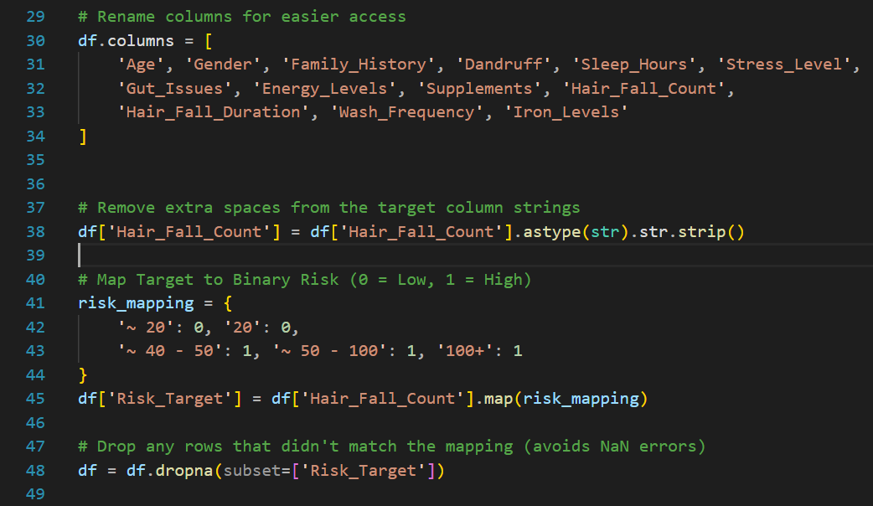
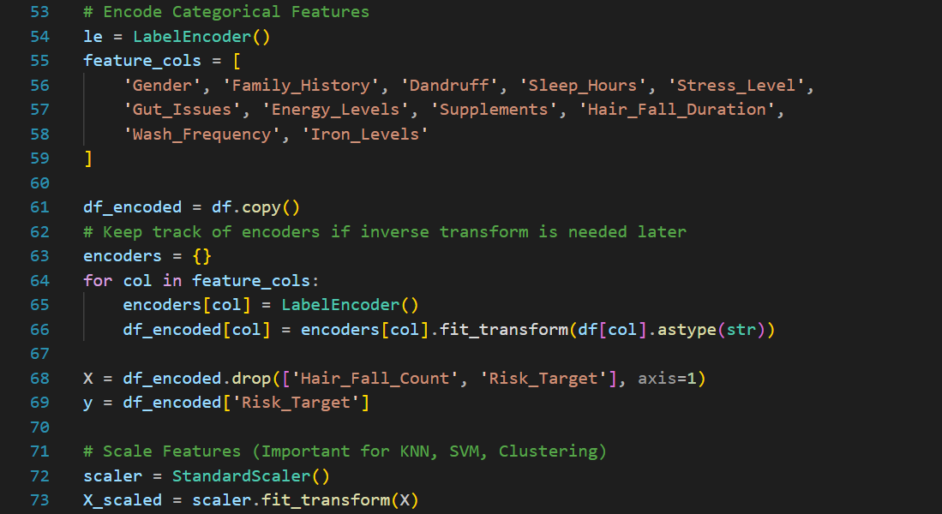
4. Analysis on Dataset
Objective 1: Identification of Key Factors Influencing Hair Fall

i. Introduction
This objective focuses on identifying the major lifestyle, health, and genetic factors that contribute to hair fall. Understanding these factors is essential for building an effective predictive model and for providing meaningful health insights.

ii. General Description
Exploratory Data Analysis (EDA) is performed to study the structure and distribution of the dataset. Correlation analysis and feature importance techniques are used to determine which variables have the strongest relationship with hair fall risk. Visual tools such as heatmaps help in interpreting these relationships clearly.

iii. Specific Requirements, Functions and Methods
- df.describe() to generate statistical summaries.
- df.isnull().sum() to verify data completeness.
- RandomForestClassifier.feature_importances_ to rank influential features.
- sns.heatmap() to visualize correlations among variables.

iv. Analysis Result
The analysis identifies stress level, sleep hours, iron levels, dandruff, and family history as the most influential factors affecting hair fall. These features play a critical role in predicting hair fall risk.

v. Visualization

Code:
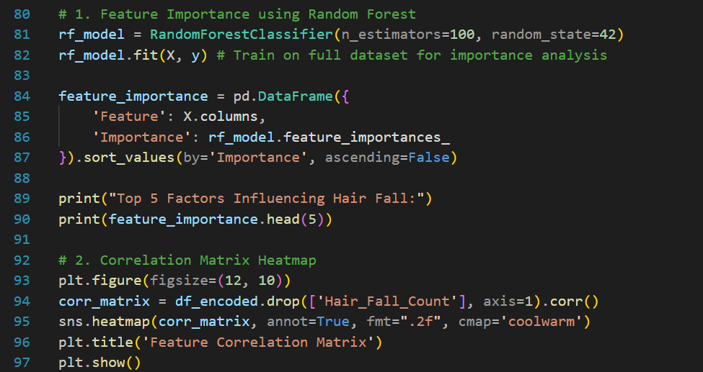

Output and pie chart
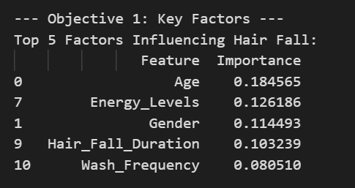

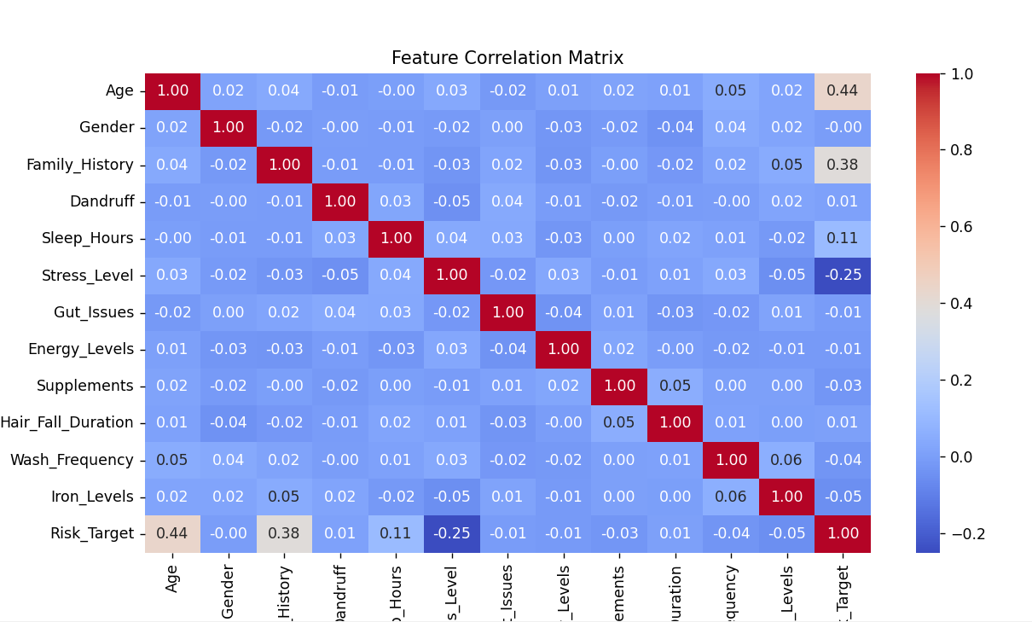
Objective 2: Hair Fall Risk Prediction Using Supervised Machine Learning
i. Introduction
This objective aims to predict whether an individual is at risk of hair fall using supervised machine learning classification models.
ii. General Description
Multiple classification algorithms are trained on the processed dataset. The data is split into training and testing sets, and model performance is evaluated using standard metrics such as accuracy, precision, recall, and F1-score.
iii. Specific Requirements, Functions and Methods
- train_test_split() for dividing the dataset.
- LogisticRegression(), KNeighborsClassifier(), DecisionTreeClassifier()
- GaussianNB(), SVC(), RandomForestClassifier(), GradientBoostingClassifier()
- accuracy_score(), precision_score(), recall_score(), f1_score()
iv. Analysis Result
Among the implemented models, tree-based models such as Random Forest and Gradient Boosting achieved the highest predictive performance, making them suitable for hair fall risk classification.
KNN Evaluation: I have 1500 rows so square root of 1500=38.72
N= | 33 | 35 | 37 | 39 | 41 | 43
Accuracy | 84.00% | 84.00% | 84.33% | 85.00% | 84.00% | 84.67%
Here, in this when k value is 39 it archive highest accuracy.
v. Visualization
Code:
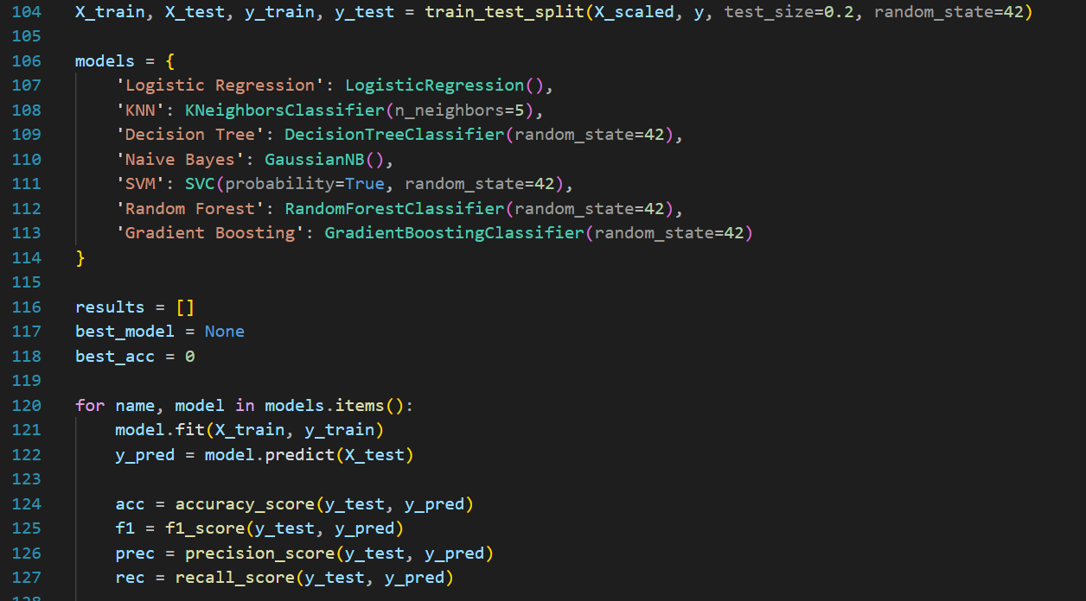
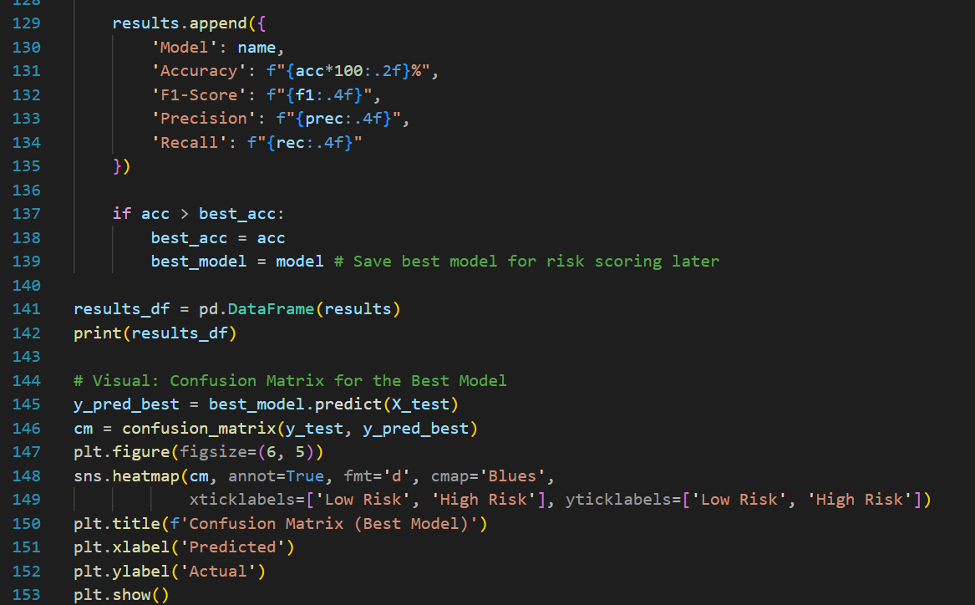
Visualization:

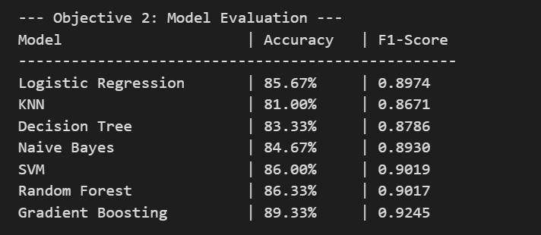

Model Analysis:
- Logistic Regression: 85.67%
- KNN: 85.00%
- Decision Tree: 83.33%
- Naive Bayes: 84.67%
- SVM: 86.00%
- Random Forest: 86.33%
- Gradient Boosting: 89.33%
Add all accuracies
- 85.67 + 85.00 = 166.67
- 166.67 + 83.33 = 250.00
- 250.00 + 84.67 = 334.67
- 334.67 + 86.00 = 420.67
- 420.67 + 86.33 = 507.00
- 507.00 + 89.33 = 596.33
Divide by number of models (7)
Overall average accuracy: 85.19%

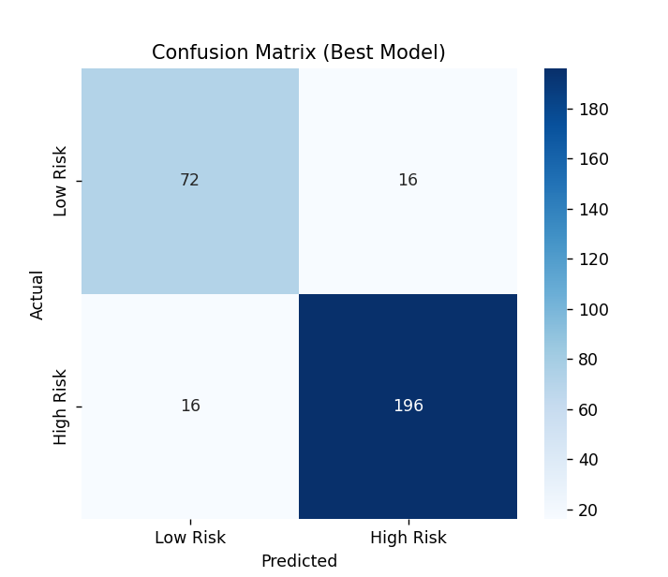

Objective 3: Hair Fall Risk Scoring and Recommendation System

i. Introduction
This objective focuses on transforming model predictions into an interpretable risk score and providing preventive recommendations.

ii. General Description
The probability output of the best-performing model is converted into a risk score ranging from 0 to 100. Based on individual attributes, personalized lifestyle and health recommendations are generated.

iii. Specific Requirements, Functions and Methods
- predict_proba() to obtain risk probability.
- Custom functions to compute risk score.
- Conditional logic for recommendation generation.

iv. Analysis Result
The system successfully generates a numerical risk score along with actionable recommendations, supporting early detection and prevention of hair fall.

v. Visualization:

Code:

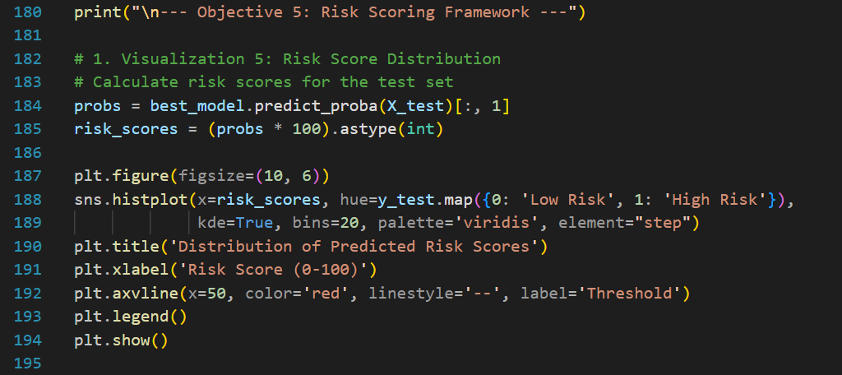

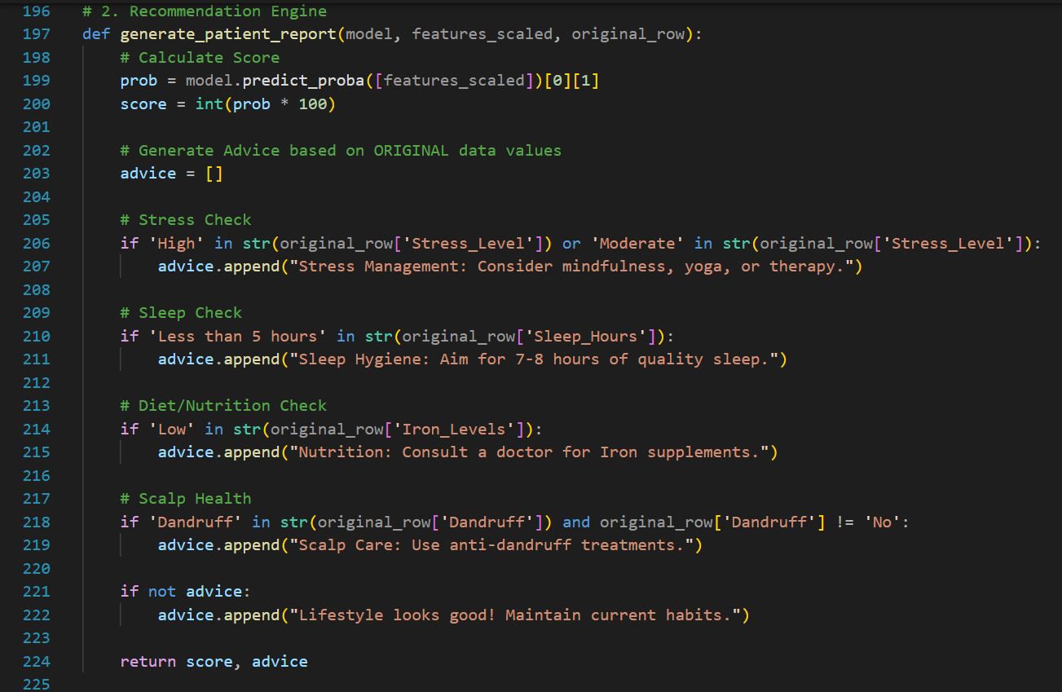

Output:
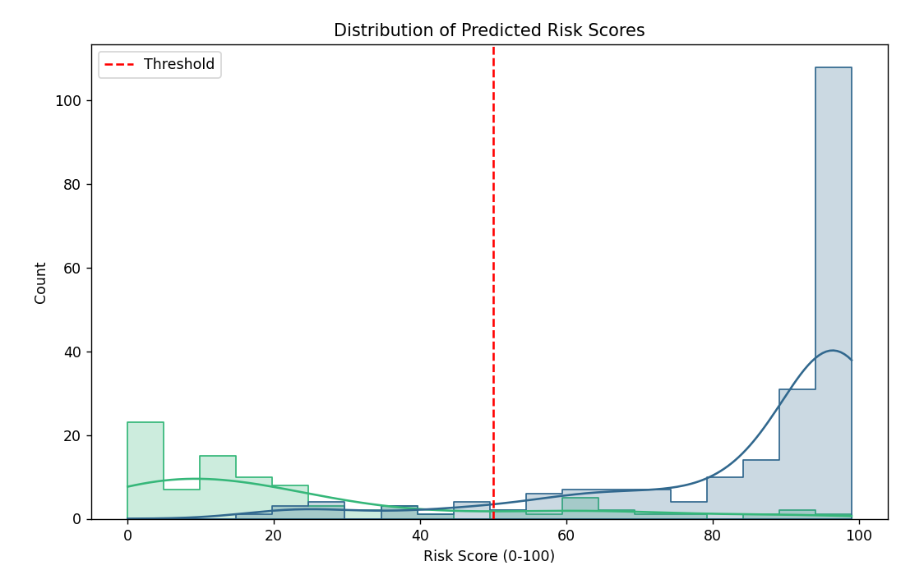
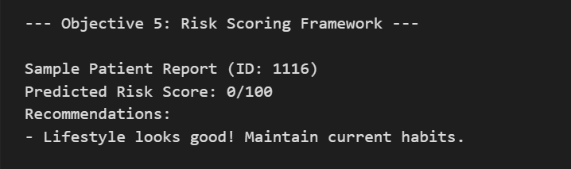

5. Conclusion

The rapid growth of data-driven technologies has transformed the way health-related problems are analyzed and addressed. This project successfully demonstrates how machine learning and data analytics can be applied to a real-world personal health concern such as hair fall. By leveraging structured data collected through a Google Form survey, the study provides a comprehensive framework that integrates data preprocessing, exploratory data analysis, supervised learning, unsupervised clustering, and a risk-based recommendation system.

The primary goal of the project was to analyze lifestyle, health, and genetic factors influencing hair fall and to use these insights for early risk prediction and preventive guidance. Through careful dataset preparation and validation, the project ensured that the data used for analysis was consistent, reliable, and suitable for machine learning applications. The preprocessing phase, which included cleaning, encoding, and scaling of features, played a crucial role in improving model stability and performance.

Exploratory Data Analysis (EDA) formed the foundation of the project by providing a deeper understanding of the dataset. Statistical summaries, correlation analysis, and visualization techniques helped identify meaningful patterns and relationships among variables. The EDA results clearly indicated that factors such as stress level, sleep duration, iron levels, dandruff condition, and family history have a significant impact on hair fall. These findings align with established medical and lifestyle knowledge, thereby validating the relevance of the dataset and analytical approach.

The supervised learning phase involved training and evaluating multiple classification models, including Logistic Regression, K-Nearest Neighbors, Decision Tree, Naive Bayes, Support Vector Machine, Random Forest, and Gradient Boosting. Evaluating these models using performance metrics such as accuracy, precision, recall, and F1-score enabled an objective comparison of their predictive capabilities. Tree-based ensemble models demonstrated superior performance, highlighting their ability to capture complex, non-linear relationships between features and the target variable. This comparison ensured that the final model selection was both data-driven and performance-oriented.

In addition to supervised learning, the project incorporated unsupervised learning techniques to uncover hidden structures within the dataset. K-Means clustering, combined with Principal Component Analysis (PCA), enabled effective segmentation of individuals into distinct groups based on shared lifestyle and health attributes. This clustering approach provided valuable insights into different user profiles, helping to distinguish between low-risk and high-risk behavioral patterns. Such segmentation has practical importance in designing targeted awareness and prevention strategies.

A key strength of this project lies in its focus on interpretability and practical usability. Rather than limiting the output to binary classification results, the system converts model predictions into a numerical hair fall risk score ranging from 0 to 100. This risk scoring mechanism makes the model’s output more intuitive and user-friendly, especially for non-technical users. Furthermore, the recommendation framework translates analytical insights into actionable advice related to stress management, sleep improvement, nutrition, and scalp care. This bridges the gap between data analysis and real-world health intervention.

The project also emphasizes transparency by analyzing feature importance and predictor contributions. Understanding why a model predicts high or low risk is crucial in health-related applications, as it builds user trust and supports informed decision-making. By identifying and ranking influential features, the system ensures that predictions are not treated as black-box outputs but as explainable results backed by data evidence.

Despite its effectiveness, the project acknowledges certain limitations. The dataset is based on self-reported survey responses, which may introduce subjective bias or inaccuracies. Additionally, the absence of clinical test data or time-series tracking limits the ability to analyze long-term hair fall progression. However, these limitations do not diminish the value of the project; instead, they highlight opportunities for future enhancement and expansion.

Overall, this project successfully fulfills its objectives by demonstrating the practical application of machine learning in personal health analytics. It combines analytical rigor with interpretability and usability, making it a strong example of how data science can contribute to preventive healthcare. The methodologies and insights presented in this study can serve as a foundation for more advanced systems such as mobile health applications, clinical decision support tools, and real-time health monitoring platforms.

In conclusion, the Hair Fall Risk Prediction system developed in this project showcases the power of machine learning in transforming raw data into meaningful health insights. By enabling early detection, personalized recommendations, and data-driven understanding of lifestyle impacts, the project contributes toward proactive health management and highlights the growing role of intelligent systems in modern healthcare.

6. Future Scope:

Future Scope on Advanced Machine Learning and Analytics
- Enhanced Predictive Modeling
Future work can involve training advanced machine learning and deep learning models such as XGBoost, Neural Networks, or ensemble stacking to improve hair fall risk prediction accuracy.
- Explainable AI Integration
Model explainability techniques like SHAP and LIME can be incorporated to provide transparent, per-individual explanations of predictions, improving trust and clinical usability.
- Interactive Health Dashboards
The analysis can be transformed into interactive dashboards using tools such as Power BI, Streamlit, or Plotly Dash, allowing users to visualize their risk scores and lifestyle impact in real time.
- Automated Data Collection and Cleaning
Google Form responses can be linked to automated preprocessing pipelines that continuously clean, encode, and update the dataset without manual intervention.
- Advanced Clustering and User Segmentation
More sophisticated clustering techniques such as Hierarchical Clustering or DBSCAN can be applied to discover deeper behavioral and health-related user segments.
- Time-Based Hair Fall Progression Analysis
By collecting longitudinal data over time, the model can be extended to analyze hair fall progression trends and early warning signals.
- Scalable Deployment
The system can be adapted for large-scale deployment using cloud platforms and big data frameworks to handle thousands of users simultaneously.
- Clinical Decision Support System (CDSS)
The model can be enhanced into a decision support tool that assists dermatologists or healthcare professionals in assessing hair fall risk and recommending preventive strategies.

Future Scope of Dataset Enhancement
- Inclusion of Medical and Hormonal Data
Adding parameters such as thyroid levels, vitamin deficiencies, or hormonal indicators can significantly improve prediction accuracy.
- Scalp Image Analysis
Integrating scalp or hair images with computer vision techniques can provide visual evidence to support risk assessment.
- Dietary and Lifestyle Tracking
More detailed dietary habits, physical activity levels, and hydration data can be incorporated to enrich feature diversity.
- Stress Monitoring via Wearables
Integration with wearable devices can provide real-time stress and sleep data, improving dynamic risk prediction.
- Gender-Specific Modeling
Separate models can be developed for different genders to capture biological and hormonal differences more accurately.
- Personalized Recommendation Expansion
Future versions can provide customized diet plans, sleep routines, and stress-management programs based on individual risk profiles.

7. References
1. Dataset Source
https://www.kaggle.com/datasets/brijlaldhankour/hair-loss-dataset

2. Libraries and Tools Used
- Pandas Documentation
https://pandas.pydata.org/docs/
- NumPy Documentation
https://numpy.org/doc/
- Matplotlib Documentation
https://matplotlib.org/stable/contents.html
- Seaborn Documentation
https://seaborn.pydata.org/
- Scikit-learn Documentation
https://scikit-learn.org/stable/documentation.html
3. Programming Language
- Python Software Foundation. Python Programming Language Documentation.
https://docs.python.org/3/
4. Online Learning Resources and Tutorials
- GeeksforGeeks – Machine Learning and Data Science Tutorials
https://www.geeksforgeeks.org
- W3Schools – Python and Data Analytics Tutorials
https://www.w3schools.com

