Data Collection, Cleaning, and Preprocessing for Logistics Analysis
Week 2 Task Report | Python (pandas, NumPy, Matplotlib)

1. Objective and Approach
Logistics decisions such as route planning, carrier selection, cost estimation and inventory replenishment are only as reliable as the shipment data behind them. This report documents a complete, reproducible data-preparation pipeline for a shipment-level logistics dataset: collection (simulated), cleaning, outlier handling, missing-value treatment and normalisation. Every step is justified, shown with Python code, and backed by measured before/after numbers from the pipeline that was actually executed.
The full source code, raw dataset, cleaned dataset and charts are available in the accompanying GitHub project (logistics-data-preprocessing).

2. Data Collection (Simulation)
A publicly shared logistics dataset can differ in column names and quality from one source to another, so a transport log was simulated with a fixed random seed (numpy default_rng(42)) to make every result reproducible. The generator (generate_data.py) mimics a real shipment register and then deliberately injects realistic defects, so the cleaning pipeline has genuine work to do and each fix can be measured.

2.1 Dataset characteristics
Property | Description
Records | 1035 rows x 11 columns (1,000 unique shipments + 35 duplicated rows)
shipment_id, ship_date | Unique shipment code (SHP100000 onwards) and dispatch date between January and September 2026
origin, destination | 8 Indian cities: Delhi, Mumbai, Chennai, Kolkata, Bengaluru, Hyderabad, Pune, Ahmedabad
transport_mode | Road (about 55%), Rail (25%), Air (15%), Sea (5%)
distance_km | Route distance, mean about 900 km
weight_kg | Shipment weight, right-skewed (gamma distribution)
shipping_hours | Transit time, derived from distance and mode speed plus handling time
shipping_cost_inr | Cost in rupees, driven by distance and weight
inventory_units | Units in stock at the origin warehouse
status | Delivered (70%), In Transit (15%), Delayed (15%)

2.2 Data-quality problems injected
Issue | How it was simulated
Missing values | 3% to 8% blanks in six columns (transport_mode, distance, weight, hours, cost, inventory)
Duplicate records | 35 shipment rows copied (3.4% of the data), as happens when a feed is loaded twice
Inconsistent labels | Cities typed as DELHI or 'delhi ' (with trailing space); modes typed in lower case
Outliers | 12 impossible transit times (900 to 2,500 hours), 10 weights of 15 to 40 tonnes, 8 costs above Rs 60,000
Invalid values | 6 negative distances

2.3 First inspection
The code below loads the file and prints a structure and missing-value summary. This is always the first step because it tells us which cleaning techniques are required.
import pandas as pd
df = pd.read_csv('raw_logistics_data.csv', parse_dates=['ship_date'])
print(df.shape) # (1035, 11)
print(df.isna().sum()) # missing values per column
print(df.describe()) # summary statistics

Missing values found in the raw data:
Column | Missing count | % of 1,035 rows | Dtype
transport_mode | 30 | 2.9% | text
distance_km | 65 | 6.3% | float
weight_kg | 52 | 5.0% | float
shipping_hours | 81 | 7.8% | float
shipping_cost_inr | 39 | 3.8% | float
inventory_units | 71 | 6.9% | float
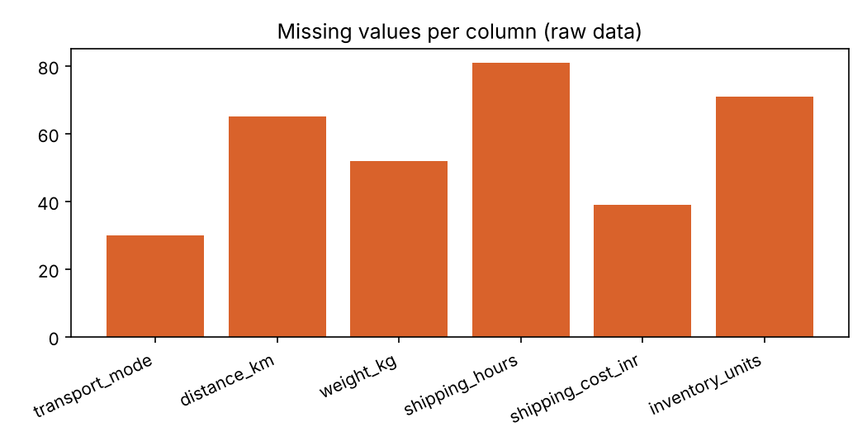
Figure 1: Missing values per column in the raw dataset

3. Data Cleaning: Issues, Fixes and Reasons
The pipeline is ordered deliberately: duplicates first (so they do not distort statistics), then labels and invalid values, then outliers, and only then imputation. Imputing before removing outliers would let extreme values contaminate the replacement values.

Step 1: Remove duplicate records
Issue: 35 of 1,035 rows were exact copies of other rows. Duplicates double-count shipments, inflating volumes and revenue. Fix: drop_duplicates() keeps the first occurrence. Result: rows reduced from 1,035 to 1,000.
n_dup = int(df.duplicated().sum()) # 35
df = df.drop_duplicates().reset_index(drop=True)

Step 2: Standardise categorical labels
Issue: the same city and mode appeared under several spellings. Before cleaning, origin had 16 distinct values (for example AHMEDABAD and Ahmedabad) and transport_mode had 8 (road and Road). Grouping by these columns would have split one city into two groups. Fix: strip whitespace and apply title case. Result: origin 16 to 8 distinct values and transport_mode 8 to 4.
for col in ['origin', 'destination', 'transport_mode']:
df[col] = df[col].str.strip().str.title()

Step 3: Fix invalid values
Issue: 6 shipments had negative distances, for example shipment SHP100314 with -740.6 km. Distance cannot be negative, so these are entry errors. Fix: the invalid values were converted to missing (NaN) so that they are handled by the imputation step instead of silently remaining in the data.
df.loc[df['distance_km'] < 0, 'distance_km'] = np.nan

Step 4: Detect and treat outliers (IQR method)
The interquartile range rule flags a value as an outlier if it lies below Q1 - 1.5 x IQR or above Q3 + 1.5 x IQR. It was chosen over the z-score because the weight and cost columns are skewed, and the z-score itself relies on the mean and standard deviation that outliers distort.
for col in ['shipping_hours', 'weight_kg', 'shipping_cost_inr']:
q1, q3 = df[col].quantile([0.25, 0.75])
iqr = q3 - q1
lo, hi = q1 - 1.5 * iqr, q3 + 1.5 * iqr
mask = (df[col] < lo) | (df[col] > hi)
df.loc[mask, col] = np.nan # re-imputed in the next step

Column | Lower bound | Upper bound | Outliers flagged
shipping_hours | -5.1 | 47.7 | 16
weight_kg | -612.99 | 3,148.31 | 36
shipping_cost_inr | 141.17 | 2,429.84 | 22

Worked example. Shipment SHP100821 travelled by Road from Hyderabad to Pune over 1,094.6 km but was recorded with 976.9 shipping hours, which is about 40 days. At a road speed near 50 km/h the trip should take roughly 22 hours plus handling, so the value is clearly an entry error. The upper IQR bound for shipping_hours is 47.7 hours, so 976.9 is flagged and replaced with the column median in the imputation step.
Note that the flagged counts (16, 36 and 22) are larger than the injected counts (12, 10 and 8). The extra values are genuine but extreme observations in the right tail of the skewed distributions, such as unusually heavy consignments. In a production setting these would be reviewed by a domain expert before removal; for this exercise they are treated uniformly.
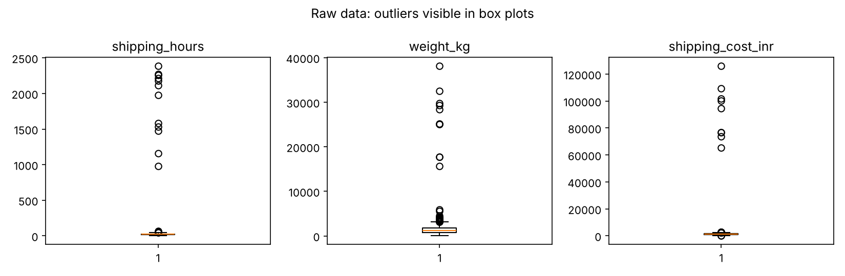
Figure 2: Box plots of the raw data. Extreme points far above the box are the outliers

Step 5: Handle missing values
After the earlier steps the gaps were larger than in the raw file: weight_kg had 86 missing values (up from 52 in the raw file), shipping_hours 95 and shipping_cost_inr 61. Dropping every row with a gap in any column would remove a large share of the 1,000 shipments (about 9.5% for shipping_hours alone), so imputation was used instead.
- Numeric columns: median imputation. The median is robust to skew and to any outliers that remain, whereas the mean is pulled upward by extreme values.
- transport_mode (categorical): mode imputation. The most frequent category (Road) replaces the 30 blanks.
for col in num_cols:
df[col] = df[col].fillna(df[col].median())
df['transport_mode'] = df['transport_mode'].fillna(df['transport_mode'].mode()[0])

Result: total missing values dropped from 338 to 0. For example, weight_kg blanks were filled with its median of 1,190.6 kg. A limitation of simple median imputation is that it ignores relationships between columns; a refinement would be to impute shipping_hours from distance and transport mode.

Step 6: Normalisation
Distance (hundreds of km), weight (thousands of kg) and cost (thousands of rupees) are on very different scales. Distance-based and gradient-based models would be dominated by the largest-scale feature. Two techniques were applied and stored in new columns:
- Min-max scaling: x' = (x - min) / (max - min), rescales to the range 0 to 1.
- Z-score standardisation: z = (x - mean) / std, centres at 0 with unit variance.
for col in num_cols:
mn, mx = df[col].min(), df[col].max()
df[col + '_minmax'] = (df[col] - mn) / (mx - mn)
df[col + '_zscore'] = (df[col] - df[col].mean()) / df[col].std()

Worked example. Shipment SHP100950 weighs 2,017.6 kg. After cleaning, weight_kg has min = 58.4, max = 3,138, mean = 1,266.14 and std = 608.06. Min-max: (2017.6 - 58.4) / (3138.0 - 58.4) = 0.6362. Z-score: (2017.6 - 1266.14) / 608.06 = 1.2358, meaning the shipment is about 1.24 standard deviations heavier than average.

4. Results: Impact of Cleaning on the Data
The table compares summary statistics of the raw and cleaned data. The raw averages were heavily distorted by a handful of impossible values.
Column | Mean (raw) | Mean (clean) | Max (raw) | Max (clean) | Std raw | Std clean
distance_km | 886.99 | 901.09 | 1,970.8 | 1,970.8 | 370.5 | 337.96
weight_kg | 1,619.61 | 1,266.14 | 38,197.4 | 3,138 | 2,776.95 | 608.06
shipping_hours | 44.27 | 21.23 | 2,389.9 | 47.1 | 209.91 | 8.83
shipping_cost_inr | 2,104.71 | 1,272.27 | 1,26,223.9 | 2,408.65 | 8,747.91 | 395.54
inventory_units | 257.13 | 258.97 | 499 | 499 | 139 | 134.09

- Mean shipping time fell from 44.27 to 21.23 hours (a 52% change), because extreme durations of up to 2,390 hours inflated the raw average. The standard deviation dropped from 209.9 to 8.8.
- Mean shipping cost fell from Rs 2,104.71 to Rs 1,272.27 (a 40% change). The raw maximum of Rs 126,224 was about 100 times the typical cost.
- Mean weight fell from 1,619.61 kg to 1,266.14 kg, and the raw maximum of 38,197 kg (a 38-tonne shipment among a typical 1.2-tonne load) was removed.
- Distance minimum moved from -918.1 km (invalid) to 60 km.
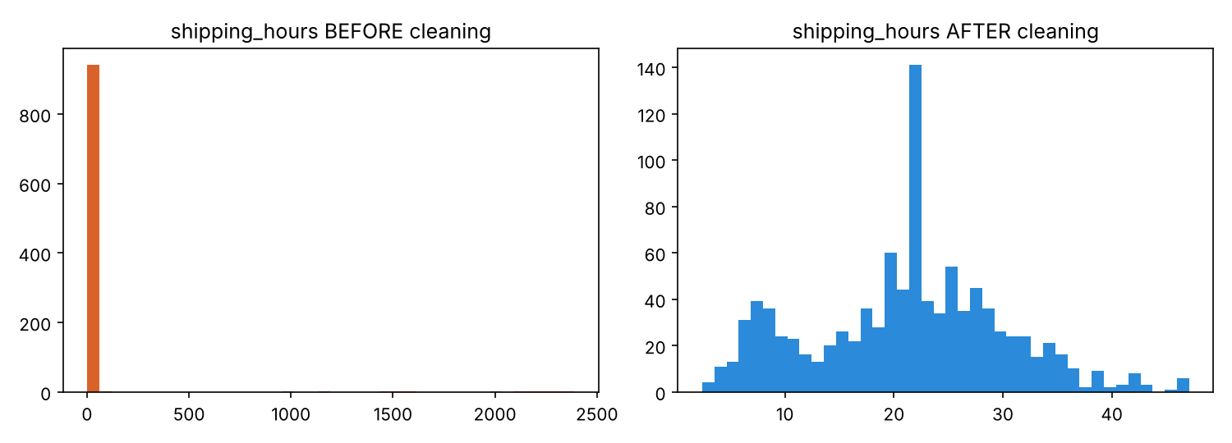
Figure 3: Distribution of shipping_hours before and after cleaning
Average cost per transport mode on the cleaned data:
Transport mode | Shipments | Mean cost (Rs)
Road | 561 | 1,257.38
Rail | 232 | 1,279.38
Air | 154 | 1,288.94
Sea | 53 | 1,350.39

This grouping is only reliable after label standardisation: in the raw file, Road and road would have formed separate groups, and the 30 missing modes would have been excluded from every group.

5. Reflection: Why Data Quality Matters in Logistics
Poor data quality translates directly into poor operational decisions. Using the raw averages above, a planner estimating delivery lead time would believe the average shipment takes 44 hours instead of 21, which could lead to roughly twice the necessary safety stock and tie up working capital. Cost forecasts built on the raw mean of Rs 2,105 per shipment would overstate budget needs by about 65% relative to the cleaned figure of Rs 1,272. Duplicate rows overstate shipment volume, mislabelled cities fragment lane-level analysis, and missing weights make load planning and vehicle utilisation impossible to calculate.
Cleaning is not free of judgement. Median imputation reduces variance and can understate real uncertainty; IQR removal can discard legitimately heavy consignments; and every transformation should be logged so that results can be audited. For these reasons the pipeline records every before/after count in results.json and keeps the raw file untouched.

Possible improvements
- Impute shipping_hours with a regression or group-wise median based on distance and transport mode.
- Add business-rule validation (for example, an Air shipment cannot take more than 48 hours over 1,000 km).
- Use a real public dataset (for example a Kaggle supply-chain or shipping-time dataset) and compare the cleaning results with this simulation.
- Feed the cleaned data into a delay-prediction model to measure the accuracy gain from preprocessing.

6. How to Reproduce
pip install -r requirements.txt
python generate_data.py # creates raw_logistics_data.csv
python preprocess.py # creates clean_logistics_data.csv, results.json, figures

Project structure: generate_data.py, preprocess.py, raw_logistics_data.csv, clean_logistics_data.csv, results.json, three figure files, requirements.txt and README.md.

